En garde

A marathon television debate marks the real start to France’s presidential campaign

The first direct clash between the internationalist Emmanuel Macron and the nationalist Marine Le Pen

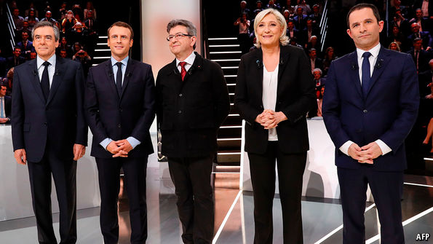

VOTERS in France are growing used to seeing would-be presidents spar aggressively on television. In recent months the Republican and Socialist parties each held a series of broadcast debates on prime-time television, in their respective primary campaigns. The result: the established **front-runner** of each party was knocked aside by **insurgent** candidates who better caught the mood of their audiences.

The presidential campaign has now begun in earnest, ahead of the first round on April 23rd, and the televised debates are about to show their influence again. Opinion polls indicate Marine Le Pen, of the far-right National Front, tied for first place with Emmanuel Macron, a centrist newcomer to electoral politics, with established parties trailing. Each of the two front-runners has some 26% support, enough to reach the run-off in early May. In that second round, if the polls hold, Mr Macron is expected to triumph. But whereas most of Ms Le Pen’s backers report an unshakable faith in her, Mr Macron’s support is less robust. Many who prefer the 39-year-old former economy minister are not entirely sure of their choice. Were he to **stumble** in a debate, or set out a programme too explicitly of the right or the left, he might scare off some of his current supporters.

So when the five main candidates met for a marathon debate—over three hours long—on national television on March 20th, the stakes were highest for Mr Macron. He has limited experience in such **confrontations**, not having taken part in a party primary. He has never been elected to any post. He is often vague about his policy programme (avowedly neither left nor right). And each of the other candidates had every **incentive** to confront him as a front-runner.

Given all this, Mr Macron defended himself well enough, despite occasional spells of **waffling** (for example when pressed on how he would handle relations with Donald Trump, and again in summing up). He rightly put the most emphasis on the need to get France’s economy moving faster. After a nervous start, he became increasingly confident as the night progressed. With his telegenic looks and frequent smile, he charmed an otherwise **stiff** studio audience into laughing along with him at the other candidates’ relentless attacks.