Dead meat

A Brazilian meat scandal damages the country’s two global producers

Chile, China and the EU have banned some or all of the country’s meat

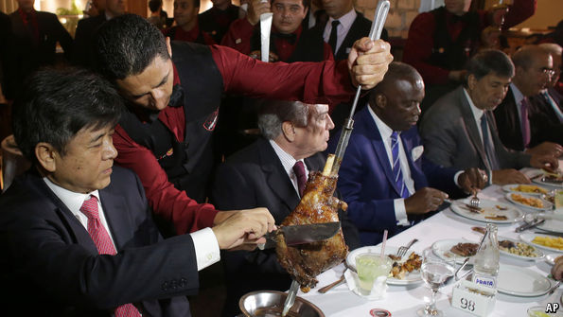

EVEN amid Brazil’s **pungent** **stew** of recent big corporate **scandals**, the latest is particularly stomach-turning. On Friday March 17th, in time for a traditional weekend churrasco, or barbecue, the federal police accused some of the country’s biggest meat producers of **bribing** health inspectors to turn a blind eye to **grubby** practices. These include repackaging beef past its sell-by date, making turkey ham out of **soyabeans** rather than actual birds and overuse of potentially harmful additives. The police operation, dubbed Weak Flesh, could reduce Brazil’s meat exports, worth $13bn a year, and damage its two big global meat producers, JBS and BRF.

Two days later the president, Michel Temer, treated 27 diplomats from the country’s main export markets to prime Brazilian cuts at a **steakhouse** (pictured) in the capital, Brasília. Nevertheless, straight after that China, the European Union, Chile and South Korea, which together consume a third of Brazilian meat sold abroad, said they would ban some or all imports from Brazil until it can allay misgivings about its inspection **regime**. The reactions from China and Chile provoked particular anguish. Unlike the EU, which has restricted products only from the 21 plants that are under investigation, they have barred all Brazilian meat from crossing their borders until further notice.

Investor fears of a widespread **embargo** quickly kicked in. By March 20th shares in JBS, the world’s biggest beef exporter, and in BRF, the largest producer of poultry globally, had lost a sixth of their market value. Like other firms involved in the affair, both companies deny wrongdoing. Their share prices have since partially recovered, helped by South Korea’s subsequent decision to lift its ban. Most of the meat-production plants under investigation belong to much smaller rivals. Only one of dozens of plants owned by BRF is under suspicion, and the same is true for JBS. Yet the damage to reputations may take a long time to repair.