API Automation with Newman’s node and newman.js
The original post is here: https://www.linkedin.com/pulse/apis-test-automation-3-easy-steps-talal-ibdah. The current post is a simplified version.

The process consists of:
- installing nodejs
- installing Newman
- access the API via postman and create verifications there
- export the collections
- run newman from the command line

Installing nodejs
You can get it from https://nodejs.org/en/download/package-manager
Make sure you add the installation folder to the PATH

installing Newman

Then as per https://www.linkedin.com/pulse/apis-test-automation-3-easy-steps-talal-ibdah also install newman with the command npm that is in the newly installed nodejs (C:\Program Files\nodejs1\npm.cmd):
npm install newman --global;
Make sure that you select a folder not in the protected c:\program files area, say in c:\temp.
The file we are insterested in is C:\temp\newman1\node_modules\newman\bin\newman.js (note: my first installations didn’t work in c:\temp\newman so I ended up having newman1, and similarly c:\program files\nodejs1 You should have it in newman and nodejs the first time ☺).

3. Access the API via postman and create the verifications:
For this exercise we use the Federal Reserve non-key API:
http://www.quandl.com/api/v1/datasets/FRED/GDP.json

We create a collection with two GET calls:
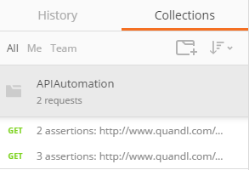
For the first one we have two test verifications:
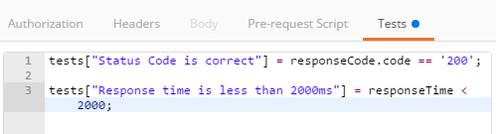

And for the second one we add a verification that the response should contains some particular data:

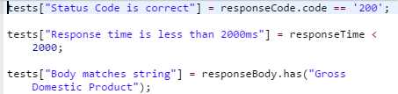
4. Export the collections
We export the collection as APIAutomation.postman_collection.json in the folder c:\temp\newman1\node_modules\newman\bin

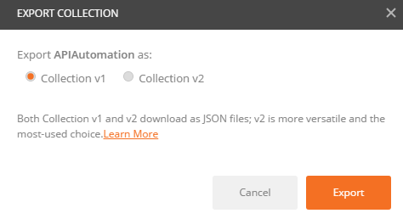
5. Run newman from the command line
We use newman to run from the command line.
Once you do that navigate to the folder where newman.js is located (e.g. c:\temp\newman1\node_modules\newman\bin) and invoke it as follows:
node newman.js run APIAutomation.postman_collection.json

Here is the sample output:
