Michael Esposito

Prof Choi

Foundations of Computing

HW7

1. FIRST(decls’) = {var, ε}

FIRST(decls) = {var, ε}

FIRST(id_list) = {id}

FIRST(type) = {int, real}

FOLLOW(decls’) = {var, $}

FOLLOW(decls) = {var}

FOLLOW(id_list) = { , , id}

FOLLOW(type) = { ; }

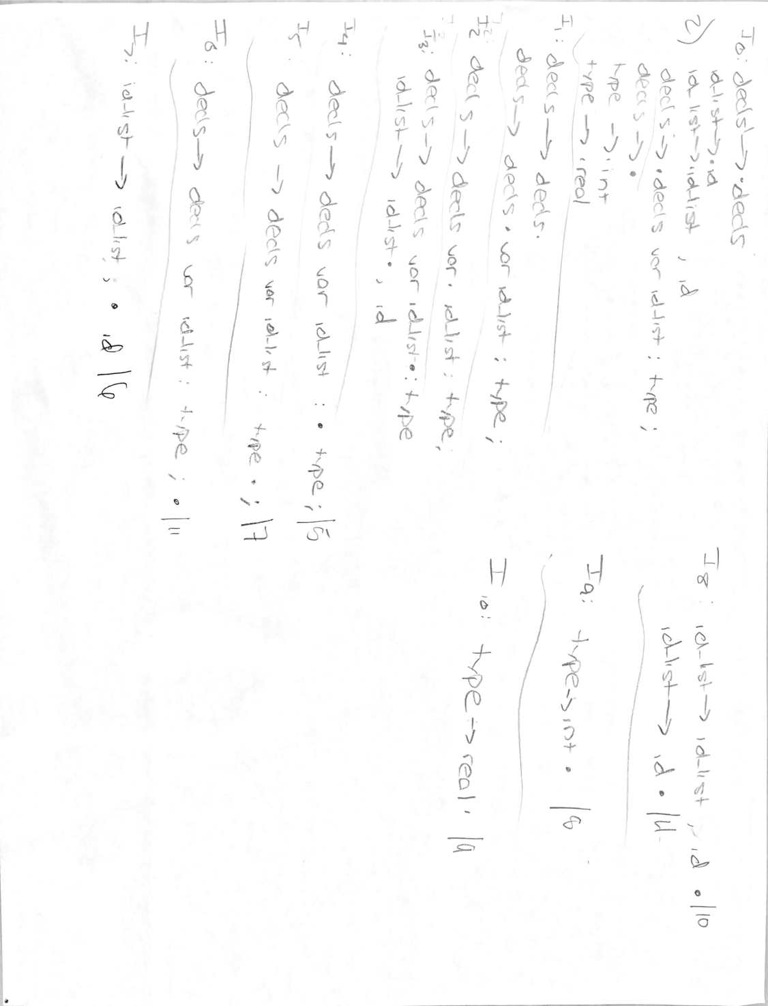

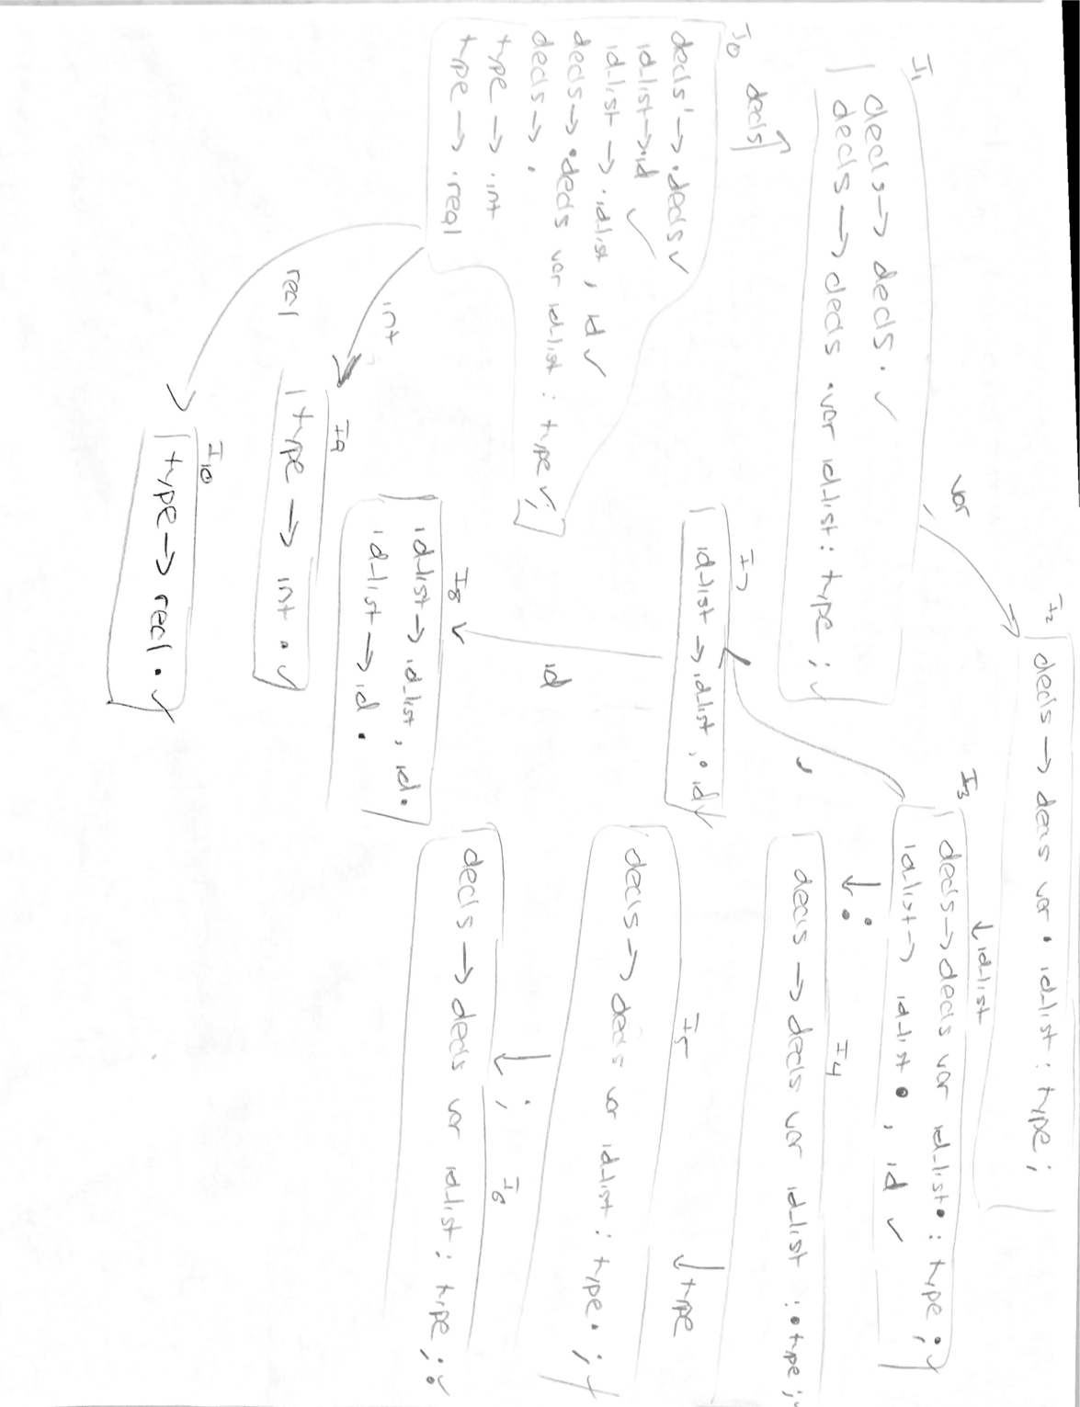

|  |  |  |  |  |  |  |  |  |  |  |  |  |
| --- | --- | --- | --- | --- | --- | --- | --- | --- | --- | --- | --- | --- |
|  | id | ; | , | var | : | int | real | $ | id_list | decls | decls' | type |
| 0 |  |  |  |  |  | s9 | s10 |  |  | 1 |  |  |
| 1 |  |  |  | s2 |  |  |  |  |  |  |  |  |
| 2 |  |  | s7 | r1 |  |  |  |  | 3 |  |  |  |
| 3 |  | s4 |  |  |  |  |  |  |  |  |  |  |
| 4 |  |  |  |  | r3 |  |  |  |  |  |  | 5 |
| 5 |  |  |  |  | s6 |  |  |  |  |  |  |  |
| 6 |  | r5 |  |  |  |  |  |  |  |  |  |  |
| 7 | s8 |  | r3 |  |  |  |  |  |  |  |  |  |
| 8 |  |  | r7 |  |  |  |  |  |  |  |  |  |
| 9 |  |  |  |  |  | r0 |  |  |  |  |  |  |
| 10 |  |  |  |  |  |  | r10 |  |  |  |  |  |

