1. Click your profile icon in the top left of the cell phone 
2. Click “Call Queues”
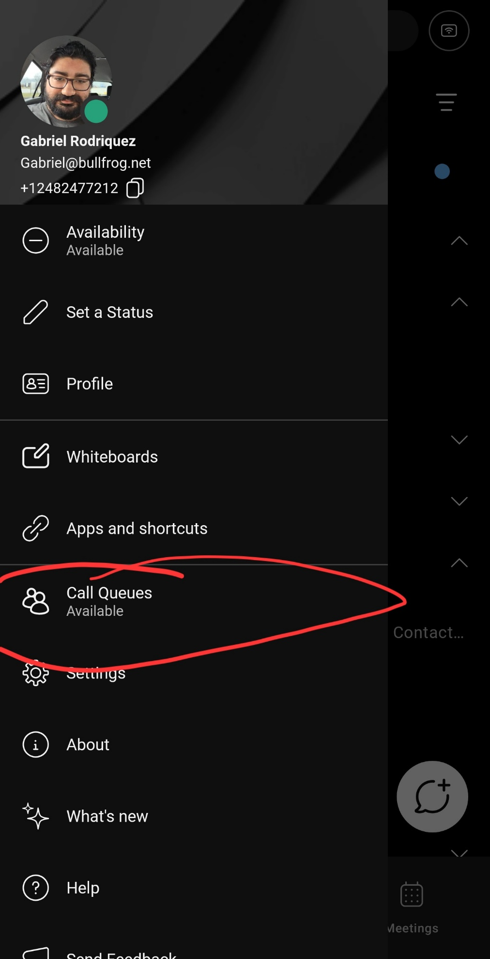
3. During 5 pm – 7 pm click the “Available” option
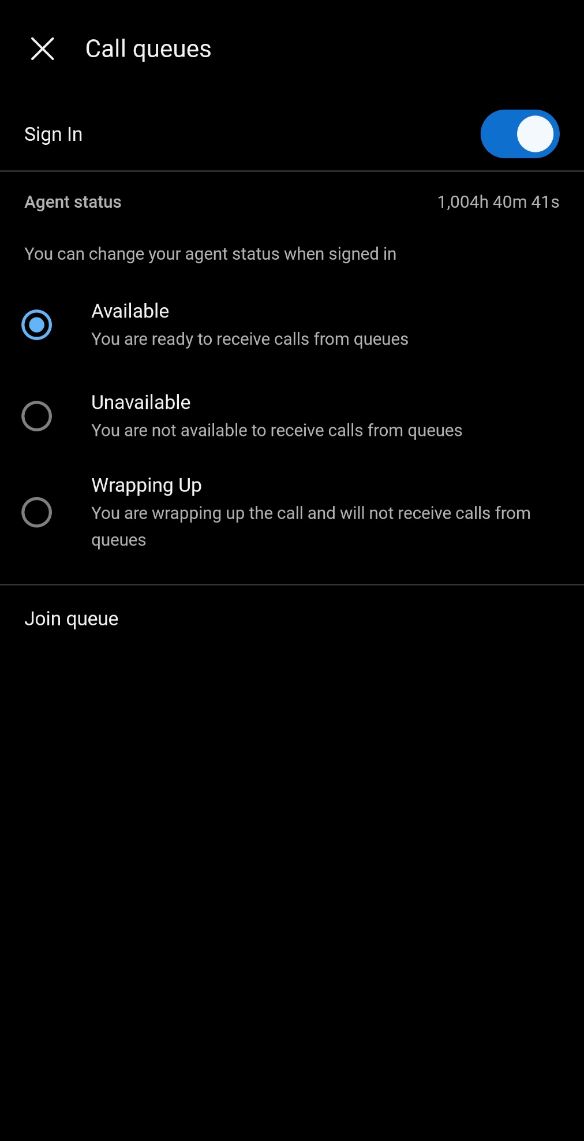
4. After 7 pm click “Unavailable” option to stop receiving calls
Note: The toggle to sign in should be greyed out/toggled on if not please toggle it like the above so it is signed in.

