- On the computer click the option in the bottom left that says available/unavailable or with this icon 
- If it doesn’t say available change it to available to start receiving calls between 5-7
- Outside of that time mark yourself unavailable from the drop-down menu
- 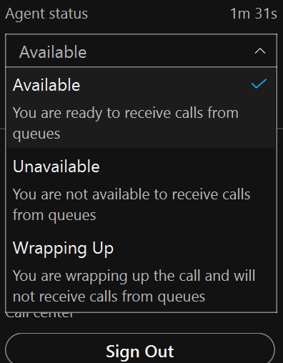
Note: You should already be signed in. If not please click sign in at the bottom