Step 1. To download the Webex app

Go to https://www.webex.com/downloads.html for all download links
Or https://apps.apple.com/us/app/webex/id833967564 for Apple iPhones
Or https://play.google.com/store/apps/details?id=com.cisco.wx2.android&pli=1 for Android phones
Step 2. Click install and once installed open the app
Step 3. Click the sign in button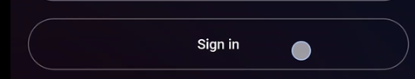
Step 4. Type the email you were given inside the box 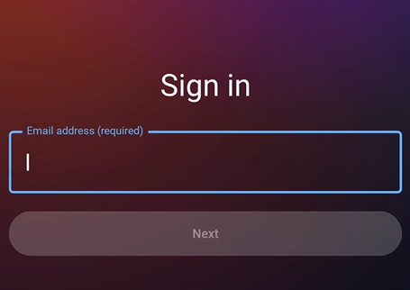
Step 5. Click next
Step 6. Type in the password you were given in the box the click sign in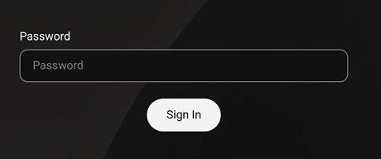
Step 7. Allow all permissions otherwise the app won’t properly work
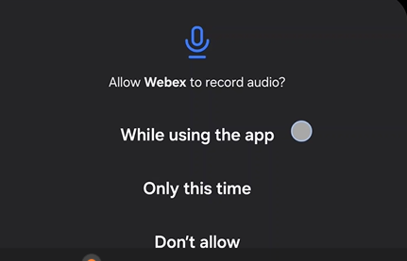

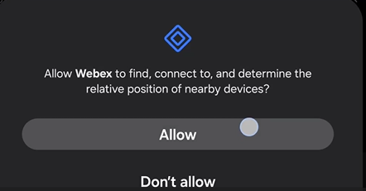

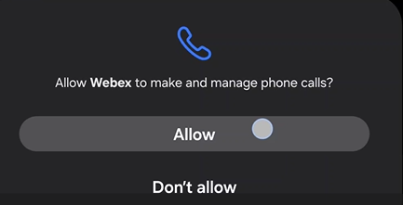

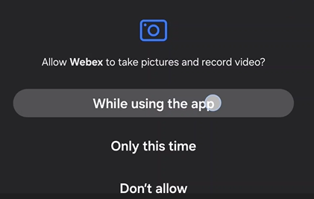

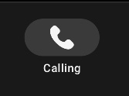
Step 8. If not already selected click the phone button at the bottom of the screen to see call history
Step 9. To answer a call click answer on the pop up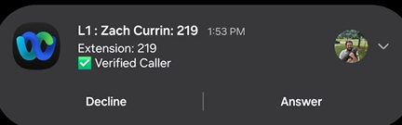
Step 10. Press the  to end the call

Tip: Leave battery save on your phone off. If it is on, please turn it off.

