
Getting started with

Daraja HTTP Framework

v 3.0
Contents
Tutorial 4
Developing a “Hello World” application 4
Project Setup 4
Creating the Web Component 4
Create the server configuration and start-up code 5
Compiling and Running the Application 6
Testing the Application 6
Terminating the HTTP server 6
Developing an HTTP Session application 7
Project Setup 7
Creating the Web Component 7
Create the server configuration and start-up code 8
Compiling and Running the Application 9
Testing the Application 9
Terminating the HTTP server 9
Multiple Mappings of a Web Component 9
Project Setup 10
Creating the Web Component 10
Create the server configuration and start-up code 11
Compiling and Running the Application 12
Testing the Application 12
Terminating the HTTP server 13
Installation 14
Requirements 14
Development Environment 14
IDE and project configuration 14
Option 1: configure source code paths 14
Option 2: compiled units 14
Official Indy installation instructions 15
Conditional Symbols 15
Introduction to Web Components 16
General structure 16
Example 16
Web Application Context 17
Path Mapping 17
Mapping rules 17
Setting parameters of a web component 19
Setting parameters of a context 19
Unicode (UTF-8) 20
HTML Encoding of special characters 20
Introduction to Web Filters 22
General structure 22
Declaration of DoFilter 22
Example: add text to the response 22
Declaration of an initialization method 23
Example: add an initialization parameter value to the response 23
Web Components and multi-threading 25
Design rules for your Web Components 25
Design for multi-threaded operation 25
Synchronization 26
Web Components thread implementation 26
Q: Are Web Components multi-threaded? 26
Appendix 28
Breaking Changes 28
Breaking Changes in v 3.0 28
Frequently Asked Questions 28
How do I allow connections from other computers? 28
Why does the server fail to run with port 8080? 28
Advanced Topics 30
Exception stack traces 30
Stack traces with madExcept 30
Stack traces with JclDebug 31
Configuration of internal Indy HTTP Server 31
MaxConnections example 31
Thread pool example 31
Interceptor example 32
SLF4P support 33
IDE configuration 33
Unit Tests 34
Expected Exceptions 34
Example Web Components 35
TdjDefaultWebComponent 35
TdjNCSALogFilter 35
TdjStatisticsFilter 36
Other optional units 37
ShutdownHelper 37
Third-Party Product Licenses 38
Internet Direct (Indy) 38
Index 39

Tutorial

Developing a “Hello World” application
The following short tutorial takes you through some of the basic steps of developing a “Hello World” example with the Daraja HTTP Framework framework.
This tutorial assumes you already have some familiarity with developing Delphi applications.
You will create an application that runs a HTTP server on the local computer and serves requests for the resource http://127.0.0.1:8080/tutorial/hello.
This tutorial takes approximately 10 minutes to complete.
To complete this tutorial, you need the software and resources listed in the following table.
- Daraja HTTP Framework 3.0
- Indy 10.6
- Delphi 2009

Project Setup
The application you create will contain one Delphi project, which is a console program.
- in the IDE, use the project wizard to create a new console line application project
- add the path to the <inst>\source folder to the project search path
- save the project as HelloWorldServer

Creating the Web Component
- create a unit with the code below and save it as HelloWorldResource.pas
Code example

unit HelloWorldResource;

interface

uses djWebComponent, djTypes;

type
THelloWorldResource = class(TdjWebComponent)
public
procedure OnGet(Request: TdjRequest; Response: TdjResponse); override;
end;

implementation

procedure THelloWorldResource.OnGet(Request: TdjRequest; Response: TdjResponse);
begin
Response.ContentText := 'Hello world!';
Response.ContentType := 'text/plain';
end;

end.

Create the server configuration and start-up code
- open the HelloWorldServer.dpr application project file
- paste the code shown below
Code example
program HelloWorldServer;

{$APPTYPE CONSOLE}

uses
djServer, djWebAppContext,
HelloWorldResource in 'HelloWorldResource.pas';

procedure Demo;
var
Server: TdjServer;
Context: TdjWebAppContext;
begin
Server := TdjServer.Create;
try
Context := TdjWebAppContext.Create('tutorial');
Context.Add(THelloWorldResource, '/hello');
Server.Add(Context);
Server.Start;
WriteLn('Hit enter to terminate.');
ReadLn;
finally
Server.Free;
end;
end;

begin
Demo;
end.

Compiling and Running the Application
- In the IDE, press F9 to start the application
Note: depending on your system, a firewall warning can appear, notifying you that the program tries to open a server port.

Testing the Application
To test the server, open a web browser and navigate to http://127.0.0.1:8080/tutorial/hello. This will cause a HTTP GET request to be sent from the web browser, asking the server for the resource at http://127.0.0.1:8080/tutorial/hello.
The server will parse the request, look up the context ('tutorial') and the web component responsible for this resource address. It will find that THelloWorldResource is mapped to the path '/hello'.
The server then will invoke the GET request handler THelloWorldResource.OnGet, passing request and response objects.
Finally, the code in THelloWorldResource.OnGet builds the response, which will be sent back to the web browser.

Terminating the HTTP server
To shut down the HTTP server, activate the console application window and press the enter key.

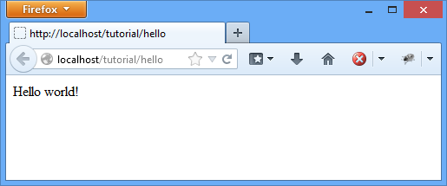Illustration 1: Hello world example

Developing an HTTP Session application
The following short tutorial takes you through some of the basic steps of developing an example for HTTP sessions with the Daraja HTTP Framework framework.
This tutorial assumes you already have some familiarity with developing Delphi applications.
You will create an application that runs a HTTP server on the local computer and serves requests for the resource http://127.0.0.1:8080/tutorial/session.
This tutorial takes approximately 10 minutes to complete.
To complete this tutorial, you need the software and resources listed in the following table.
- Daraja HTTP Framework 3.0
- Indy 10.6
- Delphi 2009

Project Setup
The application you create will contain one Delphi project, which is a console program.
- in the IDE, use the project wizard to create a new console line application project
- add the path to the <inst>\source folder to the project search path
- save the project as HttpSessionServer

Creating the Web Component
- create a unit with the code below and save it as SessionDemoResource.pas
Code example
unit SessionDemoResource;

interface

uses djWebComponent, djTypes;

type
TSessionDemoResource = class(TdjWebComponent)
public
procedure OnGet(Request: TdjRequest; Response: TdjResponse); override;
end;

implementation

uses SysUtils;

procedure TSessionDemoResource.OnGet(Request: TdjRequest; Response: TdjResponse);
var
RequestCountForSession: string;
begin
RequestCountForSession := Request.Session.Content.Values['count'];
if RequestCountForSession = '' then RequestCountForSession := '1';

Request.Session.Content.Values['count'] :=
IntToStr(StrToInt(RequestCountForSession) + 1);

Response.ContentText :=
Format('Your Session ID is %s ', [Request.Session.SessionID]) + #10 +
Format('I have received %s GET Requests during this session', [RequestCountForSession]);

Response.ContentType := 'text/plain';
end;

end.

Create the server configuration and start-up code
- open the HttpSessionServer.dpr application project file
- paste the code shown below
Code example
program HttpSessionServer;

{$APPTYPE CONSOLE}

uses
djServer, djWebAppContext,
SessionDemoResource in 'SessionDemoResource.pas';

procedure Demo;
var
Server: TdjServer;
Context: TdjWebAppContext;
begin
Server := TdjServer.Create;
try
Context := TdjWebAppContext.Create('tutorial', True);
Context.Add(TSessionDemoResource, '/session');
Server.Add(Context);
Server.Start;
WriteLn('Hit enter to terminate.');
ReadLn;
finally
Server.Free;
end;
end;

begin
ReportMemoryLeaksOnShutdown := True;
Demo;
end.

Compiling and Running the Application
- In the IDE, press F9 to start the application
Note: depending on your system, a firewall warning can appear, notifying you that the program tries to open a server port.

Testing the Application
To test the server, open a web browser and navigate to http://127.0.0.1:8080/tutorial/session. This will cause a HTTP GET request to be sent from the web browser, asking the server for the resource at this location.
The server will parse the request, look up the context ('tutorial') and the web component responsible for this resource address. It will find that TSessionDemoResource is mapped to the path '/session'.
The server then will invoke the GET request handler TSessionDemoResource.OnGet, passing request and response objects.
Finally, the code in TSessionDemoResource.OnGet builds the response, which will be sent back to the web browser.

Terminating the HTTP server
To shut down the HTTP server, activate the console application window and press the enter key.
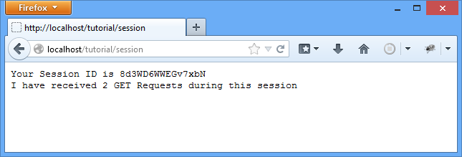Illustration 2: HTTP session example

Multiple Mappings of a Web Component
The following short tutorial takes you through some of the basic steps of creating a Daraja HTTP Framework framework application which uses multiple mappings to deliver different HTTP response content types depending on the HTTP request document path.
This tutorial assumes you already have some familiarity with developing Delphi applications.
You will create an application that runs a HTTP server on the local computer and serves requests for two resource paths.
The response content type depends on the request:
- for http://127.0.0.1:8080/tutorial/fib.txt, the content type is text/plain
- for http://127.0.0.1:8080/tutorial/fib.html, the content type is text/html
The application will expects a query parameter with the name “n” to calculate the Fibonacci number for the parameter value. So a complete request URL will be for example
- http://127.0.0.1:8080/tutorial/fib.html?n=8
This tutorial takes approximately 10 minutes to complete.
To complete this tutorial, you need the software and resources listed in the following table.
- Daraja HTTP Framework 3.0
- Indy 10.6
- Delphi 2009

Project Setup
The application you create will contain one Delphi project, which is a console program.
- in the IDE, use the project wizard to create a new console line application project
- add the path to the <inst>\source folder to the project search path
- save the project as TwoMappingsServer

Creating the Web Component
- create a unit with the code below and save it as FibonacciResource.pas
Code example
unit FibonacciResource;

interface

uses djWebComponent, djTypes;

type
TFibonacciResource = class(TdjWebComponent)
public
procedure OnGet(Request: TdjRequest; Response: TdjResponse); override;
end;

implementation

uses StrUtils, SysUtils;

function fib(n: Integer): Integer;
begin
if n=0 then begin Result := 0; Exit; end;
if n=1 then begin Result := 1; Exit; end;
Result := fib(n-1) + fib(n-2);
end;

procedure TFibonacciResource.OnGet(Request: TdjRequest; Response: TdjResponse);
const
INVALID_ARGUMENT_VALUE = -1;
var
InputParam: Integer;
begin
InputParam := StrToIntDef(Request.Params.Values['n'], INVALID_ARGUMENT_VALUE);
if InputParam <= INVALID_ARGUMENT_VALUE then begin
Response.ResponseNo := 500;
Response.ContentText := 'Internal server error: missing or invalid value';
Response.ContentType := 'text/plain';
end else if EndsText('.txt', Request.Document) then begin
Response.ContentText := IntToStr(fib(InputParam));
Response.ContentType := 'text/plain';
end else if EndsText('.html', Request.Document) then begin
Response.ContentText := Format('<html><body>Result: <b>%d</b></body></html>', [fib(InputParam)]);
Response.ContentType := 'text/html';
end;
end;

end.

Create the server configuration and start-up code
- open the TwoMappingsServer.dpr application project file
- paste the code shown below
Code example
program TwoMappingsServer;

{$APPTYPE CONSOLE}

uses
djServer, djWebAppContext,
FibonacciResource in 'FibonacciResource.pas';

procedure Demo;
var
Server: TdjServer;
Context: TdjWebAppContext;
begin
Server := TdjServer.Create;
try
Context := TdjWebAppContext.Create('tutorial');
Context.Add(TFibonacciResource, '/fib.txt');
Context.Add(TFibonacciResource, '/fib.html');
Server.Add(Context);
Server.Start;
WriteLn('Hit enter to terminate.');
ReadLn;
finally
Server.Free;
end;
end;

begin
Demo;
end.

Compiling and Running the Application
- In the IDE, press F9 to start the application
Note: depending on your system, a firewall warning can appear, notifying you that the program tries to open a server port.

Testing the Application
To test the server, open a web browser and navigate to http://127.0.0.1:8080/tutorial/fib.txt?n=7. This will cause a HTTP GET request to be sent, asking for the resource http://127.0.0.1:8080/tutorial/fib.txt, and passing the query parameter n with value 7.
The server will parse the request, look up the context ('tutorial') and the web component responsible for this resource address. It will find that TFibonacciResource is mapped to the absolute path '/fib.txt'.
The server then will invoke the GET request handler TFibonacciResource.OnGet, passing request and response objects.
Finally, the code in TFibonacciResource.OnGet builds the response, which will be sent back to the web browser.
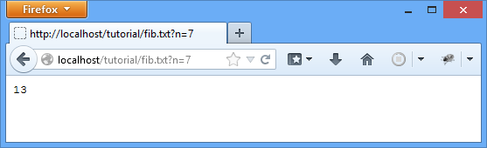Illustration 3: Fibonacci calculation result as plain text
To receive the HTTP response as HTML, use the address http://127.0.0.1:8080/tutorial/fib.html?n=7 – the same web component is mapped to the absolute path /fib.html. This time, the code in OnGet will detect the .html extension and return a response with content type text/html and a simple HTML body back to the browser.
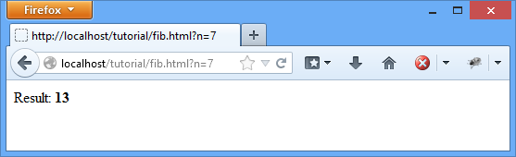Illustration 4: Fibonacci calculation result as HTML

Terminating the HTTP server
To shut down the HTTP server, activate the console application window and press the enter key.

Installation

Requirements

Development Environment
- Embarcadero Delphi 2009 (Update 4)
or
- Free Pascal 3.2.0 or newer
- Internet Direct (Indy) 10.6.2

IDE and project configuration

Option 1: configure source code paths
To make Daraja HTTP Framework and Internet Direct (Indy) available for a project,
- add the Daraja HTTP Framework <Install>/source folder to the project search path
- add the folders <Indy>/Lib/Core, <Indy>/Lib/System and <Indy>/Lib/Protocols to the project search path
- add the folder <Indy>/Lib/Core to the project include path

Note: Installation of the Indy packages in the IDE is not required

Option 2: compiled units
A second option which avoids repeated recompilation is to use compiled DCU files, and include their location in the library path.
Notes:
- if compiler settings change, the library units must be recompiled

Official Indy installation instructions
If you prefer a full installation of Indy packages in the IDE, please read the official documentation page at
http://www.indyproject.org/Sockets/Docs/Indy10Installation.aspx

Conditional Symbols
Conditional symbol | Description
DARAJA_LOGGING | Enables logging
DARAJA_PROJECT_STAGE_DEVELOPMENT | Enables development mode
DARAJA_MADEXCEPT | Enables exception stacktraces with madExcept, this requires development mode
DARAJA_JCLDEBUG | Enables exception stacktraces with JclDebug, this requires development mode
Table 1: Conditional symbols

Introduction to Web Components

General structure
A Web Component has two minimum requirements:
- it must be a subclass of TdjWebComponent
- it must override at least one of the predefined HTTP method handlers – OnGet, OnPost etc.
It may also optionally override two other methods
- the Init method, to perform initialization tasks
- the destructor (Destroy), to perform cleanup tasks

Example
A minimal example is shown below.
- It overrides OnGet, which has two parameters for the Indy HTTP Request and Response objects.
- In the method body, it sets the ContentText property of the Response object to '<html>Hello world!</html>':
Code example

type
TMyWebPage = class(TdjWebComponent)
public
procedure OnGet(Request: TdjRequest; Response:
TdjResponse); override;
end;

implementation

{ TMyWebPage }

procedure TMyWebPage.OnGet(Request: TdjRequest;
Response: TdjResponse);
begin
Response.ContentText := '<html>Hello world!</html>;
Response.ContentType := 'text/html';
Response.CharSet := 'utf-8';
end;

Web Application Context
In a Daraja HTTP Framework web application, a context is an object that is created when the web application is started and destroyed when the web application is taken out of service.
The context object can contain initialization parameters which can be accessed from web components.
A context can provide dynamic and static resources:
- Dynamic resources are created by Web Components when a client sends a request which matches their resource path mapping
- Static resources are located in the file system. A special web component in the framework handles requests for static resources. It also caches requests to save bandwidth
The context path must be set in the constructor and can not be changed later.
Code example

Context := TdjWebAppContext.Create('demo');

By default, web components can not use HTTP sessions.
A second parameter optionally enables HTTP sessions for the context.
Code example

Context := TdjWebAppContext.Create('demo', True);

Path Mapping

Mapping rules
- the framework uses path mappings to find the matching Web Component for a request URL and executes its On... method handler
- if no match is found, and a default handler has been installed, the framework will try to serve the request using a static resource
- if no static file exists, the framework will return a 404 error

Supported Mapping Syntax
Supported mapping styles in order of priority are
- absolute paths, for example '/mypage.html'
- prefix mappings, for example '/myfolder/subfolder/*'
- suffix mappings, for example '*.html' or '*.page'
If two web components declare overlapping mappings, they will be processed in the order of their priority.
Example
- WebCompontentA maps to '*.html'
- WebCompontentB maps to '/myfolder/*'
In this case, the resource /myfolder/index.html will be handled by WebComponentB because a prefix mapping (/myfolder/*) has a higher priority than an extension mapping.

Multiple mappings
Multiple mappings per component are supported. Example:
- WebCompontentA maps to '*.html', '*.doc' and '*.pdf'
- WebCompontentB maps to '/secure/*' and '/protected/*'
With this mapping, resource /context/secure/example.pdf will be handled by WebComponentB, and resource /context/example.pdf will be handled by WebCompontentA.

Setting parameters of a web component
A web component contains a key-value map which can be used to keep configuration information.
As a web component will be created on demand, there is no instance. As a workaround, parameters may be set on the ‘holder’ of the web component.
Code example

Holder := TdjWebComponentHolder.Create(TCmpReturnsInitParams);
Holder.SetInitParameter('key', 'value');
Context.AddWebComponent(Holder, '/*');

To access the context init parameter, use the GetInitParameter method of the GetWebComponentConfig.
Code example

procedure TExampleComponent.OnGet(Request: TdjRequest; Response: TdjResponse);
var
Param: string;
begin
Param := GetWebComponentConfig.GetInitParameter('key');
end;

Setting parameters of a context
A context contains a key-value map which can be used to keep configuration information.
Code example

Context.SetInitParameter('key', 'value');

To access the context init parameter, use GetInitParameter
Code example

procedure TExampleComponent.OnGet(Request: TdjRequest; Response: TdjResponse);
var
Param: string;
begin
Param := Config.GetContext.GetInitParameter('key');
end;

Use GetInitParameterNames to get a list of all parameter names:
Code example

Config.GetContext.GetInitParameterNames;

Unicode (UTF-8)
By setting the Response ContentType and CharSet, the server can respond with Unicode content:
Code example

procedure THelloPage.OnGet(Request: TdjRequest;
Response: TdjResponse);
begin
Response.ContentText := '中文';
Response.ContentType := 'text/plain';
Response.CharSet := 'utf-8';
end;

HTML Encoding of special characters
If the web component returns HTML, some characters have to be replaced as they are HTML entities.
Unit djGlobal contains the HTMLEncode function which replaces <, > , & and “ to the corresponding HTML entities &lt;, &gt;, &amp; and &quot;.
Important: only inner text (between HTML elements) must be encoded.
Code example

procedure THelloPage.OnGet(Request: TdjRequest;
Response: TdjResponse);
begin
Response.ContentText := '<html><p>' + HTMLEncode('rhythm & blues') + '</p></html>';
Response.ContentType := 'text/html';
Response.CharSet := 'utf-8';
end;

Introduction to Web Filters

General structure
A Web Filter class must fulfill two requirements:
- it must be a subclass of TdjWebFilter
- it must override at least the DoFilter method
It may also optionally override other methods:
- the Init method
- the destructor

Declaration of DoFilter
A web filter must be inherited from TdjWebFilter and at least implement the DoFilter method.

Example: add text to the response
In this example, the filter first invokes the DoFilter method of the filter chain, and finally appends a hard coded text to the response.
Code example
TTestFilter = class(TdjWebFilter)
public
procedure DoFilter(Context: TdjServerContext; Request: TdjRequest;
Response: TdjResponse; const Chain: IWebFilterChain); override;
end;
procedure TTestFilter.DoFilter(Context: TdjServerContext; Request: TdjRequest;
Response: TdjResponse; const Chain: IWebFilterChain);
begin
Chain.DoFilter(Context, Request, Response);
Response.ContentText := Response.ContentText + ' (filtered)';
end;

Declaration of an initialization method
A web filter may optionally declare a Init method which will be called by the framework on startup. The framework will pass the IWebFilterConfig to the method.

Example: add an initialization parameter value to the response
The example filter below reads a value from the filter configuration, and stores it in a field for later usage.
Code example
TFilterWithInit = class(TdjWebFilter)
private
FInitParam: string;
public
procedure Init(const Config: IWebFilterConfig); override;
procedure DoFilter(Context: TdjServerContext; Request: TdjRequest;
Response: TdjResponse; const Chain: IWebFilterChain); override;
end;
procedure TFilterWithInit.Init(const Config: IWebFilterConfig);
begin
FInitParam := Config.GetInitParameter('key');
end;
procedure TFilterWithInit.DoFilter(Context: TdjServerContext;
Request: TdjRequest; Response: TdjResponse; const Chain: IWebFilterChain);
begin
Chain.DoFilter(Context, Request, Response);
Response.ContentText := Response.ContentText + 'Param key=' + FInitParam;
end;

The unit test “TestFilterWithInit” uses the example Web Filter to add some text after the response. The filter is configured by a IWebFilterConfig, which is created before server startup, with the helper method CreateWebFilterConfig shown below.
Code example

function CreateWebFilterConfig(const Context: IContext): IWebFilterConfig;
var
C: TdjWebFilterConfig;
begin
C := TdjWebFilterConfig.Create;
C.Add('key', 'Hello, World!');
C.SetContext(Context);
Result := C;
end;

The next code excerpt is a DUnit / FPCUnit test which uses the filter and verifies that the GET request to the resource has the expected request body content.
Code example
procedure TAPIConfigTests.TestFilterWithInit;
var
Server: TdjServer;
Context: TdjWebAppContext;
FilterConfig: IWebFilterConfig;
begin
Context := TdjWebAppContext.Create('web');
Context.AddWebComponent(TExamplePage, 'example.html');
Context.AddWebFilter(TFilterWithInit, TExamplePage, CreateWebFilterConfig);

Server := TdjServer.Create;
try
Server.Add(Context);
Server.Start;
CheckGETResponseEquals('example, Param key=Hello, World!', '/web/example.html');
finally
Server.Free;
end;
end;

Web Components and multi-threading

Design rules for your Web Components

Design for multi-threaded operation
When we say that a program is multi-threaded, we are not implying that the program runs two separate instances simultaneously (as if you concurrently executed the program twice from the command line). Rather, we are saying that the same instance (executed only once) spawns multiple threads that process this single instance of code. This means that more than one sequential flow of control runs through the same memory block.
When multiple threads execute a single instance of a program and therefore share memory, multiple threads could possibly be attempting to read and write to the same place in memory.
What happens if you introduce a field in your Web Component and use it in the OnGet (or OnPost) method, when two or more threads execute it at the same time? Look at the example below. If two threads execute OnGet, they both will read and increment the value of the private MyVar variable, with unexpected results.
Code example
type
TMyWebPage = class(TdjWebComponent)
private
MyVar: Integer;
public
procedure OnGet(Request: TdjRequest; Response:
TdjResponse); override;
end;

implementation

{ TMyWebPage }

procedure TMyWebPage.OnGet(Request: TdjRequest;
Response: TdjResponse);
begin
WriteLn(MyVar);

Inc(Counter);

// ... other code

WriteLn(MyVar);
end;

It would not be practical to build a site that required a Web Component to be instantiated for each request. Web Components are multi-threaded by design, this means a single instance will handle all HTTP requests.
The framework allocates a thread for each new request for a single Web Component without any special programming.
To avoid multithreading problems, only use read-only or application-wide variables in a Web Component.
To ensure we have our own unique variable instance for each thread, we also can simply move the declaration of the variable from within the class to within the method using it.
If you discover that you must share a variable between Web Components and this variable is going to be read from and written to by multiple threads (and you are not storing it in a database), then you will require thread synchronization.

Synchronization
Thread synchronization is an important technique to know, but not one you want to throw at a solution unless required. Anytime you synchronize blocks of code, you introduce bottlenecks into your system.
Under most circumstances, there is only one instance of your Web Component, no matter how many client requests are in process. That means that at any given moment, there may be many threads running inside the Service method of your solo instance, all sharing the same instance data and potentially stepping on each others toes. This means that you should be careful to synchronize access to shared data (instance variables).

Web Components thread implementation

Q: Are Web Components multi-threaded?
A: Yes, Web Components are normally multi-threaded. The Web Component server allocates a thread for each new request for a single Web Component without any special programming. Each request thread for your Web Component runs as if a single user were accessing it alone, but you can use static variables to store and present information that is common to all threads, like a hit counter for instance.

Q: Are you saying there is only one Web Component instance for all requests?
A: The way that the server handles requests is not prescribed to this extent; it may use a single Web Component, it may use Web Component pooling, it depends on the internal system architecture. New threads are not necessarily created for every Web Component request but may be recycled through a worker thread pool for efficiency. The point is that you should write your Web Component code to take account of a multi-threaded context regardless of the server implementation you happen to be using.

Q: Can my Web Component control the number of threads it accepts?
A: Your Web Component should be designed to be thread safe and not to anticipate any limit to the number of concurrent requests it will receive.

Appendix

Breaking Changes

Breaking Changes in v 3.0
- Remove deprecated methods
- Use port 8080 as by default instead of port 80

Frequently Asked Questions

How do I allow connections from other computers?
By default TdjServer binds to 127.0.0.1 (127.0.0.1) which does not allow connections from other computers.
Solution: either bind the server to IP address 0.0.0.0, or to the IP address of a specific network adapter.
Code example
// allow incoming connections to network adapter 10.10.1.50
Server := TdjServer.Create('10.10.1.50', 8080);

Also be aware that the firewall must be configured to allow incoming connections.

Why does the server fail to run with port 8080?
If a server application is already listening on port 8080, your program will not be able to open the same port. Here are two ways find the process which opened the port:
Find the process by its process ID
Go to a command line and enter
netstat -o -n -a | findstr :8080

The last number in the output is the process ID using port 8080.
Example:
TCP 127.0.0.1:8080 0.0.0.0:0 LISTEN 5636

Find the process name (requires administrator privileges)
Run the following from an elevated command prompt:
netstat -ab

Example output:

...
TCP 0.0.0.0:135 my-PC:0 LISTEN
RpcSs
[svchost.exe]
TCP 0.0.0.0:8080 my-PC:0 LISTEN
[MyOtherServer.exe]
...

Solutions:
- stop the application or service with this process ID, and try again
- use a different port (for example 8081)
Related articles:
- http://stackoverflow.com/questions/20558410
- http://serverfault.com/questions/316514

Advanced Topics

Exception stack traces

Stack traces with madExcept
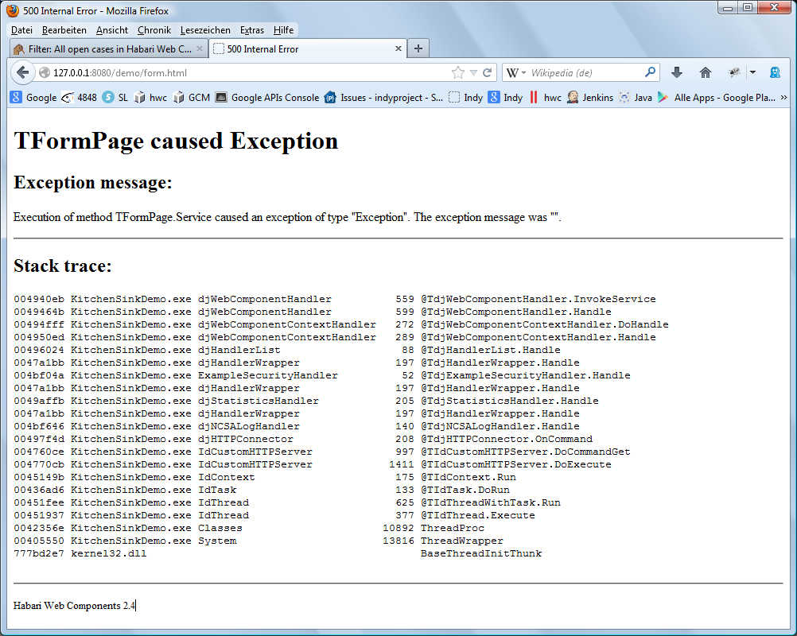
Illustration 5: Exception stack trace with madExcept
Declaring the conditional symbols DARAJA_PROJECT_STAGE_DEVELOPMENT and DARAJA_MADEXCEPT in the project settings will enable stack traces on exceptions. The stack traces will appear in the HTML response and – if DARAJA_LOGGING is defined - in the log output.
Note this is an unsupported bonus feature and only has been tested with madExcept version 3.

Stack traces with JclDebug
Declaring the conditional symbols DARAJA_PROJECT_STAGE_DEVELOPMENT and DARAJA_JCLDEBUG in the project settings will enable stack traces on exceptions. The stack traces will appear in the HTML response and – if DARAJA_LOGGING is defined – in the log output.
Note: this is an unsupported feature, tested with Jedi Code Library version 2.6.0.5178

Configuration of internal Indy HTTP Server
The new property HTTPServer of the class TdjHTTPConnector allows to query and modify properties of the internal Indy HTTP server component.

MaxConnections example
To reject new HTTP connections in high load situations, set the server property MaxConnections:
Code example

// allow a maximum of 100 concurrent connections
Connector.HTTPServer.MaxConnections := 100;

The library will log refused connections (if logging is enabled) with status “warning”.

Thread pool example
A thread pool with a maximum number of threads can be configured for the HTTP server.
In this code example a thread pool scheduler with 20 threads is created and used:
Code example

// create the thread pool scheduler
SchedulerOfThreadPool := TIdSchedulerOfThreadPool.Create(Connector.HTTPServer);
SchedulerOfThreadPool.PoolSize := 20;
// assign the thread pool scheduler to the internal Indy HTTP server
Connector.HTTPServer.Scheduler := SchedulerOfThreadPool;

Interceptor example
The unit tests include an example which shows how this property can be used to add an interceptor to the server.
After running this test, a file (httpIntercept.log) in the test source folder contains the log interceptor output.
Code example
procedure TAPIConfigTests.TestAddConnector;
var
Server: TdjServer;
Context: TdjWebAppContext;
Connector: TdjHTTPConnector;
Intercept: TIdServerInterceptLogFile;
begin
Intercept := TIdServerInterceptLogFile.Create(nil);
try
Server := TdjServer.Create;
try
// add a configured connector
Connector := TdjHTTPConnector.Create(Server.Handler);
Connector.Host := '127.0.0.1';
Connector.Port := 8080;

// new property "HTTPServer"
// here used to set a file based logger for the HTTP server
Connector.HTTPServer.Intercept := Intercept;
Intercept.Filename := 'httpIntercept.log';

Server.AddConnector(Connector);

Context := TdjWebAppContext.Create('get');
Context.Add(TNoOpComponent, '/hello');
Server.Add(Context);

Server.Start;

CheckEquals('', Get('/get/hello'));

finally
Server.Free;
end;
finally
Intercept.Free
end;
end;

Log output

127.0.0.1:49327 Stat Connected.
127.0.0.1:49327 Recv 26.06.2012 09:32:09: GET /get/hello HTTP/1.1<EOL>Host: 127.0.0.1<EOL>Accept: text/html,application/xhtml+xml,application/xml;q=0.9,*/*;q=0.8<EOL>Accept-Encoding: identity<EOL>User-Agent: Mozilla/3.0 (compatible; Indy Library)<EOL><EOL>
127.0.0.1:49327 Sent 26.06.2012 09:32:09: HTTP/1.1 200 OK<EOL>Connection: close<EOL>Content-Length: 0<EOL>Server: Internet Direct (Indy) 10.5.8.0<EOL><EOL>
127.0.0.1:49327 Stat Disconnected.
0.0.0.0:0 Stat Disconnected.

SLF4P support
The framework supports the Simple Logging Facade for Pascal (SLF4P) which is available from GitHub at https://github.com/michaelJustin/slf4p.

IDE configuration
In order to compile with logging support, add the conditional symbol DARAJA_LOGGING to the project options:
- in Delphi, choose Project | Options... | Delphi Compiler > Conditional defines and add DARAJA_LOGGING
- in Lazarus, choose Project | Project Options … | Compiler Options > Other and add -dDARAJA_LOGGING in the Custom options field

Unit Tests

Expected Exceptions
During the unit tests, some expected exceptions will be thrown. In the Delphi IDE, these exceptions should not cause the debugger to interrupt program execution.
To fix this, either add the exceptions in the IDE options dialog (“Exception types to ignore”) or check the option “Ignore this exception type” in the dialog:
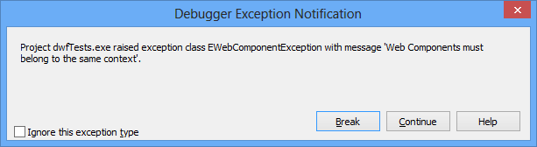
Illustration 6: Debugger Exception Notification
Currently these exceptions are thrown in the tests:
- EidHTTPProtocolException
- EWebComponentException
- EUnitTestException

Example Web Components

TdjDefaultWebComponent
For every context, the framework can provide a folder for static resources (images, scripts, style sheets or static HTML documents).
To add support for static resource folder, register TdjDefaultWebComponent:
Code example
Context.Add(TdjDefaultWebComponent, '/');

TdjDefaultWebComponent serves resources which do not match the URL mapping of any other web component, and tries to serve them from the static resource folder.
The static resource folder is located under the webapps directory of the server and has the same name as the context. Example directory:
\MyWebApp
- MyWebApp.exe
- \webapps
- \myapp1 ← folder for static resource files in context “myapp1”>

TdjNCSALogFilter
TdjNCSALogFilter is a web filter which provides logging support in the NCSA log format.
Example log output:

info | 127.0.0.1 - - [09/Apr/2013:16:00:15:853 +0200] "GET /demo/index.html HTTP/1.1" 200 9050

TdjStatisticsFilter
TdjStatisticsFilter collects statistical information about number of requests and more.

Other optional units

ShutdownHelper
This unit is included in the demo/commons folder and registers a console control event handler.
It has one method, SetShutdownHook. This method takes a single parameter which is a TdjServer instance.
If the console window receives a Ctrl+c/break/close/shutdown/logoff event, the Server.Stop method will be called.
Code example

procedure SetShutdownHook(const Server: TdjServer);

Windows platform This unit can only be used on the Windows platform.

Third-Party Product Licenses

Internet Direct (Indy)
Indy will be compiled into applications built with Daraja HTTP Framework, this means that the Indy license applies to your application.
License information for Indy can be found at http://www.indyproject.org/License/index.aspx

Index
Reference
CharSet 16, 20f.
Conditional symbols 15
Conditional Symbols 15
Configuration 19, 31, 33
ContentText 16, 20f.
ContentType 16, 20f.
Context 17ff., 26, 32
DARAJA_LOGGING 33
Destroy 16
Development mode 15
DjGlobal 20
EidHTTPProtocolException 34
EUnitTestException 34
EWebComponentException 34
Exception stack traces 30
Exceptions 30f., 34
Free Pascal 14
GetInitParameter 19f.
GetInitParameterNames 20
HTML Encoding 20
HTMLEncode 20f.
HTTP 16, 26
HTTPServer 31
Init 16
Interceptor 32
Logging 15
MadExcept 15, 30f.
MADEXCEPT 30
Mapping rules 17
MaxConnections 31
Multi-threaded 25f.
Multi-threading 25
OnGet 16, 25
OnPost 16, 25
Other optional units 37
Path Mapping 17
Request 16, 25ff.
Resource path mapping 17
Resources 17
Response 16, 25
SetInitParameter 19
SetShutdownHook 37
Setting parameters of a context 19
Setting parameters of a web component 19
ShutdownHelper 37
Special characters 20
Static resource 17
Static resource folder 35
Support 17f., 31, 33
TdjDefaultWebComponent 35
TdjHTTPConnector 31
TdjNCSALogFilter 35
TdjRequest 16, 19ff., 25
TdjResponse 16, 19ff., 25
TdjWebAppContext 17
TdjWebComponent 16, 25
TMyWebPage 16, 25
Utf-8 16, 20f.
UTF-8 20
16, 25

Table Index
Conditional symbols 15

Illustration Index
Illustration 1: Hello world example 6
Illustration 2: HTTP session example 9
Illustration 3: Fibonacci calculation result as plain text 12
Illustration 4: Fibonacci calculation result as HTML 13
Illustration 5: Exception stack trace with madExcept 30
Illustration 6: Debugger Exception Notification 34

Response.ContentType should be set before Response.CharSet
https://en.wikipedia.org/wiki/Common_Log_Format

