
Getting started with

Daraja Framework 1.2
Contents
Tutorial 5
Developing a “Hello World” application 6
Project Setup 6
Creating the Web Component 6
Create the server configuration and start-up code 7
Compiling and Running the Application 7
Testing the Application 8
Terminating the HTTP server 8
Source Code 8
Developing an HTTP Session application 9
Project Setup 9
Creating the Web Component 9
Create the server configuration and start-up code 10
Compiling and Running the Application 11
Testing the Application 11
Terminating the HTTP server 11
Source Code 11
Multiple Mappings of a Web Component 12
Project Setup 12
Creating the Web Component 12
Create the server configuration and start-up code 13
Compiling and Running the Application 14
Testing the Application 14
Terminating the HTTP server 15
Source Code 15
Installation 16
Requirements 17
Development Environment 17
IDE and project configuration 18
Option 1: configure source code paths 18
Option 2: compiled units 18
Official Indy installation instructions 18
Conditional Symbols 19
Introduction 20
General structure 21
Example 21
Web Application Context 22
Path Mapping 23
Mapping rules 23
Setting parameters of a web component 24
Setting parameters of a context 25
Unicode (UTF-8) 26
HTML Encoding of special characters 27
Web Components and multi-threading 28
Design rules for your Web Components 29
Design for multi-threaded operation 29
Synchronization 30
Web Components thread implementation 31
Q: Are Web Components multi-threaded? 31
Appendix 32
Frequently Asked Questions 33
How do I allow connections from other computers? 33
Why does the server fail to run with port 80? 33
Linux (unsupported) 34
Advanced Topics 35
Exception stack traces 36
Stack traces with madExcept 36
Stack traces with JclDebug 37
Configuration of internal Indy HTTP Server 38
MaxConnections example 38
Thread pool example 38
Interceptor example 38
SLF4P support 40
IDE configuration 41
Unit Tests 42
Expected Exceptions 43
Example Web Components 44
TdjDefaultWebComponent 45
TdjNCSALogHandler 46
TdjStatisticsHandler 47
Other optional units 48
ShutdownHelper 49
RESTful service development 50
Requirements 51
Limitations 52
Introduction 53
Step by step example 54
Demo project 54
REST configuration commands 56
Path Parameters 57
HTML Forms 58
Multiple Resource Representations 59
Example 59
Example for PATCH 60
Example for OPTIONS 60
CRUD web application example 62
Configuration code 62
Screenshots 63
References 64
Third-Party Product Licenses 65
Internet Direct (Indy) 65
Twitter Bootstrap 65
Index 66

Tutorial

Developing a “Hello World” application
The following short tutorial takes you through some of the basic steps of developing a “Hello World” example with the Daraja Framework framework.
This tutorial assumes you already have some familiarity with developing Delphi applications.
You will create an application that runs a HTTP server on the local computer and serves requests for the resource http://localhost/tutorial/hello.
This tutorial takes approximately 10 minutes to complete.
To complete this tutorial, you need the software and resources listed in the following table.
- Daraja Framework 1.2
- Indy 10.6
- Delphi 2009

Project Setup
The application you create will contain one Delphi project, which is a console program.
- in the IDE, use the project wizard to create a new console line application project
- add the path to the <inst>\source folder to the project search path
- save the project as HelloWorldServer

Creating the Web Component
- create a unit with the code below and save it as HelloWorldResource.pas
Code example

unit HelloWorldResource;

interface

uses djWebComponent, djTypes;

type
THelloWorldResource = class(TdjWebComponent)
public
procedure OnGet(Request: TdjRequest; Response: TdjResponse); override;
end;

implementation

procedure THelloWorldResource.OnGet(Request: TdjRequest; Response: TdjResponse);
begin
Response.ContentText := 'Hello world!';
Response.ContentType := 'text/plain';
end;

end.

Create the server configuration and start-up code
- open the HelloWorldServer.dpr application project file
- paste the code shown below
Code example
program HelloWorldServer;

{$APPTYPE CONSOLE}

uses
djServer, djWebAppContext,
HelloWorldResource in 'HelloWorldResource.pas';

procedure Demo;
var
Server: TdjServer;
Context: TdjWebAppContext;
begin
Server := TdjServer.Create(80);
try
Context := TdjWebAppContext.Create('tutorial');
Context.Add(THelloWorldResource, '/hello');
Server.Add(Context);
Server.Start;
WriteLn('Hit any key to terminate.');
ReadLn;
finally
Server.Free;
end;
end;

begin
Demo;
end.

Compiling and Running the Application
- In the IDE, press F9 to start the application
Note: depending on your system, a firewall warning can appear, notifying you that the program tries to open a server port.

Testing the Application
To test the server, open a web browser and navigate to http://localhost/tutorial/hello. This will cause a HTTP GET request to be sent from the web browser, asking the server for the resource at http://localhost/tutorial/hello.
The server will parse the request, look up the context ('tutorial') and the web component responsible for this resource address. It will find that THelloWorldResource is mapped to the path '/hello'.
The server then will invoke the GET request handler THelloWorldResource.OnGet, passing request and response objects.
Finally, the code in THelloWorldResource.OnGet builds the response, which will be sent back to the web browser.

Terminating the HTTP server
To shut down the HTTP server, activate the console application window and press any key.

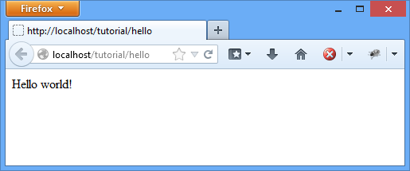Illustration 1: Hello world example

Source Code
The full project source code is included in the <inst>/demo/tutorial1 folder.

Developing an HTTP Session application
The following short tutorial takes you through some of the basic steps of developing an example for HTTP sessions with the Daraja Framework framework.
This tutorial assumes you already have some familiarity with developing Delphi applications.
You will create an application that runs a HTTP server on the local computer and serves requests for the resource http://localhost/tutorial/session.
This tutorial takes approximately 10 minutes to complete.
To complete this tutorial, you need the software and resources listed in the following table.
- Daraja Framework 1.2
- Indy 10.6
- Delphi 2009

Project Setup
The application you create will contain one Delphi project, which is a console program.
- in the IDE, use the project wizard to create a new console line application project
- add the path to the <inst>\source folder to the project search path
- save the project as HttpSessionServer

Creating the Web Component
- create a unit with the code below and save it as SessionDemoResource.pas
Code example
unit SessionDemoResource;

interface

uses djWebComponent, djTypes;

type
TSessionDemoResource = class(TdjWebComponent)
public
procedure OnGet(Request: TdjRequest; Response: TdjResponse); override;
end;

implementation

uses SysUtils;

procedure TSessionDemoResource.OnGet(Request: TdjRequest; Response: TdjResponse);
var
RequestCountForSession: string;
begin
RequestCountForSession := Request.Session.Content.Values['count'];
if RequestCountForSession = '' then RequestCountForSession := '1';

Request.Session.Content.Values['count'] :=
IntToStr(StrToInt(RequestCountForSession) + 1);

Response.ContentText :=
Format('Your Session ID is %s ', [Request.Session.SessionID]) + #10 +
Format('I have received %s GET Requests during this session', [RequestCountForSession]);

Response.ContentType := 'text/plain';
end;

end.

Create the server configuration and start-up code
- open the HttpSessionServer.dpr application project file
- paste the code shown below
Code example
program HttpSessionServer;

{$APPTYPE CONSOLE}

uses
djServer, djWebAppContext,
SessionDemoResource in 'SessionDemoResource.pas';

procedure Demo;
var
Server: TdjServer;
Context: TdjWebAppContext;
begin
Server := TdjServer.Create(80);
try
Context := TdjWebAppContext.Create('tutorial', True);
Context.Add(TSessionDemoResource, '/session');
Server.Add(Context);
Server.Start;
WriteLn('Hit any key to terminate.');
ReadLn;
finally
Server.Free;
end;
end;

begin
ReportMemoryLeaksOnShutdown := True;
Demo;
end.

Compiling and Running the Application
- In the IDE, press F9 to start the application
Note: depending on your system, a firewall warning can appear, notifying you that the program tries to open a server port.

Testing the Application
To test the server, open a web browser and navigate to http://localhost/tutorial/session. This will cause a HTTP GET request to be sent from the web browser, asking the server for the resource at http://localhost/tutorial/session.
The server will parse the request, look up the context ('tutorial') and the web component responsible for this resource address. It will find that TSessionDemoResource is mapped to the path '/session'.
The server then will invoke the GET request handler TSessionDemoResource.OnGet, passing request and response objects.
Finally, the code in TSessionDemoResource.OnGet builds the response, which will be sent back to the web browser.

Terminating the HTTP server
To shut down the HTTP server, activate the console application window and press any key.

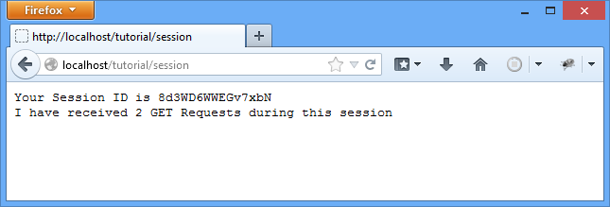Illustration 2: HTTP session example

Source Code
The full project source code is included in the <inst>/demo/tutorial2 folder.

Multiple Mappings of a Web Component
The following short tutorial takes you through some of the basic steps of creating a Daraja Framework framework application which uses multiple mappings to deliver different HTTP response content types depending on the HTTP request document path.
This tutorial assumes you already have some familiarity with developing Delphi applications.
You will create an application that runs a HTTP server on the local computer and serves requests for two resource paths.
The response content type depends on the request:
- for http://localhost/tutorial/fib.txt, the content type is text/plain
- for http://localhost/tutorial/fib.html, the content type is text/html
The application will expects a query parameter with the name “n” to calculate the Fibonacci number for the parameter value. So a complete request URL will be for example
- http://localhost/tutorial/fib.html?n=8
This tutorial takes approximately 10 minutes to complete.
To complete this tutorial, you need the software and resources listed in the following table.
- Daraja Framework 1.2
- Indy 10.6
- Delphi 2009

Project Setup
The application you create will contain one Delphi project, which is a console program.
- in the IDE, use the project wizard to create a new console line application project
- add the path to the <inst>\source folder to the project search path
- save the project as TwoMappingsServer

Creating the Web Component
- create a unit with the code below and save it as FibonacciResource.pas
Code example
unit FibonacciResource;

interface

uses djWebComponent, djTypes;

type
TFibonacciResource = class(TdjWebComponent)
public
procedure OnGet(Request: TdjRequest; Response: TdjResponse); override;
end;

implementation

uses StrUtils, SysUtils;

function fib(n: Integer): Integer;
begin
if n=0 then begin Result := 0; Exit; end;
if n=1 then begin Result := 1; Exit; end;
Result := fib(n-1) + fib(n-2);
end;

procedure TFibonacciResource.OnGet(Request: TdjRequest; Response: TdjResponse);
const
INVALID_ARGUMENT_VALUE = -1;
var
InputParam: Integer;
begin
InputParam := StrToIntDef(Request.Params.Values['n'], INVALID_ARGUMENT_VALUE);
if InputParam <= INVALID_ARGUMENT_VALUE then begin
Response.ResponseNo := 500;
Response.ContentText := 'Internal server error: missing or invalid value';
Response.ContentType := 'text/plain';
end else if EndsText('.txt', Request.Document) then begin
Response.ContentText := IntToStr(fib(InputParam));
Response.ContentType := 'text/plain';
end else if EndsText('.html', Request.Document) then begin
Response.ContentText := Format('<html><body>Result: <b>%d</b></body></html>', [fib(InputParam)]);
Response.ContentType := 'text/html';
end;
end;

end.

Create the server configuration and start-up code
- open the TwoMappingsServer.dpr application project file
- paste the code shown below
Code example
program TwoMappingsServer;

{$APPTYPE CONSOLE}

uses
djServer, djWebAppContext,
FibonacciResource in 'FibonacciResource.pas';

procedure Demo;
var
Server: TdjServer;
Context: TdjWebAppContext;
begin
Server := TdjServer.Create(80);
try
Context := TdjWebAppContext.Create('tutorial');
Context.Add(TFibonacciResource, '/fib.txt');
Context.Add(TFibonacciResource, '/fib.html');
Server.Add(Context);
Server.Start;
WriteLn('Hit any key to terminate.');
ReadLn;
finally
Server.Free;
end;
end;

begin
Demo;
end.

Compiling and Running the Application
- In the IDE, press F9 to start the application
Note: depending on your system, a firewall warning can appear, notifying you that the program tries to open a server port.

Testing the Application
To test the server, open a web browser and navigate to http://localhost/tutorial/fib.txt?n=7. This will cause a HTTP GET request to be sent, asking for the resource http://localhost/tutorial/fib.txt, and passing the query parameter n with value 7.
The server will parse the request, look up the context ('tutorial') and the web component responsible for this resource address. It will find that TFibonacciResource is mapped to the absolute path '/fib.txt'.
The server then will invoke the GET request handler TFibonacciResource.OnGet, passing request and response objects.
Finally, the code in TFibonacciResource.OnGet builds the response, which will be sent back to the web browser.
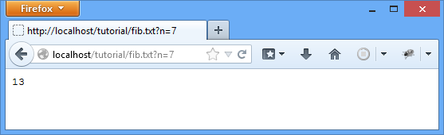Illustration 3: Fibonacci calculation result as plain text
To receive the HTTP response as HTML, use the address http://localhost/tutorial/fib.html?n=7 – the same web component is mapped to the absolute path /fib.html. This time, the code in OnGet will detect the .html extension and return a response with content type text/html and a simple HTML body back to the browser.
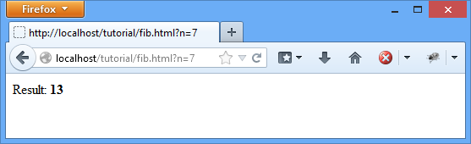Illustration 4: Fibonacci calculation result as HTML

Terminating the HTTP server
To shut down the HTTP server, activate the console application window and press any key.

Source Code
The full project source code is included in the <inst>/demo/tutorial3 folder.

Installation

Requirements

Development Environment
- Embarcadero Delphi 2009 (Update 4) and newer or Free Pascal 3.0
- Internet Direct (Indy) 10.6.2

IDE and project configuration

Option 1: configure source code paths
To make Daraja Framework and Internet Direct (Indy) available for a project,
- add the Daraja Framework <Install>/source folder to the project search path
- add the folders <Indy>/Lib/Core, <Indy>/Lib/System and <Indy>/Lib/Protocols to the project search path
- add the folder <Indy>/Lib/Core to the project include path

Note: Installation of the Indy packages in the IDE is not required

Option 2: compiled units
A second option which avoids repeated recompilation is to use compiled DCU files, and include their location in the library path.
Notes:
- if compiler settings change, the library units must be recompiled

Official Indy installation instructions
If you prefer a full installation of Indy packages in the IDE, please read the official documentation page at
http://www.indyproject.org/Sockets/Docs/Indy10Installation.aspx

Conditional Symbols
Conditional symbol | Description
DARAJA_LOGGING | Enables logging
DARAJA_PROJECT_STAGE_DEVELOPMENT | Enables development mode
DARAJA_MADEXCEPT | Enables exception stacktraces with madExcept, this requires development mode
DARAJA_JCLDEBUG | Enables exception stacktraces with JclDebug, this requires development mode
Table 1: Conditional symbols

Introduction

General structure
A Web Component has this minimum requirements:
- it must be a subclass of TdjWebComponent
- it must override at least one of the predefined HTTP method handlers – OnGet, OnPost etc.
It may also optionally override two other methods
- the Init method, to perform initialization tasks
- the destructor (Destroy), to perform cleanup tasks

Example
A minimal example is shown below.
- It overrides OnGet, which has two parameters for the Indy HTTP Request and Response objects.
- In the method body, it sets the ContentText property of the Response object to '<html>Hello world!</html>':
Code example

type
TMyWebPage = class(TdjWebComponent)
public
procedure OnGet(Request: TdjRequest; Response:
TdjResponse); override;
end;

implementation

{ TMyWebPage }

procedure TMyWebPage.OnGet(Request: TdjRequest;
Response: TdjResponse);
begin
Response.ContentText := '<html>Hello world!</html>;
Response.ContentType := 'text/html';
Response.CharSet := 'utf-8';
end;

Web Application Context
In a Daraja Framework web application, a context is an object that is created when the web application is started and destroyed when the web application is taken out of service.
The context object can contain initialization parameters which can be accessed from web components.
A context can provide dynamic and static resources:
- Dynamic resources are created by Web Components when a client sends a request which matches their resource path mapping
- Static resources are located in the file system. A special web component in the framework handles requests for static resources. It also caches requests to save bandwidth
The context path must be set in the constructor and can not be changed later.
Code example

Context := TdjWebAppContext.Create('demo');

By default, web components can not use HTTP sessions.
A second parameter optionally enables HTTP sessions for the context.
Code example

Context := TdjWebAppContext.Create('demo', True);

Path Mapping

Mapping rules
- the framework uses path mappings to find the matching Web Component for a request URL and executes its On... method handler
- if no match is found, and a default handler has been installed, the framework will try to serve the request using a static resource
- if no static file exists, the framework will return a 404 error

Supported Mapping Syntax
Supported mapping styles in order of priority are
- absolute paths, for example '/mypage.html'
- prefix mappings, for example '/myfolder/subfolder/*'
- suffix mappings, for example '*.html' or '*.page'
If two web components declare overlapping mappings, they will be processed in the order of their priority.
Example
- WebCompontentA maps to '*.html'
- WebCompontentB maps to '/myfolder/*'
In this case, the resource /myfolder/index.html will be handled by WebComponentB because a prefix mapping (/myfolder/*) has a higher priority than an extension mapping.

Multiple mappings
Multiple mappings per component are supported. Example:
- WebCompontentA maps to '*.html', '*.doc' and '*.pdf'
- WebCompontentB maps to '/secure/*' and '/protected/*'
With this mapping, resource /context/secure/example.pdf will be handled by WebComponentB, and resource /context/example.pdf will be handled by WebCompontentA.

Setting parameters of a web component
A web component contains a key-value map which can be used to keep configuration information.
As a web component will be created on demand, there is no instance. As a workaround, parameters may be set on the ‘holder’ of the web component.
Code example

Holder := TdjWebComponentHolder.Create(TCmpReturnsInitParams);
Holder.SetInitParameter('key', 'value');
Context.AddWebComponent(Holder, '/*');

To access the context init parameter, use the GetInitParameter method of the GetWebComponentConfig.
Code example

procedure TExampleComponent.OnGet(Request: TdjRequest; Response: TdjResponse);
var
Param: string;
begin
Param := GetWebComponentConfig.GetInitParameter('key');
end;

Setting parameters of a context
A context contains a key-value map which can be used to keep configuration information.
Code example

Context.SetInitParameter('key', 'value');

To access the context init parameter, use GetInitParameter
Code example

procedure TExampleComponent.OnGet(Request: TdjRequest; Response: TdjResponse);
var
Param: string;
begin
Param := Config.GetContext.GetInitParameter('key');
end;

Use GetInitParameterNames to get a list of all parameter names:
Code example

Config.GetContext.GetInitParameterNames;

Unicode (UTF-8)
By setting the Response ContentType and CharSet, the server can respond with Unicode content:
Code example

procedure THelloPage.OnGet(Request: TdjRequest;
Response: TdjResponse);
begin
Response.ContentText := '中文';
Response.ContentType := 'text/plain';
Response.CharSet := 'utf-8';
end;

HTML Encoding of special characters
If the web component returns HTML, some characters have to be replaced as they are HTML entities.
Unit djGlobal contains the HTMLEncode function which replaces <, > , & and “ to the corresponding HTML entities &lt;, &gt;, &amp; and &quot;.
Important: only inner text (between HTML elements) must be encoded.
Code example

procedure THelloPage.OnGet(Request: TdjRequest;
Response: TdjResponse);
begin
Response.ContentText := '<html><p>' + HTMLEncode('rhythm & blues') + '</p></html>';
Response.ContentType := 'text/html';
Response.CharSet := 'utf-8';
end;

Web Components and multi-threading

Design rules for your Web Components

Design for multi-threaded operation
When we say that a program is multi-threaded, we are not implying that the program runs two separate instances simultaneously (as if you concurrently executed the program twice from the command line). Rather, we are saying that the same instance (executed only once) spawns multiple threads that process this single instance of code. This means that more than one sequential flow of control runs through the same memory block.
When multiple threads execute a single instance of a program and therefore share memory, multiple threads could possibly be attempting to read and write to the same place in memory.
What happens if you introduce a field in your Web Component and use it in the OnGet (or OnPost) method, when two or more threads execute it at the same time? Look at the example below. If two threads execute OnGet, they both will read and increment the value of the private MyVar variable, with unexpected results.
Code example
type
TMyWebPage = class(TdjWebComponent)
private
MyVar: Integer;
public
procedure OnGet(Request: TdjRequest; Response:
TdjResponse); override;
end;

implementation

{ TMyWebPage }

procedure TMyWebPage.OnGet(Request: TdjRequest;
Response: TdjResponse);
begin
WriteLn(MyVar);

Inc(Counter);

// ... other code

WriteLn(MyVar);
end;

It would not be practical to build a site that required a Web Component to be instantiated for each request. Web Components are multi-threaded by design, this means a single instance will handle all HTTP requests.
The framework allocates a thread for each new request for a single Web Component without any special programming.
To avoid multithreading problems, only use read-only or application-wide variables in a Web Component.
To ensure we have our own unique variable instance for each thread, we also can simply move the declaration of the variable from within the class to within the method using it.
If you discover that you must share a variable between Web Components and this variable is going to be read from and written to by multiple threads (and you are not storing it in a database), then you will require thread synchronization.

Synchronization
Thread synchronization is an important technique to know, but not one you want to throw at a solution unless required. Anytime you synchronize blocks of code, you introduce bottlenecks into your system.
Under most circumstances, there is only one instance of your Web Component, no matter how many client requests are in process. That means that at any given moment, there may be many threads running inside the Service method of your solo instance, all sharing the same instance data and potentially stepping on each others toes. This means that you should be careful to synchronize access to shared data (instance variables).

Web Components thread implementation

Q: Are Web Components multi-threaded?
A: Yes, Web Components are normally multi-threaded. The Web Component server allocates a thread for each new request for a single Web Component without any special programming. Each request thread for your Web Component runs as if a single user were accessing it alone, but you can use static variables to store and present information that is common to all threads, like a hit counter for instance.

Q: Are you saying there is only one Web Component instance for all requests?
A: The way that the server handles requests is not prescribed to this extent; it may use a single Web Component, it may use Web Component pooling, it depends on the internal system architecture. New threads are not necessarily created for every Web Component request but may be recycled through a worker thread pool for efficiency. The point is that you should write your Web Component code to take account of a multi-threaded context regardless of the server implementation you happen to be using.

Q: Can my Web Component control the number of threads it accepts?
A: Your Web Component should be designed to be thread safe and not to anticipate any limit to the number of concurrent requests it will receive.

Appendix

Frequently Asked Questions

How do I allow connections from other computers?
By default TdjServer binds to localhost (127.0.0.1) which does not allow connections from other computers.
Solution: either bind the server to IP address 0.0.0.0, or to the IP address of a specific network adapter.
Code example
// allow incoming connections to network adapter 10.10.1.50
Server := TdjServer.Create('10.10.1.50', 8080);

Also be aware that the firewall must be configured to allow incoming connections.

Why does the server fail to run with port 80?
If a server application is already listening on port 80, your program will not be able to open the same port. Known examples are SQL Server Reporting Services, IIS, Web Deployment Agent Service, World Wide Web Publishing Service, or Skype.
There are two find the process which opened the port.
Find the process by its process ID
Go to a command line and enter
netstat -o -n -a | findstr :80

The last number in the output is the process ID using port 80.
Example:
TCP 127.0.0.1:80 0.0.0.0:0 LISTEN 5636

Find the process name (requires administrator privileges)
Run the following from an elevated command prompt:
netstat -ab

Example output:

...
TCP 0.0.0.0:135 my-PC:0 LISTEN
RpcSs
[svchost.exe]
TCP 0.0.0.0:80 my-PC:0 LISTEN
[MyOtherServer.exe]
...

Solutions:
- stop the application or service with this process ID, and try again
- use a different port (for example 8080)
Related articles:
- http://stackoverflow.com/questions/20558410
- http://serverfault.com/questions/316514

Linux (unsupported)
Checking out Indy on Linux

alice@dev-pc:~$ svn co https://svn.atozed.com:444/svn/Indy10/trunk indy-10.6 --username Indy-Public-RO

Advanced Topics

Exception stack traces

Stack traces with madExcept
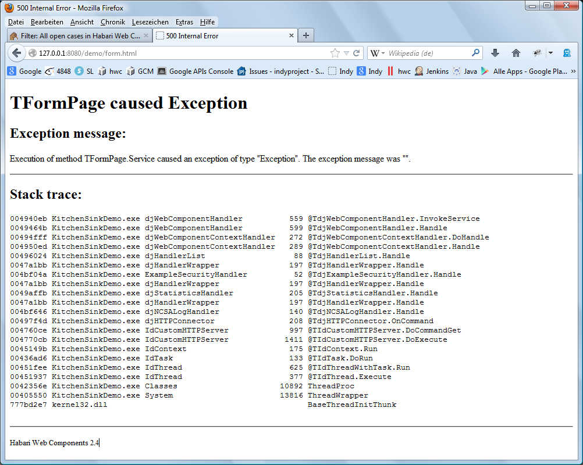
Illustration 5: Exception stack trace with madExcept
Declaring the conditional symbols DARAJA_PROJECT_STAGE_DEVELOPMENT and DARAJA_MADEXCEPT in the project settings will enable stack traces on exceptions. The stack traces will appear in the HTML response and – if DARAJA_LOGGING is defined - in the log output.
Note this is an unsupported bonus feature and only has been tested with madExcept version 3.

Stack traces with JclDebug
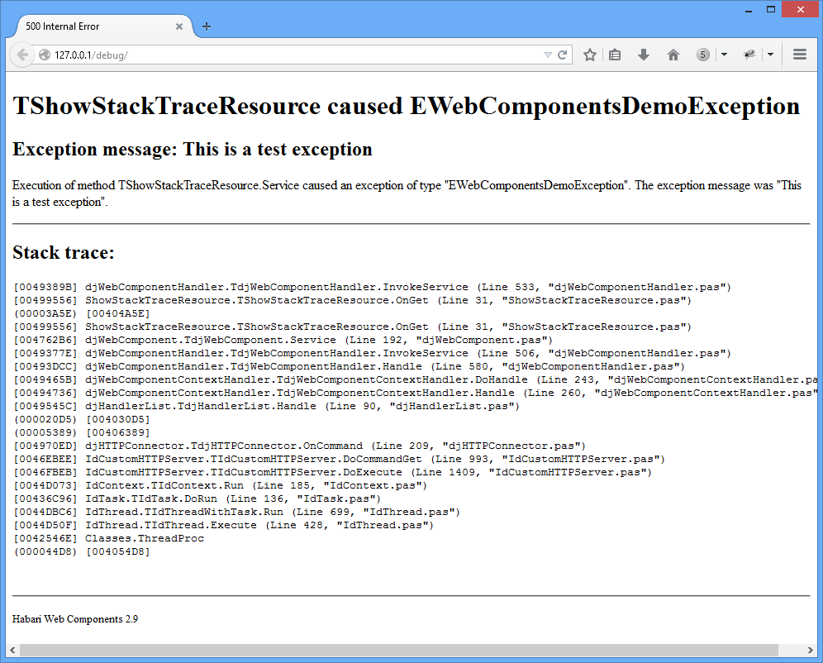Illustration 6: Exception stack trace with JclDebug
Declaring the conditional symbols DARAJA_PROJECT_STAGE_DEVELOPMENT and DARAJA_JCLDEBUG in the project settings will enable stack traces on exceptions. The stack traces will appear in the HTML response and – if DARAJA_LOGGING is defined – in the log output.
Note: this is an unsupported feature, tested with Jedi Code Library version 2.6.0.5178

Configuration of internal Indy HTTP Server
The new property HTTPServer of the class TdjHTTPConnector allows to query and modify properties of the internal Indy HTTP server component.

MaxConnections example
To reject new HTTP connections in high load situations, set the server property MaxConnections:
Code example

// allow a maximum of 100 concurrent connections
Connector.HTTPServer.MaxConnections := 100;

The library will log refused connections (if logging is enabled) with status “warning”.

Thread pool example
A thread pool with a maximum number of threads can be configured for the HTTP server.
In this code example a thread pool scheduler with 20 threads is created and used:
Code example

// create the thread pool scheduler
SchedulerOfThreadPool := TIdSchedulerOfThreadPool.Create(Connector.HTTPServer);
SchedulerOfThreadPool.PoolSize := 20;
// assign the thread pool scheduler to the internal Indy HTTP server
Connector.HTTPServer.Scheduler := SchedulerOfThreadPool;

Interceptor example
The unit tests include an example which shows how this property can be used to add an interceptor to the server.
After running this test, a file (httpIntercept.log) in the test source folder contains the log interceptor output.
Code example
procedure TAPIConfigTests.TestAddConnector;
var
Server: TdjServer;
Context: TdjWebAppContext;
Connector: TdjHTTPConnector;
Intercept: TIdServerInterceptLogFile;
begin
Intercept := TIdServerInterceptLogFile.Create(nil);
try
Server := TdjServer.Create;
try
// add a configured connector
Connector := TdjHTTPConnector.Create(Server.Handler);
Connector.Host := '127.0.0.1';
Connector.Port := 80;

// new property "HTTPServer"
// here used to set a file based logger for the HTTP server
Connector.HTTPServer.Intercept := Intercept;
Intercept.Filename := 'httpIntercept.log';

Server.AddConnector(Connector);

Context := TdjWebAppContext.Create('get');
Context.Add(TNoOpComponent, '/hello');
Server.Add(Context);

Server.Start;

CheckEquals('', Get('/get/hello'));

finally
Server.Free;
end;
finally
Intercept.Free
end;
end;

Log output

127.0.0.1:49327 Stat Connected.
127.0.0.1:49327 Recv 26.06.2012 09:32:09: GET /get/hello HTTP/1.1<EOL>Host: 127.0.0.1<EOL>Accept: text/html,application/xhtml+xml,application/xml;q=0.9,*/*;q=0.8<EOL>Accept-Encoding: identity<EOL>User-Agent: Mozilla/3.0 (compatible; Indy Library)<EOL><EOL>
127.0.0.1:49327 Sent 26.06.2012 09:32:09: HTTP/1.1 200 OK<EOL>Connection: close<EOL>Content-Length: 0<EOL>Server: Internet Direct (Indy) 10.5.8.0<EOL><EOL>
127.0.0.1:49327 Stat Disconnected.
0.0.0.0:0 Stat Disconnected.

SLF4P support
The framework supports the Simple Logging Facade for Pascal (SLF4P) which is available from GitHub at https://github.com/michaelJustin/slf4p.

IDE configuration
In order to compile with logging support, add the conditional symbol DARAJA_LOGGING to the project options:
- in Delphi, choose Project | Options... | Delphi Compiler > Conditional defines and add DARAJA_LOGGING
- in Lazarus, choose Project | Project Options … | Compiler Options > Other and add -dDARAJA_LOGGING in the Custom options field

Unit Tests

Expected Exceptions
During the unit tests, some expected exceptions will be thrown. In the Delphi IDE, these exceptions should not cause the debugger to interrupt program execution.
To fix this, either add the exceptions in the IDE options dialog (“Exception types to ignore”) or check the option “Ignore this exception type” in the dialog:
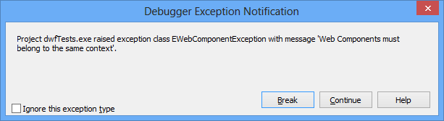
Illustration 7: Debugger Exception Notification
Currently these exceptions are thrown in the tests:
- EidHTTPProtocolException
- EWebComponentException
- EUnitTestException

Example Web Components

TdjDefaultWebComponent
For every context, the framework can provide a folder for static resources (images, scripts, style sheets or static HTML documents).
To add support for static resource folder, register TdjDefaultWebComponent:
Code example
Context.Add(TdjDefaultWebComponent, '/');

TdjDefaultWebComponent serves resources which do not match the URL mapping of any other web component, and tries to serve them from the static resource folder.
The static resource folder is located under the webapps directory of the server and has the same name as the context. Example directory:
\MyWebApp
- MyWebApp.exe
- \webapps
- \myapp1 ← folder for static resource files in context “myapp1”>

TdjNCSALogHandler
TdjNCSALogHandler is a web component which provides logging support in the NCSA log format.
To add it to the handler chain, create an instance of this class, then add the handler to the server:
Code example

// add NCSA logger handler
LogHandler := TdjNCSALogHandler.Create;
Server.AddHandler(LogHandler);

Example log output:

info | 127.0.0.1 - - [09/Apr/2013:16:00:15:853 +0200] "GET /demo/index.html HTTP/1.1" 200 9050

TdjStatisticsHandler
TdjStatisticsHandler collects statistical information about number of requests and more.
This class inherits from TdjHandlerWrapper, which is used to implement the decorator pattern.
To add a statistics handler to the request handler chain, create a single (global) instance of this class, and add it to the server handlers:
Code example
// add statistics handler
StatsWrapper := TdjStatisticsHandler.Create;
Server.AddHandler(StatsWrapper);

Other optional units

ShutdownHelper
This unit is included in the demo/commons folder and registers a console control event handler.
It has one method, SetShutdownHook. This method takes a single parameter which is a TdjServer instance.
If the console window receives a Ctrl+c/break/close/shutdown/logoff event, the Server.Stop method will be called.
Code example

procedure SetShutdownHook(const Server: TdjServer);

Windows platform This unit can only be used on the Windows platform.

RESTful service development
The RESTful library is still in development. Please understand that future versions can be incompatible, use a different API, and may contain breaking changes.

Requirements
The RESTful add-on is avalable at https://github.com/michaelJustin/daraja-restful and requires Delphi 2009 or newer or Free Pascal 3.0.

Limitations
The daraja-restful library does not compile with Free Pascal by default. It uses Delphi specific language constructs for anonymous methods.
Starting with version 2.0, the daraja-restful library now also compiles with Free Pascal, where it uses procedural types instead of anonymous methods.
In projects which must be single-source for Delphi and Free Pascal, usage of procedural types can be enforced by defining the symbol DARAJA_RESTFUL_COMPATIBLE.

Introduction
REST is an architectural style which is based on web-standards and the HTTP protocol. REST was first described by Roy Fielding in 2000.
In a REST based architecture everything is a resource. A resource is accessed via a common interface based on the HTTP standard methods.
In a REST based architecture you typically have a REST server which provides access to the resources and a REST client which accesses and modify the REST resources.
Every resource should support the HTTP common operations. Resources are identified by global IDs (which are typically URIs).
REST allows that resources have different representations, e.g. text, xml, json etc. The rest client can ask for specific representation via the HTTP protocol (content negotiation).
The architectural properties of REST are realized by applying specific interaction constraints to components, connectors, and data elements.

Step by step example
To implement a RESTful web service with TdjRestfulComponent, follow these steps:
- declare a custom subclass of TdjRestfulComponent
- in this subclass, override the Init method
- configure the RESTful services in your Init method
- register the class with the server

Demo project
This code is based on the RESTful web services example project RESTfulDemo.dpr in the /demo/restful folder.

Step 1: declare a custom subclass of TdjRestfulComponent
Code example
type
(**
* The demo RESTful web component class.
*)
TMyRestfulComponent = class(TdjRestfulComponent)
public
procedure Init(const Config: IWebComponentConfig); override;
end;

Step 2: override the Init method
Code example
{ TMyRestfulComponent }

procedure TMyRestfulComponent.Init(const Config: IWebComponentConfig);
begin
inherited; // always call inherited.Init

Step 3: configure the RESTful services in your Init method
Code example
// configure the RESTful services

// /hello ------------------------------------------------------------------
// respond to HTTP GET requests for text/html content type
&Path('hello.html');
&Produces('text/html');
GET
(procedure(Request: TRequest; Response: TResponse)
begin
Response.ContentText :=
'<html><title>Hello world</title>Hello world!</html>';
Response.CharSet := 'utf-8';
end);

Step 4: register the class with the server
Code example
// deploy the web components in server and run
procedure DeployAndRunDemo;
var
Server: TdjServer;
Context: TdjWebAppContext;
begin
Server := TdjServer.Create;
try
// add a context handler for http://127.0.0.1/
// with HTTP session support (for Form demo)
Context := TdjWebAppContext.Create('', True);

// add the RESTful component at http://127.0.0.1/rest/*
Context.Add(TMyRestfulComponent, '/rest/*');

// add the context
Server.Add(Context);

// allow Ctrl+C
SetShutdownHook(Server);

// start
Server.Start;

// launch default web browser
ShellExecute(0, 'open', 'http://127.0.0.1/rest/hello.html', '', '', 0);
WriteLn('Hit any key to terminate.');
ReadLn;

finally
// cleanup
Server.Free;
end;
end;

begin
DeployAndRunDemo;
end.

REST configuration commands
Command | Description
&Path(your_path) | Sets the path to base URL + /your_path. For example, &Path(‘hello’) will mount the request handler at http://example.com/context-name/hello
POST | Indicates that the following method will answer to a HTTP POST request.  In REST, POST updates an existing resource or creates a new resource.
GET | Indicates that the following method will answer to a HTTP GET request.  For REST, GET defines a reading access of the resource without side-effects. The resource is never changed via a GET request, e. g. the request has no side effects.
PUT | Indicates that the following method will answer to a HTTP PUT request.  PUT creates a new resource, must also be idempotent.
DELETE | Indicates that the following method will answer to a HTTP DELETE request.  DELETE removes the resources. The operations are idempotent, they can get repeated without leading to different results.
PATCH | Indicates that the following method will answer to a HTTP PATCH request (RFC 5789).  PATCH updates a resource.
HEAD | Indicates that the following method will answer to a HTTP HEAD request.  For REST, GET defines a reading access of the resource without side-effects (header only).
OPTIONS | Indicates that the following method will answer to a HTTP OPTIONS request.  For REST, GET defines a reading access of the resource without side-effects (header only).
&Produces(type) | Produces defines which MIME type is delivered by a method annotated with GET.
&Consumes(type) | Consumes defines which MIME type is consumed by this method.

The complete path to a resource is based on the base URL and the Path configuration in your class.

Path Parameters
The framework supports path parameters:
Code example
&Path('orders/{orderId}')
GET
(procedure(Request: TRequest; Response: Tresponse)
var
OrderID: string;
begin
OrderID := [Request.Params.Values['orderId']];
...
end);

Multiple path parameters are supported. A URI pattern request for a specific order line in an order could be configured as:
Code example
&Path('orders/{orderId}/lines/{lineNo');

or
Code example
&Path('orders/{orderId}/{lineNo');

HTML Forms
HTML forms require a minimum of two event handlers – one to create the form when the browser sends the GET and one to handle the form input, which usually is sent with a POST request.
The example below shows all required code to build and process a simple form. First shown below is the GET handler, note the action attribute of the form element, which points to the URL of the POST event handler (action=”form”).
Code example
&Path('form');
GET
(procedure(Request: TRequest; Response: TResponse)
begin
Response.ContentText := '<html>'
+ '<form action="form" method="POST">'
+ ' <input type="text" name="var" value="hello world" />'
+ ' <input type="submit" />'
+ '</form>'
+ '</html>';
end);

The form handler, located at the path “form”, receives the POST request, extracts the value of the “var” form parameter, and stores it in the session:
Code example
&Path('form');
POST
(procedure(Request: TRequest; Response: TResponse)
begin
// extract data (and store it in the session)
Request.Session.Content.Values['Data'] := Request.Params.Values['var'];
...
end);

Multiple Resource Representations
If a resource has more than one representation (HTML, XML or JSON), this can be handled using the same Path value but different MIME type &Produces attributes.

Example
The configuration example registers three handlers for the same REST resource location http://example.com/context-name/myresource.
Every handler declares a different response MIME type in its “Produces” attribute.

Handler for MIME type “text/html”
The first handler will respond with MIME type text/html. This is the MIME type which usually will be requested by a HTML client (web browser).
Code example
&Path('myresource');
&Produces('text/html');
GET(procedure(Request: TRequest; Response: TResponse)
begin
Response.ContentText := '<html>Hello world!</html>';
end);

Handler for MIME type “application/xml”
The second handler responds with MIME type application/xml.
Code example
&Path('myresource');
&Produces('application/xml');
GET(procedure(Request: TRequest; Response: TResponse)
begin
Response.ContentText := '<xml>Hello world!</xml>';
Response.CharSet := 'utf-8';
end);

Handler for MIME type “application/json”
The third handler responds with MIME type application/json.
Code example
&Path('myresource');
&Produces('application/json');
GET(procedure(Request: TRequest; Response: TResponse)
begin
Response.ContentText := '{"msg":"Hello world!"}';
Response.CharSet := 'utf-8';
end);

Example for PATCH
This example code from the unit tests configures a component for HTTP PATCH:
Code example
procedure TPatchRestful.Init(const Config: IWebComponentConfig);
begin
inherited;

&Path('files/{param}');
PATCH
(procedure(Request: TRequest; Response: TResponse)
begin
// see http://tools.ietf.org/html/rfc5789#section-2.1
// no response body
Response.ResponseNo := 204;
Response.Location := Request.Document;
Response.ETag := 'e0023aa4f';
end);
end;

The unit test code part which sends the PATCH request:
Code example
PatchStream := TStringStream.Create('<patch>example patch content</patch>');
try
HTTP := TIdHTTP.Create;
try
HTTP.Patch('http://127.0.0.1/rest/files/file.txt', PatchStream);
// see http://tools.ietf.org/html/rfc5789#section-2.1
CheckEquals(204, HTTP.ResponseCode);
CheckEquals('/rest/files/file.txt', HTTP.Response.Location);
CheckEquals('e0023aa4f', HTTP.Response.ETag);
finally
HTTP.Free;
end;
finally
PatchStream.Free;
end;

Example for OPTIONS
This example code from the unit tests configures a component for HTTP OPTIONS. It sets the “Allow” response header to 'OPTIONS, GET, POST':
Code example
procedure TOptionsRestful.Init(const Config: IWebComponentConfig);
begin
inherited;

&Path('testoptions');
OPTIONS
(procedure(Request: TRequest; Response: TResponse)
begin
Response.CustomHeaders.AddValue('Allow', 'OPTIONS, GET, POST');
end);
end;

The unit test code which sends the OPTIONS request:
Code example
HTTP := TIdHTTP.Create;
try
HTTP.Options('http://127.0.0.1/rest/testoptions');
CheckEquals('OPTIONS, GET, POST', HTTP.Response.RawHeaders.Values['Allow']);
finally
HTTP.Free;
end;

CRUD web application example
The folder demo/restful-crud contains a web application which allows to edit a list of 'TPerson' object.

Configuration code
Code example
procedure TMyRestfulComponent.Init(const Config: IWebComponentConfig);
begin
inherited; // always call inherited.Init

// GET http://localhost/rest/persons
// list all persons
&Path('persons');
&Produces('text/html');
GET(procedure(Request: TRequest; Response: TResponse)
begin
Response.ContentText := CRUDModule.GetPersons;
Response.CharSet := 'UTF-8';
end);

// POST http://localhost/rest/persons
// add new person
&Path('persons');
&Produces('text/html');
POST(procedure(Request: TRequest; Response: TResponse)
var
Name: string;
Person: TPerson;
begin
Name := UTF8Decode(Request.Params.Values['name']);
Person := TPerson.Create(CRUDModule.NextID, Name);
CRUDModule.SavePerson(Person);
Response.Redirect(Request.Document);
end);

// PUT http://localhost/rest/persons
// update person
&Path('persons/{id}');
&Produces('text/html');
PUT(procedure(Request: TRequest; Response: TResponse)
var
ID: string;
begin
ID := Request.Params.Values['id'];
// TODO
end);

// DELETE http://localhost/rest/persons/{id}
// delete person
&Path('persons/{id}');
&Produces('text/html');
DELETE(procedure(Request: TRequest; Response: TResponse)
var
ID: string;
begin
ID := Request.Params.Values['id'];
CRUDModule.DeletePerson(StrToInt(ID));
end);

// GET http://localhost/rest/persons/
// get person information
&Path('persons/{id}');
&Produces('text/html');
GET(procedure(Request: TRequest; Response: TResponse)
var
ID: string;
begin
ID := Request.Params.Values['id'];
Response.ContentText := CRUDModule.GetPerson(StrToInt(ID));
Response.CharSet := 'UTF-8';
end);
end;

Screenshots
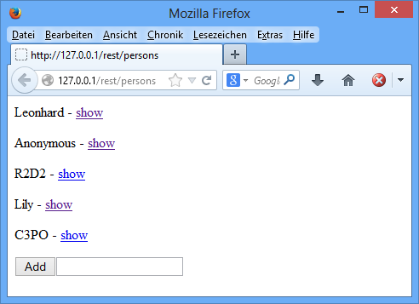
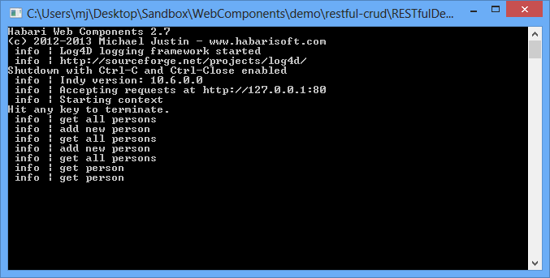

References

REST with Java (JAX-RS) using Jersey – Tutorial (Lars Vogel)
http://www.vogella.com/tutorials/REST/article.html

REST methods
https://restful-api-design.readthedocs.org/en/latest/methods.html

RFC 5789
http://tools.ietf.org/html/rfc5789

REST (Wikipedia)
http://en.wikipedia.org/wiki/Representational_state_transfer

Third-Party Product Licenses

Internet Direct (Indy)
Indy will be compiled into applications built with Daraja Framework, this means that the Indy license applies to your application.
License information for Indy can be found at http://www.indyproject.org/License/index.aspx

Twitter Bootstrap
Bootstrap is used in examples
Bootstrap is released under the MIT license and is copyright 2011-2015 Twitter.
The license text can be found at https://github.com/twbs/bootstrap/blob/master/LICENSE

Index
Reference
Application/json 59
Application/xml 59
CharSet 21, 26p.
Conditional symbols 19
Conditional Symbols 19
Configuration 24p., 38, 41
ContentText 21, 26p.
ContentType 21, 26p.
Context 22pp., 31, 39
DARAJA_LOGGING 41
DELETE 56
Destroy 21
Development mode 19
DjGlobal 27
EidHTTPProtocolException 43
EUnitTestException 43
EWebComponentException 43
Exception stack traces 36
Exceptions 36p., 43
Free Pascal 17
GET 56
GetInitParameter 24p.
GetInitParameterNames 25
HEAD 56
HTML Encoding 27
HTMLEncode 27
HTTP 21, 29
HTTP DELETE 56
HTTP GET 56
HTTP HEAD 56
HTTP OPTIONS 56, 60
HTTP PATCH 56, 60
HTTP POST 56
HTTP PUT 56
HTTPServer 38
Init 21
Interceptor 38
Logging 19
MadExcept 19, 36
MADEXCEPT 36
Mapping rules 23
MaxConnections 38
MIME type 56
Multi-threaded 29, 31
Multi-threading 28
Ods 21
OnGet 21, 29
OnPost 21, 29
OPTIONS 56
Other optional units 48
PATCH 56
Path Mapping 23
Path parameters 57
POST 56
PUT 56
Request 21, 29pp.
Resource path mapping 22
Resources 22
Response 21, 29
REST 56
SetInitParameter 25
SetShutdownHook 49
Setting parameters of a context 25
Setting parameters of a web component 24
ShutdownHelper 49
Special characters 27
Static resource 22p.
Static resource folder 45
Support 23, 36p., 41
TdjDefaultWebComponent 45
TdjHTTPConnector 38
TdjNCSALogHandler 46
TdjRequest 21, 24pp., 29
TdjResponse 21, 24pp., 29
TdjRestfulComponent 54
TdjWebAppContext 22
TdjWebComponent 21, 29
Text/html 59
TMyWebPage 21, 29
Utf-8 21, 26p.
UTF-8 26
21, 29
&Consumes 56
&Path 56
&Produces 56

Table Index
Conditional symbols 19

Illustration Index
Illustration 1: Hello world example 8
Illustration 2: HTTP session example 11
Illustration 3: Fibonacci calculation result as plain text 15
Illustration 4: Fibonacci calculation result as HTML 15
Illustration 5: Exception stack trace with madExcept 36
Illustration 6: Exception stack trace with JclDebug 37
Illustration 7: Debugger Exception Notification 43

Response.ContentType should be set before Response.CharSet
https://en.wikipedia.org/wiki/Common_Log_Format
http://en.wikipedia.org/wiki/Uniform_Resource_Identifier
http://en.wikipedia.org/wiki/Representational_state_transfer#Constraints

