Getting started with
OpenCTF
Michael Justin
A short guide for the first steps with the Open Source Component Test Framework

Trademarks
Java, JavaBean, JDK, Sun, Sun Microsystems, and the Sun Logo are trademarks or registered trademarks of Sun Microsystems, Inc. in the U.S. and other countries. All Borland brands and product names are trademarks or registered trademarks of Borland. All CodeGear brands and product names are trademarks or registered trademarks of CodeGear. Microsoft, Windows, Windows NT, and/or other Microsoft products referenced herein are either registered trademarks or trademarks of Microsoft Corporation in the United States and/or other countries. Other brands and their products are trademarks of their respective holders.
Contents
Introduction 3
About OpenCTF 3
Example Test Program 5
Simple Example 5
Release Notes 6
Version 1.1 6

Introduction

About OpenCTF

How can I use it?
The OpenCTF component test framework helps to build automatic tests for all (visual and non-visual) VCL components in a Delphi application. It is based on the DUnit framework.

How does it work?
- OpenCTF iterates over all specified Forms and DataModules and dynamically creates DUnit test cases for selected components
- Customized test classes detect which components have to be tested, and configure the test steps
How can it help me?
OpenCTF provides an easy way to build automatic quality checks for large projects where many components have to pass repeated tests.
Here are some examples:
- detect missing or wrong property values - e.g. Buttons without assigned Actions, DataSources without associated DataSet
- detect unassigned event handlers - e.g. missing OnExecute event
- check that all DataSets can be opened
- check the tab order
- find invisible components (e.g. invisible TabSheets which better should be hidden at runtime)
Is it easy to use?
Creating and customizing tests for your specific needs is very easy:
- Adding OpenCTF tests to a DUnit test suite requires only one or two lines of code
- Writing your own custom component tests is simple, many examples are included in the source distribution
Hosted on Sourceforge
- OpenCTF is hosted on Sourceforge: http://sourceforge.net/projects/openctf/
- API documentation is available online at http://openctf.sourceforge.net/
Key features:
- easy to use and extend
- includes example tests (including simple test for ADO, dbExpress, IBO, IBX, IntraWeb, JvUIB, QuickReport, Rave and TNT/TMS Unicode) and example projects
- contains the full source code
- based on DUnit

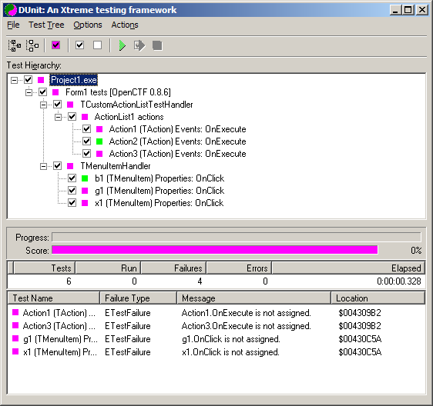

Example Test Program

Simple Example

program Program1;

{$APPTYPE CONSOLE}

uses
OpenCTF,
OpenCTFRunner,
ctfTestActnList,
ctfTestControls,
ctfTestMenus,
TestForm in 'TestForm.pas' {Form1};

begin
// Register Form classes
OpenCTF.RegisterFormClasses([TForm1]);
// run the tests
OpenCTFRunner.Run;
end.

In this example, the framework will run all registered tests on an instance of TForm1.

Release Notes

Version 1.1
Released May 17, 2008

