Getting started with

OpenCTF

Open Component Test Framework
Version 1.5

Automatic Component Tests
for VCL Based Delphi Applications

Trademarks
All Embarcadero brands and product names are trademarks or registered trademarks of Embarcadero. Oracle and Java are registered trademarks of Oracle and/or its affiliates. Microsoft, Windows, Windows NT, and/or other Microsoft products referenced herein are either registered trademarks or trademarks of Microsoft Corporation in the United States and/or other countries. Other brands and their products are trademarks of their respective holders.

Introduction

About OpenCTF

How can I use it?
The OpenCTF component test framework builds automatic tests for all components in a Delphi VCL application.

How can it help me?
OpenCTF provides an easy way to build automatic quality checks for large projects where many components have to pass repeated tests. More specifically it can
- prevent bugs by finding missing or wrong property values or event handlers
- ensure that your coding standards are followed

How does it work?
- OpenCTF iterates over all specified Forms, Frames and DataModules and dynamically creates tests for their components
- Customized test classes detect which components have to be tested, and configure the test steps

Is it easy to use?
To use OpenCTF, start a new project, add your forms and then register them in OpenCTF as shown below. The final line, RunRegisteredTests, launches the DUnit framework user interface.
program Project1;
uses
OpenCTF, ctfStandardTests, GUITestRunner,
Unit1 in 'Unit1.pas' {Form1},
Unit2 in 'Unit2.pas' {Form2};
{$R *.res}

begin
// register forms in OpenCTF
RegisterFormClasses([TForm1, TForm2]);

// Build DUnit tests
BuildTests;

// run the tests
RunRegisteredTests;
end.

Where do I find the current version?
- OpenCTF is hosted on Sourceforge: http://sourceforge.net/projects/openctf/
- API documentation is available online at http://openctf.sourceforge.net/

Screenshots
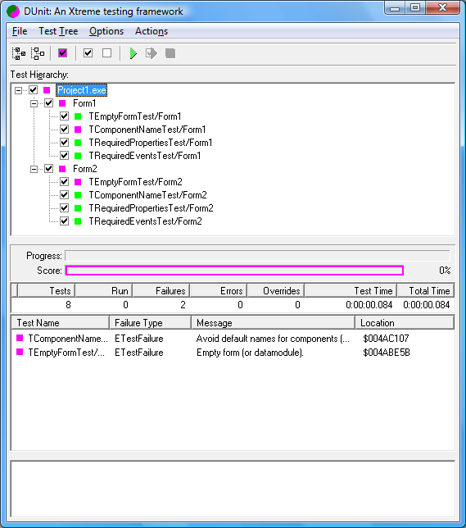
Tests grouped by form name

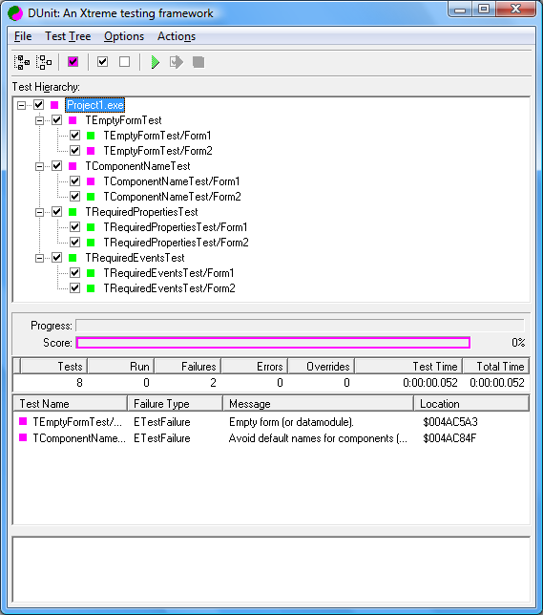
Tests grouped by test name

Included Tests

ctfStandardTests
Unit with example tests

Avoid default names for components

Description This test will find all components which still use the default name.
The Delphi IDE generates default name for new components, using the component class name and a numeric index.
If your coding standards expect meaningful names instead (for example OkButton and CancelButton instead of Button1 and Button2), this test helps to search for default name usages.
Implemented Yes
Unit ctfStandardTests

Example output:
Avoid default names for components (e.g. Button1: TButton)
Label1(TLabel)
Frame21(TFrame2)
GroupBox1(TGroupBox)
DBText1(TDBText)
DataSource1(TDataSource)

<component>.<property> is not assigned

Description todo
Implemented Yes
Unit ctfStandardTests

Example output:
Missing properties:
ClientDataSetNotOk.ProviderName is not assigned.
SQLQueryNotOk.SQLConnection is not assigned.
DataSetProviderNotOk.DataSet is not assigned.

<component>.<event> is not assigned

Description todo
Implemented Yes
Unit ctfStandardTests

Example output:
Missing events:
ClientDataSetNotOk.OnPostError is not assigned.
ClientDataSetNotOk.OnReconcileError is not assigned.

