

IT342-G3
System Integration and Architecture

System Design Document (SDD)

Project Title: WearIsIt
Prepared By: Estrera, Michaela Ma. Alexa D.

Version: 1.0
Date: 3/7/26
Status: Approved

REVISION HISTORY TABLE
Version | Date | Author | Changes Made | Status
0.1 | 2/21/26 | Michaela Ma. Alexa D. Estrera | Initial draft | Draft
0.2 | 2/27/26 | Michaela Ma. Alexa D. Estrera | Added API specifications | Review
0.3 | 2/27/26 | Michaela Ma. Alexa D. Estrera | Updated database design | Review
0.4 | 2/28/26 | Michaela Ma. Alexa D. Estrera | Added UI/UX designs | Review
0.5 | 2/28/26 | Michaela Ma. Alexa D. Estrera | Incorporated feedback | Revised
0.6 | 2/28/26 | Michaela Ma. Alexa D. Estrera | Final review and corrections | Final
1 | 3/7/26 | Michaela Ma. Alexa D. Estrera | Baseline version for development | Approved

TABLE OF CONTENTS
Contents
EXECUTIVE SUMMARY 4
1.0 INTRODUCTION 5
2.0 FUNCTIONAL REQUIREMENTS SPECIFICATION 5
3.0 NON-FUNCTIONAL REQUIREMENTS 8
4.0 SYSTEM ARCHITECTURE 9
5.0 API CONTRACT & COMMUNICATION 10
Authentication Endpoints 11
User Registration 11
User Login 11
6.0 DATABASE DESIGN 13
7.0 UI/UX DESIGN 14
8.0 PLAN
9.0 APPENDIX 17

EXECUTIVE SUMMARY
1.1 Project Overview
WearIsIt is a wardrobe management system that enables users to log clothing items, organize outfits, and view wardrobe statistics. The backend is implemented with Spring Boot providing RESTful APIs, the web frontend is built with React, and the mobile application is a native Android app developed in Kotlin. All user data, including items, outfits, categories, tags, and activity logs, is maintained in a relational database, and the system is designed to provide a consistent and usable experience across web and mobile platforms.
1.2 Objectives
- Develop a digital closet MVP that includes user authentication, wardrobe CRUD, outfit management, and wear-tracking statistics.
- Implement role-based access control with API-level and UI-level restrictions.
- Interface with an external API whose response is integrated into either the system’s functionality or user interface.
- Integrate image upload by retrieving image links from database fields and rendering them alongside UI components.
- Utilize SMTP for sending emails regarding account verification and system notifications.
- Use JSON Web Tokens (JWT) to verify API authorization for protected endpoints.
- Integrate Google OAuth Login
- Implement a three-tier architecture using Spring Boot (backend), React (web), and Android (mobile)
- Create RESTful APIs that integrate with web and mobile systems
- Design a responsive user interface that works consistently across web and mobile platforms
- Deploy all system components to production-ready environments

1.3 Scope
Included Features:
- User registration and authentication (email/password)
- API Endpoint protection with JWT
- Wardrobe item creation with image, name, categories, type, and tags
- Role-based access control with User and Administrator Roles
- Item gallery with search, sort by wear count, and filter by categories, types and tags functionality
- Outfit creation that references existing wardrobe items
- Wear count update for individual clothing items and outfits
- Email sending for account verification and wardrobe reports.
- Responsive web interface
- Native Android mobile application
- PostgreSQL database with relational schema
- Google OAuth Login
Excluded Features:
- Image detection/AI tagging
- Push notifications
- Advanced analytics & data visualization

1.0 INTRODUCTION
1.1 Purpose
This document presents the detailed software design for the WearIsIt MVP. It describes the system architecture, component design, interface specifications, data design, and implementation considerations to ensure alignment with the defined system requirements.

2.0 FUNCTIONAL REQUIREMENTS SPECIFICATION
2.1 Project Overview
Project Name: WearIsIt
Domain: Lifestyle
Primary Users:
- People seeking to manage their personal wardrobes effectively.
Problem Statement: Users struggle to track clothing usage and build creative, organized outfits, leading to suboptimal purchasing decisions.
Solution: A digital closet that tracks individual item wear counts, logs outfits, and offers search, sort, and filter features for easy wardrobe management.
2.2 Core User Journeys
Journey 1: First-time Wardrobe Item Creation Process
- User visits web application
- Clicks "Sign Up" and creates account
- Clicks “Add Item” or plus button
- Uploads image, inputs item name, selects type, inputs category and adds tags
- System confirms details and saves item to database

Journey 2: Using Search Functionalities
- User logs in with existing credentials and navigates to gallery page or screen
- User searches for item name with search feature
- User selects the UNIQLO tag to filter by that tag
- User selects sort by wear count feature
- System displays list of items sorted by wear count (descending order)

Journey 3: Outfit Creation
- User logs in with existing credentials and navigates to outfit creation page or screen
- User selects “Create new outfit” or plus button
- Fills the clothing item fields by utilizing a searchable dropdown menu (tops, bottoms, accessories, shoes)
- Inputs the outfit name and clicks the save button
- The system confirms details and saves the outfit to the database.

Journey 4: Wear Statistics Viewing
- Authenticated user navigates to wear statistics screen
- The system displays top 5 most worn clothing items alongside top 5 most worn outfits
- The system displays wear count for items and outfits
- The system additionally displays last worn date for outfits

Admin User Journeys
Journey 1: Administrator Registration
- Unauthenticated user navigates to the Admin portal
- Enters email
- Email is verified by querying the database (Admin whitelist)
- If email is valid, proceed with account registration
Journey 2: User Summary Page
- Authenticated user administrator navigates to user summary page
- The system displays a list of users and their total clothing items and outfits
Journey 2: System Statistics Page
- Authenticated user administrator navigates to user summary page
- The system displays an overview of system statistics such as total users, total items, total outfits.

2.3 Feature List (MoSCoW)
MUST HAVE
- User authentication (register, login, logout)
- Role-Based Access Control
- Admin-only User Interface
- Google OAuth Integration
- Clothing item management (add, remove, update, view)
- Outfit creation (add, remove, update, view)
- Sort by wear count
- Filter with tags
- Update wear count for clothing items and outfits
- Dashboard for most worn outfits and clothing items
- External API Integration
- Image Upload
- Email Sending
SHOULD HAVE
- Wear statistics by tags
- Real-time input validation
- Responsive UI across all platforms
COULD HAVE
- Quick add feature for clothing items via Shopee API (extract item image, name, and description)
WON'T HAVE
- AI-powered clothing categorization
- Image detection and auto tagging

2.4 Detailed Feature Specifications
Feature: User Authentication
- Screens: Registration, Login, Forgot Password
- Fields: Email, Password, Confirm Password
- Validation: Email format, password strength, uniqueness
- API Endpoints:
  - POST /auth/register - Register new account
  - POST /auth/login - Log in with existing account
  - POST /auth/refresh - Refresh access token
  - POST /auth/logout - Log out
  - POST /auth/forgot-password - Request password reset email
  - POST /auth/reset-password - Reset password request
  - GET /users/me - Get current authenticated user
- Security: JWT tokens, password hashing with BCrypt
Feature: Clothing Item Management
- Screens: Gallery View, Item Details, Add/Edit Item Form
- Display: Grid layout, product images, names, tags, wear counts
- Search: By clothing item name
- API Endpoints:
  - GET /api/items - List all items (with pagination)
  - GET /api/items/{id} - Get single item
  - POST /api/items - Create new item
  - POST /api/items/{id}/image - Upload item image
  - PUT /api/items/{id} - Update item
  - DELETE /api/items/{id} - Delete item
  - POST /api/items/{id}/wear - Increment item wear count
  - GET /api/items/search?q={query} - Search items

Feature: Outfit Management
- Screens: Outfit Gallery, Outfit Details, Outfit Creation/Edit
- Functions: Add outfit, add clothing item to outfit, edit outfit, update outfit wear count
- API Endpoints:
  - GET /api/outfits - List all outfits
  - GET /api/outfits/{id} - Get single outfit with items
  - POST /api/outfits/new - Create new outfit
  - POST /api/outfits/{id}/image - Upload outfit image
  - PUT /api/outfits/{id} - Update outfit
  - DELETE /api/outfits/{id} - Delete outfit
  - POST /api/outfits/{id}/wear - Log outfit as worn
Feature: Category Management
- Screens: Category Manager
- Functions: Get categories, Create categories, edit categories, delete categories
- API Endpoints:
  - GET /api/categories - Get ALL categories for logged-in user
  - GET /api/categories/{id} - Get SINGLE category by ID (must belong to user)
  - POST /api/categories - Create NEW category for logged-in user
  - PUT /api/categories/{id} - UPDATE category (must belong to user)
  - DELETE /api/categories/{id} - DELETE category (must belong to user)
Feature: Tag Management
- Screens: Tag Manager
- Functions: Create tags, edit tags, delete tags, get tags by category
- API Endpoints:
  - GET /api/tags - Get ALL tags for logged-in user
  - GET /api/tags/{id} - Get SINGLE tag by ID
  - POST /api/tags - Create NEW tag (requires categoryId in body)
  - PUT /api/tags/{id} - UPDATE tag
  - DELETE /api/tags/{id} - DELETE tag
  - GET /api/categories/{categoryId}/tags - Get tags for a specific category
Feature: User Dashboard
- Screens: User Dashboard
- Functions: Get most worn items (limit of 5), most worn outfits (limit of 5), recent activity (limit of 10)
- API Endpoints:
  - GET /api/dashboard/summary - Get total counts (items, outfits, wears)
  - GET /api/dashboard/most-worn/items - Get top 5 most worn items
  - GET /api/dashboard/most-worn/outfits - Get top 5 most worn outfits
  - GET /api/dashboard/recent-activity - Get recent activity
  - GET /api/dashboard - Get everything in one call
Feature: Administrator Role
- Screens: Admin Portal, User Summary, System Statistics Overview
- Functions: Admin account registration, email check, admin log in, get user summary, get system summary
- API Endpoints:

Authentication & Registration
  - POST /api/admin/check-email - Check if email is whitelisted for admin
  - POST /api/admin/register - Register new admin account
  - POST /api/admin/login - Admin login (same as regular login)

Admin Dashboard
  - GET /api/admin/users - Get user summary (list of all users with stats)
  - GET /api/admin/stats - Get system statistics overview
Feature: Google OAuth log in
- Screens: Register and log in (same as Auth)
- Functions: New user account with Google, log in with Google
- API Endpoints:
  - POST /api/auth/google/register - Register with Google (first time)
  - POST /api/auth/google/login - Login with Google (existing user)
Feature: Generate Color for User Interface
- Screens: User preference, Affects accent colors
- Functions: Get random color
- API Endpoints:
GET https://www.thecolorapi.com/random

Feature: Email Sending
- Screens: Account Confirmation Screen, Send report feature in Dashboard
- Functions: Send verification email, Send report to user’s verified email address
- API Endpoints:
  - POST /api/email/verify- verification email after registration
  - POST /api/email/report - Send generated report to user
  - POST /api/email/forgot-pw - Send password reset email
2.5 Acceptance Criteria
AC-1: Successful User Registration
- Given I am a new user
- When I enter valid email and strong password
- And confirm password matches
- And click "Create Account"
- Then my account should be created
AC-2: Add New Clothing Item
- Given I am logged in
- When I click "Add Item"
- And upload an image
- And enter item name "Blue Cashmere Sweater"
- And select item type from dropdown
- And select category"UNIQLO" from dropdown
- And select category "Tops" from dropdown
- And click "Save"
- Then the item should appear in my gallery
- And the item should have wear count = 0
- And I should see the item image and details

AC-3: Create an Outfit
- Given I have at least 4 clothing items in my wardrobe
- When I navigate to outfit creation
- And select a top from dropdown
- And select a bottom from dropdown
- And select shoes from dropdown
- And enter outfit name "Weekend Casual"
- And click "Save"
- Then the outfit should be saved
- And appear in my outfit gallery
- And show preview images of the selected items

AC-4: Log Outfit Wear
- Given I have a saved outfit
- When I view the outfit detail
- And click "Log Wear"
- Then the outfit's wear count should increase by 1
- And each clothing item's wear count should increase by 1
- And last worn date should update to today

AC-5: Search and Filter
- Given I have multiple items in my wardrobe
- When I search for "sweater"
- Then only items with "sweater" in name or notes should display
- When I filter by category "Zara"
- Then only Zara items should display
- When I sort by "Most Worn"
- Then items should display in descending wear count order

AC-6: View Statistics
- Given I have logged wears for multiple items and outfits
- When I navigate to Wear Statistics
- Then I should see my top 5 most worn items
- And my top 5 most worn outfits
- And total counts for items and outfits

AC-7: Data Validation
- Given I am adding a new item
- When I try to save without an image
- Then I should see an error: "Image is required"
- When I try to save without a name
- Then I should see an error: "Item name is required"
- When I upload an image over 10MB
- Then I should see an error: "Image size must be under 10MB"

AC-8: Category Management
- Given I am logged in
- When I navigate to Category Manager
- And I click "Add Category"
- And enter name "Summer Wear"
- And click "Save"
- Then the category should appear in my categories list
- And I can use it when adding new items

- Given I have an existing category "Tops"
- When I edit it and change name to "Upper Body"
- Then the category name should update everywhere

- Given I have a category with items
- When I try to delete it
- Then I should see a warning: "This category has X items and cannot be deleted"
- And category deletion should be prevented.

AC-9: Tag Management
- Given I am logged in
- When I navigate to tags under "Tops" category
- And click "Add Tag"
- And enter name "Striped"
- Then the tag should appear under the "Tops" category

- Given I have a tag assigned to items
- When I delete the tag
- Then it should be removed from all items
- And items should no longer show that tag

AC-11: Google OAuth Login
- Given I previously registered with Google
- When I click "Continue with Google"
- And select the same Google account
- Then I should be logged in successfully
- And redirected to my wardrobe gallery

- Given I try to login with Google using an email not in the system
- Then I should see the error: "No account found. Please register first."

AC-12: Color API Integration
- Given I am on the User Preferences Screen
- When I select “Add Random Accent Color”
- A random color is generated
- And I can choose to set it as my new accent color

AC-13: Welcome Email
- Given I successfully register a new account
- Then I should receive a welcome email at my registered address
- And email should contain my username
- And email should have subject: "Welcome to WearIsIt!"
- And email should include a verification link

AC-14: Report Email
- Given I am on the dashboard
- When I click "Generate Report"
- And select "Email me this report"
- Then the system should send an email with my wardrobe statistics
- And email should contain total items, outfits, and wears
- And email should list my top 5 most worn items
- And email should include my top 5 most worn outfits
- Then send the report as a PDF attachment

AC-15: Admin Registration (Whitelist)
- Given I am an unauthenticated user
- When I navigate to admin registration
- And enter email "admin@wearisit.com"
- Then system should check if email is whitelisted
- And if whitelisted, allow registration
- And if not whitelisted, show: "Email not authorized for admin access"

- Given my email is whitelisted
- When I complete admin registration
- Then my account should have role = "ADMIN"
- And I should have access to admin portal

AC-16: Admin User Summary
- Given I am logged in as admin
- When I navigate to User Summary page
- Then I should see a list of all users
- And each user shows: email, name, total items, total outfits
- And I can click a user to see their details
- Given I view a specific user
- When I click "View Items"
- Then I should see all items belonging to that user
- And I cannot edit/delete them (view-only)

AC-17: Admin System Statistics
- Given I am logged in as admin
- When I navigate to System Statistics
- Then I should see:

Total number of users

Total items across all users

Total outfits across all users

Total wears logged

AC-18: File Upload Validation
- Given I am adding a new item
- When I try to upload a file that's not an image
- Then I should see error: "Only image files are allowed"

- Given I try to upload an image larger than 10MB
- Then I should see error: "Image size must be under 10MB"
- Given I try to save without an image
- Then I should see error: "Image is required"

- Given I upload a valid image under 10MB
- Then the image should save successfully
- And a thumbnail should be generated
- And the image should display in gallery

3.0 NON-FUNCTIONAL REQUIREMENTS
3.1 Performance Requirements
- The system shall support at least 50 concurrent authenticated users under expected peak load conditions without degradation of core functionality.
- The system shall ensure that 95% of page load requests complete within 5 seconds under normal operating conditions.
- API response times for standard read operations shall not exceed 2 seconds for 95% of requests under a load of 50 concurrent users.

3.2 Security Requirements
- User passwords shall be hashed using the BCrypt hashing algorithm before storage.
- All API endpoints, except user registration and login endpoints, shall require a valid JWT (JSON Web Token) in the Authorization header.
- Sensitive data shall not be exposed through API responses. Data Transfer Objects (DTOs) shall be used to control and restrict exposed fields.
- JWT tokens shall expire after a defined validity period.
- All client-server communication shall occur over HTTPS.

3.3 Compatibility Requirements
- The web application shall be compatible with the latest stable versions of:
  - Google Chrome
  - Brave
  - Mozilla Firefox
- The mobile application shall support Android 7.0 (API level 24) and above and shall remain functional on all supported Android versions available at the time of release.
- The system shall accept image uploads in the following formats:
  - PNG
  - JPEG

3.4 Usability Requirements
- All core user actions shall be accessible within a maximum of five taps or clicks.
- The user interface shall maintain consistent layout, readable typography, and sufficient color contrast to ensure accessibility and minimize visual strain.
- The system shall provide clear error messages for invalid inputs and failed operations.

4.0 SYSTEM ARCHITECTURE
4.1 Component Diagram
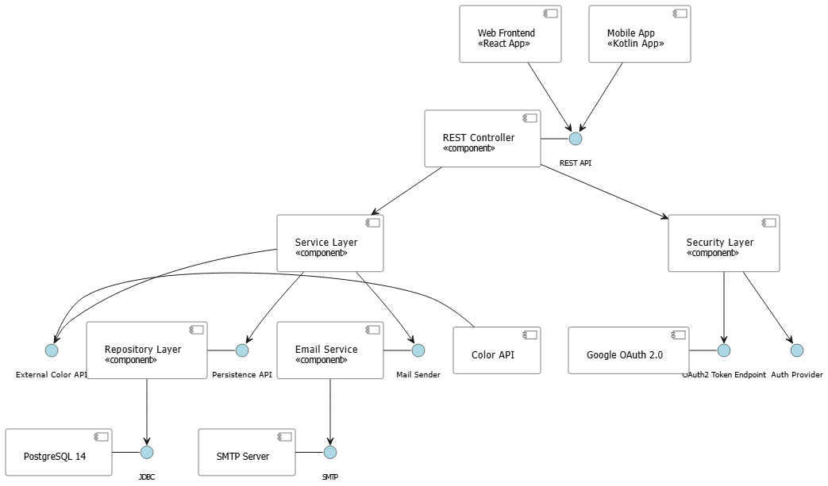
Technology Stack:
- Backend: Java 17, Spring Boot 3.x, Spring Security, Spring Data JPA
- Database: PostgreSQL 14+
- Web Frontend: React 18, JavaScript, CSS, Axios
- Mobile: Kotlin, Retrofit
- Build Tools: Maven (Backend), npm (Web), Gradle (Android)
- Deployment: Railway/Heroku (Backend), Vercel/Netlify (Web), APK (Mobile)

5.0 API CONTRACT & COMMUNICATION
5.1 API Standards
- All API endpoints return responses in JSON format.
- Authentication is performed using Bearer tokens included in the Authorization header.
- Access to protected endpoints requires a valid JWT.
- Error responses follow a standardized structure with meaningful error codes and messages.
- Timestamps are provided in ISO 8601 format (YYYY-MM-DDTHH:MM:SSZ).

5.2 Endpoint Specifications

Authentication Endpoints

User Registration
Description | User Registration
API URL | /auth/register
HTTP Request Method | POST
Format | JSON for all requests/responses
Authentication | None
Request Payload | {  "username": "johndoe",  "email": "john@example.com",  "password": "SecurePass123",  }
Response Structure | {  "success": true,  "data": {  "user": {  "username": "johndoe",  "email": "john@example.com"  },  "accessToken": "eyJhbGciOiJIUzI1NiIs...",  "refreshToken": "eyJhbGciOiJIUzI1NiIs..."  },  "error": null,  "timestamp": "2024-01-28T10:30:00Z"  }

User Login
Description | User Login
API URL | /auth/login
HTTP Method | POST
Format | JSON for all requests/responses
Authentication | None
Request Payload | {  “usernameOrEmail”: <usernameOrEmail>,  “password”: <password>,  }
Response Structure | {  "success": boolean,  "data": {  “user”: {  “email”: <email>,  “username”: <username>,  “role”: <role>,  },  “accessToken”: <token>,  “refreshToken”: <token>,  },  "error": {  "code": string,  "message": string,  "details": object|null  },  "timestamp": string  }

Get Authenticated User
Description | Get the currently logged-in user's profile
API URL | /user/me
HTTP Method | GET
Format | JSON for all requests/responses
Authentication | Bearer {accessToken}
Request Payload
Response Structure | {  "success": true,  "data": {  "user": {  "username": "johndoe",  "email": "john@example.com",  "enabled": true  }  },  "error": null,  "timestamp": "2026-02-28T10:30:00Z"  }

User Log Out
Description | User Log Out
API URL | /auth/logout
HTTP Method | POST
Format | JSON for all requests/responses
Authentication | Bearer {accessToken}
Request Payload | {  "refreshToken": "eyJhbGciOiJIUzI1NiIs..."  }
Response Structure | {  "success": true,  "data": {  "message": "Successfully logged out"  },  "error": null,  "timestamp": "2024-01-28T10:30:00Z"  }

Refresh Token
Description | Get Refresh Token
API URL | /auth/refresh
HTTP Method | POST
Format | JSON for all requests/responses
Authentication | Bearer {accessToken}
Request Payload | {  "refreshToken": "eyJhbGciOiJIUzI1NiIs..."  }
Response Structure | {  "success": true,  "data": {  "accessToken": "eyJhbGciOiJIUzI1NiIs...",  "refreshToken": "eyJhbGciOiJIUzI1NiIs..."  },  "error": null,  "timestamp": "2024-01-28T10:30:00Z"  }

Forgot Password Request
Description | Forgot Password
API URL | /auth/forgot-password
HTTP Method | POST
Format | JSON for all requests/responses
Authentication | None
Request Payload | {  "email": "john@example.com"  }
Response Structure | {  "success": true,  "data": {  "message": "Password reset email sent"  },  "error": null,  "timestamp": "2024-01-28T10:30:00Z"  }

Reset Password
Description | Reset Password
API URL | /auth/reset-password
HTTP Method | POST
Format | JSON for all requests/responses
Authentication | None
Request Payload | {  "token": "reset-token-here",  "newPassword": "NewSecurePass123"  }
Response Structure | {  "success": true,  "data": {  "message": "Password successfully reset"  },  "error": null,  "timestamp": "2024-01-28T10:30:00Z"  }

Google OAuth Endpoints

Register With Google
Description | Register with Google
API URL | /auth/google/register
HTTP Method | POST
Format | JSON for all requests/responses
Authentication | None
Request Payload | {  "googleId": "123456789",  "email": "john@gmail.com",  "firstname": "John",  "lastname": "Doe",  "profilePicture": "https://lh3.googleusercontent.com/..."  }
Response Structure | {  "success": true,  "data": {  "user": {  "id": 1,  "email": "john@gmail.com",  "firstname": "John",  "lastname": "Doe",  "role": "USER",  "provider": "GOOGLE"  },  "accessToken": "eyJhbGciOiJIUzI1NiIs...",  "refreshToken": "eyJhbGciOiJIUzI1NiIs..."  },  "error": null,  "timestamp": "2024-01-28T10:30:00Z"  }

Log In With Google
Description | Log In with Google
API URL | /auth/google/login
HTTP Method | POST
Format | JSON for all requests/responses
Authentication | None
Request Payload | {  "googleId": "123456789",  "email": "john@gmail.com"  }
Response Structure | {  "success": true,  "data": {  "user": {  "id": 1,  "email": "john@gmail.com",  "firstname": "John",  "lastname": "Doe",  "role": "USER",  "provider": "GOOGLE"  },  "accessToken": "eyJhbGciOiJIUzI1NiIs...",  "refreshToken": "eyJhbGciOiJIUzI1NiIs..."  },  "error": null,  "timestamp": "2024-01-28T10:30:00Z"  }

Item Type Endpoints

Get All Item Types
Description | Get All Item Types
API URL | /api/item-types
HTTP Method | GET
Format | JSON for all requests/responses
Authentication | Bearer {accessToken}
Request Payload

Response Structure

Category Management Endpoints

Get All Categories
Description | Get All Categories
API URL | GET /api/categories
HTTP Method | POST
Format | JSON for all requests/responses
Authentication | Bearer {accessToken}
Request Payload

Response Structure | {  "success": true,  "data": {  "itemTypes": [  {  "id": 1,  "name": "Shirt"  },  {  "id": 2,  "name": "Pants"  },  {  "id": 3,  "name": "Shoes"  }  ]  },  "error": null,  "timestamp": "2024-01-28T10:30:00Z"  }

Get Single Category
Description | Get Single Category
API URL | /api/categories/{id}
HTTP Method | GET
Format | JSON for all requests/responses
Authentication | Bearer {accessToken}
Request Payload

Response Structure | {  "success": true,  "data": {  "category": {  "id": 1,  "name": "Casual",  "itemCount": 12,  "tags": [  {  "id": 1,  "name": "Cotton"  },  {  "id": 2,  "name": "Summer"  }  ],  "createdAt": "2024-01-28T10:30:00Z"  }  },  "error": null,  "timestamp": "2024-01-28T10:30:00Z"  }

Create Category
Description | Create Category
API URL | /api/categories
HTTP Method | POST
Format | JSON for all requests/responses
Authentication | Bearer {accessToken}
Request Payload | {  "name": "Workout"  }
Response Structure | {  "success": true,  "data": {  "category": {  "id": 3,  "name": "Workout",  "itemCount": 0,  "createdAt": "2024-01-28T10:30:00Z"  }  },  "error": null,  "timestamp": "2024-01-28T10:30:00Z"  }

Update Category
Description | Update Category
API URL | /api/categories/{id}
HTTP Method | PUT
Format | JSON for all requests/responses
Authentication | Bearer {accessToken}
Request Payload | {  "name": "Athleisure"  }
Response Structure | {  "success": true,  "data": {  "category": {  "id": 3,  "name": "Athleisure",  "updatedAt": "2024-01-28T10:30:00Z"  }  },  "error": null,  "timestamp": "2024-01-28T10:30:00Z"  }

Delete Category
Description | Delete Category
API URL | /api/categories/{id}
HTTP Method | DELETE
Format | JSON for all requests/responses
Authentication | Bearer {accessToken}
Request Payload

Response Structure | {  "success": true,  "data": {  "message": "Category successfully deleted"  },  "error": null,  "timestamp": "2024-01-28T10:30:00Z"  }

Tag Management Endpoints

Get All Tags
Description | Get All Tags
API URL | /api/tags
HTTP Method | GET
Format | JSON for all requests/responses
Authentication | Bearer {accessToken}
Request Payload

Response Structure | {  "success": true,  "data": {  "tags": [  {  "id": 1,  "name": "Cotton",  "categoryId": 1,  "categoryName": "Casual",  "itemCount": 5  },  {  "id": 2,  "name": "Wool",  "categoryId": 1,  "categoryName": "Casual",  "itemCount": 3  }  ]  },  "error": null,  "timestamp": "2024-01-28T10:30:00Z"  }

Get Single Tag
Description | Get Single Tag
API URL | /api/tags/{id}
HTTP Method | GET
Format | JSON for all requests/responses
Authentication | Bearer {accessToken}
Request Payload

Response Structure | {  "success": true,  "data": {  "tag": {  "id": 1,  "name": "Cotton",  "categoryId": 1,  "categoryName": "Casual",  "itemCount": 5,  "items": [  {  "id": 10,  "itemName": "White T-Shirt"  }  ]  }  },  "error": null,  "timestamp": "2024-01-28T10:30:00Z"  }

Create Tag
Description | Create Tag
API URL | /api/tags/{id}
HTTP Method | POST
Format | JSON for all requests/responses
Authentication | Bearer {accessToken}
Request Payload | {  "name": "Striped",  "categoryId": 1  }
Response Structure | {  "success": true,  "data": {  "tag": {  "id": 3,  "name": "Striped",  "categoryId": 1,  "categoryName": "Casual",  "createdAt": "2024-01-28T10:30:00Z"  }  },  "error": null,  "timestamp": "2024-01-28T10:30:00Z"  }

Update Tag
Description | Update Tag
API URL | /api/tags/{id}
HTTP Method | PUT
Format | JSON for all requests/responses
Authentication | Bearer {accessToken}
Request Payload | {  "name": "Patterned",  "categoryId": 1  }
Response Structure | {  "success": true,  "data": {  "tag": {  "id": 3,  "name": "Patterned",  "categoryId": 1,  "updatedAt": "2024-01-28T10:30:00Z"  }  },  "error": null,  "timestamp": "2024-01-28T10:30:00Z"  }

Delete Tag
Description | Delete Tag
API URL | /api/tags/{id}
HTTP Method | DELETE
Format | JSON for all requests/responses
Authentication | Bearer {accessToken}
Request Payload

Response Structure | {  "success": true,  "data": {  "message": "Tag successfully deleted"  },  "error": null,  "timestamp": "2024-01-28T10:30:00Z"  }

Get Tags by Category
Description | Get Tags by Category
API URL | /api/categories/{categoryId}/tags
HTTP Method | GET
Format | JSON for all requests/responses
Authentication | Bearer {accessToken}
Request Payload

Response Structure | {  "success": true,  "data": {  "categoryId": 1,  "categoryName": "Casual",  "tags": [  {  "id": 1,  "name": "Cotton",  "itemCount": 5  },  {  "id": 2,  "name": "Wool",  "itemCount": 3  }  ]  },  "error": null,  "timestamp": "2024-01-28T10:30:00Z"  }

Clothing Item Endpoints

Get All Items (with Pagination)
Description | Get All Items (with Pagination)
API URL | /api/items?page=1&limit=20&sort=recent
HTTP Method | GET
Format | JSON for all requests/responses
Authentication | Bearer {accessToken}
Request Payload

Response Structure | "success": true,  "data": {  "items": [  {  "id": 1,  "itemName": "Blue Denim Jacket",  "imageUrl": "https://storage.com/images/denim-jacket.jpg",  "itemWc": 12,  "type": {  "id": 1,  "name": "Jacket"  },  "category": {  "id": 1,  "name": "Casual"  },  "tags": [  {  "id": 1,  "name": "Denim"  }  ],  "lastWorn": "2024-01-25"  }  ],  "pagination": {  "currentPage": 1,  "totalPages": 5,  "totalItems": 98,  "limit": 20  }  },  "error": null,  "timestamp": "2024-01-28T10:30:00Z"  }

Get Single Item
Description | Get Single Item
API URL | /api/items/{id}
HTTP Method | GET
Format | JSON for all requests/responses
Authentication | Bearer {accessToken}
Request Payload

Response Structure | {  "success": true,  "data": {  "item": {  "id": 1,  "itemName": "Blue Denim Jacket",  "imageUrl": "https://storage.com/images/denim-jacket.jpg",  "itemWc": 12,  "type": {  "id": 1,  "name": "Jacket"  },  "category": {  "id": 1,  "name": "Casual"  },  "tags": [  {  "id": 1,  "name": "Denim"  },  {  "id": 5,  "name": "Blue"  }  ],  "lastWorn": "2024-01-25",  "createdAt": "2023-12-01T10:30:00Z"  }  },  "error": null,  "timestamp": "2024-01-28T10:30:00Z"  }

Create New Item
Description | Create New Item
API URL | /api/items
HTTP Method | POST
Format | JSON for all requests/responses
Authentication | Bearer {accessToken}
Request Payload | {  "itemName": "White Cotton Shirt",  "typeId": 1,  "categoryId": 1,  "tagIds": [1, 3]  }
Response Structure | {  "success": true,  "data": {  "item": {  "id": 2,  "itemName": "White Cotton Shirt",  "imageUrl": null,  "itemWc": 0,  "type": {  "id": 1,  "name": "Shirt"  },  "category": {  "id": 1,  "name": "Casual"  },  "tags": [  {  "id": 1,  "name": "Cotton"  },  {  "id": 3,  "name": "White"  }  ],  "lastWorn": null,  "createdAt": "2024-01-28T10:30:00Z"  }  },  "error": null,  "timestamp": "2024-01-28T10:30:00Z"  }

Upload Item Image
Description | Upload Item Image
API URL | /api/items/{id}/image
HTTP Method | POST
Content Type | multipart/form-data
Authentication | Bearer {accessToken}
Request Payload | {  "image": (binary file data)  }
Response Structure | {  "success": true,  "data": {  "itemId": 2,  "imageUrl": "https://storage.com/images/white-cotton-shirt.jpg"  },  "error": null,  "timestamp": "2024-01-28T10:30:00Z"  }

Update Item
Description | Update Item
API URL | /api/items/{id}
HTTP Method | PUT
Format | JSON for all requests/responses
Authentication | Bearer {accessToken}
Request Payload | {  "itemName": "White Linen Shirt",  "typeId": 1,  "categoryId": 1,  "tagIds": [2, 3]  }
Response Structure | {  "success": true,  "data": {  "item": {  "id": 2,  "itemName": "White Linen Shirt",  "type": {  "id": 1,  "name": "Shirt"  },  "category": {  "id": 1,  "name": "Casual"  },  "tags": [  {  "id": 2,  "name": "Linen"  },  {  "id": 3,  "name": "White"  }  ],  "updatedAt": "2024-01-28T10:30:00Z"  }  },  "error": null,  "timestamp": "2024-01-28T10:30:00Z"  }

Delete Item
Description | Delete Item
API URL | /api/items/{id}
HTTP Method | DELETE
Format | JSON for all requests/responses
Authentication | Bearer {accessToken}
Request Payload

Response Structure | {  "success": true,  "data": {  "message": "Item successfully deleted"  },  "error": null,  "timestamp": "2024-01-28T10:30:00Z"  }

Increment Item Wear Count
Description | Increment Item Wear Count
API URL | /api/items/{id}/wear
HTTP Method | PUT
Format | JSON for all requests/responses
Authentication | Bearer {accessToken}
Request Payload

Response Structure | {  "success": true,  "data": {  "itemId": 1,  "newWearCount": 13,  "lastWorn": "2024-01-28"  },  "error": null,  "timestamp": "2024-01-28T10:30:00Z"  }

Search Items
Description | Search Items
API URL | http://api/items/search?q=denim&categoryId=1&typeId=2&page=1
HTTP Method | GET
Format | JSON for all requests/responses
Authentication | Bearer {accessToken}
Request Payload

Response Structure | {  "success": true,  "data": {  "items": [  {  "id": 1,  "itemName": "Blue Denim Jacket",  "imageUrl": "https://storage.com/images/denim-jacket.jpg",  "itemWc": 13,  "type": {  "id": 2,  "name": "Jacket"  },  "category": {  "id": 1,  "name": "Casual"  }  }  ],  "pagination": {  "currentPage": 1,  "totalPages": 1,  "totalItems": 1,  "limit": 20  }  },  "error": null,  "timestamp": "2024-01-28T10:30:00Z"  }

Outfit Management Endpoints

Get All Outfits
Description | Get All Outfits
API URL | /api/outfits?page=1&limit=20
HTTP Method | GET
Format | JSON for all requests/responses
Authentication | Bearer {accessToken}
Request Payload

Response Structure | {  "success": true,  "data": {  "outfits": [  {  "id": 1,  "name": "Casual Friday",  "outfitWc": 5,  "coverImageUrl": "https://storage.com/images/outfit1.jpg",  "itemCount": 3,  "lastWorn": "2024-01-26"  }  ],  "pagination": {  "currentPage": 1,  "totalPages": 3,  "totalItems": 25,  "limit": 20  }  },  "error": null,  "timestamp": "2024-01-28T10:30:00Z"  }

Get Single Outfit with Items
Description | Get Single Outfit with Items
API URL | /api/outfits/{id}
HTTP Method | GET
Format | JSON for all requests/responses
Authentication | Bearer {accessToken}
Request Payload

Response Structure | {  "success": true,  "data": {  "outfit": {  "id": 1,  "name": "Casual Friday",  "outfitWc": 5,  "coverImageUrl": "https://storage.com/images/outfit1.jpg",  "lastWorn": "2024-01-26",  "items": [  {  "id": 10,  "itemName": "White T-Shirt",  "imageUrl": "https://storage.com/images/white-tshirt.jpg",  "position": 1,  "notes": "Basic tee"  },  {  "id": 15,  "itemName": "Blue Jeans",  "imageUrl": "https://storage.com/images/blue-jeans.jpg",  "position": 2,  "notes": null  }  ],  "createdAt": "2024-01-15T10:30:00Z"  }  },  "error": null,  "timestamp": "2024-01-28T10:30:00Z"  }

Create New Outfit
Description | Create New Outfit
API URL | /api/outfits
HTTP Method | POST
Format | JSON for all requests/responses
Authentication | Bearer {accessToken}
Request Payload | {  "name": "Weekend Casual",  "itemIds": [10, 15, 22],  "notes": [  {  "itemId": 10,  "note": "Roll up sleeves"  }  ]  }
Response Structure | {  "success": true,  "data": {  "outfit": {  "id": 2,  "name": "Weekend Casual",  "outfitWc": 0,  "coverImageUrl": "https://storage.com/images/outfit2.jpg",  "itemCount": 3,  "items": [  {  "id": 10,  "itemName": "White T-Shirt",  "imageUrl": "https://storage.com/images/white-tshirt.jpg",  "position": 1,  "notes": "Roll up sleeves"  },  {  "id": 15,  "itemName": "Blue Jeans",  "imageUrl": "https://storage.com/images/blue-jeans.jpg",  "position": 2,  "notes": null  }  ],  "createdAt": "2024-01-28T10:30:00Z"  }  },  "error": null,  "timestamp": "2024-01-28T10:30:00Z"  }

Upload Outfit Image
Description | Upload Outfit Image
API URL | /api/outfits/{id}/image
HTTP Method | POST
Content Type | multipart/form-data
Authentication | Bearer {accessToken}
Request Payload | {  "image": (binary file data)  }
Response Structure | {  "success": true,  "data": {  "outfitId": 2,  "imageUrl": "https://storage.com/images/diva-alert.jpg"  },  "error": null,  "timestamp": "2024-01-28T10:30:00Z"  }

Update Outfit
Description | Update Outfit
API URL | /api/outfits/{id}
HTTP Method | PUT
Format | JSON for all requests/responses
Authentication | Bearer {accessToken}
Request Payload | {  "name": "Updated Weekend Look",  "itemIds": [10, 15, 23],  "notes": [  {  "itemId": 10,  "note": "Keep sleeves down"  }  ]  }
Response Structure | {  "success": true,  "data": {  "outfit": {  "id": 2,  "name": "Updated Weekend Look",  "items": [  {  "id": 10,  "itemName": "White T-Shirt",  "notes": "Keep sleeves down"  },  {  "id": 15,  "itemName": "Blue Jeans"  },  {  "id": 23,  "itemName": "Sneakers"  }  ],  "updatedAt": "2024-01-28T10:30:00Z"  }  },  "error": null,  "timestamp": "2024-01-28T10:30:00Z"  }

Delete Outfit
Description | Delete Outfit
API URL | /api/outfits/{id}
HTTP Method | DELETE
Format | JSON for all requests/responses
Authentication | Bearer {accessToken}
Request Payload

Response Structure | {  "success": true,  "data": {  "message": "Outfit successfully deleted"  },  "error": null,  "timestamp": "2024-01-28T10:30:00Z"  }

Log Outfit as Worn
Description | Increment Outfit Wear Count by 1
API URL | /api/outfits/{id}/wear
HTTP Method | POST
Format | JSON for all requests/responses
Authentication | Bearer {accessToken}
Request Payload

Response Structure | {  "success": true,  "data": {  "outfitId": 1,  "newWearCount": 6,  "lastWorn": "2024-01-28",  "itemsUpdated": [  {  "itemId": 10,  "newWearCount": 15  },  {  "itemId": 15,  "newWearCount": 8  }  ]  },  "error": null,  "timestamp": "2024-01-28T10:30:00Z"  }

Dashboard Endpoints

Get Dashboard Summary
Description | Get Dashboard Summary
API URL | /api/dashboard/summary
HTTP Method | GET
Format | JSON for all requests/responses
Authentication | Bearer {accessToken}
Request Payload

Response Structure | {  "success": true,  "data": {  "totalItems": 45,  "totalOutfits": 12,  "totalWears": 128,  "totalCategories": 5,  "totalTags": 18  },  "error": null,  "timestamp": "2024-01-28T10:30:00Z"  }

Get Most Worn Items
Description | Get Most Worn Items (Top 5)
API URL | /api/dashboard/most-worn/items
HTTP Method | GET
Format | JSON for all requests/responses
Authentication | Bearer {accessToken}
Request Payload

Response Structure | {  "success": true,  "data": {  "items": [  {  "id": 5,  "itemName": "Black Jeans",  "imageUrl": "https://storage.com/images/black-jeans.jpg",  "wearCount": 25,  "lastWorn": "2024-01-27"  },  {  "id": 3,  "itemName": "White T-Shirt",  "imageUrl": "https://storage.com/images/white-tshirt.jpg",  "wearCount": 22,  "lastWorn": "2024-01-28"  }  ]  },  "error": null,  "timestamp": "2024-01-28T10:30:00Z"  }

Get Most Worn Outfits
Description | Get Most Worn Outfits (Top 5)
API URL | /api/dashboard/most-worn/outfits
HTTP Method | GET
Format | JSON for all requests/responses
Authentication | Bearer {accessToken}
Request Payload

Response Structure | {  "success": true,  "data": {  "outfits": [  {  "id": 2,  "name": "Work Casual",  "coverImageUrl": "https://storage.com/images/work-casual.jpg",  "wearCount": 15,  "lastWorn": "2024-01-26"  }  ]  },  "error": null,  "timestamp": "2024-01-28T10:30:00Z"  }

Get Recent Activity
Description | Get Recent Activity (Top 10)
API URL | /api/dashboard/recent-activity
HTTP Method | GET
Format | JSON for all requests/responses
Authentication | Bearer {accessToken}
Request Payload

Response Structure | {  "success": true,  "data": {  "activities": [  {  "id": 156,  "actionType": "WEAR",  "entityType": "OUTFIT",  "entityId": 2,  "entityName": "Work Casual",  "timestamp": "2024-01-28T09:30:00Z"  },  {  "id": 155,  "actionType": "CREATE",  "entityType": "ITEM",  "entityId": 46,  "entityName": "Blue Sweater",  "timestamp": "2024-01-28T08:15:00Z"  }  ]  },  "error": null,  "timestamp": "2024-01-28T10:30:00Z"  }

Get Complete Dashboard
Description | Get Complete Dashboard
API URL | /api/dashboard
HTTP Method | GET
Format | JSON for all requests/responses
Authentication | Bearer {accessToken}
Request Payload

Response Structure | {  "success": true,  "data": {  "summary": {  "totalItems": 45,  "totalOutfits": 12,  "totalWears": 128  },  "mostWornItems": [  {  "id": 5,  "itemName": "Black Jeans",  "wearCount": 25  }  ],  "mostWornOutfits": [  {  "id": 2,  "name": "Work Casual",  "wearCount": 15  }  ],  "recentActivity": [  {  "actionType": "WEAR",  "entityType": "OUTFIT",  "entityName": "Work Casual",  "timestamp": "2024-01-28T09:30:00Z"  }  ]  },  "error": null,  "timestamp": "2024-01-28T10:30:00Z"  }

Admin Endpoints

Check Email
Description | Check Email if in Admin Whitelist
API URL | /api/admin/check-email
HTTP Method | POST
Format | JSON for all requests/responses
Authentication | None
Request Payload | {  "email": "admin@example.com"  }
Response Structure | {  "success": true,  "data": {  "isWhitelisted": true,  "message": "Email is eligible for admin registration"  },  "error": null,  "timestamp": "2024-01-28T10:30:00Z"  }

Register Admin
Description | Register New Admin User
API URL | /api/admin/register
HTTP Method | POST
Format | JSON for all requests/responses
Authentication | None
Request Payload | {  "username": "adminuser",  "email": "admin@example.com",  "password": "AdminSecurePass123"  }
Response Structure | {  "success": true,  "data": {  "user": {  "id": 1,  "username": "adminuser",  "email": "admin@example.com",  "firstname": "Admin",  "lastname": "User",  "role": "ADMIN"  },  "accessToken": "eyJhbGciOiJIUzI1NiIs...",  "refreshToken": "eyJhbGciOiJIUzI1NiIs..."  },  "error": null,  "timestamp": "2024-01-28T10:30:00Z"  }

Admin Log In
Description | Log in as Admin User
API URL | /api/admin/login
HTTP Method | POST
Format | JSON for all requests/responses
Authentication | Bearer {accessToken}
Request Payload | {  "email": "admin@example.com",  "password": "AdminSecurePass123"  }
Response Structure | {  "success": true,  "data": {  "user": {  "id": 1,  "email": "admin@example.com",  "username": "adminuser",  "role": "ADMIN"  },  "accessToken": "eyJhbGciOiJIUzI1NiIs...",  "refreshToken": "eyJhbGciOiJIUzI1NiIs..."  },  "error": null,  "timestamp": "2024-01-28T10:30:00Z"  }

Get All Users (Admin)
Description | Get all Users (Requires Admin Role)
API URL | /api/admin/users?page=1&limit=50
HTTP Method | GET
Format | JSON for all requests/responses
Authentication | Bearer {accessToken}
Request Payload

Response Structure | {  "success": true,  "data": {  "users": [  {  "id": 2,  "username": "johndoe",  "email": "john@example.com",  "role": "USER",  "provider": "LOCAL",  "createdAt": "2024-01-01T10:30:00Z",  "stats": {  "totalItems": 23,  "totalOutfits": 8,  "totalWears": 67,  "lastActive": "2024-01-28T09:30:00Z"  }  }  ],  "pagination": {  "currentPage": 1,  "totalPages": 3,  "totalUsers": 125,  "limit": 50  }  },  "error": null,  "timestamp": "2024-01-28T10:30:00Z"  }

Get System Statistics
Description | Get System Statistics (Requires Admin Role)
API URL | /api/admin/stats
HTTP Method | GET
Format | JSON for all requests/responses
Authentication | Bearer {accessToken}
Request Payload

Response Structure | {  "success": true,  "data": {  "overview": {  "totalUsers": 125,  "totalItems": 2876,  "totalOutfits": 543,  "totalWears": 8921,  "totalCategories": 312,  "totalTags": 845  },  "userStats": {  "activeToday": 23,  "activeThisWeek": 89,  "activeThisMonth": 112,  "newUsersThisMonth": 15  },  "systemStats": {  "totalStorageUsed": "1.2 GB",  "averageItemsPerUser": 23,  "mostActiveUser": {  "id": 42,  "username": "fashionista",  "totalWears": 234  }  }  },  "error": null,  "timestamp": "2024-01-28T10:30:00Z"  }

User Preference Endpoints

Get User Preferences
Description | Get User Preferences
API URL | /api/user/preferences
HTTP Method | GET
Format | JSON for all requests/responses
Authentication | Bearer {accessToken}
Request Payload

Response Structure | {  "success": true,  "data": {  "preferences": {  "accentColor": "#3A5F8B",  "themeMode": "light”  }  },  "error": null,  "timestamp": "2024-01-28T10:30:00Z"  }

Update User Preferences
Description | Get User Preferences
API URL | /api/user/preferences
HTTP Method | GET
Format | JSON for all requests/responses
Authentication | Bearer {accessToken}
Request Payload

Response Structure | {  "success": true,  "data": {  "preferences": {  "accentColor": "#3A5F8B",  "themeMode": "light”  }  },  "error": null,  "timestamp": "2024-01-28T10:30:00Z"  }

Email Service Endpoints

Send Verification Email
Description | Sends verification email to user
API URL | /api/email/verify
HTTP Method | POST
Format | JSON for all requests/responses
Authentication | None
Request Payload | {  "email": "john@example.com",  "username": "John",  "verificationLink": "https://yourapp.com/verify-email?token=eyJhbGciOiJIUzI1NiIs..."  }
Response Structure | {  "success": true,  "data": {  "messageId": "<1234567893@mail.example.com>",  "status": "sent",  "recipient": "john@example.com"  },  "error": null,  "timestamp": "2024-01-28T10:30:00Z"  }

Send Report Email
Description | Sends report to user
API URL | /api/email/report
HTTP Method | POST
Format | JSON for all requests/responses
Authentication | Bearer {accessToken}
Request Payload | {  "email": "john@example.com",  "reportType": "wardrobe_summary",  "dateRange": {  "start": "2024-01-01",  "end": "2024-01-31"  },  "summary": {  "totalItems": 45,  "totalOutfits": 12,  "totalWears": 128,  "mostWornItems": [  {  "name": "Black Jeans",  "wearCount": 25  },  {  "name": "White T-Shirt",  "wearCount": 22  }  ],  "mostWornOutfits": [  {  "name": "Work Casual",  "wearCount": 15  }  ],  "categories": {  "Casual": 20,  "Formal": 15,  "Workout": 10  }  }  }
Response Structure | {  "success": true,  "data": {  "messageId": "<1234567892@mail.example.com>",  "status": "sent",  "recipient": "john@example.com",  "reportType": "wardrobe_summary",  "sentAt": "2024-01-28T10:30:00Z"  },  "error": null,  "timestamp": "2024-01-28T10:30:00Z"  }

Send Forgot Password Email
Description | Sends a Forgot Password email to user
API URL | /api/email/forgot-pw
HTTP Method | POST
Format | JSON for all requests/responses
Authentication | None
Request Payload | {  "email": "john@example.com",  "resetLink": "https://yourapp.com/reset-password?token=eyJhbGciOiJIUzI1NiIs..."  }
Response Structure | {  "success": true,  "data": {  "messageId": "<1234567891@mail.example.com>",  "status": "sent",  "recipient": "john@example.com"  },  "error": null,  "timestamp": "2024-01-28T10:30:00Z"  }

External API
Description | Generate random color
API URL | https://www.thecolorapi.com/random
HTTP Method | GET
Format | JSON for all requests/responses
Authentication | None
Request Payload

Response Structure | {  "success": true,  "data": {  "color": {  "hex": "#A1B2C3",  "rgb": {  "r": 161,  "g": 178,  "b": 195  },  "hsl": {  "h": 210,  "s": 20,  "l": 70  },  "name": "Light Steel Blue"  }  },  "error": null,  "timestamp": "2024-01-28T10:30:00Z"  }

5.3 Error Handling
HTTP Status Codes
- 200 OK - Successful request
- 201 Created - Resource created
- 400 Bad Request - Invalid input
- 401 Unauthorized - Authentication required/failed
- 403 Forbidden - Insufficient permissions
- 404 Not Found - Resource doesn't exist
- 409 Conflict - Duplicate resource
- 500 Internal Server Error - Server error
Error Code Examples

Example 1  Invalid Credentials | {  "success": false,  "data": null,  "error": {  "code": "AUTH-001",  "message": "Invalid email or password",  "details": {  "field": "credentials",  "reason": "The email or password you entered is incorrect",  "attemptsRemaining": 3,  "suggestions": [  "Check your email for typos",  "Reset your password if you've forgotten it"  ]  }  },  "timestamp": "2024-01-28T10:30:00Z"  }
Example 2  Resource Not Found | {  "success": false,  "data": null,  "error": {  "code": "DB-001",  "message": "Resource not found",  "details": {  "resourceType": "Item",  "resourceId": 123,  "reason": "The requested item does not exist or has been deleted"  }  },  "timestamp": "2024-01-28T10:30:00Z"  }
Example 3  File Too Large | {  "success": false,  "data": null,  "error": {  "code": "FILE-001",  "message": "File too large",  "details": {  "fileName": "image.jpg",  "fileSize": "15MB",  "maxSize": "5MB",  "allowedTypes": ["image/jpeg", "image/png", "image/webp"],  "suggestion": "Compress your image before uploading"  }  },  "timestamp": "2024-01-28T10:30:00Z"  }

Common Error Codes
Code | Description
AUTH-001 | Invalid credentials
AUTH-002 | Token expired
AUTH-003 | Insufficient permissions
AUTH-004 | Email already registered
AUTH-005 | Account not found
VALID-001 | Validation failed
VALID-002 | Missing required field
DB-001 | Resource not found
DB-002 | Duplicate entry
FILE-001 | File too large
FILE-002 | Invalid file type
SYSTEM-001 | Internal server error

6.0 DATABASE DESIGN
6.1 Entity Relationship Diagram
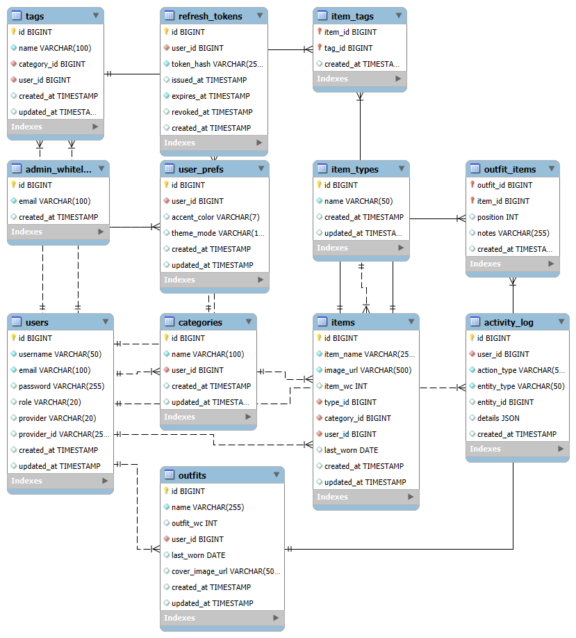

Detailed Relationships:
- One-to-One: User ↔ UserPrefs (Each user has exactly one preferences record)
- One-to-Many: User → Categories (User can create multiple categories)
- One-to-Many: User → Items (User can own multiple clothing items)
- One-to-Many: User → Outfits (User can create multiple outfits)
- One-to-Many: User → RefreshTokens (User can have multiple active sessions)
- One-to-Many: Category → Tags (Each category contains multiple tags
- One-to-Many: Category → Items (Each category contains multiple items)
- One-to-Many: Outfit → OutfitItems (Outfit contains multiple items)
- Many-to-One: Items → ItemType (Each item belongs to one type)
- Many-to-Many: Items ↔ Tags (Through item_tags
- Many-to-Many: Outfits ↔ Items (Through outfit_items)

Key Tables:
- users - User accounts and authentication (Local + OAuth)
- user_prefs - User interface preferences
- refresh_tokens - JWT refresh tokens
- item_types - System-defined clothing types
- categories - User-defined item categories
- tags - Labels within categories
- items - Clothing items
- item_tags - Item–tag relationships
- outfits - Outfit collections
- outfit_items - Items inside outfits
- activity_log - User activity tracking
- admin_whitelist - Approved administrator registration emails
Table Structure Summary:
- users: id, username, email, password, role, provider, provider_id, created_at, updated_at
- user_prefs: id, user_id, accent_color, theme_mode, created_at, updated_at
- refresh_tokens: id, user_id, token_hash, issued_at, expires_at, revoked_at, created_at
- item_types: id, name, created_at, updated_at
- categories: id, name, user_id, created_at, updated_at
- tags: id, name, category_id, user_id, created_at, updated_at
- items: id, item_name, image_url, item_wc, type_id, category_id, user_id, last_worn, created_at, updated_at
- item_tags: item_id, tag_id, created_at
- outfits: id, name, outfit_wc, user_id, last_worn, cover_image_url, created_at, updated_at
- outfit_items: outfit_id, item_id, position, notes, created_at
- activity_log: id, user_id, action_type, entity_type, entity_id, details, created_at
- admin_whitelist: id, email, created_at

7.0 UI/UX DESIGN
7.1 Web Application Wireframes
Register, Log in, Profile
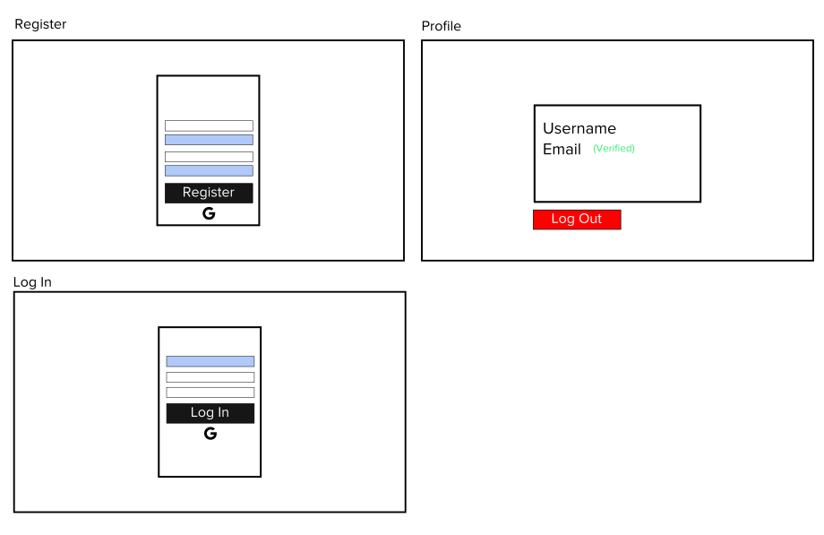

Outfit Gallery and Navigation Menu
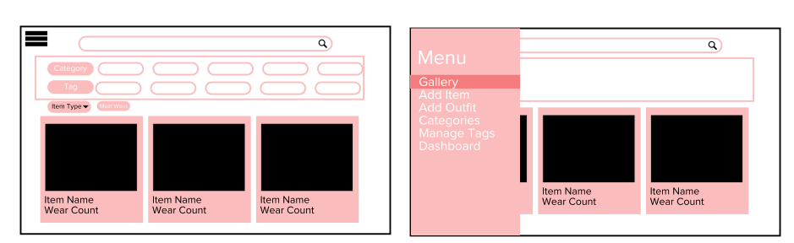
Clothing Item View Page, Clothing Item Add/Edit Form
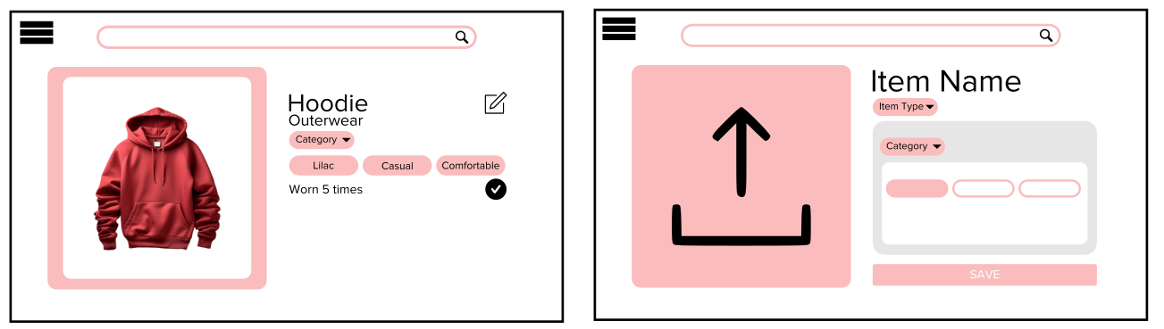
User Preferences and Dashboard
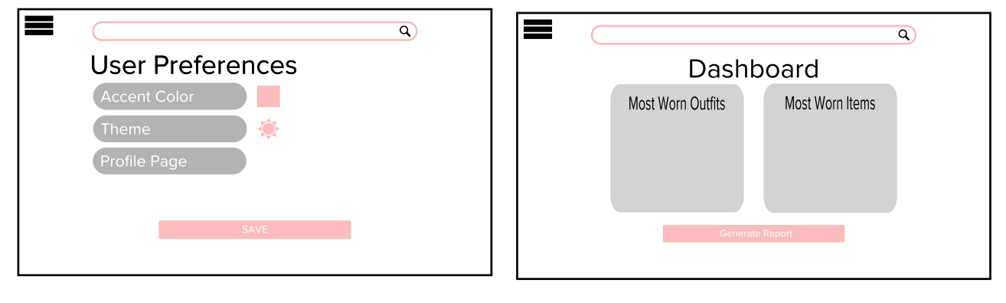

Outfit Gallery, Outfit View Page
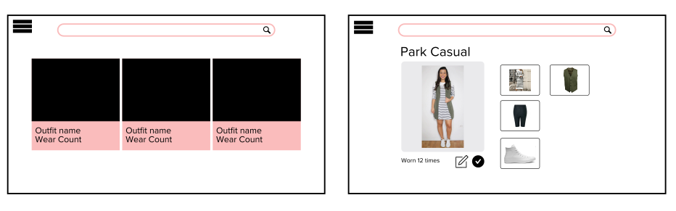
Outfit Add/Update Form, Category and Tags Management
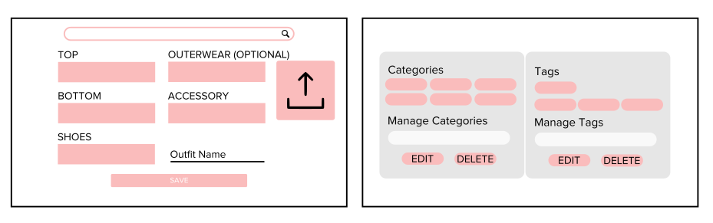
Mark as Worn Prompt
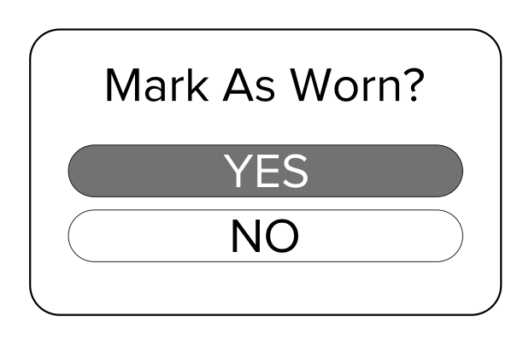
Email Confirmation Pages, Password Reset
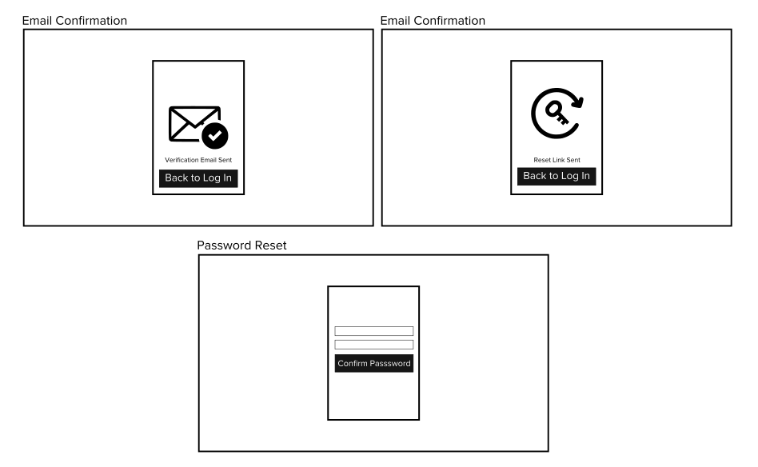
Admin Dashboard, Unauthorized Email
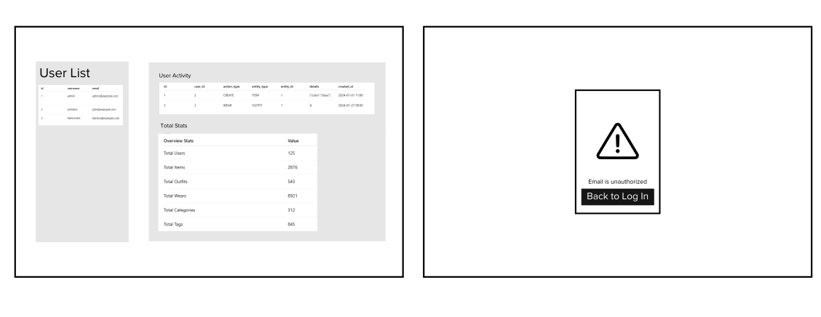

7.2 Mobile Application Wireframes
Clothing Gallery and Clothing Item View
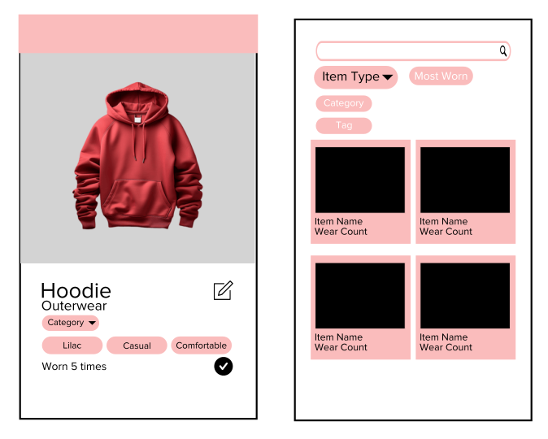
Outfit View Page and Outfit Gallery
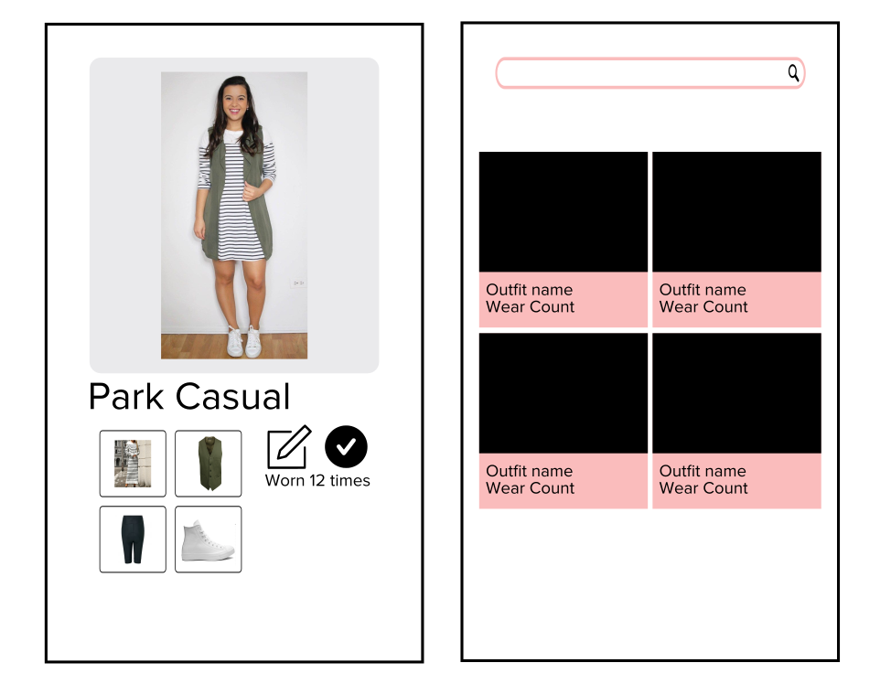

Add/Edit Forms
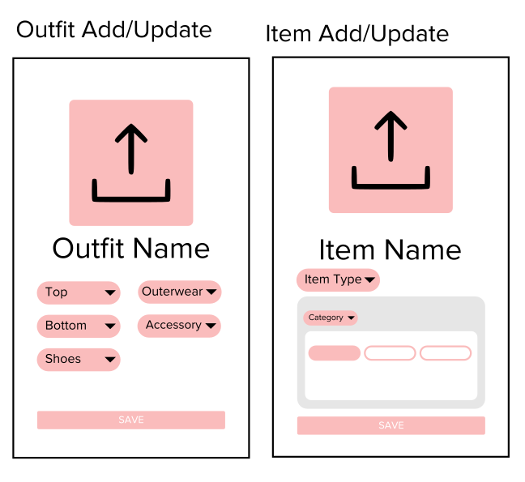
User Preferences & Dashboard
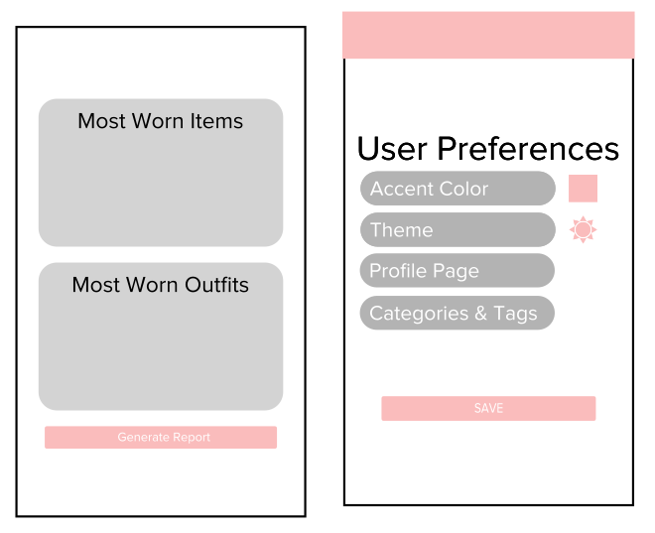
Admin Interface
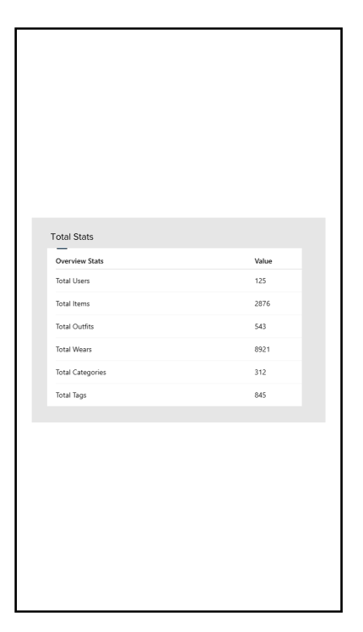
Categories & Tags
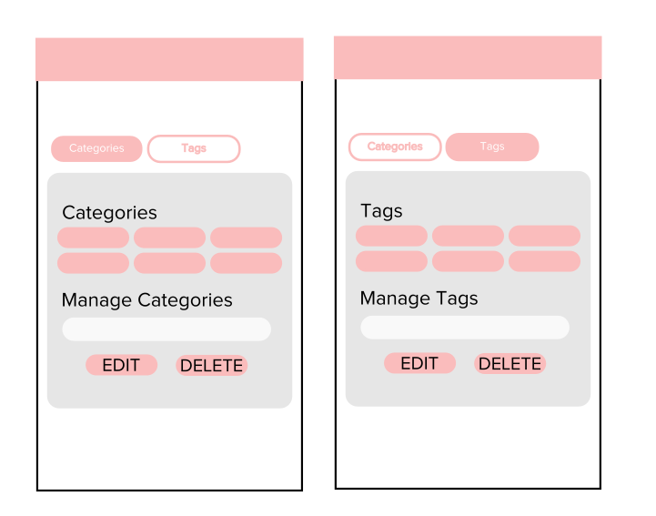

Bottom Navigation
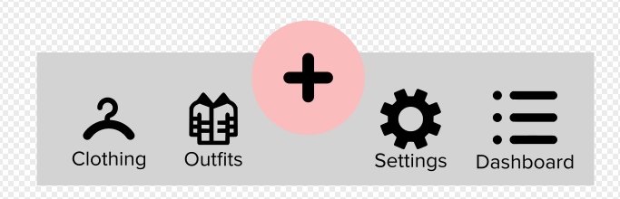
Mobile-Specific Features:
- Bottom navigation for main actions
- Simplified forms for mobile input
Design System:
- Reusable React Components (Web): Modular components (buttons, cards, forms, layouts) ensure consistency and maintainability.
- CSS Variables (Web): Centralized colors, spacing, and typography for consistent styling and easy theming.
- Main XML Theme (Android): Centralized theme (styles.xml) to maintain consistent colors and typography.
- Clean, Minimal Interface: Simple layout focused on clothing images with minimal clutter.
- Consistent Spacing & Typography: Unified spacing scale and text hierarchy across web and mobile.

8.0 PLAN

8.1 Project Timeline

Phase 1: Planning & Design (Week 1–2)

Week 1: Requirements & Architecture
- Day 1–2: Project setup and documentation structure
- Day 3–4: Finalize Functional & Non-Functional Requirements
- Day 5–7: System architecture design (Spring Boot, JWT, DB schema, role model)

Week 2: Detailed Design
- Day 1–2: API specifications (all endpoints defined)
- Day 3–4: Database schema design (Users, Items, Outfits, Categories, Tags, Wears)
- Day 5–6: UI/UX wireframes (Web & Mobile)
- Day 7: Finalize implementation plan & risk assessment

Phase 2: Backend Development (Week 3–5)

Week 3: Authentication & User Management
- Day 1: Spring Boot project setup with dependencies
- Day 2: Database configuration and entity modeling
- Day 3: JWT authentication implementation
- Day 4: User registration & login endpoints
- Day 5: Role-based access control (USER, ADMIN)

Week 4: Core Wardrobe Features
- Day 1: Clothing Item CRUD + image upload
- Day 2: Category management
- Day 3: Tag management
- Day 4: Outfit management
- Day 5: Wear count tracking logic (items & outfits)

Week 5: Advanced Backend Features
- Day 1: Dashboard statistics endpoints
- Day 2: Google OAuth integration
- Day 3: Email service (welcome + report)
- Day 4: Admin portal APIs (user summary & system stats)
- Day 5: Validation, error handling, and API documentation
Phase 3: Web Application (Week 6–7)

Week 6: Core Web Features
- Day 1: React + JavaScript setup
- Day 2: Authentication screens (Register, Login, Google OAuth)
Day 3: Clothing item gallery & CRUD UI
- Day 4: Outfit management UI
- Day 5: Category & tag management UI

Week 7: Advanced Web Features
- Day 1: Dashboard with statistics
- Day 2: Admin portal UI
- Day 3: Color preference integration
- Day 4: Form validation & error handling
- Day 5: API integration testing
Phase 4: Mobile Application (Week 8–9)

Week 8: Core Mobile Features
- Day 1: Android project setup
- Day 2: Authentication screens
- Day 3: Clothing item browsing & CRUD
- Day 4: Outfit management
- Day 5: API service integration

Week 9: Advanced Mobile Features
- Day 1: Dashboard implementation
- Day 2: Admin screens (if applicable)
- Day 3: UI polish & responsiveness
- Day 4: Testing on emulator & physical device
- Day 5: APK generation & documentation
Phase 5: Integration & Deployment (Week 10)

Week 10: Finalization
- Day 1: End-to-end testing (Web + Mobile + Backend)
- Day 2: Security review (JWT, roles, file validation)
- Day 3: Performance testing
- Day 4: Production deployment (Backend + Web)
- Day 5: Final documentation & submission
Milestones
- M1 (End Week 2): All design documentation complete
- M2 (End Week 5): Backend fully functional (all APIs complete)
- M3 (End Week 7): Web application complete
- M4 (End Week 9): Mobile application complete
- M5 (End Week 10): Full system integrated and deployed

Critical Path
- Authentication system (JWT + Roles)
- Clothing item management with image upload
- Outfit wear tracking logic
- Dashboard statistics aggregation
- Google OAuth integration
- End-to-end integration testing
Risk Mitigation
- Implement authentication first (foundation for everything)
- Test file upload and image storage early
- Validate role-based access before admin features
- Implement dashboard queries after wear logic is stable
- Maintain version control backups at each milestone
- Prioritize core wardrobe functionality before UI polish

9.0 APPENDIX
Appendix A – System name change
Due to the similarity between the name WearAmI with WearM.AI, the system name has been modified to WearIsIt. [1]
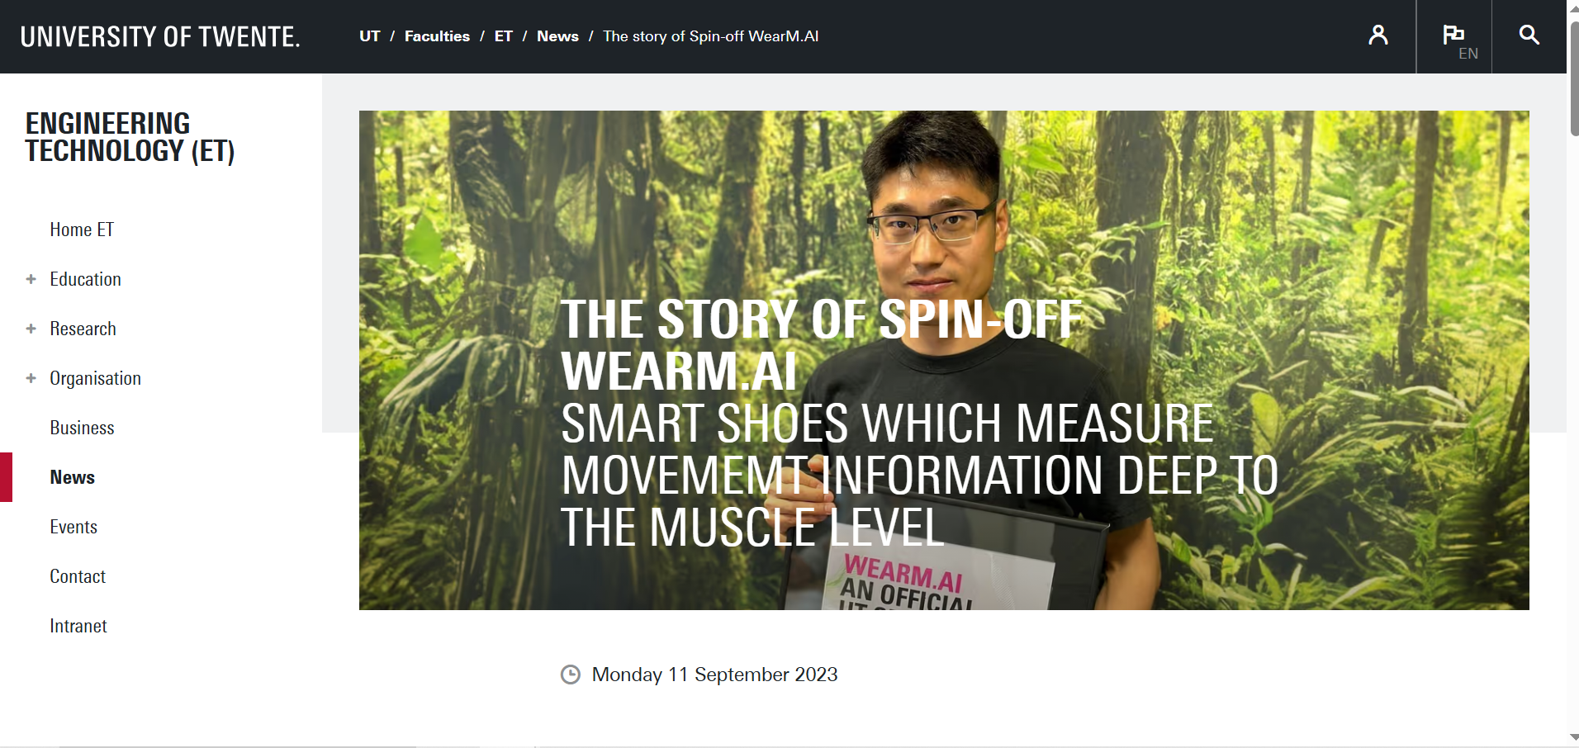
[1] “The story of Spin-off WearM.AI,” Universiteit Twente. Accessed: Feb. 27, 2026. [Online]. Available: https://www.utwente.nl/en/et/news/2023/9/1130318/the-story-of-spin-off-wearm.ai

