STANDARD OPERATING PROCEDURE
Order Fulfillment Process
Pick, Pack, Ship & Quality Control

Document No. | SOP-VA-FUL-001
Version | 1.0
Effective Date | Demo build — July 2026
Prepared By | Michael Abat, Operations & Process VA
Reviewed By | [Self-reviewed — demo project]
Approved By | [Fictional Client — not applicable]
Next Review | 12 months from effective date

SELF-INITIATED DEMONSTRATION PROJECT — Clearwater Supply Co. is a fictional company created to show a realistic order fulfillment process. No real client, data, or business is involved.

1. Purpose
This Standard Operating Procedure (SOP) defines the process for picking, packing, and shipping customer orders at Clearwater Supply Co. It applies to a small e-commerce and manufacturing supply operation seeking a repeatable, error-resistant fulfillment process.
The procedure ensures that:
- Every order follows the same picking, packing, and shipping steps.
- Two built-in quality checks catch errors before an order ships.
- Each order is logged so error patterns can be tracked and reduced over time.
2. Scope
This SOP applies to:
- All warehouse staff involved in order fulfillment, from order receipt to carrier hand-off.
- Standard online orders processed through the company's order management system.
This SOP does not cover:
- Damaged, defective, or returned item processing.
- Bulk or freight orders requiring third-party logistics coordination.
3. Roles & Responsibilities
Role | Responsibilities
Packer | Picks, packs, weighs, labels, and logs each order. Performs both quality checkpoints.
Shift Lead | Reviews the Fulfillment Tracker daily and follows up on flagged issues.
Operations Coordinator | Updates this SOP when the process changes and reviews error trends monthly.

4. Process Flow — Swimlane Diagram
The diagram below shows each step in sequence, the role responsible, and a short description of what happens at that step. The two orange checkpoints are quality checks; work stops if either check fails.
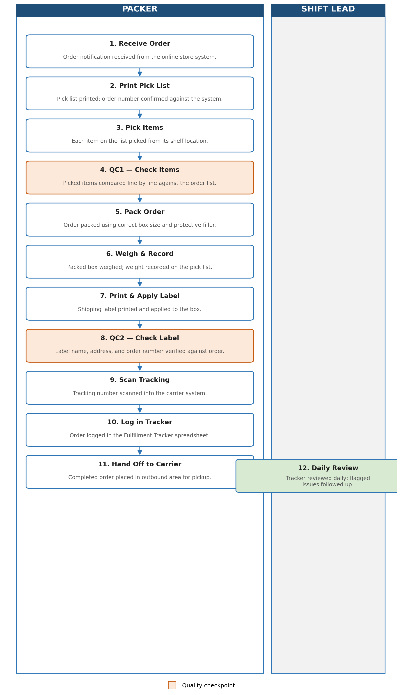

5. Step-by-Step Instructions
- Receive the order notification from the online store system.
- Print the pick list and confirm the order number matches the system.
- Pick each item on the list from its shelf location.
- Quality Check 1: Compare picked items against the order list, line by line. If anything does not match, stop and re-pick before continuing.
- Pack the order using the correct box size and protective filler.
- Weigh the packed box and record the weight on the pick list.
- Print the shipping label and apply it to the box.
- Quality Check 2: Confirm the label's name, address, and order number match the order. If anything does not match, stop and reprint the label.
- Scan the tracking number into the carrier system to confirm the shipment.
- Log the order in the Fulfillment Tracker (see Section 7).
- Place the completed order in the outbound area for carrier pickup.
- Shift Lead reviews the Fulfillment Tracker daily and follows up on any flagged rows.
6. Common Errors & How to Avoid Them
- Wrong item shipped — caused by skipping Quality Check 1. Always check items against the list before packing, not after.
- Wrong shipping label — caused by printing labels for multiple orders at once. Print and apply one label immediately after packing one order.
- Missing tracking number — caused by forgetting to scan before hand-off. Make scanning part of the packing station routine, not a separate task.
- No record of what happened — caused by skipping the tracker log. Log every order, even with no issue, so patterns can be seen later.
7. Fulfillment Tracker
Every packer logs each completed order in the Fulfillment Tracker spreadsheet (separate file: Clearwater_Order_Tracker.xlsx). This creates a record of who packed each order, whether it passed both quality checks, and any issue found. The Shift Lead reviews flagged rows daily.
8. Revision History
Version | Date | Change
1.0 | Demo build | Initial SOP created as a self-initiated demonstration project, formatted to match client SOP standards.

