STANDARD OPERATING PROCEDURE
Damaged Shipment Claims Handling
Inspection, Documentation, Filing & Resolution

Document No. | SOP-VA-CLM-001
Version | 1.0
Effective Date | Demo build — July 2026
Company | Swift Freight Logistics (fictional)
Prepared By | Michael Abat, Operations & Process VA
Reviewed By | [Self-reviewed — demo project]
Approved By | [Fictional Client — not applicable]
Next Review | 12 months from effective date

DEMO COPY ONLY — SELF-INITIATED DEMONSTRATION PROJECT. Swift Freight Logistics is a fictional company created to show a realistic damaged shipment claims process. No real client, data, or business is involved.

1. Purpose
This Standard Operating Procedure (SOP) defines the process for handling damaged shipment claims at Swift Freight Logistics. It applies to a small freight and logistics operation seeking a consistent, well-documented claims process.
The procedure ensures that:
- Every damaged shipment is inspected and documented the same way.
- Two built-in quality checkpoints catch incomplete claims before filing.
- Each claim is logged and tracked from report to resolution.
2. Scope
This SOP applies to:
- All warehouse staff who receive and inspect damaged shipments.
- Claims Coordinators who file, track, and resolve carrier claims.
This SOP does not cover:
- Lost shipment investigations (separate process).
- Customer disputes unrelated to physical shipment damage.
3. Roles & Responsibilities
Role | Responsibility
Warehouse Handler | Receives, inspects, and photographs damaged shipments. Logs claim details in the tracker.
Claims Coordinator | Reviews claim packets, verifies carrier policy terms, files claims, and manages resolution.

4. Process Flow
The diagram below shows the full claims process across both roles, including the two quality checkpoints.
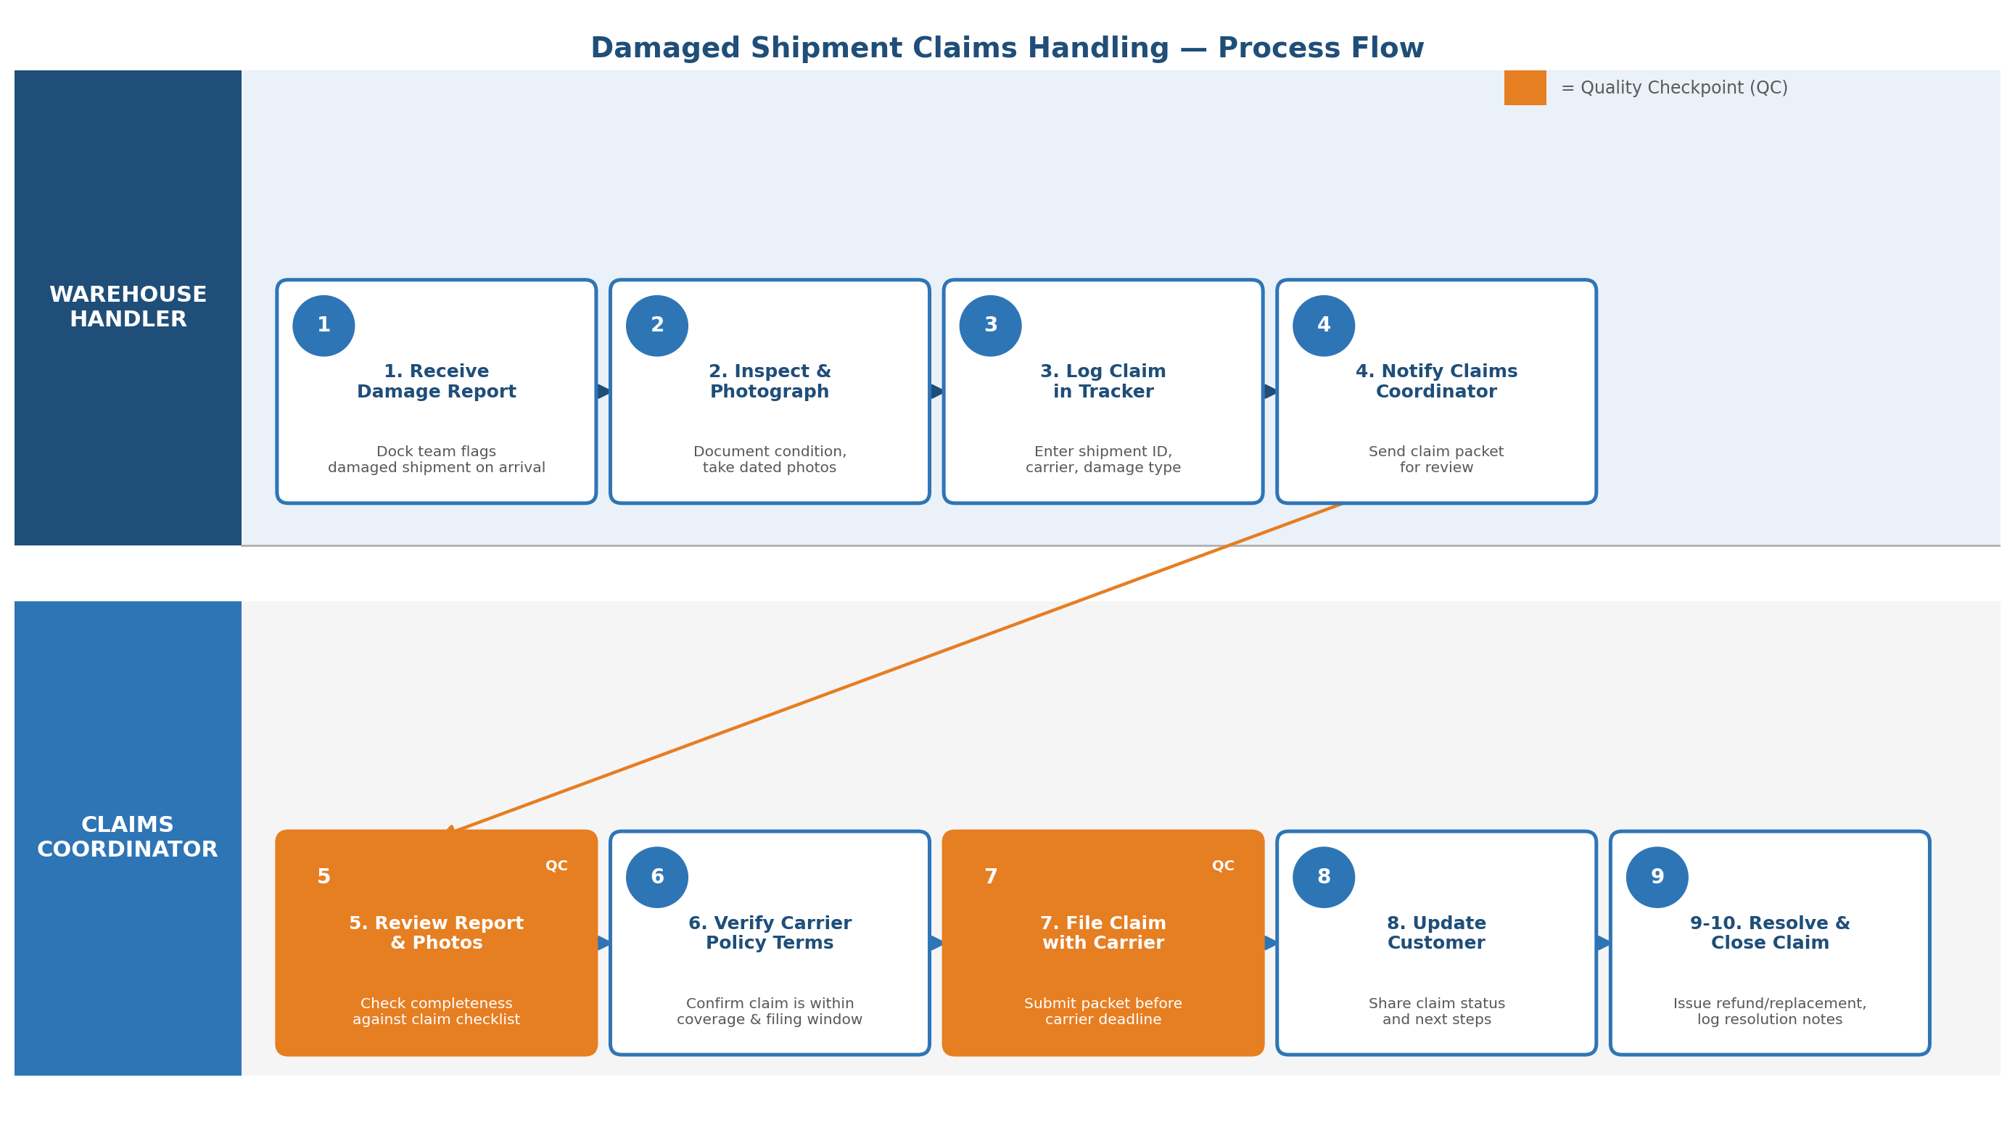

5. Procedure
5.1 Damage Report & Inspection (Warehouse Handler)
- Receive damage report from driver or dock team upon shipment arrival.
- Inspect the shipment and photograph all visible damage from multiple angles.
- Record shipment ID, carrier name, and damage type in the claims tracker.
- Notify the Claims Coordinator and forward the claim packet (photos, notes, shipment ID).
5.2 Claim Review & Filing (Claims Coordinator)
- Review the damage report and photos against the claim completeness checklist. (Quality Checkpoint 1)
- Verify the claim falls within the carrier's coverage and filing deadline.
- Submit the completed claim packet to the carrier before the filing deadline. (Quality Checkpoint 2)
- Update the customer with the claim status and expected timeline.
- Resolve the claim once the carrier responds — issue replacement, refund, or credit as applicable.
- Close the claim in the tracker with final resolution notes.
6. Common Errors & Prevention
Common Error | Prevention
Missing or unclear damage photos | Use the photo checklist: 4 angles minimum, include shipment label.
Claim filed after carrier deadline | Flag claims within 24 hours of receipt; tracker auto-highlights aging claims.
Customer not updated on status | Send a status update at each stage change, logged in the tracker.
7. Revision History
Version | Date | Description | Author
1.0 | July 2026 | Initial demo release | Michael Abat

