Account User Application
  - Proposed screens and wireframes
Table of Contents

Account User Application — Proposed Screens & Wireframes
Status: Proposal for review. Q1–Q11 answered 13 Feb 2026 and folded in. No code has been written. Date: 13 February 2026
A new front end for account users — the members and customers of an organisation, as opposed to the org admins served by /orgadmin and the super admins served by /admin.
This document has three parts:
- Requirements analysis — what the platform already supports, and the gaps that must be closed before these screens can exist.
- Proposed architecture and screen inventory.
- Wireframes — 51 screens, desktop and mobile.
Followed by the cart arithmetic, the offline behaviour matrix, the decisions taken and the remaining questions those decisions surfaced.
Editing a wireframe — the diagrams are generated SVGs. Edit the ASCII source in images/account-user/src/ and rebuild with python3 scripts/wireframes/ascii_to_svg.py build --out docs/images/account-user. See images/account-user/README.md.
Changes in this revision — handling fees are now configured by the super admin per organisation type per payment method, with fixed + percentage + tax elements (G5), which in turn requires an organisation to share its type’s currency (G12); registration approval is an org-admin toggle (G6); event ticketing is in scope (G11). Six new screens: A8, C9, C10, I3, I4, J1. The worked cart totals throughout have been recalculated under the new fee formula — the example cart now comes to €288.45 with €108.45 charged to the card.

Part 1 — Requirements analysis

1.1 What the platform already gives us
Capability | Status
Keycloak identity, realm aws-framework, JWT validated by authenticateToken() | ✅ Exists
Account users as a distinct user_type in organization_users | ✅ Exists
A user belonging to several organisations (one row per org) | ✅ Supported by the schema already
Per-organisation capability flags (enabled_capabilities) | ✅ Exists
Capability-gated module registration, lazy-loaded, menu-aware | ✅ Exists (ModuleRegistration)
Application forms + form_submissions | ✅ Exists
Domain data — events/activities, membership types, registration types, merchandise, calendars | ✅ Exists
Per-item supported_payment_methods on membership/merchandise/calendar/registration types | ✅ Exists
Payment methods per org (pay-offline, stripe, helix-pay) with credentials in org_payment_method_data.payment_data | ✅ Exists
Six locales, org-derived locale selection | ✅ Exists
Per-organisation branding (logo + 5 colours) in settings.branding | ✅ Exists (new, uncommitted)

1.2 Gaps that must be closed
These are the things the requirements assume but the codebase does not yet have. Each one is work that precedes or accompanies the screens.

G1 — There is no account-user API surface at all
Every backend route today is mounted under /api/admin/* or /api/orgadmin/*, and every one of them resolves the caller’s organisation with:
SELECT organization_id FROM organization_users
WHERE keycloak_user_id = $1 AND user_type = 'org-admin' AND status = 'active'
An account user fails that lookup by design. Nothing in the current API can be reused as-is.
Proposed two new route families:
Prefix | Auth | Purpose
/api/public/* | none | Organisation directory, org lookup by code, branding, public event/membership/merchandise listings for the pre-login landing page
/api/account/* | authenticateToken() + a new resolveAccountOrganisation() middleware | Everything behind the login
resolveAccountOrganisation() is the account-user mirror of the org-admin resolver: it takes the organisation from the URL/header, checks the caller has an active organization_users row of user_type = 'account' for it, and rejects otherwise. Capability gating then reuses the existing loadOrganisationCapabilities() / requireCapability() middleware unchanged.

G2 — Organisations have no URL-friendly short code
organizations has id, name, display_name, domain — no slug. Requirement (2) needs one.
Proposed: migration adding organizations.url_code varchar(50) UNIQUE NOT NULL, plus a field on the super-admin create/edit organisation pages with format validation (^[a-z0-9][a-z0-9-]{1,49}$), a uniqueness check, and a reserved-word list so khpc is fine but api, admin, login, assets, static, health are not — they would collide with the app’s own paths.

G3 — payments cannot represent a multi-item basket
This is the single biggest gap. The table is one-payment-per-thing:
payments( id, organisation_id, user_id, payment_type, context_id, amount, currency,
payment_method, payment_status, payment_provider, provider_transaction_id, ... )
payment_type + context_id point at exactly one entry / membership / booking. A checkout that covers an entry and a membership and three bookings has nowhere to live, and the “drill into a payment and see its transactions” requirement has nothing to drill into.
Proposed new tables:
carts id, organisation_id, user_id, status(open|checked_out|abandoned),
currency, created_at, updated_at
UNIQUE (organisation_id, user_id) WHERE status = 'open'
cart_items id, cart_id, item_type(event_entry|membership|registration|booking|merchandise),
context_ref jsonb, -- activity id, membership type id, slot, variant…
form_submission_id, -- the completed application form
quantity, unit_fee, fee,
payment_method_id, -- the user's current choice
handling_fee_included bool, -- snapshot from the source item
discount_id, discount_amount,
expires_at, -- soft hold for capacity-limited items
created_at
payment_transactions id, payment_id, organisation_id, item_type, context_id,
description, fee, handling_fee, payment_method_id,
form_submission_id, status, created_at
and additions to payments:
+ handling_fee decimal(10,2)
+ offline_amount decimal(10,2)
+ card_amount decimal(10,2)
+ offline_received_at timestamp
+ offline_received_by uuid -- organization_users.id of the admin who marked it
+ cart_id uuid
payment_type / context_id → become nullable (a basket payment has many)
Existing single-context payments keep working; a basket payment leaves context_id null and hangs its detail off payment_transactions. The org-admin Payments list reads the parent row, the new detail drill-down reads the children.

G4 — handling_fee_included exists only on event activities
event_activities.handling_fee_included is there. membership_types, registration_types, merchandise_types and calendars have supported_payment_methods but no handling-fee flag.
The cart rules in the requirements apply the included/not-included distinction to entry, membership, calendar, registration and merchandise fees. So this needs a migration adding the column to the other four tables, plus the corresponding checkbox in each org-admin type form (mirroring EventActivityForm, which reveals it only when a card method is selected).

G5 — Handling fees are configured per organisation type
The flag says whether the fee is absorbed. Nothing says what the fee is — the Payment Configuration section that held currency and handling fees was removed from PaymentSettingsTab.tsx in recent work, so today the rate has no home at all.
Decided (Q3): the super admin configures handling fees on the organisation type, once per card payment method. Every organisation of that type inherits them; there is no per-organisation override. Three elements per method:
Element | Example | Notes
Fixed | €0.25 | A flat amount per card payment
Percentage | 1.5% | Of the amount being charged to the card
Tax percentage | 23% | May be 0, in which case no tax element is added
Proposed storage — a table rather than JSONB, because these are queried on every cart load and a new provider must not need a schema change:
organization_type_payment_fees
id
organization_type_id → organization_types(id) ON DELETE CASCADE
payment_method_id → payment_methods(id) ON DELETE CASCADE
fixed_fee decimal(10,2) NOT NULL DEFAULT 0
percentage_fee decimal(6,3) NOT NULL DEFAULT 0 -- 1.500 = 1.5%
tax_percentage decimal(6,3) NOT NULL DEFAULT 0 -- 0 = no tax element
created_at, updated_at
UNIQUE (organization_type_id, payment_method_id)
Only methods classified as card methods (stripe, helix-pay, and anything else whose name contains card/stripe/helix) get a row; pay-offline never carries a handling fee.
Auto-populated defaults. The Create Organisation Type page must arrive with Stripe and Helix-Pay pre-filled. Those defaults should live on the payment method itself — payment_methods.default_fee_config jsonb — rather than being hard-coded in the admin front end, so that when Stripe changes its published rates a super admin can update the platform default without a release. Existing organisation types keep whatever they were configured with; only new ones pick up the changed default.
Resolution at runtime. organization → organization_type_id → organization_type_payment_fees, cached per request. A missing row means zero fee, not an error — an organisation type whose fees have never been set simply charges no handling fee.
This changes the arithmetic in Part 4 and adds one new super-admin screen, J1.

G6 — Auto-registration is an org-admin setting
Keycloak’s registration flow creates an identity. It does not create the organization_users row that connects that identity to Kildare Hunt Pony Club. Something must: POST /api/public/organisations/:code/register creates the Keycloak user (via the existing keycloak-admin.service) and the organization_users row with user_type = 'account'.
Decided (Q4): the org admin controls whether that row starts active, via an Auto-registration toggle stored in organizations.settings.registration.autoRegistration (merged into the JSONB, never replacing it — see architecture.md).
Auto-registration ON — the current-best case:
register → Keycloak user created, organization_users.status = 'active'
→ verification email → user activates → signs in → full access
Auto-registration OFF — approval required:
register → Keycloak user created, organization_users.status = 'pending'
→ verification email → user activates their account (they can sign in)
→ signs in → sees "Awaiting approval" (screen A8), no app access
→ org admin approves in the pending-registrations queue (screen I3)
→ status = 'active' + approval email → user signs in → full access
The distinction that matters in the implementation: account activation and organisation approval are two separate gates. Keycloak owns the first (email verification), organization_users.status owns the second. A pending user authenticates successfully — they simply have no capabilities, so the shell renders A8 instead of the app. Rejection is a third state (rejected) with its own variant of A8.
New screens: A8 (account app), I3 (approval queue) and I4 (the toggle).

G7 — Renewal needs a source for its pre-populated answers
“Much of the required information is already available in the system” — concretely, the previous membership’s form_submission_id plus the members row. The renewal flow loads the prior submission, maps answers onto the current form definition by field id, and marks fields that no longer exist (dropped from the form) or have no prior answer (newly added to the form). Fields whose validation rules have tightened since must be re-validated, not trusted.
Same mechanism serves registration renewal.

G8 — Eligibility rules need a server-side answer
“Not open yet / closed / full” must be decided by the backend, not the browser — a client-side check is a race with every other user. Proposed: every activity/type in a listing response carries a computed availability object:
{ "state": "open|not_yet_open|closed|full|activity_full",
"opensAt": "...", "closesAt": "...",
"spacesRemaining": 12 }
and POST /api/account/cart/items re-checks it server-side and can reject with 409. The cart item expires_at gives a soft hold so a user filling in a long form does not lose a place they were shown as available.

G9 — All money arithmetic belongs on the server
The requirements are emphatic that the total must be correct, and the rules are genuinely fiddly (offline vs card, included vs added-on handling fee, discounts, quantities, multi-currency). The cart UI must never compute a total. GET /api/account/cart returns the fully-computed breakdown, and checkout re-computes it from the database rather than trusting anything posted. See Part 4.

G10 — Translations
Six locale files (en-GB, de-DE, es-ES, fr-FR, it-IT, pt-PT) for the new shell, holding every string for the shell and all account modules — the same arrangement as orgadmin-shell. That is a substantial translation surface; expect ~450–550 keys × 6.
Decided (Q11): all six locales from day one, not English-first. The practical consequence is that the key tree must be settled early — retro-fitting keys across six files after the UI is built is where org-admin’s i18n debt came from. Every PR that adds a string adds it to all six.

G11 — Event ticketing is in scope
Decided (Q9). orgadmin-ticketing already issues electronic tickets against event entries (electronic_tickets), configured per event in event_ticketing_config (header text, instructions, footer, validity period, logo, background colour) and scanned into ticket_scan_history. What does not exist is any way for the member to get at their ticket.
What this adds:
- An account-ticketing package gated on event-ticketing, with My Tickets (C9) and a ticket view (C10).
- Account endpoints to list a user’s tickets and fetch one for rendering.
- Automatic issuance. Today tickets are issued from the org-admin side. For the account app a ticket must appear on its own once the entry is confirmed — on successful card payment, or when an org admin marks an offline payment received (I2). This is the same confirmation transition that activates a membership, so it belongs in the same service method, not a parallel one.
- Offline-first rendering. A ticket that needs a signal at a field gate is worthless. Tickets for events in the next 30 days are precached with their QR payload and rendered entirely from the cache — see Part 5.
- services/ticketGeneration.ts currently lives in orgadmin-ticketing and builds tickets client-side. Both front ends must render an identical ticket, so per §1.5 it moves to packages/components.

G12 — An organisation’s currency must match its type’s
Decided (N3). Because fixed_fee is a currency amount held on the organisation type and inherited by every organisation of that type, the two currencies cannot be allowed to diverge — a €0.25 fixed fee inherited by an organisation trading in GBP is meaningless.
Today they can. organization_types.currency is varchar(3) NOT NULL DEFAULT 'USD'; organizations.currency is varchar(3) and nullable, set independently on the super-admin organisation form.
What this requires:
- Backfill — a migration setting organizations.currency from its type wherever it is null or differs. Existing mismatches need reviewing before the migration runs rather than being silently overwritten; there may be none, but that has to be checked, not assumed.
- Constraint — a foreign-key-style check is not expressible in SQL across the join, so enforce it in organization.service on create and update, and add a repo-level test.
- Super-admin UI — the currency field on Create/Edit Organisation becomes read-only, showing the inherited value with “Set by the Pony Club organisation type”, rather than a free choice that can be set wrong. Changing an organisation’s type therefore changes its currency, which deserves a confirmation.
- Organisation type currency changes are the dangerous case: they would reinterpret every inherited fixed_fee and every historical price. Blocked once the type has organisations, with the error explaining why.
This is a small change with a wide surface — it touches the super-admin app, the organisation service and a migration — so it is called out separately rather than buried in the fee work.

1.3 Interpretation decisions
Point | Decision
Landing page (1) or short code (2)? | Both (Q1). /account gives the directory, /account/khpc skips straight to that org’s gateway — option 2 is a deep link into option 1’s flow.
Where does merchandise history appear? | The “My …” areas listed cover entries, bookings, memberships and registrations, but the use case mentions “purchased merchandise”. Added as My Orders (C8), gated on merchandise.
Is the cart per-organisation? | Yes. Carts are scoped by organisation_id; switching org switches cart. Merging carts across orgs is meaningless — different currencies, different payment providers, different handling fees. The header cart badge shows the current org’s cart only, and the switcher flags other orgs with open carts.
Ticketing? | In scope (Q9) — see G11. My Tickets, a rendered ticket, and automatic issuance on entry confirmation.
Discounts? | In scope (Q8). Automatic discounts are applied and shown per line at the point of application and again in the cart; a discount-code box sits in the cart. A fee shown without an applicable discount is simply wrong.
Self-cancellation? | Bookings only (Q6), governed by the existing cancellationValidator. Entries, memberships, registrations and orders cannot be cancelled by the account user — they contact the club.
Entering on behalf of someone else? | Yes (Q7). Every application form starts with “who is this for?”, offering the people on the user’s membership.

Part 2 — Architecture and screen inventory

2.1 Packages
Mirrors the org-admin arrangement exactly, so the module registry, capability gating, useApi pattern and lazy-loading all carry over unchanged.
packages/
account-shell Deployable SPA. Auth, org resolution/switching, routing,
module registry, layout, PWA service worker,
locales/<locale>/translation.json × 6 :5176
account-core Always-on: Home, Cart, Checkout, Payments, Profile,
useAccountApi, OrganisationContext, CartContext,
OfflineContext, ApplicationFormRenderer
account-events capability: event-management
account-memberships capability: memberships
account-registrations capability: registrations
account-merchandise capability: merchandise
account-calendar capability: calendar-bookings
account-ticketing capability: event-ticketing
Per project rule §1.5, anything both front ends can use goes to packages/components instead — concretely: the application-form renderer (metadata-driven, already half-there in MetadataForm), the payment widgets in OrgPaymentWidget, OrgDataTable, OrgDatePicker, OrgFileUpload, and the new cart-total presentation component.

2.2 URL scheme
Basename /account. Organisation code is the first path segment — it is in the URL rather than only in session state so links are shareable, refresh-safe, and a user can keep two orgs open in two tabs.
/account Organisation directory (public)
/account/:orgCode Org gateway (public) → Home (authenticated)
/account/:orgCode/pending Awaiting approval (auto-registration off)
/account/:orgCode/tickets My Tickets
/account/:orgCode/tickets/:id A ticket
/account/:orgCode/entries My Entries & Bookings
/account/:orgCode/entries/:id
/account/:orgCode/bookings/:id
/account/:orgCode/memberships My Memberships
/account/:orgCode/memberships/:id
/account/:orgCode/registrations My Registrations
/account/:orgCode/registrations/:id
/account/:orgCode/orders My Orders (merchandise)
/account/:orgCode/orders/:id
/account/:orgCode/browse/events Events
/account/:orgCode/browse/events/:id
/account/:orgCode/browse/events/:id/activities/:activityId/apply
/account/:orgCode/browse/memberships Membership types
/account/:orgCode/browse/memberships/:id
/account/:orgCode/browse/memberships/:id/apply?renew=:membershipId
/account/:orgCode/browse/registrations Registration types
/account/:orgCode/browse/registrations/:id
/account/:orgCode/browse/registrations/:id/apply
/account/:orgCode/browse/merchandise Merchandise
/account/:orgCode/browse/merchandise/:id
/account/:orgCode/browse/calendars Calendars
/account/:orgCode/browse/calendars/:id
/account/:orgCode/browse/calendars/:id/book
/account/:orgCode/cart Cart
/account/:orgCode/checkout Checkout
/account/:orgCode/checkout/confirmation/:paymentId
/account/:orgCode/payments My Payments
/account/:orgCode/payments/:id
/account/:orgCode/payments/:id/transactions/:transactionId
/account/:orgCode/profile Profile & Settings
/account/switch Organisation switcher

2.3 Screen inventory
51 screens. ✳ marks a screen with a distinct mobile layout, not just a reflow. New in this revision: A8, C9, C10, I3, I4, J1.
# | Screen | Area | Gated on
A1 | Organisation Directory | Entry | —
A2 | Organisation Gateway (branded) | Entry | —
A3 | Keycloak login (branded theme) | Entry | —
A4 | Register with organisation | Entry | —
A5 | Registration submitted | Entry | —
A6 | Not connected to this organisation | Entry | —
A7 | Organisation switcher ✳ | Entry | —
A8 | Awaiting approval | Entry | —
B1 | App shell — desktop | Shell | —
B2 | App shell — mobile ✳ | Shell | —
B3 | Home / My Dashboard | Shell | —
C1 | My Entries & Bookings | My activity | event-management ∨ calendar-bookings
C2 | Entry detail | My activity | event-management
C3 | Booking detail | My activity | calendar-bookings
C4 | My Memberships | My activity | memberships
C5 | Membership detail + renew | My activity | memberships
C6 | My Registrations | My activity | registrations
C7 | Registration detail | My activity | registrations
C8 | My Orders | My activity | merchandise
C9 | My Tickets | My activity | event-ticketing
C10 | Ticket ✳ | My activity | event-ticketing
D0 | Application form step (shared) ✳ | Browse | —
D1 | Events list | Browse | event-management
D2 | Event detail + activities | Browse | event-management
D3 | Enter an activity | Browse | event-management
D4 | Membership types list | Browse | memberships
D5 | Membership type detail | Browse | memberships
D6 | Membership application / renewal | Browse | memberships
D7 | Registration types list | Browse | registrations
D8 | Registration type detail + apply | Browse | registrations
D9 | Merchandise list | Browse | merchandise
D10 | Merchandise detail | Browse | merchandise
D11 | Calendars list | Browse | calendar-bookings
D12 | Calendar availability ✳ | Browse | calendar-bookings
D13 | Slot booking form | Browse | calendar-bookings
E1 | Cart — desktop | Cart | —
E2 | Cart — mobile ✳ | Cart | —
E3 | Change payment method | Cart | —
E4 | Checkout review | Cart | —
E5 | Card payment (Stripe / Helix-Pay) | Cart | —
E6 | Payment confirmation | Cart | —
E7 | Offline checkout confirmation | Cart | —
E8 | Payment failed | Cart | —
F1 | My Payments | Payments | —
F2 | Payment detail + transactions | Payments | —
F3 | Transaction detail | Payments | —
P1 | Profile & Settings | Profile | —
P2 | Change password (Keycloak) | Profile | —
H1 | Offline mode | PWA | —
H2 | Offline-blocked action | PWA | —
H3 | Install prompt | PWA | —
I1 | Org admin: Offline Payments list | orgadmin-core | —
I2 | Org admin: Mark received / undo | orgadmin-core | —
I3 | Org admin: Pending registrations | orgadmin-core | —
I4 | Org admin: Registration settings | orgadmin-core | —
J1 | Super admin: Handling fees on an organisation type | admin | —
Screens I1–I4 are additions to the existing org-admin app (packages/orgadmin-core), and J1 is an addition to the existing super-admin app (packages/admin) — not the new front end.

2.4 Responsive strategy
Breakpoint | Layout
xs < 600 | Bottom navigation bar (5 items: Home, Browse, My Stuff, Cart, Profile), overflow in a drawer. Lists become cards. Tables become stacked key/value blocks. Calendar defaults to day view.
sm 600–899 | Collapsible drawer, 2-column grids, calendar defaults to 3-day view.
md 900–1199 | Permanent sidebar, 3-column grids, calendar week view.
lg ≥ 1200 | Sidebar + content max-width 1280, cart summary becomes a sticky right rail.

Part 3 — Wireframes

A. Entry, identity and organisation context

A1 — Organisation Directory
Route: /account (public) · API: GET /api/public/organisations?q=
The base-URL landing page from requirement option (1).
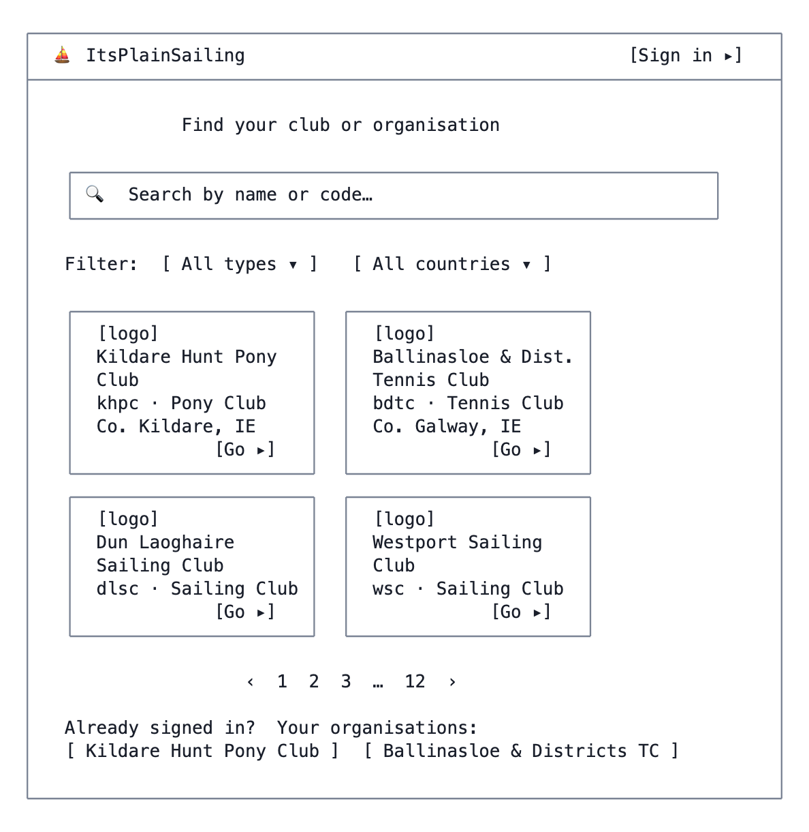
A1 — Organisation Directory
Notes - Search matches display_name and url_code, debounced, server-side. - The “Your organisations” strip appears only when a valid session already exists — it is the fast path for the returning multi-org user and is populated from GET /api/account/organisations. - Only organisations with status = 'active' and a flag such as settings.listedInDirectory (default true) appear. A club that does not want to be publicly discoverable is still reachable by its code (Q5) — hiding from the directory is not access control.

A2 — Organisation Gateway
Route: /account/:orgCode when unauthenticated · API: GET /api/public/organisations/:code
Requirement option (2) lands here directly. Branded from settings.branding.
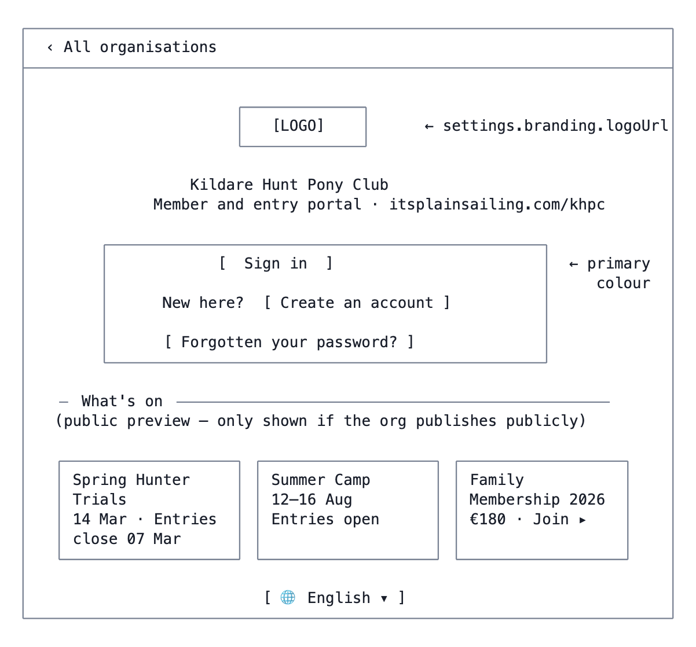
A2 — Organisation Gateway
Notes - “Sign in” redirects to Keycloak with kc_locale set from the org’s language and a redirect_uri back to /account/khpc. - If a valid session already exists, this screen never renders — the router goes straight to B3 (Home), satisfying “if the person was previously logged in, then they will be brought to the specific page”. - Unknown :orgCode → a 404 screen offering the directory. - The “What’s on” preview is optional per org and read-only; every card’s CTA routes through login.

A3 — Keycloak login (branded)
Not a React screen — Keycloak’s own login page, using the custom theme machinery already documented in docs/KEYCLOAK_MULTIPLE_LOGIN_THEMES.md / KEYCLOAK_THEME_SWITCHING.md.
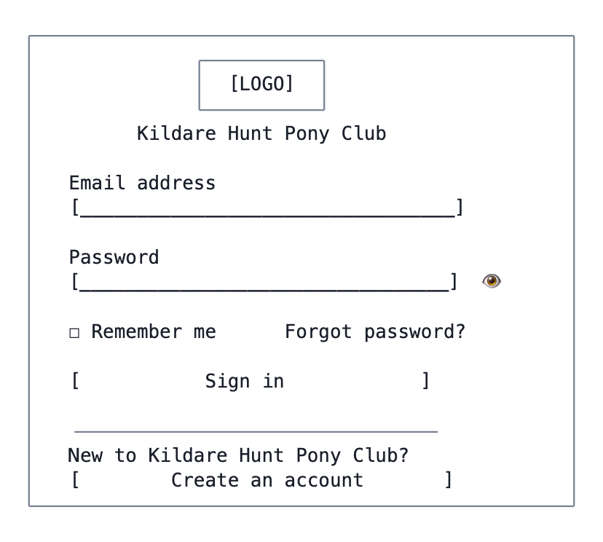
A3 — Keycloak login (branded)
Notes - One realm, one credential set — this is what makes “one set of credentials for many organisations” work with no extra machinery. The org branding is a theme parameter, not a separate realm. - Forgot-password and registration are Keycloak’s own flows; registration hands off to A4 to capture the organisation connection (see G6).

A4 — Register with organisation
Route: /account/:orgCode/register
Two entry paths: a brand-new user, or an existing ItsPlainSailing user who is not yet connected to this organisation (arriving from A6).
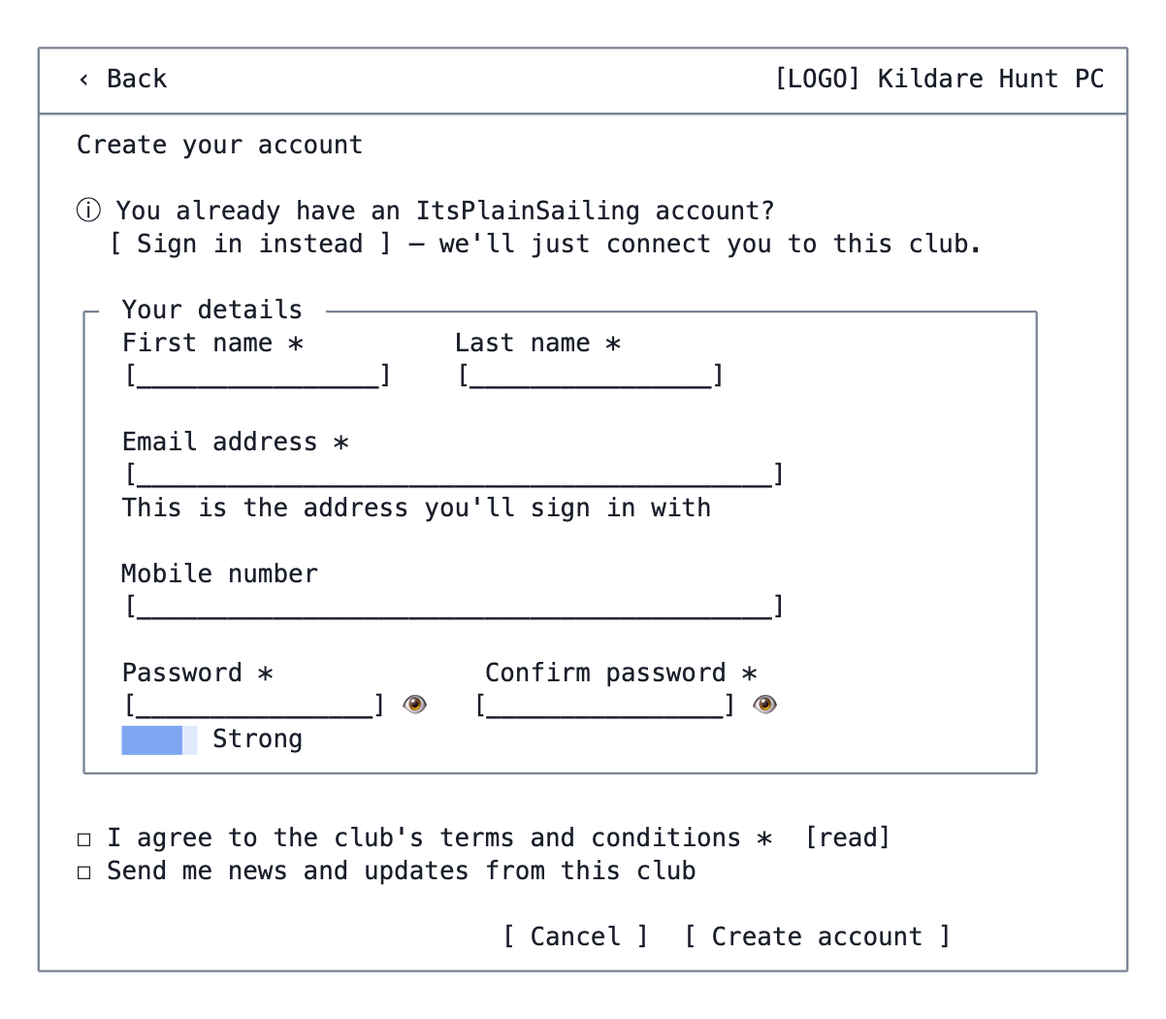
A4 — Register with organisation
Notes - Creating an account here does not create a membership — it creates the login and the organization_users connection. Applying for membership is a separate, paid flow (D4–D6). - If the email already exists in Keycloak, the response must not leak that fact: show a neutral “Check your email” screen and send a connect-this-club link instead. - Existing-user path (from A6) collapses this to a single “Connect to this club” confirmation.

A5 — Registration submitted
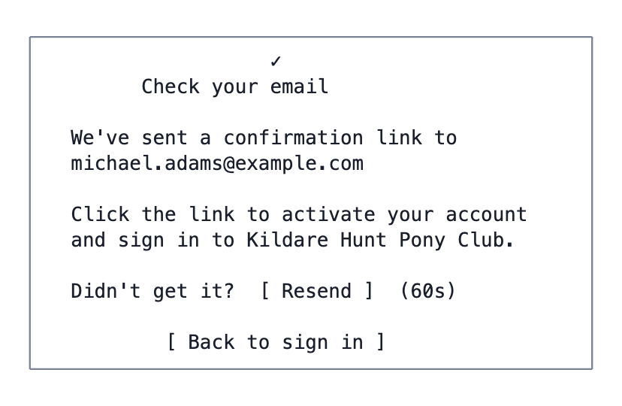
A5 — Registration submitted
Variant when the org has auto-registration off (G6): the body gains a second sentence — “Once you’ve activated your account, a club administrator will review your request before you can sign in.” The user still activates via the email; approval is the separate second gate, and they land on A8 when they next sign in.

A6 — Not connected to this organisation
Shown when authentication succeeds but there is no active organization_users row for this org — the “otherwise they should be redirected to a registration page” branch.
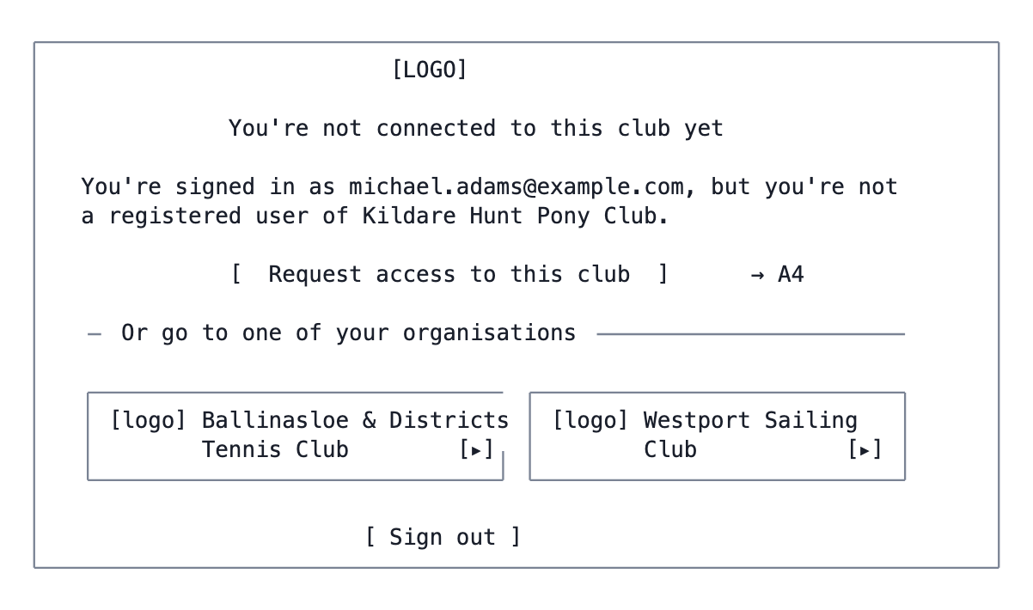
A6 — Not connected to this organisation
A status = 'pending' row shows a third variant: “Your request is awaiting approval.”

A7 — Organisation switcher ✳
Route: /account/switch, and as a header popover. API: GET /api/account/organisations
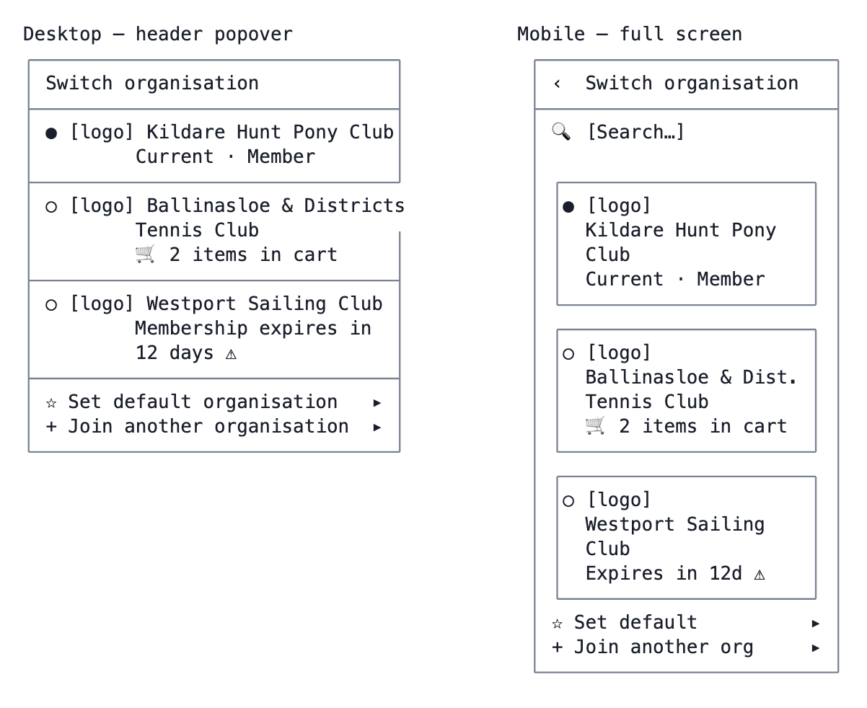
A7 — Organisation switcher ✳
Notes - Switching is a client-side context change plus a URL change, not a re-authentication — the Keycloak token is realm-wide, so the same token serves every org the user belongs to. This is what makes switching instant. - What switching must do: change orgCode in the URL, swap the active OrganisationContext, re-resolve capabilities and therefore the menu, re-theme from the new org’s branding, reload the locale if the org’s language differs, and swap to that org’s cart. - Open carts in other orgs are surfaced here so a half-finished basket is not silently orphaned. - The default organisation is stored per user (reuse user_preferences) and decides where a bare /account sends an authenticated user.

A8 — Awaiting approval
Route: /account/:orgCode/pending
Where a user lands after signing in when the org has auto-registration off and their organization_users.status is still pending. They are authenticated — they simply have no capabilities yet, so the shell renders this instead of the app.
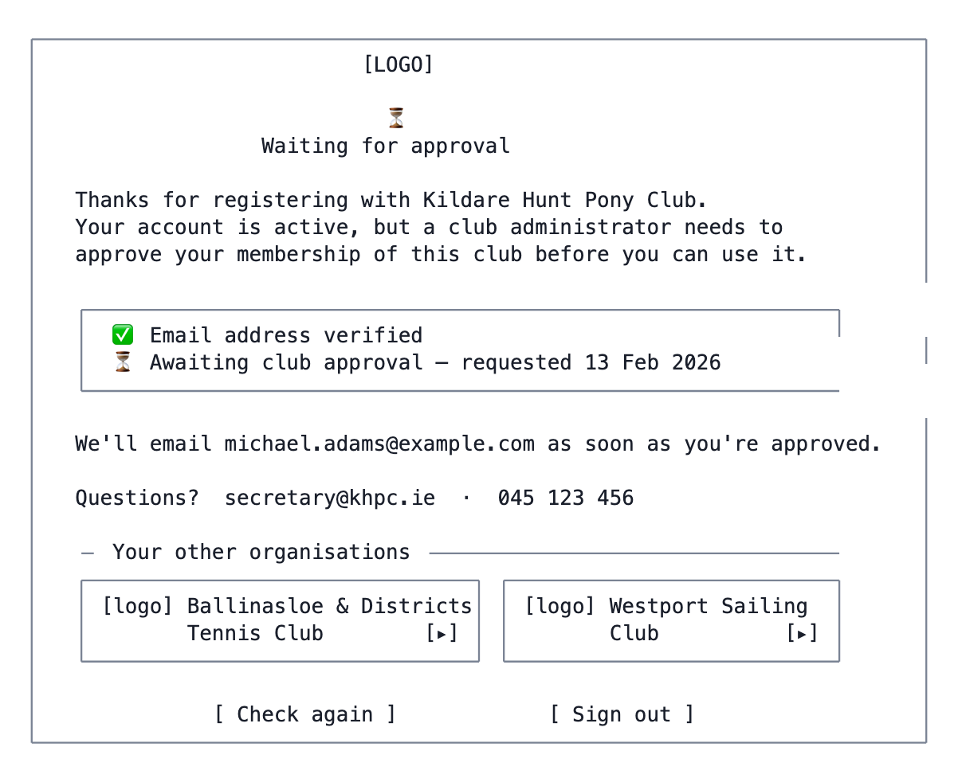
A8 — Awaiting approval
Rejected variant
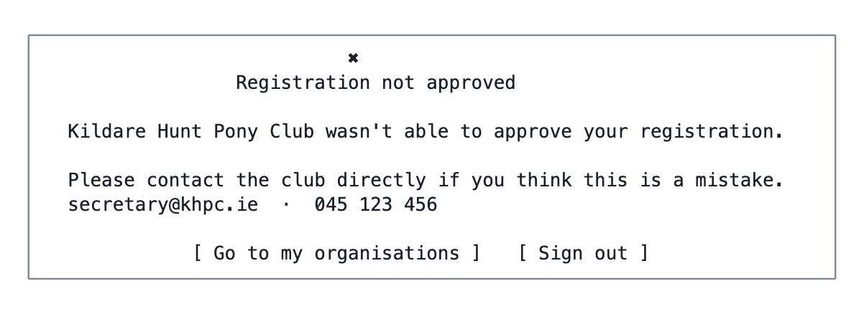
A8 — Awaiting approval
Notes - The two-line status block makes the two gates visible, which matters when a user has verified their email and cannot understand why they are still locked out. - The “other organisations” strip prevents the dead end where a multi-org user is stuck on a pending club with no way through to one they already belong to. It is omitted when they have no others. - “Check again” re-fetches status rather than reloading, so an approval that happened a minute ago is picked up without a sign-out/sign-in cycle. - The rejection message deliberately gives no reason. Whatever the admin recorded in I3 is internal — surfacing it invites arguments the platform cannot adjudicate.

B. Application shell

B1 — App shell (desktop)
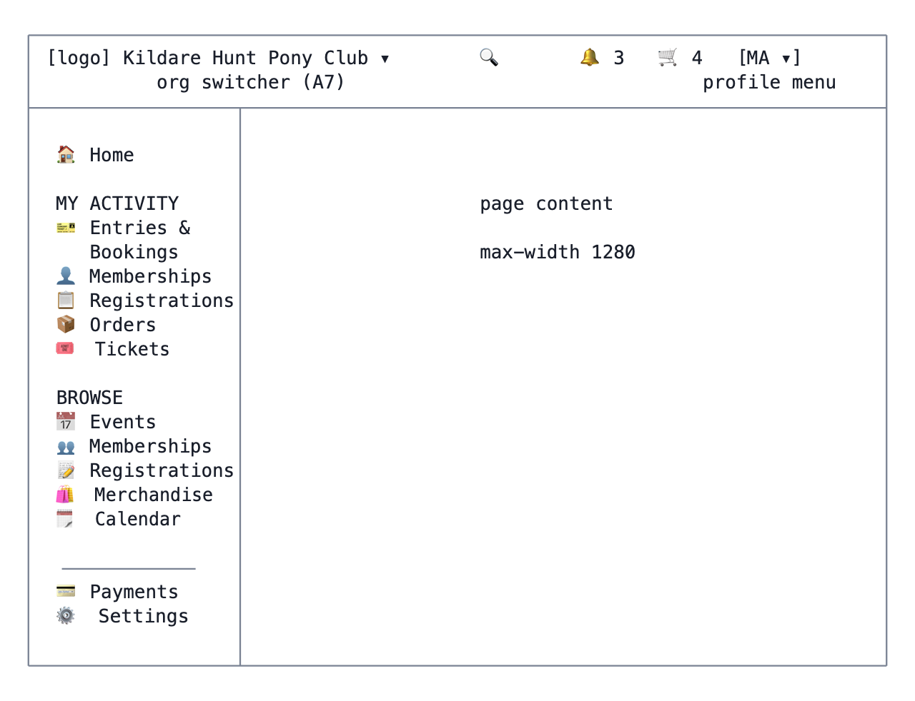
B1 — App shell (desktop)
Notes - Every item under MY ACTIVITY and BROWSE is capability-gated; an org with only memberships enabled sees four items in total, not thirteen. Section headings hide when empty. - The org name in the header is the switcher trigger and doubles as the “it should be clear which organisation they are accessing” affordance required by the brief. It carries the org’s primary colour and logo. - Theme derives from settings.branding at runtime, so the shell must build its MUI theme after the org resolves — the same ordering constraint orgadmin-shell has with i18n.

B2 — App shell (mobile) ✳
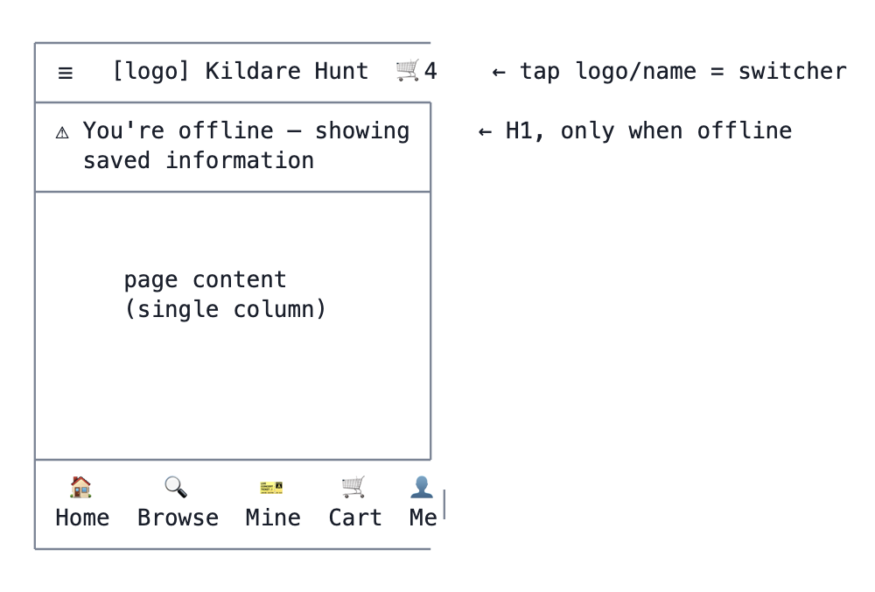
B2 — App shell (mobile) ✳
Browse and Mine open a sheet listing only the capability-enabled areas; with a single enabled area the tab navigates directly instead of opening a sheet.

B3 — Home / My Dashboard
Route: /account/:orgCode
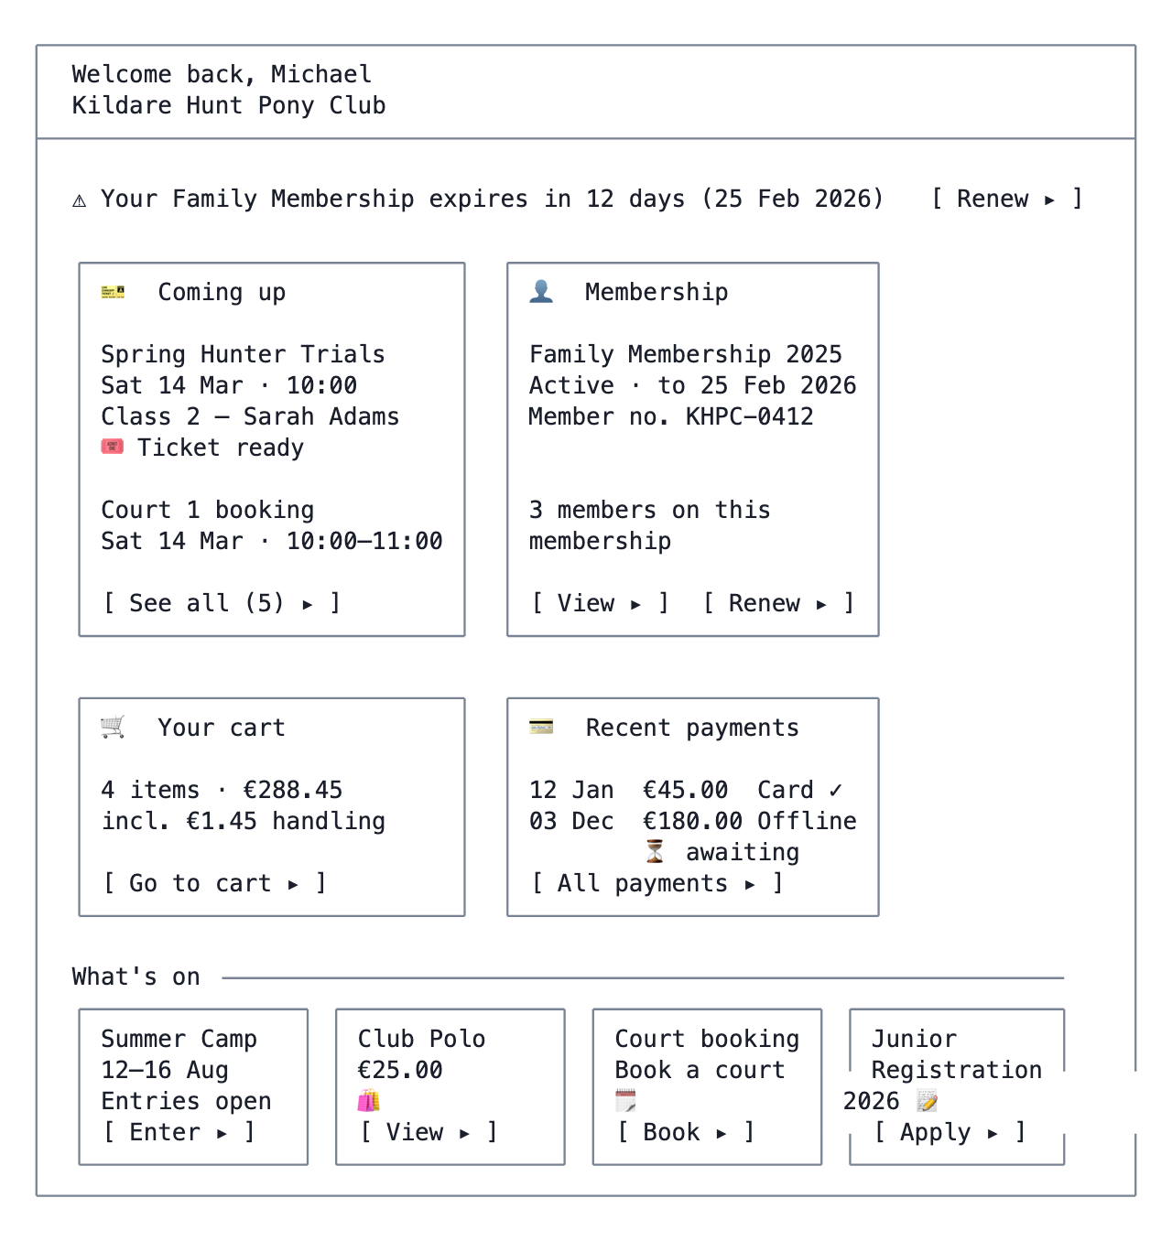
B3 — Home / My Dashboard
Notes - Every card is capability-gated and hides entirely when it has nothing to show, so a memberships-only org sees a clean two-card dashboard rather than a grid of empty states. - The renewal banner is driven by the same rule as C4: valid_until - today ≤ 30 days and a membership type exists for the following period. Without the second condition the button leads to a dead end.

C. My activity

C1 — My Entries & Bookings
Route: /account/:orgCode/entries
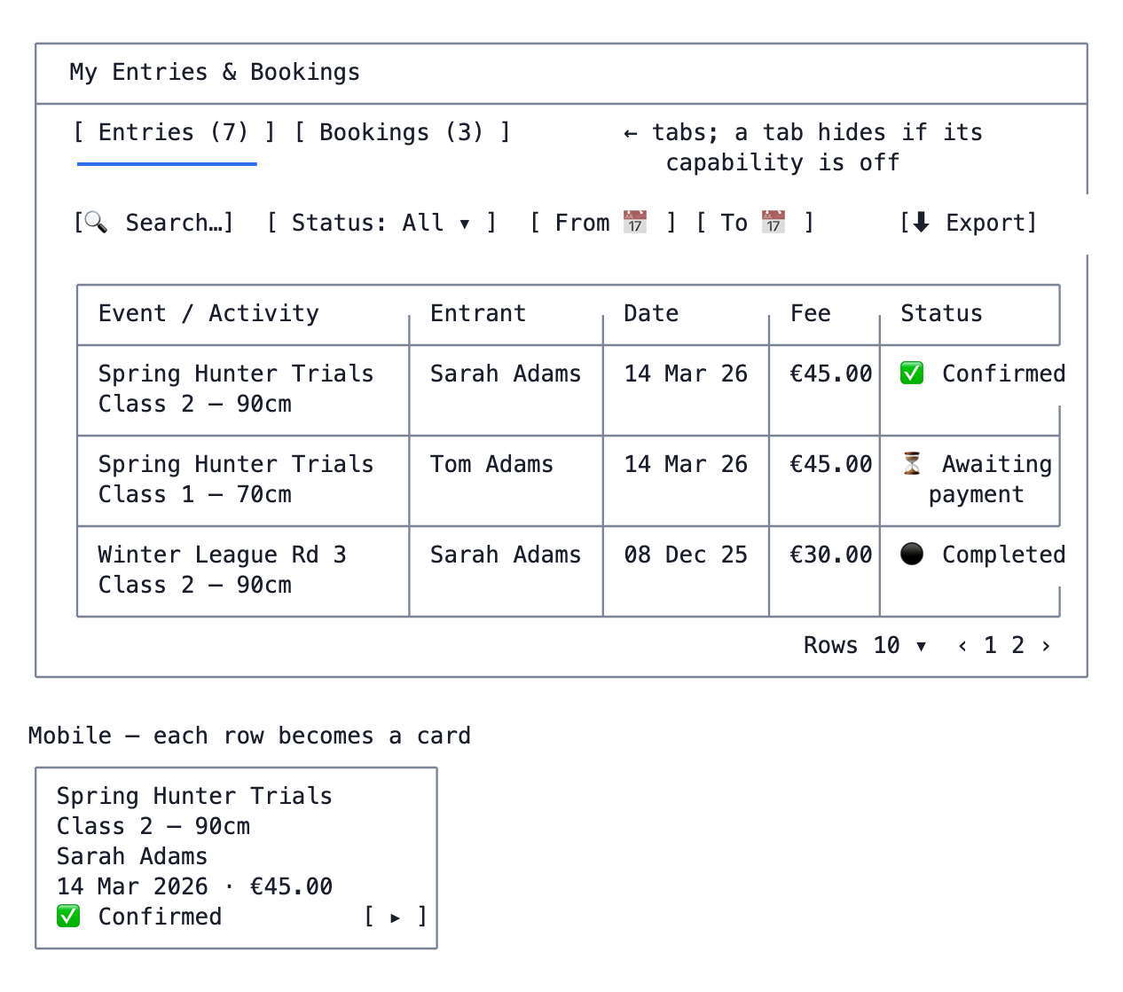
C1 — My Entries & Bookings
Notes - Status vocabulary, shared across C1/C4/C6/C8: Awaiting payment (in a checked-out offline payment not yet received), Confirmed, Completed (in the past), Cancelled. - The Bookings tab swaps the columns for Calendar / Slot / Date / Duration / Fee / Status, and adds a calendar-view toggle.

C2 — Entry detail
Route: /account/:orgCode/entries/:id
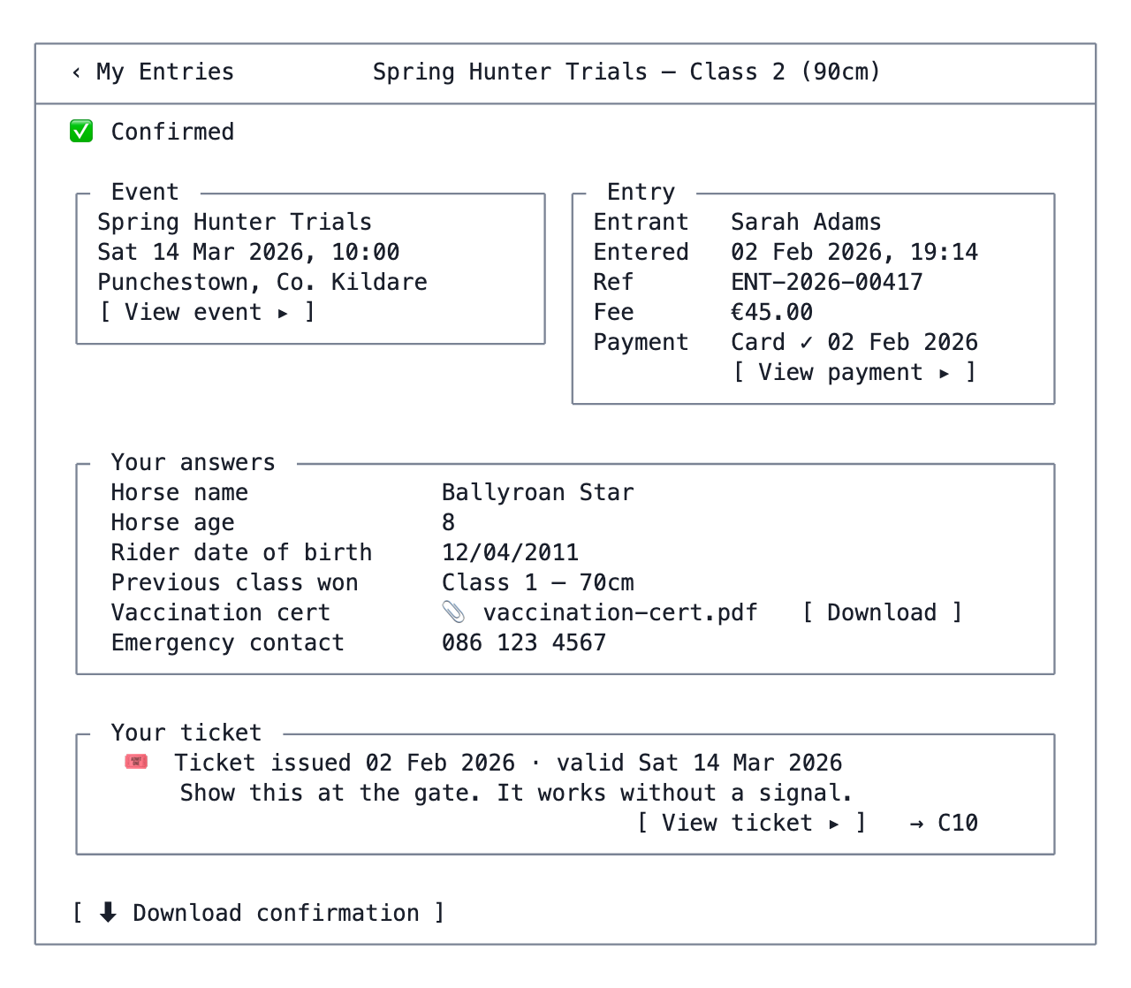
C2 — Entry detail
Notes - “Your answers” renders the stored form_submissions row against the form definition as it was at submission time. Rendering against the current definition would silently drop answers to since-deleted fields. - No self-cancellation (Q6). Entries cannot be cancelled by the account user — the confirmation panel gives the club’s contact details instead. Only bookings are self-cancellable (C3). - The ticket panel appears only when event-ticketing is enabled, the event is ticketed, and the entry is confirmed. While an offline payment is outstanding it shows “🎟 Your ticket will be available once the club records your payment” with no button — see G11.

C3 — Booking detail
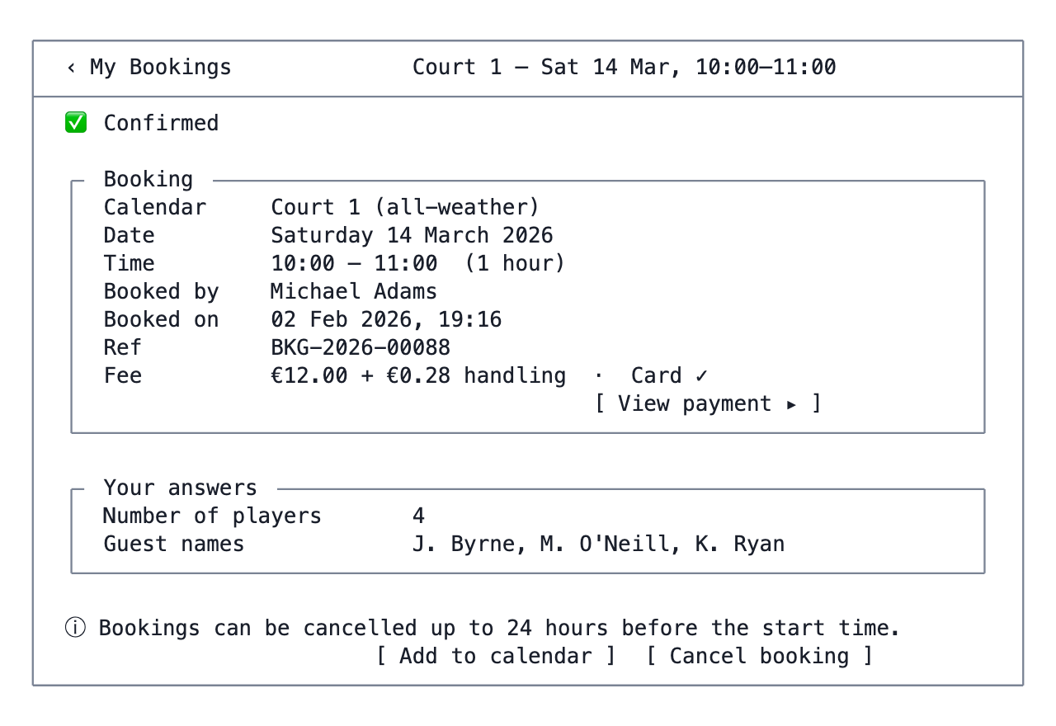
C3 — Booking detail
The cancellation rule reuses the existing cancellationValidator.ts from orgadmin-calendar, which is exactly the sort of logic that should move to packages/components rather than being reimplemented (§1.5).

C4 — My Memberships
Route: /account/:orgCode/memberships
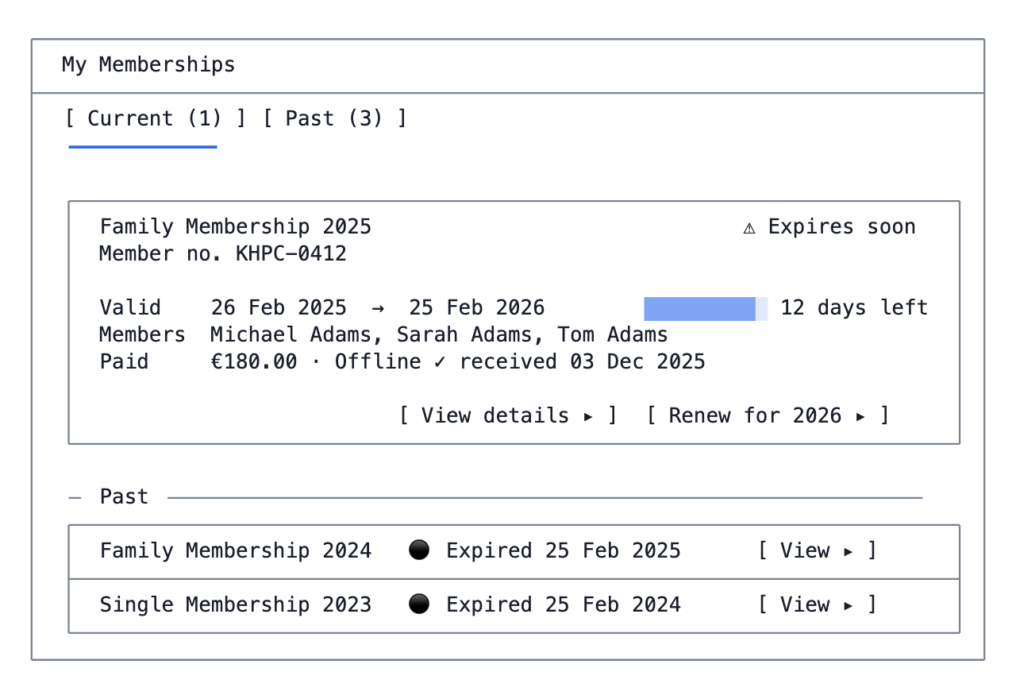
C4 — My Memberships
Renew button logic — the brief’s rule, made explicit:
show Renew ⟺ status = active
∧ valid_until − today ≤ 30 days
∧ ∃ a membership type for the following period that is
open for applications and available to this member
If the first two hold but the third does not, show “Renewals for 2026 are not open yet” instead of a button that leads nowhere.

C5 — Membership detail + renew
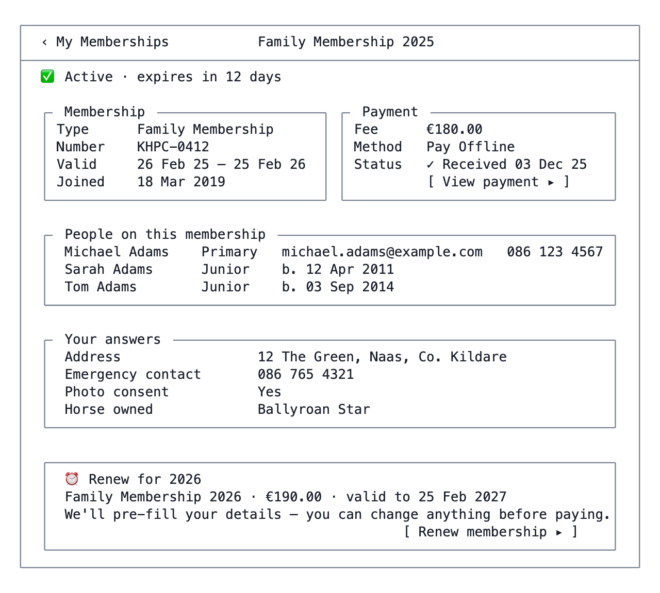
C5 — Membership detail + renew

C6 / C7 — My Registrations, Registration detail
Structurally identical to C4/C5 with membership vocabulary replaced. Registrations have no member-number concept and typically no group of people, so the “People” panel is absent and the renewal panel keys off the registration type’s period rather than valid_until where the type is period-based.
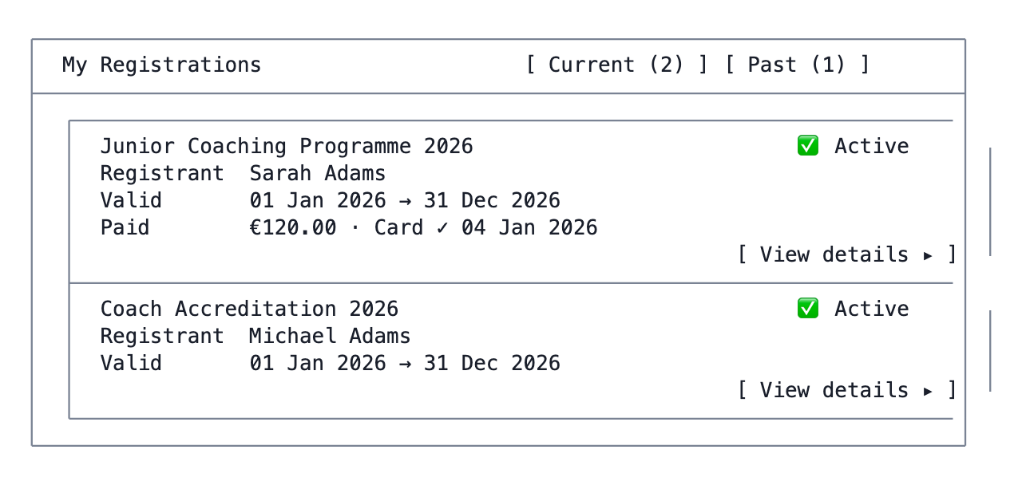
C6 / C7 — My Registrations, Registration detail

C8 — My Orders (merchandise)
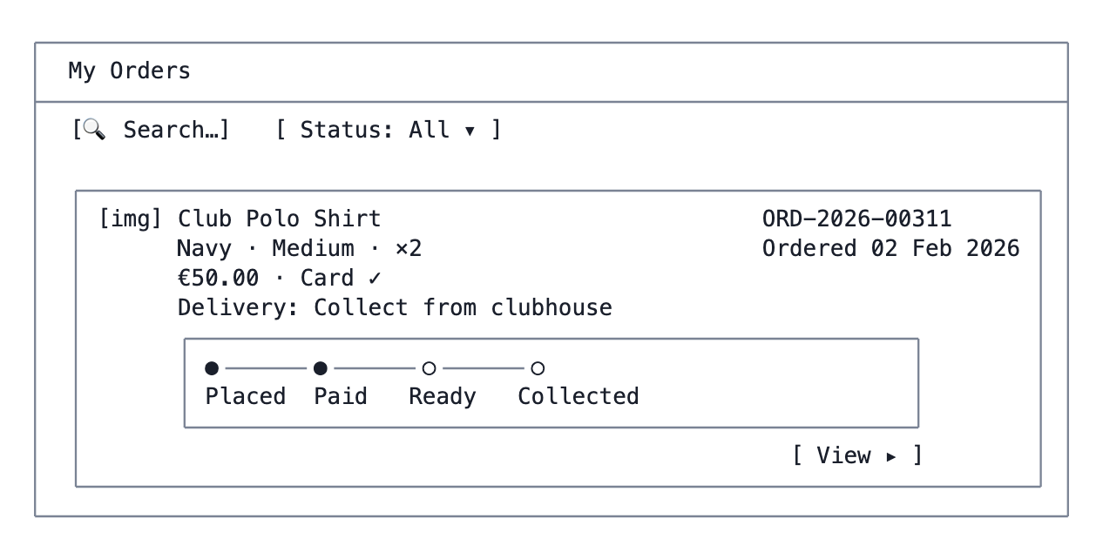
C8 — My Orders (merchandise)
Status steps come from merchandise_orders and the existing OrderStatusUpdateDialog vocabulary.

C9 — My Tickets
Route: /account/:orgCode/tickets · Capability: event-ticketing
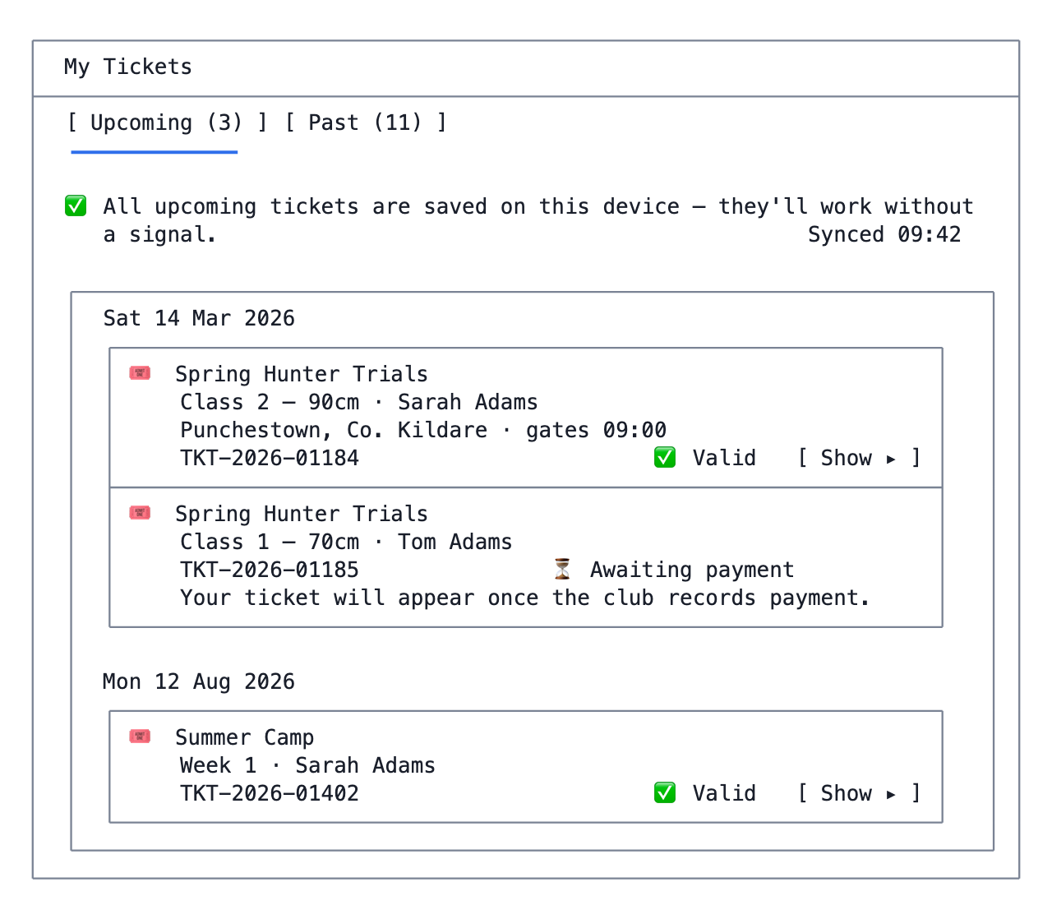
C9 — My Tickets
Notes - Grouped by event date, soonest first — at a gate, the ticket you want is almost always the next one. - Four ticket states: Valid, Awaiting payment (entry confirmed only once the offline payment is recorded), Used (a scan exists in ticket_scan_history), Expired (past the config’s validity period). - A user holding tickets for several people sees one row each, with the entrant’s name prominent — a parent at a gate needs to hand over the right one.

C10 — Ticket ✳
Route: /account/:orgCode/tickets/:id
Rendered from event_ticketing_config — header text, instructions, footer, logo and background colour are all the org’s. The layout below is the frame; the content is configuration.
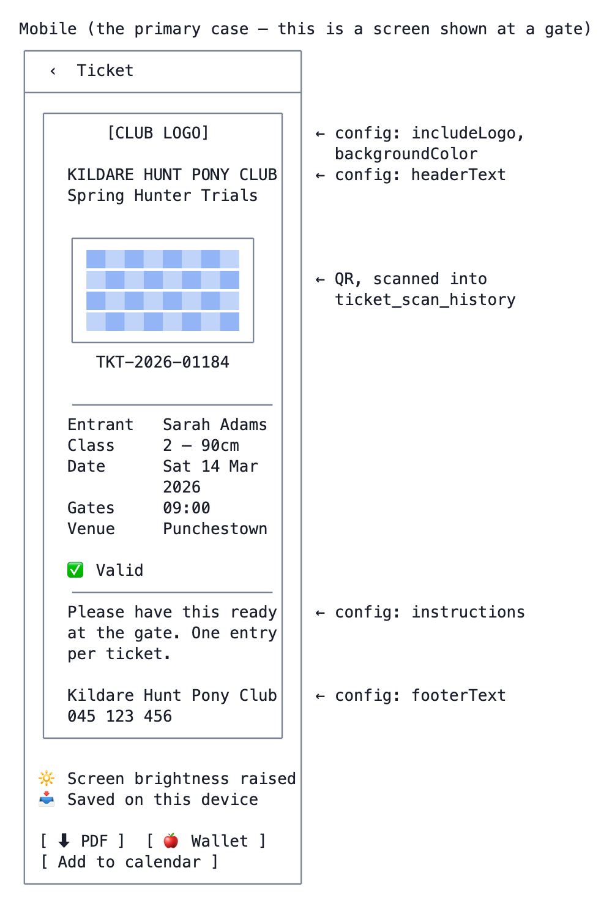
C10 — Ticket ✳
Notes - Screen brightness is raised automatically while a ticket is open and restored on exit. Gate scanners fail on dim phone screens, and this is the single cheapest thing that makes scanning work in daylight. - Fully offline. The QR payload, the config and the entrant details are precached for every valid ticket for an event in the next 30 days. No network call renders this screen. - Used and expired tickets render the same frame with the QR greyed and a clear banner — “Used 14 Mar 2026, 09:52”. Never hide a used ticket; a member who scanned in and out needs to see why it will not scan again. - Apple/Google Wallet passes are a nice-to-have, not v1 — they need pass-type certificates per organisation, which is real operational work. Shown here so the layout allows for them. - PDF generation reuses services/ticketGeneration.ts, moved to packages/components.

D. Browse and apply

D0 — Application form step (shared) ✳
The single most reused screen in the app. Every one of D3, D6, D8, D10, D13 ends here, so it is specified once and parameterised. It should be built in packages/components so the org-admin form preview and this renderer are the same code.
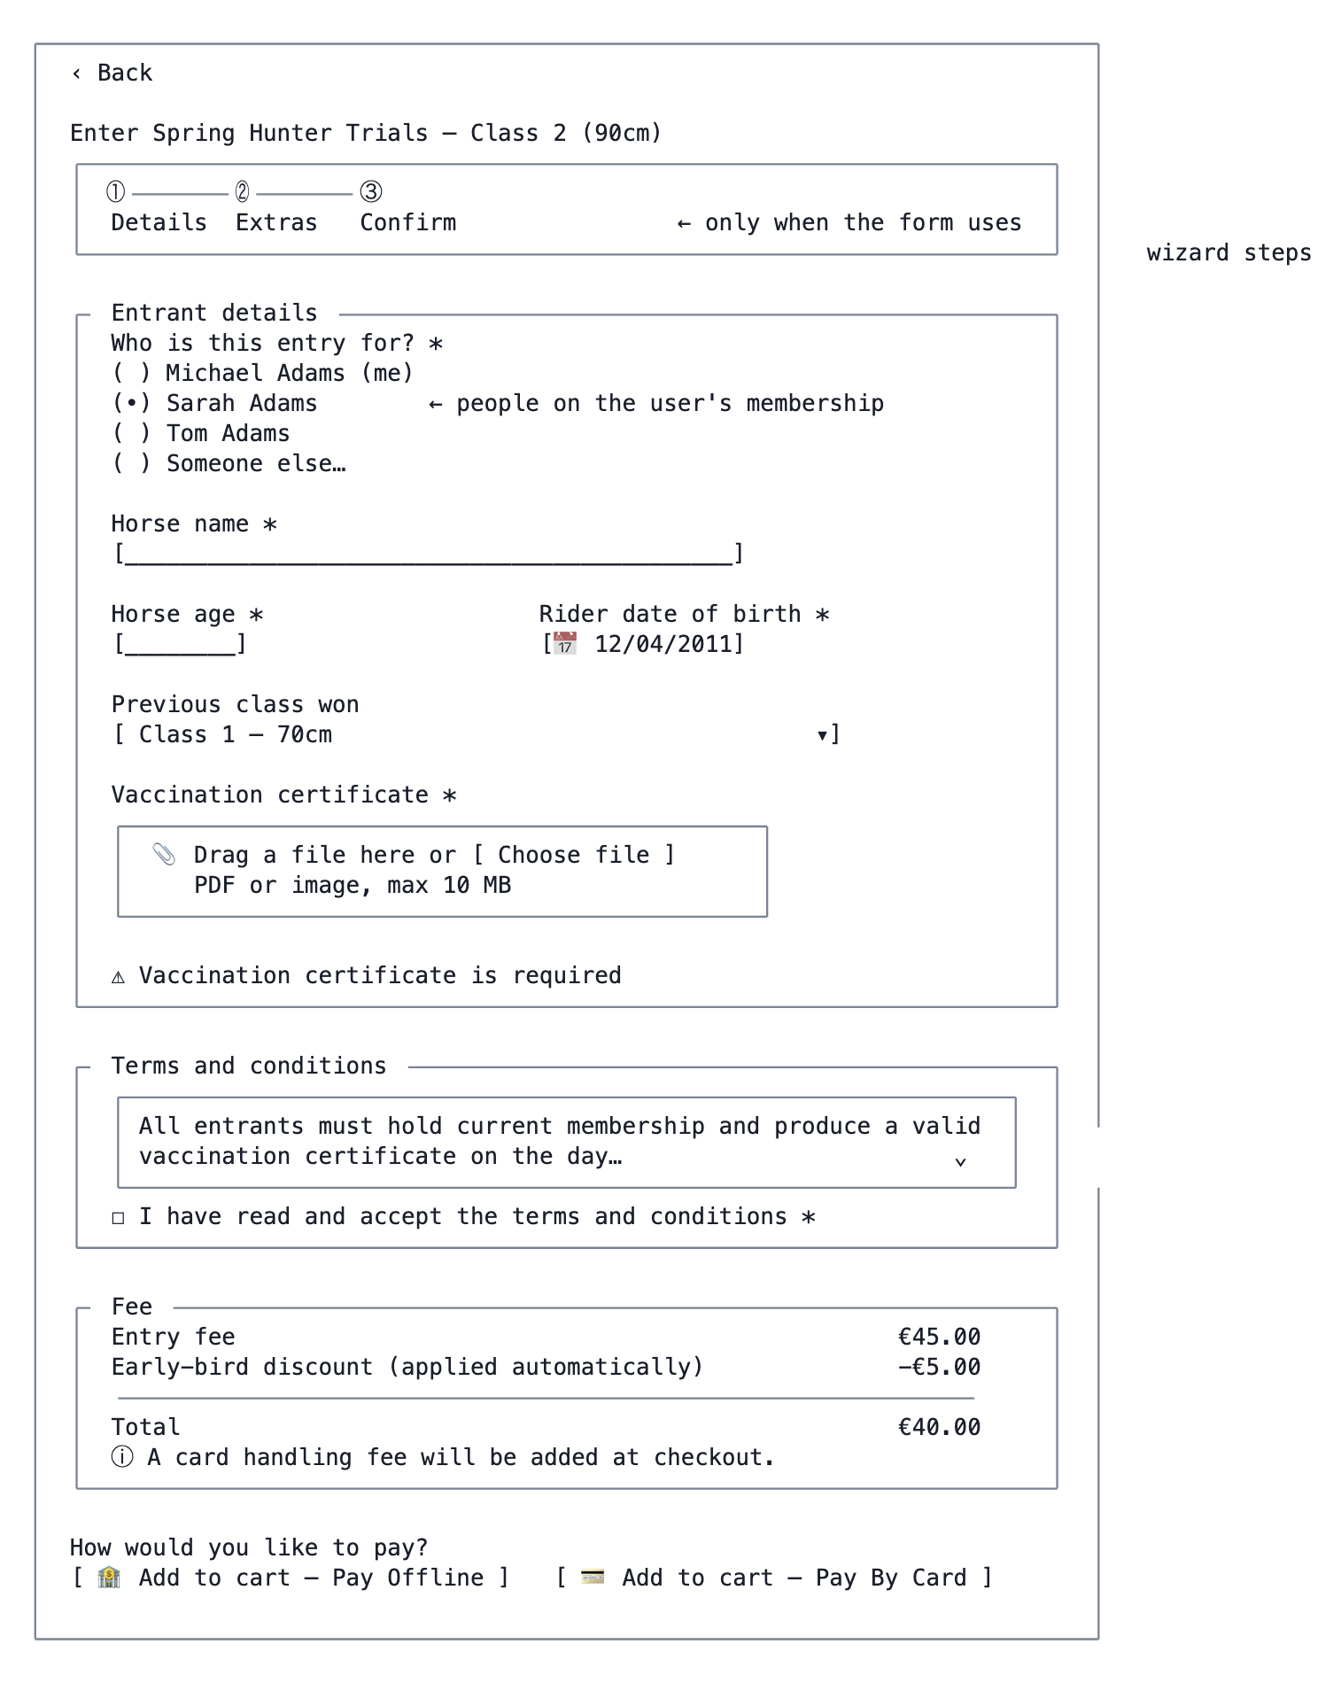
D0 — Application form step (shared) ✳
Notes - The two-button pattern is the brief’s requirement: when the source item supports both an offline and a card method, both buttons show. When it supports one, a single “Add to cart” button shows and the method is implicit. When it supports two card methods (Stripe and Helix-Pay), the choice is the org’s, not the user’s — a single “Pay By Card” button. - The method chosen here is only a default; it is changeable in the cart (E3), as required. - “Who is this entry for?” (Q7) — entering on behalf of a child is the overwhelmingly common case for a pony club or junior tennis section, and without it the entrant’s details have to be retyped every time. The list is the people on the user’s active membership, plus “someone else”, which falls back to free entry of the entrant’s details. - Field rendering reuses FieldRenderer and its existing renderers; wizard steps reuse MetadataWizard / WizardConfiguration, which application_forms already supports via form_groups_wizard_config. - On mobile the fee panel and buttons become a sticky bottom bar.

D1 — Events list
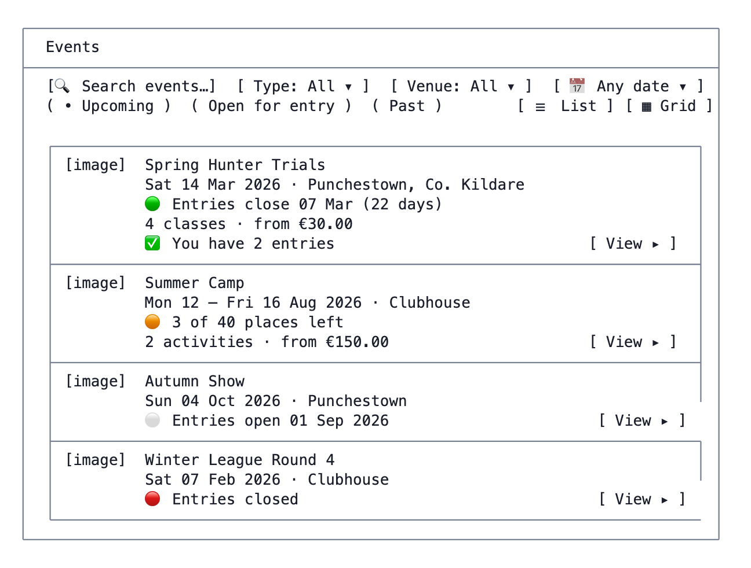
D1 — Events list
The four availability states — open / filling / not yet open / closed — are server-computed (G8) and colour-coded consistently everywhere they appear.

D2 — Event detail
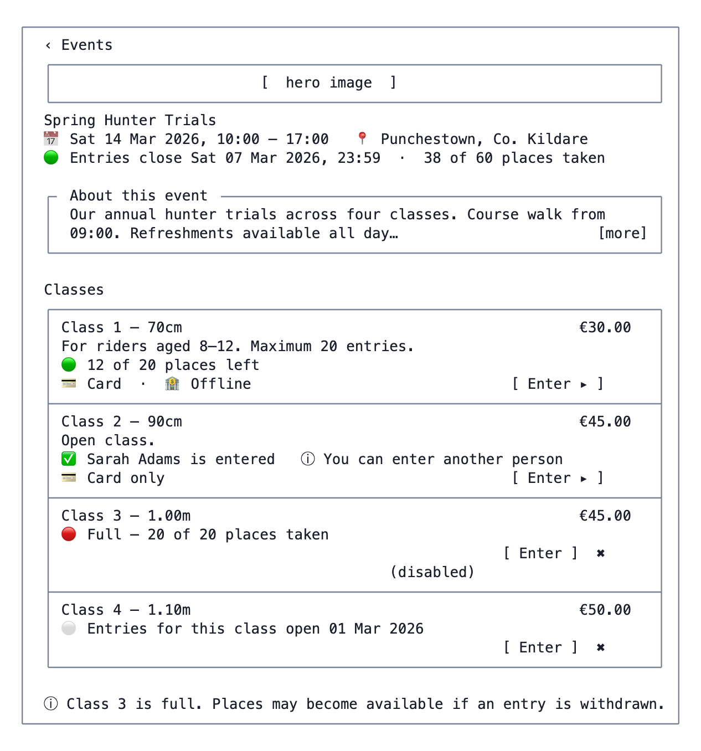
D2 — Event detail
Notes — the four disable reasons required by the brief, each with its own message:
Condition | Button | Message
now < event.open_date_entries or activity’s own open date | disabled | “Entries open date”
now > event.entries_closing_date | disabled | “Entries closed on date”
event-level limit reached | disabled on all activities | “This event is full”
applicants_limit reached for the activity | disabled on that one | “This class is full”
Never hide the activity — a hidden class reads as a bug to a member who knows it exists.

D3 — Enter an activity
D0 with the event/activity’s application form, terms and fee. No separate wireframe.

D4 / D5 — Membership types
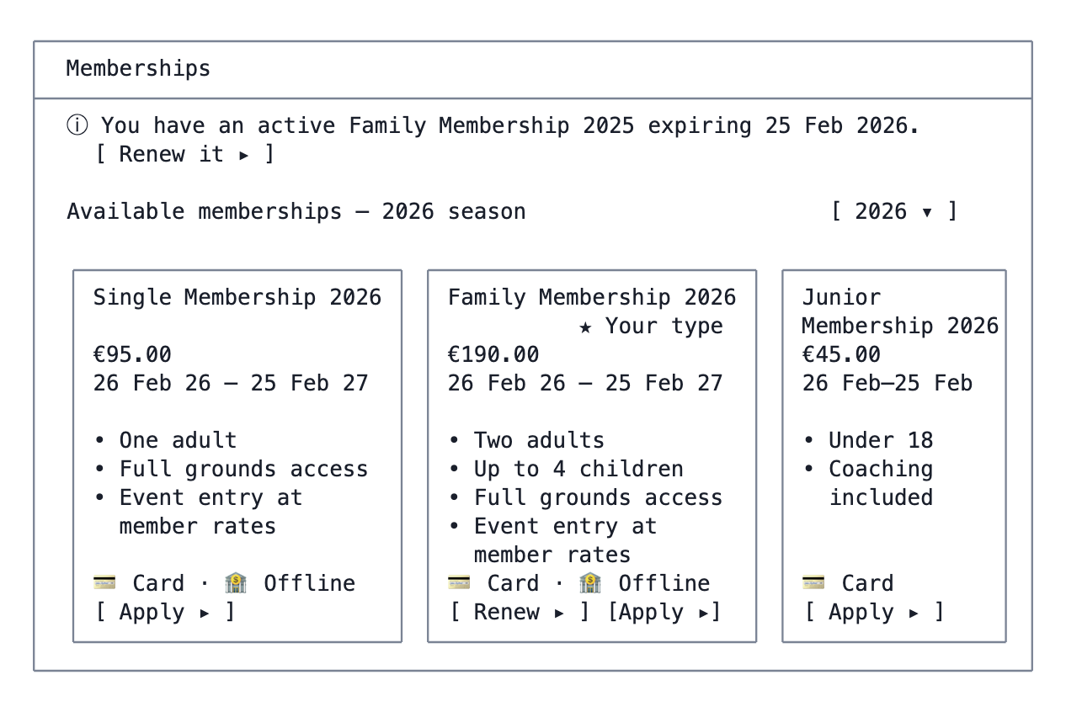
D4 / D5 — Membership types
The detail screen (D5) expands one card: full description, benefits, what the application asks for, who it is available to, and the same Apply/Renew actions.

D6 — Membership application / renewal ✳
The renewal variant of D0. The distinction the brief calls for — “much of the required information is already available… the application form can be auto populated and then only needs to be confirmed” — is expressed as a review-first layout:
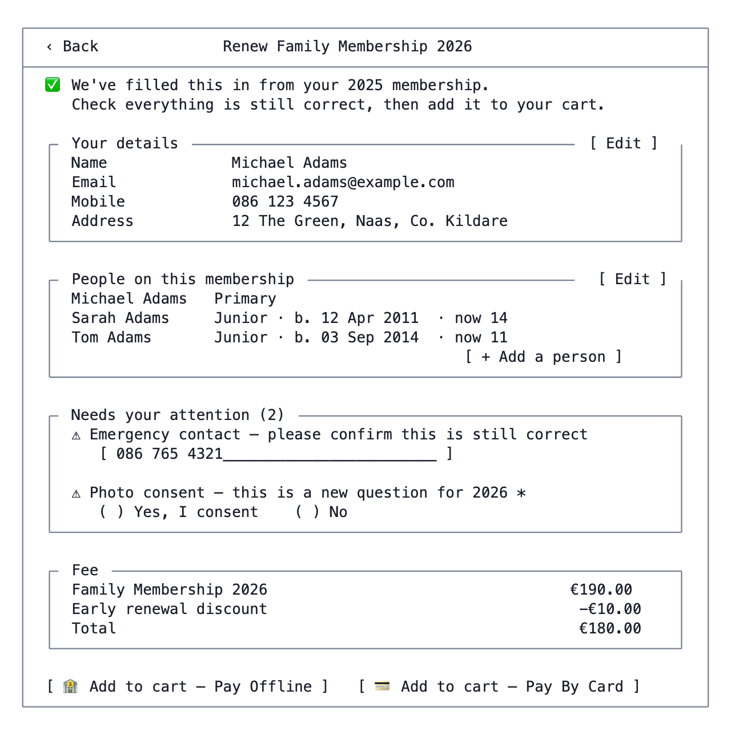
D6 — Membership application / renewal ✳
Notes - Three field categories, visually separated: carried over (collapsed, editable), needs attention (prior answer exists but is stale/expiring, or the field is new since last year), and cannot be carried over (fails current validation — surfaces as a normal required field). - A new application uses the plain D0 layout with nothing pre-filled beyond the user’s own contact details. - Group membership types drive the “People” panel from PersonConfigurationSection’s configuration; single types omit it.

D7 / D8 — Registration types
Same shape as D4/D5. Cards show the registration period, fee, and available-to rules; the detail screen adds the description and the Apply action, which routes to D0.

D9 — Merchandise list
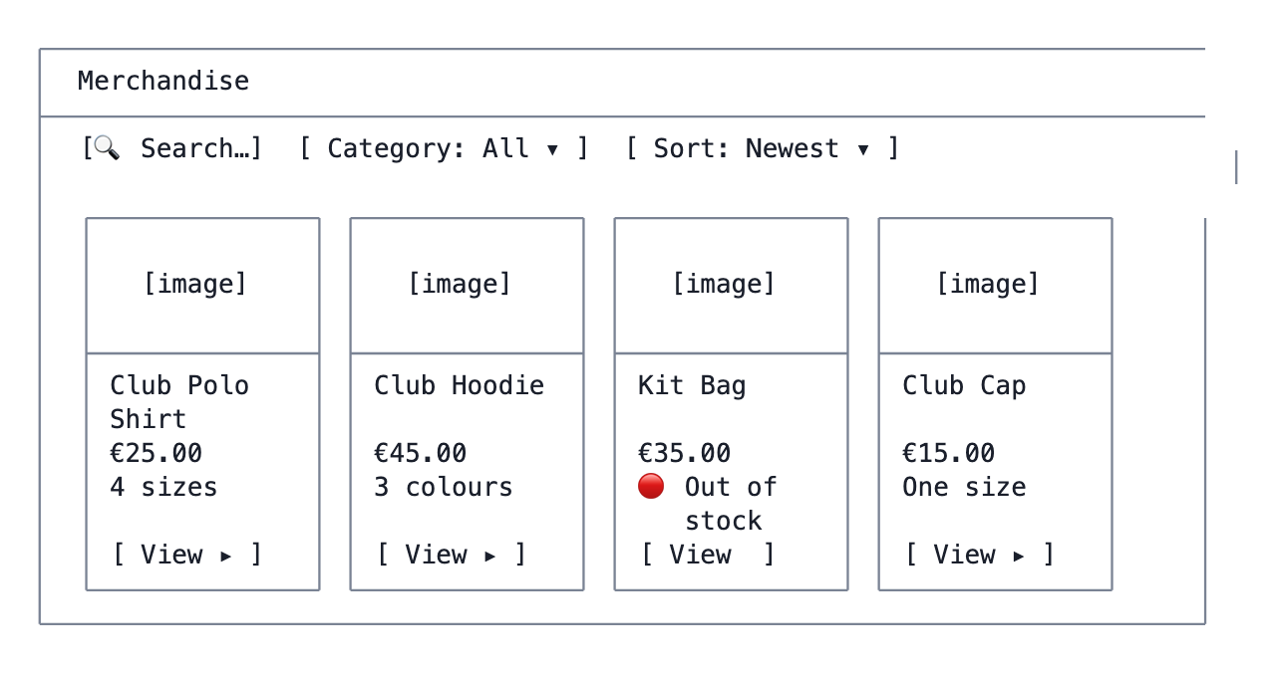
D9 — Merchandise list
Mobile: two columns at xs, four at md.

D10 — Merchandise detail
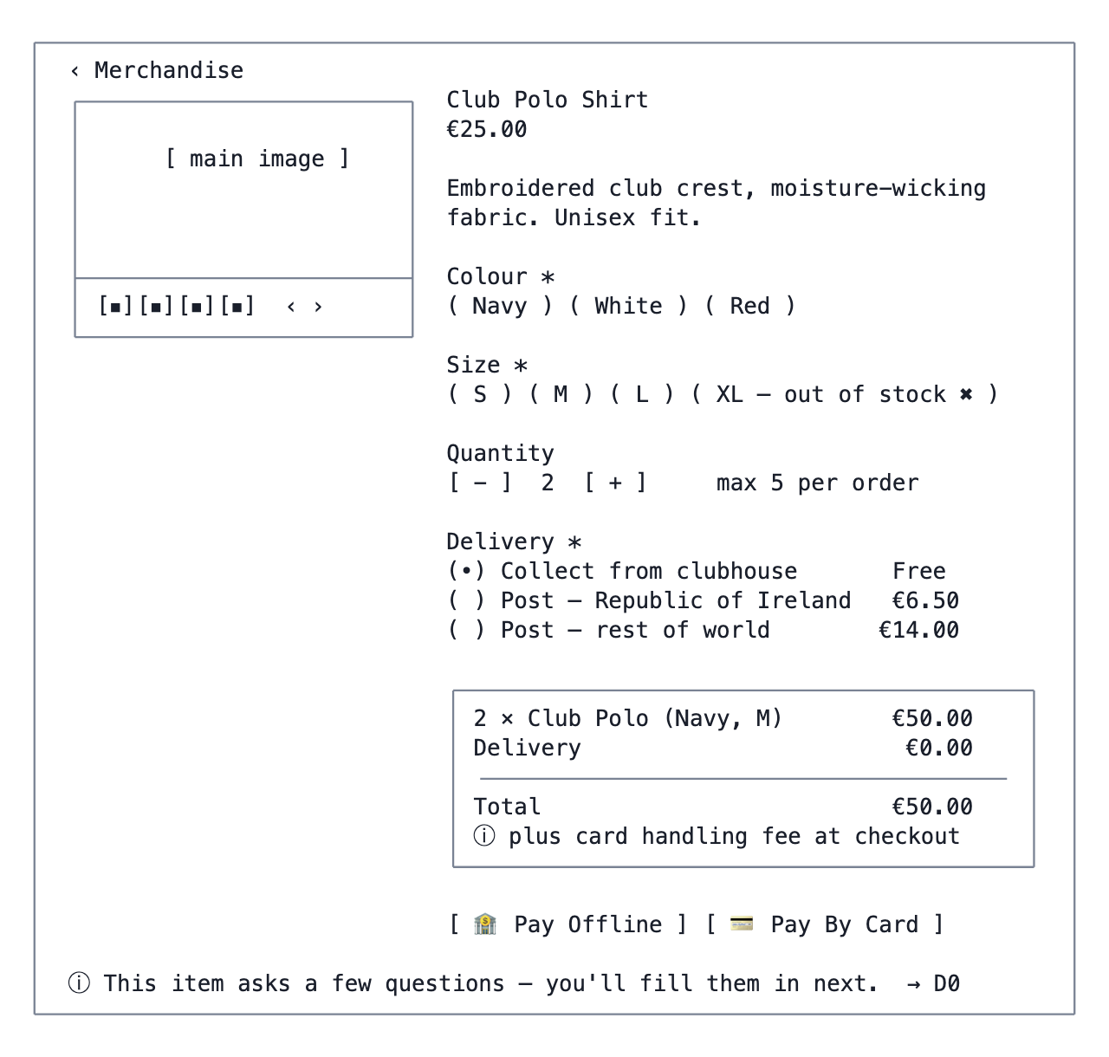
D10 — Merchandise detail
Pricing display comes from the server, computed by the same rules as orgadmin-merchandise/utils/priceCalculator.ts — which should move to packages/components so the two front ends cannot drift.

D11 — Calendars list
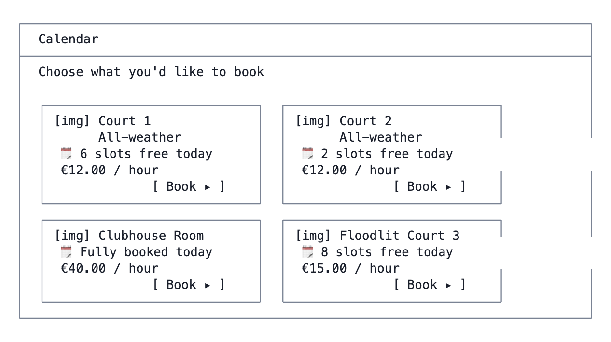
D11 — Calendars list

D12 — Calendar availability ✳
The one screen where desktop and mobile genuinely need different structures.
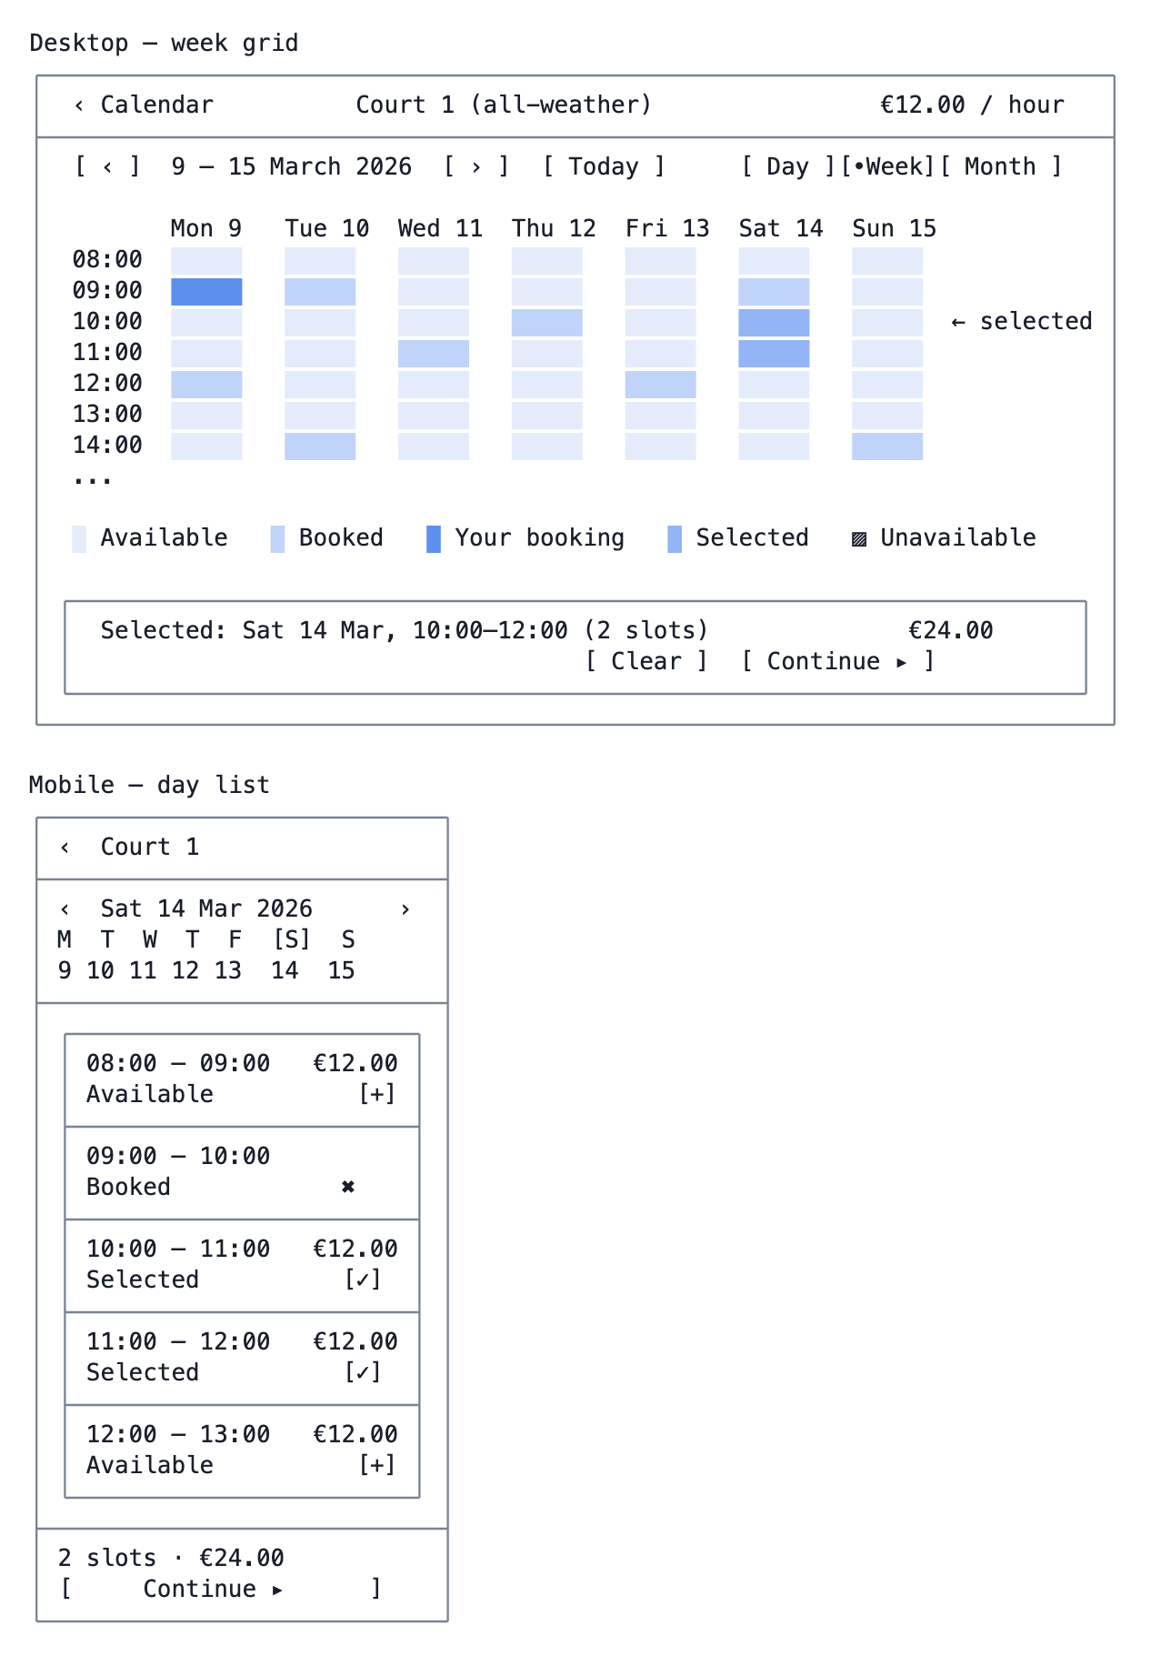
D12 — Calendar availability ✳
Notes - Availability is derived, never stored — slotAvailabilityCalculator.ts is the authority and must run server-side for the account app (the org-admin version runs client-side over a full data set that an account user must not receive). - Contiguous selected slots collapse into one cart item (“10:00–12:00, 2 hours”) when the calendar’s duration options allow it; otherwise they become separate items. - Selection places a soft hold (cart_items.expires_at) so the form in D13 does not lose the slot.

D13 — Slot booking form
D0 with the calendar’s application form, preceded by a fixed summary of the chosen slots.

E. Cart and checkout

E1 — Cart (desktop)
Route: /account/:orgCode/cart · API: GET /api/account/cart
The worked example from Part 4 — a deliberately mixed cart.
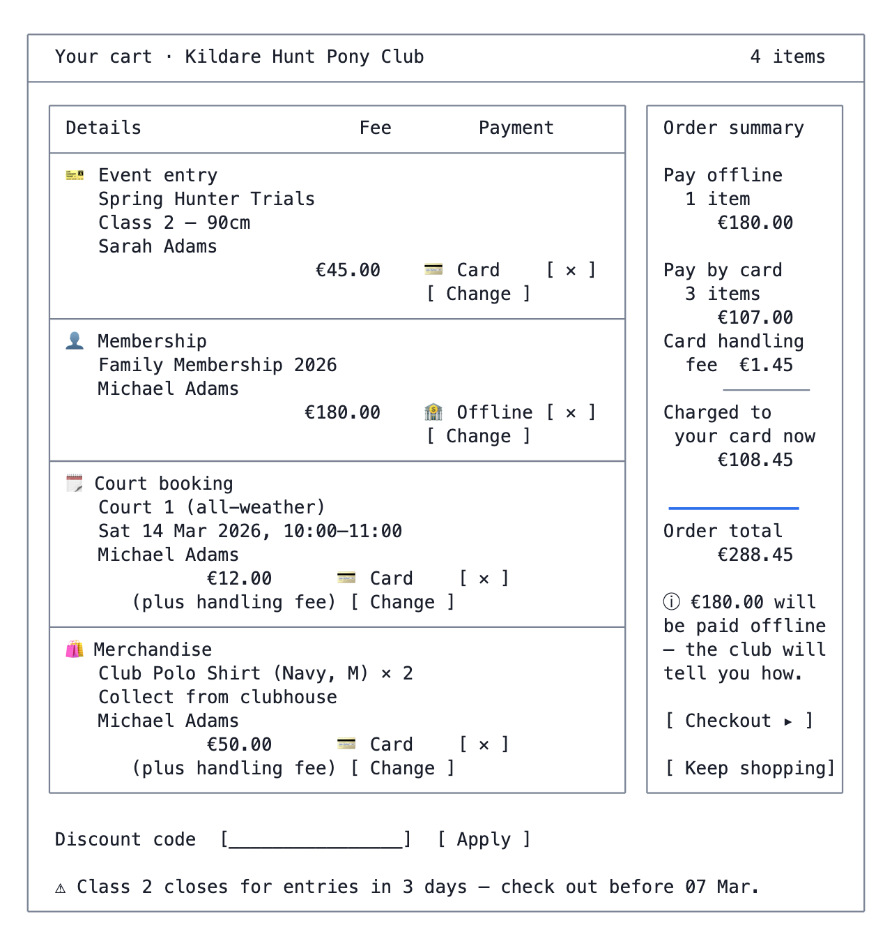
E1 — Cart (desktop)
Notes - “(plus handling fee)” appears exactly where the brief specifies: on a card item whose handling_fee_included = false. The €45.00 entry shows no such note because its handling fee is already inside the €45. - “[ Change ]” appears only on items whose source declared more than one usable payment method. - The summary shows the three-block breakdown because the cart is mixed. The display rules below collapse it to a single total when it is not. - Item-level warnings (an event closing, a held slot expiring, an item that has since sold out) appear inline and again on E4 — the cart is re-validated on load and on checkout.

E2 — Cart (mobile) ✳
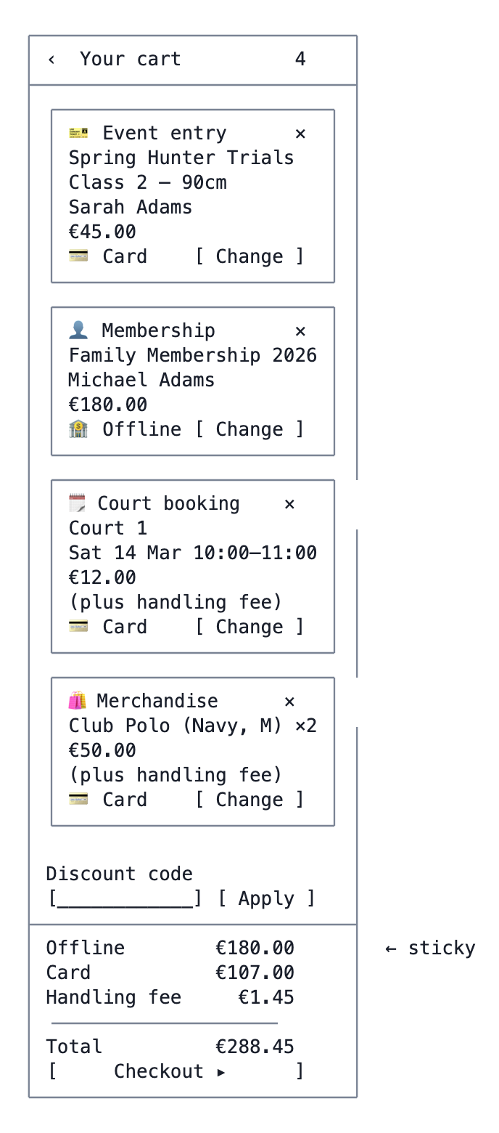
E2 — Cart (mobile) ✳

E3 — Change payment method
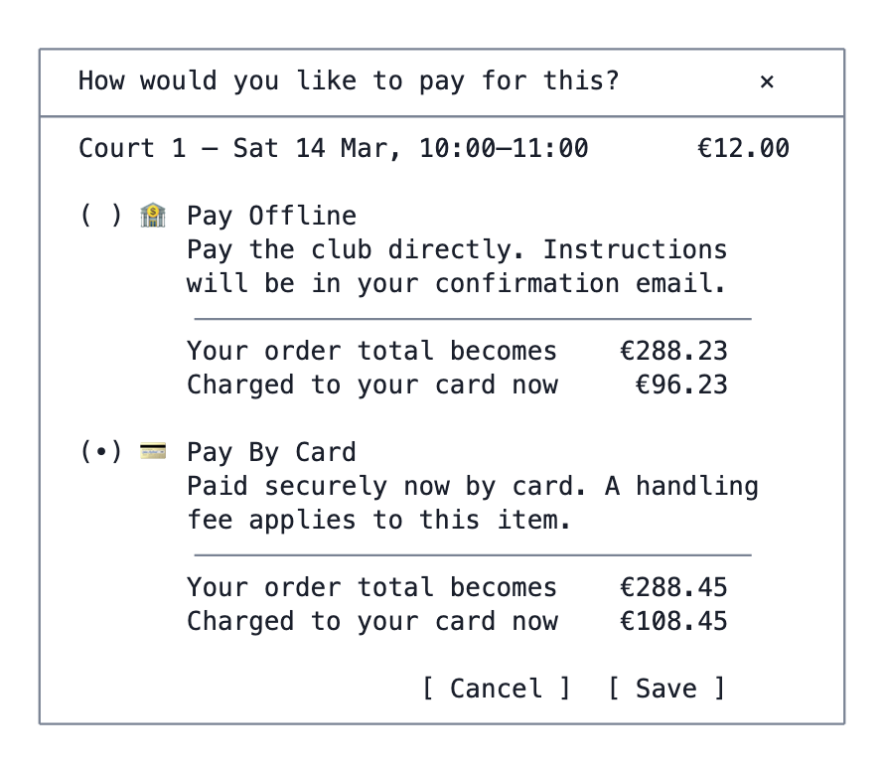
E3 — Change payment method
Notes - Each option shows the resulting order total, not a per-item handling fee. Once the fee formula has a fixed element (G5), per-item fees are not additive — moving this €12.00 booking to card adds only €0.22 here, because the fixed €0.25 is already being charged for the merchandise item. Standalone, the same booking would carry €0.53. Quoting either number as “the handling fee for this item” would be wrong, and quoting nothing would leave the member guessing. The order total is the honest figure, and the one they actually care about. - Both figures move, because switching an item between offline and card changes what is collected now as well as the total. - Only methods the source item actually supports are listed; a method whose org credentials are missing or inactive is hidden.

E4 — Checkout review
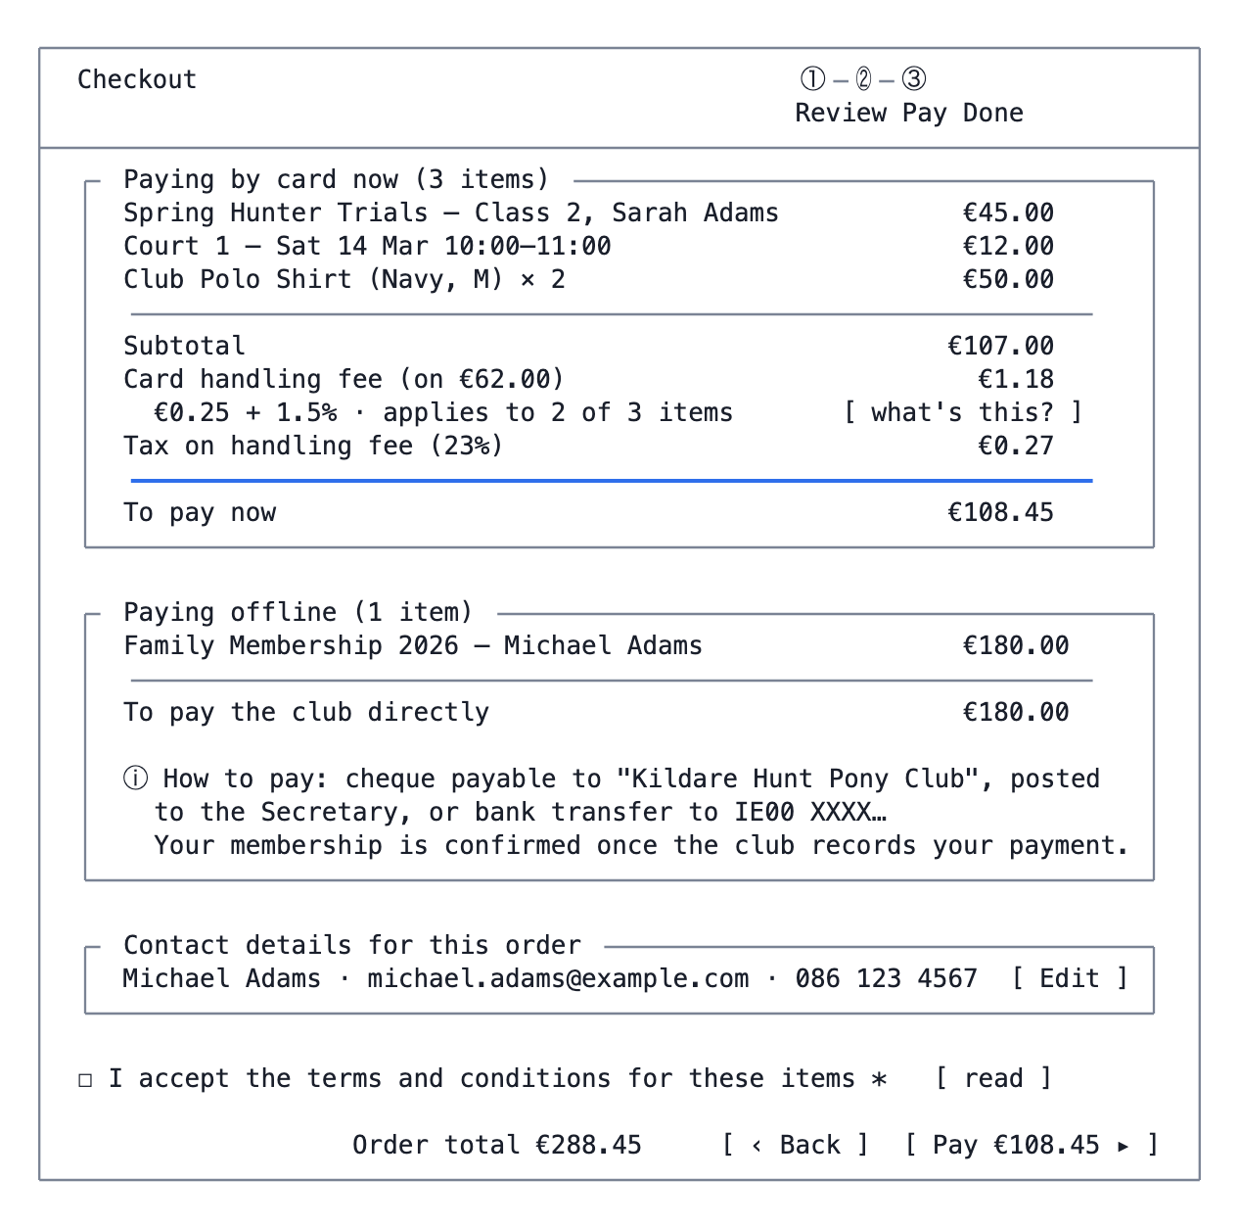
E4 — Checkout review
Notes - The button says what will actually be charged to the card now (€108.45), not the order total (€288.45) — this is precisely the requirement that “only that part of the cart total that is Pay By Card based needs to be collected, plus any calculated handling fee”. - If every item is offline the button becomes “Confirm order” and no provider is involved. - The offline instructions come from the source item’s cheque_payment_instructions (which exists on event_activities today) falling back to an org-level default; where items give different instructions, all distinct sets are listed. - Totals are re-computed server-side on submit. If anything changed since the cart was loaded — a place taken, a held slot expired, a fee changed — checkout stops and returns to a re-validated cart with the change explained. Never silently charge a different amount.

E5 — Card payment
Two implementations behind one screen, chosen by which method the org has active.
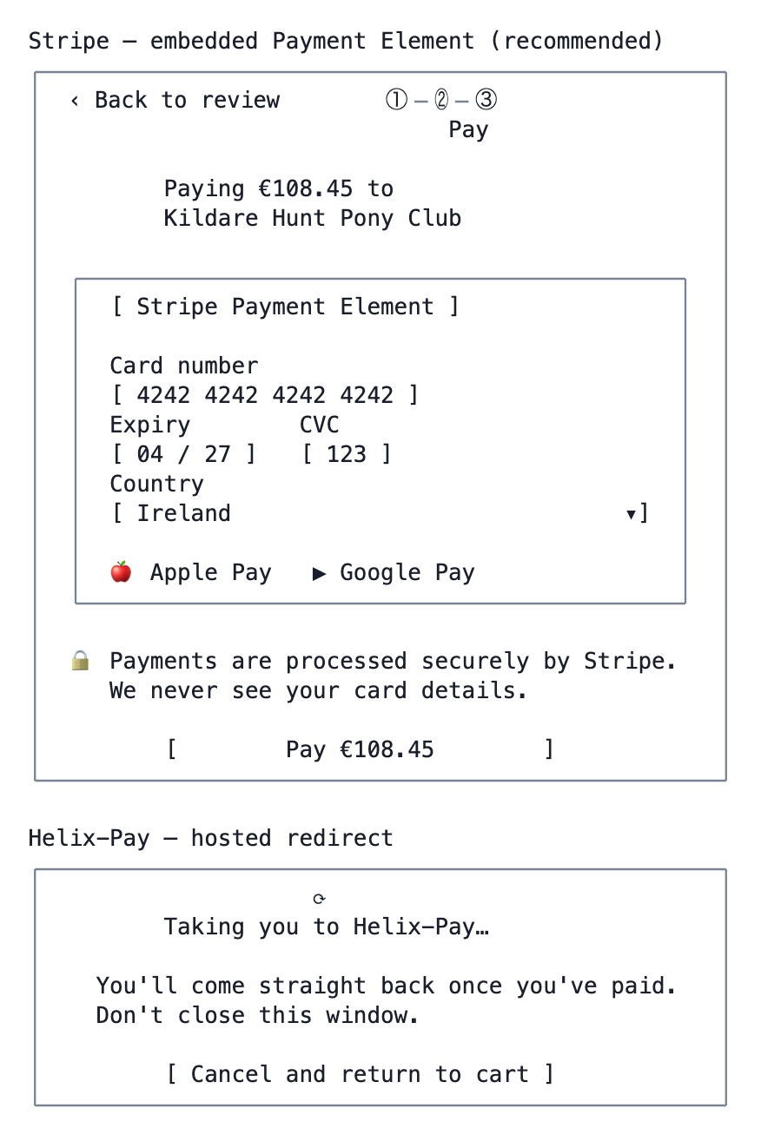
E5 — Card payment
Implementation notes - Stripe: POST /api/account/checkout creates a PaymentIntent server-side for the card portion only, returns the client secret, and the browser confirms it. The order is created from the webhook (payment_intent.succeeded), never from the browser’s success callback — a closed tab must not lose the order. Idempotency key = cart id. - Helix-Pay: same server-side shape, hosted redirect + webhook confirmation, returning to /account/:orgCode/checkout/confirmation/:paymentId. - 3-D Secure / SCA is handled by the provider’s own step-up; the confirmation screen must tolerate a “processing” state that resolves asynchronously.

E6 / E7 — Confirmation
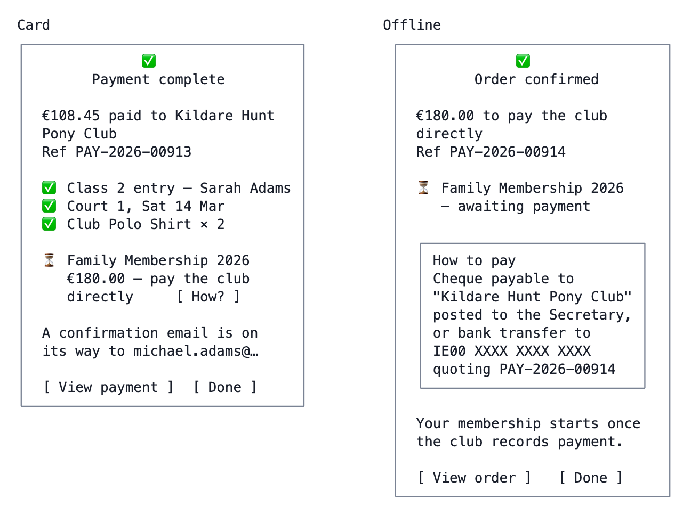
E6 / E7 — Confirmation
A mixed cart produces one payment record with both portions, as shown in the card variant.

E8 — Payment failed
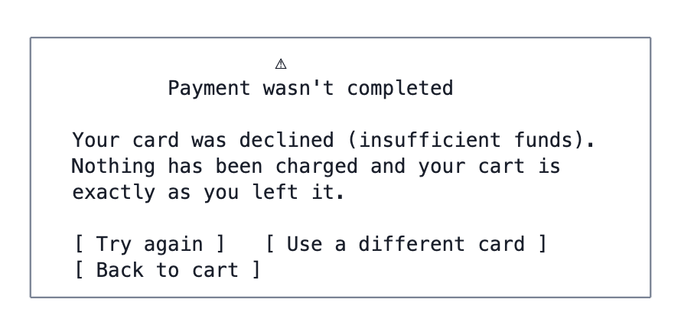
E8 — Payment failed
Provider decline codes map to plain-language reasons; the raw code goes to the log, not the screen. Held items keep their hold for a grace period after a failure.

F. Payments history

F1 — My Payments
Route: /account/:orgCode/payments
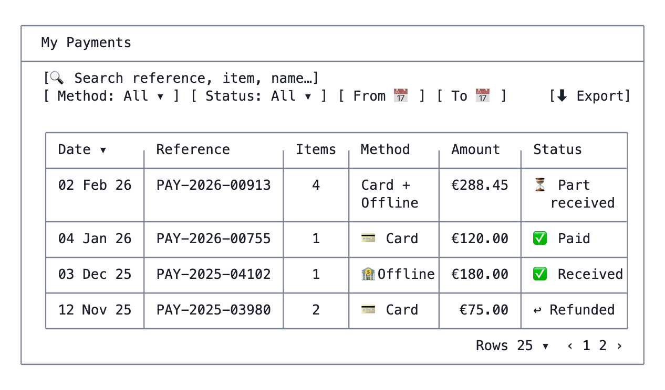
F1 — My Payments
Sortable on every column, searchable across reference and item descriptions, filterable by method, status and date range — as the brief requires. Available offline, read-only (see Part 5).

F2 — Payment detail
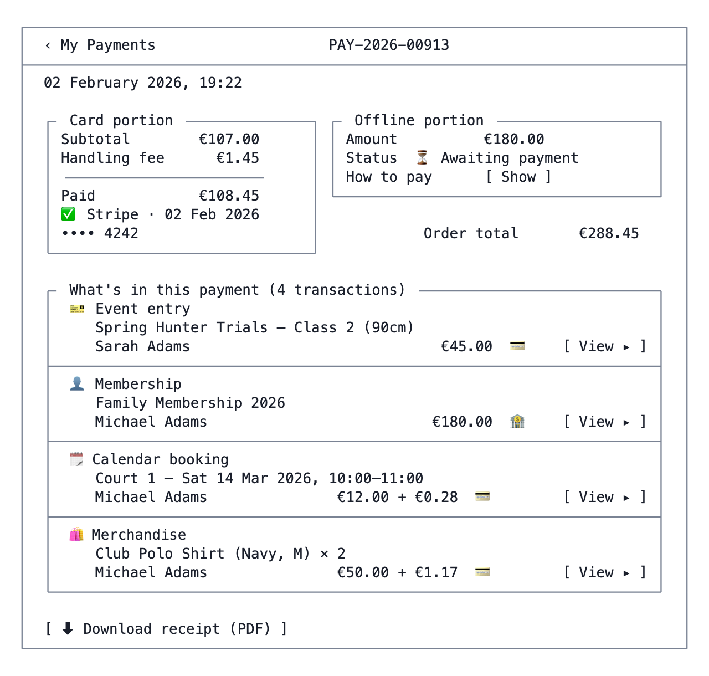
F2 — Payment detail
This is the screen that payment_transactions exists for (G3) — it cannot be built on today’s schema.

F3 — Transaction detail
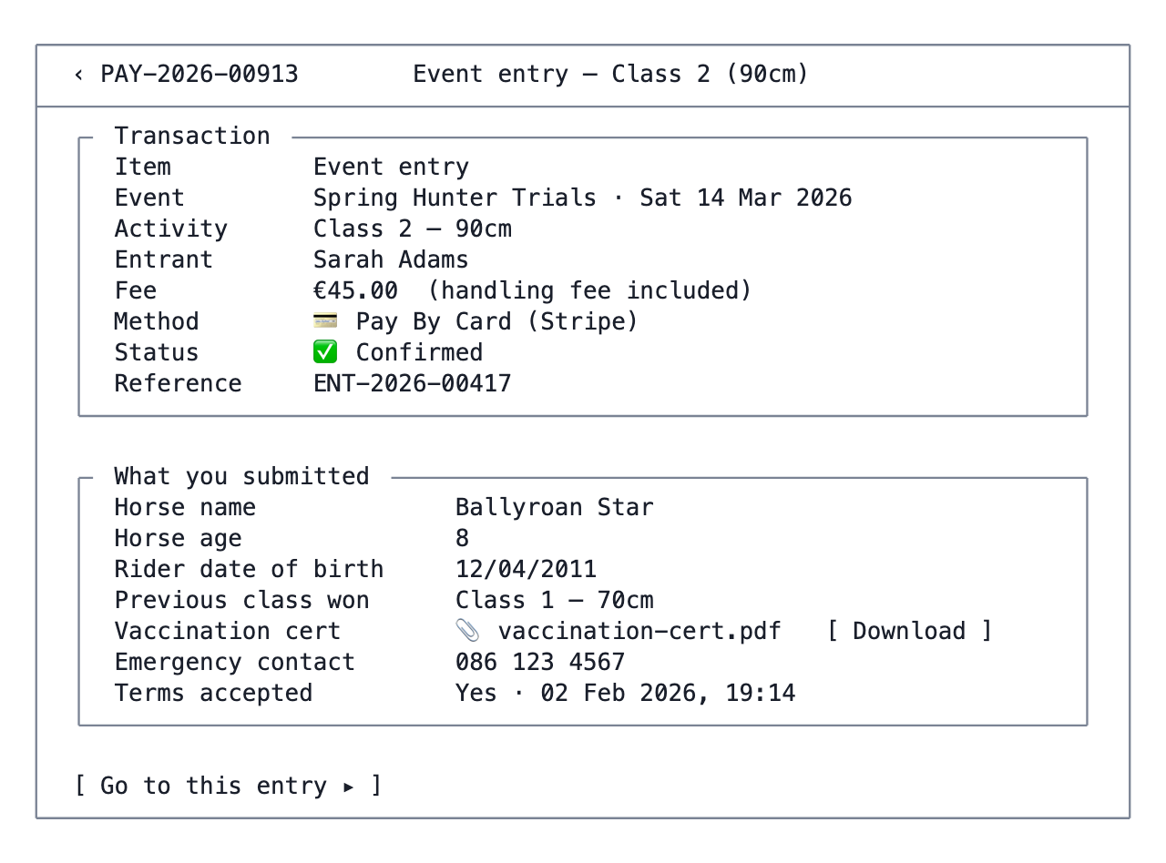
F3 — Transaction detail
“All of the information provided in the original order for that specific item” — the stored form_submissions row rendered against the form definition captured at submission time.

P. Profile

P1 — Profile & Settings
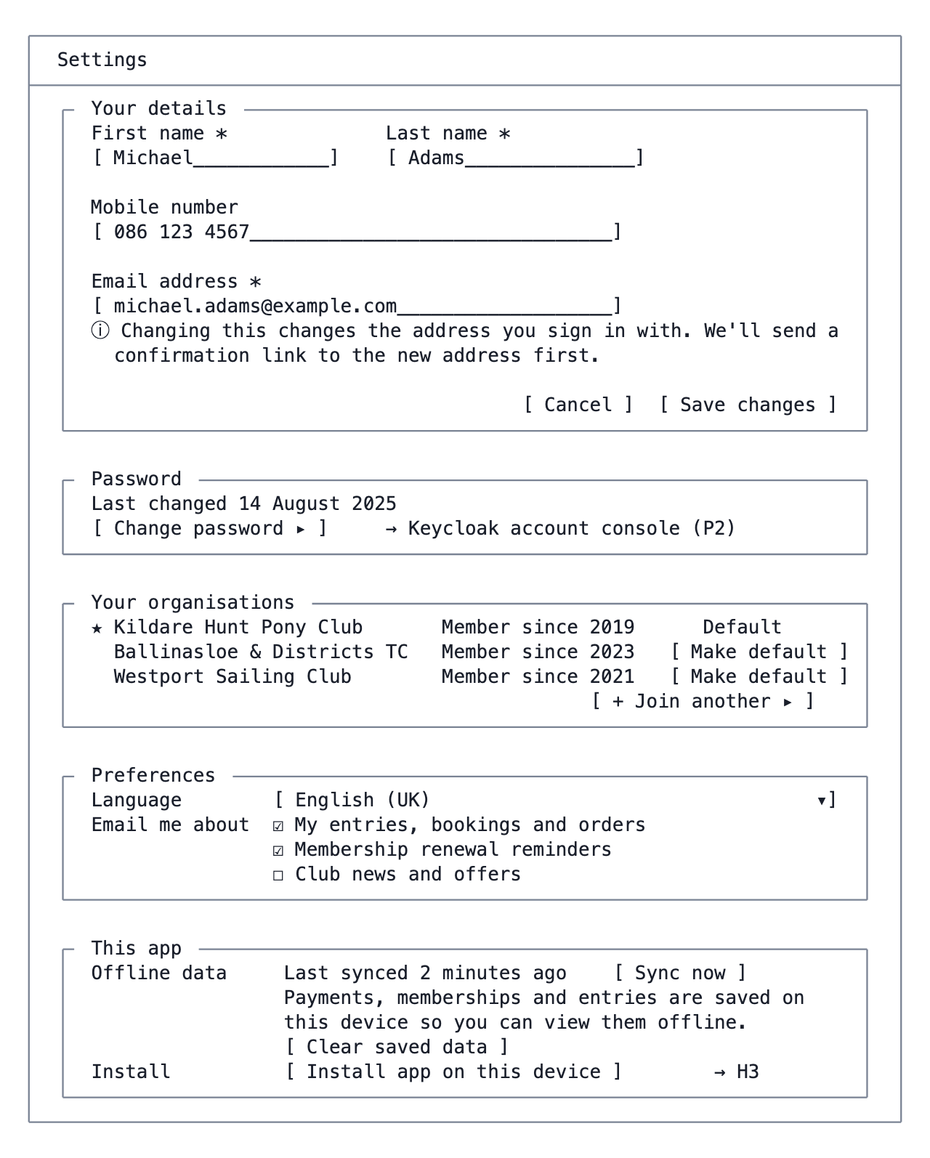
P1 — Profile & Settings
Notes - Name/mobile/email write to both Keycloak (the identity) and organization_users (the org’s copy). Email changes need verification before the sign-in address moves — otherwise a typo locks the user out. - These details are shared across every organisation the user belongs to, since there is one identity. That should be said on the screen; a user who changes their mobile for the tennis club will change it for the pony club too. - Language preference: per user, overriding the org default; the org default remains the fallback.

P2 — Change password
Redirect to the Keycloak account console with a return URL, exactly as the brief assumes. A brief interstitial explains where the user is going and that they will come back.

H. PWA and offline

H1 — Offline mode
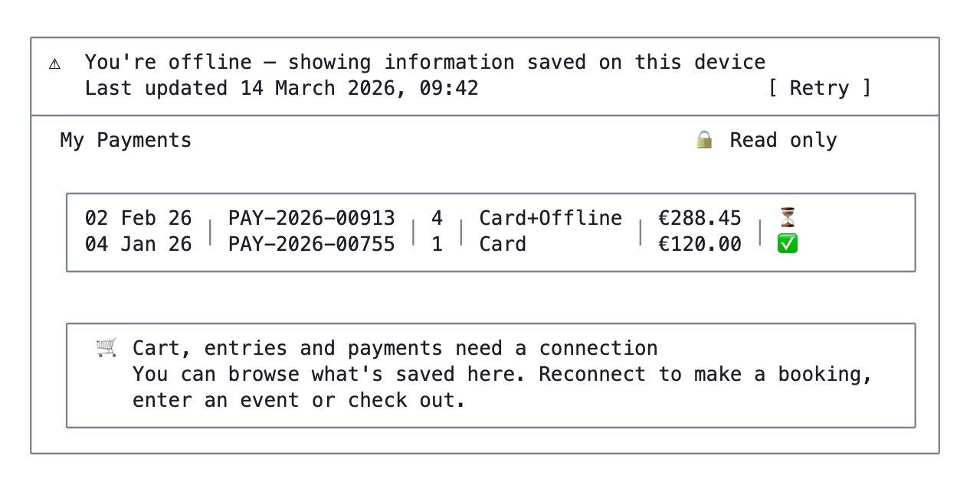
H1 — Offline mode
The banner is persistent, dismissible only to a compact chip, and coloured distinctly from success and error states.

H2 — Offline-blocked action
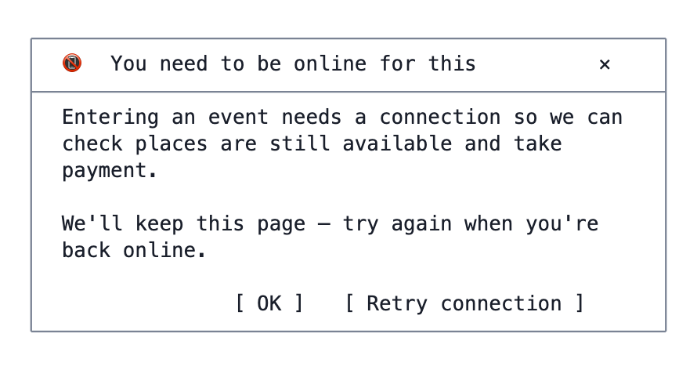
H2 — Offline-blocked action

H3 — Install prompt
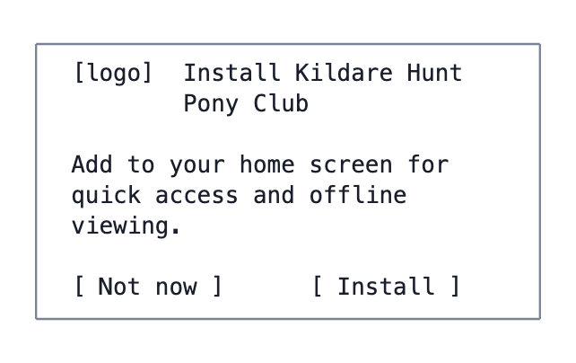
H3 — Install prompt
Shown once, after a successful checkout or on the third visit — never on first load.

I. Org-admin additions
These belong in the existing org-admin app, under Payments (packages/orgadmin-core/src/payments), as a second menu item beside the current list.

I1 — Offline Payments
Route: /orgadmin/payments/offline
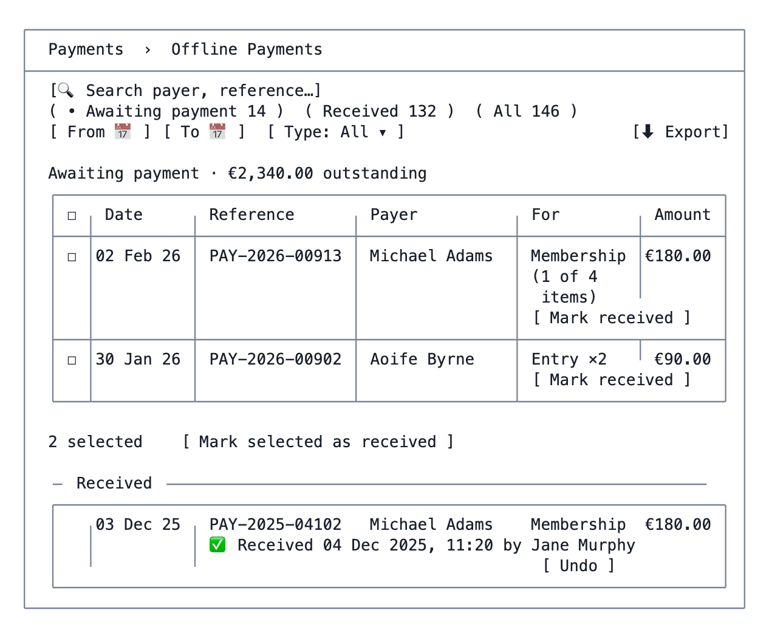
I1 — Offline Payments

I2 — Mark received / undo
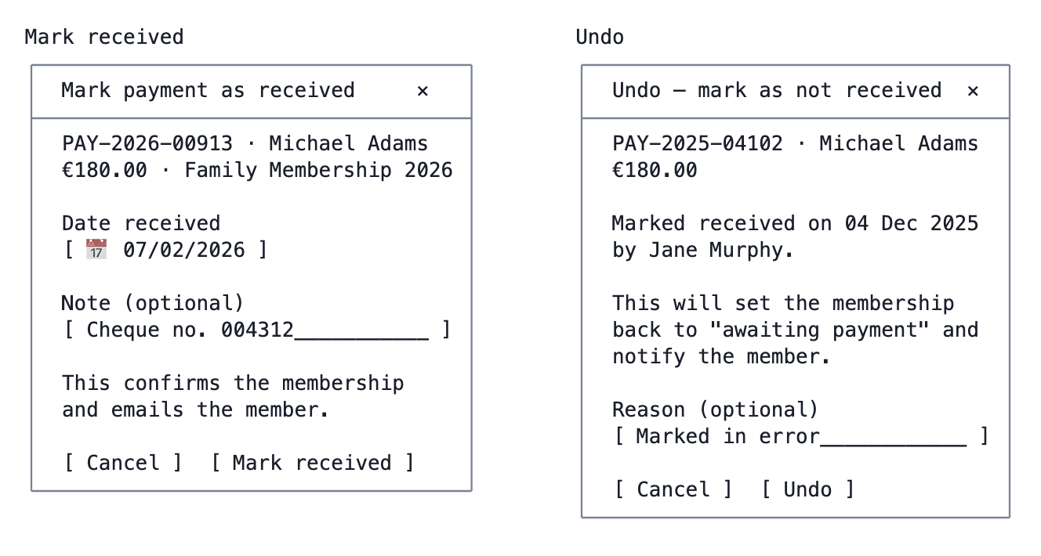
I2 — Mark received / undo
Notes - Recording who and when is a requirement: payments.offline_received_at and offline_received_by. Undo must not erase that history — write both actions to organization_audit_log and keep the trail, clearing only the current-state columns. - Marking received is what confirms the underlying items (membership active, entry confirmed, booking confirmed, order released) — the same state transition a successful card payment triggers. That transition should be one service method with two callers, not two implementations. - Where a payment is partly card and partly offline, only the offline portion is affected; the card portion is already settled. - Marking an offline payment received is also what issues electronic tickets for any ticketed entries in it (G11) — the same transition, one service method.

I3 — Org admin: Pending registrations
Route: /orgadmin/users/accounts/pending · Shown only when auto-registration is off.
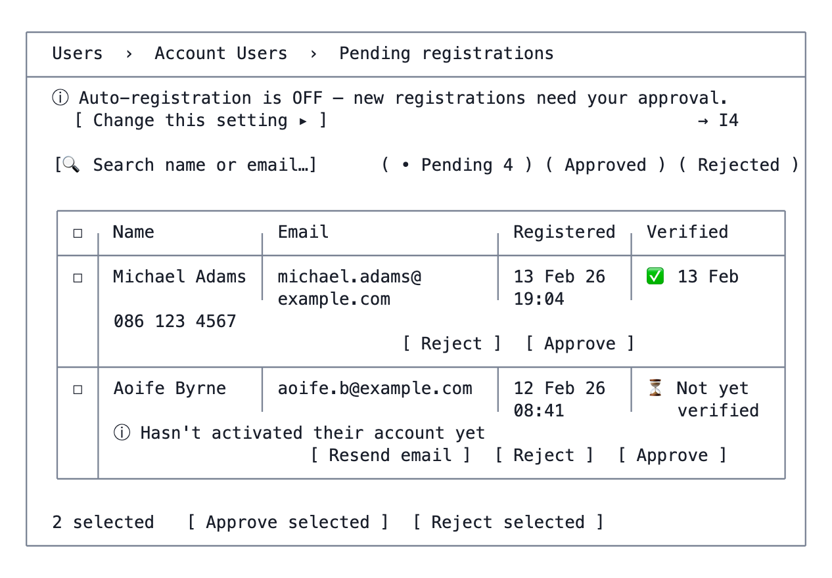
I3 — Org admin: Pending registrations
Notes - The Verified column is the crux of the two-gate model (G6): Keycloak email verification and club approval are independent, and an admin needs to see both. Approving someone who has not verified is allowed — they simply get in once they do. - Approve → organization_users.status = 'active' + approval email. Reject → 'rejected' + a neutral email. Both write to organization_audit_log with the acting admin and timestamp. - The rejection dialog takes an internal note. It is not shown to the applicant (A8). - A pending count badge belongs on the Users menu item — an approval queue nobody looks at is worse than no queue, because the member is left waiting on A8 indefinitely.

I4 — Org admin: Registration settings
A new block in Settings, alongside Organisation Details and Payment Settings.
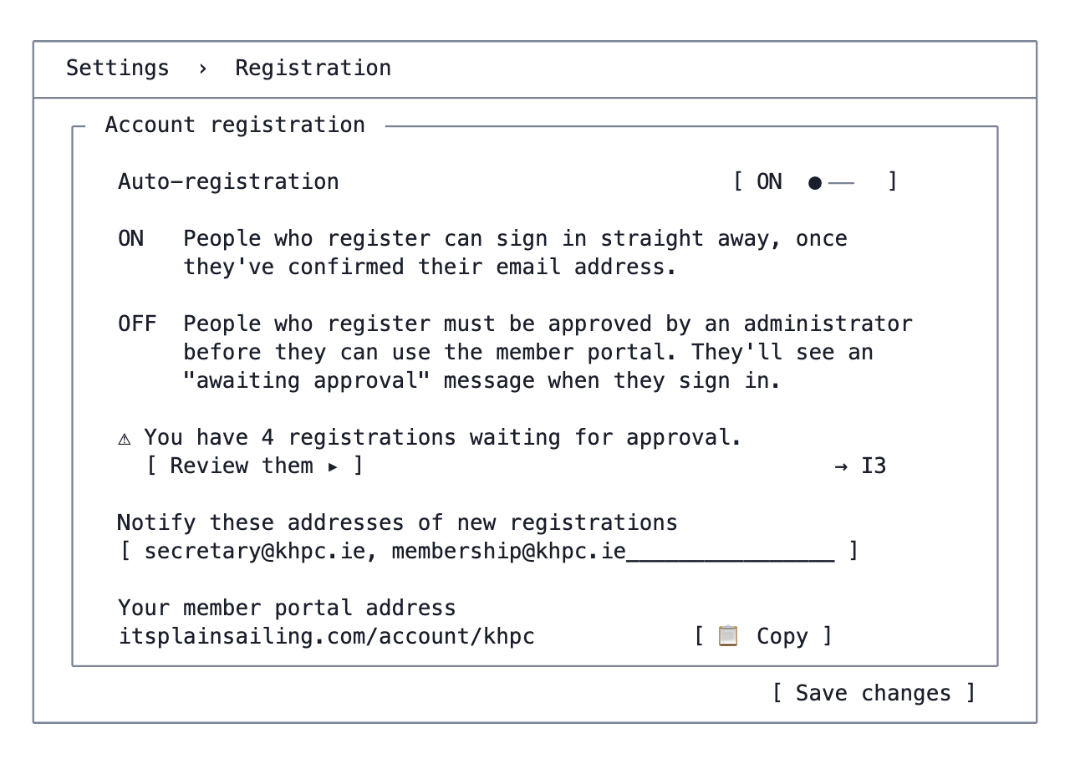
I4 — Org admin: Registration settings
Notes - Stored at organizations.settings.registration — merged into the JSONB, never replacing it. A wholesale write here would destroy branding, payment settings and email templates. - Switching from OFF to ON does not retroactively approve the existing pending queue. That has to be a deliberate act, so the toggle offers it as a separate confirmation: “Approve the 4 people currently waiting as well?” - The portal address is surfaced here because this is where an admin is thinking about how members get in — it is the url_code from G2.

J. Super-admin additions

J1 — Super admin: Handling fees on an organisation type
Added to CreateOrganizationTypePage and EditOrganizationTypePage in packages/admin.
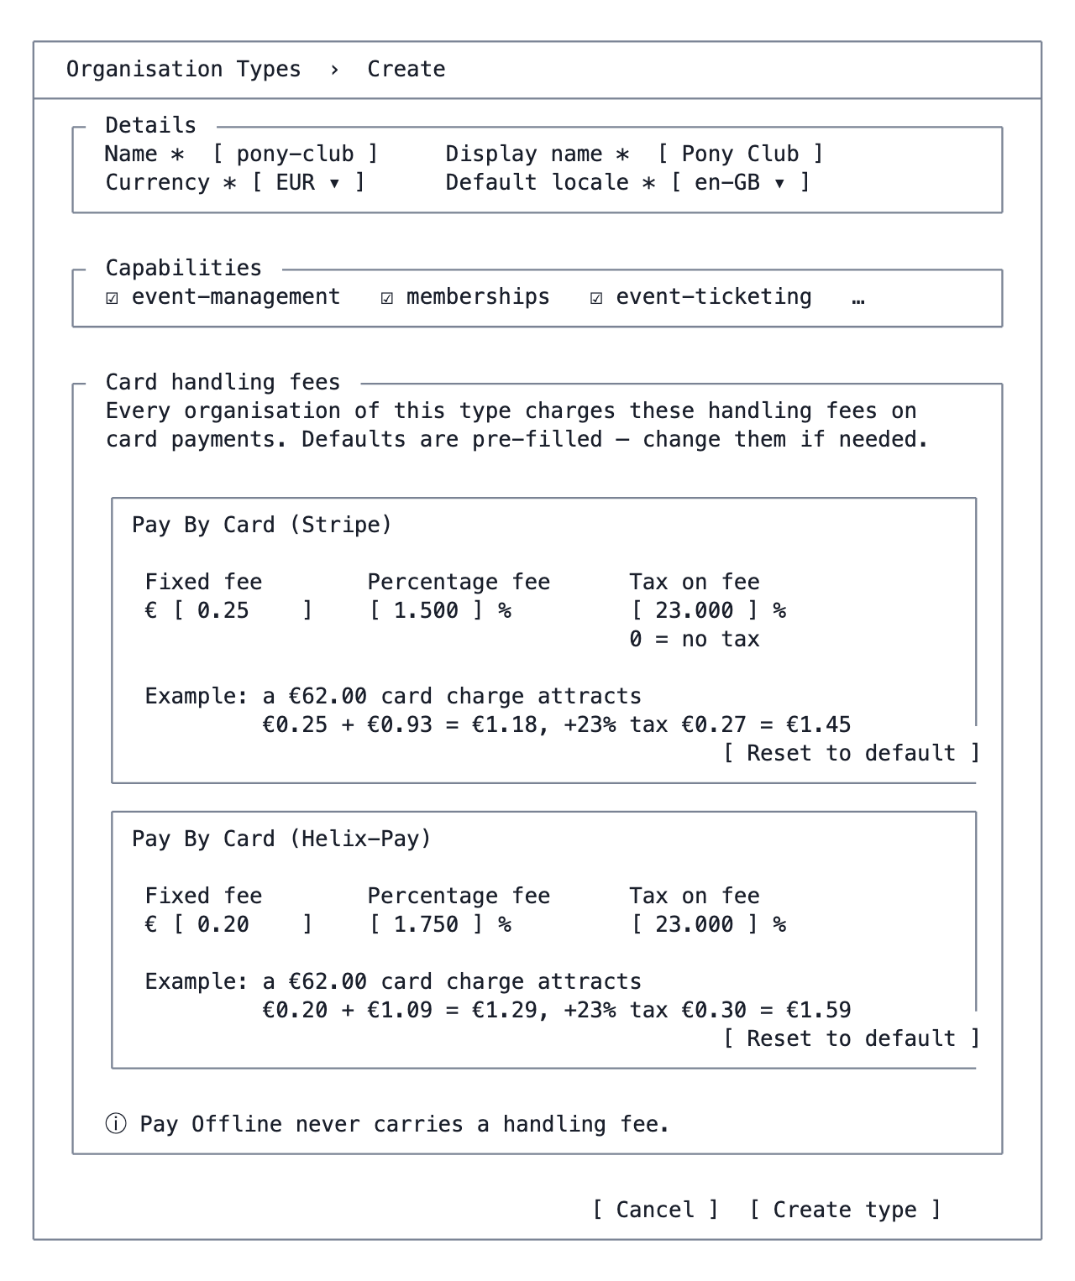
J1 — Super admin: Handling fees on an organisation type
Edit-mode variant carries one extra warning, because the blast radius is large:
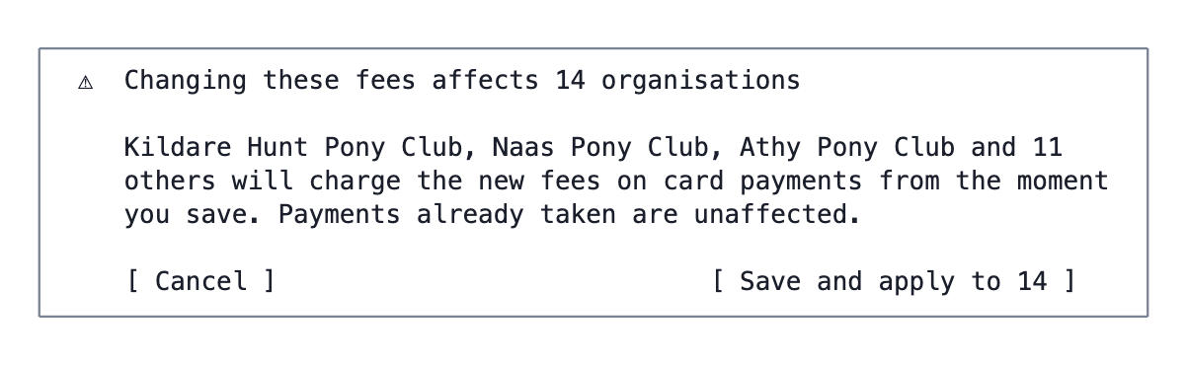
J1 — Super admin: Handling fees on an organisation type
Notes - The live example under each method is the point of the screen. Three abstract numbers are hard to reason about; a worked figure that updates as you type makes a fat-fingered 15.000 instead of 1.500 obvious immediately. - Defaults come from payment_methods.default_fee_config, so “Reset to default” is meaningful and the platform’s notion of Stripe’s going rate can be updated without a release (G5). - Only methods classified as card methods get a card here. The list is driven by the same name-based classification the rest of the platform uses. - Validation: fixed ≥ 0, percentage 0–100, tax 0–100. Tax of exactly 0 is valid and expected — the form must not treat it as “not filled in”. - The fixed fee’s currency symbol is the type’s currency, set above in Details, and every organisation of the type inherits it (G12). Changing the type’s currency once it has organisations is blocked. - packages/admin is not internationalised, so this screen needs no locale keys.

Part 4 — Cart arithmetic
The rules, then the worked example, then what to display.

4.1 Per-item inputs
Field | Source
fee | The source item’s fee × quantity, minus any discount
paymentMethod | The user’s choice, constrained by the source item’s supported_payment_methods
handlingFeeIncluded | Snapshot from the source item at add-to-cart time
isCard | paymentMethod.name contains card, stripe or helix — the platform’s existing name-based classification

4.2 Fee configuration inputs
Resolved from the organisation’s type, per card payment method (G5):
Field | Example
fixedFee | €0.25
percentageFee | 1.5%
taxPercentage | 23% (may be 0)

4.3 Totals
offlineSubtotal = Σ item.fee where ¬isCard
cardSubtotal = Σ item.fee where isCard
feeBearingBase = Σ item.fee where isCard ∧ ¬handlingFeeIncluded
netHandlingFee = fixedFee + (percentageFee × feeBearingBase) if feeBearingBase > 0
= 0 otherwise
handlingTax = taxPercentage × netHandlingFee
handlingFee = netHandlingFee + handlingTax
chargedToCardNow = cardSubtotal + handlingFee
orderTotal = offlineSubtotal + chargedToCardNow
Four rules this encodes, each of which is easy to get wrong:
- feeBearingBase, not cardSubtotal, drives the percentage. Items whose fee already absorbs the handling fee are excluded — charging on them bills the member twice.
- The fixed element is charged once per payment, not once per item (N2). The provider charges the organisation once per transaction, and one checkout produces one card charge. Four fee-bearing items in a cart still attract one €0.25.
- No fee-bearing items means no fee at all — including no fixed element. A cart of entirely fee-included card items must not be handed a stray €0.25.
- Tax applies to the handling fee, not to the order (N1). taxPercentage is a tax on the service charge the organisation is levying, so it multiplies netHandlingFee — never cardSubtotal. Setting it to 0 removes the element entirely, as required.
Where a cart mixes two card providers the whole calculation runs per provider and the results are summed; the summary still shows one “Card handling fee” line, and the fixed element is charged once per provider because that is how many transactions there are.

4.4 Allocating the fee back to individual transactions
payment_transactions records a handling_fee per line (F2 shows them), but the fee is computed on the aggregate. Allocate pro rata by fee-bearing amount, giving the last line the rounding remainder so the parts always sum to the whole:
booking 12.00 / 62.00 × 1.45 = 0.2806 → €0.28
polo remainder = 1.45 − 0.28 → €1.17
─────
€1.45 ✓
Never re-derive a line’s fee from the rate — that reintroduces the fixed element per line and the parts stop summing to the total.

4.5 Display rules
Straight from the brief:
Cart composition | Summary shows
All offline | One total
All card, all handlingFeeIncluded | One total
All card, some not included | Card subtotal, handling fee, tax on it (if non-zero), total
Mixed offline + card | Offline subtotal, card subtotal, handling fee (if any), tax (if non-zero), order total, and a note that the offline portion is paid to the club
Per line: handlingFeeIncluded = false and card → append “(plus handling fee)”. Never on an offline line, never when the fee is included.
The tax line is suppressed entirely when taxPercentage is 0 rather than shown as €0.00 — a zero-tax organisation type should produce a summary with no trace of tax in it.

4.6 Worked example (the cart in E1)
# | Item | Fee | Method | Handling included?
1 | Event entry — Class 2, Sarah Adams | €45.00 | Card | Yes
2 | Family Membership 2026 | €180.00 | Offline | n/a
3 | Court 1, Sat 14 Mar 10:00–11:00 | €12.00 | Card | No
4 | Club Polo (Navy, M) × 2 | €50.00 | Card | No
Organisation type “Pony Club”, Stripe: fixed €0.25, percentage 1.5%, tax 23% (illustrative values — the real ones are whatever the super admin sets in J1):
offlineSubtotal = 180.00
cardSubtotal = 45.00 + 12.00 + 50.00 = 107.00
feeBearingBase = 12.00 + 50.00 = 62.00 ← item 1 excluded
netHandlingFee = 0.25 + (1.5% × 62.00)
= 0.25 + 0.93 = 1.18
handlingTax = 23% × 1.18 = 0.2714 = 0.27 ← rounded once, here
handlingFee = 1.18 + 0.27 = 1.45
chargedToCardNow = 107.00 + 1.45 = 108.45 ← this is what goes to Stripe
orderTotal = 180.00 + 108.45 = 288.45
The two traps this is designed to avoid:
- Charging the percentage on €107.00 (€1.61 + tax) rather than €62.00 — double-charging the member for item 1, whose €45.00 already absorbs its handling fee.
- Charging the €0.25 fixed element twice, once for the booking and once for the polo shirt. There is one card transaction, so there is one fixed element.

4.7 Rounding, currency and integrity
- Store and compute in integer minor units (cents), format for display only. Decimal arithmetic in JavaScript floats will produce off-by-a-cent totals on a cart this shape.
- One currency per cart, taken from the organisation. Two orgs’ items can never share a cart — another reason carts are org-scoped.
- Round twice, not more: once when netHandlingFee is computed, once when handlingTax is computed. Rounding per line, or at every intermediate step, drifts by cents on a cart this shape.
- fixedFee is a currency amount, so it is meaningful only in a known currency. It is stored in the organisation type’s currency and inherited by that type’s organisations. Per N3, an organisation must therefore share its type’s currency — see G12 for what that constrains.
- The fee configuration in force is snapshotted onto the payment at checkout (payments.fee_config_snapshot jsonb). A super admin changing an organisation type’s rates must not retroactively change what a historical receipt says.
- The server returns every figure above; the client renders them. If the client ever needs to recompute, that is a bug.

Part 5 — PWA and offline behaviour
Area | Offline | Notes
Home | ✅ Read-only, cached | Actions disabled with H2
My Entries & Bookings | ✅ Read-only | Including detail and stored answers
My Memberships / Registrations / Orders | ✅ Read-only | Renew button → H2
My Tickets / a ticket | ✅ Fully functional | The strongest offline case in the app — see below
My Payments | ✅ Read-only | The brief’s explicit requirement
Events / Memberships / Merchandise / Registrations browsing | ✅ Last-fetched list and detail, marked stale | Availability may be out of date — say so
Calendar availability | ⚠ Cached grid, visibly stale | Never allow selection offline
Application forms | ❌ | Form definitions cached, submission blocked
Cart | ⚠ View cached contents; no add/remove/change | Mutations require the server
Checkout | ❌ | H2
Profile | ⚠ View only
Implementation
- vite-plugin-pwa with Workbox; app shell precached, API responses cached stale-while-revalidate into IndexedDB keyed by (orgCode, resource).
- Cached data is per organisation and per user, and must be cleared on sign-out and on org switch-away — a shared device must not leak one member’s payment history to the next.
- Every cached screen shows its lastSynced time. Stale data presented as current is worse than no data.
- No background sync of mutations. Queuing an event entry made offline and replaying it later would hand a member a place that was taken hours earlier; the honest answer is H2.
- Service-worker updates prompt rather than reload silently — a silent reload mid-checkout would be destructive.
Tickets are the exception that justifies the PWA. Everything else degrades to read-only gracefully; a ticket has to work. Rural showgrounds, sailing clubs and pitches are exactly where mobile coverage fails, and a member standing at a gate with a spinner has a broken product.
- Every valid ticket for an event within the next 30 days is precached — QR payload, ticket config, entrant details, event details — on every successful sync.
- The QR payload is generated and signed server-side at issue time and stored, not derived at render time. A client that cannot reach the server must still produce a scannable code.
- C10 makes no network call at all, online or offline. It reads the cache in both cases, so the offline path is the path that is exercised every time and cannot rot.
- Scan state (used/unused) is the one thing that may be stale offline. The gate scanner is the authority; the member’s copy is a display. Show the last-synced time on the ticket and never let a cached “Valid” contradict a scanner.

Part 6 — Decisions taken
Answered 13 February 2026. Everything above reflects these.
# | Question | Decision | Where it lands
Q1 | Landing directory and short-code URLs, or only one? | Both | A1, A2, G2
Q2 | Confirm the new cart/payment schema | Proceed — carts, cart_items, payment_transactions, plus additions to payments. Existing single-context payments keep working | G3
Q3 | Where does the handling-fee rate live, and what shape is it? | Super admin configures it per organisation type, per card payment method. Three elements: fixed amount, percentage of the card charge, and a tax percentage (0 = no tax). Stripe and Helix-Pay defaults are pre-filled on the create page. All organisations inherit from their type; no per-org override | G5, J1, Part 4
Q4 | Immediate access on registration, or admin approval? | Org-admin toggle. Auto-registration ON → access once the email is verified. OFF → the user verifies their email and can sign in, but sees “awaiting approval” until an admin approves | G6, A8, I3, I4
Q5 | Can an org stay out of the public directory but remain reachable by code? | Yes — settings.listedInDirectory, default true | A1
Q6 | Self-cancellation? | Bookings yes, via the existing cancellationValidator. Entries, memberships, registrations and orders no | C2, C3
Q7 | Apply on behalf of another person? | Yes | D0
Q8 | Discounts in the account UI? | Yes — automatic discounts shown per line at application and in the cart, plus a discount-code box | D0, E1
Q9 | Event ticketing? | In scope — My Tickets, a rendered offline-capable ticket, and automatic issuance on entry confirmation | G11, C9, C10
Q10 | Stripe embedded or hosted redirect? | Embedded Payment Element. Helix-Pay stays a hosted redirect | E5
Q11 | Six locales from day one? | All six, from day one | G10
Three follow-ups from Q3, confirmed the same day:
# | Question | Decision | Where it lands
N1 | Does the tax percentage apply to the handling fee, or to the whole card charge? | To the handling fee. €62.00 base → €1.18 fee → €0.27 tax. Applying 23% to the full €107.00 card charge would have added €24.61 | §4.3
N2 | Is the fixed element charged once per payment, or once per fee-bearing item? | Once per payment. One checkout is one card transaction, and the provider charges the organisation once | §4.3
N3 | An organisation’s currency can differ from its type’s, but fixedFee is a currency amount inherited from the type. Which wins? | The organisation type’s currency is authoritative. An organisation must match its type’s currency, enforced in the super-admin UI and the backend | §4.7, G5

Part 7 — Remaining questions
Three left, none of them blocking. Each has a stated assumption the document is built to; overriding any of them is a contained change.
# | Question | What I have assumed
N4 | When exactly is a ticket issued for an entry paid offline? On entry, or when the club records payment? | On payment received. Otherwise a member can attend without paying, which defeats ticketing. The entry shows “your ticket will be available once the club records your payment” in the meantime
N5 | Does an org admin need to see and act on a member’s cart (abandoned-basket recovery, or adding an item for someone who phoned in)? | Out of scope for v1
N6 | Should approving a registration in I3 also create a members record, or is club membership always a separate paid application? | Separate. Registration grants portal access; membership is a paid application through D6

Next steps
- Requirements document — docs/ACCOUNT_USER_APP_REQUIREMENTS.md, incorporating Q1–Q11 and N1–N3, and resolving N4–N6.
- Design document — docs/ACCOUNT_USER_APP_DESIGN.md: schema migrations, the /api/public/* and /api/account/* route inventories, the account-user auth middleware, the fee-resolution service, the cart/checkout state machine, ticket issuance, and the PWA caching policy.
- Task breakdown, sequenced so the platform gaps land first:
Phase | Work
1 | G2 org url_code + super-admin field
2 | G5 fee config: migration, payment_methods.default_fee_config, J1, fee-resolution service, plus G12 currency backfill and constraint — everything downstream needs a total
3 | G1 /api/public/* + /api/account/* + account auth middleware
4 | G3 + G4 cart, transaction and handling-fee schema, plus the four org-admin type forms
5 | G6 registration, approval and the org-admin screens I3/I4
6 | account-shell — auth, org resolution and switching, branding, layout, routing, six locale files
7 | One vertical slice end to end: memberships. It exercises application forms, renewal pre-population, the cart, both payment paths, offline payments (I1/I2) and confirmation — everything the rest of the modules then repeat
8 | Events → ticketing → calendar → merchandise → registrations
9 | Payments history, profile
10 | PWA and offline, with tickets as the first-class case
- Phase 2 before phase 4 is deliberate: the cart cannot render a line, let alone a total, until the fee configuration exists and can be resolved.

