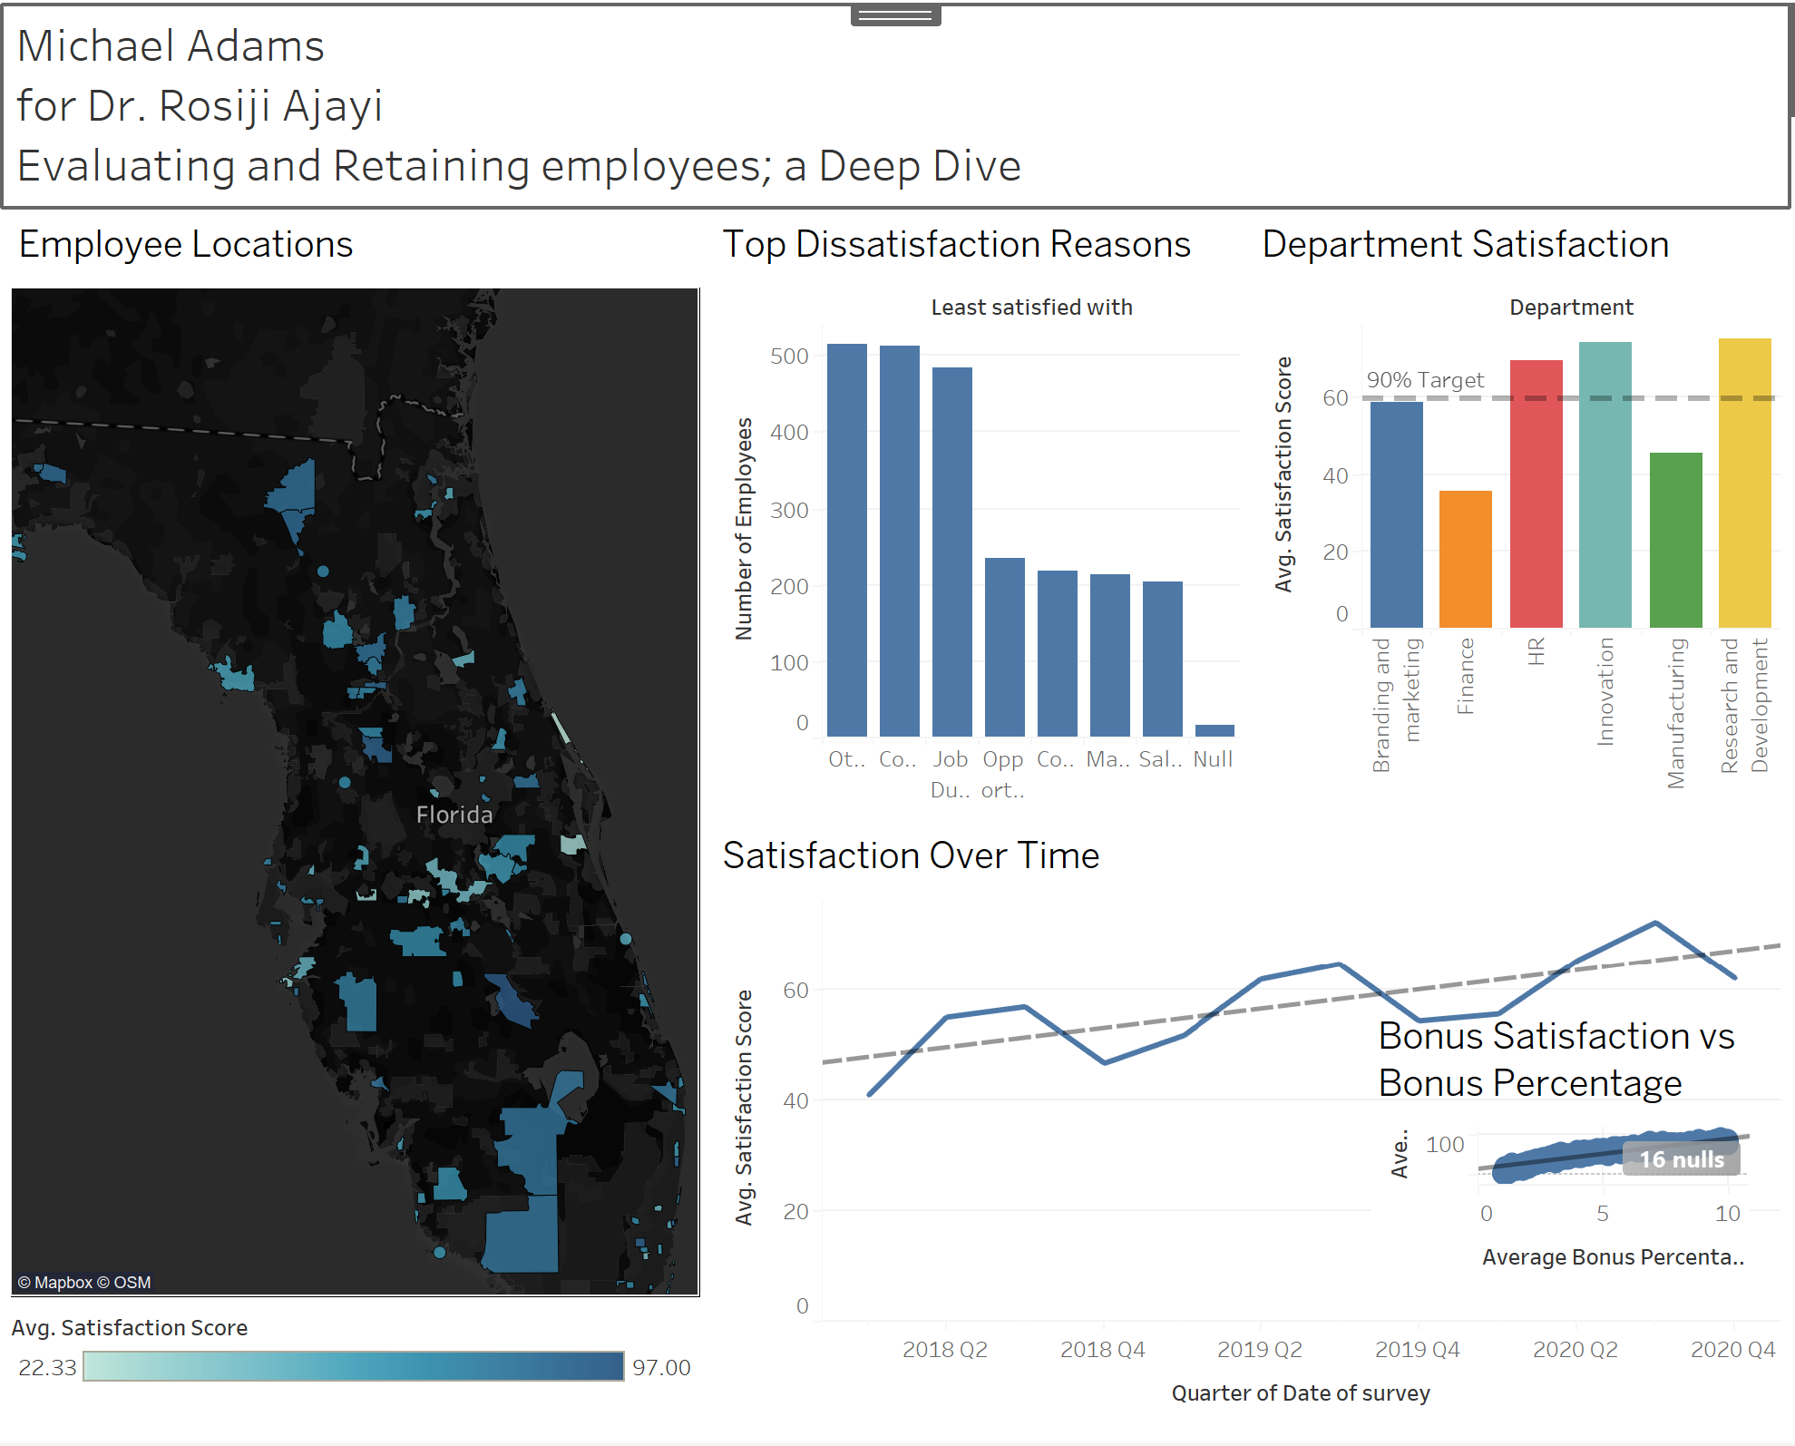

"Good morning, everyone. Today, I'm excited to share with you the insights we've gained from analyzing our employee satisfaction survey data.

As you can see in the Department Satisfaction view, the departments with the highest average satisfaction scores are [Innovation] and [Research and development], both exceeding our 90% target. However, [Manufacturing] and [Finance] have room for improvement, with scores below the target.

Moving on to the top reasons for dissatisfaction, we can see that [Commute], [Job Duties], and [Other] are the most frequently cited issues. We should focus our efforts on addressing these concerns to improve overall employee satisfaction.

Looking at the map of employee locations, we notice a higher density of employees in the [28052 and 33857] zip code, particularly both near and furthest from our headquarters. This information can help us plan employee events, transportation, and remote work policies.

Turning to the satisfaction trend over time, we observe a slight upward trend, indicating that our efforts to improve employee satisfaction are having a positive impact. However, we still have work to do to consistently meet our targets.

Lastly, the scatterplot of bonus satisfaction versus bonus percentage reveals a positive correlation, suggesting that employees who receive higher bonuses relative to their salaries tend to be more satisfied with their bonuses. The R-squared value of [0.896122] indicates a [strong/moderate/weak] relationship between these variables.

In summary, this dashboard provides valuable insights into our employee satisfaction levels, key areas for improvement, and the factors influencing satisfaction. By leveraging this information, we can make data-driven decisions to enhance our employee experience and retention. I'm happy to answer any questions you may have."

Feel free to customize this narrative based on the specific insights and visuals in your own dashboard. Remember to highlight the key takeaways, provide context for the data, and connect the insights to actionable recommendations for the management team.