**CS 602 Module 3 Homework Assignment**

**By: Eric Kutarnia**

1. **Write a client that connects to the MongoDB database, uses the Mongoose schema, and creates the saves the data for the three employees used in the previous homework.**before running ‘empclient.js’ there are no collections:  
   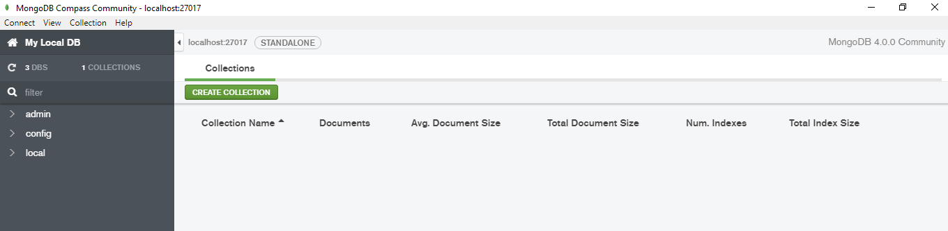

Running ‘empclient.js’:

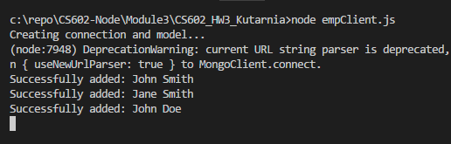

DB view in Compass tool:  
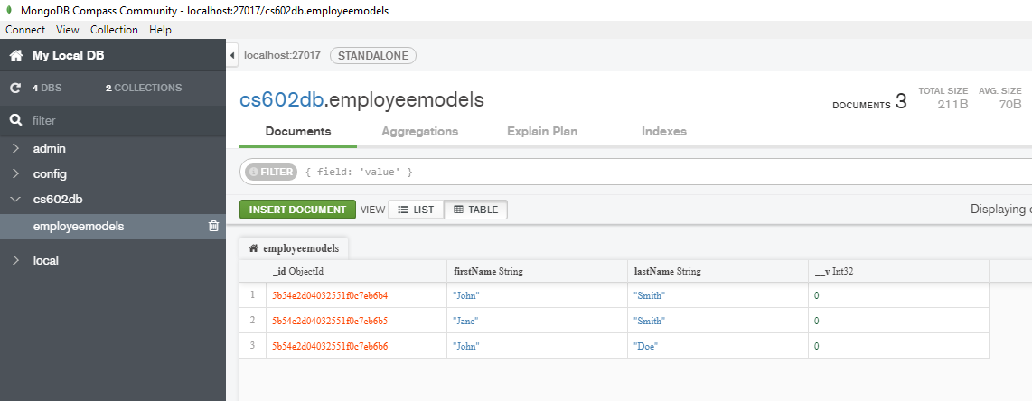

1. **Now, write the Express web application similar to ex13_caseStudy and use the Express Router to configure the paths for adding a new employee, deleting an existing employee, displaying all employees, and editing an existing employee. The data is persisted to the MongoDB database.**
   1. **Display Employees (initial View after running ‘empclient.js’)**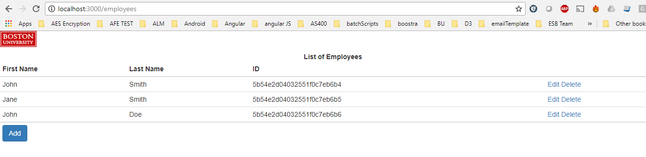
   2. **Add New Employee**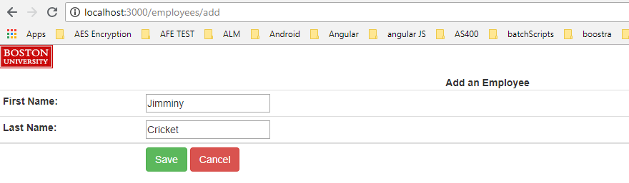After adding:  
      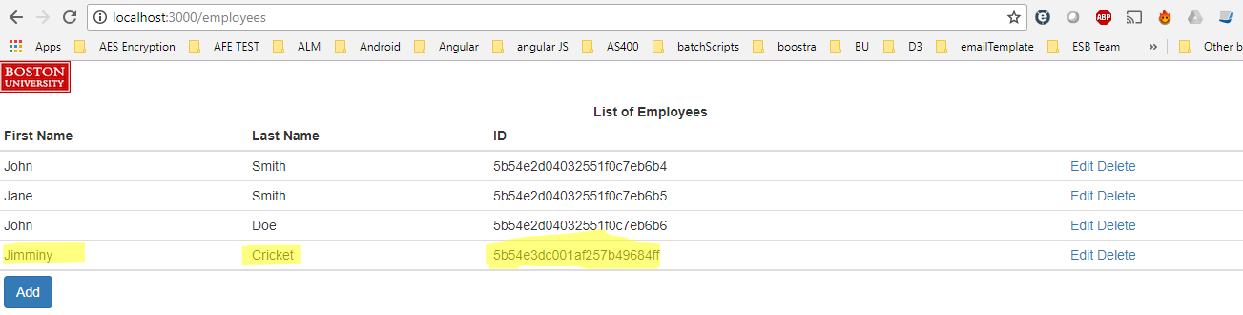
   3. **Delete Existing Employee**Deleting ‘Jimminy Cricket’:  
      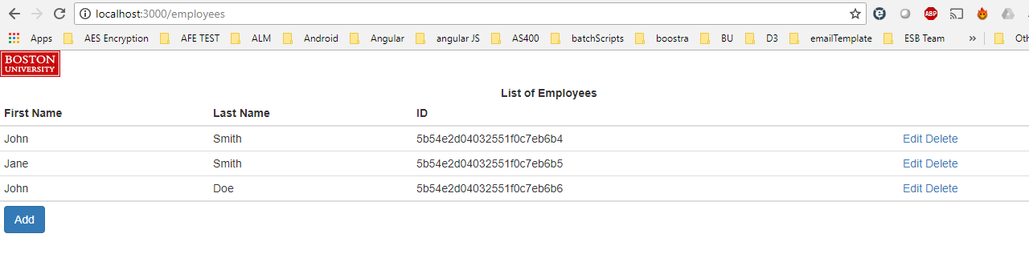
   4. **Displaying All Employees**Added a new user: ‘Test User’ (so the screen shot is not the same as the last)  
      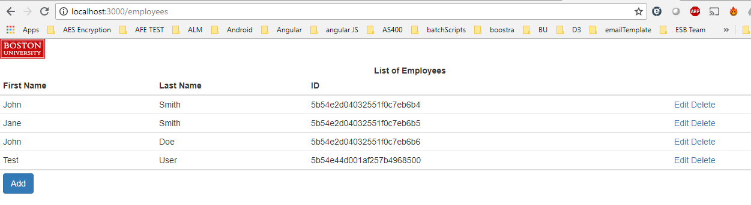
   5. **Editing existing employee**

Editing ‘Test User’:  
