Project Wireframe

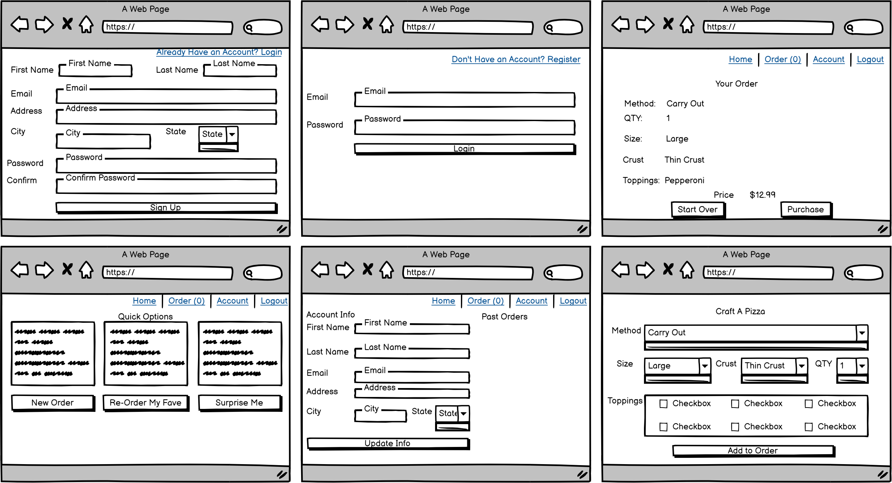

|  |  |  |
| --- | --- | --- |
| Features List | Description | Team member roles |
| MVP Features   * Login and signup * Show quick options for orders as; New, Favorite, and Random * User can tag an order as favorite * User can update account information * User can purchase order   Future Features   * Add delivery charges * Add taxes | Develop a website that allows the customers of Pizza Pete’s to sign-in and place orders for pizza that is customized to their requirements. | * Wendy Wu responsible for front-end of Account Info & Past Orders page * Danielle Bergbower responsible for Data Schema, front-end of Quick Options page * Jeremy Helms responsible for front-end of Craft-A-Pizza and Your Order pages * Michael Akinosho responsible for front-end of Login and Sign-up pages, responsible for back-end on pages |