Michael Andre Franiatte

**Joycons Setting**

**with Codes in Gamepad Libraries**

**to Play PC Games**

*Joycons Setting for Playing PC Games*

Copyright 2007-2017

EBOOK

|  |
| --- |
| ebook |
| Joycons Setting with Codes in Gamepad Libraries to Play PC Games |
| Joycons Setting for Playing PC Games |
|  |
| **Michael Franiatte** |
| **06/09/2018** |

|  |
| --- |
| Joycons used on PC Games can be very competitive compared to keyboard and mouse and more enjoyable than joystick because it use motion recognizing and only four fingers are used to push the buttons, other fingers are used to stabilized the Joycons. All buttons and motion recognizing are easy of access. Information about license, EULA and contract for using these following works can be found at <https://michaelfraniatte.wordpress.com>. |

## joyconleft.pngJoycons Setting with Codes in Gamepad Libraries to Play PC Games

Michael Franiatte*

## Abstract

With this book you will have easy to have a competitive controller or gamepad able to interface in all your PC (Personal Computer) games. The Joycons are designed to be the best controller for having the best of fun, when the program to play Joycons have the settings adapted to your games. The codes used to take the control of games are the best than you can find in comparison to other programs or other platforms. Since 2008, the works made on this controller have never touched such a perfection, and in comparison with other programs or controllers or platforms, such an enjoyment to play with it… because such a perfect controller with such perfect codes, on the best platform to play which is a PC, using a native program language, made the gameplay very realistic and immersive. If you don’t have trouble to aim something or drive a car, Joycons connected with a Bluetooth key, the information presented here is made for you to enjoy a maximum to play all PC games on your favorite platform which is the PC having the best game fluidity and resolution. All other platforms with all other controllers can’t have such realistic, easy and immersive gameplay.

***Keywords:*** *Joycons, Nunchuck, PC, controller, play, codes*

* Author correspondence: [michael.franiatte@gmail.com](mailto:michael.franiatte@gmail.com)

## 1. JoyconsTheory for Playing Joycons on All Games

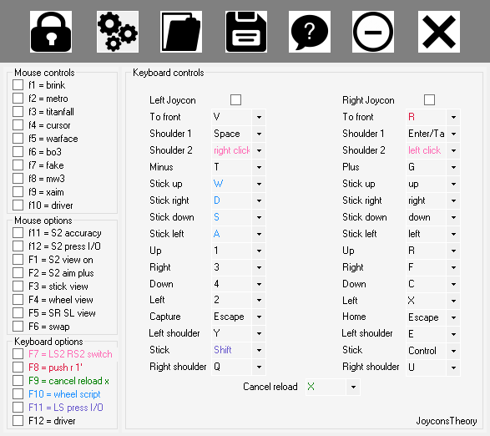

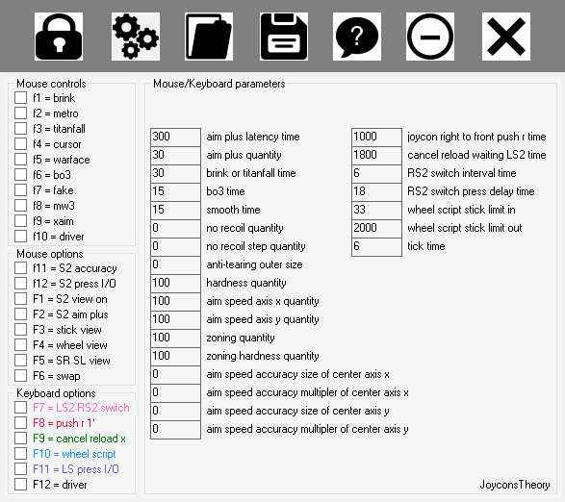

## 2. Configuration in plugin X-Aim of Cronusmax Pro application

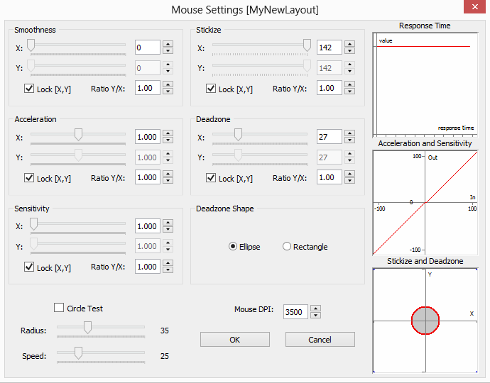

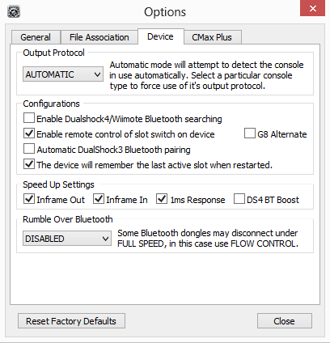

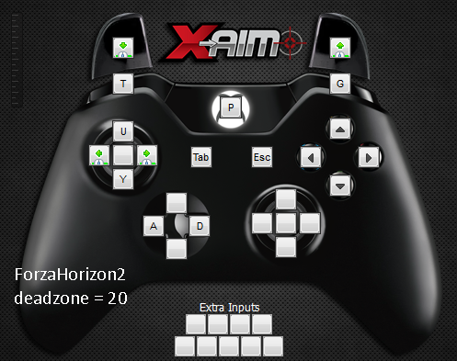

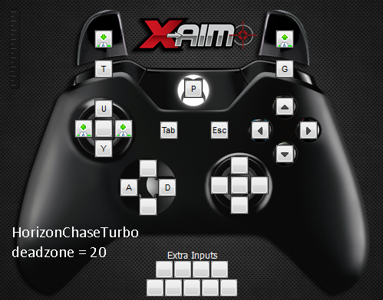

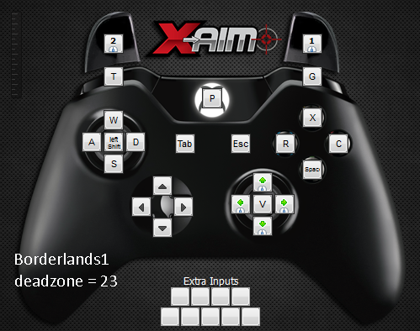

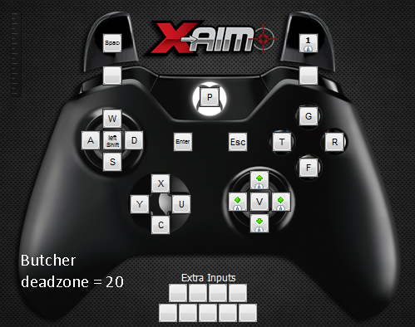

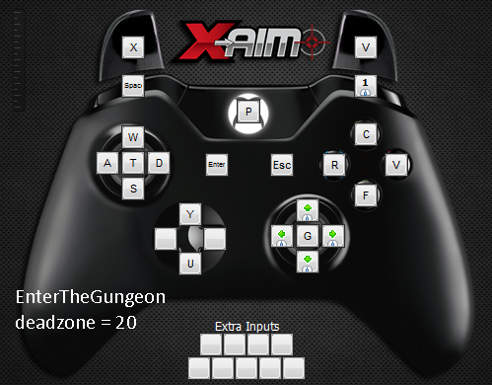

**3. Use and Agreement Contract**

**Owner:** Michael Andre Franiatte.

**Contact:** [michael.franiatte@gmail.com](mailto:michael.franiatte@gmail.com).

**Owning:** All works from scratch of the owner.

**Proof of Owning:** Works published, and writings/speakings all over.

**Requirements of Use:** Pay the owner, quote the owner, agreement of the owner.

**Availability of Works:** Only under the shapes of the owner built, only for personal use.

**Subjects of Claims:** Works published by the owner on Google Play and Google Books.

**Concerning Author Rights:** Equations and codes from scratch of the owner, softwares built from it, all things of people arising from it.

**End User License Agreement:** A commercial license is required to use in personal manner. Do not redistributing in any manner, including by computer media, a file server, an email attachment, etc. Do not embedding in or linking it to another programs, source codes and assistances including internal applications, scripts, batch files, etc. Do not use for any kind of technical support including on customer or retailer computer, hardware or software development, research, discovery, teachery, talk, speech, write, etc. Do not use for win money or for commercialisation of any products arising from my programs, source codes and assistances. Do not use and do not copy the way it run in other programs, source codes and assistances. Do not use without pay me, quote me and my agreement. Do not steal or copy or reproduce or modify or peer or share. Do not use in other manner than personal. It stand for my programs, source codes and assistances or programs, source codes and assistances stealing or copying or reproducing or modifying or peering or sharing my programs, source codes, and assistances. If you aren't agree you shall not use.

**Terms of License and Price:** The present contract acceptance is required to use works of the owner and built from it in all kind of manner. The price for each user shall be defined with the owner by contacting him and this for each subject of works the owner claims. Each user shall contact the owner for asking his agreement. It can be refused by the owner depending who asking and the price defined. People don’t respecting the present contract shall not use the works of the owner.