EBOOK
Copyright 2007-2017
An Equation of State Resolution
for the Study of Fluids
EoS Resolution
Michael Andre Franiatte
ebook
An Equation of State Resolution for the Study of Fluids
EoS Resolution
Michael Franiatte
08/31/2014

Before the past nobody had generalized a tool to understand the behavior of fluids. The synthesis presented here attempt to correlate all data on fluids with a simple program. Information about license, EULA and contract for using these following works can be found at https://michaelfraniatte.wordpress.com.

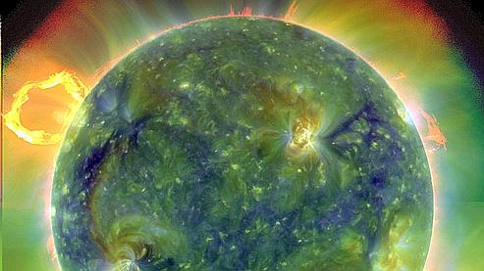An Equation of State Resolution for the Study of Fluids

Michael Franiatte*

Abstract
Fluids play an important role in many high-temperature geological and chemical processes. Consequently, understanding the behaviour of fluids at high temperature and high pressure in geological and industrial processes are of fundamental importance. The properties of fluids have been the object of numerous measurement and fitting studies but have never been represented and compared with simple parameters in an only equation of state (EOS). This has been done for the determination of pressure-volume-temperature-composition (PVTX) relations using different equations together simulating the measurements of fluids. An appropriate generalized method to resolve PVTX data of fluids combined with only four parameters describing a gas (molar mass and the three critical parameters), are in good agreement with the volumes observed by the studies made by the Scientifics in the past. The properties of fluids as well as the properties of the reactions occurring in the fluids were deduced from simple calculations and methods considering the studies of Scientifics whom were working on EOS. Such resolved equation of state is important to understand and correlate all the data on the fluids and the reactions acquired until this day and it’s pretty innovating in chemical and petroleum industries.

Keywords: fluids, PVTX properties, gas, critical parameters, reactions, equation of state

* Author correspondence: michael.franiatte@gmail.com

1. Introduction
Seward and Franck (1981) have studied the phase relations in the system H₂-H₂O covering the range of temperature between 175°C and 440°C and of pressure between 100 and 2500 bar. They have established the critical curves and the surface dividing the phase domains in term of PVTX data of this system.
The relations between the H₂ dissolved concentrations and the H₂ fugacities in the system H₂-H₂O were studied at elevated temperatures and pressure in the years of 1980 by Seward and Franck (1981) in term of volumetric properties of the system H₂-H₂O and by Kishima and Sakai (1984) in term of in situ H₂ concentrations with the mineral buffer Hematite-Magnetite.
The EOS of H₂-H₂O was determined by Rimbach and Chatterjee (1987) whom have used mixture rules in order to calculate attraction and repulsion parameters of the system. The EOS is in agreement with the PVTX measurements of Seward and Franck (1982) but should be confirmed for the range of temperature (T) and pressure (P) around the experimental measures. Rimbach and Chatterjee (1987) have established a Redlich-Kwong type modified EOS (MRK equation) in order to calculate H₂ and H₂O volumetric properties and the phase equilibrium in the system H₂-H₂O in the conditions of temperature and pressure of geologic interest (until 1000°C and 2000 bar).

2. Method

2.1. Redlich-Kwong type EOS
Fluids play an important role in the meteoric, diagenetic, hydrothermal, metamorphic and magmatic processes. By consequence it’s necessary to calculate their thermodynamic properties in the temperatures and pressures encountering in the different geologic environnements. These thermodynamic proporties could be calculate from the EOS determining the fluid molar volume (V) function of T and P expressed by
(1)
The EOS most known was established by Van der Waals (1873). This EOS is written
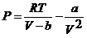
(2)
where R is the gas perfect constant, b is called repulsion parameter and a attraction parameter. Molar fractions of constituents deduced from there concentrations in mol number for one kilogram of solvent are introduced in the Redlich-Kwong EOS (Redlich and Kwong, 1949) modify by Soave (1972), in order to calculate the fugacity coefficients of volatile species in the fluid. The Soave-Redlich-Kwong EOS is written
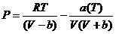
(3)
where P is the total pressure (Pa), R is the gas constant (8.314472 J/mol/K), T is the absolute temperature (K), and V is the molar volume (m³/mol). The a(T) and b coefficients in Equation (3) are the attraction and repulsion parameters of the original van der Waals equation, given by
(4)
and
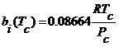
(5)
where T_{c} and P_{c} are the critical temperature and pressure, characteristic of a pure constituent. The a_{i}(T_{c}) term in Equation (4) is given by
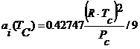
(6)
where the division by 9 come from the better results enounced by Fowler and Guggenheim (1939) adapted for a mixture and not for a perfect gases without divide by 9. The temperature-dependent α_{i}(T) term, equal to 1 at T_{c} and P_{c}, is evaluated from
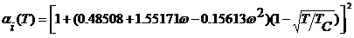
(7)
where is the acentric factor, characteristic of a given pure constituents. The expressions for the a(T) and b parameters for a fluid mixture are written
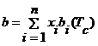
(8)
and
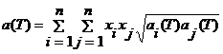
(9)
The molar volume is expressed in m³/mol by
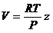
(10)
where z is the compressibility factor. The Newton-Raphson method is used to resolve z in the equation written
(11)
with
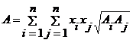
(12)
and
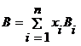
(13)
with
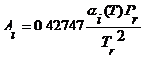
(14)
and
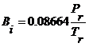
(15)
where T_{r} = T / T_{c} and P_{r} = P / P_{c} are the reduced temperature and pressure, and α_{i}(T) the temperature-dependent term in Equation (7). The fugacity coefficient of the i^{th} gas derived from the Redlich-Kwong EOS (Soave, 1972) is expressed by
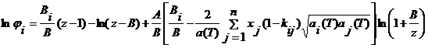
(16)
The fugacity is written
(17)
where ϕ_{i} and x_{i} stand for the fugacity coefficient and mole fraction of the i^{th} gas in the gas mixture, respectively.
The method presented here is inspired from the theoric study of Rimbach and Chatterjee (1987) because they obtained a good agreement in the reproduction of experimental volumes function of introduced quantities in the system, important for express the saturation pressure of a mixture multi-constituent for a given temperature. From molar fractions and quantities known of introduced constituents in a system, the method is based on the derivation of the EOS used by Rimbach and Chatterjee (1987) in order to determine constituent molar partial volumes of the system.

2.2. EOS Derivation
The Soave-Redlich-Kwong EOS derived is function of V, a and b allowing to obtain the partial derived V/x to calculate the molar partial volumes (V_{i}) of n constituents in a fluid according to the equations of Rimbach and Chatterjee (1987). In the study here, the n constituent’s mixture is described by an improvement of the definition of the molar partial volume for the constituent i for a mol number of gas n^{g,l} expressed by
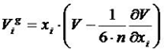
(18)
because the ancient definition expressed by
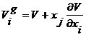
(19)
can’t be resolved for a large number of constituents. The total molar volume of a gas mixture is written
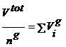
(20)
where V^{tot} correspond to the total volume occupied by the fluid.
The demonstration of the coefficient 1/6n is as followed. The hypothesis presented here, named H_{L}, for a polynomial function L(x^{m}) is expressed by
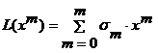
(21)
and can be written
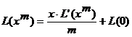
(22)
define on the interval [0,1] and derivable on the interval ]0,1[. Using the existing hypothesis H_{F} for the hypothesis H_{L} it exist a point x on the interval like it appear
(23)
being
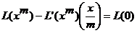
(24)
So we would have with the Equation (18)
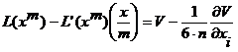
(25)
being
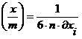
(26)
With m=3, because it correspond to the dimension of a molar volume, we would obtain
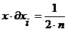
(27)
The end of the demonstration is to put x=0, n=∞, or x=1, n=1, or x=0.5, n=2, thus x is function of 1/n, with δx=1 for x=1 and δx=0 for x=0. So for 1<n<∞, so we have
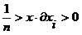
(28)
while imposing
(29)
like an average between 1 and the infinite for a large number of constituents n for the resolution of the partial molar volume, it’s a good approximation well demonstrated here.
The coefficient 9 at the Equation (22) denominator according to Fowler and Guggenheim (1939) is caused by the modification of a(T) expression written
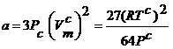
(30)
and
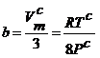
(31)
becoming
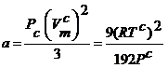
(32)
and
(31)
The factor 3 between the definition of A and a(T) (or the volume and it’s derived) where the hypothesis H_{L} allow to demonstrate the existence of the volume partial Equation (18) (where for V, it’s A present, and for V it’s a(T) present) demonstrated by
(33)
and
(34)
with s=3, because both equations with the equation of the hypothesis H_{L} for m=1 are compatible giving
(35)
and
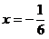
(36)
By resolving the Equation (33) for s=3 written
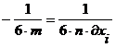
(37)
and
(38)
with m=1
(39)
and
(40)
so we would have with the Equation (18) and Equation (36)
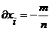
(41)
and the Equation (26) give
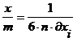
(42)
so we would have with the Equation (36) for m=1
(43)
with the Equation (26)
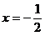
(44)
and
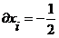
(45)
and
(46)
corresponding to a molar volume equal to 0 having only one dimension, because when the constituents are in equimolar proportions, the results of calculations show the equality between molar partial volumes with Equation (45), because for m=3, n=2 and x_{i}=1/2
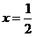
(47)

2.3. EOS Derived
The derived function of V, a and b of the Equation (3) is written
(48)
a and b are function of x_{i}
(49)
written on the shape of
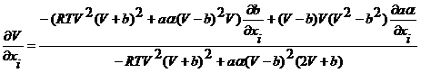
(50)
with
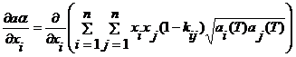
(51)
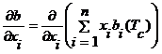
(52)
so by derivation
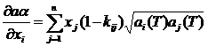
(53)
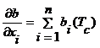
(54)

2.4. Molar volumes determination in the gas and liquid phases
In order to calculate the molar volumes in the gas and liquid phase and in both phases the following equations are used.
At T and P
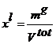
(55)
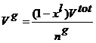
(56)
so
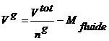
(57)
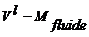
(58)
with M_{fluide} the molar mass of the fluid corresponding to the sum of each constituent molar mass multiply by their molar fractions in the fluid.
Because x^{l} at T and P is incorporated in the molar volume calculation of the gas phase, the following relations are adopted
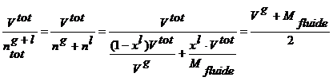
(59)
imply
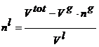
(60)
and
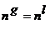
(61)

2.5. Molar fraction determination in the gas and liquid phases
In order to deduce the liquid molar fraction (x_{i}^{l}) and the vapor fraction (x^{v}) this study use the following relations
(62)
and
(63)
with
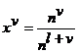
(64)
and
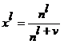
(65)
so
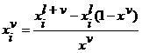
(66)
and
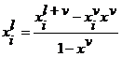
(67)

3. Analyze
The equilibrium constant (K_{eq}) of a reaction is given by
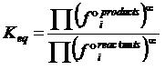
(68)
where f°_{i}^{products} and f°_{i}^{reactants} correspond respectively to the pure fugacities of products and reactants in a given reaction, and α corresponds to the stoichiometric coefficient of the i constituent in the reaction. The reaction constant (K_{r}) of a reaction is given by
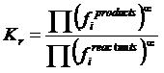
(69)
where f_{i}^{products} and f_{i}^{reactants} correspond respectively to the mixture fugacities of products and reactants in a given reaction. When K_{r}=K_{eq}, the reaction is possible and reaction’s one product can be purify with
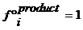
(70)
and
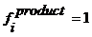
(71)
So it’s possible to know the product activity (a_{i}^{product}) using the formulation corresponding to
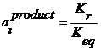
(72)
The experiments on hydrothermal stability of adenine realized by Franiatte and al. (2008) can be discussed in regards of this analyze on the reactions and the method resolving the EOS of Soave (1972). The fugacities of gases obtained from the molar fraction considering mass balance and reactions explained in the paper of the authors and recalculate in this study must be in good agreement with the reality occurring on the reaction capacity of a fluid, because PVTX data is in good agreement with the literature in regards of results, discussed in the next chapter. The Table 1 report the calculation on the experiment of the stability of adenine in an hydrothermal system at 300°C and 400 bar made by the authors. This imply that an equilibrium state was hinted in their experiments because the same fugacities of H₂ were calculate in this study with the reactions of iron oxidation and water dissociation using the equilibrium constant of these reactions and the fugacities of the fluid. The Table 2 report the calculation on the experiment of the synthesis of acridine orange in a potential hydrothermal system at 250°C and 140 bars looking like the experiment of the authors whom report later the synthesis by an observation of an orange liquid after warmed 3 days and thin white sticks after one month. Both Tables reports the adenine and the acridine orange concentrations, the same as those observed by the authors. Despite of a little incertitude on the pressure and the water quantities but it’s were calculate with accuracy using the method of resolving equation of state for the PVTX data and how the authors observed the remaining quantities in their experiments for the water quantities measurements.

4. Results

4.1. Pure gases
The values of molar masses and critical parameters of the ten gases studied are reported in the Table 3. The molar volumes of H₂ gas determined by Presnall (1969) are compared in the Figure 1 and in the Table 4 with values calculated as part of this work from the resolution of Redlich-Kwong EOS (Redlich and Kwong, 1949) modified by Soave (1972) dependent of only four parameters describing a gas.
The molar specific volumes of H₂O reported in Figures 2 (a) and (b) can be used both to compare the experimental values of Kennedy (1950) with the values of steam tables (Grigull, 1984) and with the values obtained in this study. Densities of CO₂ are presented and compared with the experimental values reported by Kennedy (1954) in the Figure 3. The molar volumes of H₂, SO₂ and H₂S obtained in this study are presented and compared with the values reported by Shi and Saxena (1992) in the Figures 4 and 5. The comparisons of the molar volumes of CH₄, CO₂, N₂, H₂, Cl₂, O₂ and CO between the values obtained in this study and the values reported by Duan at al. (1992) are shown in the Tables 5 and 6. These comparisons show the good agreement with the authors for all gases exempted for H₂S.

4.2. Mixture gases
The molar volumes of the system H₂O-CO₂ obtained in this study are presented and compared with the values reported by Shi and Saxena (1992) and the envelop of experimental values reported by Plyasunov and Zakirov (1991) in the Figure 6 and the Figure 7 respectively for each author. The molar volumes of the system H₂O-H₂ are reported in Figure 8 and compared with envelop of experimental values reported by Seward and Franck (1981) but for this Figure, the comparison isn’t in good agreement with the authors. The data of Takenouchi and Kennedy (1964) on the composition of CO₂ in H₂O under and beneath their system is compared with an interpretation resulting of this study. In the calculation of the composition, the consideration take place when all the CO₂ gas and liquid is in the less dense phase for the composition of the gas and none appear in the liquid while the vapor fraction (X^{V}) is the sum of the less dense phases and is used to calculate the composition of the liquid with the Equation (67) (Table 7).

5. Conclusion
The developing EOS resolution, unlike other EOS developed by Shi and Saxena (1992) or Duan and al. (1992), need only four parameters (M, P_{c}, T_{c} and ω) to be accurate to describe PVTX and the fugacities of a pure gas and mixture gases. This study demonstrate that a liquid have always a density of 1 g/cm³ and a fluid with both liquid and gas phase have a possible maximum density of 2 g/cm³. The equation of state resolution presented here can predict PVTX properties and fugacities of gases and systems which aren’t limited to eight gases like the program realized for these fittings. This is practical for the study of chemical synthesis and analysis and somehow for the study of fluid inclusions.

References
Duan Z., Moller N. and Weare J.H. (1992) Molecular dynamics simulation of PVT properties of geological fluids and a general equation of state of nonpolar and weakly polar gases up to 2000 K and 20 000 bar. Geochim. Cosmochim. Acta 56, 3839-3845.
Fowler R.H. and Guggenheim E.A. (1939) Statistical Thermodynamics, New York and Cambridge, pp 345-346, 425. Cambridge University Press.
Franiatte M., Richard L., Elie M., Nguyen-Trung C., Perfetti E. and LaRowe D. (2008) Hydrothermal stability of adenine under controlled fugacities of N₂, CO₂ and H₂, Orig. Life evol. biosph. 38, 139-148.
Grigull U. (1984) Concise steam tables in SI-units (student’s tables). Properties of ordinary water substance up to 1000°C and 100 megapascal .In Steam Tables in SI-units, Springer-Verlag, Berlin, Heidelberg, New York, 2nd revised edition. U. Grigull, J. Straub and P. Schiebener.
Holloway J.R. (1977) Fugacity and activity of molecular species in supercritical fluids. In Thermodynamics in Geology (éd. D.G. Fraser), Reidel Publishing Company, pp. 161-181.D.
Kennedy G.C. (1950) Pressure-volume-temperature relations in water. Amer. J. Sci. 248, 540-564.
Kennedy G.C. (1954) Pressure-volume-temperature relations in CO₂ at elevated temperatures and pressures. Amer. J. Sci. 252, 225-241.
Kishima N. and Sakai H. (1984) Fugacity-concentration relationship of dilute hydrogen in water at elevated temperature and pressure. Earth and Planetary Science Letters 67, 79-86.
Plyasunov A.V. and Zakirov I.V. (1991) Estimation of the thermodynamic properties of homogeneous water-carbon dioxide mixtures at high temperatures and pressures. Ocherki Fiz.-khim. Petrol. 17, 71-88.
Presnall D.C. (1969) Pressure-volume-temperature measurmeents on hydrogen from 200° to 600°C and up to 1800 atmospheres. J. Geophys. Res. 74, 6026-6033.
Prausnitz J.M., Lichtenthaler R.N and de Azevedo E.G. (1986) Molecular Thermodynamics of Fluid-Phase Equilibria (second edition), Prentice-Hall.
Shi Pingfang and Saxena S.K. (1992) Thermodynamic modeling of the C-H-O-S fluid system. American Mineralogist 77, 1038-1049.
Redlich O. and Kwong J.N.S. (1949) On the thermodynamics of solutions. V. An equation of state. Chem. Phys. 44, 233-244.
Rimbach H. and Chatterjee N.D. (1987) Equations of state for H₂, H₂O, and H₂-H₂O fluid mixtures at temperatures above 0.01°C and at high pressure. Phys. Chem. Minerals 14, 560-569.
Seward T.M. and Franck E.U. (1981) The system hydrogen-water up to 440°C and 2500 bar pressure. Berichte der Bunsengesellschaft für Physikalische Chemie 85, 2-7.
Soave G. (1972) Equilibrium constants from a modified Redlich-Kwong equation of state. Chem. Eng. Sci. 27, 1197-1203.
Takenouchi S. and Kennedy G.C. (1964) The binary system H₂O-CO₂ at high temperatures and pressures. Am. J. Sci. 262, 1055-1074.
Van der Waals J.D. (1873) Over de Continuïteit van den Gas- en Voleistoftoestand. Thèse de Doctorat de l’Université de Leyde.

Listing of Tables
Table 1: Thermodynamic interpretation of the experiments realized by Franiatte and al. (2008) on the adenine stability at 300°C and 400 bar.
Table 2: Thermodynamic interpretation of the experiments realized during the works of Franiatte and al. (2008) on the acridine orange synthesis at 250°C and 140 bars.
Table 3: Molar masses, critical parameters and acentric factors for the ten gases studied here.
Table 4: Comparison of molar volumes of H₂ measured [404.5] by Presnall (1969) and the calculate values in this study [402.4] from the resolution of Redlich-Kwong EOS modified by Soave (1972). The values between brackets correspond to the errors expressed in percents.
Table 5: Molar volumes of CO₂, N₂, CH₄, H₂, Cl₂, O₂ and CO function of T and P. The calculated molar volume values in this study (V* = M/x^{l}) are closer to the molar volumes (V) reported by Duan and al. (1992).
Table 6: Molar volumes of CH₄ function of T and P. The calculated molar volume values in this study (V* = M/x^{l}) are closer to the molar volumes (V) reported by Duan and al. (1992).
Table 7: Experimental data of Takenouchi and Kennedy (1964) compared to this study on the fraction of CO₂ in H₂O+CO₂ in the gas phase X_{i,gas}= n_{i}/(n_{j}(1-x^{l})+ n_{i}) expressed in percents. The vapor fraction X^{v} = 1- n_{j}(x^{l}) with V_{i}^{g}<V_{i}^{l} and V_{j}^{g}>V_{j}^{l} allow to deduce fraction of CO₂ in the liquid phase X_{i,liq} = 0.

Listing of Figures
Figure 1: The pressure-volume-temperature relations for H₂ gas. The symbols correspond to the values measured by Presnall (1969). The curves were calculated in this study from the Redlich-Kwong EOS modified by Soave (1972) and improved as part of this work.
Figure 2: Specific volumes of H₂O reproduced with the steam table of Grigull (1984) for (a) and reproduced with this study for (b) (dashed lines), compared with the experimental specific volumes of Kennedy (1950) drawn for some pressures (dark lines).
Figure 3: Density of CO₂ reproduced in this study. The dashed lines are the results of this study for CO₂, and the dark lines are the results of the experimental study of Kennedy (1954) for the some pressures. The results are relatively closed (with V^{fluid} = M/ x^{l}).
Figure 4: Molar volumes of H₂ for (a), (b) and (c) and SO₂ for (d), (e) and (f) function of T and P. The curves were drawn for pressures from 5 to 100 bars for (a, d) from 200 to 1000 bars for (b, e) and from 1000 to 10000 for (c, f). The values were calculated in this study (dashed lines) compared to the molar volumes reported by Shi and Saxena (1992) reproduced and drawn from their figures (dark lines). The results are relatively closed (with V^{fluid} = M/ x^{l}).
Figure 5: Molar volumes of H₂S function of T and P. The curves were drawn for pressures from 100 to 500 bars for (a) and from 600 to 10000 bars for (b). The values were calculated in this study (dashed lines) compared to the molar volumes reported by Shi and Saxena (1992) reproduced and drawn from their figures (dark lines). The results are relatively closed (with V^{fluid} = M/ x^{l}).
Figure 6: Molar volumes of H₂O-CO₂ system at 400°C for (a), at 500°C for (b), at 600°C for (c) and at 700°C for (d), function of molar fraction of H₂O and P. The curves were drawn for pressures from 1000 to 6000 bars and calculated in this study (dashed lines). The values reported by Shi and Saxena (1992) were reproduced and drawn from their figures (dark lines). The results are relatively closed (with V^{fluid} = M/ x^{l}).
Figure 7: Specific volume of H₂O-CO₂ system reproduced in this study. The dashed lines are the results of this study, and the dark lines are the results of the experimental study of Plyasunov and Zakirov (1991) for the extreme pressures. Both results are in good agreement (with V^{fluid} = M/ x^{l}).
Figure 8: Specific volume of H₂O-H₂, with 0.5% to 100% of H₂, reproduced in this study (dashed lines). The dark line corresponds to the values of Seward and Franck (1981) for 0.5% and 90% of H₂. Both results aren’t in good agreement (with V^{fluid} = M/ x^{l}).

Table 1: Thermodynamic interpretation of the experiments realized by Franiatte and al. (2008) on the adenine stability at 300°C and 400 bar.
 | Starting mass (g) | M (g/mol) | Mol number
Fe | 2.0000 | 55.0000 | 0.0364
H₂O | 10.0000 | 18.0158 | 0.5551
C₂H₂O₄,2H₂O | 0.2660 | 126.0660 | 0.0021
NH₄Cl/NaNO₂ | 0.1998 | 53.5900 | 0.0037
C₅H₅N₅ | 0.0013 | 134.6950 | 0.00001
 | Mol number | Intermediary mass | Mass and mol of transformed water
3Fe + 4 H₂O = Fe₃O₄ + 4 H₂ | 0.0507 | 0.2048 | 1.8300
H₂O = H₂ + 0.5 O₂ | 0.5666 | 10.2086 | 0.1016
C₂H₂O₄,2H₂O = H₂ + 2 CO₂ + 2 H₂O | 0.0043 | 0.1879 | mass and mol of producted H₂
NaNO₂ + NH₄Cl = N₂ + NaCl + 2 H₂O | 0.0038 | 0.1052 | 0.2048
C₅H₅N₅ + 10 H₂O = 5 CO₂ + 2.5 N₂ + 12.5 H₂ | 0.0000 | 0.0013 | 0.1016
 | Final mass (g) | Massic fraction/H₂O | X_{i}
H₂ | 0.2048 | 0.9761 | 0.1767
H₂O | 8.3786 | 1.0000 | 0.8088
CO₂ | 0.1879 | 0.9781 | 0.0074
N₂ | 0.1052 | 0.9876 | 0.0065
O₂ |  |  | 0.0005
 | P_{i} | φ_{i} | f_{i}
H₂ | 70.6645 | 6.4639 | 456.7660
H₂O | 323.5351 | 0.2705 | 87.5215
CO₂ | 2.9705 | 2.2757 | 6.7600
N₂ | 2.6116 | 7.3329 | 19.1506
O₂ | 0.2183 | 4.6005 | 1.0041
 | φ_{i}° | f_{i}° | a_{i}
H₂ | 1.1554 | 462.1436 | 0.9884
H₂O | 0.2213 | 88.5223 | 0.9887
CO₂ | 1.0049 | 401.9508 | 0.0168
N₂ | 1.2192 | 487.6827 | 0.0393
O₂ | 1.1409 | 456.3403 | 0.0022
 | Equilibrium constant | Reaction constant | f_{i}
3Fe + 4 H₂O = Fe₃O₄ + 4 H₂ (H₂) | 2.8709 | 2.8703 | 456.9187
H₂ + 0.5 O₂ = H₂O (H₂) | -2.0474 | -0.7236 | 456.6454
C₅H₅N₅ + 6.25 O₂ = 5 CO₂ + 2.5 N₂ + 2.5 H₂O (C₅H₅N₅) | 7.9883 | 12.1994 | 6.1505×10⁻⁵
C₅H₅N₅ + 10 H₂O = 5 CO₂ + 2.5 N₂ + 12.5 H₂ (C₅H₅N₅) | 33.58039 | 21.18021 | 2.5129×10¹²

Table 2: Thermodynamic interpretation of the experiments realized during the works of Franiatte and al. (2008) on the acridine orange synthesis at 250°C and 140 bars.
 | Starting mass (g) | M (g/mol) | Mol number
Fe | 2.0000 | 55.0000 | 0.0364
H₂O | 10.0000 | 18.0158 | 0.5551
C₂H₂O₄,2H₂O | 0.2660 | 126.0660 | 0.0021
NH₄Cl/NaNO₂ | 0.1998 | 53.5900 | 0.0037
C₅H₅N₅ | 0.0000 | 134.6950 | 0.0000
 | Mol number | Intermediary mass | Mass and mol of transformed water
3Fe + 4 H₂O = Fe₃O₄ + 4 H₂ | 0.0506 | 0.1606 | 1.4350
H₂O = H₂ + 0.5 O₂ | 0.5667 | 10.2104 | 0.0797
C₂H₂O₄,2H₂O = H₂ + 2 CO₂ + 2 H₂O | 0.0042 | 0.1857 | mass and mol of producted H₂
NaNO₂ + NH₄Cl = N₂ + NaCl + 2 H₂O | 0.0037 | 0.1045 | 0.1606
C₅H₅N₅ + 10 H₂O = 5 CO₂ + 2.5 N₂ + 12.5 H₂ | 0.0000 | 0.0000 | 0.0797
 | Final mass (g) | Massic fraction/H₂O | X_{i}
H₂ | 0.1606 | 0.9820 | 0.1378
H₂O | 8.7754 | 1.0000 | 0.8425
CO₂ | 0.1857 | 0.9793 | 0.0073
N₂ | 0.1045 | 0.9882 | 0.0064
O₂ |  |  | 0.0060
 | P_{i} | φ_{i} | f_{i}
H₂ | 19.2868 | 29.0147 | 559.6001
H₂O | 117.9434 | 0.3239 | 38.1970
CO₂ | 1.0218 | 6.1792 | 6.3141
N₂ | 0.9029 | 32.4364 | 29.2882
O₂ | 0.8451 | 17.1127 | 14.4617
 | φ_{i}° | f_{i}° | a_{i}
H₂ | 1.0554 | 147.7499 | 3.7875
H₂O | 0.2738 | 38.3324 | 0.9965
CO₂ | 0.9565 | 133.9039 | 0.0472
N₂ | 1.0715 | 150.0148 | 0.1952
O₂ | 1.0415 | 145.8122 | 0.0992
 | Equilibrium constant | Reaction constant | f_{i}
3Fe + 4 H₂O = Fe₃O₄ + 4 H₂ (H₂) | 2.3438 | 4.6634 | 147.2278
H₂ + 0.5 O₂ = H₂O (H₂) | -1.6679 | -1.1676 | 10.0929
C₁₃H₉N + 26 H₂O = 13 CO₂ + 0.5 N₂ + 30.5 H₂ (C₁₃H₉N) | 53.7342 | 53.8149 | 8.3051×10⁻¹
C₁₃H₉N + 15.25 O₂ = 13 CO₂ + 0.5 N₂ + 4.5 H₂O (C₁₃H₉N) | 2.86457 | 0.56315 | 2.0018×10²

Table 3: Molar masses, critical parameters and acentric factors for the ten gases studied here.

Gas | M (g/mol) | T_{c}(K) | P_{c} (bar) | ωª
H₂ | 2.0158 | 33.20 | 13.00 | -0.2150
H₂O | 18.0158 | 647.30 | 221.20 | 0.3440
CO₂ | 44.0496 | 304.20 | 73.80 | 0.2250
CH₄ | 16.0486 | 190.60 | 46.00 | 0.0080
N₂ | 28.0134 | 126.20 | 33.90 | 0.0400
SO₂ | 64.1508 | 430.64 | 78.84 | 0.2557
H₂S | 34.0814 | 373.20 | 89.40 | 0.1000
Cl₂ | 70.9000 | 416.90 | 79.77 | 0.0000
O₂ | 32.0852 | 154.60 | 50.50 | 0.0210
CO | 28.0102 | 132.90 | 35.00 | 0.0490
ª without dimension

Table 4: Comparison of molar volumes of H₂ measured [404.5] by Presnall (1969) and the calculate values in this study [402.4] from the resolution of Redlich-Kwong EOS modified by Soave (1972). The values between brackets correspond to the errors expressed in percents.
 | Température (°C)
Pression (bar) | 200°C | 300°C | 400°C | 500°C | 600°C
101 | 404.5 | 486.1 | 567.4 | 649.0 | -
 | 402.4 | 485.2 | 567.7 | 650.1 | 732.3
 | (0.51) | (0.19) | (0.05) | (0.16) | -
152 | 274.6 | 329.5 | - | - | -
 | 273.1 | 328.5 | 383.6 | 438.6 | 493.5
 | (0.53) | (0.31) | - | - | -
203 | 210.4 | 251.4 | 291.1 | 331.8 | 372.6
 | 208.6 | 250.2 | 291.6 | 332.9 | 374.1
 | (0.88) | (0.49) | (0.17) | (0.33) | (0.41)
304 | 145.4 | 172.7 | 199.3 | 226.2 | 253.3
 | 144.1 | 171.9 | 199.6 | 227.2 | 254.8
 | (0.92) | (0.45) | (0.16) | (0.45) | (0.58)
405 | 113.3 | 133.4 | 153.2 | 174.0 | 193.6
 | 111.9 | 132.8 | 153.7 | 174.4 | 195.1
 | (1.24) | (0.42) | (0.30) | (0.23) | (0.77)
507 | 93.9 | 109.9 | 125.6 | 142.2 | 158.3
 | 92.6 | 109.4 | 126.1 | 142.7 | 159.3
 | (1.35) | (0.44) | (0.41) | (0.37) | (0.63)
608 | 80.9 | 94.3 | 107.5 | 121.1 | 134.7
 | 79.8 | 93.8 | 107.8 | 121.6 | 135.4
 | (1.33) | (0.49) | (0.24) | (0.43) | (0.55)
709 | 71.5 | 83.1 | 94.4 | 106.0 | 117.4
 | 70.7 | 82.7 | 94.7 | 106.6 | 118.4
 | (1.12) | (0.46) | (0.28) | (0.53) | (0.86)
811 | 64.6 | 74.7 | 84.7 | 94.8 | 104.8
 | 63.9 | 74.4 | 84.8 | 95.3 | 105.6
 | (1.13) | (0.42) | (0.17) | (0.49) | (0.80)
912 | 59.2 | 68.1 | 76.9 | 85.8 | 94.7
 | 58.6 | 67.9 | 77.2 | 86.5 | 95.7
 | (0.98) | (0.26) | (0.42) | (0.79) | (1.07)
1013 | 54.7 | 62.9 | 70.7 | 78.7 | 86.6
 | 54.3 | 62.8 | 71.1 | 79.5 | 87.8
 | (0.69) | (0.24) | (0.60) | (0.97) | (1.36)
1115 | 51.2 | 58.5 | 65.6 | 72.9 | 80.1
 | 50.9 | 58.5 | 66.1 | 73.7 | 81.3
 | (0.52) | (0.10) | (0.82) | (1.13) | (1.47)
1216 | 48.2 | 54.9 | 61.4 | 68.1 | 74.7
 | 48.0 | 55.0 | 62.0 | 68.9 | 75.9
 | (0.32) | (0.20) | (0.96) | (1.23) | (1.57)
1317 | 45.6 | 51.9 | 57.9 | 64.0 | 70.0
 | 45.6 | 52.0 | 58.5 | 64.9 | 71.3
 | (0.12) | (0.33) | (1.05) | (1.40) | (1.85)
1419 | 43.5 | 49.2 | 54.8 | 60.5 | 66.1
 | 43.5 | 49.5 | 55.5 | 61.4 | 67.4
 | (0.04) | (0.56) | (1.26) | (1.54) | (1.92)
1520 | 41.6 | 46.9 | 52.1 | 57.4 | 62.6
 | 41.7 | 47.3 | 52.9 | 58.4 | 64.0
 | (0.35) | (0.74) | (1.51) | (1.79) | (2.19)
1621 | 39.9 | 44.9 | 49.8 | 54.7 | 59.6
 | 40.1 | 45.4 | 50.6 | 55.8 | 61.0
 | (0.66) | (1.14) | (1.67) | (1.98) | (2.40)
1723 | 38.4 | 43.1 | 47.7 | 52.3 | 56.9
 | 38.7 | 43.7 | 48.6 | 53.5 | 58.4
 | (0.87) | (1.28) | (1.95) | (2.19) | (2.69)
1824 | 37.0 | 41.4 | 45.7 | 50.1 | 54.4
 | 37.5 | 42.2 | 46.8 | 51.4 | 56.1
 | (1.38) | (1.72) | (2.33) | (2.65) | (3.13)

Table 5: Molar volumes of CO₂, N₂, CH₄, H₂, Cl₂, O₂ and CO function of T and P. The calculated molar volume values in this study (V* = M/x^{l}) are closer to the molar volumes (V) reported by Duan and al. (1992).

P (bar) | T (°C) | V* (cm³/mol) | V (cm³/mol) | P (bar) | T (°C) | V* (cm³/mol) | V (cm³/mol)
CO₂ |  |  |  | CH₄
25.0 | 800.00 | 3594.0520 | 3587.93 | 16.4 | 0.1 | 1330.4 | 1333.46
100.0 | 100.00 | 250.7958 | 238.45 | 41.8 | 350.1 | 1250.5 | 1253.88
100.0 | 800.00 | 917.2769 | 911.47 | 2026.5 | 50.4 | 35.8 | 40.20
500.0 | 100.00 | 56.2962 | 55.13 | 8612.6 | 50.4 | 28.4 | 29.01
500.0 | 800.00 | 203.5707 | 199.33 | 2026.5 | 400.4 | 51.2 | 55.29
1000.0 | 100.00 | 43.0439 | 45.46 | 8106.0 | 400.4 | 32.2 | 33.76
1000.0 | 800.00 | 114.4235 | 112.22 | 8612.6 | 400.4 | 31.8 | 33.16
2000.0 | 100.00 | 35.7606 | 39.11 | 18935.0 | 940.9 | 30.9 | 30.26
2000.0 | 300.00 | 46.5327 | 48.51 | 23436.0 | 315.9 | 27.6 | 24.72
4000.0 | 375.00 | 38.1752 | 41.25
8000.0 | 200.00 | 29.85202 | 31.93 | H₂
8000.0 | 399.90 | 32.18632 | 34.49 | 5000.0 | 100.0 | 20.5 | 19.98
8000.0 | 700.00 | 35.49961 | 37.97 | 6000.0 | 100.0 | 19.5 | 18.64
9208.2 | 1022.35 | 36.90336 | 39.72 | 7000.0 | 100.0 | 18.8 | 17.62
19911.3 | 916.55 | 30.33205 | 30.34 | 5000.0 | 150.0 | 21.3 | 20.99
28315.3 | 1672.05 | 30.82903 | 30.87 | 6000.0 | 150.0 | 20.2 | 19.53
21678.3 | 500.65 | 28.33784 | 27.51 | 7000.0 | 150.0 | 19.4 | 18.43
N₂ |  |  |  | Cl₂
52.9 | 0.0 | 423.4 | 424.20 | 10.0 | 277.0 | 4488.2 | 4504.52
299.6 | 100.0 | 117.6 | 120.20 | 100.0 | 277.0 | 370.9 | 384.81
1444.0 | 100.0 | 42.1 | 47.54 | 250.0 | 277.0 | 121.4 | 117.02
2602.6 | 100.0 | 33.6 | 38.54 | 100.0 | 627.0 | 735.3 | 736.58
1594.5 | -25.0 | 33.2 | 38.95 | 250.0 | 627.0 | 292.8 | 290.59
5107.7 | -25.0 | 26.3 | 29.09
7988.8 | -25.0 | 25.0 | 26.29 | O₂
1000.0 | 1526.9 | 170.7 | 180.73 | 5066.0 | 200.0 | 25.2 | 28.91
5000.0 | 1526.9 | 52.0 | 58.51 | 7092.0 | 200.0 | 23.2 | 26.10
3000.0 | 0.2 | 29.3 | 33.81 | 5066.0 | 300.0 | 26.9 | 30.76
20000.0 | 0.2 | 23.7 | 21.64 | 9119.0 | 300.0 | 23.0 | 25.41
3000.0 | 24.3 | 30.0 | 34.55 | 5066.0 | 400.0 | 28.6 | 32.61
22000.0 | 24.3 | 23.7 | 21.26 | 10132.0 | 400.0 | 23.3 | 25.68
3000.0 | 47.7 | 30.7 | 35.26 | 1801.0 | 121.2 | 33.6 | 38.60
22000.0 | 47.7 | 23.8 | 21.33 | 6027.6 | 1022.8 | 35.8 | 40.27
3000.0 | -25.7 | 28.6 | 33.01 | 4049.2 | 134.0 | 25.5 | 29.62
5000.0 | -25.7 | 26.3 | 29.22 | 17037.2 | 920.7 | 23.7 | 25.74
10000.0 | -25.7 | 24.5 | 25.01
15000.0 | -25.7 | 23.9 | 22.90 | CO
3000.0 | 0.2 | 29.3 | 33.81 | 2000.0 | 35.0 | 34.3 | 40.15
5000.0 | 0.2 | 26.8 | 29.74 | 5000.0 | 35.0 | 27.9 | 31.11
10000.0 | 0.2 | 24.7 | 25.27 | 10000.0 | 35.0 | 25.6 | 26.20
15000.0 | 0.2 | 24.0 | 23.06 | 2000.0 | 100.0 | 37.2 | 43.00
20000.0 | 0.2 | 23.7 | 21.64 | 5000.0 | 100.0 | 29.0 | 32.38
3000.0 | 24.3 | 30.0 | 34.55 | 10000.0 | 100.0 | 26.1 | 26.86
5000.0 | 24.3 | 27.2 | 30.21 | 2000.0 | 200.0 | 41.8 | 47.43
10000.0 | 24.3 | 24.9 | 25.51 | 5000.0 | 200.0 | 30.7 | 34.37
15000.0 | 24.3 | 24.2 | 23.21 | 10000.0 | 200.0 | 27.0 | 27.97
20000.0 | 24.3 | 23.8 | 21.72 | 2500.0 | 300.0 | 41.7 | 47.11
22000.0 | 24.3 | 23.7 | 21.26 | 5000.0 | 300.0 | 32.4 | 36.39
3000.0 | 47.7 | 30.7 | 35.26 | 10000.0 | 300.0 | 27.8 | 29.17
5000.0 | 47.7 | 27.6 | 30.66
10000.0 | 47.7 | 25.1 | 25.74
15000.0 | 47.7 | 24.3 | 23.35
20000.0 | 47.7 | 23.9 | 21.81
22000.0 | 47.7 | 23.8 | 21.33

Table 6: Molar volumes of CH₄ function of T and P. The calculated molar volume values in this study (V* = M/x^{l}) are closer to the molar volumes (V) reported by Duan and al. (1992).

P (bar) | T (°C) | V* (cm³/mol) | V (cm³/mol) | P (bar) | T (°C) | V* (cm³/mol) | V (cm³/mol)
50.5 | -14.6 | 363.3 | 364.96 | 2697.1 | 1607.6 | 83.5 | -
60.6 | 20.4 | 360.5 | 360.65 | 3156.2 | 1993.0 | 85.1 | -
86,3 | 109,7 | 355,5 | 355.13 | 3810,8 | 2425,0 | 83,9 | -
131,1 | 284,0 | 362,1 | 361.96 | 313,4 | 19,4 | 70,3 | 71.01
193,3 | 517,6 | 359,2 | 359.48 | 455,6 | 73,6 | 69,0 | 71.12
281,9 | 855,5 | 356,9 | 357.79 | 611,5 | 136,5 | 68,5 | 71.39
407,4 | 1339,3 | 354,6 | - | 821,7 | 218,9 | 67,5 | 70.97
587,2 | 2041,5 | 352,8 | - | 1050,2 | 317,6 | 67,4 | 71.26
60,4 | -62,1 | 166,3 | - | 1335,9 | 441,6 | 67,2 | 71.26
85,1 | -21,4 | 181,3 | 182.03 | 1656,5 | 577,2 | 66,6 | 70.89
118,5 | 31,0 | 182,2 | 180.62 | 2053,5 | 742,8 | 65,9 | 70.35
158,2 | 92,0 | 180,5 | 179.42 | 2750,8 | 1059,5 | 65,7 | 70.43
209,5 | 175,8 | 180,8 | 180.54 | 3723,1 | 1500,1 | 65,1 | -
266,7 | 270,2 | 180,5 | 180.88 | 4464,1 | 1855,5 | 65,1 | -
342,2 | 390,3 | 178,2 | 179.09 | 5412,0 | 2300,0 | 64,8 | -
429,4 | 538,4 | 178,0 | 179.33 | 6419,2 | 2817,2 | 65,1 | -
535,9 | 724,4 | 178,1 | 179.86 | 251,1 | -31,1 | 59,8 | 60.08
667,6 | 950,0 | 177,1 | 179.37 | 307,3 | -15,6 | 59,2 | 60.33
833,2 | 1230,9 | 175,5 | 178.44 | 490,3 | 33,9 | 57,7 | 60.38
1035,6 | 1566,9 | 173,2 | - | 661,7 | 87,2 | 57,8 | 61.19
1261,3 | 1976,9 | 173,5 | - | 885,4 | 153,0 | 57,2 | 61.14
1551,8 | 2487,9 | 172,6 | - | 1166,3 | 228,5 | 56,0 | 60.27
1894,6 | 3103,8 | 172,1 | - | 1432,6 | 320,5 | 56,5 | 60.89
131,9 | -8,6 | 120,9 | 120.06 | 1734,7 | 429,0 | 57,0 | 61.44
183,2 | 39,8 | 122,2 | 121.00 | 2161,8 | 554,9 | 56,1 | 60.68
261,6 | 109,6 | 120,1 | 119.91 | 2639,2 | 700,2 | 55,5 | 60.17
344,9 | 190,9 | 120,4 | 121.21 | 3122,5 | 867,7 | 55,6 | 60.33
437,1 | 282,9 | 120,5 | 121.93 | 3719,0 | 1073,0 | 55,5 | 60.39
565,7 | 404,0 | 118,8 | 120.75 | 4427,9 | 1332,6 | 55,7 | -
715,8 | 549,2 | 117,6 | 120.03 | 5341,2 | 1640,5 | 55,3 | -
880,5 | 728,4 | 118,5 | 121.24 | 6258,3 | 2005,6 | 55,7 | -
1096,4 | 938,5 | 116,8 | 120.03 | 7353,6 | 2445,3 | 56,0 | -
1367,6 | 1195,2 | 114,7 | - | 8753,9 | 2950,8 | 55,7 | -
1692,0 | 1523,3 | 113,8 | - | 373,5 | -39,8 | 48,4 | 50.37
2073,6 | 1902,0 | 112,6 | - | 594,3 | 2,9 | 47,8 | 51.28
2503,6 | 2387,2 | 113,3 | - | 908,0 | 49,4 | 45,8 | 50.06
3071,1 | 2961,5 | 112,0 | - | 1148,2 | 110,4 | 46,8 | 51.31
135,0 | -33,0 | 90,4 | 90.75 | 1516,2 | 177,2 | 46,1 | 50.67
198,6 | -192,4 | 29,5 | 91.83 | 1890,0 | 257,6 | 46,1 | 50.71
266,4 | 50,4 | 92,5 | 92.50 | 2383,9 | 359,3 | 45,9 | 50.42
372,2 | 111,4 | 90,2 | 91.33 | 2927,2 | 479,4 | 45,9 | 50.36
494,9 | 185,0 | 89,0 | 90.97 | 3651,6 | 621,7 | 45,4 | 49.78
806,7 | 380,6 | 87,7 | 90.67 | 4340,2 | 799,0 | 45,8 | 50.25
1011,1 | 508,4 | 86,8 | 90.11 | 5178,8 | 995,5 | 45,8 | 50.27
1245,4 | 663,9 | 86,5 | 90.12 | 6220,9 | 1251,2 | 45,9 | 50.44
1495,3 | 843,5 | 86,9 | 90.79 | 8668,1 | 1920,4 | 46,5 | -
1838,1 | 1057,5 | 85,5 | 89.74 | 10059,7 | 2353,3 | 47,1 | -
2233,1 | 1304,5 | 84,3 | - | 11928,8 | 2857,8 | 47,1 | -
739,0 | -29,2 | 40,7 | 44.48 | 9082,9 | 1037,3 | 37,5 | 40.61
971,4 | 1,0 | 40,4 | 44.70 | 10282,8 | 1243,6 | 37,8 | 40.97
1271,6 | 56,2 | 41,2 | 45.76 | 11901,1 | 1521,4 | 38,1 | -
1622,2 | 106,5 | 40,9 | 45.55 | 13573,5 | 1831,3 | 38,4 | -
2080,2 | 171,4 | 40,6 | 45.13 | 15513,5 | 2175,1 | 38,6 | -
2422,1 | 234,4 | 40,9 | 45.37 | 2060,1 | -52,4 | 31,7 | 34.68
2821,1 | 306,0 | 41,1 | 45.46 | 2482,4 | -22,4 | 31,8 | 35.22
3131,0 | 350,6 | 40,9 | 45.16 | 2992,7 | 14,5 | 31,9 | 35.40
3305,3 | 391,2 | 41,2 | 45.44 | 3458,5 | 50,4 | 32,0 | 35.42
4002,6 | 496,3 | 40,9 | 44.95 | 4017,3 | 96,8 | 32,2 | 35.39
4390,0 | 589,8 | 41,4 | 45.48 | 4651,6 | 152,0 | 32,3 | 35.31
5232,5 | 737,0 | 41,3 | 45.33 | 5444,8 | 214,0 | 32,4 | 35.03
5833,9 | 855,1 | 41,5 | 45.45 | 6256,3 | 291,5 | 32,6 | 34.99
6546,7 | 992,6 | 41,5 | 45.52 | 6977,8 | 379,6 | 33,0 | 35.23
7508,3 | 1201,4 | 41,8 | - | 8118,6 | 470,7 | 32,9 | 34.88
8592,9 | 1427,5 | 42,0 | - | 9224,6 | 588,8 | 33,2 | 34.97
9906,1 | 1730,6 | 42,3 | - | 10372,2 | 735,0 | 33,5 | 35.32
11507,9 | 2056,0 | 42,3 | - | 11863,6 | 903,5 | 33,7 | 35.48
13101,0 | 2495,6 | 43,0 | - | 13543,8 | 1089,5 | 33,9 | 35.60
15227,7 | 2956,6 | 43,0 | - | 15302,5 | 1309,3 | 34,1 | 35.90
968,4 | -52,2 | 36,2 | 39.70 | 17317,8 | 1596,0 | 34,5 | -
1149,8 | -30,1 | 36,4 | 40.46 | 20099,1 | 1934,9 | 34,7 | -
1537,9 | 2,1 | 35,9 | 40.26 | 22438,8 | 2619,6 | 36,2 | -
1889,4 | 36,9 | 35,8 | 40.23 | 5077,9 | -42,7 | 28,7 | 29.92
2320,4 | 86,3 | 36,0 | 40.28 | 5549,5 | -24,3 | 28,7 | 30.09
2791,0 | 139,6 | 36,0 | 40.16 | 6096,7 | -1,9 | 28,8 | 30.16
3249,1 | 208,3 | 36,5 | 40.46 | 6583,8 | 29,1 | 28,9 | 30.36
3606,4 | -259,8 | 25,7 | 40.06 | 7111,6 | 53,3 | 29,0 | 30.29
3866,9 | 280,0 | 36,5 | 40.19 | 7705,3 | 84,3 | 29,1 | 30.23
4447,0 | 363,3 | 36,7 | 40.30 | 8278,6 | 120,1 | 29,2 | 30.21
5216,9 | 452,4 | 36,6 | 39.98 | 9207,3 | 169,5 | 29,3 | 30.03
5641,1 | 515,3 | 36,8 | 40.07 | 9742,8 | 207,2 | 29,4 | 30.02
6002,3 | 575,4 | 37,0 | 40.25 | 10655,1 | 260,5 | 29,5 | 29.88
6434,3 | 643,2 | 37,1 | 40.37 | 11623,5 | 321,5 | 29,6 | 29.79
6985,3 | 705,1 | 37,0 | 40.14 | 12582,3 | 392,2 | 29,8 | 29.80
7397,9 | 780,7 | 37,2 | 40.40 | 13754,1 | 472,6 | 30,0 | -
8138,7 | 854,3 | 37,0 | 39.99 | 16291,4 | 654,7 | 30,2 | -
8638,4 | 949,2 | 37,2 | 40.31 | 20041,0 | 920,7 | 30,5 | -

Table 7: Experimental data of Takenouchi and Kennedy (1964) compared to this study on the fraction of CO₂ in H₂O+CO₂ in the gas phase X_{i,gas}= n_{i}/(n_{j}(1-x^{l})+ n_{i}) expressed in percents. The vapor fraction X^{v} = 1- n_{j}(x^{l}) with V_{i}^{g}<V_{i}^{l} and V_{j}^{g}>V_{j}^{l} allow to deduce fraction of CO₂ in the liquid phase X_{i,liq} = 0.
 | This study |  |  | Exp. study |  |  |  | This study |  |  | Exp. study
P  (bars) | X_{i,liq} | X_{i,gas} | X^{v} | X_{i,liq} | X_{i,gas} | X^{v} | P  (bars) | X_{i,liq} | X_{i,gas} | X^{v} | X_{i,liq} | X_{i,gas} | X^{v}
350°C, 10.5% |  |  |  |  |  |  | 250°C, 28.8%
200 | 0.00 | 11.99 | 0.88 | 1.50 | 9.00 | 1.20 | 100 | 0.00 | 30.55 | 0.94 | 1.20 | 41.00 | 0.69
250 | 0.00 | 13.80 | 0.76 | 4.00 | 16.20 | 0.53 | 200 | 0.00 | 45.15 | 0.64 | 2.70 | 63.60 | 0.43
300 | 0.00 | 15.76 | 0.67 | 6.40 | 16.60 | 0.40 | 300 | 0.00 | 49.79 | 0.58 | 4.20 | 68.00 | 0.39
325 | 0.00 | 16.37 | 0.64 | 10.50 | 10.50 | - | 400 | 0.00 | 52.98 | 0.54 | 5.50 | 67.60 | 0.38
325°C, 18% |  |  |  |  |  |  | 500 | 0.00 | 55.62 | 0.52 | 6.40 | 66.00 | 0.38
150 | 0.00 | 19.56 | 0.92 | 1.00 | 10.60 | 1.77 | 600 | 0.00 | 57.93 | 0.50 | 7.40 | 63.60 | 0.38
200 | 0.00 | 20.77 | 0.87 | 2.60 | 24.60 | 0.70 | 700 | 0.00 | 60.03 | 0.48 | 8.40 | 61.30 | 0.39
250 | 0.00 | 23.68 | 0.76 | 4.30 | 32.10 | 0.49 | 800 | 0.00 | 61.97 | 0.46 | 9.40 | 59.30 | 0.39
300 | 0.00 | 26.48 | 0.68 | 6.10 | 34.20 | 0.42 | 900 | 0.00 | 63.79 | 0.45 | 10.40 | 58.00 | 0.39
350 | 0.00 | 28.27 | 0.64 | 8.20 | 33.40 | 0.39 | 1000 | 0.00 | 65.51 | 0.44 | 11.50 | 56.70 | 0.38
400 | 0.00 | 29.67 | 0.61 | 11.20 | 28.60 | 0.39 | 1100 | 0.00 | 67.16 | 0.43 | 12.50 | 55.50 | 0.38
435 | 0.00 | 30.51 | 0.59 | 18.00 | 18.00 | - | 1200 | 0.00 | 68.73 | 0.42 | 13.20 | 54.80 | 0.38
300°C, 23.6% |  |  |  |  |  |  | 1300 | 0.00 | 73.28 | 0.31 | 13.60 | 54.20 | 0.37
100 | 0.00 | 24.80 | 0.95 | 0.40 | 8.00 | 3.05 | 1400 | 0.00 | 71.72 | 0.40 | 14.00 | 54.00 | 0.37
150 | 0.00 | 25.82 | 0.91 | 1.60 | 29.00 | 0.80 | 1500 | 0.00 | 73.15 | 0.39 | 14.40 | 54.00 | 0.36
200 | 0.00 | 27.86 | 0.85 | 2.90 | 39.00 | 0.57 | 200°C, 28.8%
250 | 0.00 | 32.44 | 0.73 | 4.10 | 43.40 | 0.50 | 100 | 0.00 | 55.72 | 0.52 | 1.30 | 71.50 | 0.39
300 | 0.00 | 35.44 | 0.67 | 5.40 | 45.40 | 0.46 | 200 | 0.00 | 59.00 | 0.49 | 2.60 | 82.00 | 0.33
350 | 0.00 | 37.48 | 0.63 | 6.80 | 45.60 | 0.43 | 300 | 0.00 | 61.73 | 0.47 | 3.40 | 82.50 | 0.32
400 | 0.00 | 39.12 | 0.60 | 8.40 | 44.80 | 0.42 | 400 | 0.00 | 64.14 | 0.45 | 4.10 | 81.60 | 0.32
450 | 0.00 | 40.54 | 0.58 | 10.40 | 42.20 | 0.42 | 500 | 0.00 | 66.33 | 0.43 | 4.70 | 80.00 | 0.32
500 | 0.00 | 41.80 | 0.56 | 12.70 | 38.00 | 0.43 | 600 | 0.00 | 68.36 | 0.42 | 5.20 | 78.00 | 0.32
550 | 0.00 | 42.96 | 0.55 | 17.00 | 32.00 | 0.44 | 700 | 0.00 | 70.27 | 0.41 | 5.60 | 76.00 | 0.33
575 | 0.00 | 43.51 | 0.54 | 23.60 | 23.60 | - | 800 | 0.00 | 72.08 | 0.40 | 5.80 | 74.50 | 0.33
275°C, 27% |  |  |  |  |  |  | 900 | 0.00 | 75.71 | 0.32 | 6.10 | 73.20 | 0.34
100 | 0.00 | 28.47 | 0.95 | 1.00 | 25.60 | 1.06 | 1000 | 0.00 | 75.47 | 0.38 | 6.30 | 72.00 | 0.34
150 | 0.00 | 29.92 | 0.90 | 1.90 | 42.60 | 0.62 | 1100 | 0.00 | 77.07 | 0.37 | 6.50 | 71.60 | 0.34
200 | 0.00 | 35.53 | 0.76 | 2.80 | 50.00 | 0.51 | 1200 | 0.00 | 78.62 | 0.37 | 6.70 | 70.60 | 0.35
250 | 0.00 | 40.45 | 0.67 | 3.80 | 54.00 | 0.46 | 1300 | 0.00 | 80.12 | 0.36 | 6.90 | 70.00 | 0.35
300 | 0.00 | 43.00 | 0.63 | 4.90 | 55.80 | 0.43 | 1400 | 0.00 | 81.58 | 0.35 | 7.00 | 69.40 | 0.35
400 | 0.00 | 46.58 | 0.58 | 7.20 | 55.80 | 0.41 | 1500 | 0.00 | 83.01 | 0.35 | 7.20 | 69.00 | 0.35
500 | 0.00 | 49.34 | 0.55 | 9.60 | 53.00 | 0.40 | 150°C, 28.8%
600 | 0.00 | 51.69 | 0.52 | 12.00 | 49.60 | 0.40 | 100 | 0.00 | 70.88 | 0.41 | 1.35 | 88.00 | 0.32
700 | 0.00 | 53.79 | 0.50 | 14.40 | 46.00 | 0.40 | 200 | 0.00 | 73.20 | 0.39 | 2.15 | 91.00 | 0.30
800 | 0.00 | 55.72 | 0.48 | 17.50 | 42.00 | 0.39 | 300 | 0.00 | 75.36 | 0.38 | 2.60 | 90.00 | 0.30
885 | 0.00 | 57.25 | 0.47 | 27.00 | 27.00 | - | 400 | 0.00 | 77.39 | 0.37 | 2.90 | 88.20 | 0.30
270°C, 28.8% |  |  |  |  |  |  | 500 | 0.00 | 76.96 | 0.34 | 3.20 | 86.20 | 0.31
200 | 0.00 | 37.50 | 0.77 | 2.70 | 53.00 | 0.52 | 600 | 0.00 | 81.15 | 0.35 | 3.45 | 84.00 | 0.31
250 | 0.00 | 42.62 | 0.68 | 3.60 | 57.00 | 0.47 | 700 | 0.00 | 82.92 | 0.35 | 3.70 | 82.40 | 0.32
300 | 0.00 | 45.30 | 0.64 | 4.60 | 59.00 | 0.44 | 800 | 0.00 | 84.62 | 0.34 | 3.90 | 80.80 | 0.32
400 | 0.00 | 49.05 | 0.59 | 6.70 | 59.00 | 0.42 | 900 | 0.00 | 86.26 | 0.33 | 4.05 | 79.40 | 0.33
500 | 0.00 | 51.92 | 0.55 | 8.70 | 57.00 | 0.42 | 1000 | 0.00 | 87.86 | 0.33 | 4.20 | 78.00 | 0.33
600 | 0.00 | 54.36 | 0.53 | 10.60 | 54.60 | 0.41 | 1100 | 0.00 | 90.92 | 0.32 | 4.40 | 77.00 | 0.34
700 | 0.00 | 56.53 | 0.51 | 12.50 | 52.00 | 0.41 | 1200 | 0.00 | 92.39 | 0.31 | 4.50 | 76.40 | 0.34
800 | 0.00 | 58.52 | 0.49 | 14.50 | 49.60 | 0.41 | 1300 | 0.00 | 93.83 | 0.31 | 4.60 | 75.80 | 0.34
900 | 0.00 | 60.38 | 0.48 | 16.60 | 46.20 | 0.41 | 1400 | 0.00 | 95.24 | 0.30 | 4.70 | 75.40 | 0.34
1000 | 0.00 | 62.12 | 0.46 | 19.00 | 42.40 | 0.42 | 1500 | 0.00 | 70.88 | 0.41 | 4.80 | 75.20 | 0.34
1100 | 0.00 | 63.78 | 0.45 | 21.50 | 38.20 | 0.44 | 110°C,. 28.8%
1200 | 0.00 | 65.36 | 0.44 | 25.00 | 34.00 | 0.42 | 100 | 0.00 | 84.13 | 0.34 | 1.40 | 95.60 | 0.29
1230 | 0.00 | 65.82 | 0.44 | 28.80 | 28.80 | - | 200 | 0.00 | 86.14 | 0.33 | 2.10 | 95.80 | 0.28
260°C, 28.8% |  |  |  |  |  |  | 300 | 0.00 | 77.72 | 0.35 | 2.40 | 94.80 | 0.29
200 | 0.00 | 41.77 | 0.69 | 2.70 | 57.20 | 0.48 | 400 | 0.00 | 89.92 | 0.32 | 2.60 | 93.20 | 0.29
250 | 0.00 | 45.23 | 0.64 | 3.50 | 62.00 | 0.43 | 500 | 0.00 | 91.70 | 0.31 | 2.80 | 91.40 | 0.29
300 | 0.00 | 47.53 | 0.61 | 4.40 | 64.00 | 0.41 | 600 | 0.00 | 93.43 | 0.31 | 3.00 | 89.30 | 0.30
400 | 0.00 | 50.98 | 0.56 | 5.90 | 64.20 | 0.39 | 700 | 0.00 | 95.10 | 0.30 | 3.15 | 87.20 | 0.31
500 | 0.00 | 53.73 | 0.54 | 7.30 | 62.40 | 0.39 | 800 | 0.00 | 96.73 | 0.30 | 3.30 | 85.40 | 0.31
600 | 0.00 | 56.10 | 0.51 | 8.70 | 60.40 | 0.39 | 900 | 0.00 | 98.31 | 0.29 | 3.45 | 84.00 | 0.31
700 | 0.00 | 58.24 | 0.49 | 10.00 | 58.00 | 0.39 | 1000 | 0.00 | 99.86 | 0.29 | 3.60 | 83.00 | 0.32
800 | 0.00 | 60.21 | 0.48 | 11.30 | 56.00 | 0.39 | 1100 | 0.00 | 101.37 | 0.28 | 3.70 | 82.20 | 0.32
900 | 0.00 | 62.04 | 0.46 | 12.50 | 54.80 | 0.39 | 1200 | 0.00 | 102.85 | 0.28 | 3.75 | 81.60 | 0.32
1000 | 0.00 | 63.78 | 0.45 | 13.50 | 53.60 | 0.38 | 1300 | 0.00 | 104.30 | 0.28 | 3.85 | 81.00 | 0.32
1100 | 0.00 | 65.43 | 0.44 | 14.50 | 52.40 | 0.38 | 1400 | 0.00 | 105.72 | 0.27 | 3.90 | 80.40 | 0.33
1200 | 0.00 | 67.01 | 0.43 | 15.50 | 51.00 | 0.37 | 1500 | 0.00 | 107.11 | 0.27 | 4.00 | 80.00 | -0.05
1300 | 0.00 | 68.53 | 0.42 | 16.00 | 50.40 | 0.37
1400 | 0.00 | 70.00 | 0.41 | 16.50 | 50.20 | 0.36
1500 | 0.00 | 71.42 | 0.40 | 17.50 | 50.00 | 0.35

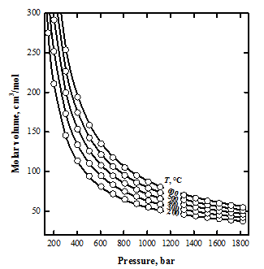
Figure 1: The pressure-volume-temperature relations for H₂ gas. The symbols correspond to the values measured by Presnall (1969). The curves were calculated in this study from the Redlich-Kwong EOS modified by Soave (1972) and improved as part of this work.

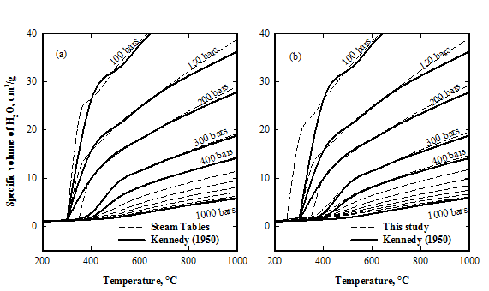
Figure 2: Specific volumes of H₂O reproduced with the steam table of Grigull (1984) for (a) and reproduced with this study for (b) (dashed lines), compared with the experimental specific volumes of Kennedy (1950) drawn for some pressures (dark lines).

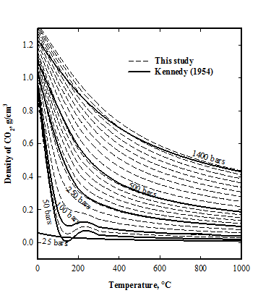
Figure 3: Density of CO₂ reproduced in this study. The dashed lines are the results of this study for CO₂, and the dark lines are the results of the experimental study of Kennedy (1954) for the some pressures. The results are relatively closed (with V^{fluid} = M/ x^{l}).

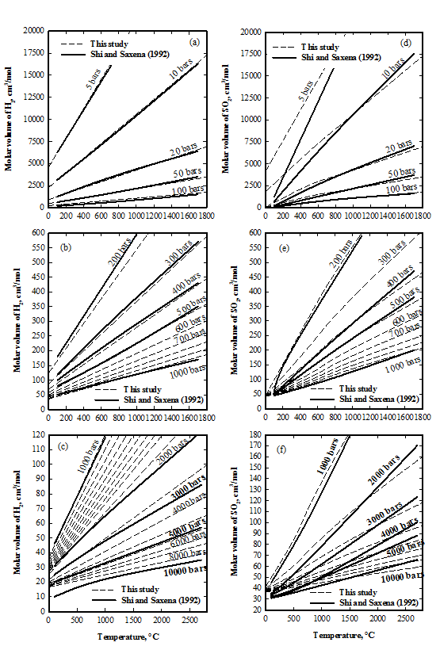
Figure 4: Molar volumes of H₂ for (a), (b) and (c) and SO₂ for (d), (e) and (f) function of T and P. The curves were drawn for pressures from 5 to 100 bars for (a, d) from 200 to 1000 bars for (b, e) and from 1000 to 10000 for (c, f). The values were calculated in this study (dashed lines) compared to the molar volumes reported by Shi and Saxena (1992) reproduced and drawn from their figures (dark lines). The results are relatively closed (with V^{fluid} = M/ x^{l}).

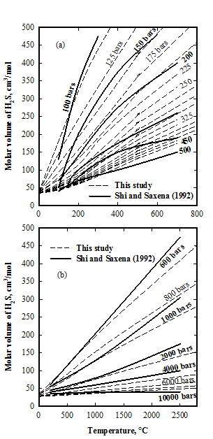
Figure 5: Molar volumes of H₂S function of T and P. The curves were drawn for pressures from 100 to 500 bars for (a) and from 600 to 10000 bars for (b). The values were calculated in this study (dashed lines) compared to the molar volumes reported by Shi and Saxena (1992) reproduced and drawn from their figures (dark lines). The results are relatively closed (with V^{fluid} = M/ x^{l}).

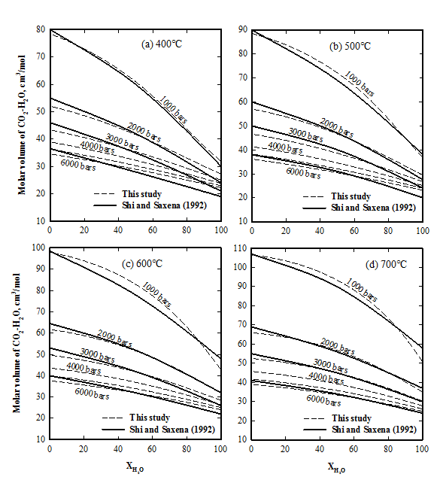
Figure 6: Molar volumes of H₂O-CO₂ system at 400°C for (a), at 500°C for (b), at 600°C for (c) and at 700°C for (d), function of molar fraction of H₂O and P. The curves were drawn for pressures from 1000 to 6000 bars and calculated in this study (dashed lines). The values reported by Shi and Saxena (1992) were reproduced and drawn from their figures (dark lines). The results are relatively closed (with V^{fluid} = M/ x^{l}).

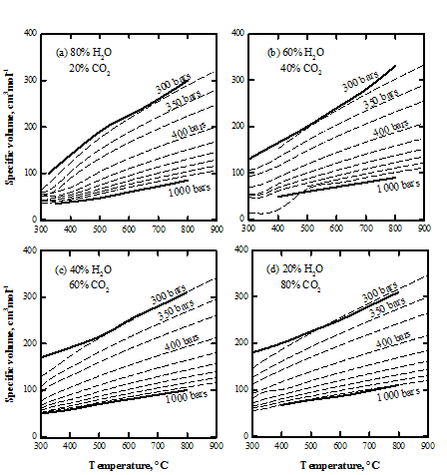
Figure 7: Specific volume of H₂O-CO₂ system reproduced in this study. The dashed lines are the results of this study, and the dark lines are the results of the experimental study of Plyasunov and Zakirov (1991) for the extreme pressures. Both results are in good agreement (with V^{fluid} = M/ x^{l}).

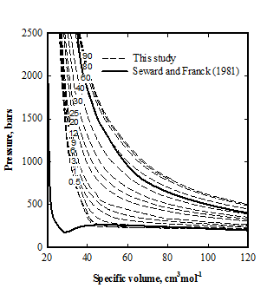
Figure 8: Specific volume of H₂O-H₂, with 0.5% to 100% of H₂, reproduced in this study (dashed lines). The dark line corresponds to the values of Seward and Franck (1981) for 0.5% and 90% of H₂. Both results aren’t in good agreement (with V^{fluid} = M/ x^{l}).
6. Use and Agreement Contract

Owner: Michael Andre Franiatte.
Contact: michael.franiatte@gmail.com.
Owning: All works from scratch of the owner.
Proof of Owning: Works published, and writings/speakings all over.
Requirements of Use: Pay the owner, quote the owner, agreement of the owner.
Availability of Works: Only under the shapes of the owner built, only for personal use.
Subjects of Claims: Works published by the owner on Google Play and Google Books.
Concerning Author Rights: Equations and codes from scratch of the owner, softwares built from it, all things of people arising from it.
End User License Agreement: A commercial license is required to use in personal manner. Do not redistributing in any manner, including by computer media, a file server, an email attachment, etc. Do not embedding in or linking it to another programs, source codes and assistances including internal applications, scripts, batch files, etc. Do not use for any kind of technical support including on customer or retailer computer, hardware or software development, research, discovery, teachery, talk, speech, write, etc. Do not use for win money or for commercialisation of any products arising from my programs, source codes and assistances. Do not use and do not copy the way it run in other programs, source codes and assistances. Do not use without pay me, quote me and my agreement. Do not steal or copy or reproduce or modify or peer or share. Do not use in other manner than personal. It stand for my programs, source codes and assistances or programs, source codes and assistances stealing or copying or reproducing or modifying or peering or sharing my programs, source codes, and assistances. If you aren't agree you shall not use.
Terms of License and Price: The present contract acceptance is required to use works of the owner and built from it in all kind of manner. The price for each user shall be defined with the owner by contacting him and this for each subject of works the owner claims. Each user shall contact the owner for asking his agreement. It can be refused by the owner depending who asking and the price defined. People don’t respecting the present contract shall not use the works of the owner.

