CSCI 4333

Design of Database Systems

Fall 2021

Homework #1

2a)

2b)

2c)

2d)

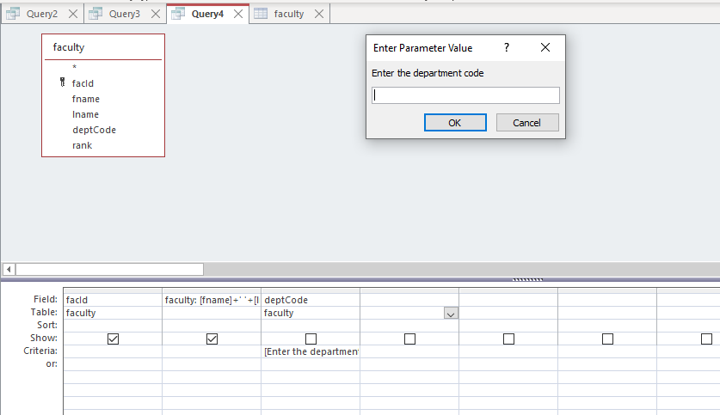

If CINF is entered:

If CSCI is entered:

2e)



