GPT Researcher Phase 1 Technical Report
SENG 691 AI Agent Computing
Agent Analysis Future Development and Demonstration

Field | Details
Team members | Michael Obeng Antwi, Mathew Mesfin, Chelsea Okoroji, Nathan Huang
Project | GPT Researcher
Repository | github.com/umbc-seng691-team/SENG-691-gpt-researcher
Verified baseline | Version 0.14.7, Python 3.11+, commit 6f998577
Date | October 25, 2026

Executive Summary
This Phase 1 report evaluates GPT Researcher as the foundation for the team's SENG 691 agent project. The team established a shared GitHub repository, analyzed the code and technology choices, modeled the research data flow, selected three existing capabilities for enhancement, proposed two new features, and demonstrated a successful local research run. The verified team baseline is GPT Researcher 0.14.7 on commit 6f998577, requiring Python 3.11 or later. The repository and deliverables were integrated through pull requests and validated by automated GitHub checks.
GPT Researcher is suitable for the project because it exposes a visible planning, retrieval, filtering, and report-generation workflow while supporting different models, retrievers, interfaces, and research depths. The team selected hybrid local and web retrieval, context deduplication, and relevance-guided deep research as the three capabilities to improve. It also proposed an optional sub-question approval checkpoint and automated source-credibility labeling as new features.

1 Project Scope and Phase 1 Objectives
The purpose of Phase 1 was to understand the current agent before implementing changes. The work focused on six outcomes:
- Establish and verify a shared repository baseline.
- Analyze the current agent architecture, source code, and technology stack.
- Document the system's core entities and relationships.
- Select three existing capabilities for enhancement with technical reasoning.
- Select two feasible new features and describe their expected value.
- Demonstrate the agent running locally and producing a cited research report.

2 Repository and Reproducible Baseline
Item | Verified value
Team repository | https://github.com/umbc-seng691-team/SENG-691-gpt-researcher
Package version | 0.14.7
Python requirement | >= 3.11
Baseline commit | 6f998577
Baseline commit date | August 23, 2026
Phase 1 integration commit | b5853b26
Repository status | Team main and Michael's fork synchronized after merge

Recording the exact version and commit is important because GPT Researcher evolves quickly. The baseline prevents the report from mixing features from a newer upstream release with the code actually reviewed by the team.

3 System Purpose and Agent Architecture
GPT Researcher is an open-source autonomous research agent that accepts a question, plans supporting research, gathers external or private information, processes the evidence, and produces a report with citations. Its standard workflow follows a planner, executor, and publisher pattern.
Stage | Primary responsibility | Representative output
Plan | Interpret the request and generate supporting questions. | Research plan and sub-questions
Retrieve | Search web or local sources for each question. | Candidate sources and content
Process | Scrape, filter, summarize, and organize evidence. | Relevant passages and source metadata
Synthesize | Combine evidence into a structured answer. | Draft report sections
Publish | Format the final report and attach citations. | Cited report and source list

The system also supports a LangGraph-based multiagent workflow with specialized roles such as researcher, reviewer, reviser, writer, and publisher. This can improve specialization and review for complex tasks, but it increases model calls, coordination overhead, execution time, and cost.

4 Code and Technology Choices
Layer | Technology | Rationale
Core | Python 3.11+ | Strong AI ecosystem, readable implementation, and asynchronous network support.
Agent integration | LangChain | Common interfaces for models, prompts, tools, retrieval, and documents.
Orchestration | LangGraph | Explicit stateful graphs for multi-step and multiagent execution.
Provider abstraction | LiteLLM and provider packages | Supports hosted and local models without replacing the entire workflow.
API | FastAPI and Pydantic | Asynchronous endpoints, WebSockets, request validation, and generated API documentation.
Retrieval | Tavily and pluggable retrievers | Current web information with reduced dependence on one search vendor.
Integration | Model Context Protocol | Controlled access to repositories, databases, and other specialized sources.
Frontend | Next.js and React | Interactive configuration, progress updates, results, and history.
Deployment | Docker and Docker Compose | Repeatable packaging of backend and frontend dependencies.
Testing | pytest and GitHub Actions | Automated regression checks across supported Python versions.

5 Strengths Limitations and Risks

Strengths
- Clear separation of planning, retrieval, processing, and reporting.
- Asynchronous and parallel research operations.
- Citations and retained source URLs in generated reports.
- Configurable models, retrievers, report formats, and research depth.
- Multiple interfaces through Python, API, WebSocket, web application, Docker, and MCP.
- Multiagent roles for specialized research and review.

Limitations and risks
- Report quality still depends on retrieval quality, source credibility, model reasoning, and citation support.
- Multiagent runs can duplicate effort, propagate errors, and increase token cost.
- Retrieved web pages and uploaded documents are untrusted inputs and may contain prompt injection or malicious content.
- Private files, API keys, and environment settings require least-privilege access and secure secret handling.
- A real citation can still fail to support the nearby claim; important claims require passage-level verification.
- A full run should record its model, retriever, configuration, runtime, failures, and costs for reproducibility.

6 Conceptual Data Model
The ER model identifies six major concepts: Agent, Research Task, Sub-Question, Source, Extracted Passage, Research Report, and Citation. It captures the path from a user task through decomposed questions and evidence to a cited final report.
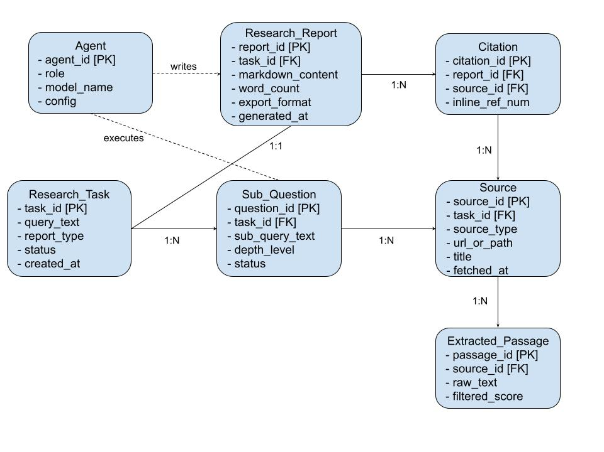
Figure 1. Team conceptual ER diagram for the GPT Researcher workflow
Implementation clarification: the diagram connects Sub-Question to Source, but Source currently displays task_id rather than question_id. A relational implementation should either add question_id to Source or connect Source directly to Research Task. Citation contains source_id, so the intended relationship is one Source to many Citations, while each Citation references one Source. These clarifications preserve the conceptual model while avoiding inconsistent foreign keys and cardinalities.

7 Demonstrated Agent Execution
Chelsea Okoroji demonstrated the team fork running locally at 127.0.0.1:8000. The research query was “Multi-agent systems in Video Games.” The interface was configured for a short summary report, an objective tone, web sources, and five websites per query. The recording shows research progress, scraping, evidence collection, a generated report, references, raw URLs, and research history. The exact LLM and retriever were not visible in the recording and are therefore not asserted in this report.
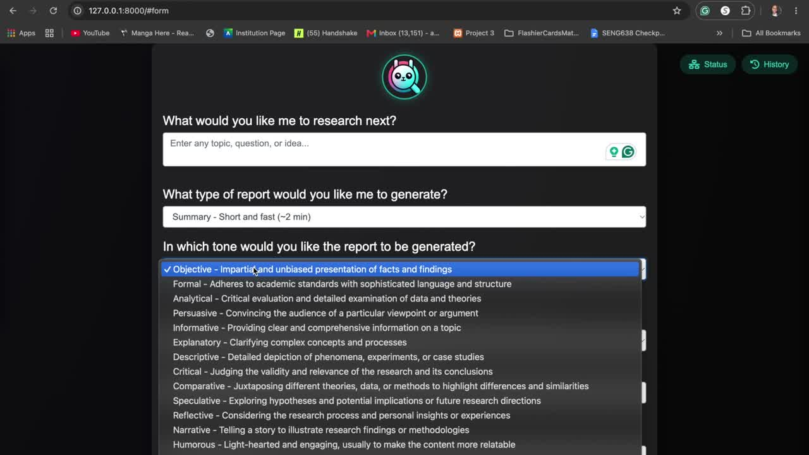
Figure 2. Research query and report configuration
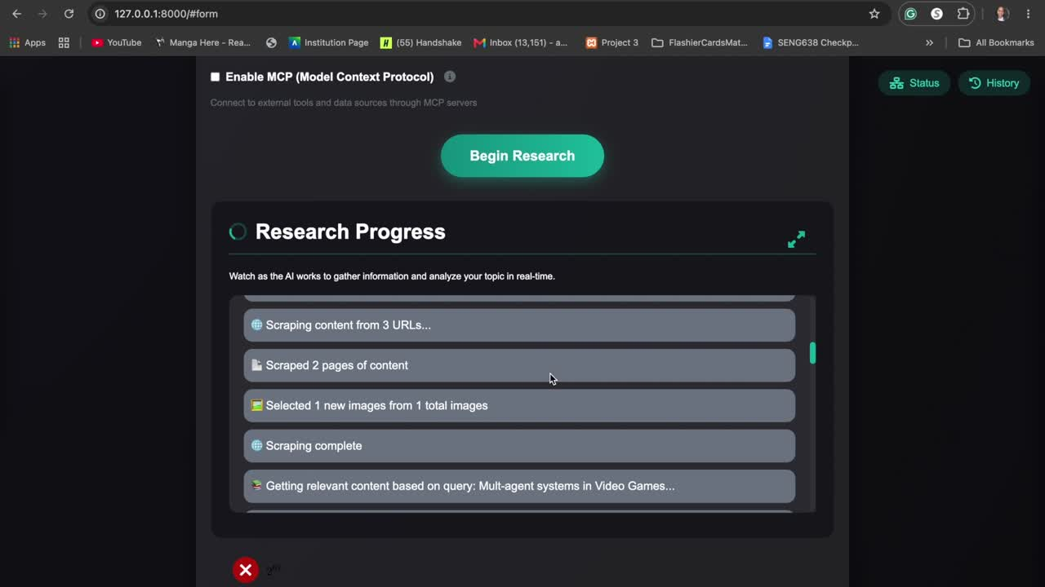
Figure 3. Live research progress and evidence collection
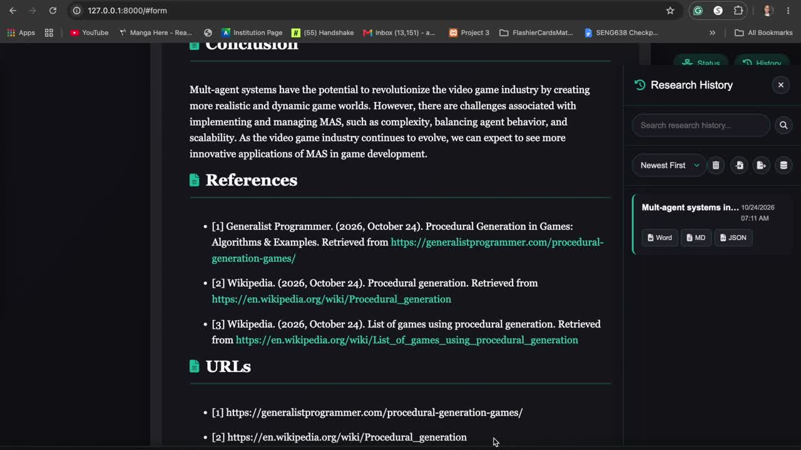
Figure 4. Generated report with references and source URLs
The original recording lasted approximately 5 minutes 9 seconds. A compliant 4 minute 58 second version was produced by removing the first 11 seconds, which showed a static repository screen. The research execution and final report remain intact.

8 Selected Enhancements to Existing Capabilities

8.1 Parallel hybrid web and local retrieval
Current capability: GPT Researcher can combine web research with local private files such as PDF and Word documents. Proposed enhancement: search and parse authorized local files and web materials concurrently, normalize the results, and remove duplicate or extraneous evidence before synthesis. This should reduce elapsed research time and provide broader context, but it requires source labeling, access controls, deduplication, and a deterministic merge policy.

8.2 Context deduplication after relevance filtering
Current capability: the agent filters scraped research material to reduce irrelevant text before sending context to the language model. Proposed enhancement: add a second stage that identifies overlapping passages and retains unique, relevant evidence for the report. This can improve information density and citation clarity while reducing repeated claims. Evaluation should compare answer quality, evidence coverage, token use, and execution time.

8.3 Relevance-guided deep research
Current capability: deep research decomposes a question into branches and explores follow-up questions recursively. Proposed enhancement: score generated sub-questions for relevance and importance, then allocate more depth and resources to higher-value branches. This could improve answer quality within a fixed time or token budget, provided the scoring method does not prematurely discard minority or contradictory evidence.

9 Proposed New Features

9.1 Optional sub-question approval checkpoint
After the agent generates sub-questions, it would optionally pause and present the proposed outline to the user. The user could approve, remove, edit, or reprioritize branches before research begins. This human-in-the-loop control should improve relevance and reduce wasted searches. The feature is feasible because it adds a state transition and user decision without replacing the existing research workflow; noninteractive mode can preserve current behavior.

9.2 Automated source-credibility labeling
Each source would receive a transparent credibility label based on defined signals such as publisher identity, domain type, author information, recency, corroboration, citation quality, and known review processes. The label must not be treated as proof of truth. It should display the supporting signals, confidence, and reasons so users can independently evaluate the evidence. This feature is more complex because criteria can encode bias and domain authority alone is insufficient.
Feature | Expected impact | Relative feasibility | Key risk
Sub-question checkpoint | Higher relevance and user control | High | Excessive interruption if enabled by default
Credibility labeling | Improved source awareness and verification | Medium | Oversimplified or biased trust scores

10 Alternatives and Lessons Learned
The current architecture favors flexibility through LangChain, LangGraph, model-provider packages, retrievers, FastAPI, and a separate frontend. A smaller implementation could use FastAPI, direct provider clients, and a limited retriever layer for the standard workflow, reserving LangGraph and multiple agents for tasks that justify the added complexity. Citation validation could also be separated into a dedicated stage that maps important claims to supporting passages and flags unsupported claims.
The analysis showed that an agent is more than a language model. Reliability depends on planning, tool use, retrieval, filtering, state management, source handling, and report generation. It also showed that flexibility creates a testing burden: every supported model, retriever, interface, and agent role adds configuration and failure paths. Version-controlled branches, pull requests, review, and automated checks created a reproducible process for integrating the team's Phase 1 work.

11 Phase 2 Implementation and Evaluation Priorities
Priority | Action | Evidence of success
1 | Implement optional sub-question checkpoint behind a configuration flag. | User can approve or revise branches; noninteractive workflow remains unchanged.
2 | Add structured source and passage identifiers needed for credibility and citation checks. | Every important claim can be traced to one or more extracted passages.
3 | Prototype concurrent hybrid retrieval with deduplication. | Lower elapsed time or token usage without reducing evidence coverage.
4 | Add run metadata and evaluation logging. | Recorded model, retriever, settings, runtime, tokens, costs, failures, and output.
5 | Create comparative tests and a small benchmark set. | Baseline and enhanced agent evaluated on relevance, correctness, citation support, time, and cost.

12 Team Contributions
Contributor | Phase 1 contribution
Michael Obeng Antwi | Created and organized the GitHub repository; coordinated access and deliverables; analyzed code, architecture, technologies, alternatives, and lessons learned; supported GitHub submission; integrated team artifacts; and compiled the consolidated report.
Nathan Huang | Prepared the Future Development Plan and technical reasoning for three enhancements and two new features.
Mathew Mesfin | Prepared the conceptual ER diagram, feature findings and notes, and meeting documentation.
Chelsea Okoroji | Prepared and recorded the local GPT Researcher demonstration video.

13 Conclusion
Phase 1 established GPT Researcher as a credible foundation for the group project. The agent already provides planning, web and document retrieval, context processing, configurable research depth, and cited report generation. The selected enhancements and new features target clear weaknesses: duplicate context, undifferentiated research branches, limited human guidance, and insufficient source-quality signaling. The next phase should implement changes incrementally, preserve the existing workflow behind configuration flags, and evaluate improvements against the verified 0.14.7 baseline using measurable quality, time, cost, and citation-support criteria.

References
- GPT Researcher. (2026). GPT Researcher GitHub repository. https://github.com/assafelovic/gpt-researcher
- GPT Researcher. (2026). Documentation. https://docs.gptr.dev/
- GPT Researcher. (2026). Docker quickstart. https://docs.gptr.dev/docs/gpt-researcher/getting-started/getting-started-with-docker
- GPT Researcher. (2026). Python package documentation. https://docs.gptr.dev/docs/gpt-researcher/gptr/pip-package
- GPT Researcher. (2026). MCP server documentation. https://docs.gptr.dev/docs/gpt-researcher/mcp-server/getting-started
- UMBC SENG 691 Team. (2026). SENG 691 GPT Researcher team repository. https://github.com/umbc-seng691-team/SENG-691-gpt-researcher

