

SLP01_APP_REQUIREMENT_ANALYSE

Michael bai

V1.0

Author | Revision | Changes | Date
Michael bai | V1.0 | initial | 2019/7/9

Confidential Material: This document contains information that is proprietary and confidential, reading and copying this document is prohibited without permission from AsiaTelco Technologies Co.
Index
SLP01_APP_ARCH 1
1 App entry 3
2 OTA service 3
2.1 Function provide 3
3 System init 3
3.1 IP service init 3
3.2 GPS init 3
4 Ignition judge 3
4.1 Ignition on 3
4.1.1 report init GPS location which predefined 3
4.1.2 start a duration configurable timer to update the location 3
4.1.3 Send GPS signal once every 15 secs as required. 3
4.1.4 Judge the location info 3
4.2 Ignition off 4
5 Change History 5

App entry
Quectel_task_entry

OTA service
Provide firmware update functionality

Function provide
1 replace current image with new one
2 store both new and old image in flash
3 able to go back to old image once error ocurrs in download new image
4 other capabilities will be suspended during the process
5 will overwrite any stored messages if image require more memory than available
6 upon conclusion or early termination of download, device will report the resulting status

System init
IP service(either TCP or UDP) and GPS init are included

IP service init
Provide TCP or UDP session based on the requirement, refer to demo we implemented

GPS init
Just follow the API or the GPS demo app

Ignition judge

Ignition on

report init GPS location which predefined

start a duration configurable timer to update the location
【note】step above have two modes to distinguish. watch mode and tow mode
Just parameters diff from one other.

Send GPS signal once every 15 secs as required.
For internal use

Judge the location info
step1 not suspect: report GPS location and store it as last good location.
step2 suspect: report the last good location and fix the new location
step3 driving behavior detect(include speeding, hard acc, sharp turn and so on )
step4 alarms and events report and log save(to server and backup server)
step5 back to ignition detect.

Ignition off
Step1 blocked to receive the specified request --- use to disable the engine starter
Step2 report GPS location and send ack to disable the vehicle.
Step3 judge to whether to disable the engine starter
Step3a condition not met: alarms and events report and log save(to server and backup server)
Step3b condition met: report GPS location and disable the engine starter.
Step4 init MSO functionality
Step5 deal with engine starter disable, judge whether to re-enable it.
Step6 back to step3a

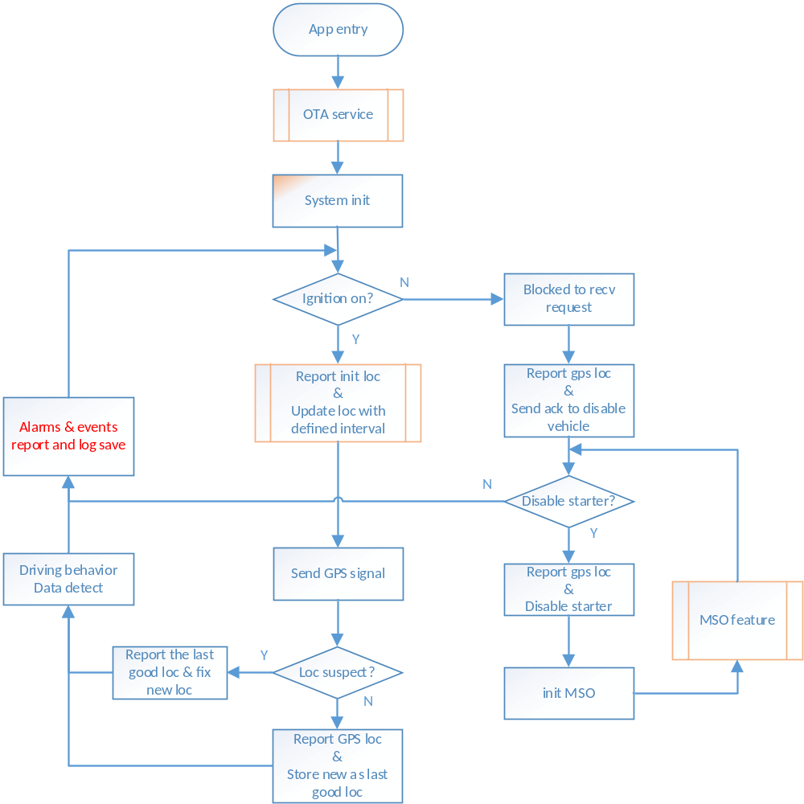

Change History

Revision | Author | Date | Change Notes
V1.0 | Michael bai | 2019/6/19 | initialize

