ITCS 1010 Programming Logic

Logic Plan 8 – Chapter 8 – 20 points

“Sum of Numbers in a String” using String and Tokens

Student Name: **Michael Beebe**

Given the following problem statements, perform the steps and answer the questions listed below, which are designed to help you analyze the problem and prepare a strategy for solving the problem. Submit this logic plan and C­­­­# Project ***into a folder, zip the folder, and submit in Blackboard for grading.***

**Problem statement:** Create and design an *application that lets the user enter a string containing a series of numbers separated by commas.*

***This is an example of valid input:***

*7, 9, 10, 2, 18, 6*

The program should calculate and display the sum of all the numbers entered as input.

**This is an example of my test a run time, calculating the input string of numbers and an “info” tooltip on the Exit button.**

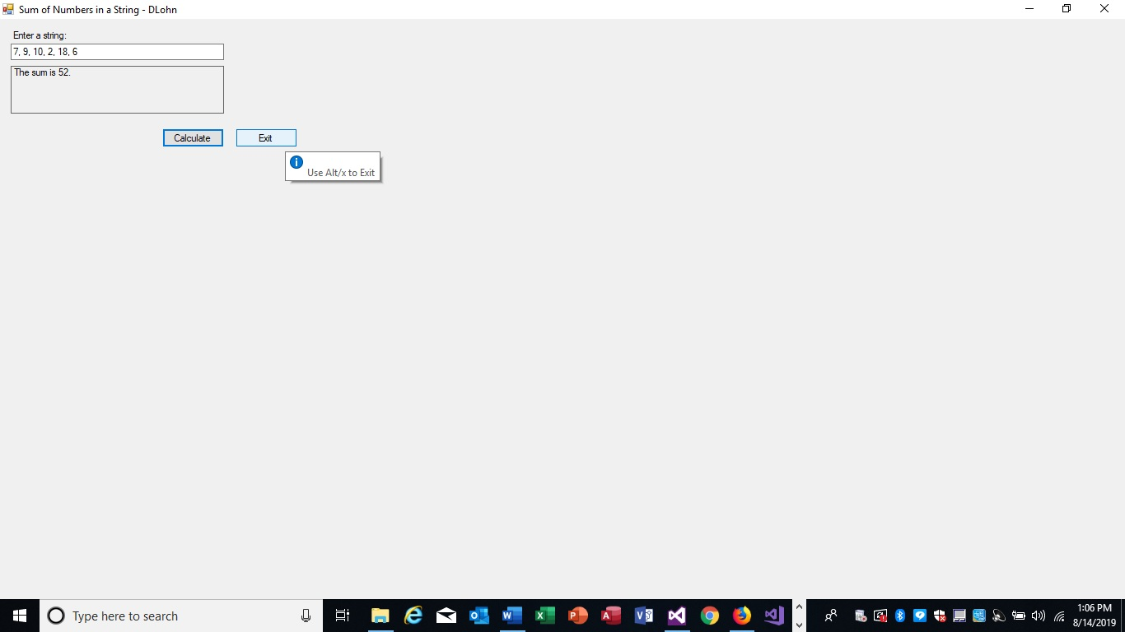

*Use label controls, button controls, and program comments where applicable. Make sure the C# program is free of syntax and logic errors. Also, include user-friendly ToolTips on all button controls.*

Change the **property ToolTipIcon** of the **ToolTip** in the **component** **tray** to ***Info*** (this will be a selection from the pull down).

*Create an* ***access key*** *on the* ***Exit*** *button so that the user can run the command associated with the Exit button by pressing* ***Alt+X****.*

At **Design** **time**, create an access key as an **underlined** **character** in the **text** property of the **Exit button control** by using an **&.** For example: **E&xit**

The label in the button control should show the underlined letter x. Change the Tooltip message to “Use Alt/x to Exit”.

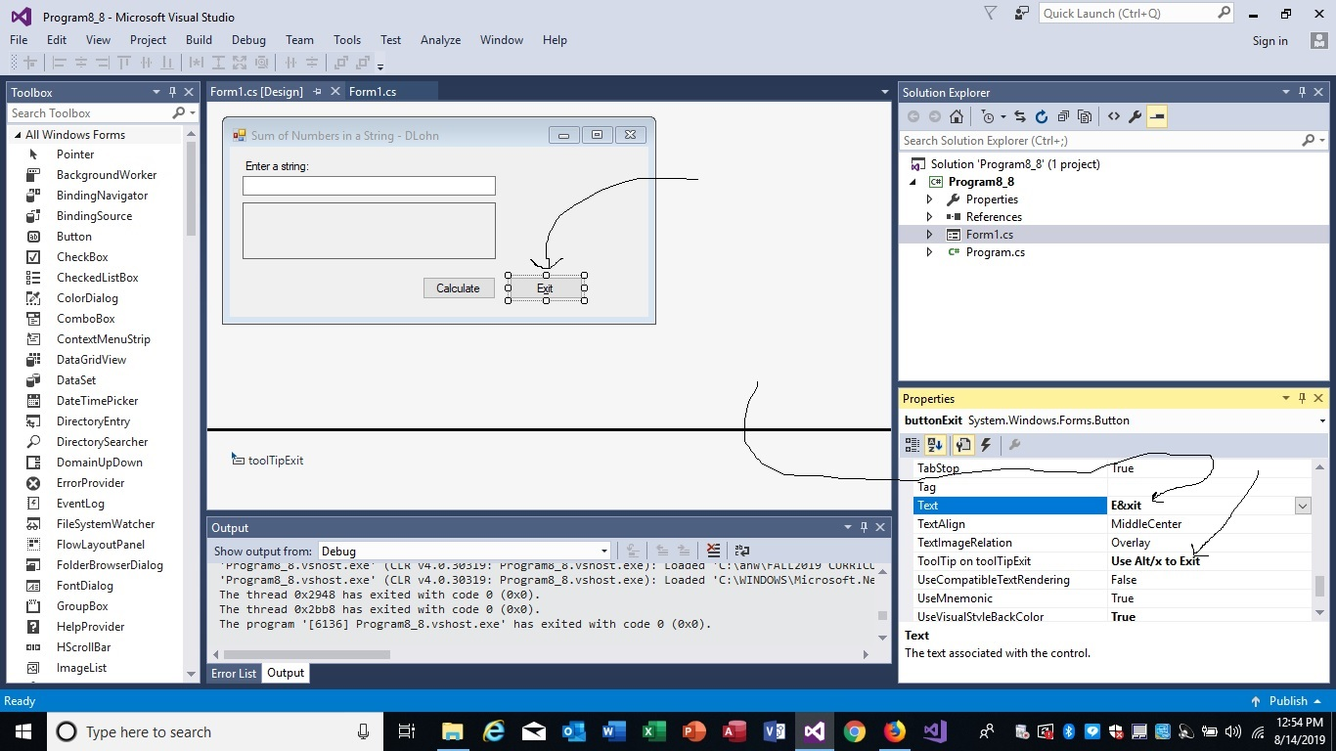

**Create a file folder on your USB Port drive or hard drive** at home, call it “Logic Plan8 Your student name”.

For example “Logic Plan8 DLohn”.

There is a **VideoNote** associated with this Lab. Enter:

<https://mediaplayer.pearsoncmg.com/assets/secs-es-08_Vid08_Solving_Sum_Numbers>

**Create the Logic Plan!**

***Design the Program’s Logic:*** *enter your answers in the* ***IPO chart*** *below.* ***Write pseudocode*** *and insert* ***below. Draw a flowchart*** *and insert below.*

What must the user enter as **INPUT**?

|  |
| --- |
| **INPUT** |
| A string containing numbers.  **Ex:** 1, 2, 3, 4, 5 |

How will the **program generate the 5 random numbers as output**?

|  |
| --- |
| **PROCESSING** |
| Iterate through each char in the input string.  TryParse each char to an int.  If it’s an int, add it to a counter (which starts at 0)  **Ex:**  foreach (char i in input)  {  int.TryParse(i.ToString(), out num);  sum += num;  } |

What **OUTPUT** will the program display?

|  |
| --- |
| **OUTPUT** |
| “The sum is {sum}”  **Ex:**  The sum is 15 |

**ENTER PSEUDOCODE HERE** the **pseudocode** you wrote below in this Word document for grading.

1. Get user input, set it equal to *input*
2. Declare variables *sum* = 0 and *num*
3. Loop through each index in *input* and TryParse it to an int, set all ints equal to *num*
4. *sum += num*
5. Output “The sum is {*sum*}”
6. Clear Button to clear input textbox and output label
7. Exit Button or Alt+x to close form.

**Fourth: Complete the programming problem.**

Save this project as **“Logic Plan 8 your student name”,** for example “ Logic Plan 8 Dlohn”, in your **“Logic Plan 8 your student name”** file folder and submit in this category for grading.