ITCS 1010 Programming Logic

Logic Plan 3 – Chapter 3 – 20 points

“Calculate Purchase”

Student Name: Michael Beebe

Given the following problem statements, perform the steps and answer the questions listed below, which are designed to help you analyze the problem and prepare a strategy for solving the problem. Submit this logic plan and C# Project into a folder, zip the folder, and submit in Blackboard for grading.

Create a file folder on your USB Port drive or hard drive at home, and call it “Logic Plan3 Your student name”. For example “Logic Plan3 DLohn”.

There is no VideoNote associated with this Lab.

Problem statement: Suppose your Employer needs an application designed and written, that applies a 10% discount for any amount of a purchase entered by a user.
When the user clicks the Calculate Purchase button, the application should calculate and display as output in textbox controls, Amount of Purchase, Total Discount Amount and Total of the Sale.
You will need to properly format the output data using the ToString method with a $ and decimal position. See Formatting Numbers with the ToString Method, textbook pages 153-154.
Be sure to practice good decimal alignment in your output textbox controls by right aligning the data.
Also, the output textbox controls should be protected from user entry by setting the property ReadOnly to True.

Parse the input Amount of Purchase to convert the string to numeric. (See Getting a Number from a TextBox, textbook pages 145-148.)
Use and declare a named constant for the 10% discount variable. (See Using Named Constants, textbook pages 168-169.)
The Total Discount Amount is calculated by multiplying the Amount of Purchase by 10%.
The Total of the Sale is the calculated by subtracting the Total Discount Amount from the Amount of Purchase.

Also, include an Exit button so the user can close the form and include your student name and a proper Title in the title bar of the form.
Also, include a user friendly Tool Tip on the Calculate Purchase button.

Use label controls, button controls, and program comments where applicable. Make sure the C# program is free of syntax and logic errors.

(Hint: reference the Tutorial 3-3 “Sale Price Calculator” program found in this Tutorial!)

Below is an example of my form design and tested output:
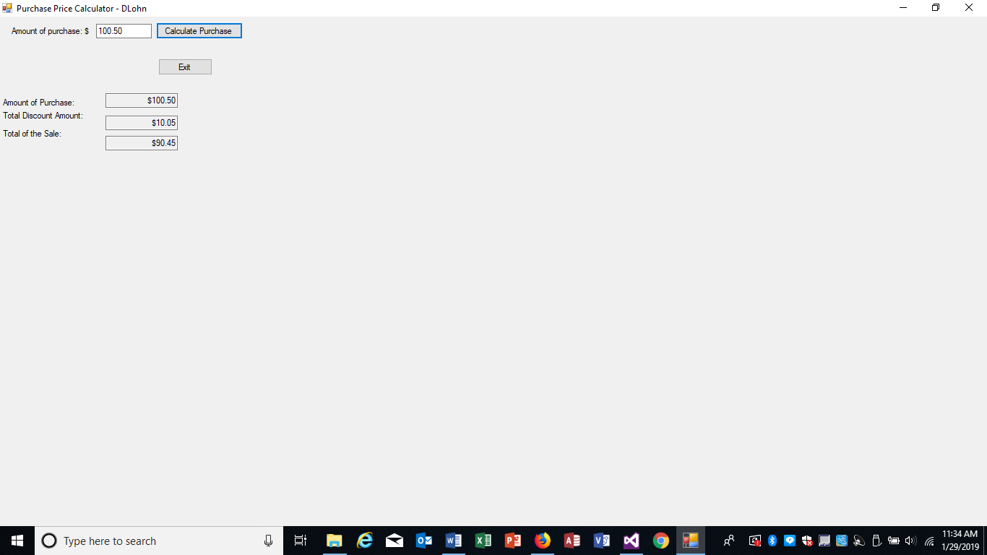
Now you are ready to Design the Program’s Logic.

Enter your answers in the IPO chart below. Write pseudocode and insert below. Draw a flowchart and insert below. (Hint: reference the Tutorial 3-3 Logic Plan found in this Tutorial!)

What must the user enter as INPUT?

INPUT
User must enter a number that will represent the original price of the purchase before the discount.

Ex: 10

How will the program calculate the total purchase?

PROCESSING
The program will calculate the total purchase by:
- Calculate the total discount amount by multiplying the user input by 10%.
- Subtracting the total discount amount from the user input.

What OUTPUT will the program display?

OUTPUT
The program will output the following:
- Amount of initial purchase (user input) Ex. 10
- Total Discount Amount (user input * 0.10) Ex. 1
- Total of the Sale (user input – total discount amount) Ex. 9

ENTER PSEUDOCODE HERE the pseudocode you wrote below in this Word document for grading. (Hint: reference the Tutorial 3-3 Logic Plan found in this Tutorial!)

Steps Needed:
- Create form components.
- Get user input (initial purchase amount before application of discount).
- Calculate the discount amount (user input * 10%).
- Subtract the discount amount from the user input to get the total of the sale.
- Render the user input, total discount amount, and total of the sale to their perspective labels.

DRAW OR COPY/PASTE FLOWCHART HERE the flowchart you designed below in this Word document for grading. (Hint: reference the Tutorial 3-3 Logic Plan found in this Tutorial!)

calculateButton
calculateButton

Close Form
Declare variables:
originalPrice
discountAmount
totalOfSale

End

Get input

1.) Calculate the discount amount.
2.) Subtract discount Amount from Input

Render Output:
originalPrice
discountAmount
totalOfSale

Complete the programming problem using the program logic you designed!

Save this project in your “Logic Plan 3 your student name” file folder and submit in this category for grading.

