ITCS 1010 Programming Logic

Logic Plan 6 – Chapter 6 – 20 points

“Retail Price Calculator using a Method that Receives Arguments and Returns a Value”

Student Name: Michael Beebe

Given the following problem statements, perform the steps and answer the questions listed below, which are designed to help you analyze the problem and prepare a strategy for solving the problem. Submit this logic plan and C# Project into a folder, zip the folder, and submit in Blackboard for grading.

Problem statement: Create an application that lets the user enter an item’s wholesale cost and its markup percentage in input text boxes. When the user clicks the Calculate button, the application should have a METHOD named CalculateRetail that receives two inputs in text boxes, the wholesale cost and markup percentage as arguments, and returns the output retail price of the item in a text box. See textbook page 392, under Programming Problems, the Retail Price Calculator for guidance.

For example: Retail Price = (Wholesale Cost * Markup Percentage)

$10.00 = ($5.00 x 100%)
$7.50 = ($5.00 x 50%)

Also, include an Exit button so the user can close the form and include your student name in the title bar of the form.

Use label controls, button controls, and program comments where applicable. Make sure the C# program is free of syntax and logic errors. Also, include user-friendly ToolTips on all button controls.
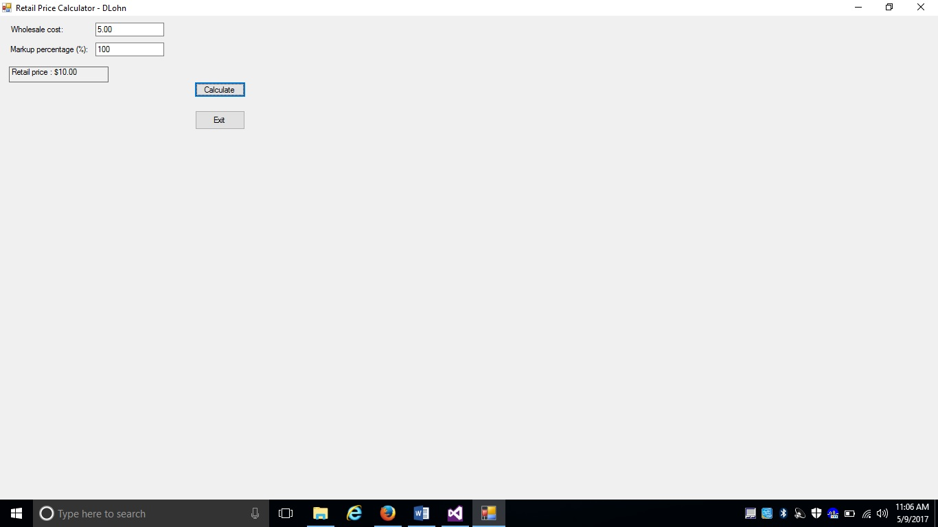
Create a file folder on your USB Port drive or hard drive at home, and call it “Logic Plan6 Your student name”. For example “Logic Plan6 DLohn”.

There is no VideoNote associated with this Lab.

Create the Logic Plan!

Before coding this program design the Program’s Logic: enter your answers in the IPO chart below. Write pseudocode and insert below. Draw a flowchart and insert below. (Hint: reference the logic plans in this Tutorial and Tutorial 6-4 for guidance.)

What must the user enter as INPUT?

INPUT
Wholesale Cost, Markup Percentage

Testing: $10, 100%

How will the program calculate the retail price?

PROCESSING
calculateRetailPrice takes in two parameters: wholesaleCost and markupPercentage
retailPrice = wholesaleCost * ((markupPercentage / 100) + 1)
returns retailPrice
Example: returned value is 10 * ((100 / 100) + 1)

calculateButton_Click
Parse the input wholesaleCost and markupPercentage
Pass parsed inputs to calculateRetailPrice
Render calculation for calling the method to the form
Example: $20

What OUTPUT will the program display?

OUTPUT
Retail Price

Example: $20.00

ENTER PSEUDOCODE HERE

- Declare calculateRetailPrice method that will return a double and take in two double parameters: wholesaleCost and markuoPercentage
  - retailPrice = wholesaleCost * ((markupPercentage / 100) + 1)
  - return retailPrice

- Declare click method claculateButton_Click that will not return anything.
  - TryParse the user inputs for wholesale cost and markup percentage.
    - If they are doubles, pass the inputs to calculateRetailPrice and set that returned value to retailPrice
    - If not, display error message
  - Render retailPrice to the form.

- Clear button to reset the form.

- Exit button to close the form.
DRAW OR COPY/PASTE FLOWCHART HERE

calculateRetailPrice Method
calculateButton_Click Event

False
Declare variables double wholesaleCost, markupPercentage
retailPrice =
wholesaleCost * ((markupPercentage / 100) + 1)

A

Parse wholesaleCost, markupPercentage

Return retailPrice

Valid numeric data in wholesaleCost, markupPercentage
?
True

exitButton
End

Close()

Call calculateRetailPrice method passing wholesaleCost, markupPercentage as arguments.

Display returned calculated retailPrice
End
Display “Please enter a valid input”
A
Save this project in your “Logic Plan 6 your student name” file folder and submit in this category for grading.

