ITCS 1010 Programming Logic

Logic Plan 7 – Chapter 7 – 20 points

“Lottery Numbers Using an Array to Hold a List of Random Lottery Numbers and
Totaling the values in the Array”

Student Name: Michael Beebe

Given the following problem statements, perform the steps and answer the questions listed below, which are designed to help you analyze the problem and
prepare a strategy for solving the problem. Submit this logic plan and C# Project into a folder, zip the folder, and submit in Blackboard for grading.

Problem statement: Revise the application created in Tutorial 7-1 to accumulate all 5 values in the array. Show the accumulated values from the array in an output label control.

For example: Total = (Total + lotteryNumbers [index])
or
Total += lotteryNumbers[index]

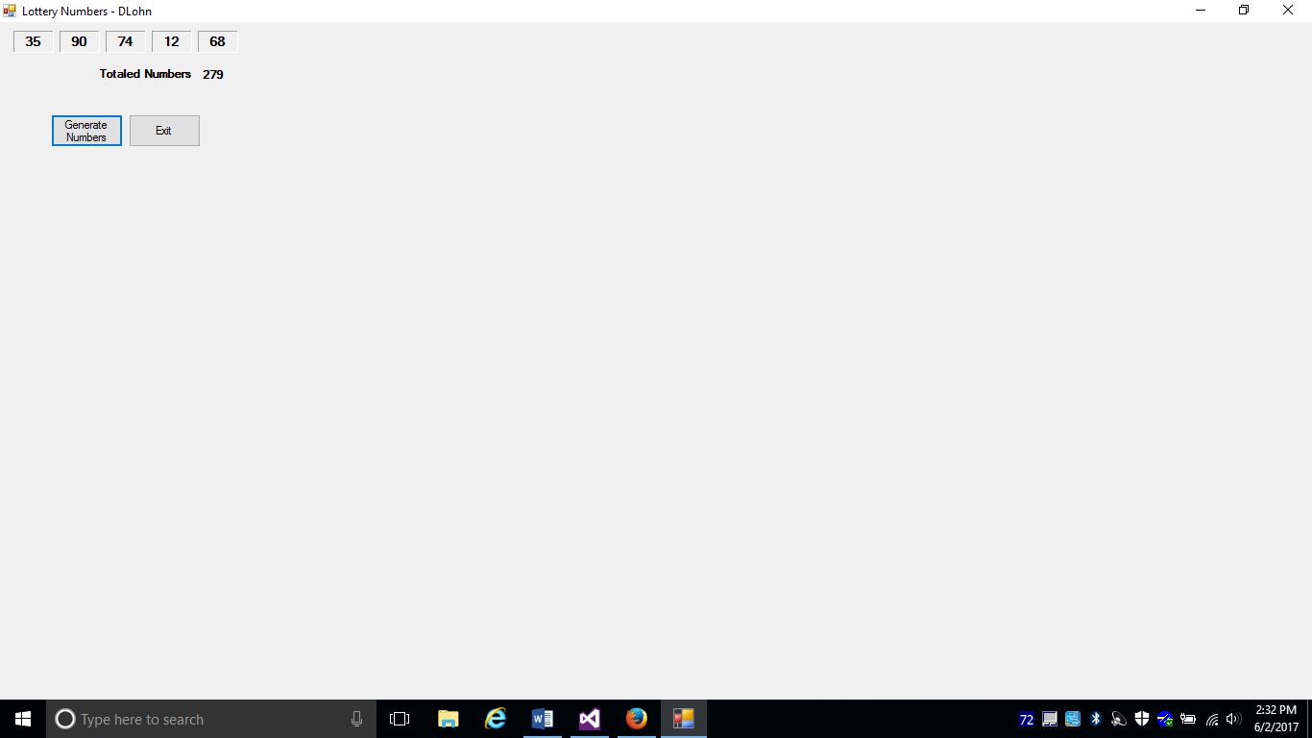

Use label controls, button controls, and program comments where applicable. Make sure the C# program is free of syntax and logic errors. Also, include user-friendly ToolTips on button controls.

First: Create a file folder on your USB Port drive or hard drive at home, and call it “Logic Plan7 Your student name”.
For example “Logic Plan7 DLohn”.

Second: There is no VideoNote associated with this Lab.

Third: Create the Logic Plan!

Design the Program’s Logic: enter your answers in the IPO chart below. Write pseudocode and insert below. Draw a flowchart and insert below.

What must the user enter as INPUT?

INPUT
Left click the Generate Numbers button

How will the program generate the 5 random numbers as output?

PROCESSING
Declare int variable total = 0
FOR loop fills the array with 5 random numbers in the range 0 through 99
Testing: FOR int i = 0 and index < lotteryNumbers.length
Fill the Array with 5 random numbers
LotteryNumbers[i] = rand.Next(100)
Total += LotteryNumbers[i]

What OUTPUT will the program display?

OUTPUT
Display 5 random numbers in 5 label control
Display the sum of the 5 numbers in another label control

ENTER PSEUDOCODE HERE the pseudocode you wrote below in this Word document for grading.

- Declare int lotteryNumbers with 5 elements and an int variable called total set to 0 by default.
- Declare a random object, referenced by a variable named rand
- FOR loop uses an int variable named i as its counter. i is initialized to 0 and incremented by 1 after each iteration. Loop will iterate as long as i is < lotteryNumbers.Length. Get a random number in the range 0 through 99 and assign it to lotteryNumbers[i]. Increase total by lotteryNumbers[i].
- Display the 5 label controls and total as output
- Left click the Clear button to reset form/erase output.
- Left click the Exit button to close the form.

DRAW OR COPY/PASTE FLOWCHART HERE the flowchart you designed below in this Word document for grading:
generate Number Button
A

lotteryNumbers[0]
A

clearButton
End

exitButton
End
i < lotteryNumbers.length
?
B
End
lotteryNumbers[4]
Declare int: total = 0
Declare int array lotteryNumbers = new int[5]
Declare random variable to generate random numbers: rand

Clear Form

Close Form

TRUE

lotteryNumbers[i] = rand.Next(100)

index++
total+=lotteryNumbers[i]

FALSE
B
lotteryNumbers[0]
lotteryNumbers[1]
lotteryNumbers[2]
lotteryNumbers[3]
Fourth: Complete the programming problem.

Save this project as “ Tutorial 7-1 your student name”, for example “ Tutotorial 7-1 Dlohn”, in your “Logic Plan 7 your student name” file folder and submit in this category for grading.

