Michael Beebe

Dr. Jennifer Crissman

ITCS 1880

August 24, 2020

Lab Assignment 1

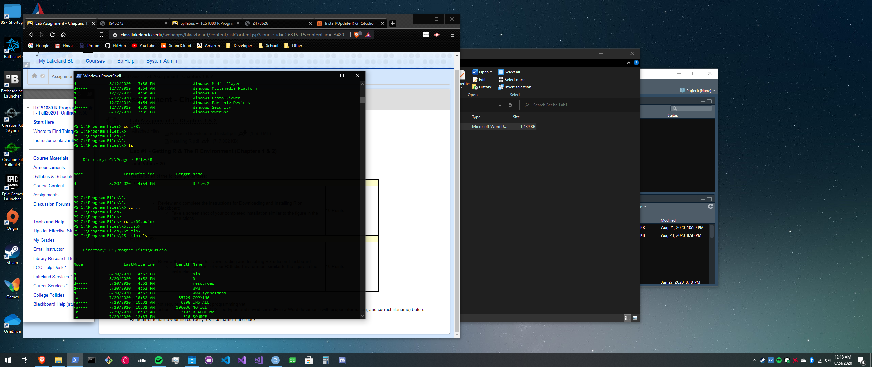

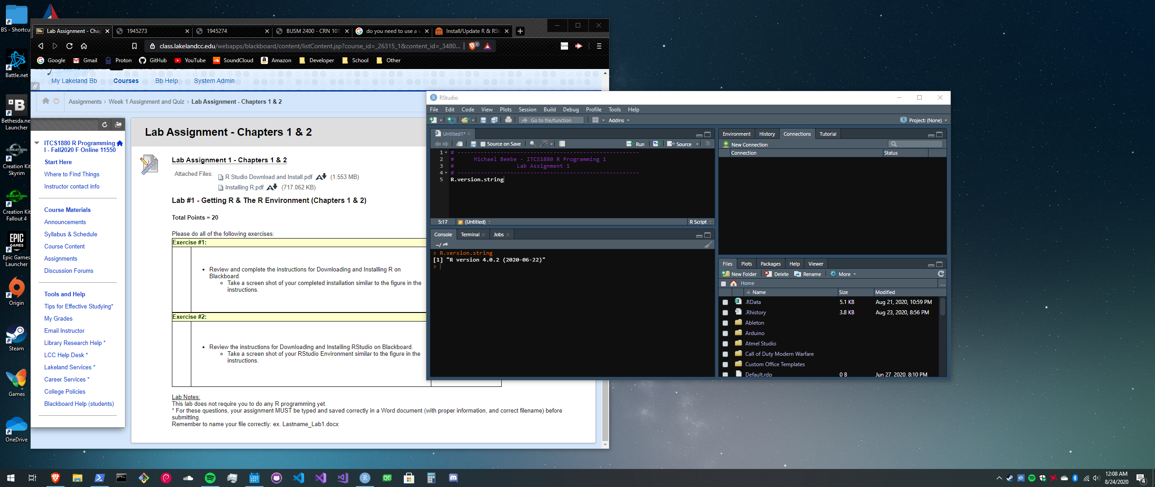I have the most up to date version of R (4.0.2) as you can see in the console. If I need to revert back to version 3.6.0 that will not be a problem.