Michael Beebe

Dr. Jennifer Crissman

ITCS 1880

August 29, 2020

**Lab Assignment: Chapter 3 – Packages**

1. Review Installed Packages

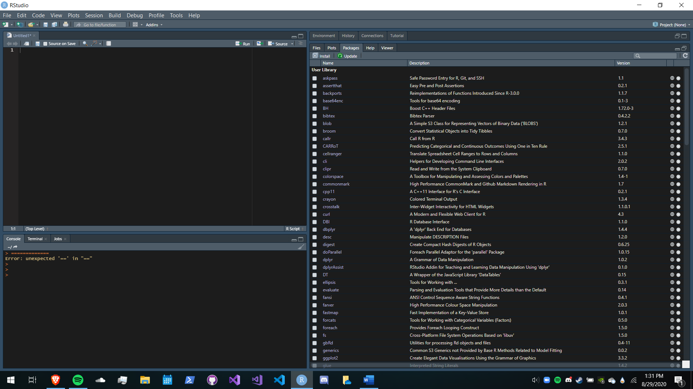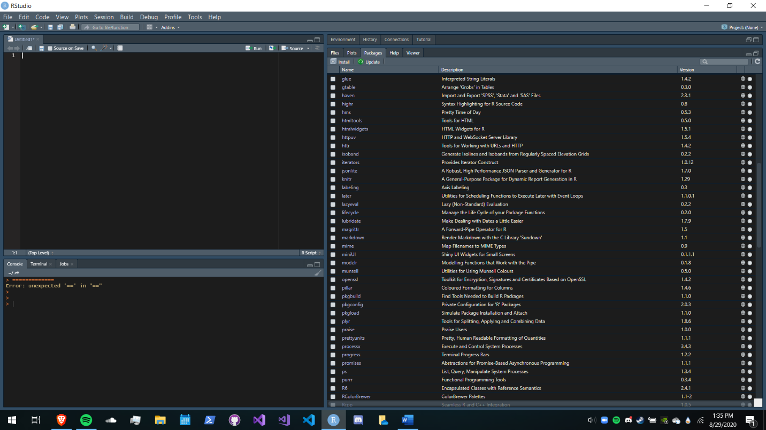

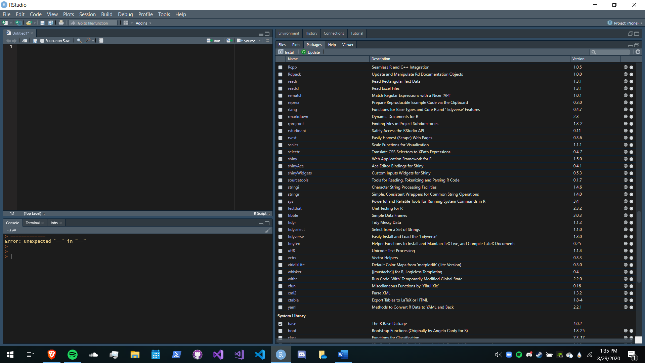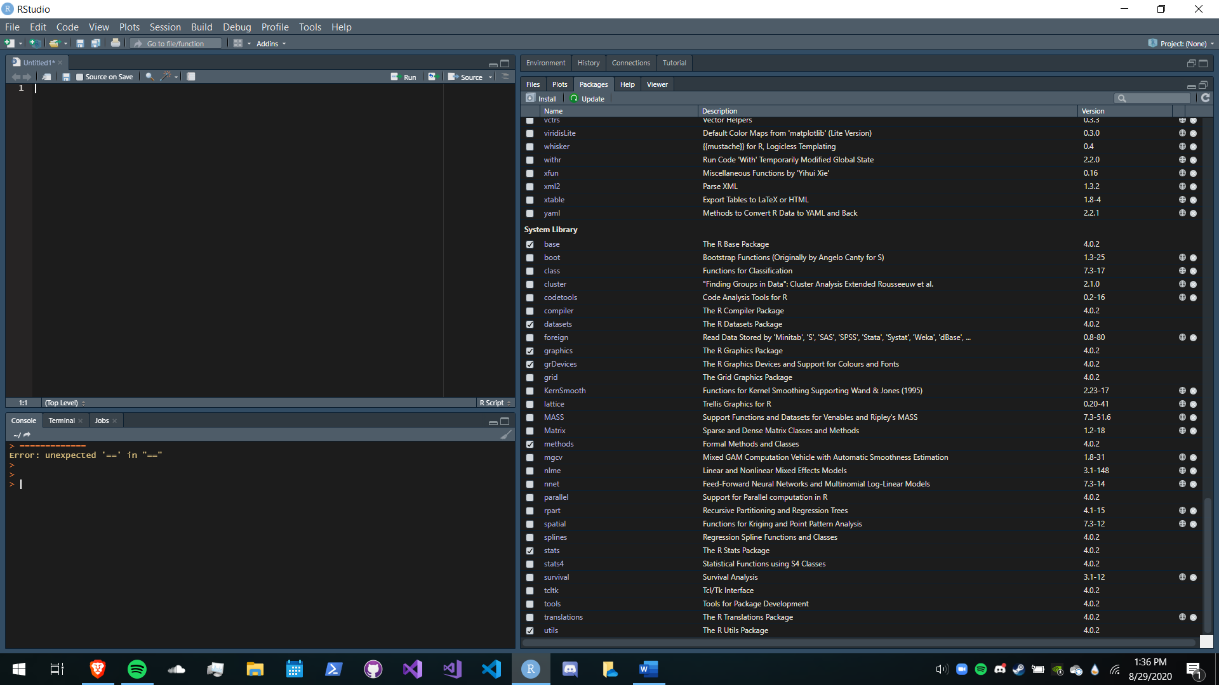

1. Install RTools

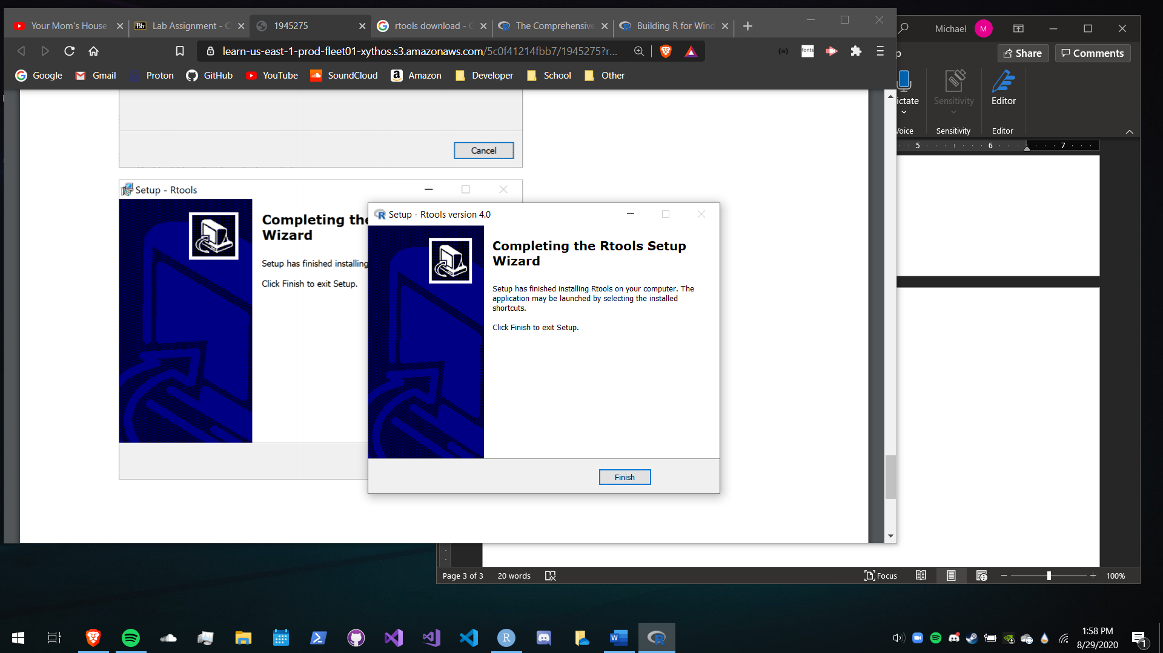

I installed the version of RTools that is compatible with my installed version of R.

1. Install and load the coefplot package

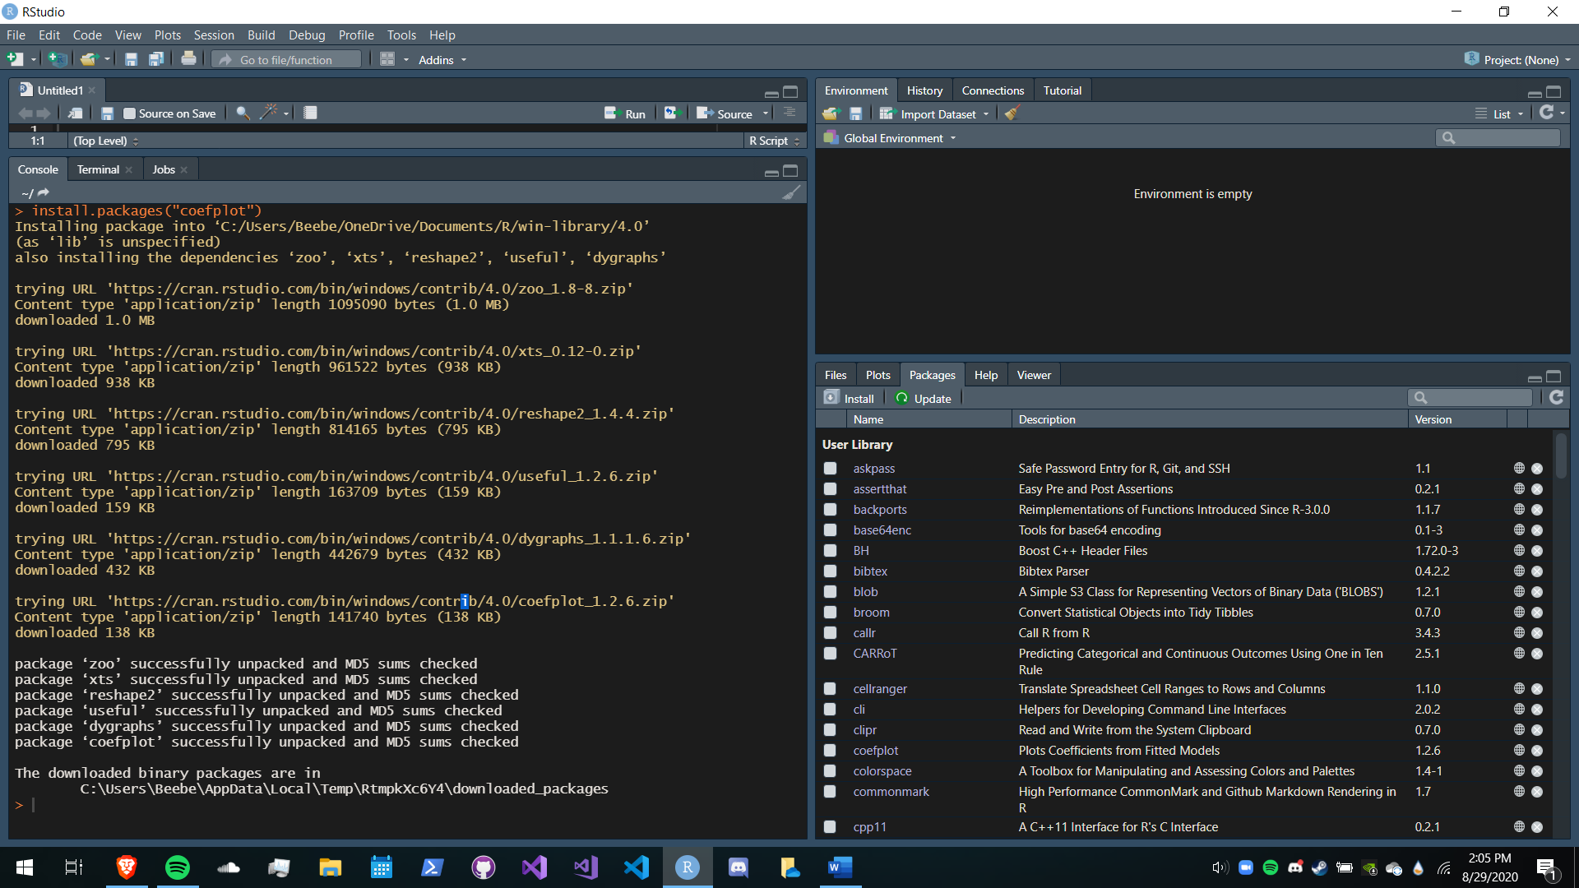

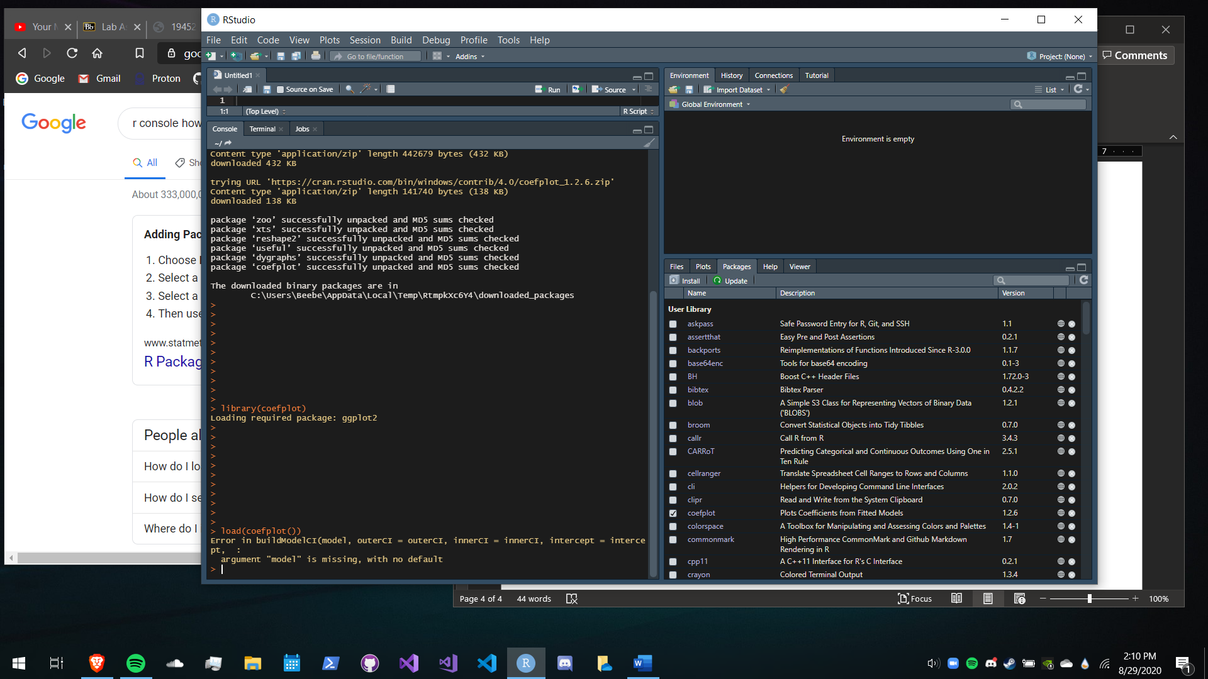

**Lab Assignment: Chapter 4 – Basics of R**

1. Basic Math

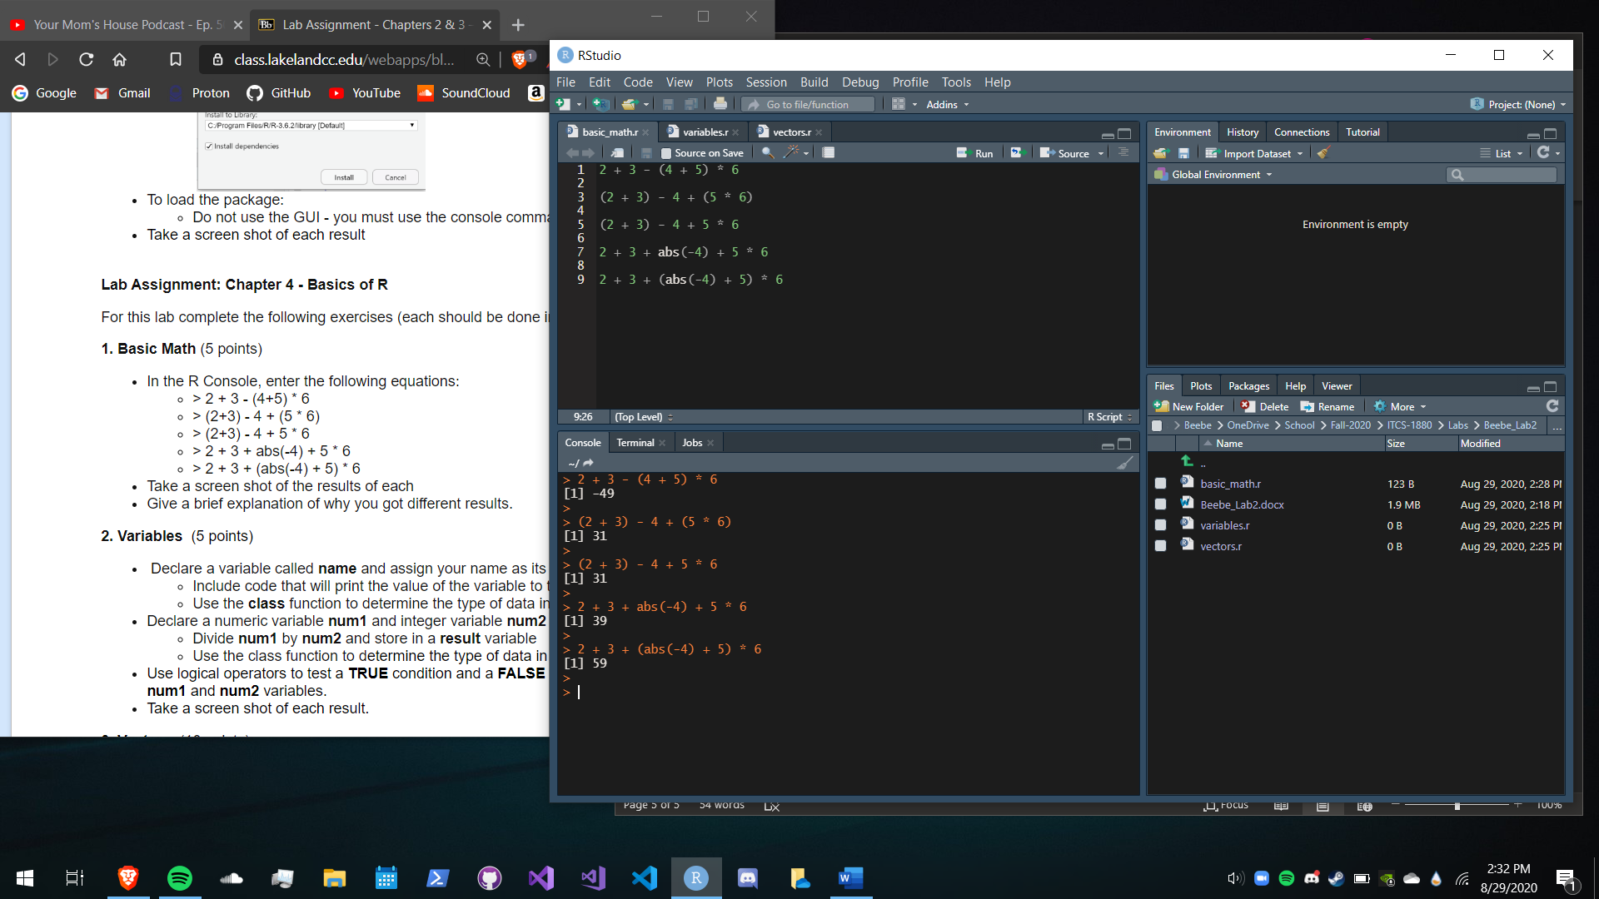

The reason why each of these equations yielded different results is because the R interpreter uses the order of operations.

1. Variables

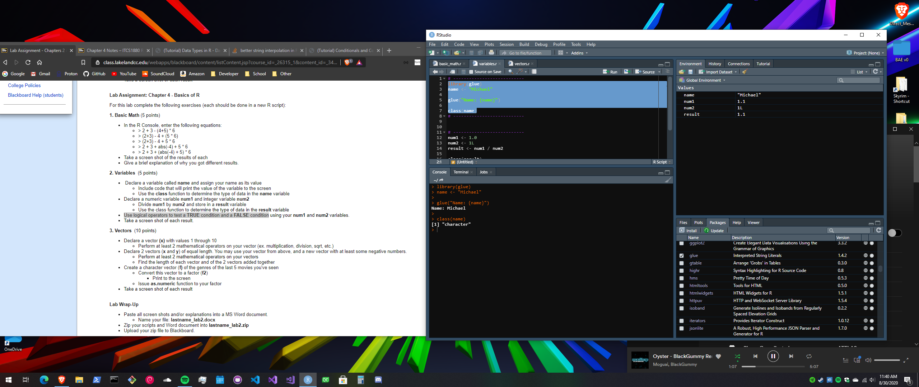

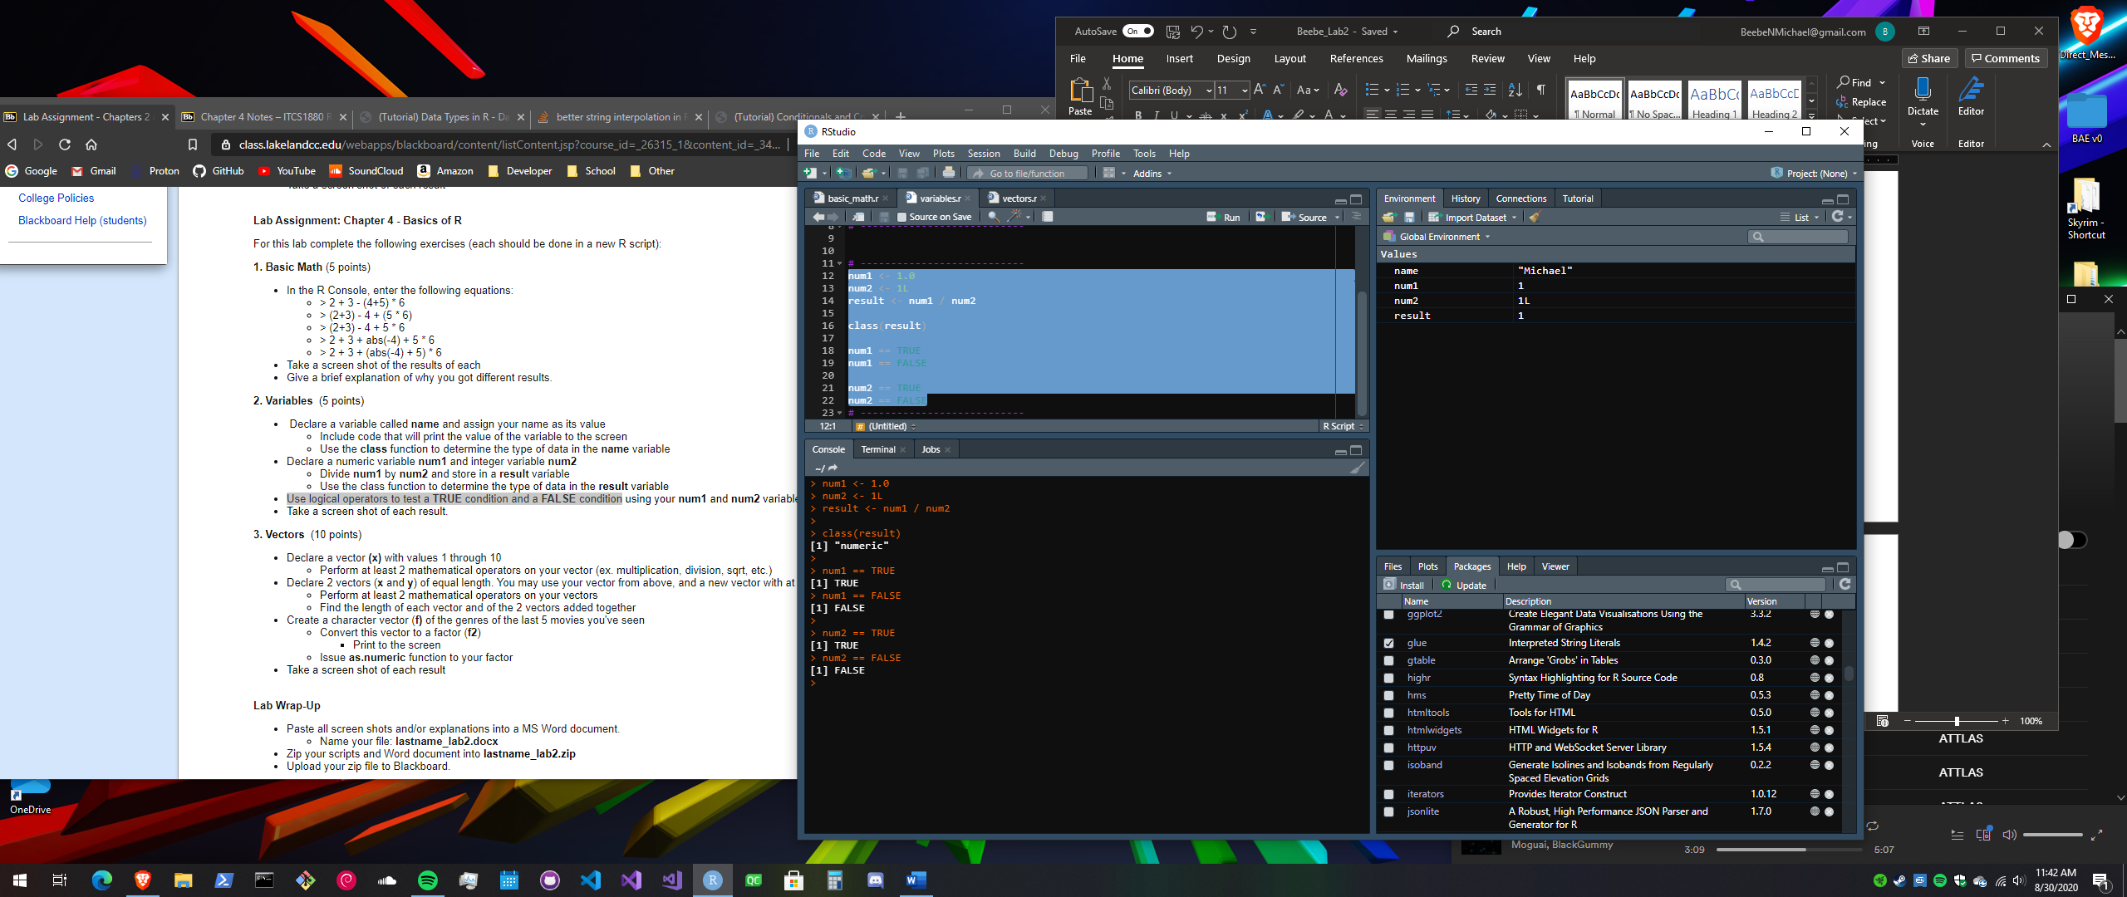

1. 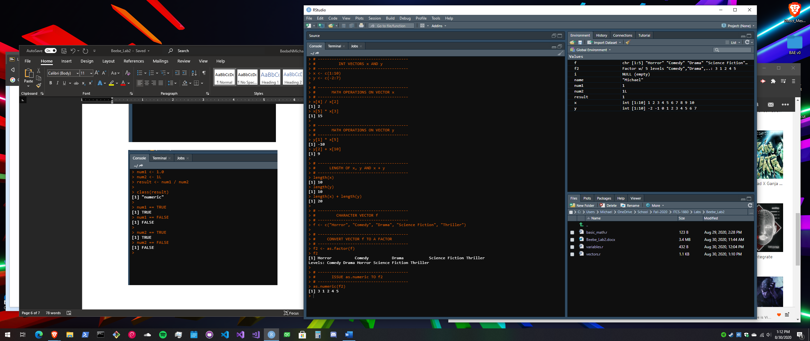Vectors