- Lab 1 - CS 142 RPG Review
January
31
Tuesday, January 31 at 11:59pm
Purpose
Inheritance is a powerful and integral component of object-oriented programming. Hierarchies existing in the real world can be easily modeled using inheritance; this practice can greatly simplify code.

This, and all 235 assignments will be verified by a TA-written test driver.
Key Reading
- CS 142 Text
Background
A major part of modern computer use is video games, and it's all fun and games until someone has to program them. Even the most simple video games, like the ancient Pong, require a lot of code to work properly. Many of the most basic concepts in programming appear in simple text-based role playing games, or RPGs.
For old time's sake, a friend has hired you to help write just such a game for his new company. Your first assignment is to implement the fighters awaiting battle at an arena. With three kinds of fighters and many stats for each fighter, you will need all of your previous programming experience to do well and keep your new job.
If terms like "hit points", "stats", or "damage" are unfamiliar within an RPG setting, please speak with a TA, read this article, or play any game made by this company.
Requirements
Overview
You will need this zip file (cs235_lab1_0.3.zip Download) to start the lab.
When you are finished with a lab assignment you may (1) meet with a TA to pass it off in person or (2) request that it be graded by a TA in your absence. If you select the former, you may need to wait in line. However, during the in-person pass-off, you may discover deficiencies in your program at which point you can terminate the pass-off and continue working on your program. If you select the latter, you will not need to wait in line, but you will forego the advantages of an in-person pass-off. If deficiencies are discovered in your absence, you may resubmit, but any resubmission may forfeit early days or incur late days in accordance with the usual early day / late day policy.
When you finish the lab, create a zip file and submit it through Learning Suite. Add a comment to your submission with "Grade In Person" or "Grade in My Absence" to indicate your grading preference. If you add the comment "Grade In Person" you will need to wait in line to meet with the TA.
File1 - Construct the Arena (2 points)
- Make a class that inherits from the ArenaInterface provided; the arena is simply a collection of fighters, each with a unique name
- For Part 1 only, you may assume all strings passed to the arena's adding method will be of the correct format
- For Part 1 only, you may assume all strings passed to the arena's getting and removing methods will be names already existing in the arena
File2- Let the Battle Begin (3 points)
- Make a class that inherits from the FighterInterface provided; details about abilities, stats, and more can be found in the FighterInterface
- For Part 2, the test driver will not call your useAbility() or regenerate() methods, so it is possible to receive credit for Part 2 without these methods being complete
- Completion of Part 1 is required to submit Part 2
File3 - Reset Testing (1 point)
- This is a more thorough testing of battling and resetting.
File4- Fortify the Walls (2 points)
- Make adding new fighters to your arena robust; this involves rejecting any string that is not of the correct format or that would add a duplicate name to the arena
- Make getting and removing existing fighters in your arena robust
- Completion of Part 1 is required to submit Part 3
File5 - Let Me Show You My True Form... (6 points)
- Add functionality to the useAbility() method and the regenerate() method for each fighter type
- Completion of Parts 1 and 2 is required to submit Part 5
UML design document. (1 point)
- Refer to page 113 in the book for an example.
- Please bring when asking TAs questions.
- You must bring a HARD COPY to the TAs when you pass off. (There is a printer upstairs if you made a digital copy)
Requirement Notes
General
- You are required to write a seperate '.cpp' and '.h' for each class you implement.
- You are required to use inheritance to implement the three kinds of fighters. The TAs reserve the right to deny pass off to programs utilizing inheritance incorrectly or that do not have the expected inheritance hierarchy.
- Unless otherwise instructed, use standard integer division for all division operations specified. This means all fractional results should be rounded down (ex: 17/10 = 1).
- You should not call a Fighter's useAbility() function in the getDamage() function, the test driver will handle all function calls for the Fighters.
- It is highly recommended to use the standard vector as the underlying representation for the Arena class. You are welcome to use other underlying structures, but those will be covered later in the course.
Fighter String Format
- Fighters are represented as strings when added to the arena. The following format is expected:
  - (name) (type) (maximum hit points) (strength) (speed) (magic)
  - Example: Xephos A 200 13 21 10
- The name is a single word; the type is a single capital letter ((R)obot, (A)rcher, or (C)leric); the remaining four stats are positive integers.
Fighting
- The following is a table of battles that will be run by the test driver:
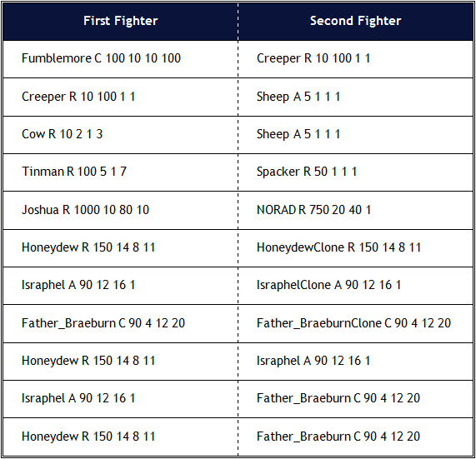
Class Hierarchy
- The following class hierarchy diagram shows the expected inheritance relationship between classes. Each box represents a class with inheritance indicated by the arrows. You will still need to make a complete UML diagram that includes the data members and member functions of each class in order to receive full credit for the lab.
