: Modelling the Appearance of Masses

Introduction
In chapter 6 we described a method for representing each region in our training data as the linear sum of two images. We defined the two images as the mass image and the background image such that:
- The mass image contained grey-levels corresponding to the pattern of increased attenuation associated with the central density of the lesion
- The background image represents the appearance of all other breast tissue in the region
In this chapter, the set of mass images become our sole data, as depicted in Figure 7.1. Because these are the only data we use, we no longer need to disambiguate between other uses of the term mass. As such, we drop the image suffix.
Our aim is to model the statistical variation in appearance of these data. The principal application of our model is to produce realistic synthetic masses, and thus in addition to describing the data, the model must be generative. This chapter describes how, using an existing model of mammographic masses as a base, we have developed a generative statistical model that optimally fits our data. A description of the remaining chapter sections is given below.
In the next section we describe in detail a model of mass appearance developed by Caulkin [\cite bib]. This was reviewed in section [] and identified as a good starting point on which to base our method.
Having established the basic framework for a generative statistical model of our data, in section 7.3 we discuss the properties required of the model. In particular we look at how well the model fits the dataset of masses, and, importantly, show how we can measure model fit directly from the data.
Original regions
Masses
Background images
Data used in chapter 7
Figure 7.1: Separating mass regions into two sources of intensity: masses and mass regions

In sections 7.4 to 7.6 we use the measures of model fit to show how three of the main components of Caulkin’s model can be optimised resulting in a significant improvement in model fit. The resulting improvement to the full model of mass appearance is presented in section 7.7.
Finally, in sections 7.8 and 7.9, we show how the generative nature of the model can be exploited to produce realistic synthetic examples of masses. We qualitatively evaluate the appearance of such masses when superimposed on regions of normal breast tissue, and describe how this motivates the work on background modelling presented in the following chapter.

Caulkin’s model of mass appearance
In section [\ch chapter 4] we reviewed the class of statistical models developed as part of the Active Appearance Model framework [\cite Cootes]. These models were designed to describe the variation in appearance of a training set of image objects. Here the term objects is necessarily vague – the only requirement of the object is that it has some characteristic shape and texture (where texture refers to the spatial distribution of grey-level across the object) such that a correspondence can be established between each example of the object in the training data.
By design, the set of masses obtained using the separation process described in the last chapter meet this requirement. That is in each mass, we can define a shape using the mass border (as annotated by a radiologist). This in turn defines mass texture as the pattern of grey-levels across the shape. Approximately speaking, we expect these grey-levels to be highest in the centre of the shape, tapering to a value of zero at the mass border. As such, there should be an approximate correspondence between each mass in the training data.
In our review of previous attempts to synthesise mammographic masses, we described a method developed by Caulkin [\cite Caulkin] in which a statistical appearance model was applied to a similar set of masses that had been subtracted from mammographic backgrounds. Having fitted the model to the training data, Caulkin used the generative properties of the model to synthesise new masses that could be superimposed on real normal mammograms.
In section [], we discussed the reasons why we think this was a good approach to modelling masses. As a result, we chose to use the model developed by Caulkin as the basis for our own synthesis method. Therefore in this section we describe the model fitted by Caulkin in more detail.
The three main components of the model were: a model of mass shape; a model of mass texture; and a combined model of shape, texture and mass size. We look at each component in turn below. In each case we describe the results of model fitting reported by Caulkin (in terms of the number of modes comprising each model) and also the results we have obtained applying the model to our own training data.

Shape
The mass border, as demarcated by a breast radiologist, defines the shape of each mass. To construct shape vectors, Caulkin first defined two reference points. These were the points of intersection of the mass border with a line connecting the nipple to the mass centroid, labelled as 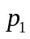 and 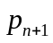 in Figure 7.2. Shape vectors 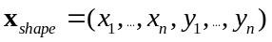 were then completed by placing n equally spaced points between the two reference points along each mass border (as depicted Figure 7.2). The number of points, n = 150, was chosen to be as small as could adequately describe the most complex of mass borders.
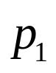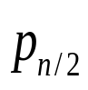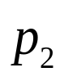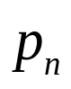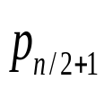
To the nipple
Centroid of the mass
Figure 7.2: Caulkin's method for placing landmark points on a mass outline

Having defined a set of landmark points on each mass border, a point distribution model (PDM) was built (see section [\ch 4]) to capture shape variation. That is, the set of mass shapes were aligned using Procrustes analysis [\cite bib], and a compact model of shape variation was built by applying principal component analysis such that for each mass 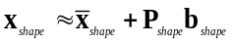, where  is a matrix of principal modes (with modes of negligible variance discarded) and 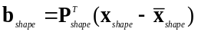is the vector of model parameters stored for each shape. The set of vectors 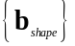 were assumed to be random variables drawn from a zero-mean multivariate Gaussian, with a diagonal covariance matrix comprising the variance 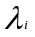 along each retained mode. After discarding modes of negligible variance, Caulkin’s original model comprised 23 modes describing 98% of the total shape variance. Applying this method to our data resulted in a shape model consisting of 25 modes. Given that our dataset contains nearly double the number of training examples (101 compared to 56), the fact that only 2 more modes of variance were required to describe our data suggests the shape model has captured the intrinsic shape characteristics of a mass boundary. That said, in section [], we show the shape data can be further compacted to construct a model with improved generality and specificity.

Texture
Using a thin-plate spline interpolant [\cite bookstein] each mass border was warped to the shape mean (see appendix X), mapping the regions into a common coordinate frame. Shape free texture vectors were then extracted from each region. The size of the mean was chosen such that the texture vectors had 10,000 elements, again as a compromise between fidelity and compactness. As with shape, PCA is used to build a model of texture variation: 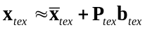. Again keeping 98% of the total variance, Caulkin’s original model yielded 37 modes. To give a direct comparison to Caulkin’s method, we fitted the texture model using to our data using subtracted mass intensities that had not had high-frequency background components removed (that is, masses obtained using the initial separation method defined in section [ch 6] without further applying the methods described in sections [\ch6] and [\ch6]). This resulted in a model comprising 77 modes. We note that this large increase in the number of modes is most likely to be due increase in image resolution between our data (40μm per pixel) and that used by Caulkin (100μm per pixel). In section [] we describe the effect of modelling the texture of masses obtained using the complete separation method described in chapter 6.

Combined appearance
A model of combined appearance was built by concatenating the weighted shape and texture parameters and 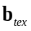, together with the size parameter returned from Procrustes alignment, and applying PCA to compute  as before. Note that the size parameter is not usually included in appearance models (and is usually treated separately as part of pose) but was included by Caulkin to account for any correlations between mass size and appearance. This correlation is likely to exist as, for example, larger masses would be expected to cause greater x-ray attenuation, and would thus correspond to higher grey-levels in a digitised mammogram. The weighting accounts for differences in metric between the three components (shape, texture and size), and was computed as the inverse of the average variance per mode. Thus for each component, 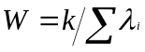 where is the number of retained modes, and the variance along each mode. The number of significant modes retained in Caulkin’s combined model was not recorded; however applying the method to our data constructed a combined model containing 65 modes (using the same texture model as before).
Having learned the distributions of mass appearance, new examples were generated by randomly sampling from the model as follows:
- Sample a new combined appearance vector , and compute 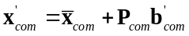
- Separate 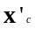 and invert the weighting to form 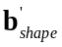, 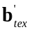and 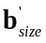
- Compute 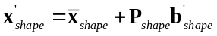 etc.
- Map the new texture 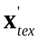to the new shape 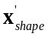, scaled by 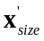, to produce the new synthetic mass 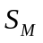
The process above highlights a major advantage of using the appearance model framework as a basis for mass synthesis. Having built the models, no user parameters are needed to generate new examples. The appearance of a new mass is completely determined by a vector that can be randomly (and thus automatically) sampled from the model distribution. As a result, the process can be repeated to produce limitless examples of unique masses that match the appearance properties of real lesions.
However, having applied the model described by Caulkin’s to our training set of masses, we do not think it adequately fits our data. As a result the model distributions learnt from the data are not truly representative of the variation in appearance of the global set of masses. This, in turn, would mean that synthetic masses generated from the model could not be used in place of real data. To determine how we can improve model fit, in the next section we expand on the desirable properties of this form of statistical model and describe how we can measure model performance.

Measuring model errors
In this section we define a method for quantifying how well a statistical model fits a set of training data. To do this, we first consider what properties we require a model to have. Throughout we reference the particular application of modelling mammographic masses, although we note the properties and measures we discuss are applicable to any class of image object.

Model properties
From the description of how a mass appearance model is constructed (section 7.2), it should be apparent that a statistical model provides a compact representation of our training data. Where previously, each mass was defined by several hundred thousand pixels, it is now fully described by its vector of combined model parameters . Thus the complete set of training data is defined by the set of vectors 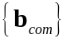, and the matrix of principal modes of variation for each component, 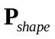, 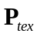and .
However, in using the model to generate synthetic masses, we make two important assumptions about the model that extends its use beyond simply representing the data we already have. Firstly, we assume the model can describe any mass appearance from the global population. Secondly, we assume that anything that doesn’t match the appearance of a mass cannot be represented in the model. These two model properties are usually known as generality and specificity, respectively. If we can measure the generality and specificity of a given model, we can compare the performance of one model relative to another, enabling us to find the optimal model for our data.

Specificity
We assume specificity is directly linked to the compactness of the model, which itself can be measured by the total variance in the model. With the mean mass appearance at the centre of the model, the variance along each mode defines how the probability density reduces moving away from the mean. As the variance increases, the probability is spread further from the mean, increasing the likelihood that an object whose appearance does not match that of mass has non-negligible probability in the model.
One way of reducing the amount of variance stored in a model is to reduce the number of modes retained. Taken to the extreme, a model with no modes only allows the mean mass to be generated and is therefore guaranteed to be specific. Of course such a model suffers from a total lack of generality, and is unable to explain any of the variance in the population of masses (or indeed in the training sample). Thus in constructing each of the component models, we choose to retain a fixed amount of the total variance, selecting the number modes required to match this threshold. For this work 98% of the total variance was chosen as a sufficient compromise between specificity and generality. As a result, our aim in improving the specificity of the models is to reduce the total variance in the data, prior to discarding modes of negligible variance. An alternative measure would be to try and use an objective function to measure model specificity as was described by Cootes et al [\cite Cootes].

Generality and the residual errors for an unseen mass
To get a measure of model generality, we assume we have built shape, texture and combined appearance models from a training set of masses. In addition, we assume we have a mass not used in building the models, which we refer to as an unseen mass. The more general the full combined appearance model, the better it will be able to represent the unseen mass. To measure this, we can transform the unseen mass into a point in model space, and then reconstruct a representation of the mass from the model. We can then compute the residual error of the unseen mass as the difference between its original form and its reconstruction in the model. Below, we give a fuller description of this process. In addition, the error calculation is depicted in diagrammatically Figure 7.3.

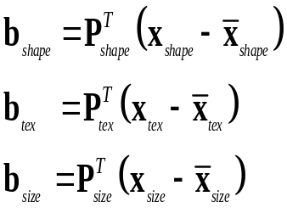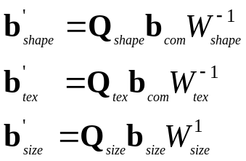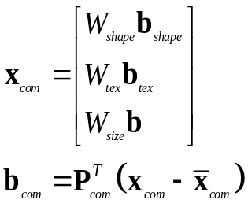

2
3
4
5

Combined model error:
1
Individual model error:
Masses
Individual models
Combined model
Figure 7.3 Calculating the residual errors in the model representation of a mass 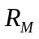. For the error to be unbiased must not have been used in the construction of the model

We call the unseen mass 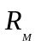, and assume this is in the same form as those used to train the model (i.e. with a continuous border outlined and the original position relative to the nipple known). This allows us to obtain vectors 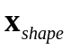 and 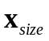, and, after warping to the shape-free space, 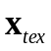. Using the principal modes of the shape model, we can calculate the model parameters 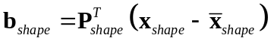, and similarly, compute 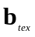 and 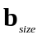 (step 1 of Figure 7.3). Now we regenerate the shape, texture and size vectors as approximated by the individual models: 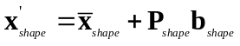 etc. as depicted by step 2 in Figure 7.3. From here the full mass region 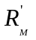 can be regenerated. The root mean squared error between the mass regions and and/or the individual vectors can be used to quantify how well the individual models represent the new mass.
Of course, the individual models are further combined into the full appearance model, and so returning to 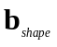, and , we build the combined vector and compute  as depicted in step 3 of Figure 7.3. This is the representation of the original mass in the full model space and, following the reconstruction described in section 7.2, can be used to generate 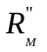(steps 4 and 5 of Figure 7.3). As with the approximation from the individual models, we can use the root mean square error between and to quantify how well the full appearance model has described the original mass. It is also useful to consider the difference between and . This shows the added error induced by the combining the individual models in the full appearance model, and as we see in section 7.6, will be useful when we optimise the weighting of the shape, texture and size parameters in the combined appearance vectors.

Leave-one-out testing
The process above describes how we calculate residual errors for a single mass represented by the model. For this error to be unbiased the mass should not have been used to build the model. To have a useful measure of the performance of the model, we need to calculate this error for a sample of masses large enough to be representative of the global population. However, we only have a limited number of masses available, and require all of these to construct the model. To satisfy both needs, we employ leave-one-out testing to calculate residual errors for each of the N masses in the dataset. The set of errors can then be used to quantify how well the model can describe unseen masses in the global population, and so provides our measure of the model’s generality. The leave-one-out testing algorithm we apply is summarised below:
for i = 1 to N
construct model from the set of masses 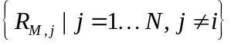
compute residual errors for mass 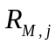
end
Algorithm 7.1: Leave-one-out computation of residual errors
Such a scheme works on the assumption that the model constructed from any N-1 subset of masses is negligibly different from the model built from all N masses. This assumption holds true if we believe our set of masses sufficiently represents the global population, which itself is a condition of constructing the models. Thus using leave-one-out testing does not require any further assumptions about data than had been made already.
Having described how we can measure the desired properties of specificity and generality of a model, in the next two sections we show how we can construct an optimal model of mass appearance given a set of masses (complete with annotated borders).

Optimising the shape model
The key to building a compact representation of mass shape is to establish a set of dense correspondences between the annotated borders. Finding such a set may be problematic due to the lack of features present in each mass border. In section 7.2, we described how Caulkin defined two common feature points on each mass shape, and used these to determine the location of a further set landmark points. The reference points were constructed by extending a line from the breast nipple through the centroid of the mass, before setting the point of origin as the intersection of this line with the mass border nearest to the nipple, and a halfway point as the point of intersection furthest from the nipple, as was shown in Figure 7.4. Fixing the origin in this manner aimed to introduce a correspondence based on the theory that masses form in ducts approximately radiating from the nipple, as in the simplified depiction of masses in Figure 7.4.
Mass centroid
Mass centroid
Point of origin on mass shape
Point of origin on mass shape
Alignment of masses after applying Procrustes analysis
Figure 7.4: Depiction of two mammographic masses oriented towards nipple. With a fixed point of origin, the mass shapes form a compact alignment after Procrustes analysis
Mass centroid
Point of origin on mass shape
Mass centroid
Point of origin on mass shape
Alignment of masses after applying Procrustes analysis
Figure 7.5: Depiction of two mammographic masses with random alignment. By fixing a point of origin, Procrustes alignment will not align the mass shapes despite their similarity

If all the masses in the dataset followed such an alignment to the nipple, then after adding in the remaining equally spaced border points and applying Procrustes analysis, we would expect to obtain a compact shape model. However, analysis of our data suggests no evidence for masses radiating from the nipple. A more realistic diagram of mass alignment is presented in Figure 7.5. In this case, shapes A and B will not correspond after Procrustes analysis, so in fact fixing the origin simply introduces rotational variance in the model. That is, objects that have the same shape but differing orientations are described differently in the model. This has two negative effects: firstly, and most obviously, the model will not be optimally compact, as additional model parameters are required to describe the differing orientations of the same shape. Secondly, subtle variations may be discarded from the model because the retained modes describe a fixed amount of the total shape variation, and a significant amount of this would be due to the rotational variance. This would reduce the model’s ability to represent masses in the dataset, and more generally, those in the global population.

Optimising the point of origin on mass shapes
A solution to remove the rotational variances from the model is to allow the optimal origin of each mass border to be selected during Procrustes alignment. This requires modifying the iterative Procrustes algorithm. The new algorithm is given in detail below (note as all vectors in the algorithm refer to shape, we will drop the shape suffix for convenience, for example instead of 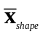).

Select a random seed shape as the target 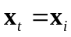for some 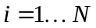
for each shape i = 1 to N
for each point j = 1 to n
permute 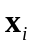 so that the j-th element is now the first
align to 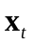 to find optimal rotation, scaling and translation
record the distance from the aligned shape to the target: 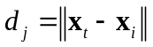
end
set 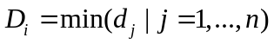
and set the origin of as the associated j
end
Compute the mean of the differences across the set: 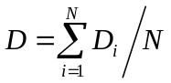
Compute the mean shape: 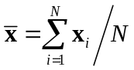
Set 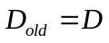, 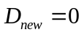 and 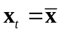
while 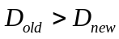
repeat
set 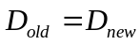, 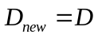and
end
Algorithm 7.2: Procrustes alignment of shape, with optimisation of shape origin
To check the algorithm is robust to the choice of initial seed shape, the algorithm is repeated for a random selection of seed shapes. In each case the difference between the resulting mean shapes is calculated to establish whether choice of seed affects the algorithm outcome. In our experiments there was negligible difference between the mean shapes obtained from any of the randomly selected seed shape, satisfying the desired robustness.

Applying MDL optimisation to mass shapes
Whilst allowing the origin of each mass border to vary removes much of the rotational variance in the data, there may still be a better set of shape correspondences we can obtain. In section [], we reviewed a method developed by Davies et al [\cite bib] for computing the optimal set of correspondences for a training set of shapes. In this method, the locations of points on the continuous shape borders are allowed to vary (as opposed to sampling equally spaced points) during the alignment optimisation. The objective function used in the optimisation is a measure of compactness termed the Minimum-Description Length (MDL) that quantifies the amount of data that is required to fully describe the set of shapes given their parameterisation under the model.
In addition to allowing the origin of each shape to be optimised as described in the previous section, we applied the MDL optimisation algorithm to our set of mass shapes to see if further improvements in correspondence could be made. The results of applying each alignment method are given in the following section.
As noted in section 7.2, the spatial resolution of digitised mammograms in our data was greater than that used in Caulkin’s original experiments. For this reason, we required an increase in n, the number of points sampled along the demarcated border of each mass. The mean length in pixels of the masses in our dataset was 1560 (compared to 700 in Caulkin’s work) and thus a value of n = 400 was chosen (compared to n = 150 in Caulkin’s work).

Results
After applying the standard Procrustes alignment algorithm to the set of 101 mass shapes, the total variance was 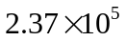. As noted in 7.3.2, the total variance of the aligned data provides a measure of how specific the resulting shape model will be, with lower variance resulting in increased specificity.
To measure model generality, the residual shape error 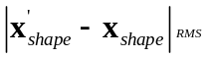 was computed for each mass using leave-one-out testing (see sections 7.3.3 and 7.3.4 for more details), and the mean of these errors taken. For the standard Procrustes algorithm, the mean generalisation error was 3.78.
Applying the origin optimisation alignment algorithm described in 7.4.1 to our dataset, reduced the total shape variance by 48% to 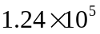. The mean generalisation error was also reduced to 3.64.
Applying MDL optimisation in addition to allowing the origin of each shape to vary further reduced the total shape variance to 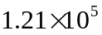. This was associated with a reduction in model generalisation error to 3.60.
These data are summarised in Table 7.1.
Table 7.1: Model generalisation error and variance for methods of aligning mass shape
 | Variance | Model generalisation error
Procrustes analysis |  | 3.78
Procrustes analysis using optimised origins |  | 3.64
MDL optimisation | 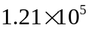 | 3.60

As a result of optimising the origin of each shape and applying MDL optimisation, we have greatly reduced the total variance in the shape model, making the model more specific and thus less likely to generate unrealistic shapes when used to synthesise new masses. Further, because the model is not required to describe the rotational variances present in the mass shapes aligned using the standard Procrustes algorithm, the model modes are better able to describe subtle variations in the mass shape. This allows the model to be more general, as seen in the reduced mean generalisation error. To test the statistical significance of the reduction in model error, we applied the Wilcoxon signed-rank test to compare the three methods. The results of the test show that allowing the origin of each shape to optimised during Procrustes alignment produced a significant reduction in errors (p < 0.0001). Subsequently applying MDL optimisation produced a further statistically significant reduction model error (p < 0.0001).

Modelling mass texture
With regards to modelling mass texture, the only change we have made to the method described by Caulkin is to increase the length of texture vector extracted, from 10,000 to 50,000 pixels (controlled by scaling the size of the mean shape used to warp the masses into a shape-free coordinate frame). As with mass shape, this was to accommodate the increase in mass size within each image as a result of the increased spatial resolution of the mammograms in our data.
However, as a result of changing the process by which mass intensities were separated, as described in chapter 6, the data modelled is very different. Most importantly, we have transferred high-frequency components that previously were included with mass intensities into the background region. Our reasons for doing so were detailed in section []. To recap, we observe that the majority of such structures do not belong to the mass (that is, their intensity can be attributed to x-ray attenuation through normal structures in the breast superimposed in the mass region). If these structures were included in a synthetic mass, then when we added the mass to a normal mammogram we would be simulating a localised increase in attenuation above that corresponding solely to the presence of a mass.
Where high frequency components do belong to the mass (principally, mass spicules), these are better accommodated in the background regions because:
- They do not form a consistent set of correspondences that can be captured using the form of appearance model described in this chapter. Analogous to the discussion on rotational variance (section 7.4), this reduces model compactness (because extra modes of variance will be needed to describe the individual structures) and may cause subtle variations in texture that are characteristic of the central density to be discarded from the model (because the high frequency components have used up the total variance retained).
- By including them in the background regions we have a set of data from which the interaction between mass spicules and normal tissue can be modelled. As we show in the following chapter, we design models to capture and synthesise high-frequency texture components that do not have a consistent global correspondence across an image
In this section we give evidence to support the first point. Using the optimised shape model described in the previous subsection, we built texture models of our set of masses both with and without high frequency components included. We then computed the mean texture generalisation error 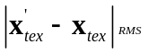 for each mass using leave-one-out testing. The errors for masses with high frequency components removed were dramatically, the mean errors across the set being 3.80 and 1.73 respectively (Wilcoxon signed-rank p < 0.0001). We also note the modes required to maintain 98% of texture variance were reduced from 77 to 28.

Weighting shape, texture and size
The final step in building the full model of mass appearance is to combine the model parameters of shape, texture and size for each mass before further applying PCA. As noted previously, the inclusion of the size parameter is unusual in appearance models, but is important in this instance to account for the expected correlation between the size of a mass and its shape and, in particular, texture.
However, including size makes correctly weighting the individual components in the combined appearance vectors crucial. Prior to weighting, the size parameters 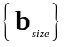of our dataset of masses have an order approximately 10³ smaller than the texture parameters 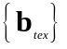. Thus, if unweighted, real size variation would be equivalent to random texture noise and would be discarded when removing negligible modes from combined model.
We recall that Caulkin used the inverse of the mean variance per mode in each component. That is, for each of shape, texture and size, 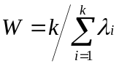 where is the number of retained modes, and the variance along each mode (by construction 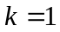 size, and thus 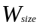 is just the inverse of the size variance). In the following sections, we show why we do not think these are a good of choice weights and present three alternative methods for computing component weights. In section 7.6.4, we quantitatively evaluate each method and thus choose the best method to use in our model.

Equalising mode variance
We presume that dividing each set of model parameters by the mean variance for that component was an attempt to equalise the variance of shape, texture and size in the full model. This appears to be a sensible idea, however because variance has the order of the square of the parameters, equality will not be achieved by dividing the variance. As a simple example, assume the texture parameters have, on average, a magnitude A times larger than the size parameters . Then 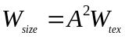, and so, after weighting, we have simply reversed the problem such that 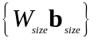now have, on average, a magnitude A times larger than 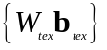.
In the previous section we stated that in fact A is approximately 10³ and so computing weights proportional to the inverse of each components total variance results in the size parameter of the combined appearance vectors being 1000 times larger than the texture parameters; and by a similar calculation, 200 times larger than the shape parameters. As we see in 7.6.4, this weighting does not produce a model that fits the data well.
The solution to this problem should be clear: if we are trying to equalise the mean variance of shape, texture and size in the model, we should be dividing each component by the mean standard deviation. Thus for each component 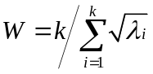. We will show in section 7.6.4 that using mean standard deviation does indeed improve on weights calculated using the mean of the variances. However in sections 7.6.2 and 7.6.3 we describe two further methods for computing weights that produce models that describe mass appearance with significantly lower residual error.

Equalising texture displacement
Having shown how to equalise the total variance of each component in the combined model, we now consider whether this is in fact desirable. It may be that shape, texture and size have different magnitudes of effect on mass appearance and thus should have different magnitudes of representation in the combined model.
A better method for computing the model weights would be to quantify the magnitude of the effect of each component on mass appearance. Such a method was used in the original Active Appearance Model work by Cootes et al. [\cite bib]. Below we show how this method is applied to our data.
Consider any mass from our dataset, comprising shape, texture and size vectors 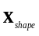, 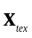 and 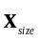 respectively, with texture model parameters 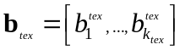. Due to the linearity of the model, if we displace any mode in 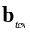 by a unit then we cause a unit displacement in the model approximation to . That is, if we define
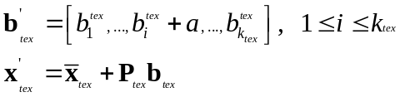
and
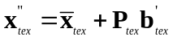
then
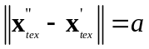

Since the shape and size vectors determine the texture vector sampled, we can then estimate the displacement of the sampled texture vector caused by systematically displacing each mode of the shape and size model parameters, and subsequently calculate the weight needed to cause a unitary shift in the texture vector. We apply this process to the full set of masses to approximate the mean weight needed so that a unitary displacement along any mode of the shape, texture or size model parameters results in an equivalent displacement in the resampled texture vector. The algorithm for calculating the shape weight is given below:
for each mass 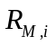
calculate
resample 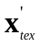given 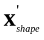scaled by 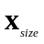
for each shape mode 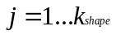
displace parameter j by a constant
set 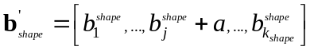;
calculate 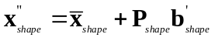 ;
resample 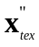given 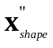 scaled by ;
define 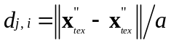;
end
end
set 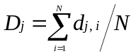
set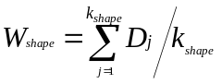
Algorithm 7.3: Computing the effect of shape mode variance on shape-normalised mass texture
Note that we could use the texture displacement per unit shape displacement for each mode to define a weight for each individual shape mode as in the method described in by Cootes. However, the per unit displacement was found to be approximately constant across the modes, and computing the resulting model error as described in section 7.3.4, no significant difference was found between using individual mode weights and a combined weight.
To calculate 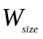 we apply a similar algorithm to above, with the obvious change that the re-sampled textured vectors are calculated given the original shape vector multiplied by a displaced size parameter, as opposed to a displaced shape vector multiplied by the original size parameter. By construction, 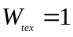.

Directly optimising weights
The methods described in sections 7.6.1 and 7.6.2 attempt to calculate weights that make the individual components theoretically commensurate in the combined model. However, an alternative approach to the problem is to see the weights as variables to be optimised given some objective function.
For a suitable error function, we refer back to the method for quantifying model generality in 7.3. Using leave-one-out testing, for each mass we showed how to calculate 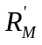 and 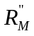 as the approximations of the mass given the individual models and the full appearance model respectively. The root mean-squared error between and is the added error caused only by the approximation of the combined model. If we fix all aspects of constructing the combined model, except the component weights, then any change in 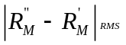 is associated with the weights. Thus, in combination with leave-one-out testing, we can compute a mean generalisation error for the dataset associated with any given set of weights, as described in Algorithm 7.4.
for each 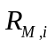
construct model from the set of masses 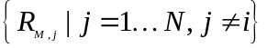
compute approximations 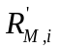and 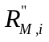 for mass
compute 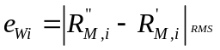
end
set 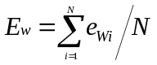
Algorithm 7.4: Computing the mean residual error associated with component weighting in the combined model for a set of masses using leave-one-out testing
Having defined an objective function, we consider the variables we seek to optimise. Given the linear nature of the models, it is only the relative magnitudes of the weights that are important, and so without loss of generality, we can fix 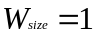, and optimise 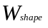and 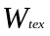. In addition, we note that the sign of the weights is irrelevant and so fix the constraints that , 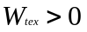. Computing a set of weights is now formulated as a constrained non-linear optimisation over two variables, minimising the objective function 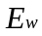. All that remains is to choose an optimisation algorithm. For this we use the sequential quadratic-programming (SQP) method implemented in the Matlab toolbox, and described in [\cite bib]. This has been shown to be one of the most accurate and efficient algorithms over a large range of problems [\cite bib].
To narrow the range over which we apply the optimisation, we first computed for a coarse grid of values and . was varied from 0 to 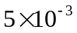 at intervals of 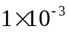, whilst was varied from 0 to at intervals of 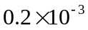. The resulting error map is shown in Figure 7.6. This confirms that behaves suitably as an objective function, and provides an approximate region to start the SQP algorithm. Of the range of values initially tested, of 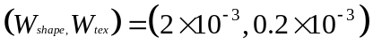 corresponded to the lowest value of . Four pairs of 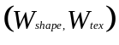 values were chosen symmetrically about this minima () and used in turn to initialise an SQP optimisation. To aid computational efficiency, only a randomly selected subset of the full training data (25 out of 101 masses) was used during each optimisation. However, when each optimisation had converged, the final weights were used to compute for the full set of data. The weights corresponding to the lowest overall error were selected.

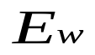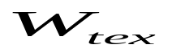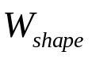
Figure 7.6: Map of mean generalisation error associated with component weights () for varying combinations of and ()

Results
In the previous section we showed how we can calculate the residual error in approximating mass as a result of combining the shape and texture models into a single model of appearance (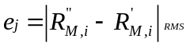). By keeping all other aspects of model building the same, we were able to associate this error with changes to the weights applied to the shape, texture and size parameters so that they were commensurate. Again employing leave-one-out testing we used this error to define a mean generalisation error for the dataset, given a particular set of component weights ().
We have discussed four methods for selecting component weights , and . These were:
- Computing each weight as the mean variance per mode (as used originally by Caulkin)
- Computing each weight as the mean standard deviation per mode so that the total variance in shape, texture and size parameters were equal in the combined
- Applying the texture displacement method described in section 7.6.2
- Directly optimising as described in section 7.6.3
We used to compare the performance of each of the four methods. The individual models used during the evaluation were the optimised shape and texture models described in 7.4 and 7.5 respectively, built from the dataset of 101 mass regions. To recap, this produced a shape model comprising 32 modes and a texture model of 28 modes. The parameters along each shape and texture mode, complete with the single size parameters, produced 61-element combined appearance vectors for each mass. Boxplots of the set of errors (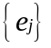 in the notation above) for each method are shown in Figure 7.7, whilst the mean errors () are summarised in Table 7.2.

Table 7.2: Comparison of error for different methods of selecting component weights
1. Mean variance per mode | 3.10
2. Mean standard deviation per mode | 1.76
3. Texture displacement | 1.00
4. Direct optimisation | 0.82

Method 1 was included to enable a comparison with Caulkin’s model. However there is little theoretical justification for dividing each component by the mean variance per mode and, as expected, it produced the highest errors. Dividing instead by the mean standard deviation, as in method 2, equalises the variance of the pooled set of parameters for each component. This assumes shape, texture and size affect appearance equally, and whilst producing lower errors than method 1, method 2 performed poorly relative compared to methods 3 and 4.
By construction, we would expect direct optimisation to generate the lowest errors, and indeed was the case. However we were interested to see whether computing weights using the texture displacement method produced similarly low errors. In fact the reduction in error using method 4 compared to method 3 is statistically significant (p < 0.0001). As a result, the combined appearance model was constructed using the weights computed using the directly optimisation method.
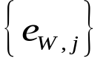
Figure 7.7: Boxplots of model generalisation error for different component weighting methods

Results
Using our dataset of 101 masses, we built a combined model of appearance using the steps described in sections7.4, 7.5, and 7.6 for improving model fit. That is, we constructed a shape model having first aligned the set of mass borders using the MDL optimisation algorithm [\cite Davies]; we then constructed a texture model using masses, separated from background regions using the completed method described in chapter 6; finally we weighted the parameters of shape, texture and size to form combined appearance vectors for each mass, using weights that had been directly optimised to reduce the generalisation error associated with the combined model. This model was compared to the model we constructed using Caulkin’s method without modifications (see section 7.2).

To compare the two models, we define the total model error for a given mass 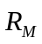 as the difference between itself and its regeneration from the combined appearance model (that is, 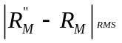). Again, leave-one-out was employed to compute unbiased errors for the full dataset, and allowing us to compute the total mean generalisation error (MGE) for each model. These data, along with the respective number of modes contained in shape, texture and combined models are given in Table 7.3. We can see that the improvements to individual stages of the model building process have resulted in a model that generalises significantly better (p < 0.0001 on comparison of total MGE). Moreover the model is more compact requiring just 32 combined appearance modes compared to 65.

Table 7.3: Comparison of total model generalisation error and number of model modes
 |  | Caulkin’s model | Optimised model
 | Total MGE | 3.11 | 1.26
Number  of modes | Shape | 25 | 32
Number  of modes | Texture | 77 | 28
Number  of modes | Combined | 65 | 32

In the next section, we describe how we can use the model we have constructed to sample new synthetic masses.

Synthesising New Masses
Having constructed a model of mass appearance we use the model to generate synthetic masses. The first step in this process is to sample new appearance vectors from the model distribution. To do this, we assume a Gaussian distribution 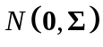 over the space of combined model parameters. The covariance matrix 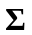 is diagonal such that 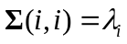, where 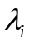 the eigenvalue associated with the i-th mode (and equal to the variance of model parameters in the training data along that mode). Because is diagonal, we can sample independently from the univariate Gaussian distribution 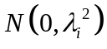 along each mode.
If we label a new appearance vector sampled from the model as 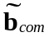, then we can reconstruct a synthetic mass in the same way we reconstructed real masses to compute model generalisation errors.
In Figure 7.8 we show six synthetic masses generated using the method outlined above. Qualitatively, these masses appear to have a good likeness to real masses in the training data. Of course the ultimate test of such synthetic masses will be how realistic they appear when they added to real normal mammograms. With regards to this, Figure 7.9 shows one of the six masses depicted in Figure 7.8 super imposed on two regions of mammographic background. The first background is a region from a normal mammogram (Figure 7.8 (b)). The second background is one of the background images from which a mass was subtracted in the previous chapter (Figure 7.8 (c)). We can see that the latter region contains spicules associated with the mass that has been subtracted, and that existing breast tissue in the region appears to have been distorted (with the appearance that breast parenchyma has been pulled in toward to the centre of the region). Figure 7.9 (d) and (e) show the synthetic mass added to the two background regions. We can see that when added to the normal region, the mass does not appear to match its surroundings. Meanwhile when added to the background in (Figure 7.8 (c)), the synthetic mass appears to be a very convincing simulation of a real malignant mass.
From this example we can see that whilst the we have developed a statistical model that provides a good description of the central density in mass lesions, to properly generate the full mammographic appearance of real malignant masses we must…
Figure 7.8: Six synthetic masses randomly sampled from the combined appearance model

Discussion

Discussion
Why Caulkin’s model?
We think that this form of data is suitable for modelling the appearance of masses for the following reasons:
Compared to other models that have previously been used to synthesis masses, the models described in the chapter provide a more flexible representation of appearance. For example previous methods have imposed the constraint that all masses should have an approximately elliptical shape [\cite ?]. In contrast, the template to which masses should conform using a point distribution model (that is the mean shape) is learnt from the data itself and does not have to conform to a predetermined shape. Moreover, the set of shape modes provide a rich set of descriptors to…
Another advantage of the models used in this chapter is the fact that the combined appearance model allows for a correlation between shape, texture and size to be learnt. Our model of image appearance is designed to correspond to a physical model of x-ray attenuation through a mass. In the physical model we would expect there to be a strong correlation between the size and shape of a mass and the amount by which it increases attenuation. Therefore it is important our model is able to represent this correlation as it appears in digitised mammograms.
Having determined that a principal components based statistical appearance model was suitable for our needs, we set about optimising the way such a model could fit our data. In particular, we improved how mass shapes were aligned prior to applying PCA and improved the method for select weights with which to ensure the parameters of shape, texture and size were commensurate in the combined model (the issue of mass texture was primarily dealt with in the previous chapter).
We propose the changes were necessary improvements to the model, as evidenced by the statistically significant reduction in the mean generalisation error of the model. Having implemented these changes, we believe the model we have constructed from our data provides a good representation of mass fit. However, we have only described a model for the appearance of the central density in malignant mass lesions. As noted in section [], our goal is to synthesise the complete appearance of malignant mass lesions – including spicules associated with the central density and the distortion of normal breast tissue in the mass region. This added appearance information is stored in the background regions from which masses were subtracted in the previous chapter.
In Figure 7.1, we highlight the difference in appearance between a normal region and a mass background region. In Figure 7.1 (a) we show a mass sampled from the appearance model developed in this chapter. In Figure 7.1 (b) we show a normal region alongside a real mass background region in Figure 7.1 (c). We can see in the mass background region a pattern of spicules and a general distortion of structures in the region. In Figure 7.1 (d) and (e) we show the synthetic mass added the normal and mass background region respectively. Figure 7.1 (e) is a much more convincing simulation of a real malignant mass than Figure 7.1 (d). Thus our goal for the next chapter can be summarised as developing a method to modify normal regions (as depicted in Figure 7.1 (c)) so that the have the appearance of mass background regions (as depicted in Figure 7.1 (c)).
(a)
(b)
(c)
(d)
(e)
Figure 7.9: a) a synthetic mass b) a region of normal mammogram c) a mass region d) adding the synthetic mass to the normal region e) adding the synthetic mass to the mass region

Summary
In this chapter we have presented a method for modelling and synthesising masses. In this context, the term mass has specific meaning, and refers to the images we obtained in chapter 6 by separating the pixel grey-levels corresponding to attenuation through the central density of lesion from background.
In section 7.2, we described a method developed by Caulkin for modelling this form of image object. The model learned the variation in appearance of masses across a training set of data, and could subsequently be used to sample new synthetic masses.
We noted however that the basic model described by Caulkin did not adequately fit our training data. To show evidence for this, in section [] we discussed the properties we would like a model to have, and described how such properties could be measured directly from the training data. In particular, we introduced the idea of model generalisation errors that could be used to quantify how well various components of the model might describe a global set of data.
In sections [], [] and [],
Having established the basic framework for a generative statistical model of our data, in section 7.3 we discussed the properties required of the model. In particular we look at how well the model fits the dataset of masses, and, importantly, show how we can measure model fit directly from the data.
In sections 7.4 to 7.6 we use the measures of model fit to show how three of the main components of Caulkin’s mass model can be optimised resulting in a significant improvement in model fit. The resulting improvement to the full model of mass appearance is presented in section 7.7.
Finally, in sections 7.8 and 7.9, we show how the generative nature of the model can be exploited to produce realistic synthetic examples of masses. We qualitatively evaluate the appearance of such masses when superimposed on regions of normal breast tissue, and describe how this motivates the work on background modelling presented in the following chapter.
As discussed

This parameter is usually described as the scale parameter in Procrustes alignment. However, we use the term size to make clear the relationship to the physical property of the mass; and also to avoid confusion when we discuss scaling the magnitudes of model parameters in section 7.6.
Although we recall that each optimisation was trained only on a subset of the full data and thus wasn’t guaranteed to produce a lower than the other three methods

