: Computational Techniques

Principal component analysis
Principal Component Analysis is a well established and commonly used statistical technique that can be used to parameterise high dimensional data in a compact way. PCA is fundamental to the application of the appearance models described in section [] and applied throughout this thesis. A brief review of the technique is given below.
Consider we have data consisting of  examples, each of which is an -dimensional vector. That is,
First we calculate the covariance matrix  of the sample
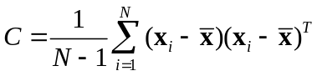
We then perform an eigenvalue decomposition 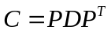, such that 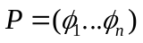 is an matrix of the eigenvectors of and  is a diagonal matrix of the associated eigenvalues 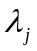.
If 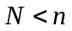 there are only 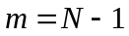 eigenvectors with non-zero associated eigenvalues, and so we define 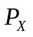 as the matrix consisting of the eigenvectors 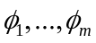 with associated non-zero eigenvalues 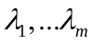, sorted such that 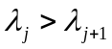
If we now define the -dimensional vector 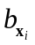, as 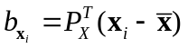 then we can write each of our sample points as
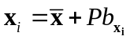
That is, each data point is described by its displacement from the mean along a set of orthogonal principal components (modes) defined by the eigenvectors. The variance of the data along each of the modes is given by the associated eigenvalues, and the total variance by the sum of the eigenvalues. Since many of the eigenvalues will very small, we can discard the associated modes by using only the first rather than all eigenvectors. That is, we define 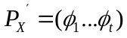 and calculate 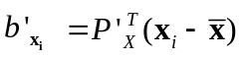, so that each data point is approximated as:
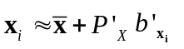
Thus our data is now represented in the smaller -dimensional space as opposed to the original -dimensional space. The total variance encapsulated in this model is 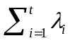, and so the value of can be chosen to ensure an arbitrary level of accuracy is maintained.

: Thin-plate spline interpolation
The thin-plate spline is a commonly used tool for interpolating surfaces over scattered data. We assume we have set of data 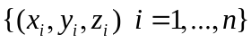 where 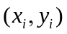 are coordinates on an infinite thin plate of metal, and is the vertical displacement of the plate at that point. The thin-plate spline returns a function 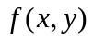 that defines the height of the plate for any 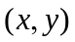 pair such that the overall bending energy of the plate is minimised.
Formally, we aim to find the function that minimises
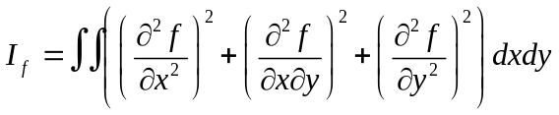
The solution can be expressed as a superposition of fundamental solutions of the biharmonic equation 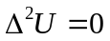 given by 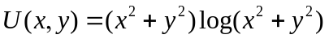
First we define the following matrices:
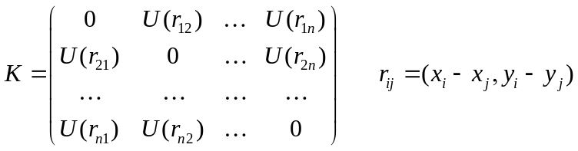
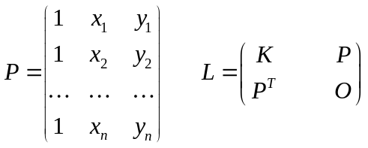
and the vector of known displacements
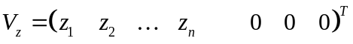
From these we can calculate a set of weighting coefficients
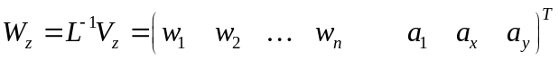
We can now explicitly write
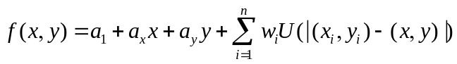
The method as shown above leads itself naturally to interpolating grey-levels in a 2-D by thinking of the image as a surface with vertical displacements defined by the known grey-levels of a set of source pixels. The method can also be extended to be used a warping tool, performing non-linear deformations as is described in the following section.

Warping using thin-plate spline interpolation
Thin-plate spline interpolation can be used to warp one image (the source) to another (the target), based on a set of landmark points in the two images.
Let 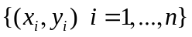be the coordinates of the landmark points in the source image. Similarly, let 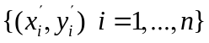 be the coordinates of the landmark points in the target image.
To compute a function that maps every point in the source image to a point in the target image we calculate two thin-plate splines, defining the displacement of the source points to the target points in the and directions.
Thus using the method described in the previous section, we calculate the first spline using input data
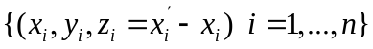
to compute an interpolating function 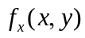. Similarly, we compute 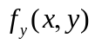 using input data
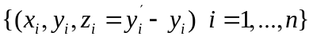
The resulting 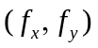 defines a non-linear mapping of any point in the source image to the target image

