From Gaps to Gains
  - Practical Applications for Teaching and Learning
Michael – AI Facilitator
2025-01-01

Companion Website
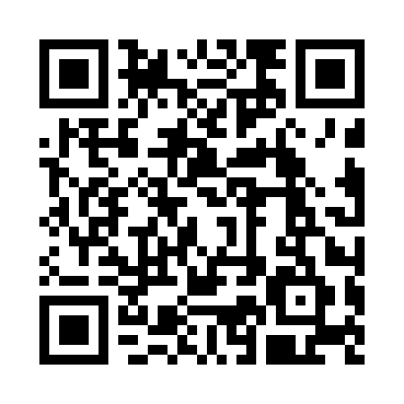
https://michaelborck.education/ai

Today’s Journey
- From Gaps to Gains — setting the scene
- Talk Buddy — student practice with feedback
- Insight Lens — turning surveys into action
- Quick Win — FAQ → interactive quiz
- Discussion & Concerns — practical realities
- Closing Reflection — where do we go from here?

From Gaps to Gains
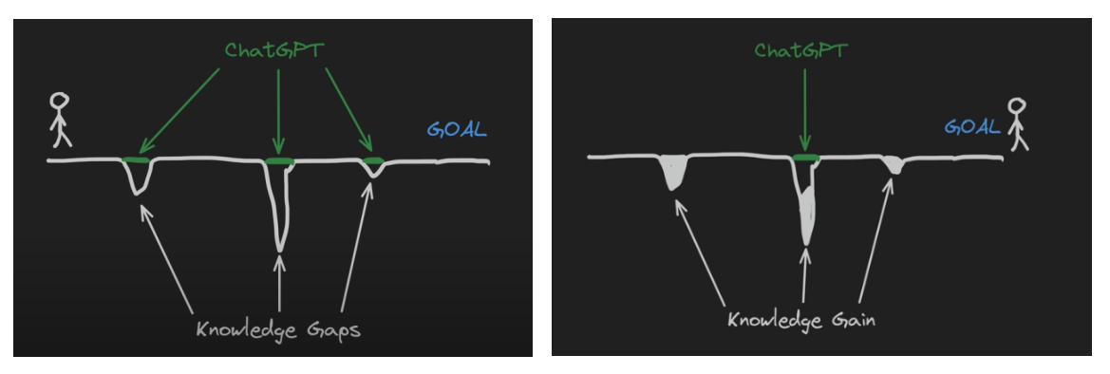
Gaps-to-Gains: Start -> End
Start → End
- Students begin with gaps in knowledge
- Our goal: help them transform gaps into genuine gains
“So the question is: which story do we want to write in our classrooms?”

Talk Buddy — Conversation Practice
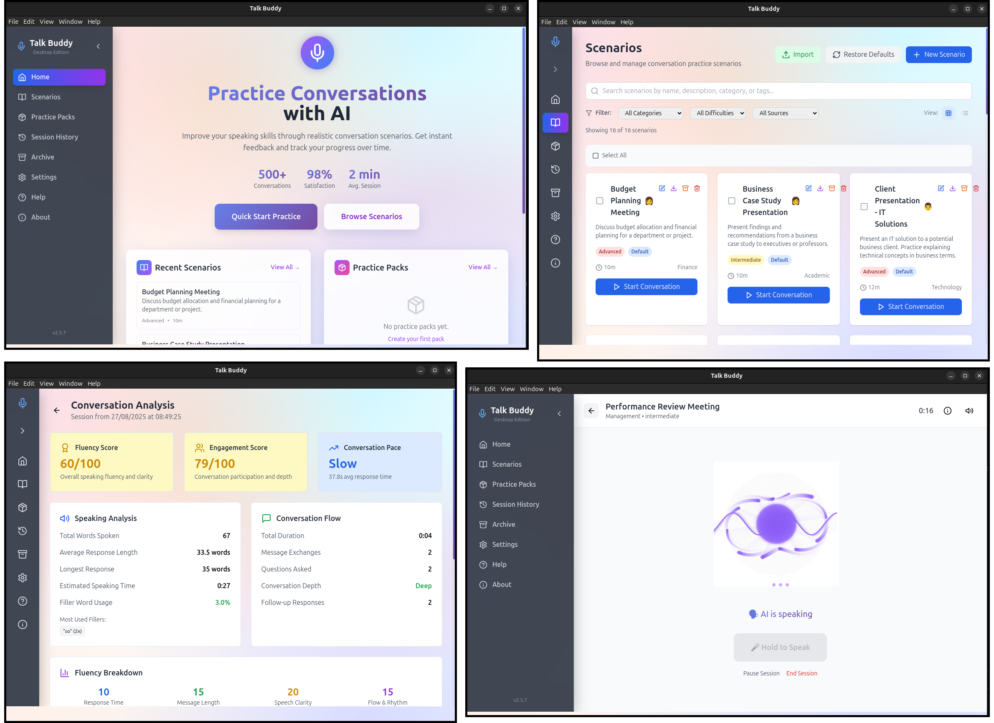
Talk Buddy
 Real Impact
“I practiced breaking bad news 10 times before placement. I felt prepared instead of terrified.”
Students:
- Practice professional conversations
- Role-play difficult scenarios
- Get instant feedback
- Build confidence safely
Lecturers:
- Create custom scenarios
- Track common struggles
- Provide targeted support
- Value: Fail safely, learn, try again — no real-world consequences.

Insight Lens — Your Feedback, Actionable
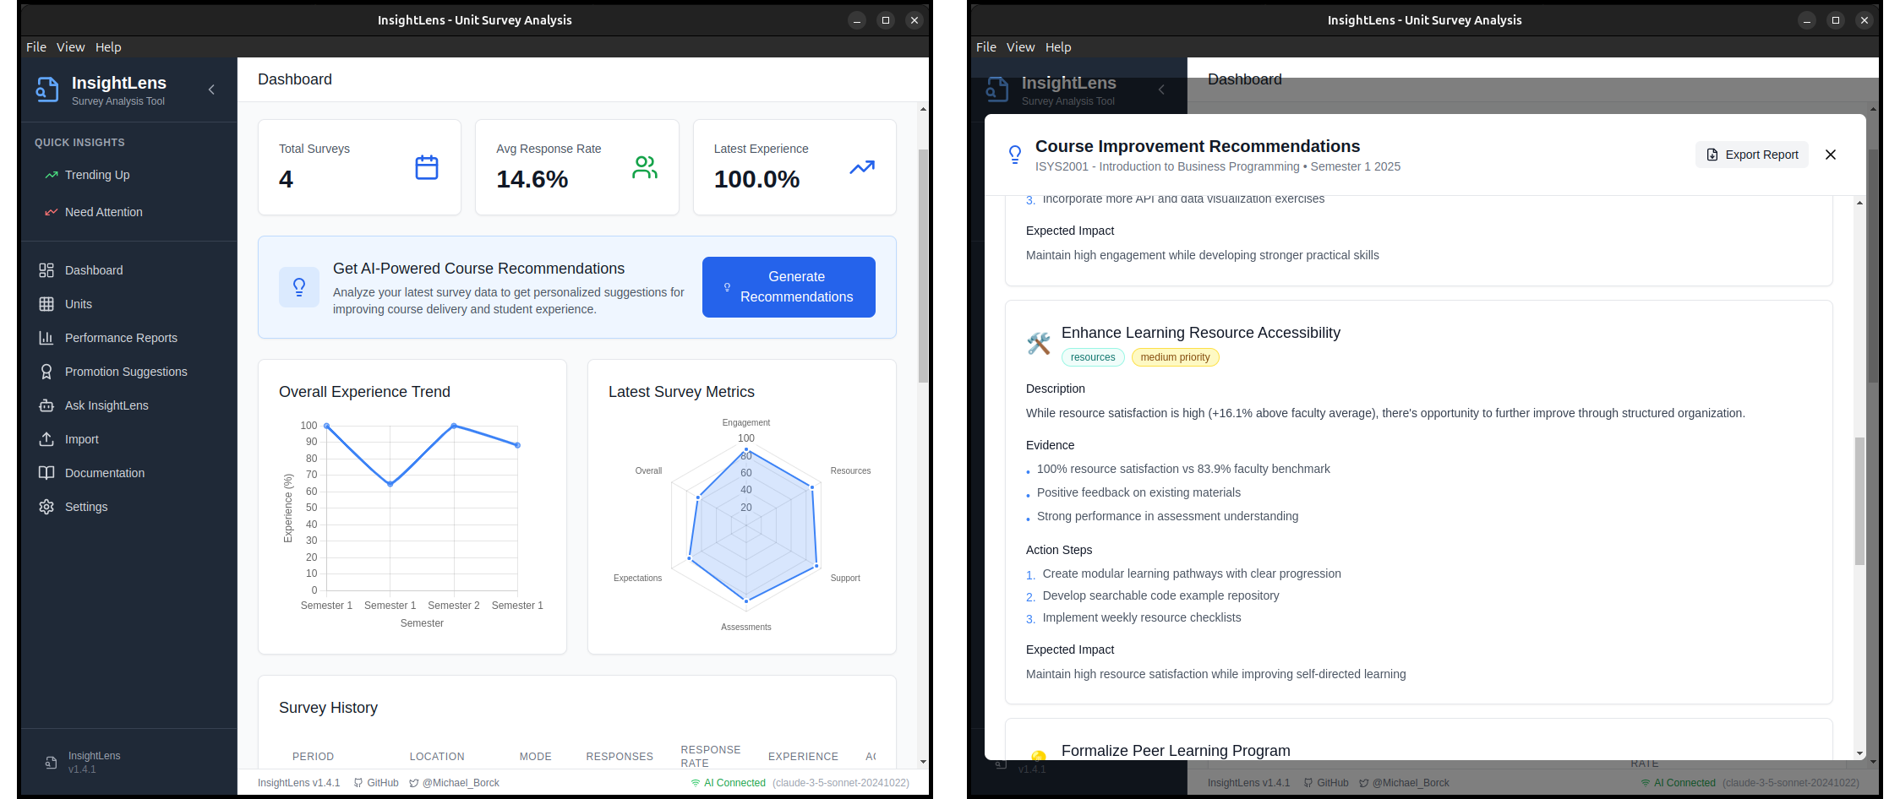
Insight Lens
You upload:
- Student evaluations
- Unit surveys
- Mid-semester reviews
Insight Lens finds:
- Common themes
- Hidden patterns
- Specific improvements
Value: Your expertise + data insights = better outcomes.

Quick Win: Static → Interactive
In 2 minutes:
1. Take an FAQ or worksheet
2. Ask AI to make a interactive web page 3. Upload to Blackboard
4. Students interact, save locally
“No programming required — copy template, swap questions, done.”
 Privacy First
Runs in the browser. No logins. No data leaves the device.

Common Concerns — Quick Answers
- Plagiarism? → Use AI as editor + require transparency
- Lazy students? → Design critique & reflection tasks
- Replace teachers? → No — AI handles routine, we do relationships
- Data privacy? → Use safe tools, no sensitive data in consumer AI
Reassure without lecturing. Keep it short, confident, balanced.

Beyond Today: Other Tools in the Toolkit
- CloudCore – Scenario-based teaching platform
- FeedForward – Structured learning from feedback
- Curriculum Curator – AI-assisted course design
- Study Buddy – Offline AI tutor
- TechNova-Sim – Cybersecurity simulation
- Critique Quest – AI-powered case studies
Explore more: michaelborck.education

Beyond Teaching: AI in Research
AI can also support research practice:
- Audio transcription & thematic analysis (Otter-style tools)
- Literature review assistance (search, summarise, compare)
- Data handling & visualisation (survey analysis, charting)
- Drafting & editing support (grants, papers, reviews)
Should the AI Facilitator role extend to research support?
Add your view in the poll.

Shaping Our Support
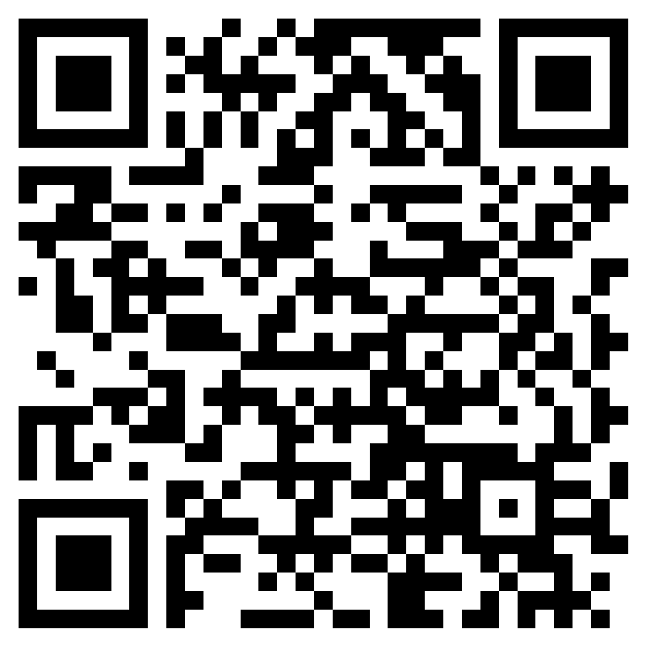
Poll open for the next few days — your input will shape how this role develops.
- Guidance on safe use & policy
- Practical demos & workshops
- Help with curriculum integration
- Tools & resource curation
- One-to-one support for teaching/assessment
- Research support (e.g. transcription, analysis, writing)
- Other (open text)

Closing Reflection
AI isn’t about replacing educators —
it’s about amplifying teaching and learning.
So the real question is:
How do we take our students from gaps… to gains?

Discussion & Next Steps

What feels most relevant for your teaching?
- Try the FAQ → quiz activity
- Experiment with Talk Buddy or Insight Lens
- Explore more at michaelborck.education

