**MATLAB – LAB3 – EXERCISE 4**

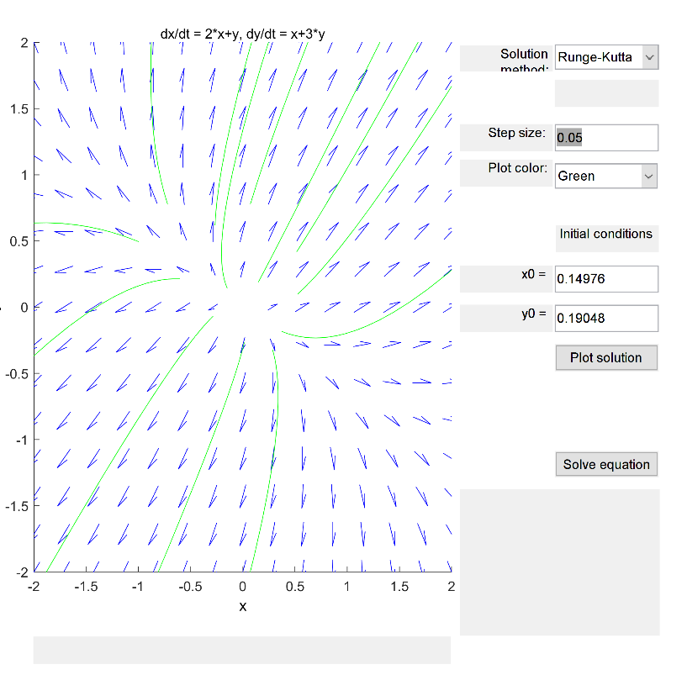

**4.1: $λ_{1}= \frac{5+√5}{2}, λ_{2}= \frac{5-√5}{2}$ Source Node – both eigenvalues are positive**

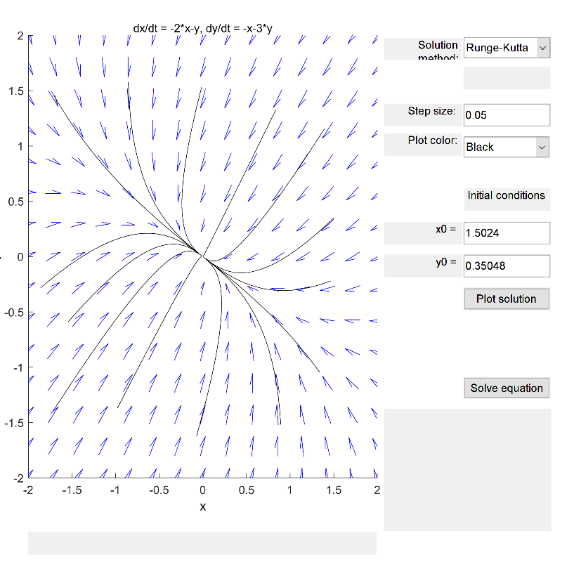

**4.2: $λ_{1}= \frac{-5+√5}{2}, λ_{2}= \frac{-5-√5}{2}$ Nodal sink – asymptotically stable – both eigenvalues are negative**

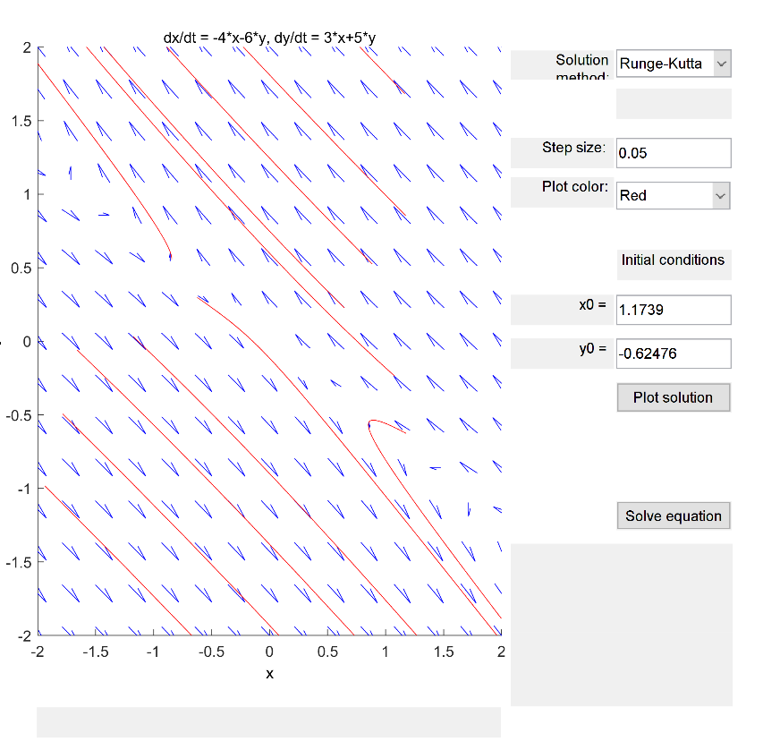

**4.3: $λ_{1}=-1, λ_{2}=2$ Unstable Saddle Point – distinct eigenvalues with one positive and one negative**

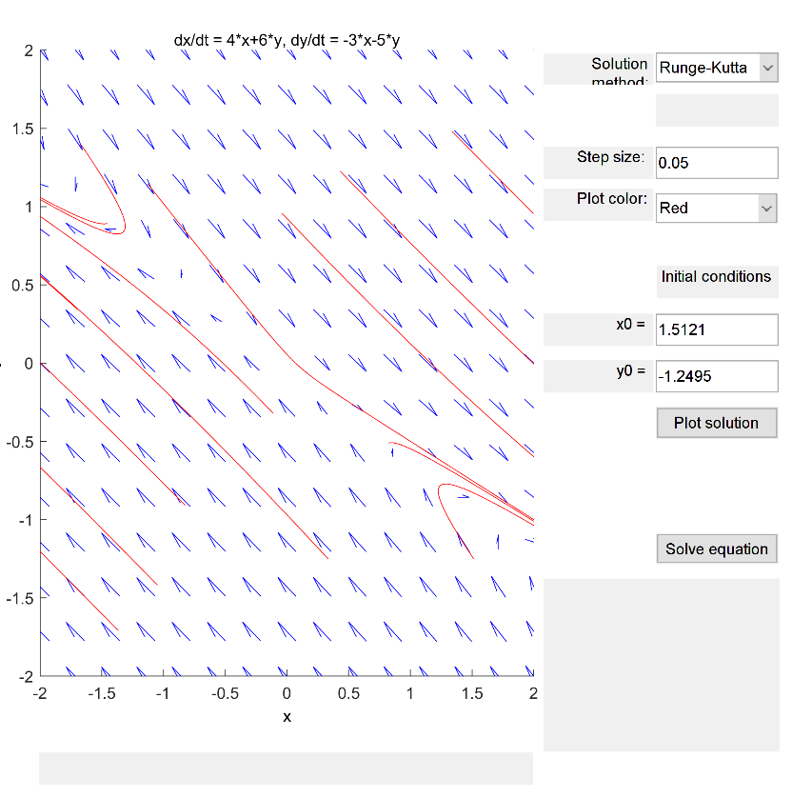

**4.4: $λ_{1}=1, λ_{2}=-2$ Unstable Saddle Point – distinct eigenvalues one positive and one negative**

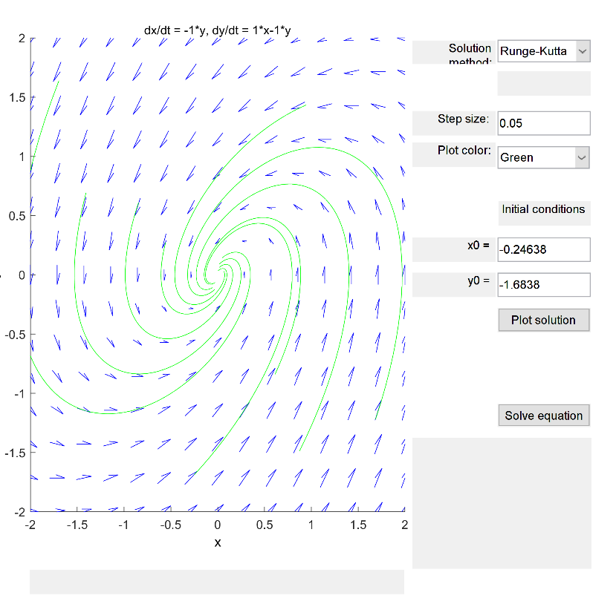

**4.5: $λ_{1}= -\frac{1}{2}+i\frac{\sqrt{3}}{2}, λ_{2}= -\frac{1}{2}-i\frac{\sqrt{3}}{2}$ Nodal sink – distinct complex eigenvalues spiralling inwards (real part is negative)**

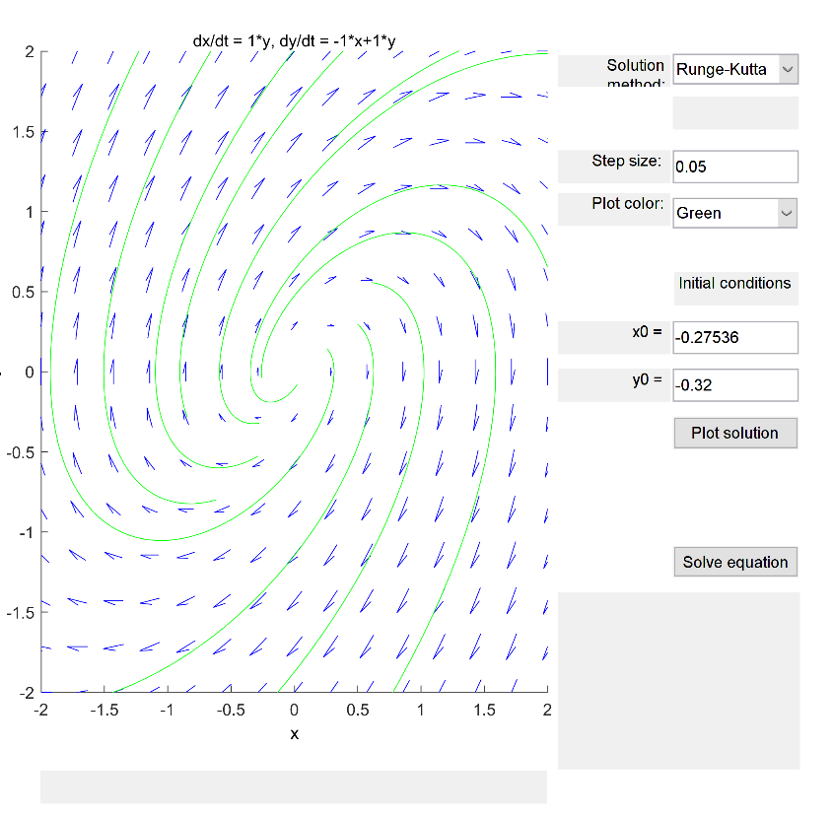

**4.6: $λ_{1}= \frac{1}{2}+i\frac{\sqrt{3}}{2}, λ_{2}= \frac{1}{2}-i\frac{\sqrt{3}}{2}$ Unstable nodal source – distinct complex eigenvalues – spirals outwards as real part is positive**

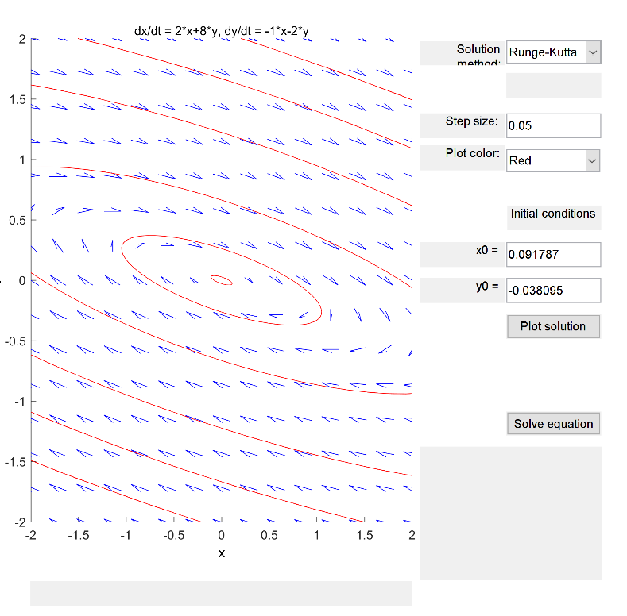

**4.7: $λ_{1}=2i, λ_{2}=-2i$ Stable center clockwise – no real component in the eigenvalues**

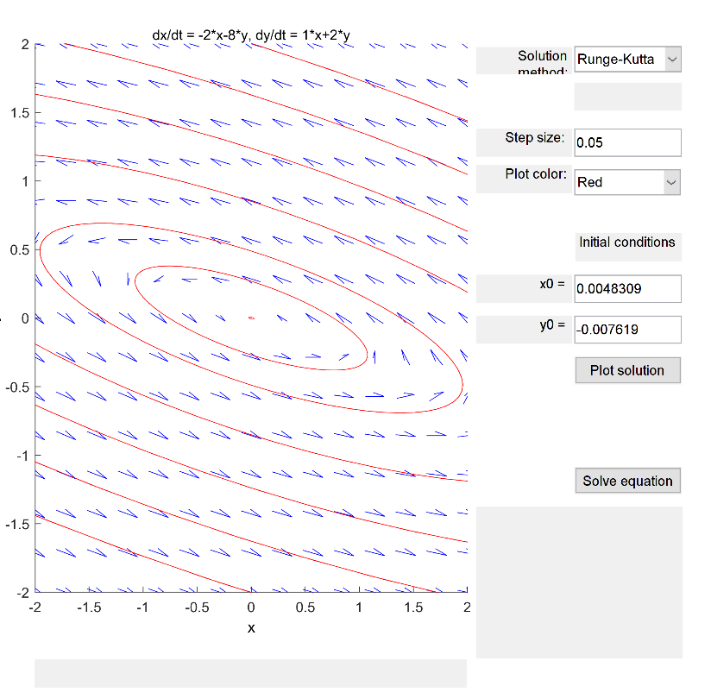

**4.8: $λ_{1}=-2i, λ_{2}=2i$ Stable center counter-clockwise – no real component to eigenvalues**

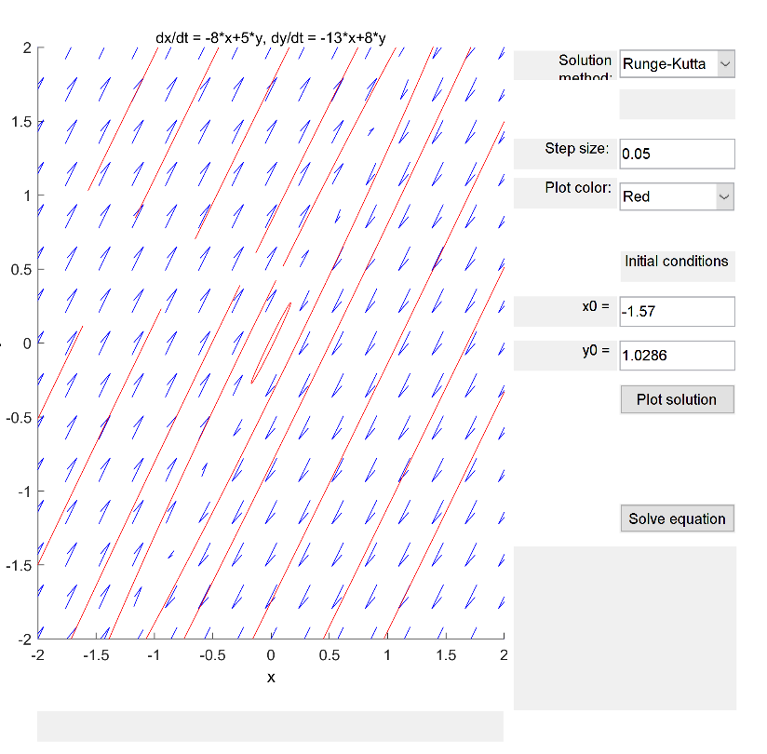

**4.9: v $λ_{1}=i, λ_{2}=-i$ Clockwise stable center – no real component to eigenvalues**

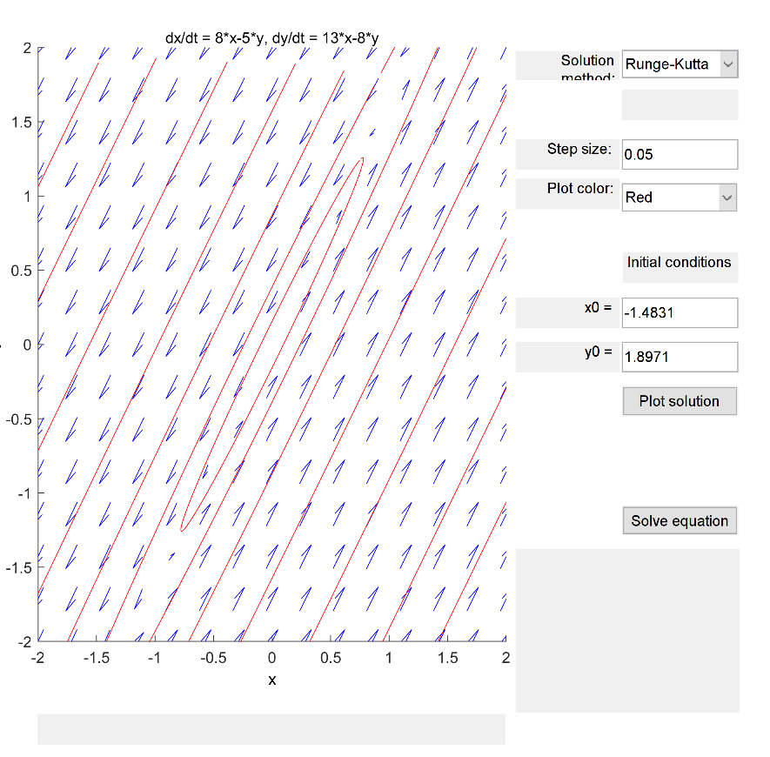

**4.10: $λ_{1}=i, λ_{2}=-i$ Counter-clockwise stable center – no real component to eigenvalues**