5/21/2018 Notes:

**GIT & GITHUB**

Git and github are 2 technologies that perform one function

***GIT*** = source control management(SCM) / backs up to cloud

Push code to repository (cloud) at least 1x per day

***REPO*** = repository

Keep repositories organized

Store all REPOs in c:\repos

DO NOT DO A GIT INIT IN REPOS!!!

~ = sitting in your home directory

Create all of our code inside c:\repos with subfolders

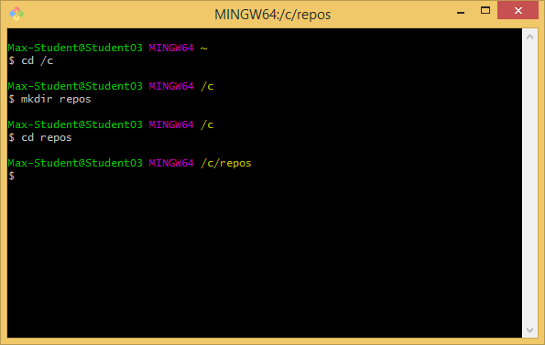

!!!NOTE that /c/repos is not a repository!!! --- The real repositories will be in subfolders

***SOURCE CONTROL*** = manages multiple versions of documents and keeps it in order

***GITHUB*** = same thing as GIT but in the cloud

Topics for GIT AND GITHUB today include: (1) Bash shell (see image above); (2) Command line interface (CLI); (3) File structure; and (4) Commands

***Bash shell:***

Similar to Linux command line

Commands are in book (pg.14 or so in book)

Also Greg will be getting us the slides for this presentation

***Command Line Interface (CLI):***

Git commands entered at command line (git cmd [opts}

In book on page 14

git: program name

cmd: what to do

[opts]: options based on command

All commands are lower case

>Git status –s

***File structure:***

How to tell if it is a file repository

Add –a to see hidden files

If it has a .git folder inside then it is a repository

You don’t want repositories inside of other repositories

Removing the .git folder removes git control

***Commands:***

All commands begin with git (lower case)

See GIT/GITHUB slide printouts for other commands such as init, remote, etc.

If you forget –m on message commits then add comments to top and “:X” in place of insert on text editor that pops up

Steps to add/commit things on github:(slide 17)

1. git init adds folder to start with git
2. git add to start tracking
3. git commit to commit (don’t forget to use -m for message)