***5/23/2018:***

* SQL server 2017 google search will yield lots of results on the topic as will searches for C#
* Coding from scratch helps ingrain things better than copy and paste so code from scratch where possible
* Create apps in 2 steps:

1. Make it work/***FUNCTIONAL*** no matter how ugly it looks; and
2. Make it ***ELEGANT*** meaning:
   1. Robust meaning it doesn’t break;
   2. It is easily enhanced by someone else; and
   3. It’s efficient

* How do we keep learning:
  + Meetups
  + CLEs
  + Pro-bono work
* Make sure to verify your understanding of what an individual wants in their program
  + Verify by reflection – repeat back the request in your own words
* Join customer and order, sort by order amount biggest first so desc, no id fields but all other columns in
* Functions page for strings on Microsoft website:
* 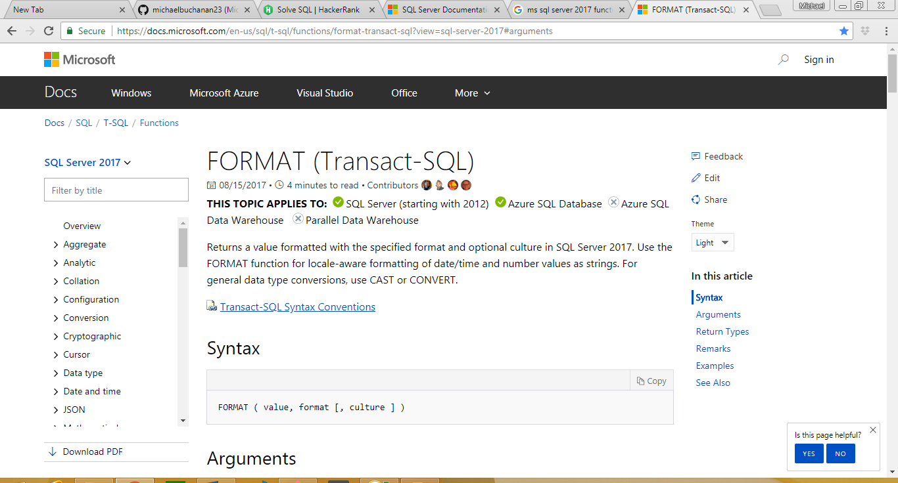
* When doing a delete make sure there is a where clause or it will delete everything…use where clause even if you intend to delete everything
* You can highlighted certain portions of code in Sql Server if you only want to run that particular portion of the code
* Comment group of lines shortcut key is ctrl+k+c
* Uncomment group of lines shortcut key is ctrl+k+u
* Read the data you want to change first via UPDATE with a where clause then copy that WHERE clause to your update in order to accurately update the data
* Don’t ever update your primary key
* The only time (usually) you should use null with numbers is when using foreign keys
* nvarchar is now the new way to define a string because of international languages where you need a double byte
* zip codes should always be strings because it doesn’t represent a mathematical number