Carlos, Michael Jeffrey D.

2ECE-A

Numpy Proofs

Problem 1

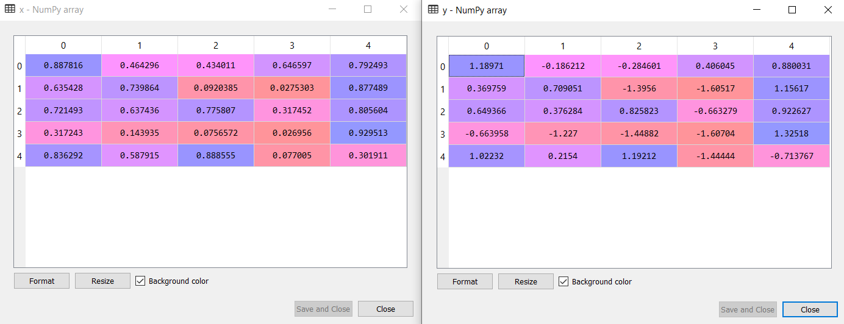

*A 5x5 randomized X and its corresponding normalized Y*

Problem 2

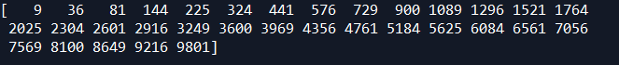

*Extracted squared integers from 1-100 that are divisible by 3*