Database Design and Implementation for a
Fitness Center
Group Name: DeltaSquad (Group D)
Group Members:
Mitchell, Michael, Pelumi, Sai Krishna, Gagandeep, Quinn

Team Responsibilities and Work Completed
S. No. | Student Name | Responsibilities | Work Completed
1 | Mitchell | Data Structure Diagram – Review & Update; AWS & DB Infrastructure Setup | Set up the shared AWS/SQL Server database, prepared connection instructions, assisted with reviewing & updating the relational design and data insertion.
2 | Michael | Conceptual EER Diagram – Draft; Project Submission Package – Review & Tweak | Prepared and coordinated the conceptual EER diagram, collected group feedback, coordinated tasks, prepared timeline, reviewed table creation scripts, produced SQL queries and reviewed the final submission package.
3 | Pelumi | Data Insertion; SQL Query – Review & Update; Submission Package Assistance | Reviewed and finalized data insertion scripts, checked insertion consistency, reviewed SQL queries, and compiled the Word submission package.
4 | Sai Krishna | Database Implementation – Review & Finalise; Project Submission Package – Draft | Did not contribute
5 | Gagandeep | Database Implementation – Draft; SQL Query – Development | Prepared the SQL table-creation implementation and data insertion script and updated table constraints based on group feedback.
6 | Quinn | Data Structure Diagram – Draft; Conceptual EER Diagram – Review & Update | Prepared the DSD/3NF draft and reviewed the conceptual EER diagram.

1. Conceptual Model – Conceptual EER Diagram
The conceptual model represents the main business entities and relationships required for the Fitness Center database. The wireframes were used as the primary source of requirements to identify entities, attributes, keys, relationships, cardinalities, and participation constraints.
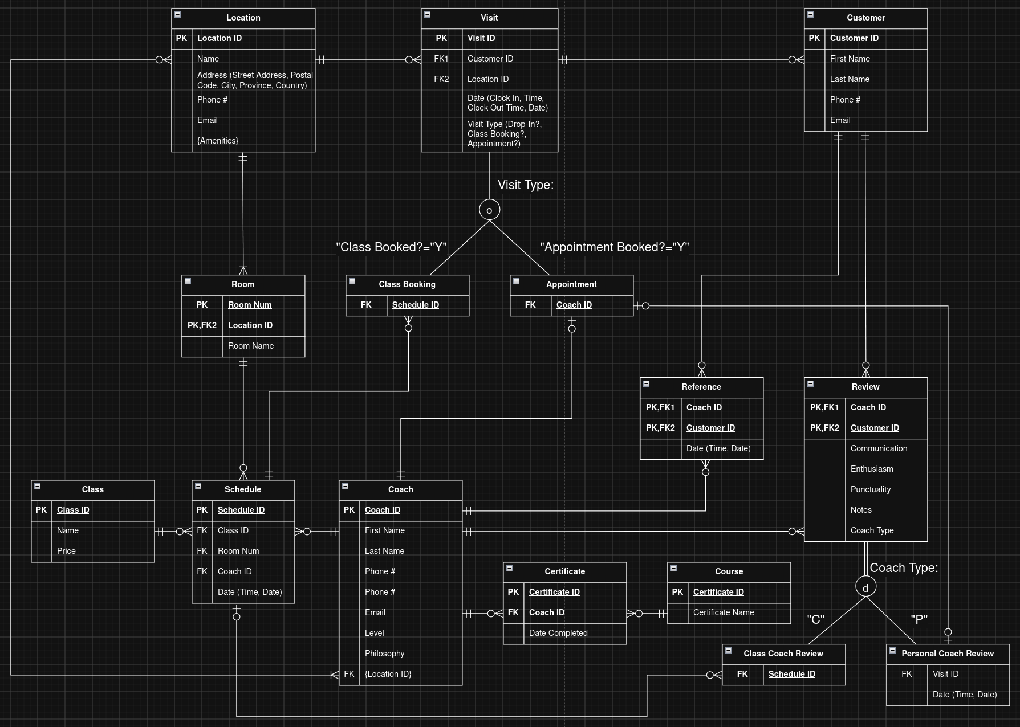
Delta Squad (Group D) Enhanced Entity-Relationship Diagram: The EER diagram models locations, rooms, classes, schedules, coaches, customers, visits, class bookings, appointments, reviews, references, courses, certificates, amenities, and the relationships between them.

Design Decisions and Assumptions
- ClassBooking and Appointment are used to store information specific to the two visit types.
- Visit is the general entity for customer visits. Visit_Type distinguishes class visits from personal coaching appointments.
- Used partial specialization for visit super-type as visit type could be to attend a class, appointment with a personal coach or a self-directed visit
- Review is the general review entity, while PersonalCoachReview and ClassCoachReview store information specific to each review type.
- Coach reviews can be for either a class instruction or personal coaching & have respective super-type & sub-types entities with communication, enthusiasm, punctuality & notes attributes in common for both sub-types
- Total specialization chosen for review as considered reviews collected in relation to only class coaches or personal coaches
- Visit table uses clock in & out time as customers can visit multiple times a day
- Visit sub-types exist to differentiate between class booking, personal coach appointment or other type visits
- My coach is not a separate table but a designation based on a query of any coaches visited by the customer
- Home location is not a table but a query of most visited location of a customer
- Reference is separate from Review because client references and coach reviews represent different information.
- References are from other customers & phone # & email address stored in customer table
- Rooms can have the same room number at different locations, hence room table uses composite key by combining room number with location ID
- ﻿Rating attributes depend on the full (coach, customer, schedule) combination
- Course & Certificate are separated so course/certificate information is not repeatedly stored for every coach.

2. Relational Logical Data Model – DSD and 3NF
The conceptual model was converted into a relational logical model. Primary keys and foreign keys preserve the relationships, and junction tables are used where required for many-to-many relationships.
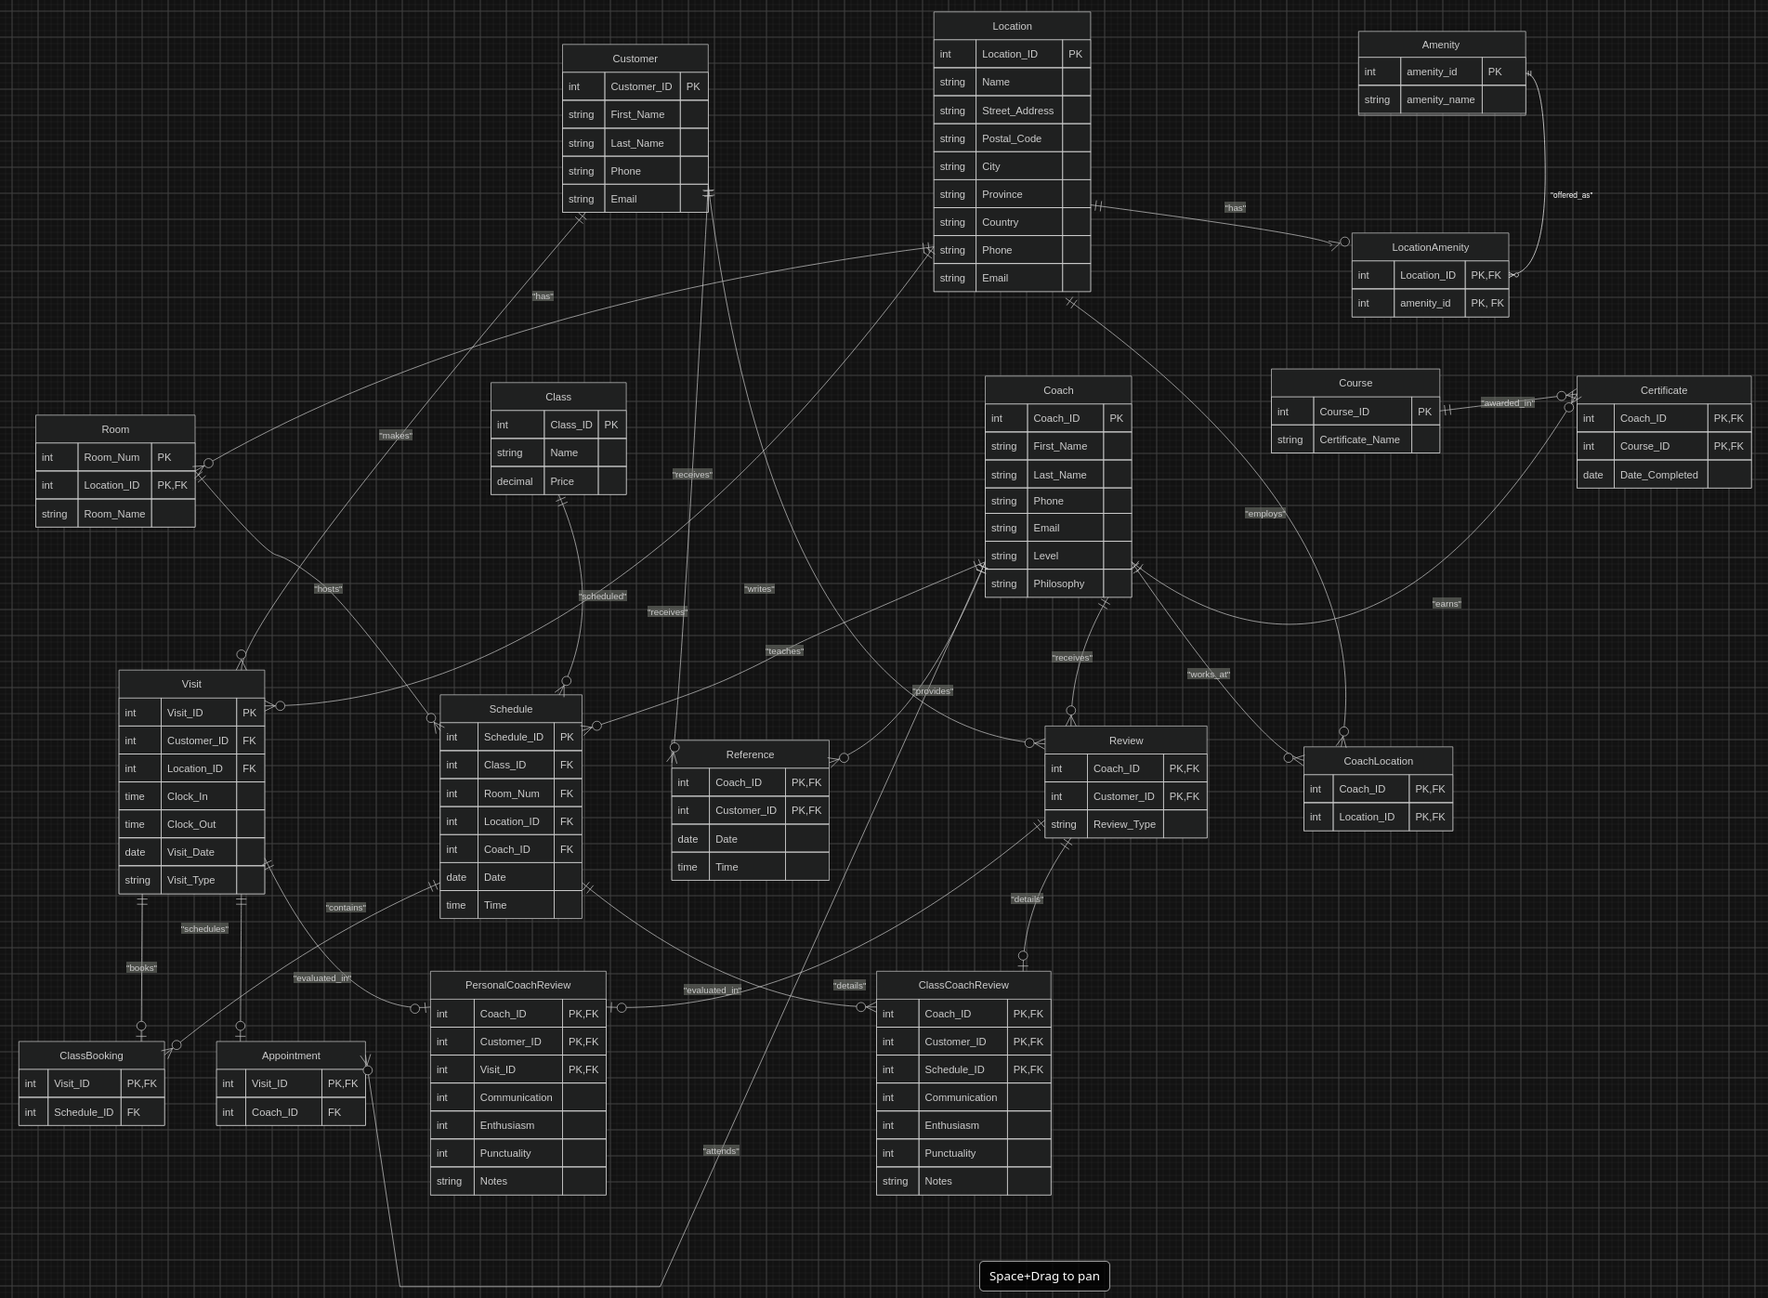
DSD / RELATIONAL MODEL DIAGRAM: The DSD shows the tables, attributes, primary keys, foreign keys, and relationships used to implement the Fitness Center database. It also shows how the tables are connected to reduce repeated data and maintain the relationships between customers, coaches, locations, visits, classes, reviews, and other information.
- CoachLocation table added to resolve the {Location ID} multivalued attribute from Coach table.
- Amenities and AmentitiesLocation tables added, amenities are stored separately and connected to locations through LocationAmenity to normalize the multivalued attribute from the Location table and so the same amenity can be used by more than one location.
- String data type used for phone number attributes to enter (###) ###-#### format.
- Coach level attribute string data type used to provide more semantic meaning.

3. SQL Database Implementation
The database implementation uses SQL Server CREATE TABLE statements based on the final relational model. The script includes the required primary keys, foreign keys, UNIQUE constraints, NOT NULL constraints, CHECK constraints, and identity columns where applicable.
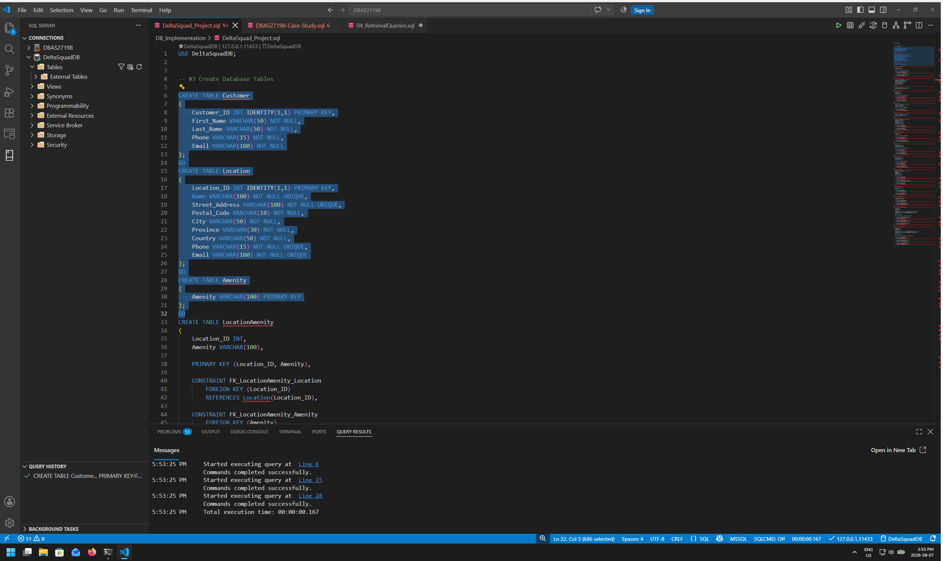
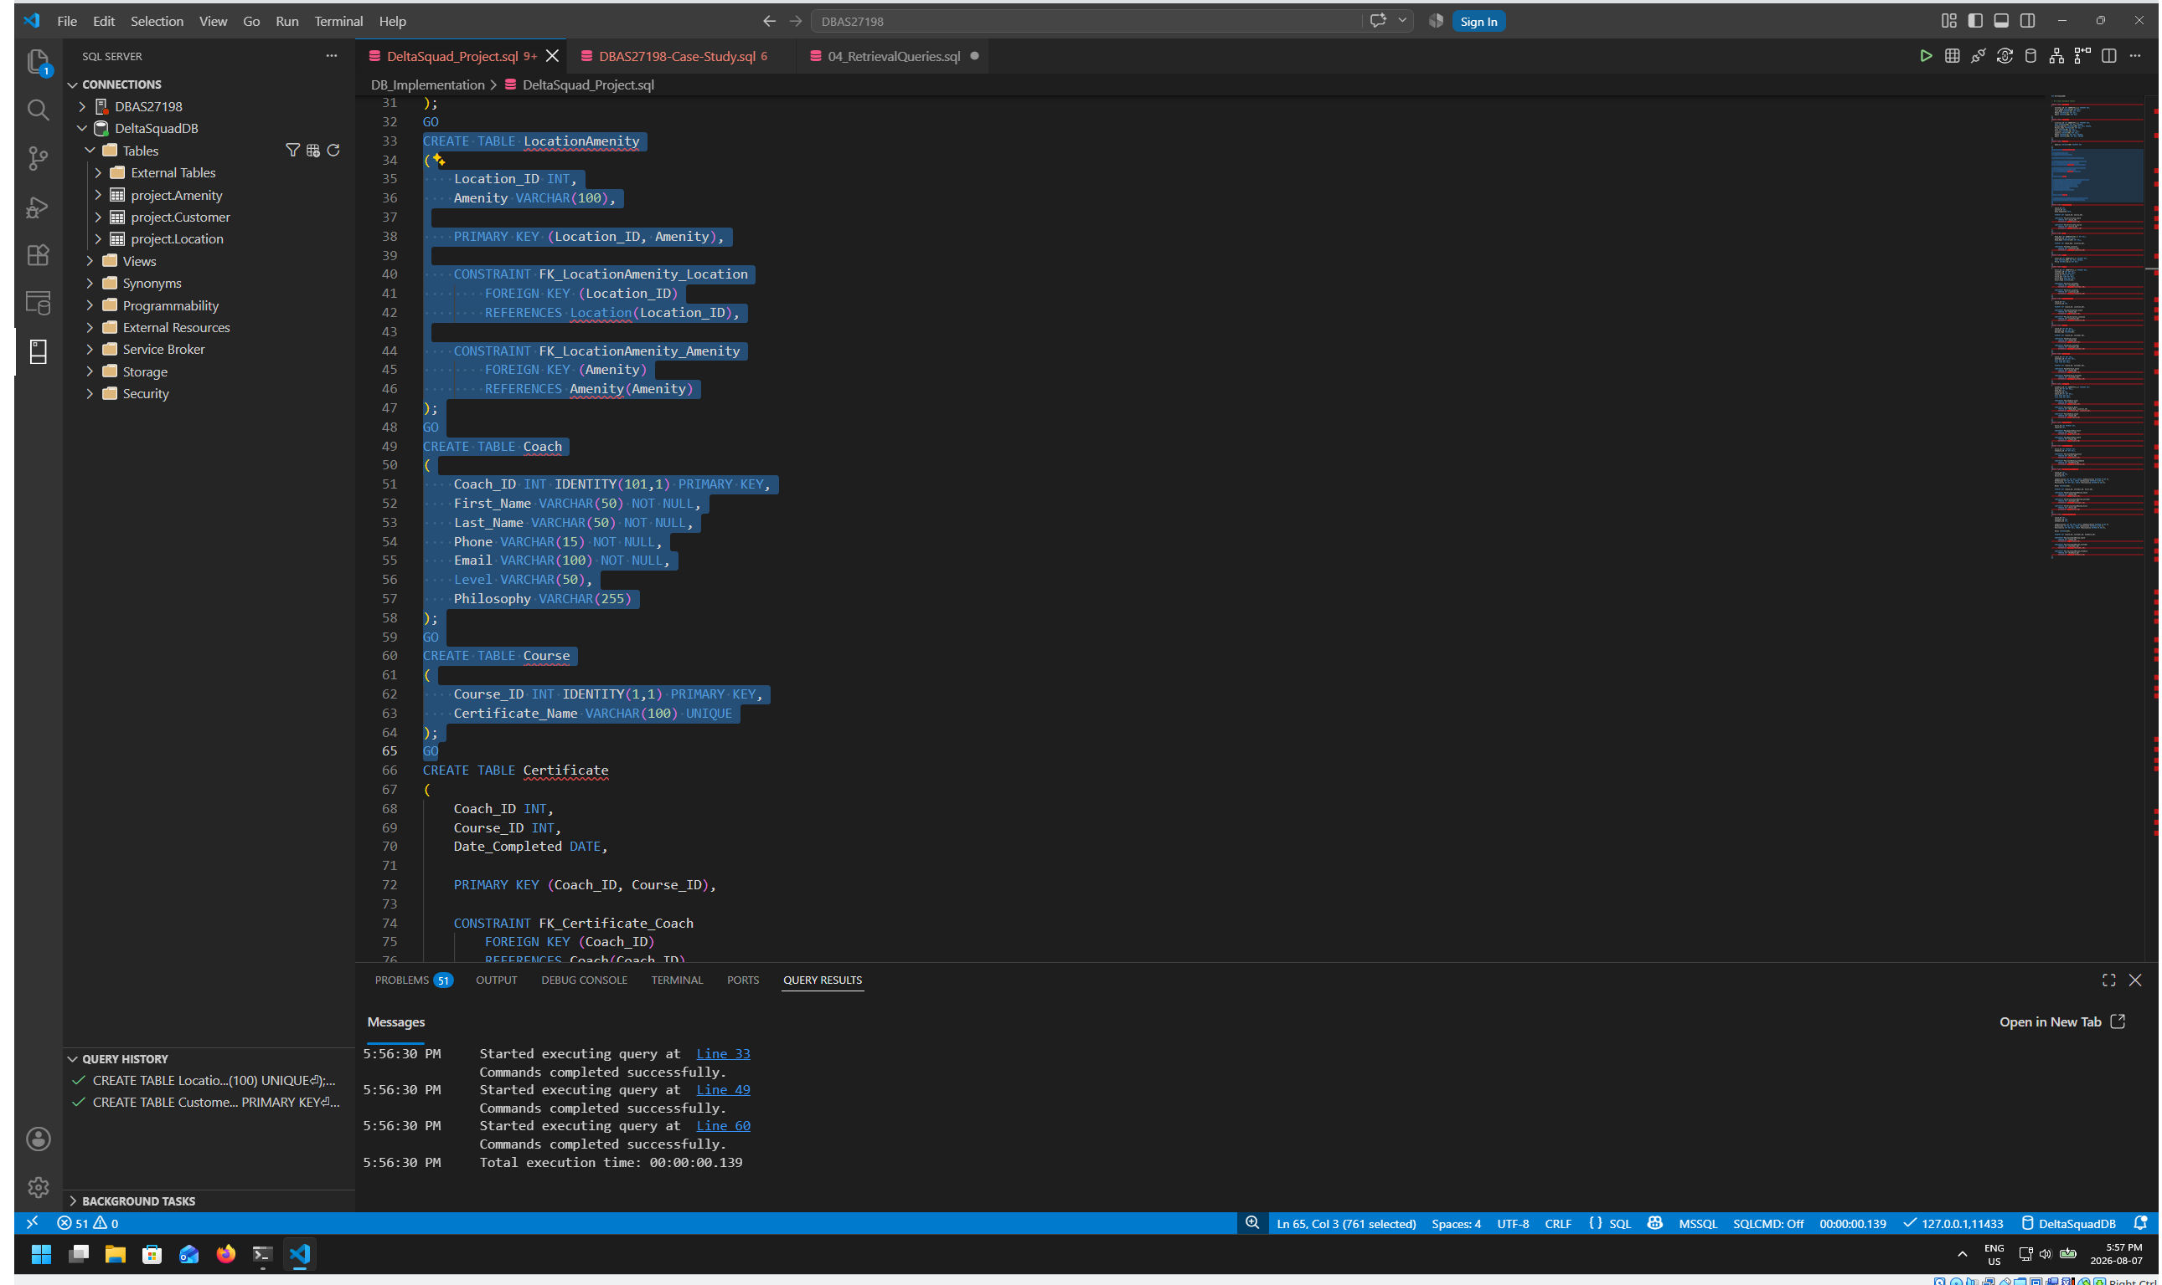
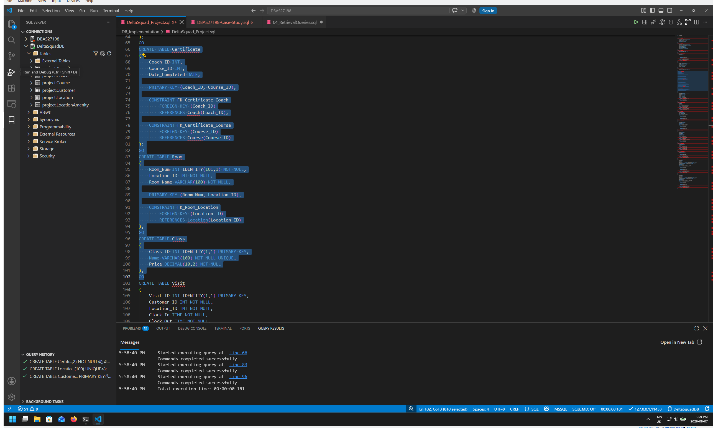
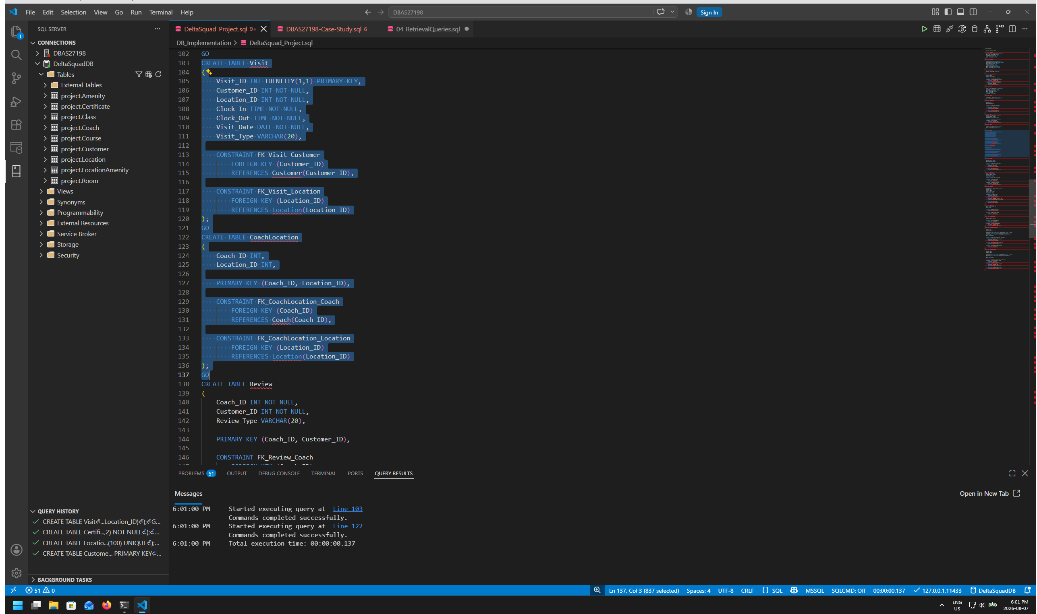
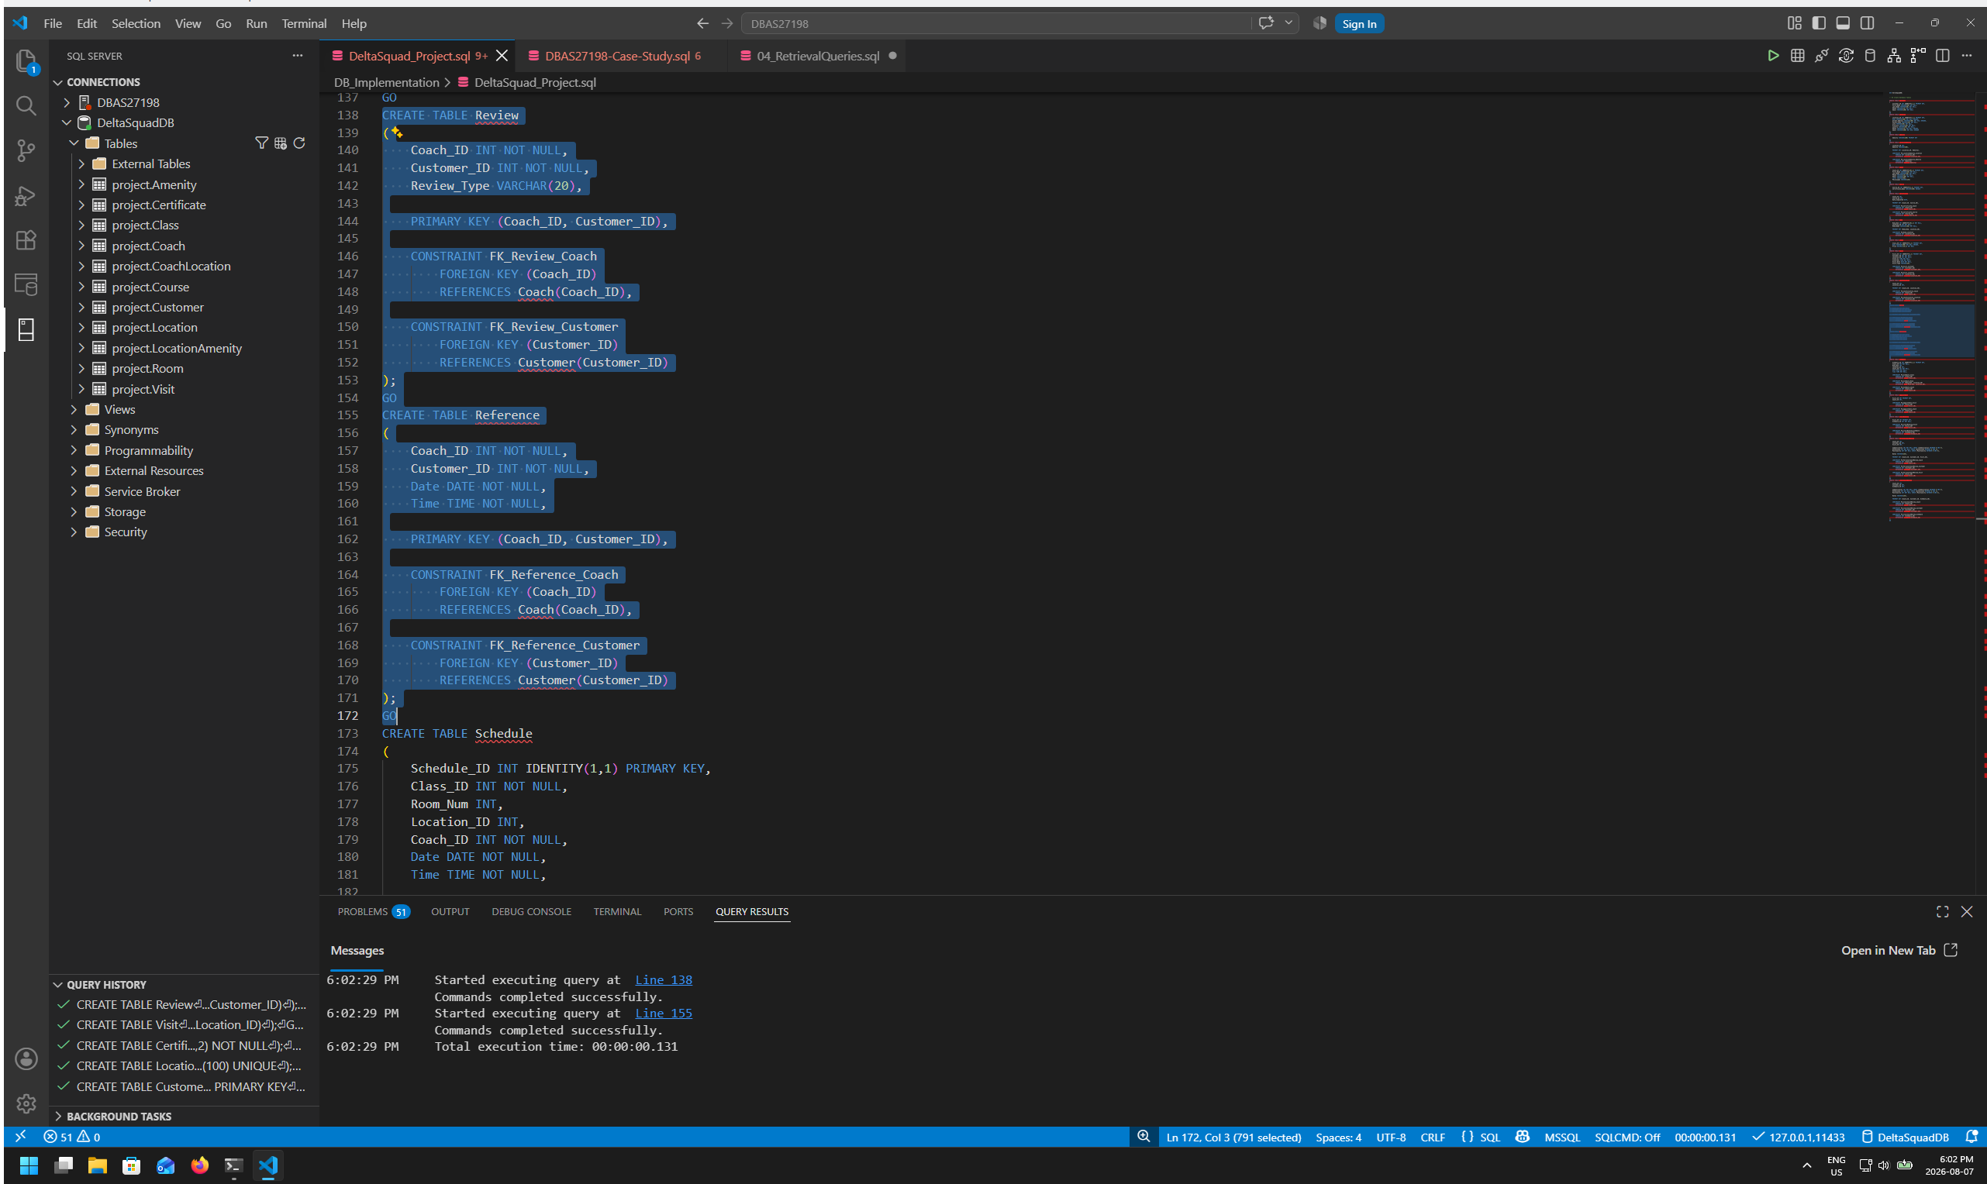
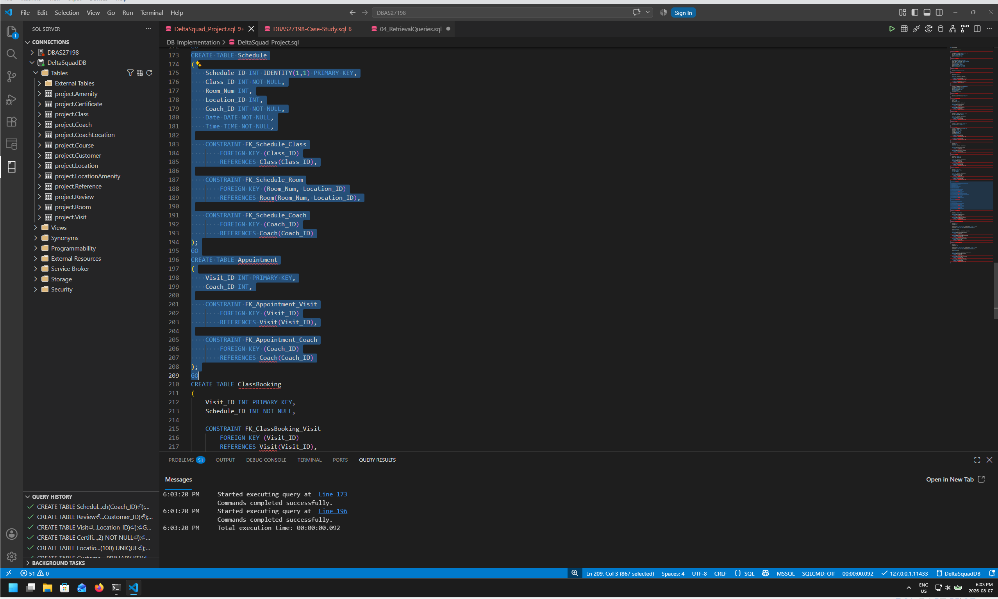
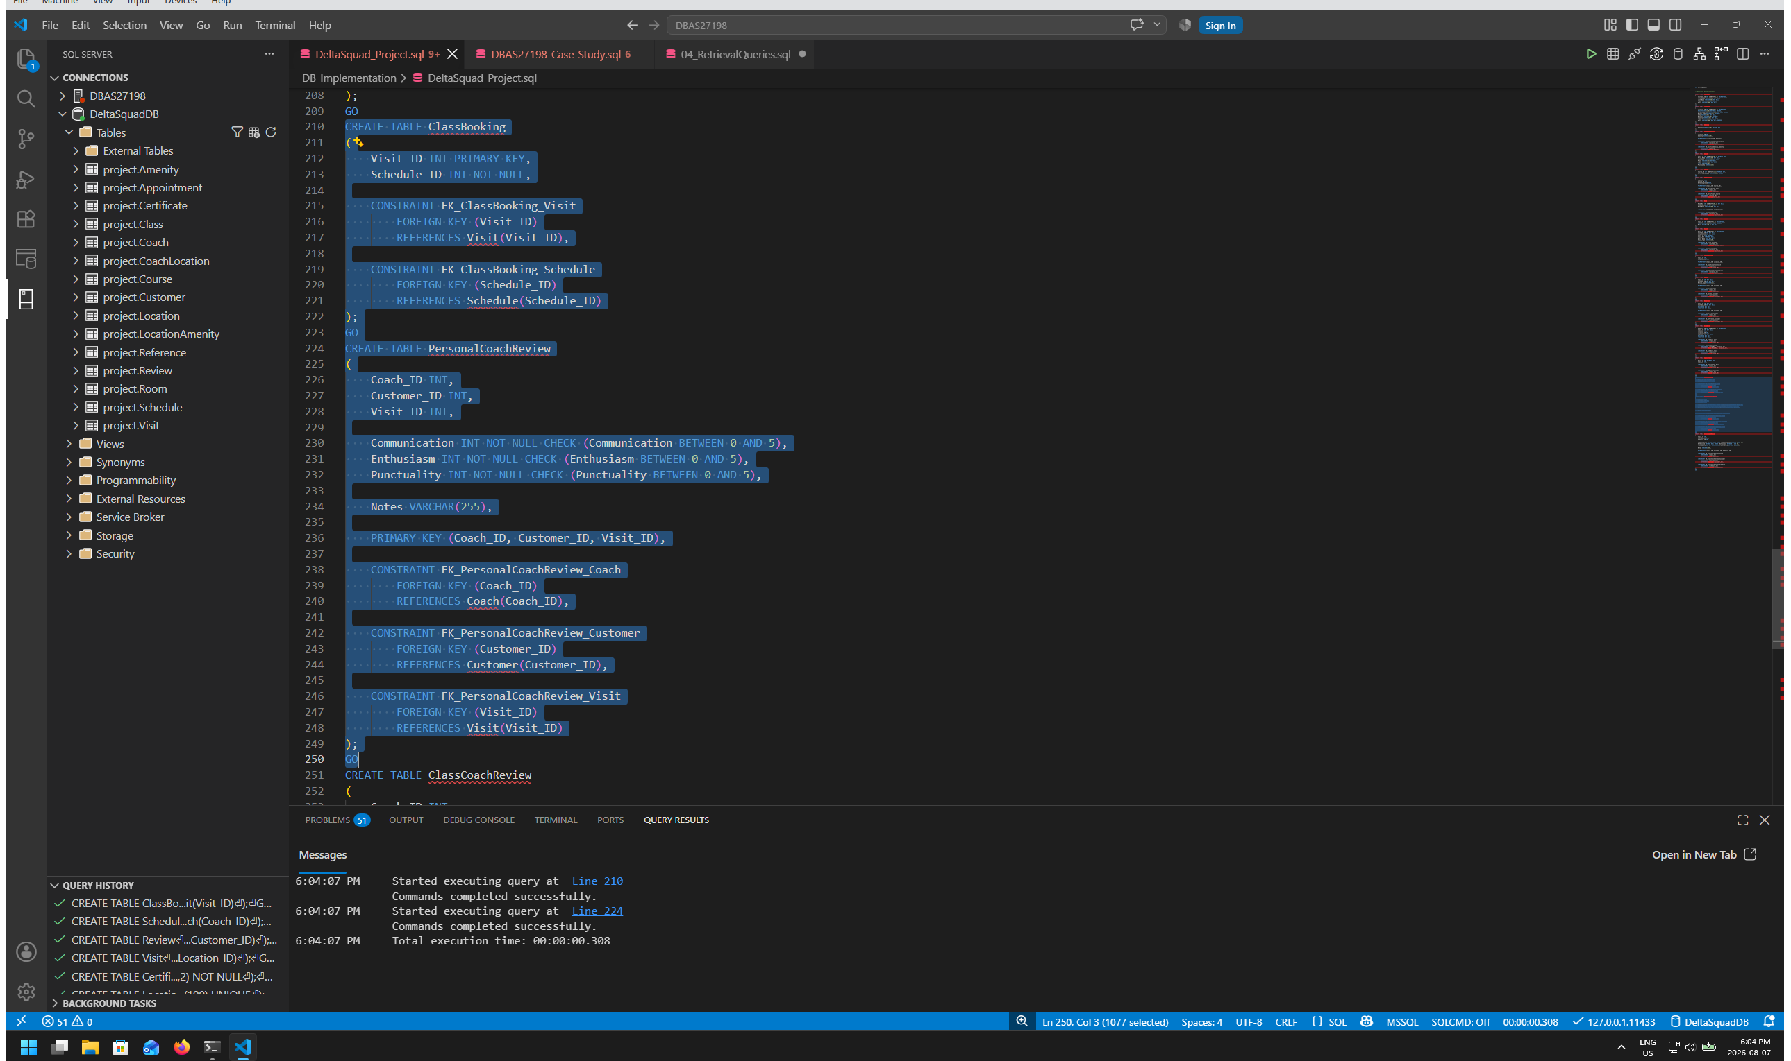
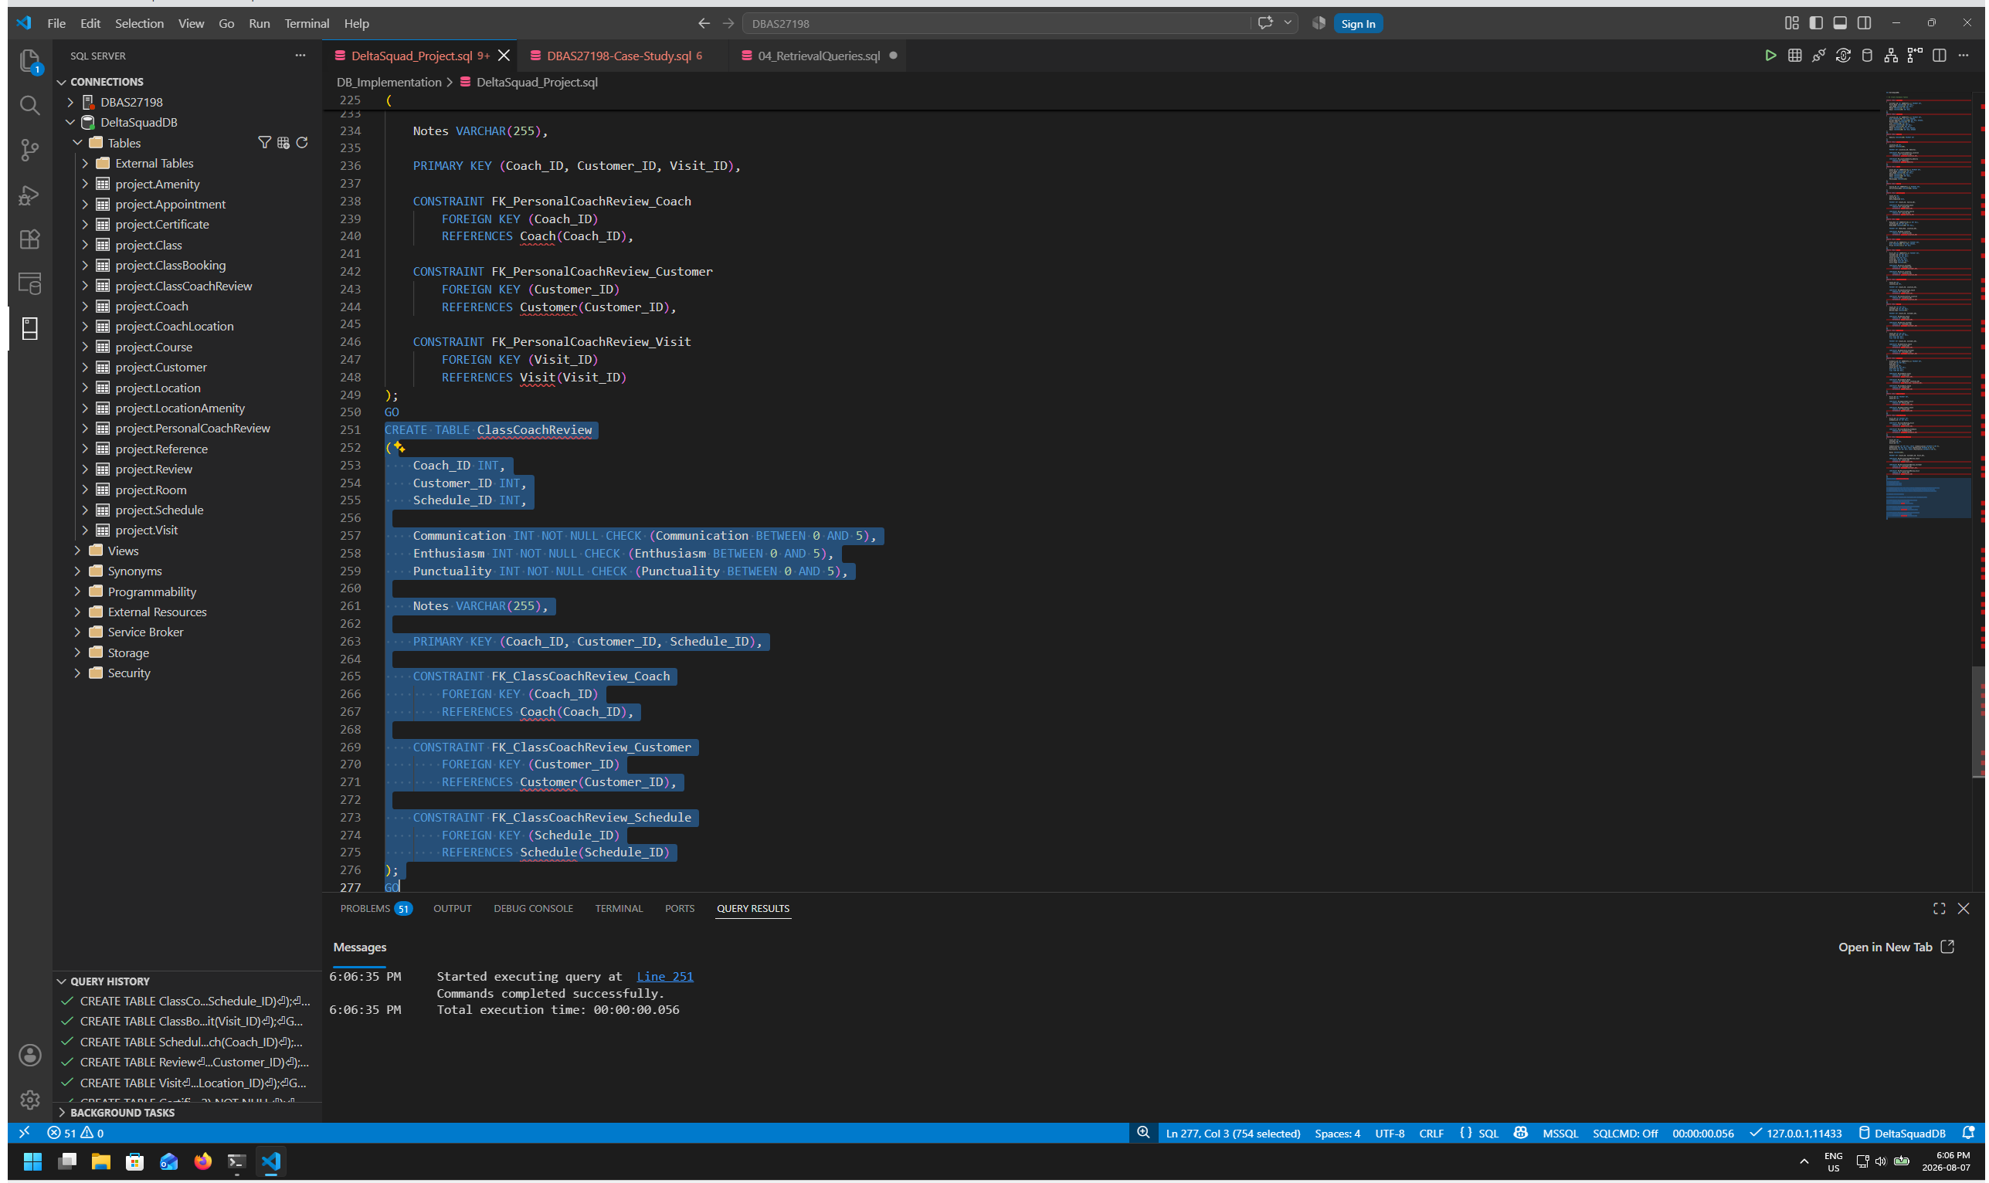
SQL Database Implementation: The final CREATE TABLE script creates the Fitness Center tables and enforces the relationships and constraints agreed on by the group.

Final Implementation Checks
- IDENTITY is used for Customer_ID, Location_ID, Coach_ID, Course_ID, Room_Num, Class_ID, Visit_ID, and Schedule_ID where defined in the final SQL to automate numbering.
- Location table Name, Location table Street Address, Location table Phone Number, Location table Email, Course table Certificate Name & Class table Name unique constraint added to avoid duplicate or erroneous entries added to tables
- NOT NULL & check constraints added to PersonalCoachReview & ClassCoachReview tables Communication, Enthusiasm & Punctuality to ensure ratings not unfairly affected by customers not choosing values & applicable.

4. Data Insertion
Sample data is inserted using SQL INSERT statements. The assignment requires at least four meaningful records in every table. The final data was reviewed so that foreign-key values point to existing records and the visit/review subtype data is consistent.
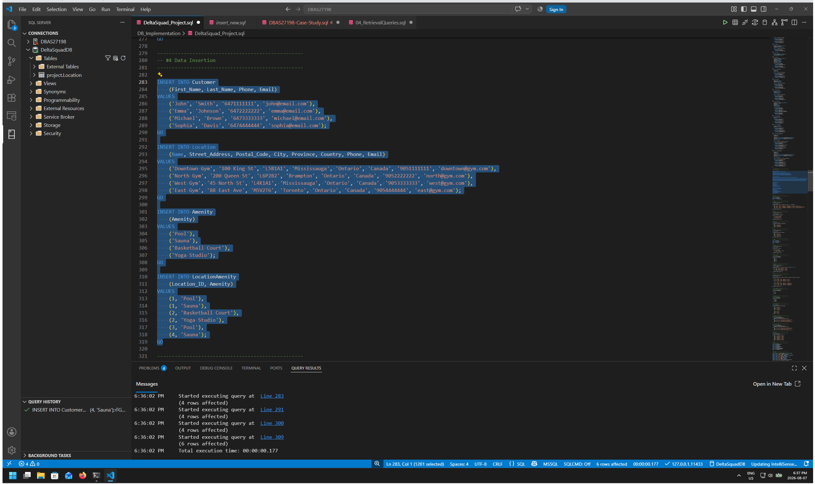
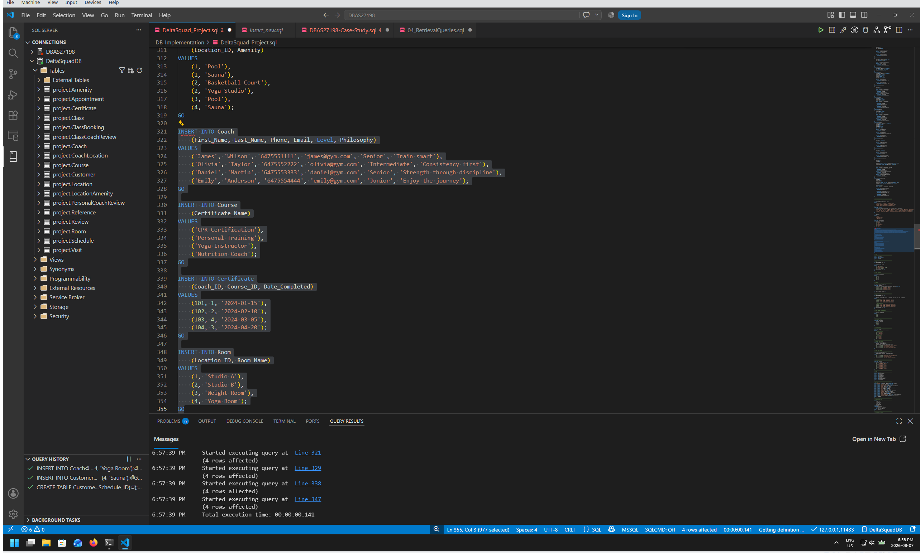
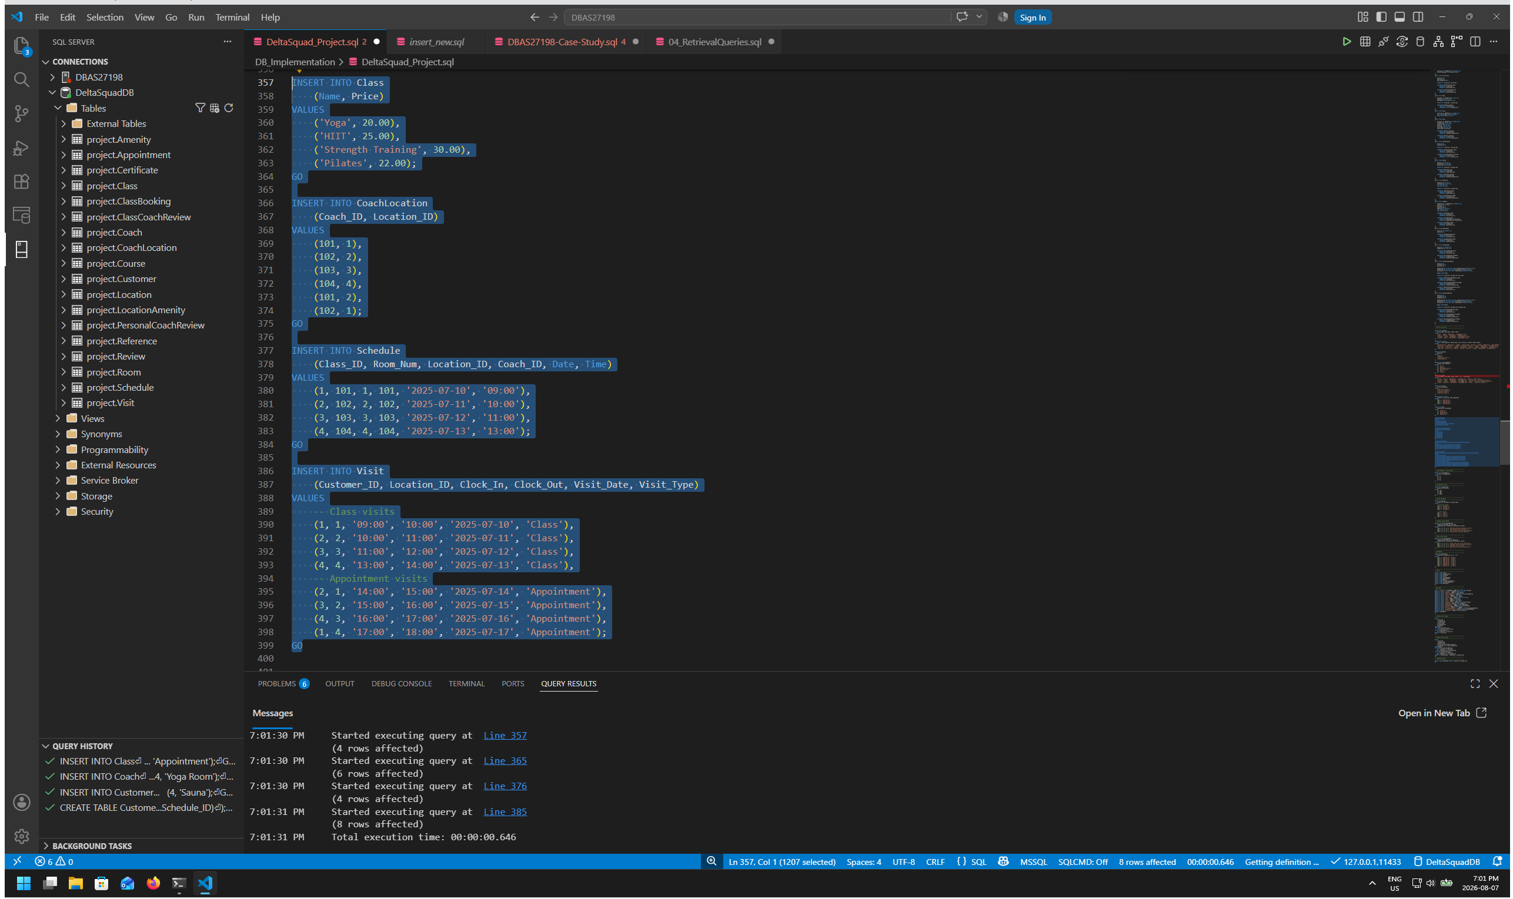
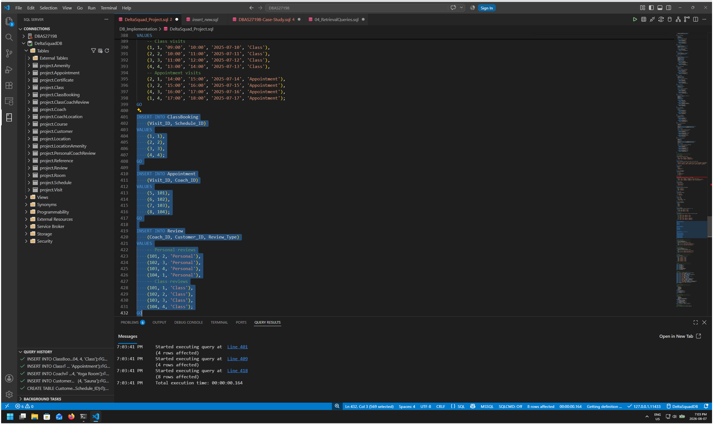
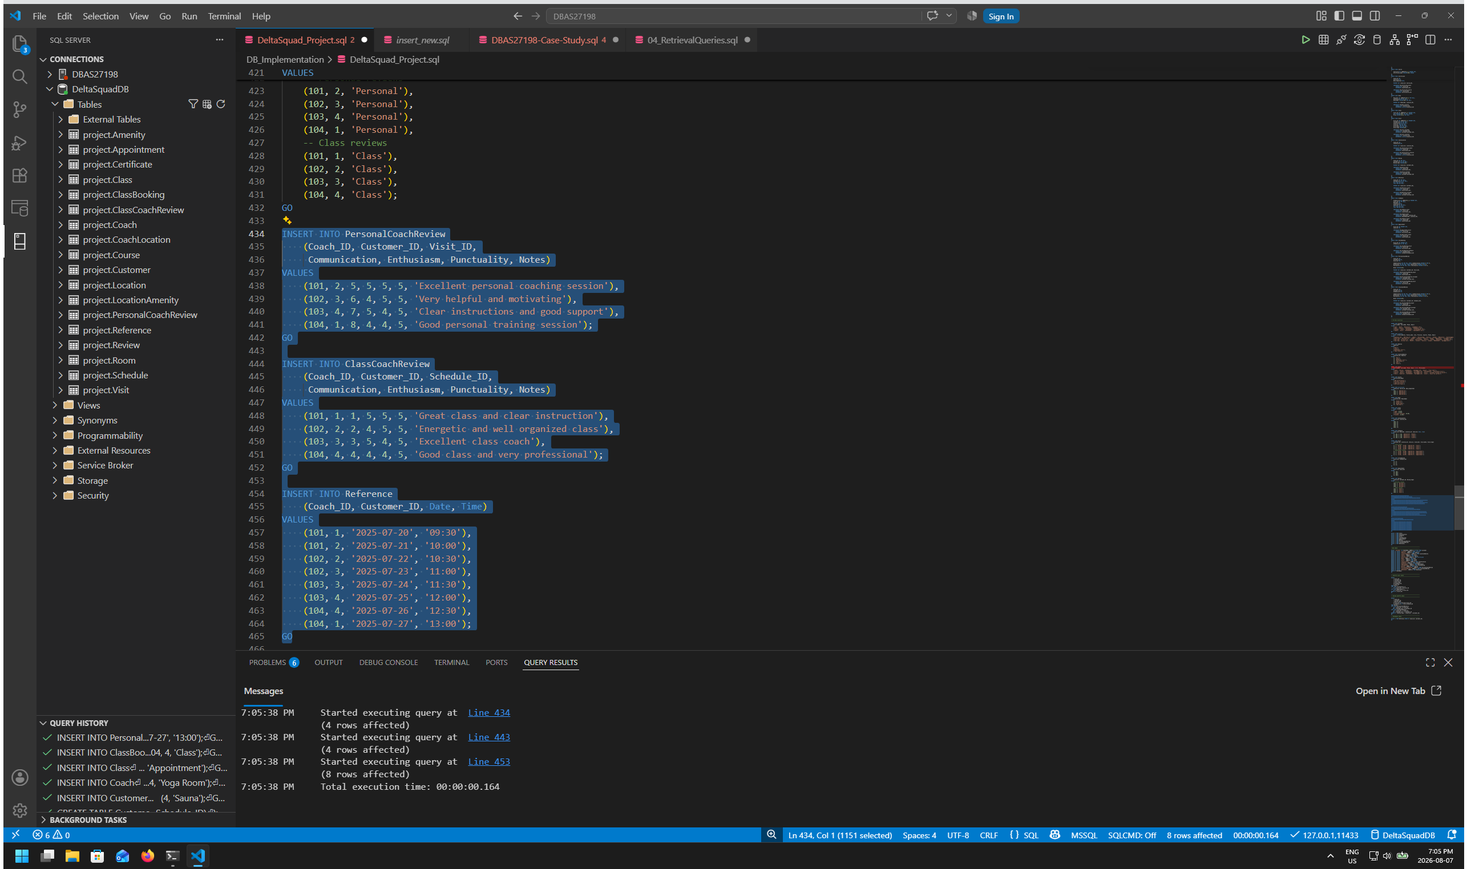
Data Insertion: The sample data represents realistic Fitness Center customers, locations, amenities, coaches, courses, rooms, classes, schedules, visits, bookings, appointments, reviews, and references. The Visit supertype contains both class and appointment visits, while the Review supertype contains both class and personal coaching reviews.

Data Insertion Verification
- At least 4 records exist in every table.
- Visit contains 8 records: 4 Class visits and 4 Appointment visits to relate to 4 entities in each of their respective sub-type tables.
- All foreign-key values reference valid parent records.
- The data is meaningful and supports the required retrieval queries.

5. SQL Queries
The required SELECT statements retrieve the information represented by the project wireframes. The sample names in the wireframes are references; the group may use its own realistic data as long as the required information is returned.

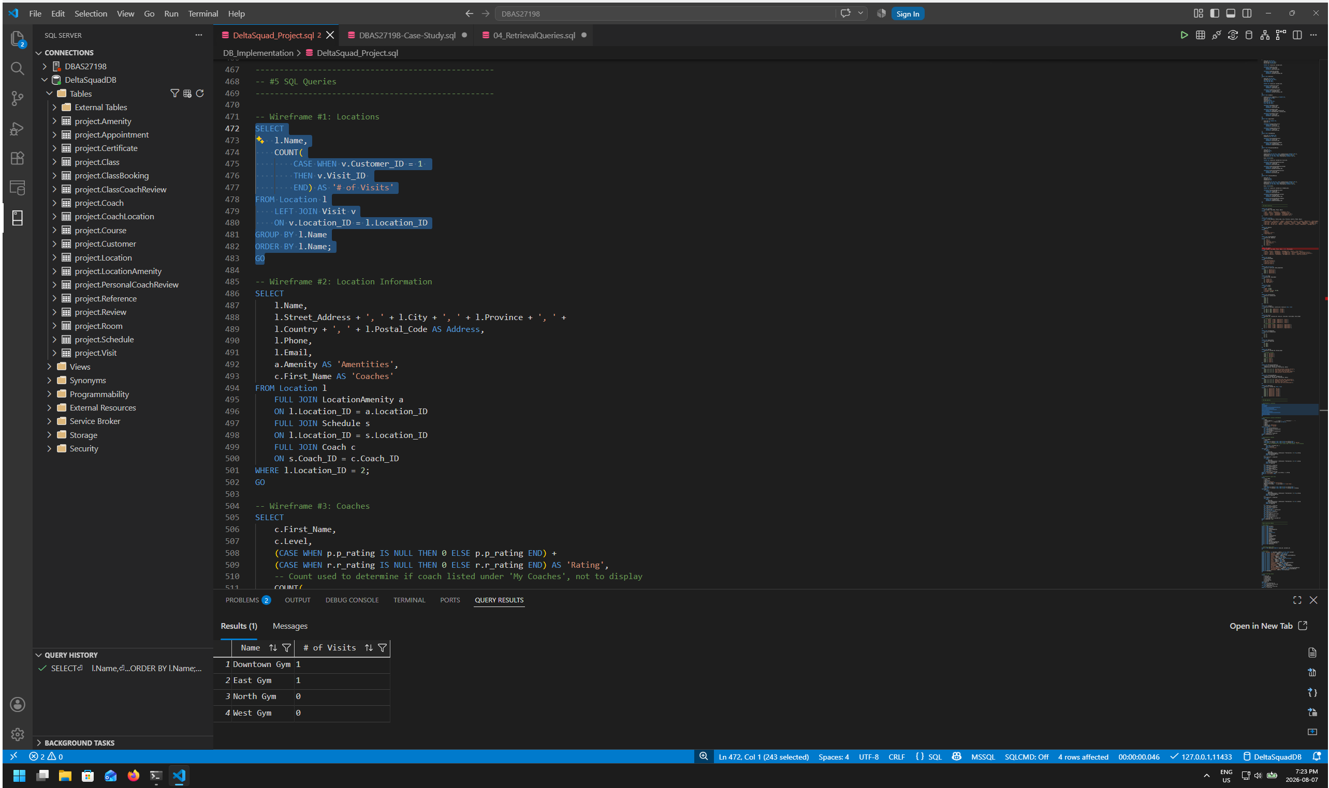
Retrieved list of organisation’s gyms and number of visit’s associated to the customer’s account (used customer ID 1 for this example). Home location is automatically calculated by the top gym ranked by number of visits. Delineation between Home Gym, other visited locations & full list of locations to be performed by front end software.

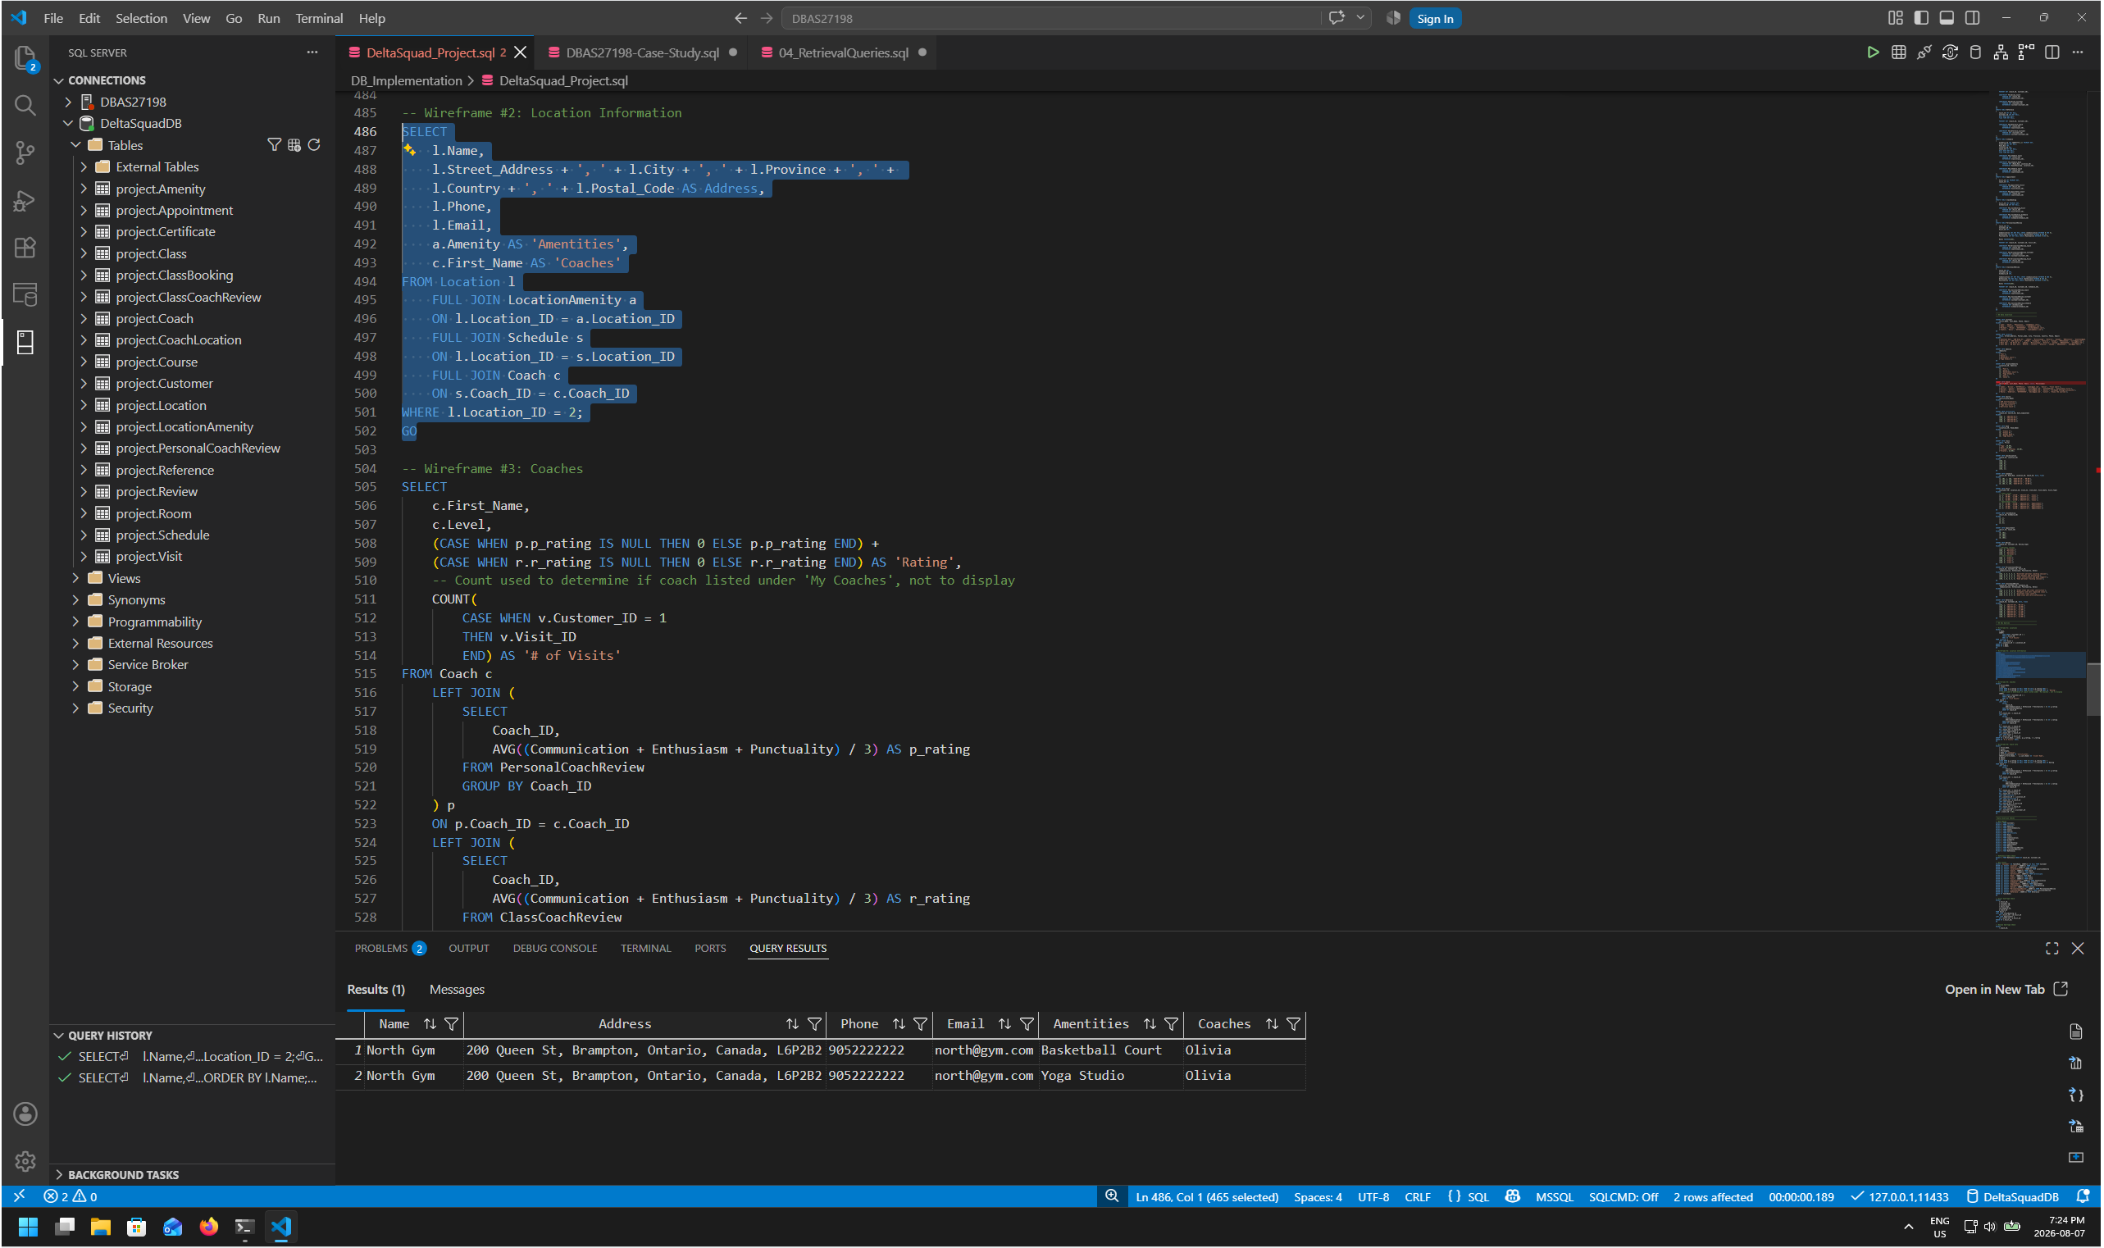
Retrieved location information including name, address (full address retrieved if required to share with map application), phone number, email address, amenities, & coaches. (Multiple rows for coaches and/or amenities to be managed by front-end software)

Query 3 – Coaches Tab
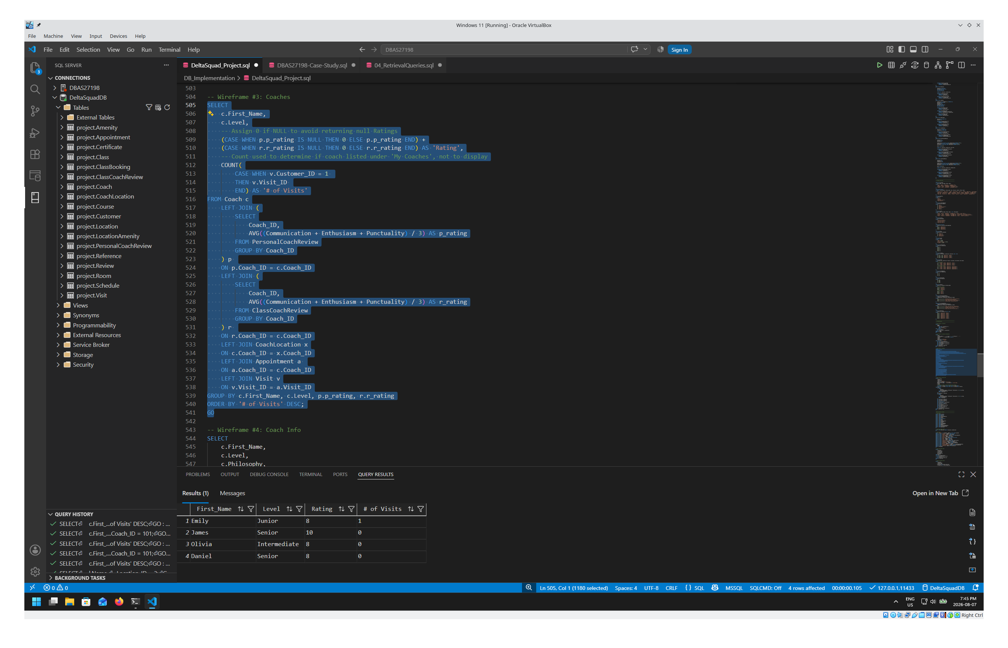
Retrieved coach list including first name, level, rating and number of visits associated to the customer’s account using customer ID 1 for this example. (Number of visits per coach retrieved to differentiate between My Coaches and All coaches lists. Delineation to be performed by front end software.)
(Reviews considered as a separate button to be pressed to execute the query in relation to all coach reviews).

Query 4 – Coach Details
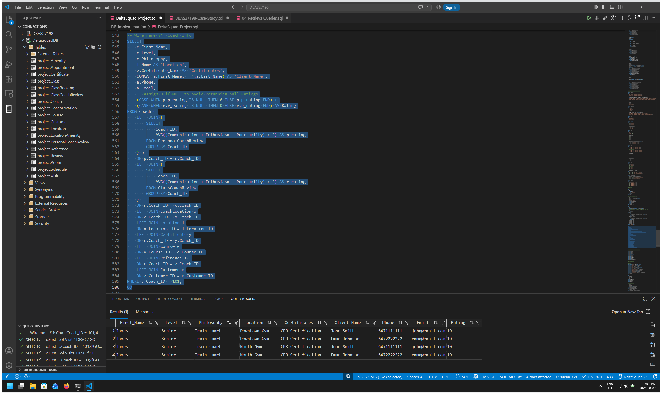
Retrieved coach information including first name, level, rating, locations, philosophy, certificates, reference client name, reference client phone number and reference client email. Multiple rows for locations, certificates and/or reference information to be managed by front-end software

Additional Notes:

- Microsoft SQL Database server deployed to Amazon cloud service using AWS ’s RDS to allow for simultaneous access & modification by multiple group members during project development. Configuration included setting up secure remote access through AWS Systems Manager, database roles and users, AWS IAM Identity Center. Instructions created for team members to connect to remote server. Additional information available on request.
- Additional data insertion check queries created and used to confirm proper data insertion into tables added to bottom of SQL file

