4/11/23

The plan:

* First go through L_J.2, and then consider going back
  + running gnuplot/vmd from cmd line (and running them generally, including linux what is a module and more on this whole situation?)
  + very quick review of gnuplot and vmd
  + Thinking through LJ exercises meticulously
  + paper
  + make google calendar
  + and update with some of the things you were worrying about, e.g. im not sure, just a few things?

4/17/23

* massively behind
* if move on today must remember
  + proper scale for VDW?
  + **Phase diagram and phases? (temperature density)**
  + Obv the question of constant temperature vs energy **the subtle point**
    - **And just the general ideas of this simulation**
  + **Are your plots even good?**
  + **Other things before**
    - Like Boltzmann, basic questions
  + ?

4/18/23

* are your plots even good for the original three under temperature?
* Consolidate the to do lists?
* Did you get caught up in the weird jump, which you should have avoided that and instead asked about the energy, which did appear to stay?
  + Why did energy stay constant?
  + Equilibrium, and same for temperature in the other one?

4/23/23

* Long break is not good
* Maxwell Boltzmann distribution – for some reason is broken?
* **Need to go over all of the things**
* **Was there something else I could do for an exercise, I totally forgot!?**
* Big issue is still the outside of work stuff, need to sort that out.
  + Seems like you’ve forgotten a lot of the last week stuff, including vdw size and subtle point, more important is the other exercise, I’m hoping after the outside of school stuff is figured out you can come back and it will be here
* So would ideally be, after c4 is done and then c3 is in a place where you can work:
  + Mb distribution make it work
    - **Main issue solved, need to think through the math better – WHAT IS THE MEANING OF IT? Must, as says in diary. Just simply must.**
    - Also why is it slightly off?
    - Oh! That was nve, which should actually be at a higher temp on average. It quickly goes up to slightly higher.
    - **How does adding those 2 distributions work?**
      * **How would changing the lattice constant in nve change U and T?**
    - **So if this is right, my nvt should be exactly right**
  + Do the other exercise (first need to figure out what it was)
  + Review what was went over last time and make sure you understand it all
  + Then start on research
* The update for 4/25/23 which is actually one day is that c4 has not been solved so still in the same place, perhaps luckily perhaps unluckily you still don’t have things. So today work till 8pm basically nothing do the things above or ps3, I do not want to mess with the things above until I have a brain, so I guess will try mb distribution or ps3, yes do not mess with it time goes on which is bad but it is simply outweighed and yes it is very very bad but it is simply outweighed, not sure since, yes well with the science not sure how it should fit into the c4 issue, it could help okay so let it by having a relaxed 1 hour, should it be longer? Enough to effectively reset, forget about it.
  + But remembering things – I don’t know how well that’d go since I am not technically entirely focused and so it is difficult, don’t want to mess with it. So simply right now to reset: mb distribution and then some ps3.
  + Ok so chilling, for next time either tmr or Thursday or later, do the rest and ps3 if necessary, chill for now outweigh, relax
    - Was just bad, also should I say sorry for bothering? Agh whatever. But yes not good, but above is allowed, but outweigh via this. Ps3 and also the above things, math and other
    - Not perfect but should be fine, messing up the math?
    - MAYBE DO THE MATH – not something you can mess up, but does take time?
  + **So: do the above things, and ps3**. Outweigh. Review for both points VERY IMPORTANT.

5/17/23

* Time has flied by. Today I am in no state to do anything, I am absolutely so mentally destroyed, a few different things but there’s one important thing.
* In any case you really need to do the above asap, today would be good but you can’t. You can try tomorrow maybe, but just asap. For today then, just work.
* You can probably shoot a message tomorrow.
* Today probably just do the Will thing, answer any questions, and just start on the simulation.
* Oley simulation: finish understanding code, look over issues from Friday, then start
* Will code get that to work
* Amines sticking to gold paper
* I should read the other paper again, not sure when.

5/19/23

* Today is a good day to really start, there is *so much* stuff but you can forget all of it until 7 ish, which gives you a while, and then after you can start again.
* The first thing that is clear is the lack of time: you have 2 full weeks left, about 2 half weeks, so really it’s about 3 weeks and scraps, which is just not a long time.
* This is separate from all other parts of life, this is isolated. This is a chance to prove yourself. This is a chance to test yourself. Without any of the other strange things that are affecting you right now, this is the true beauty in life, everything else is often disgusting and frightening, but this will remain as the only way forward, there are all of these things even with things like testing which are agonizing and you will have to face them quite soon. But I truly believe nothing else matters if you can do this, you ignore all, it is about finding a way, it is about finding a way. No but that is the truth, all of these things they destroy you, but with this you can forget and just find a way. Even all of that testing stuff like it doesn’t really matter, it is about finding a way here, and becoming better.
* So the two goals are finding a way and benefiting (however you can).
* So with respect to the current project situation:
  + For finding a way, I think it is vital that you take good notes when you are taught things, that seems like a big weakness. And then with experience and lots of practice and more consistent working this should get better.
  + And for benefiting I think it is just that mindset of always trying to be the best, it is that hard mindset. Always striving to be better.
* So what I am supposed to touch
  + MB distribution math thing
  + Other exercise from LJ_2 review? And ps3…
  + **Review LJ_2 lots of different lessons and things…**
* None of these seem too necessary, but the last one is definitely very important and I should at least go over it at some point(s), if not right now.
* So for now will start research with the premise that you should understand everything, and then if you don’t obviously just ask, and be better.

Notes for today:

* For today, goal is to get as far as possible into counting things, and make sure vDW radius is understood.
* Also send Will the message if there are any questions.

Questions for today:

5/26/23

* I feel very not balanced because of the lack of work, I wanted to finish this early this week but did not have time. Just finish it right now, only goal right now is finish this one thing and then after can fix everything, need to fix everything.
* But for now please just use your brain and finish this.

5/30/23

* It is go time.
* You essentially have 2 weeks plus crumbs left.
* I think the only thing that is really worth it to look at from before is **reviewing LJ_2 for the different lessons – so keep it open and remember always that there is stuff in there you need to look at at some point.**
* So what you are going to do is go 100% obviously, but the idea is
  + Keep essentially everything on the other doc, this one is just for log and important questions.
  + About finding a way to be better every day, the basic organization is fine I think, it is about keeping your brain 100% always
  + Your goal is paper obviously, so that just means going through the work that is given to you, work like you never have before
  + Time is what you need, and it is limited of course, you will address that tonight, 100% efficient, always focused, you know here how important it is, it is up to you in the other world to schedule, so about being better, so scheduling,
    - It must be scheduling not here, it must be objective, but it must weigh this correctly as you think now, so you must do that.
* So here it is about being 100% efficient, having a goal
* Today it is finishing everything from last time, and gaining better understanding of this, organization, getting everything and doing everything ! ?

Bunch of things on my mind,

**Please look at it**

5/31

* Finish everything from last time

6/4

* General work

6/5

* Get ebind done early, then you can start analysis
* Then move onto getting ligand number done for the quantitative, should be relatively quick

6/6

* You need to be better, and this is the most basic way to express yourself.
* You just don’t have a lot of time, you need to give this more time, you knew this, but it is the basic seeing that this is more valuable than really bad things, if they weren’t bad we’d have to think but stop, see your situation, and see that this is key.
* Actually thinking through the physics needs to start today.
* Not focused, why? Think about Zhu or the place.

New plan for organizing my work:

* Broad project: build a simulation consistent with the French collaborator’s experiment, and see if we reproduce their results. Study these systems (gather data and observations on how these systems behave).
  + First part: AuNP + amines –
    - See how binding energy, solvent quality, and number of ligands affects the equilibrium number of ligands bound to the AuNP **and** the formation of interesting patterns.
    - Read the literature, and see if it is consistent.
    - Organization of results: I think it makes the most sense to look at the system under the 3 parameters separately.
      * So for binding energy, quantitative analysis is just the coordination number. The trick is figuring out how to report the error. If you are unable to report the error, you should organize the data so others can do it.
      * So generally: have some key qualitative observations from vmd and the g(r), and then include quantitative analysis which should probably just be the average coordination number, and then the distribution of the coordination number (which is a sample).
      * See oley_au_notes for the exact stuff
    - **Extension**: having a 3D table, so for each of the parameters, have every other parameter, but this is a lot of simulations – would need to figure out how to automate slurm even more, and then automate finding second equilibrium point even more… (which you can if you are better)
  + Second part:

So oley_au_notes is essentially my lab notebook, write down everything in there

The organized results will come somewhere else

6/7

* You need to do better
* I think the simple goal is to have everything done by the end of today

6/8

* Figuring things out

**6/8**

6/19

* Back, and it has been too long.
* You need to figure out what you want to get done, and then set out on a quest

To do list general

* Get vmd to run on laptop

Questions

Week 0

Week 1 5/22-5/28

Week 2 5/29-6/4 (! 6/1-6/3)

* 5/30
  + Understanding the lj/expand, what exactly does the Delta mean? With respect to defining sizes, e.g. for counting coordination numbers
    - And hence what is the correct sphere scale for the amines?
  + Updating selections in vmd so it is more like real time?
    - For example, using g(r)
  + What determines what is printed in the log.lammps since there is no thermo_style?
  + How do you cancel a job in slurm queue?

Week 3 6/5-6/11

* 6/5
  + What is that extra peak in one of the g(r) plots?
* 6/6
  + Is the different sized time steps for 14-20 bad?
* 6/7
  + What is the advantage to looking at PE and not coord # directly? (to find eq)

Week 4 ! 6/12-6/18

Week 5 6/19-6/25

* 6/21
  + 32 CPUs work but 64 doesn’t – I get a lost bond atoms error
    - well this is actually really important, it reflects a fundamental misunderstanding about how this works
    - like what am I changing about this?
    - Is it not deterministic?

## LJ_exercises 2

* Keys:
  + Temperature?
  + Always check vmd

To do list

* Plot Maxwell Boltzmann in gnuplot
* Look up all of the lammps commands for the basic commands
* Understand the NH and LV thermostat, and the lammps commands
* The phase diagram of the 10-100-800
* How to calculate the correct size to use in VMD

Questions:

* How does gnuplot log.lammps? since there is a bunch of text before the actual data
* Was lennard jones what defined the noble gas-like atoms? Since LJ can do dipole-dipole?
  + ?
* Gen questions about lammps
  + Should look at fix nve to understand what time integration and all of that is
  + How to calculate size of particles in vmd? Is it you take the lattice constant then have the lattice as the lowest energy?
  + When does the range kill come in? like at some certain range you kill the force
  + The sig figs, e.g. everything has .0 for some reason?
  + Does it assume particles of infinitesimal size or no?
  + Equal-style variable
    - Is the v_name notation required?
    - It says we can specify formulas and use thermo_style keywords time dependent variable
    - Tstart stop kind of makes sense?
  + Compute
  + Dump
  + Thermos_style
  + What is style?

### Temperature

* I do see in log.lammps temperature being printed as a function of time
* Manual calculation of temperature from K using the equipartition theorem:
  + K_avg = 0.5 * k * T
  + K_total = N*3*K_avg
  + **T = (2/3)*(K_total/(N*K))**
  + The calculation was done in jupyter, and the percent differences between my calculations and lammmps were all under 1%.
* Velocities
  + Added a dump line: dump 2 all custom vel.dmp vx vy vz
  + Pulled this into a python file
    - It was here where I vector summed to find the magnitude of velocity
  + Got the histogram data
    - Using python got the x increments and the y, number within increments
  + Sent to kingspeak and plotted using gnuplot
    - 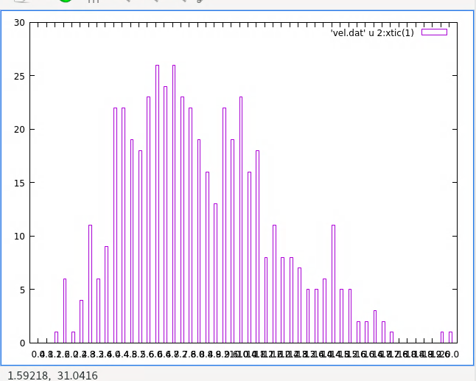
    - 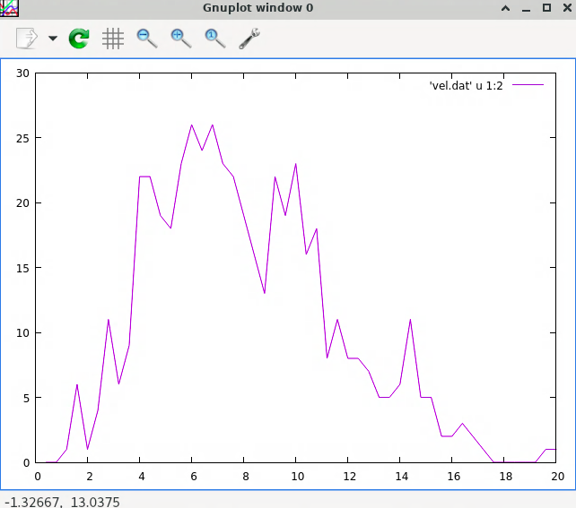
    - 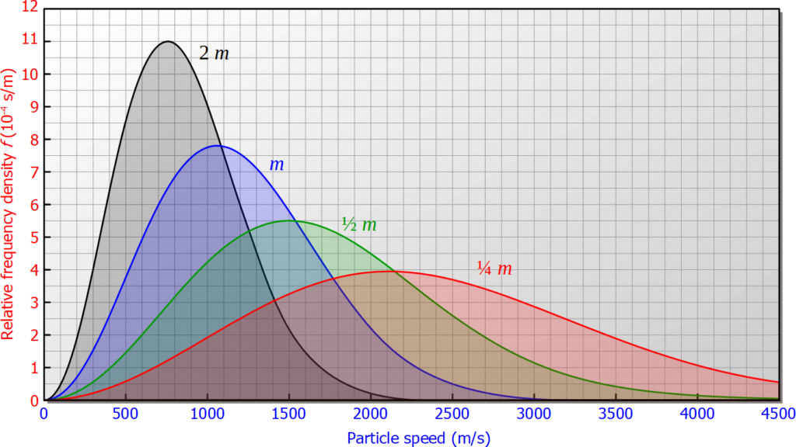
    - also plotting them side by side by using:
    - with T = 354 (at same time step, not sure what means)
    - couldn’t figure this out for now, moving on
    - to smooth out
      * dump more frequently
        + limit
      * speeds for all particles
      * running longer
    - what stays constant when T changes?
      * PV=nRT is not valid here I think since well we have an infinite box…
      * ?
    - plot
      * with units
  + New plot (4/24)
    - Why do I get that extra 500 (250500) vels?
    - The speeds are in: angstroms/picoseconds
      * Thus the conversion factor is 100
    - 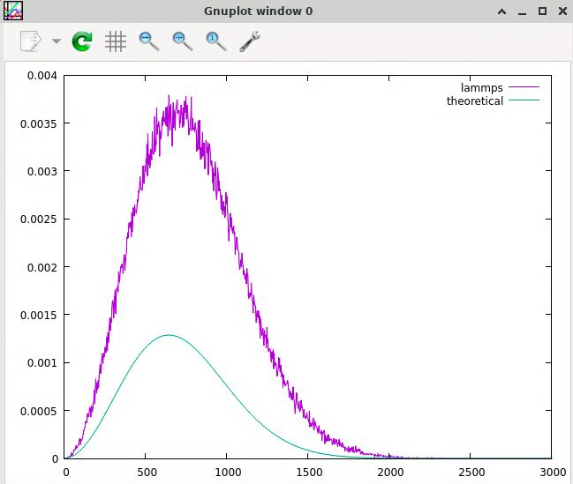
    - not sure why
    - Well it is because your histogram segments are not of length 1 – the interpretation of the theoretical curve is if we integrate from a to b then that gives the number of particles in the simulation that have that velocity
    - So for histogram it should be from start to end of segment will give me the number there. Right now that is number of particles, but since the box is not length 1, it will give me a nuber which is not the number in simuation, but number times box length.
    - I think the solution is to divide by box length in addition to the number of particles.
    - So it can be first divide by box length so it gives correct, then divide by number to give me the pdf?
    - AGH – my math is so bad and the thing, but it is okay! No it is not ?
    - 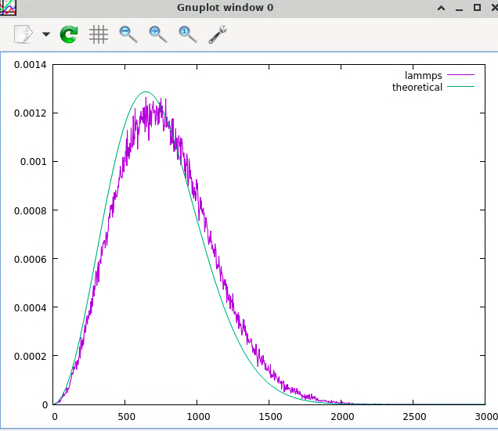
    - still not great looking,
    - get the math better
    - with all same but nvt:
    - 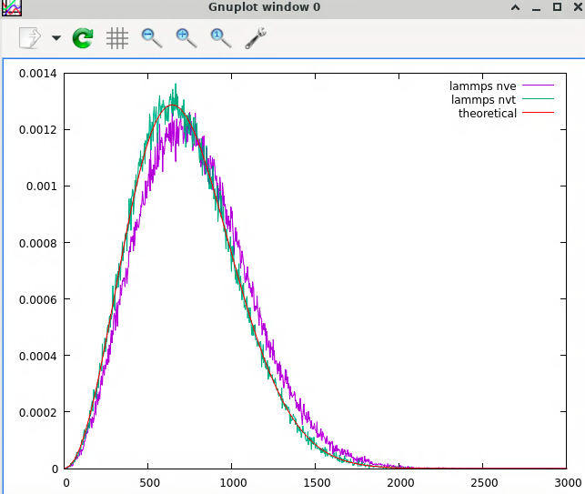
    - see above issues with nvt
* It makes sense that temperature increases since if they get closer the U decreases meaning work is done on them and their K increases, which increases T
  + Did not find a way to check average temperature besides just seeing that it was clearly above it
* Fixing temperature ideas
  + Simply resetting the temperature
  + Somehow using PV=nRT?
  + IRL, we use a heat sink – yes so just particles at the boundary we add velocities as if they have a collision, but this qould require constant V? or I guess in a weird way it could still work?
    - With periodic boundary conditions, this is not constant volume also?
    - How do periodic boundary conditions work with respect to things like a heat sink, and it is not equal to an infinite container?
* *fix temp/rescale*
  + target temp is ramped – is this just linear increase?
  + Is window a relative value or just absolute, then wouldn’t you need to redo it like your tstart?
  + This doesn’t do time integration – does fix nve *just* do time integration?
    - Almost makes it sound like you do the new velocities and then integrate, but it can’t be from the beginning but then is it like just for a little? Not sure?
    - Fundamental issue with how this works – fix nve does time integration
    - And the last warning about likewise should not use another temperature control?
  + Some weird things: compute, the fix-ID type thing ID and group, changing attributes just doesn’t make much sense, missing information on compute and how fix work? ?
  + pure questions
    - bias velocity
  + agh
  + ?

### Random Seeds

* deterministic v probabilistic
  + computers are deterministic?
* testing two identical input scripts
  + in2.lj was a copy of in.lj
  + 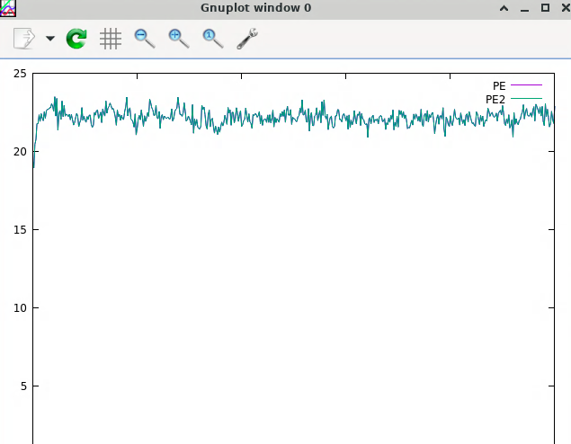
  + they are on top of each other
* changed variable seed to 11111
  + 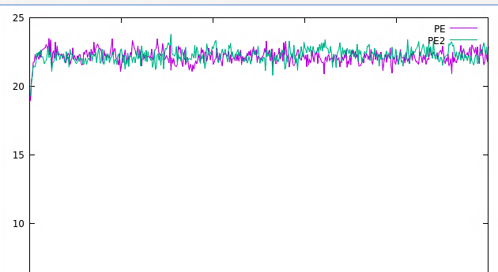
  + as expected, different

### Controlling Temperature and Pressure

Where did the first two bullets come from?

#### Canonical ensemble

* The general issue
  + So when we have a system isolated from the surroundings, I can imagine it easily gain KE and lose U, thus E is conserved but T is increased.
  + Yet it is not so simple to imagine a situation where KE is decreased and U increased, and T decreases… 2nd law?
    - So if this is true T is always increased from initial?
  + Is the Boltzmann distribution for systems at equilibrium (which have microscopic changes in the system, and thus different microstates overtime, and maybe change in E) or is it saying given that you have this system at this temperature, here is the distribution of general systems at this temperature?
    - Something in the middle here?
    - Probability difference is greater as T decreases
      * Entropy with energy distribution
  + For the comment on periodic: I guess the most straightforward way of taking velocity out via collisions at the boundary is not possible .. ?
  + Why can’t rescaling the velocities keep the Boltzmann distribution? The issue here seems to be I don’t get the Boltzmann distribution.
* Nose-Hoover
  + New degree of freedom, which regulates particle velocities so that Boltzmann is achieved
  + ?
  + so the question with the nvt command – of Nose Hoover is just a thermostat, then why worry about anything other than temperature?
  + It appears on quick inspection it is just additional more complex things, but the Tdamp parameter is chill (unit son that) the temp keyword is good enough now, and the Tdamp probably gives the how quickly they are regulated?
    - Time unit v time step (?)
    - Remember the Tdamp should be about 100-1000 **timesteps**
    - Tdamp def? how it is relaxed? (see above for 2nd law?)
* Langevin
  + Particles are in an implicit solvent
  + We get a stochastic force that acts on particles to represent collisions
  + The disappate heat of stochastic force via friction term just doesn’t make much sense to me – isn’t the whole point of the force to dissipate the heat of the particles? Like is it we need one way but f it goes too far the other? But then I don’t really get how the temperature dependence works? ?
    - **Either with or without Boltzmann understanding?**
* More thoughts
  + NH seems a lot more brute force?
  + For NH we are representing this very large material, so I guess constant temp would just be the internal interactions represented here?
  + So the heat sink vs solvent – solvent is everywhere and thus collisions are everywhere
  + For NH heat sink is only on edges, so we only care about the internal interactions which are shown like this?
  + NH is energy conserving?
  + NH is more accurate for no solvent? LV is more accurate for solvent, which makes sense ig, I still don’t get friction tho?
    - Specifically for dynamics and kinetics

Using the NH thermostat

* Not really sure, so nvt outside of constant temp?
* Really confusing: for the first NH at 10 kelvin your initial velocity was at 300K, yet they didn’t go crazy
  + Was it cuz the nvt command immediately changed the temperature down to 10K? like if it increases it will modulate it?
  + How does this even work? (the nvt)
  + Could check if time steps is correct, but yes just like without super high initial when they get high initival it takes it out
* First, how do I get accurate representations for the sizes of the particles in VMD?
  + Are they ‘touching’?
  + ?
  + atomselect top all
  + [take atomselect and] set radius 0.5
    - this is the radius of the vdw representation
    - can be a good test and other test
* It appears the 10, 100, and 800 represent solid, liquid, and gas
  + Phase diagram?
  + No, 10 and 100 are solids
  + 800 is liquid?
  + The issue is the periodic boundaries mess it up, e.g. if it was a gas it wouldn’t be able to?
* What are the phases?
  + Solid v liquid v gas? The phase diagram,?
* No:
* 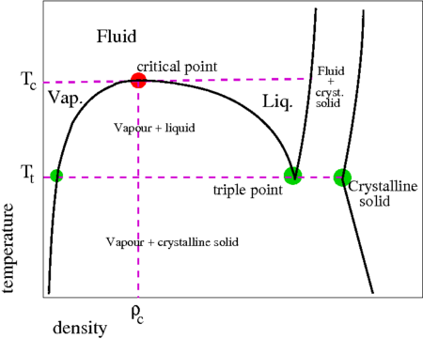
* inside the snail = coexistence phase
* computer does not like give you interface, will give one pahse
  + still a bit rusty on critical points
  + but the important part is that I think this remains as a solid in the first two, then becomes a liquid
    - how do I know it’s not a fluid?
  + I guess it oculd bea supercritical fluid
  + Are these always like IMFs are negligible but high density?

Two key points:

* What is the meaning of a supercritical fluid?
  + Is it simply no IMFs but high density?
* What is the meaning of atomic radius, and what is the more ‘accurate’ representation in VMD?
* Third point: the phases in the simulation?
* Fourth point: are your plots even good?

Density calculations?

**Some of what was said about density and that type of thing?**

* Temperature and energy plots
  + T = 10

Energy then temperature

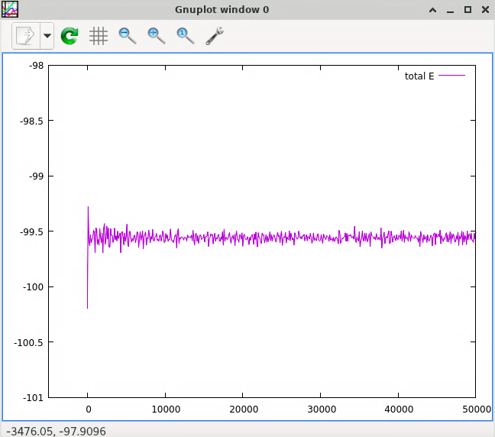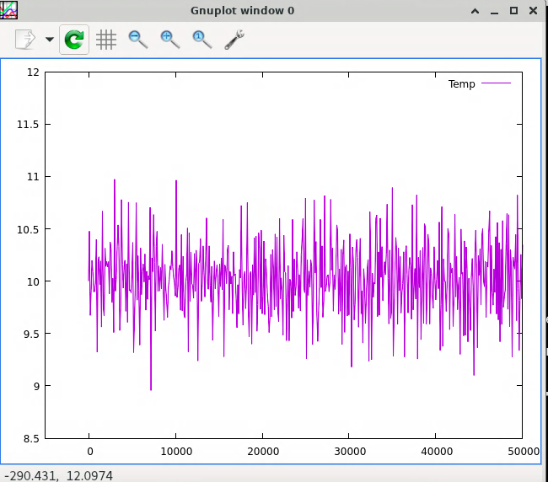

T = 100

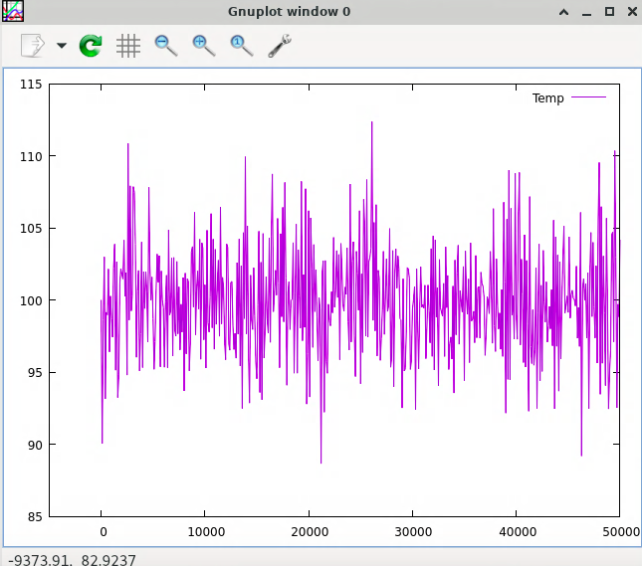

* Temperature is only really constant if size is infinity
* The temperature should fluctuate, not numerical
* Energy is not conserved since there is still heat transfer but at equilibrium the average is constant

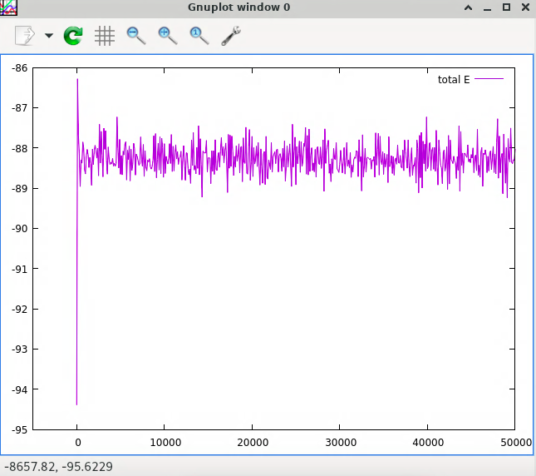

T = 800

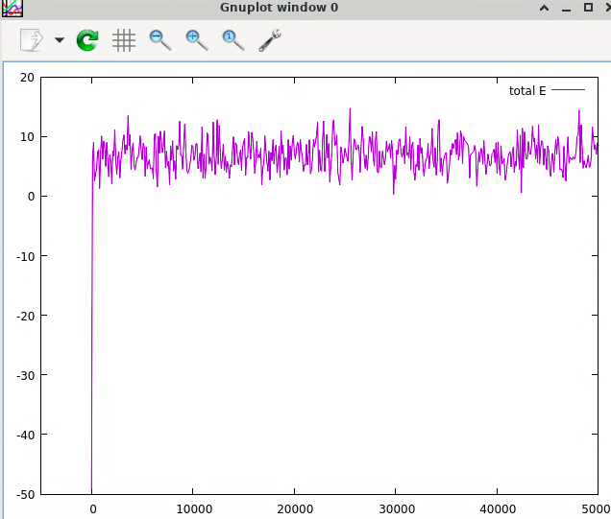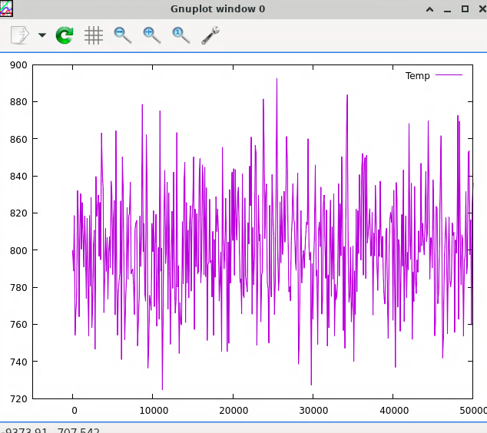

* Higher temperature makes it easier to access higher energy states, applies to PE, and thus phase changes
* Big jump is thermostat calibration of new degree of freedom
* Start initial conditions with thinking so the thermostats don’t breal

Notes on the plots:

* They appear to be analogous, maybe as T increases so does the range of the T but percentage not even sure
* Total E is not conserved, and T is approximately conserved

This doesn’t make much sense….?

And then other things, scheduling or whatever, and then move?

* Why would total E increase?
  + Goes against the intuitive idea
* It increases since PE increases,
* Okay so:
  + PE increases because of the lower lattice constant (I think)
  + And then it slowly comes back down as it turns into KE which is wasted away
  + The point about temperature increasing with total E makes sense and seems important, not entirely sure how it links here
* Still no solution for the subtle point

?

#### The structure of liquids and solids

* Selections?
  + It appears it means so g(r) is calculated considering what atoms, i.e. say you have one atom at the origin and you want to find the pdf with respect to radius, what atoms do you consider
  + So in this case I assume selection 2 should be all
  + And for selection 1 it doesn’t matter but using 1 smooths it out since we get more calculations?
  + If is uniform, shouldn’t it be the same for all of them?
* g(r) and integrated g(r)?
  + g(r) would have these peaks for solids because the uniform structure is high geometric order – so like at ceratin distances we have these atoms, but of course other atoms also at that distance in other direction
  + integrated g(r) would then be like the literal number probability of finding something in that region, while other is the like probability of this one tiny space
  + not very high…?
  + So nearest neighbors okay? (somehow, see below…)
* probably should look at figure first

T = 10K

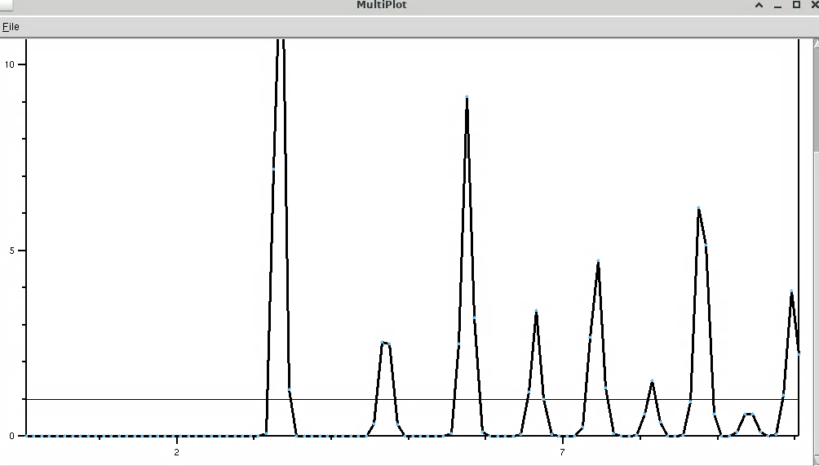 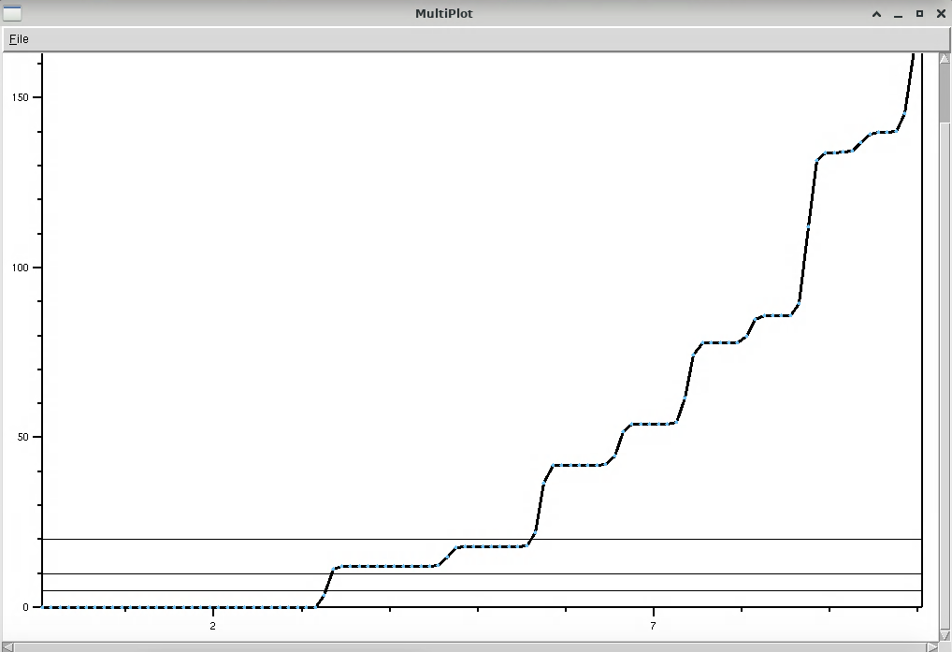

T = 100K

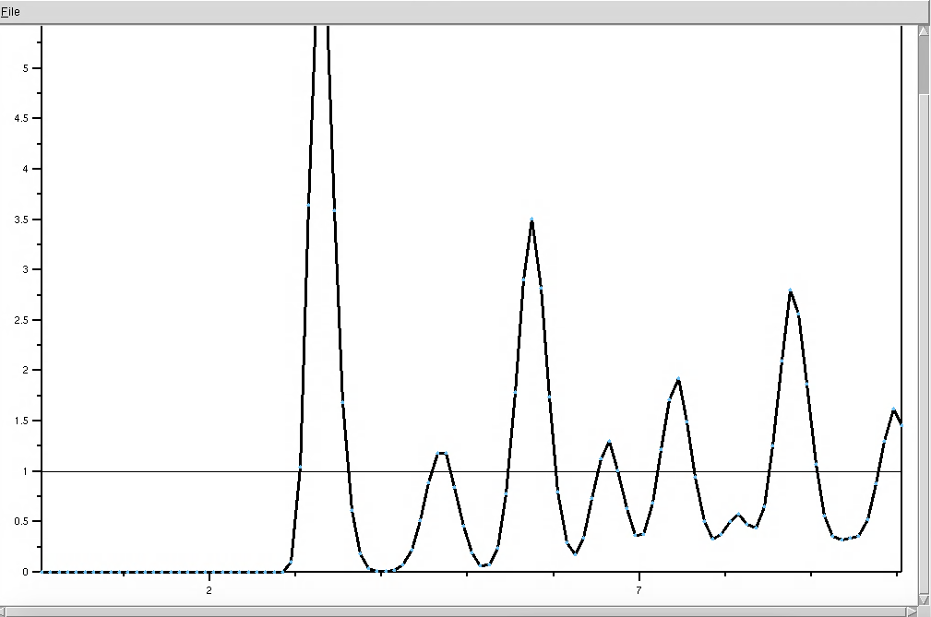 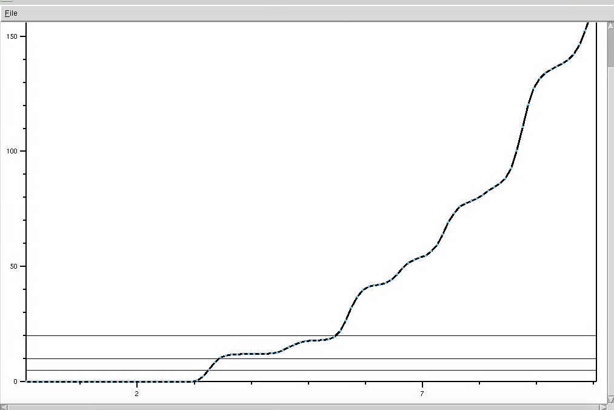

1st and 2nd, delta function, integral values at small distances

vmd tools: index, name, mathematical inequality

average

T = 800K

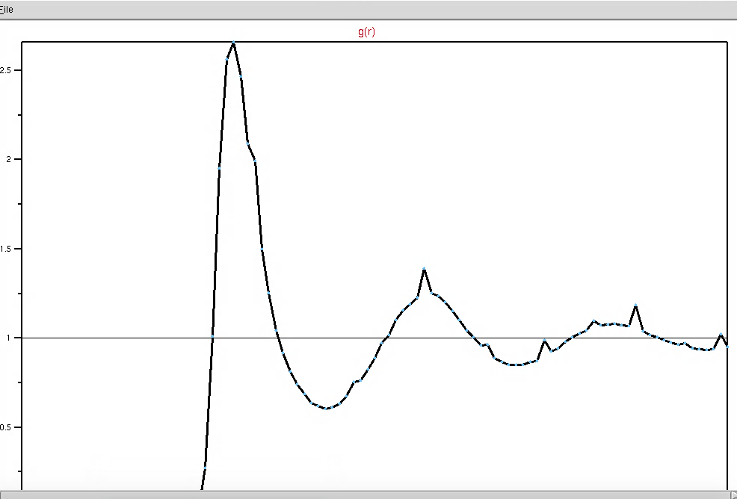 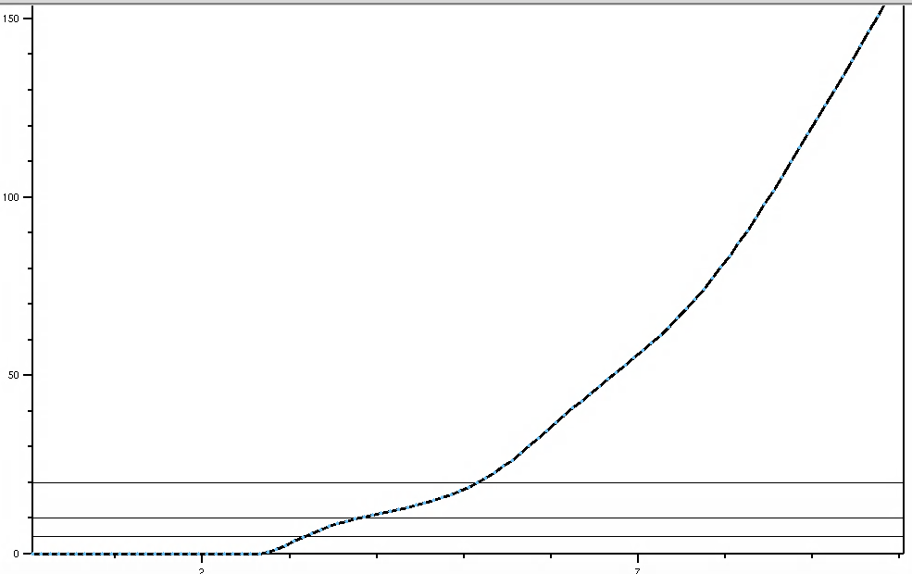

* so yes it appears the higher temperatures are just less clear versions of the 10K
* oscillatory motion decreases it
  + liquid to solid? Definition of these?
* Is there such thing as a liquid structure?

Determining number of nearest neighbors:

* First, selection all vs one atom for 1 doesn’t change this, so I assume they like average when they use all the atoms, so given *one* atom at the origin, what is possibility, …?
  + Moving origin?
* The 12 and 6 is simply the value of the integrated g(r), and these are onsistent. 2 key questions
  + Why are these just the value? I.e. why does integrated g(r) give this?
    - Meaning of a pdf?
  + Why is it easier for lower T run? (separate thing: Bad)
    - More defined, since fixed position?
    - Particles in these spaces in between?

590K:

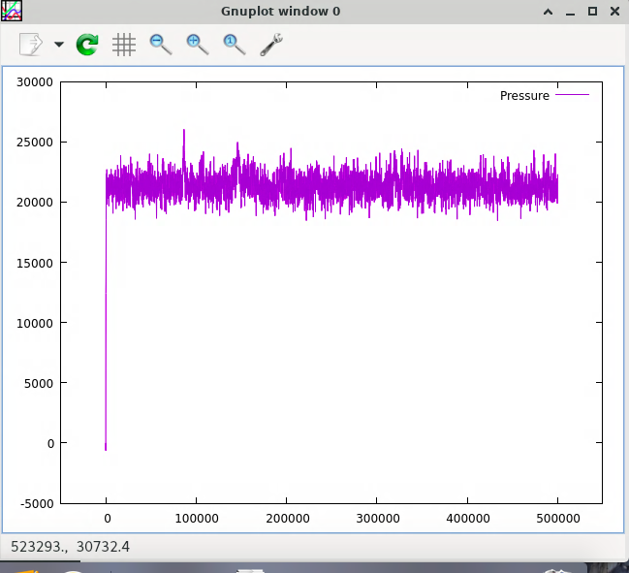

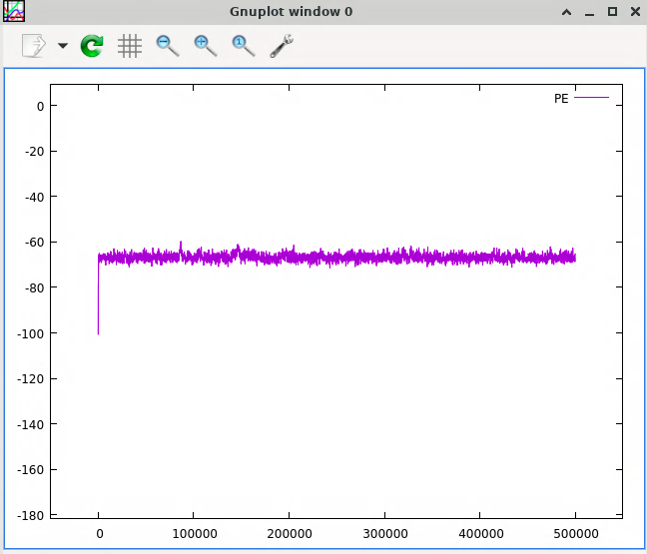

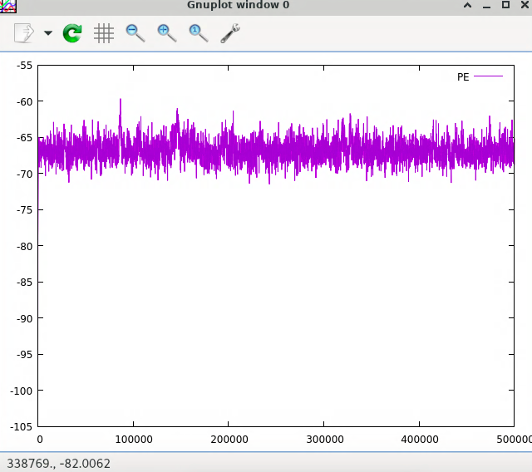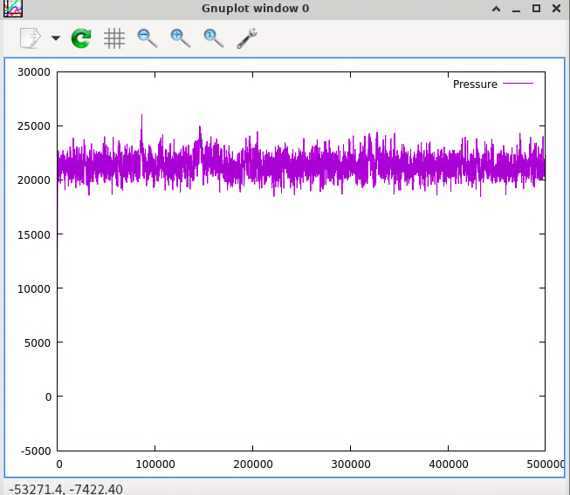

Observations:

* Other things how this shows other bad?
* Vmd
  + I suppose you could say that it is in between solid and liquid?
  + And I guess it is still oscilatting, like on the line?
  + So not in equilibrium or yes since it oculd still change?
* Plots
  + These weird peaks
  + Peaks would indicate liquification?
  + If something liquefies, it expands so pressure also increases as they hit each other harder?
  + And PE increases?

Maybe run after with long temperatuater

* How to tell if something is crystal
  + Orthographsci
  + Grid lines
  + Trajectory smoothing

Has everything been wrong?

?

this is very bad (everything being very wrong, feel not good right now)

**just ignoring the first E jump for the temperature ones?**

### Constant Pressure

* The biggest confusion is over how periodic boundary conditions affect pressure
  + A definition of pressure without the number of collisions against a wall?
  + How can changing the volume of the simulation box change *anything* since aren’t we simulating this massive thing anyways?
    - The density is changing
* **Phase coexistence**
  + They are difficult – an interface with non-negligible free energy contribution?
  + At constant temperature and pressure in a one-component system, only one phase is supposed to exist, but in constant volume (and changing pressure) systems there can be multiple phases?
  + And phase transitions are easiest to see without phase coexistence (last exercise)
  + Mixture vs gradual change (but homogeneously)
    - No
    - ?
* Barostats
  + If constant pressure, volume must change?
    - If T increases, and P is constant,
      * Either like the number of collisions with the box or
      * Decrease number of collisions
  + Rescales box and positions…?
* NPT v NVT conducive-ness towards phase coexistence is reflected in the phase diagrams
  + If two systems are in equilibrium, they must have same pressure
  + Constant pressure – therefore better for phase transition, the snail diagram has like the whole thing, that is why
  + Density is also just volume, so if constant pressure but density can change
  + Thinking about it like that
* There must be an interface (why?)
  + Free energy bad: worst of both worlds
    - Doesn’t get high entropy, also doesn’t get bonds to decrease enthalpy
  + The computer will make a total crystal that is too big (not ideal), or a liquid that is too dense, because the free energy is too high
  + Larger system: SA:V, volume makes surface area negligible
    - That is why it matters for simulation
    - Surface effects
    - ? -- ?
    - ligands have favorable surface effects
    - matters for researchers at small sizes
    - small?

NPT simulation

* What is a NPT phase diagram?

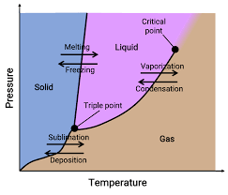

* May run into obviously phase changes
  + If past the critical point, not sure if that would change things…
* At the lines, like weird melting things?
* Not sure?
* npt – question was a bout nvt?
  + Oh so I was maybe ready for pressure being introduced but confused about what the NH thermostat meant
  + So this is also a Nose Hoover thing, but now a barostat
  + Which not sure how this works, could just be
  + I think it was confusion with the situation of being a thermostat and barostat?
  + Like it was introduced as just a thermostat
  + Confusion over something like this, I think now thought it in my head is
  + Thermostat is like one thing and barostat is another, they are a set of mechanicsms that happen, and then this is just the like mode
  + But I can’t change volume when the other thing happens?
  + Constant volume is just what?
  + Honestly very confusing
  + Constant volume, but now we are doing pressure?
  + ?
* So is this npt ensemble not the canonical (Boltzmann distribution)?
  + Nve nvt npt
  + Distriubtion, ?
* Does channging the initial temperature matter at all?
  + How quickly, a few hundred time steps does it get fixed
* Observations
  + Appears to slowly melt and then vaporize
* Melting and boiling point
  + 1710 – boiling point that is 350 K
  + 1120 – melting point that is 250K
  + Relation to phase question on NVT simulation?
* Running it backward
  + Appeared about 700 (so 1300) would be boiling point 280
  + Never really saw the melting, maybe like ?
* Hysterisis plot 1
  + 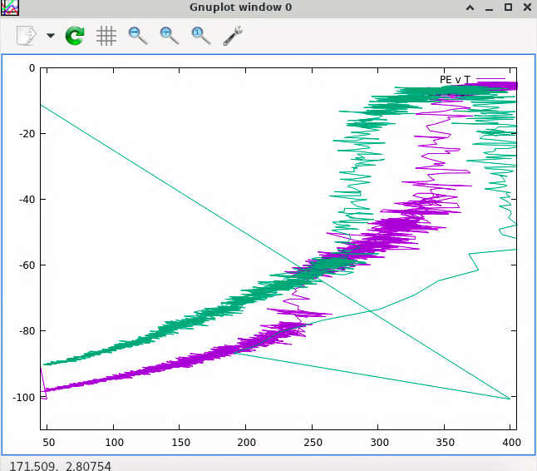
  + explanation
  + honestly no idea
    - hysteresis decreases slower as the gap shrinks
    - litearlly heated it faster
    - very long time for coolig
* Hystersis plot 2
  + 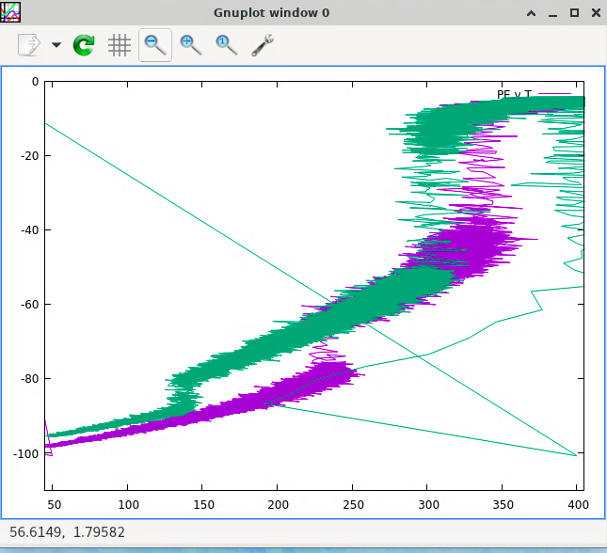
* Questions
  + Why does the hysteresis happen at all?
    - Supercooling effect
  + Comparison and difference?
    - Cool
    - Increasing time makes super cooling not happen
    - As we get longer time, the decrease in hysteresis gets slower
    - As the gap gets smaller, so the thing is more accurate and so yes get closer to actual value, it is harder, which would make sense if exponential like with the cooling thing, but anyways how does that work?
      * **So this exponential thing**
      * **Why for gas is better?**
      * **And then forward (superheating?)**
    - How does it work on the way forward?
      * Reverse effect of nucleation, like breaking the crystal at multiple pointS?
  + Free energy barriers (diff or just generally)
    - Only thing left
    - Problem sets
* So the new questions are:
  + Apparently better way for boiling points is through free energy math calculation?
  + Nucleation related to entropy? – why not immediately it can’t? or I thought melting boiling was at a specific entropy thing?
    - Well the actual question is how does the plot tell me about free energy barriers? **And more on this**
  + **So I guess the thermo of a phase transition – free energy specifically – and then also lilke at a specific pressure these change, also reflects how conditions like pressure and temperature changes thermodynamic situation?**
    - How does P change this?
* Delta function on the g(r) thing

**Definitely think the weird stuff was just weird stuff, go back and fix canonical before meet tomorrow**

* **Free energy**
* **Free energy for hysteresis**
  + **Other things on hysteresis**
* **Problem sets**
* **Some other things**

For now:

* Questions above that haven’t been answered and are most immediate
  + And what else?
  + Mostly just above things
* All of the thinking today, above (questions and everything, questions? Like more but also everything)
* **Maxwell Boltzmann distribution on gnuplot, and making histogram better**
* Problem set 3

So either stats or this last thing, either way should prob go home? Or no idk?

If tired, think through, weak?

Think through later if possible with more depth

With everything make sense

Will time help or no?

Maybe, to think?

## Problem Set 3 (CHEM 7530) Question 1

* NH function again?

lammps

* Fix nose?