LAMMPS files simulating the adsorption of oleylamine ligands on the surface of a single nanoparticle

mpirun -np 8 ./lmp_mpi < in.NP

* run these simulations on a CHPC cluster, using 8, 12, or 18 CPUs for each run. (Above, I have used 8.)
  + how to modify the command above such that it works on the cluster, and how to submit such jobs on the cluster.

The simulation starts with a bunch of free ligands in solution and a single NP in the middle of the simulation box. Ligands will adsorb to the surface of the nanoparticle as the simulation proceeds and if you run it long enough, equilibrium will settle in and the number of ligands on the surface will become constant on average.

* determine the number of adsorbed ligands in equilibrium. This will depend strongly on the binding energy of ligands with the nanoparticle surface, which is a parameter of the simulation (called E_bind). You will need to systematically vary this number from, say, 2 kcal/mol to 20 kcal/mol and determine the number of adsorbed ligands for each binding strength.
* you can repeat the whole thing for different NP sizes, say 3, 5 and 7 nm diameters. Let me and/or Will know if anything is unclear or if you have any questions!

**Will need to finish up with lj_2 before really start, right now just doing some of the busy work essentially**.



Notes on in.NP:

* ‘solvent’ variable: does this just affect scaling of ligand attraction?
  + Other interactions between other particles
  + Does this affect the LV thermostat? (which is supposed to be modeling a solvent interacting with the particles, and friction)
* real units
* molecular atom style: stores data on bonds, angles (bond angles?), dihedrals (?), impropers (?)
* 4 atom types, 2 bond types, 1 angle type, 2 bonds per atom, 1 angle per atom, 3 special neighbors per atom
  + what are angles and special neighbors?
  + Angle appears to be the potential from bending angles?
  + So molecular atom_style dictates that we store angle data for each atom, so each atom has one angle? (what about atoms on the ends of the chain?)
  + Atom types: NP, carbon in the oleylamine, amine group, ?
* A molecule template file is used to define a molecule template for oleylamine:
  + MARTINI model ?
  + 5 atoms, 4 bonds, 3 angles (in each molecule)
  + Coords – 5 atoms are in a straight line, 4.7 units apart
  + Types – the first atom is type 2 (amine+ethane), rest are all one type (4 carbons)
    - 2=amine+ethane, 1=4-carbon for the rest of the program I think
  + Bonds – all the same bond, in between all
  + Angles – also all the same angles
  + **So this defines oleylamine, to be used in the rest of the file (IDs conserved**)
  + Where is the double bond bend?
* ‘mass’ sets the mass, physically significant
  + shouldn’t it be closer to 56? For the 4-carbon
  + and shouldn’t amine + ethyl be smaller?
  + Neither 3 or 4 are referenced in ligand.mol, which makes sense
  + What are the codes?
* create_atoms – conserves atom types, starts oley at random positions. First time we draw in mol file. Why random seed necessary here?
  + For order, we see we first say using create_box what we have, then both mol file and mass commands just give info, then create_atoms references it all?
  + I think type is assigned.
  + This does not create the NP…?
* pair_style is lj/expand (since oley/au different size)
  + Only one pair_style allowed?
  + So shift gives 0 at cutoff of 12?
  + Using /expand we use a Delta which fixes the math?
  + And thus for oley-oley: the pair_coeff 11 is for carbon-carbon (dispersion), 22 is for amine amine (HB), and 12 is for carbon-amine (dispersion). Why is 11 so high?
    - The solvent variable is used here, makes sense so with a strong solvent (small s) we decrease these interactions
    - Epsilon, and then sigma/Delta/cutoff are all same, Delta is 0 here obv since they’re the same size. Epsilon is well depth, how strong, which kind of makes sense, sigma is vdW radius.
    - Why is sigma the same? Beads? Ig the beads are the same mass also?
  + No solvent-oley since we don’t have solvent?
  + For Au:
    - Ignore the 34
    - 14: **solvent does not affect ligand-NP interaction**, this is stronger than oley-oley interaction, they can get closer, I guess balls on balls vs balls on stick?, okay yes and Delta is dependent on NP size, and also same cutoff
    - 44 is very similar why do we have a shift for this? Both are dispersion, so epsilon makes sense, but how did these sigma come about?
    - 24: this is very strong, why is this so much stronger than HB of NH? Is there even HB? Is it just dipole-dipole? How did this number get here?
      * Also distance is same for all gold particles, same shift.
      * The sigma is a bit weird: so for martini martini we have all same which is fine, and Au-Au being the same would also be fine, but why is Au-Martini the same as Au-Au?
  + Do these values for epsilon/sigma have physical meaning?
* bond_style: harmonic
  + ?
  + Defines the coefficients of K, which is how strong the bond is, and r0 which is equil distance. For us it is c1-c1, also n6d-c1 and n6d-n6d?
  + Bond style 2 is not used in this one I think
* angle_style is cosine/squared
  + ?
  + Defines the energy and equilibrium angle (180 for us)
* Special_bonds
  + Has something to do with special neighbors?
  + So I think this is for the lj between bonded atoms?
* group
  + just for clean (so amine/ethyl + 4 carbon)

Equilibration section:

* Uses a langevin thermostat, which review lj_2 but uses solvent particles, damp is 1000 which is pretty high (low viscosity, which makes sense since it’s a good solvent)
* nve/limit – in essence it seems to be the thermostat and makes sure there’s no overlap
  + the doc seems to focus more on explosions rather than overlap?
  + Interaction with neighborS?
  + Pressures still large?
  + Big issue, need to read more into this
* Important simulation parameters:
  + 30 femtoseconds per step
  + Every 5000 timesteps output thermo, dump on 5000 and 10000 (and 0?)
    - Shouldn’t it be dumping more often for the lammpstrj?
  + Run 10,000 timesteps, then 5,000,000 timesteps
    - 1.5 E -7 seconds total
    - 10E3 total dumps for vmd/thermo
  + What is per-atom lines?

Last part:

* Commands that need to look over
  + unfix, undump, region center sphere box, delete_atoms, create_atoms
* The situation?
  + So it appears we first get the ligands together and then start that and run for a little, that is just to get things started (oh get them in equilibrium)
  + Then chuck in the NP and see what happens…
  + Stop dumping for the other thing (why don’t we use dump 1 again?)
  + thermo still happens
  + give a new dump, and then run for 5,000,000
* Look over command, otherwise should be fine
* Better understanding of this equilibriation situation and lammps

Solvent?

* Is pair_coeff always in order?
* Physical meaning of epsilon and energy units?
* First run: 2, 4, 6, 8, 10, 12, 14, 16, 18, 20
* Using lammps.slurm to do this?
  + Why is there an output script?
  + Is ntasks number of cpus?
  + Number of nodes is 1?
  + Working directory?
  + Remove old ones?
  + Run it I think makes sense, why need to rename the in and out?
  + HOW SHOULD I RUN THIS?
  + Output? Name?

Is the working directory simply ‘where’ the linux commands are executed (i.e. when I have command line the [u1276798@kingspeak26:oley_au]$ directory) or something else? And disregarding the last question, is the main significance of the working directory where the input file is read from and where the output is sent to?

I ask because right now I have one main folder for the oleylamine-NP simulations, and within this I have a directory for each binding energy. Right now I am creating a copy of the slurm file each time

Is the output file just the one thing and the one thing?

Does the script self destruct

The lammps output does that just go in the working directory?

Is it working?

Kind of got interrupted – just make sure you get this slurm thing, and then think through to make sure everything is running the best that it can be

Then also starting would be good

Otherwise just finish this first run situation, finish understanding the script, then go from there? AGH

5/12 meeting:

* Textmate download
* For equilibrium, mass doesn’t matter (only for kinetics)
  + Masses only affect the distribution of speeds, not position
* By making the mass smaller – increases kinetics of the
* For ligands we care about dynamics with solvent, thus the realistic masses
* Ratio of ligand to np is important, size and mass link?
* Oleylamine is a weak ligand
  + Nitrogen is negative
  + Read papers on amine-gold interacton
  + MARTINI – defined by them these numbers of the epsilon for ligand ligand interaction
  + Ligang-ligand are maritini
* Lj expand – wall shifted right, think about the well size
  + Point about last variables
* A lot of the numbers ma ynot matter
* 0.2-0.5-1, 0.5 is where we start to get aggregation
* Amine is classified as an acceptor, not the donator (nitrogen not electronegative enough)
* Bond style and angle style is from MARTINI
* Special bond is from MARTINI
* Special neighbor
  + For us lj 0 for 12, yes for 13, 14
* vdW and other
* MARTINI does not do NP ligand, ligang ligand what does MARTINI do?
  + Last part
  + Solvent is also us

5/17 update:

* Personally/mentally destroyed today so will not be able to really start the way I want to, that start will be a different day.
* Today is just limbo again.
* Reading through, mostly done
* Now starting to run the simulations for 2 through 20, just organization at this point.
  + Brainless, need to start actually figuring out what is happening next time, this is intentionally brainless
* For now just run, don’t worry about counting ligands yet

5/18

* Running everything
* If have time, message Will
* Message gc with update

Also there’s gotta be a faster way to do this with just the one energy

Tomorrow with brain ask Will question, for now you can ask a quick one

Update:

I’ve run all the simulations (for 2-20 binding energy), and am currently figuring out how to count the number of ligands effectively (I attached a screenshot where I isolated all of the amine groups attached to the Au NP at E_bind=10). I don’t think a meeting this week would be particularly helpful (I just need to work more), but next week may be.

Btw, Will the slurm file worked well, I have a few questions but I’ll send those tomorrow.

5/19

* Getting my count on
* Organization makes no sense right now, for now so tired just get
* VDW, count, and Will message sent is the goal.

VDW:

* So I think the automatic radius is just randomly assigned…? (just the van der Waals radius assigned by computer to type of atom)
* So the idea is set the radius for all atoms to be 0.5 angstroms, so if I multiple this by some number say x (scale it), then the resulting atom will have diameter x (and radius 0.5x).
* Still a bit confused, especially by the lj expand situation, but oh well.

Count:

* So NP diameter is 50, that is in the code
  + Lj expand stil confuses me, I really need more time
  + For now **assume** **diameter of NP is 50** (this is good assumption)
  + And then **diameter of amine is** PROBABLY **5.0**, I think 4.7 is the sigma which is slightly smaller than VDW. Well actually is VDW just sigma over 2?
  + Maybe, but I think in this case either way VDW is kind of meaningless, it is just the diameter, which for us should be 5.0.
* Two ways:
  + Way 1, use the compute coord/atom command
    - This group id stuff has got to be wrong, since I already have the type thing?
    - typeN thing?
  + Way 2, use vmd
    - **How to have vmd constantly update? (frame value?)**
    - Ok this is weird, there is only 578 of type 2 (amines) but there is 2312 of type 1 (four carbon), well actually this is consistent, but where did the ligands go?
    - Ok this works:
    - So atomselect 0 “type 2 and within 28 of type 4” will give the number
    - Need to figure out how to update this number

And is slurm file ok? Honestly I think it is

It was just a few small things, maybe question tomorrow?

Coordination number via vmd

Count via Way 2:

* Not sure if it is 50 and 5.0, but if so 27.5 would make sense, not sure why before I thought it was this, I had a reason in my head for why it should work like this?
* Appears to be only 1 shell…

|  |  |
| --- | --- |
| Binding Energy (kcal/mol) | Equilibrium coordination number |
| 2 | 17 |
| 4 | 102 |
| 6 | 210 |
| 8 | 292 |
| 10 | 334 |
| 12 | 362 |
| 14 | 387 |
| 16 | 394 |
| 18 | 391 |
| 20 | 402 |

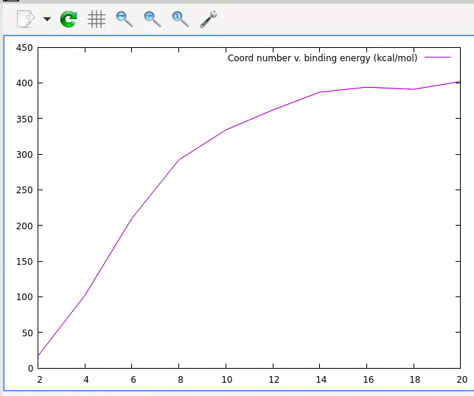

use g(r)

* Fit it using a Langmuir isotherm
* Rewrite simulation so the # of particles is a constant
* To get the average:
  + Potential energy to find the equilibrium point
  + Then use coord/atom to find the average past this point
  + (can also plot coord/atom to make sure it is approximately aligned with equilibrium point)
* change solvent quality to see second shell
* change ligand number

5/30/23

read papers on something? Langmuir isotherm?, coord energy vs binding energy?

Or something else

Something else also in my head?

Finishing for tonight:

* Ran everything with the new simulation (NP first) and a good dump file for coordination number (maybe should have dumped more?)
* Next time need to
  + Get the average for coord vs ebind
  + Figure out how want to analyze ligand number and solvent quality
  + Fit using Langmuir isotherm
  + Look ahead, work better
* Analysis tomorrow, done for now

Getting the average via coord/atom:

* Must remember which numbers are made up and which ones are MARTINI to determine like the ligands radii for the cor_del num…
* Mostly just a bunch of weird like performance stuff, everything real seems chill?
  + The only question is if you defined the region correctly (is the simulation box implied since I only explicitly say outside of this sphere, not within the box)
    - Is 28 a good number for coordination number? CHECK 2 AND 4
  + Some of the weird stuff: slurm file stopped working, original file the compute won’t work even though in vmd everything looks good (well the actual new file looks like the old one and the number is also constant, just this weird compute file not working which is so weird)
  + Ok so this got fixed (I just defined group in the wrong place, but now something else is broken – if it is deterministic, why does it give me diff numbers?)
    - Ok so this happened once, no idea wy, you got like 182 at the end which was weird, now it is fine, so we are chilling
  + Now it is just about fixing the slurm file…
* Runs that need to be done
  + Comparison between modified and original NP/ligand placement order:
    - Make sure everything is consistent, except the modified should stay at 600 ligands but original changes
  + Change binding energy and see effect on coordination number (averaging coordination number after second equil reached)
  + Change ligand number at constant BE and see how this changes coordination number
  + Change solvent quality at constant BE and ligand # to see different shells form

DID YOU RUN WITH THE WRONG NODE WHAT HAPPENED?

Bash profile

* ALIASES ARE A THING

alias w cd '/uufs/chpc.utah.edu/common/home/gruenwald-group4/Michael’

alias w5 cd '/uufs/chpc.utah.edu/common/home/gruenwald-group5/Michael'

alias scratch cd '/scratch/local/u0936637'

alias si 'sinfo -o "%20P %5D %14F %8z %10m %11l %16f %N"'

alias q 'squeue -u ${USER} -o "%16i %50j %8T %1D %4C %10M %10L" -S +i'

alias sj 'scontrol show job'

alias kinD 'salloc --time=8:00:00 --ntasks=24 --nodes=1 --mem=6GB --account=gruenwald-kp --partition=gruenwald-kp'

alias df1 'df /uufs/chpc.utah.edu/common/home/gruenwald-group1'

alias df2 'df /uufs/chpc.utah.edu/common/home/gruenwald-group2'

alias df3 'df /uufs/chpc.utah.edu/common/home/gruenwald-group3'

alias df4 'df /uufs/chpc.utah.edu/common/home/gruenwald-group4'

alias df5 'df /uufs/chpc.utah.edu/common/home/gruenwald-group5'

alias df6 'df /uufs/chpc.utah.edu/common/home/gruenwald-group6'

alias qa 'squeue | grep "gruenwald"'

alias group1 cd /uufs/chpc.utah.edu/common/home/gruenwald-group/

alias group2 cd /uufs/chpc.utah.edu/common/home/gruenwald-group2/

alias group3 cd /uufs/chpc.utah.edu/common/home/gruenwald-group3/

alias group4 cd /uufs/chpc.utah.edu/common/home/gruenwald-group4/

alias group5 cd /uufs/chpc.utah.edu/common/home/gruenwald-group5/

alias group6 cd /uufs/chpc.utah.edu/common/home/gruenwald-group6/

alias notD 'salloc -t 5:00:00 -n 4 -N 1 -A Notchpeak-shared-short -p notchpeak-shared-short'

alias amber 'module load gcc/8.5.0 intel-oneapi-mpi/2021.4.0 amber/20.20'

alias lammps ‘module load gcc/8.5.0 openmpi/4.1.4 lammps/20220623’

Using 28 as my num? Was a chill num, maybe should think of a more precise number?

It seems relatively chill, I think maybe 29?

USE g(r)

* Two big issues: couldn’t get multiple frames, couldn’t get earlier frames
* 20
  + 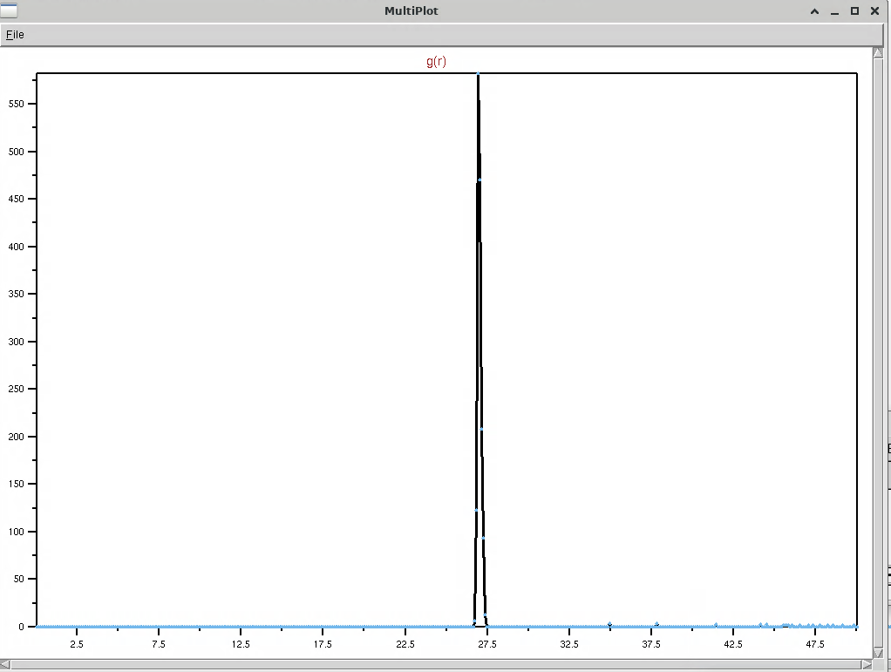
* 14
  + 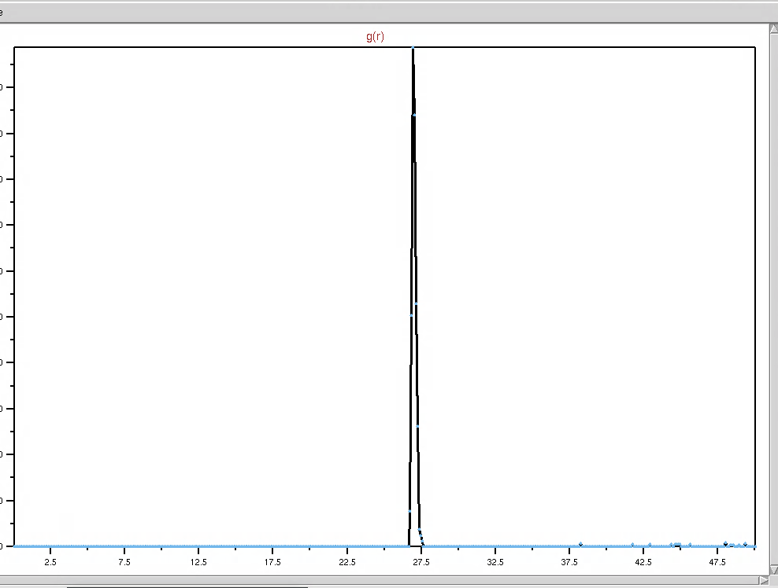
* 6
  + 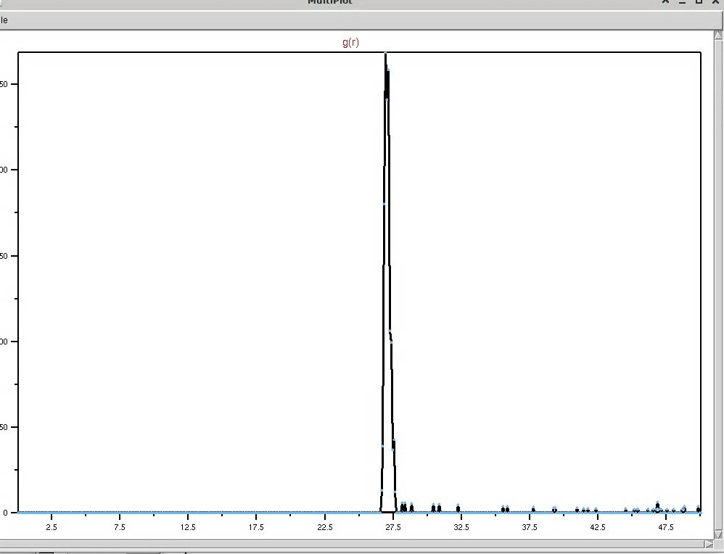

28 is actually a very good number to use here

it’s between the correct peaks

SHOOT forgot to do 2 or 4?

Selecting a constant BE, ligand number, and solvent as you change stuff:

* For changing ligand number:
  + Let’s just do 8, so we can expect it to saturate but then still has a lot to go down
  + And let’s go
    - 100 200 300 400 500 600 700 800 900 1000 1100
* For changing solvent:
  + Same deal for binding energy, and keep the original amount of ligands
  + 0 0.1 0.2 0.3 0.4 0.5 0.6 0.7 0.8 0.9 1.0
* s

5/31

* Sims did not run
  + Ebind is almost done right now, just 20 left. Can probably delete ebind.
  + Compare will run on compare., so will lig_num.
  + Probably just have run s run on s
* Now for the actually hard part, analusis

Coordination number vs. binding energy:

* Plan is this: (for BE = 8 kcal/mol)
  + Find the point at which second equilibrium happens (time step)
  + From this time step, get the average of the coordination number and the 1 sigma and 2 sigma error bars
* Repeat this for all BE

Vmd:

* Using 6 for sphere scale since that is the shell?
* Or actually maybe do 5 or 4.7?
  + What is correct sphere scale according to the code?
  + For now use 4.7 since that is diatomic
* Is there a way to constantly update the number in a particular section in vmd? Like maybe frames option? But like the selection is updated?

Vmd seems pretty chill

What even is thermos is it just a dump?

Now lets pull this into python:

* Big issue: where is PE?

Okay, have to take a break to watch this meeting, kind of, at this point just getting into the technique of Python but have not started thinking yet

* The total energy: The weird thermostat thing how does this work again?
  + Agh

Check if original and modified is approximately equal:

* They appear to be pretty similar in vmd, one runs faster which is weird
* Ligand number also similar at least for this BE

They look relatively similar, will assume is good

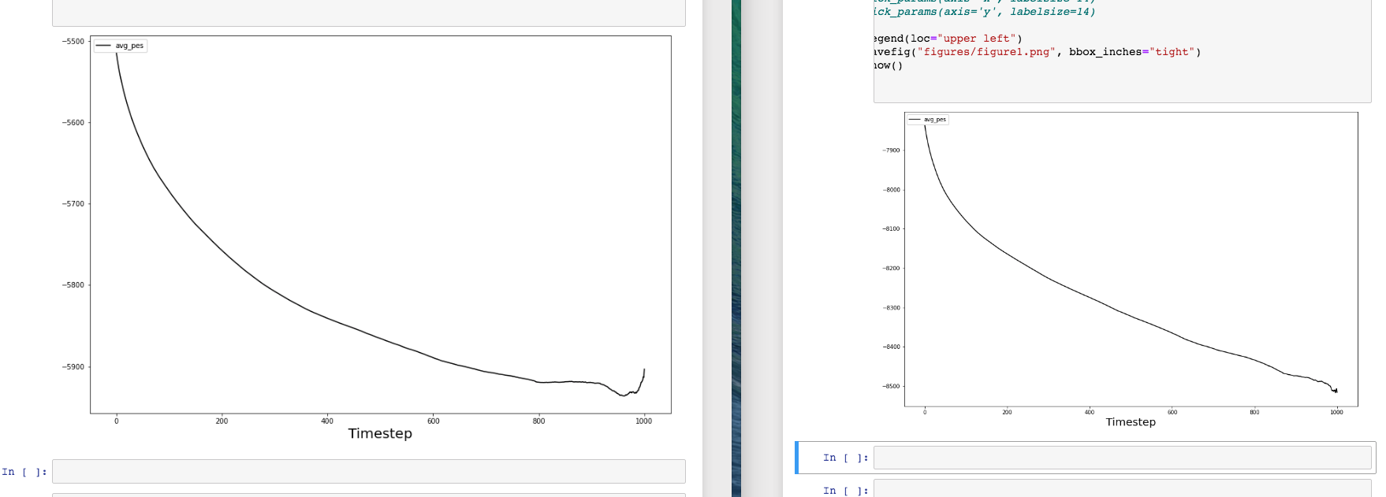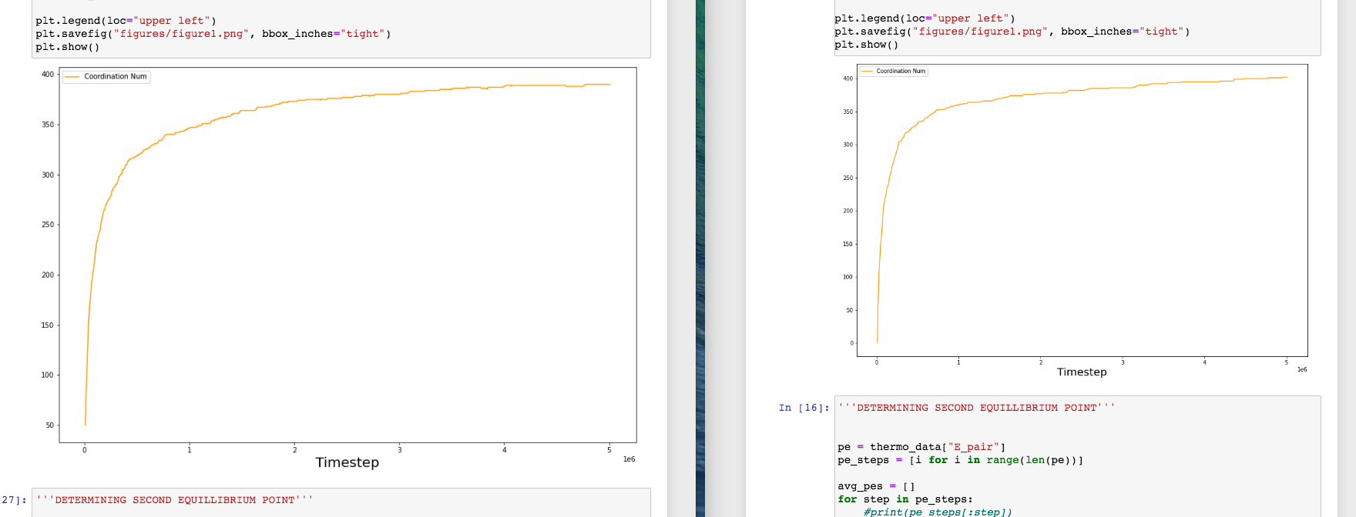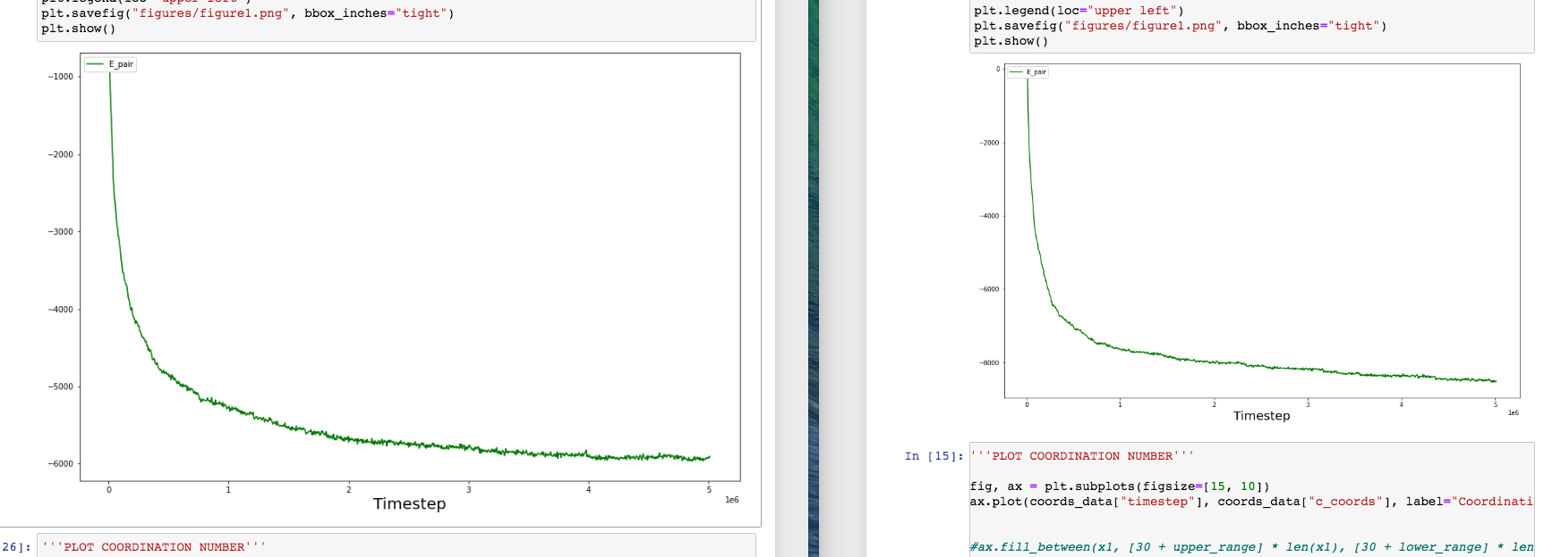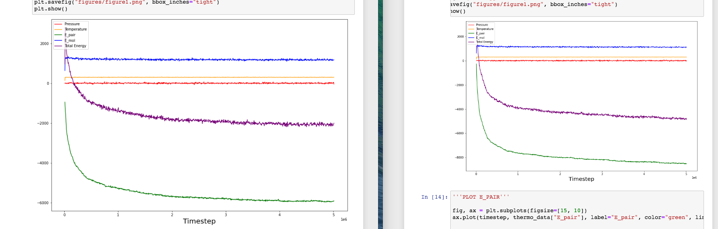

left is modified, original is right

Here is the plan:

* For ligand number, will also just be doing the same plots
  + Will also look at vmd to see if there’s anything weird, especially at large ligand number
* For s, will not really touch, only thing will be looking for is multiple shells, which will wait to see for that

So for ligand number and ebind:

* For each run, want to find the average coordination number after second eq, and the standard deviation
* This requires manually finding the eq point
* My method may be flawed, not sure

For ebind, will check for 14 and above if more time is needed, probably will be. Then run essentially the exact same thing, and then it is just about getting the data

For ligand number, need to do from scratch

* Look at vmd
* Look at radial distributions
* Make sure everything in the code is running well
* Get the data

Could fit a normal distribution curve?

6/4

* Head is lightheaded cuz of bathroom chemicals

Observations for ebind:

* I think that I need to do longer for 16-20, it will look like there is an eq at the end but this doesn’t seem trustworthy…?
* Bit lazy, this is bad
* 14 looked really good, not sure if because more stuff or something else
* things like why the normal distribution will look fine for 16 even though I know it hasn’t reached equilibrium yet
* For ebind it would be good to explain your methods and general notes
* I mean the
* Idk
* On both the 5 mil and 25 mil, it looked like the ebind=16 was displaying some non-uniform behavior on the average graphs. The normal distribution graph also looked approx. normal for ebind=16 and 25 mil, but I take this to be misleading. It is possible that 20 mil is the real number for ebind=16, the graphs do look pretty convincing that there is a change I behavior right there and this is consistent with it – ok nvm
  + This is all bs
  + Yeah I probably captured it but I will extend it to make sure
  + The goal is to have at least half of it be eq to
* Explaining the peavg graph strange behavior?

Do 16 – 20 tomorrow morning, and then fit using Langmuir isotherm…

Then can make a bunch of plots

Give analysis

METHODS?

SOMETHINGWRONG WITH G(r)? (where is limitation)

Observations for ligand number (this is a step behind ebind, I am first looking for basic analysis, and then do the quantitative via a similar program)

VMD:

* Ligand = 200
  + The plot: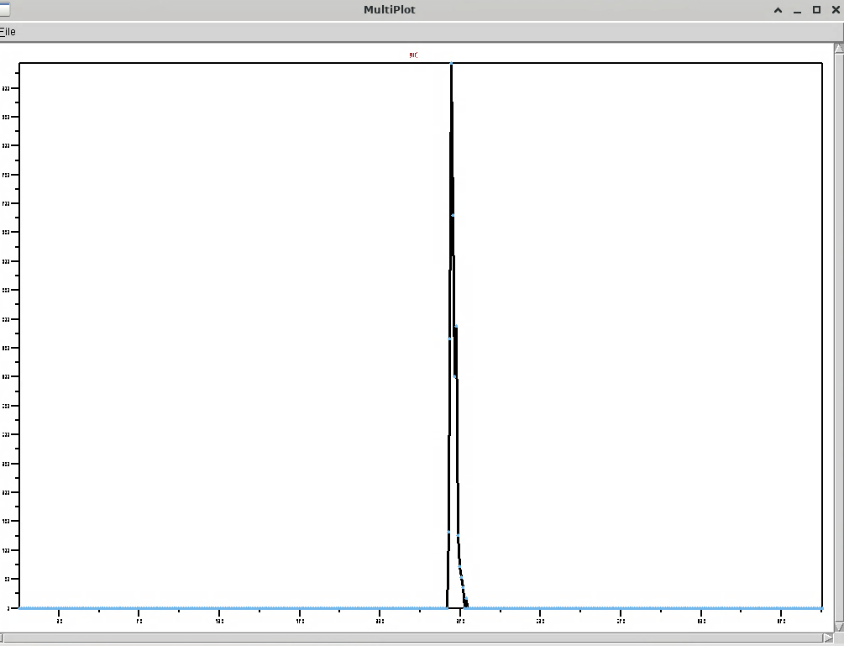
  + Looks very similar, rightmost peak is about 28.15
  + Looks like a high ebind, the lower ebind was more split
* Ligand = 1100 (is run using a different node, but should be fine (checked log.lammps))
  + The plot: 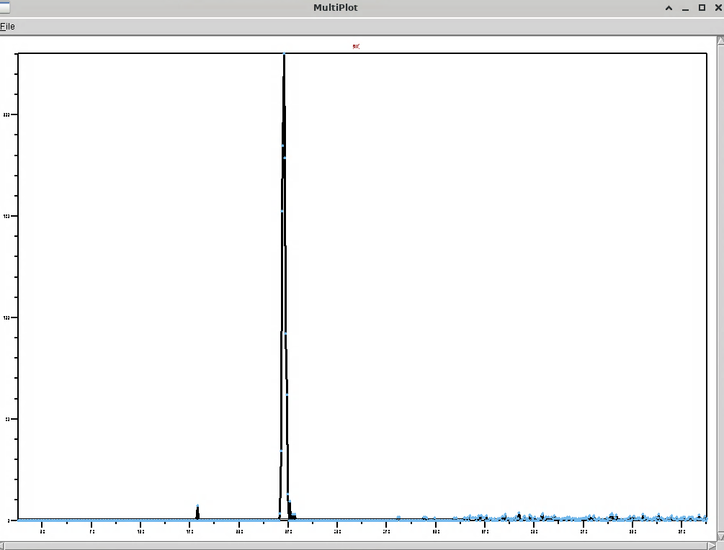
  + Looks very similar, the rightmost peak is maybe a bit higher like 28.4 ish
  + There is also a strange peak at about 19, which is very weird, lthere is also a bunch more peaks to the right which makes it look more dirty, kind of like lower ebind
* Looks like should use 29 if we count those ones was in the shell which looks like we should
  + Had to rerun everything in lig_num…lig 1 definitely reached equilibrium, so will start with that. So did lig11. They all did
* Checked out to 200, no second peak
* But now it is time to do the quantitative analysis and find coord vs ligand number

Finding eq point and then calculating avg (using python):

* Checked the reading log.lammps and coord.dmp to make sure everything is being read.
* For lig1, after the initial drop in PE there is a small increase, will take this **not** to be equilibrium, still equilibrating, will start once the real constant part starts.
  + Not sure why the **normal plot looks so bad**, could be because the eq is very stable?
  + Compare to other plots?
* Ready to take the observations, just do it
* Doing the observations
  + Very rough right now, need to be more meticulous here
* Also can do solvent at some point, at this point just waiting.
* Can read up on Langmuir isotherms…
  + Plan is this: read, then brute force just do the ligand, then need to look at s and run with correct g(r), then do ebind fully with whatever you have, ideally 18 is done but I we will see
  + Finding how long 16 took?

Not enough work today

Need to take observations down better

6/5

* Doing 16 with the 50 mil, 50 000
* Unclear whether the increase after the first max is in equilibrium or not in equilibrium. Since the end goes as high in PE, will take the first max.
* Justification for use of the PE and Coord average plots:

14 with wrong time steps:

* I think this is unfair since it will decrease st dev
* Will change it now
* Some really gross coding for 18

Get 18 by 12:30 pm, then start analysis (including using Langmuir isotherm). For now go back to ligand number.

Would be nice to figure out how to find and replace all files in a folder in linux terminal.

Notes on Langmuir, and how it can be used with ebind:

* Assumes unimolecular layer?
* Will do analysis via Langmuir fit, hurry and have time to run all lig num and also would be ideal to run s ones.

Big question is:

* What even is the goal?

Notes 6/5 meeting

* Block average rather than variable time length
* Normality of the last distribution is not a given, depending on the physics
* Sampling distribution of the mean is different than the mean
  + The points close in time may be correlated, so error bars have to be calculated in more complex ways, related to ebind

Solvent vmd notes:

* 29 is the right number
* there are not noticeable second shells in the g(r) plot, they are pretty not noticeable
* eq reached in both 1 and 10
* 10 has a very noticeable trend – there is two equilibriums
* The second shell is very much noticeable
  + 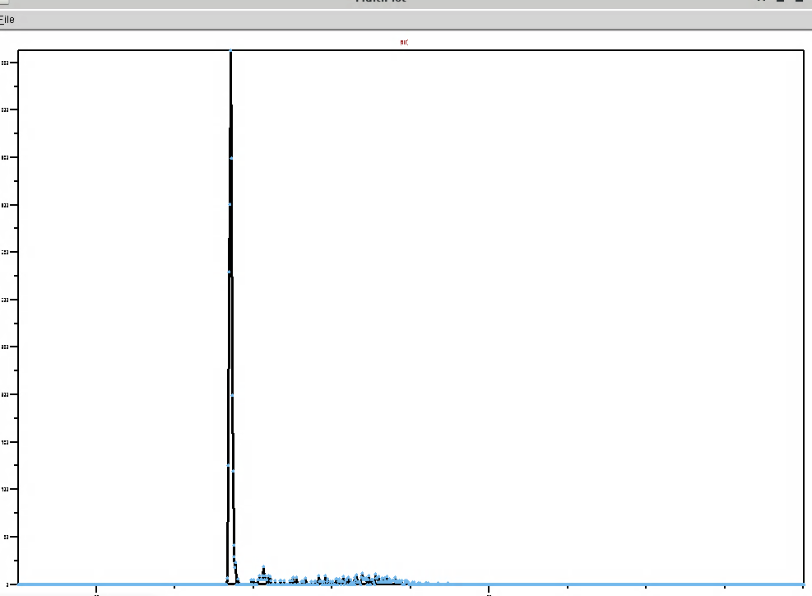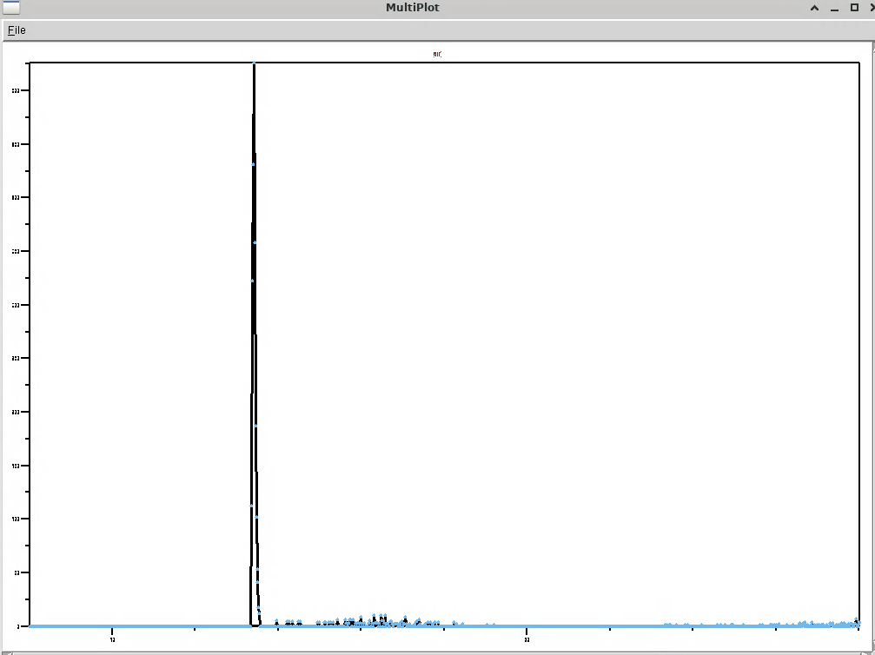

you fell asleep, not okay, will need to do more work tonight

for now just get the solvent ones done

for now, 33 seems like a good number:

* so change to make 29 and 33…
* and then go and run

going to go with 35 since on the 1 that’s where it starts, although we do kind of cutoff randomly on the s10…,

gotta be a better way to do all of these runs, whatever

ervtyhign else is same I think isnc eq is reached and whatever

and 29 was made

MAKE SURE 29 IS GOOD WITH G?

Maybe check ebind20

THINK ABOUT ERROR AND WHAT WE ARE DOING AND OTHER THIKNG?

Is the different size of time steps bad?

Okay so the new plan:

* Binding energy
  + Key qualitative observations from vmd and radial distribution function
  + Report: average coordination number after equilibrium, the distribution of coordination number after equilibrium in a .dat file, time to second equilibrium standard deviation of the distribution, if you have time the standard error of the mean
    - Would be nice to automate the determination of the second equilibrium, but need to find a way
    - Lack of time, just do it by hand
* Ligand number
  + Key qualitative observations from vmd and radial distribution function
  + Report: average coordination number after equilibrium, the distribution of coordination number after equilibrium in a .dat file, time to second equilibrium standard deviation of the distribution, if you have time the standard error of the mean

Binding Energy:

* For 2-14
  + 5 000 000 timesteps, output every 5 000

Ligand number:

* Generally it is 1 by 1, so I will first do it for 100 and then repeat the process for everyone…
* Do observations after, although did check before to make sure sims give me what I want
* Goal is to give
  + Average coord number after eq
  + Distribution of coord number after eq in .dat file
  + Time to eq
  + St dev of distribution
  + If you have time standard error of mean
* For ligand number, kind of out of time, so just for now just do this with the current method

Ligand analysis:

* For ligand = 100:
  + After the initial decrease in PE, there is a slight increase to a point that looks greater than the eq point. This is considered to be some sort of kinetics thing, so eq will start after this.
  + Eveyrthing else is chill, the normal plot looks crap but that’s cuz it’s very tight
* Ligand = 200
  + There is definitely still a negative trend, which may indicate it has not reached eq yet
  + **Inconclusive for now, see other, may need to run longer**
* Ligand = 300
  + The graph oscilates kind of a lot, but there is no clear negative trend or positive trend
  + There is a farther decreasing trend it appears, and then it switches to oscillations around an average. ..there is alost just like 100 a trend where we go back up a little in PE
  + My reasoning is the pre and post last increase in PE could equally be eq oscillations or reaching eq, I will take it to be eq oscillatons since if we do it makes sense since the pre jump is in line with eq stuff
  + Need better analysis on the rest
* Ligand = 400
  + Also has an increasing trend

They all seem to be shaking a lot, and there are weird trends, thus I am running everything at 25 mil to see what they show

Once I finish this investigation, I need to focus

The question on my mind is:

* How do I determine the 2nd eq point consistently for these ligand number simulations?
  + I could just use what I am currently doing with some more work and investigation
  + Or create new method, preferably more automated.

This is so weird – for lig = 100, it seems to reach equilibrium very quickly, but then for lig = 200, it seems to take longer than 25 mil…

I think the r^2 is good – this is the proportion of variability from the mean that is accounted for by the line. So if it is high a line of non zero slope does a good job explaining the variation, which indicates it is time correlated, while a low one indicates the mean does a good job, i.e. it is no longer changing with respect to time.

Criteria for equilibrium being reached:

*I’m having a lot of trouble figuring this out, I am restarting. You absolutely have to do this. I am restarting by doing it 1 by 1.*

* For Ligand = 100
  + The initial increase is similar to many other increases seen later. Thus although it is possible that it is not part of equilibrium, it is indistinguishable in any case.
  + I want to find the initial minimum – even if it’s not exact (it could be **lower** or higher than the real eq point), it makes sure it is not too high which is good since the PE originally comes from a high place, so we are sure we are out of the initial equilibration phase.
  + The normal graph would be concerning since all the 97s are early, which indicates that we are too early and the actual is higher and this shouldbe excluded, but looking at the longer graph shows this is wrong.
    - Saturated? So taking one out and putting one in – or in this case it is 100
  + The output is all contained in the out file, and I added the key figures to the results file
* For Ligand = 200
  + **Run longer**
  + First 1 is fine, but 2 and 3 are heavy one sided. At 25 il 1 is fine again, but 2 and 3 are again not great, but they are heavy other side. So can conclude eq reached. **Run longer to chec to make sure this initial pattern is not continued**.
  + Second first min should be safe, it goes up but then it def goes down, def feasible overall, -- the whole point is to choose a spot which could be it in that the equilibru mixture reaches it, i.e. it is not outside of the range of the equil, but that is redundant, def could be assuming above is true then it def could be a part of it
* For Ligand = 300
  + First: it is clear that we have reached equilibrium since: 1 inspection of PE/coord plot, 2 the average coord is stabilizing, 3 r shows that neither positive or negative is favored
  + Second: the point is that it is *feasible* that this is where eq started, i.e. when comparing this point and the equilibrium section they are similar, there is no clear trend afterwards, i.e. you see the clear trend and when it ends. In this case there is a clear downwards trend, no clear upwards, so I do the min – I know for sure this is the end of the trend. It may be too far in the down direction, but we know we are out of the equilibriation phase (it does go down a lot farther which could mean it is not yet equilibrated, but it goes up which also could be a trend, but I will say more likely is simply in equilibrium)
    - Normal looks approx.. good
* Ligand = 400
  + First: not comfortable equilibrium has been reached, we have a long downwards but then a consistent upwards. 1 may be barely passed but there is a positive thrend, average coord is not stabilizing (it is continuing to decrease), and 3 we have a clear trend in the r values, thus moving to long distance. The longer shows us we are in fact in equilibrium, 1, 2, and 3 are all passed.
  + Second: same reasoning, we do the first min. Principle of *end of first trend*, assuming the trends afterwards are all equilibrium fluctuations, I want the end of the first trend, which I take to be the downward scoop. **It is possible the actual first trend (pre equi) includes the upwards motion like a spoon (and thus my average includes stuff which is too low, bringing it down), but even if I am wrong it goes down there later anyways**.
    - Normal looks approx.. good
* Ligand = 500
  + First: 1, 2, 3 all look good, so eq is reached
  + Second: there is def an initial positive trend, but for the same reasoning as above I will use the first min and take this first trend to be part of eq.
* Ligand = 600
  + First 1, 2, and 3 all don’t look good because of a clear positive trend in PE, using longer. This positive is over balanced by a negative, take this all to be eq.
    - Feasible that it keeps going, **run longer to check**
  + Second use the same principle as above, the min of the first decrease
* Ligand = 700
  + First 1 there is some slight concern about a negative and then positive, but not really 2 shows it is stabilizing and 3 confirms
  + Second is an issue, the end makes it seem like first min may not be actual min, we never return to that high, first min could be much later, longer would be nice – rest shows it is bs, we do return to that high, safe to use the first min (before the first downward trend)
    - So the general process is: 1 if it goes up after the first min, take the first min, check to make sure it does go down that far again. 2 if it goes down after the first min, check to make sure it goes back up at some point. (so it is feasible, and number okay).
* Ligand = 800
  + First 1 is okay, 3 is fine, 2 shows it may have an increasing trend, would like the rest **long run wanted**
  + **Assume that the trend will be reversed, and the first min will be returned to**
  + Using the first min, it def gets up
* Ligand = 900
  + **Both runs needed**
* Ligand = 1000
  + **Long run wanted** – same deal as 800
  + First 1 Maybe a slight increase, 2 maybe a slight increase,
* Ligand = 1100
  + First 1 looks good (no clear trends) 2 also looks good no clear trends 3 alos looks good no clear favor
  + Second assume the min min is not part of equilibration, **check longer to make sure the min at 1.2 E 6 is reached again** , instead use the first min, same logic, principle of very first min (not second min)

Runs needed/wanted:

* 900, runs at 5 and 25 mil needed
* 1000, run at 25 mil needed
* 800, run at 25 mil
  + Check to see if PE trend decrease continues, make sure the first min is returned to
* 600 at 50 mil
  + Check to see if PE decreasing trend continues
* 200 at 75 mil
  + Check to see that PE clear trend is just oscillations and r graph is calmed

Need to delete old runs and the 2 mil run

Need to write for ligand the 29 detail

And other things, all write down

Got distracted, but the issue is still not a great way to find the second eq?

If we are in equilibrium, then with a large enough interval the average will change only a small amount across all different intervals. To make this ‘small’ amount make more sense, take it relative to the size of these averages.

* No clear directional favor by r – if r is equally likely to be positive or negative, this indicates
  + Obviously the block width must be wider than the small fluctuations, these are meaningless
  + There may also be major fluctuations on the order of the general trend – that is, assuming eq has not been reached and there is some trend, there may be brief periods where the overall trend is reversed – really we should have an interval which is larger than these fluctuations, or be able to recognize if the correlation is briefly reversed this doesn’t matter.

Selection of precise equilibrium point:

By the end of today you *need* to have a method to determine precise equilibrium point for ligand number and binding energy, and preferably have the busy work done (all of the quant data you want to produce, also the qual observations) and emailed.

Before this you should figure out slurm: how to do time limit, how to cancel jobs, how to restart jobs

And then tomorrow you can do solvent, and hopefully you can move on to the next section after this. Ideally you do that meeting sometime tomorrow. It also requires that you think through this – have you completed everything you want to do with these NP sims? I guess this type of thinking and the literature stuff happens tomorrow

Today your only goal which is very much achieveable is

1 determine 2nd eq point

2 do the work for lig and ebind

3 slurm

all you can do now is work

for bem how did that one time step work?

Binding energy:

* Taking for granted all of the work I did to say that 2-12 are good with 5mil, 14 needs
* In fact taking granted all of the work period, at this point simply running to get out files, and checking to make sure the spots are the same, nvm not even checking spots

Obs

* Ebind 2
  + Why is this not a negative change for PE at beginning?
* Checked ebind 14 – seemed chill enough (maybe want to run at 50 or 75 mil)
  + Make sure it goes up and this trend stops
* Same for 16 – would want to check to make sure, at least appears is fine (okay?)
  + Expect PE to go up, or else may be way wrong
* To do 18
  + Same as 14 and 16, I want to run longer for sure, not sure if equilibrium is reached at all

Need to:

* lig9 and ebind20 gr

text when get home, the point is:

* a defined, but slow, routine to get the data. Data almost done, a few long simulations left to run, you can probably finish everything in like a few hours when the sims are done
* Observations qualitative are not done
* Solvent parameter is not really touched, may want to spend some time on that
* Lit has not been read

Plan:

* Do solvent from scratch
  + Have qual obs
* Reconsider what you want to do, esp with reading the literature and qual obs and generally what I want to do to help
  + Did kind of, but more after, but chill right now just go or what? Plan was, go back to it, can have mind

Still need to run:

* 20 at 500 mil (pr is running)
  + How to restart jobs, run on kingspeak-shared or other in myall, extend time limit (right now I am just doing preempt which sucks, or kingspeak which is slow) [missing?]
* 14 at 75, 16 at 150, 18 at 250
* 900 at 25 mil and 600 at 50 mil (still running)
* 800 and 1000 at 25 mil

Solvent Parameter s:

Qualitative Observations:

* Why don’t we use the Langevin model?
* I assume the friction terms added produce a different effect than solvent parameter – friction terms damp the simulation, i.e. the velocity is forgotten, while solvent parameter changes the forces between them.
  + So many confusing things and interesting things, what you need is complete focus to do this well. Like do this qual section well and then use that to inform the quant section. I guess the goal is to really do this qual section well, then the quant section. Then you need to reconsider all, esp literature reading but also AuNP stuff, and then the super lattice stuff, like figure out what you want to do overall very hard. Figure it all out. For now working on solvent qual obs and quant is probably fine, you want to do this in most cases, quant in most cases, but qual obs may be good to think through what I want, and this also helps quant or affects it?
  + What I want is
    - Systematic study of AuNP-NH2R interactions. I have 3 main dimensions of analysis: binding energy, solvent parameter s, and ligand number.
    - Basic qualitative observations
    - Literature informed qualitative observations, inform quant as well
    - Quantitative observations: key is average coordination number and distribution after equilibrium, and auxiliary data. This is where technical skill and good insight need to come in in order to make it quick and effective and new things like creating some sort of distribution over the reals instead of integers for coord number, things like this, you must have a line.
* Okay moving on. Above is pre. **Below is the start**.

**General notes**:

* Can’t figure out a good way to show the hc chains for certain amine groups, like grouping them as one molecule instead of two separate groups
  + Giving up on this, the big question is is there a way to get atomselects from the command ine into the representations?
  + The goal was to show okay here is the first shell of amines, and here are its carbon chains, they are going out, and then here is the second shell, its carbon charins are going in good since then if there is three shells, can see where the center shell HC chains are….
* The first min logic
  + The premise is that you have first established that equilibrium has been reached in this frame, so the question is what point to use as the starting point for equilibrium (and data for things like coord avg)
  + Be skeptical of any trend other than the typical monotonically decreasing into zero slope trend.
    - Assuming that the trend is met, choose the lowest possible point. Could exclude some high PE values, but this should be balanced later. Important to make sure we are out of the initial equilibration phase, which are high PE. Or choose the point which includes the entire trend.
    - If the trend is not met,
* I used to use the fat derivatives to tell when eq was period? When it was clear and in the middle, which never really in there??

**Start of the line**: I am looking at how solvent parameter affects the AuNP-NH2R interaction.

* Basic qualitative observations
  + General process: they quickly form clumps, and then gradually the clumps merge with the AuNP and its ligands, the final form yes is amines, ligands, amines, but more on that below.
  + For the amines:
    - There is a shell within 29 of the AuNP
    - There appears to be another peak approx 30-33 (can’t really see in vmd)
    - And a third, even flatter peak 42-51 (can’t really see in vmd)
    - 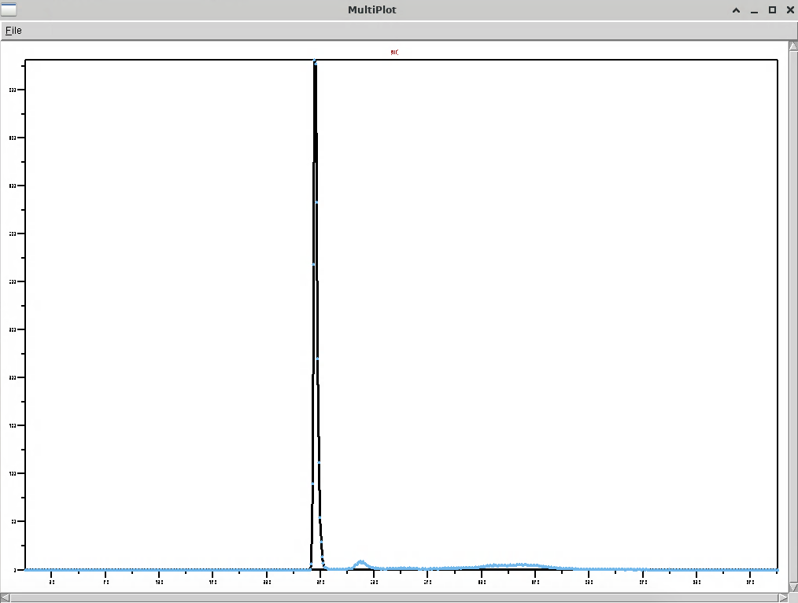
  + For the hc chains:
    - There is 4 peaks: 29 – 32.65, 32.65 – 37.25, 37.25 – 41, 41 – 52.5
    - 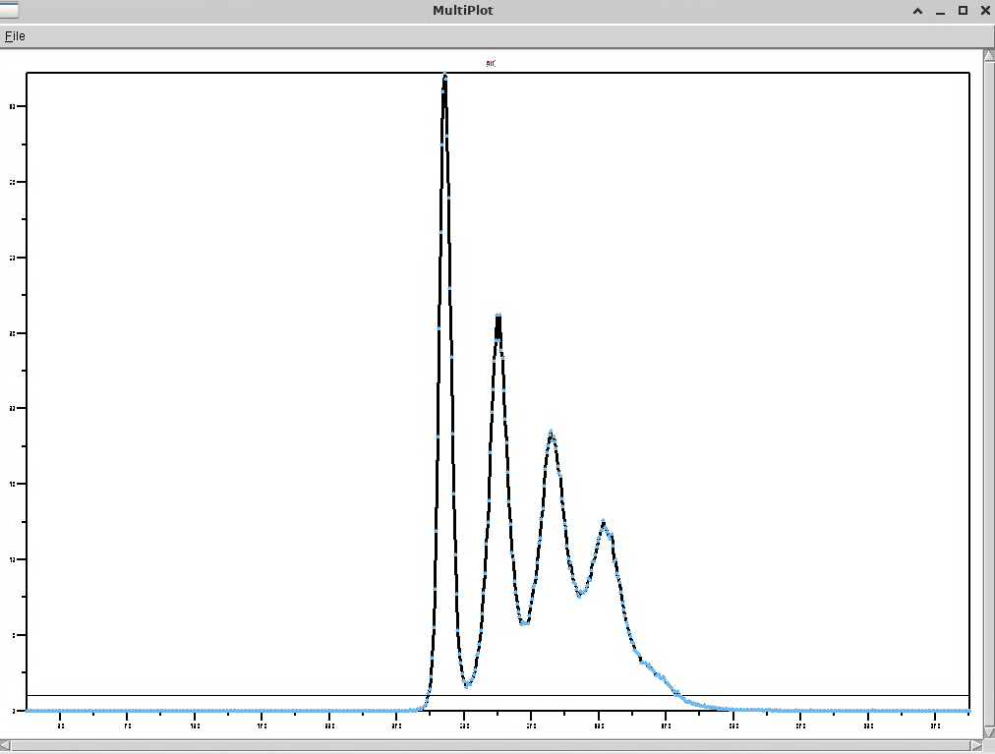
    - the ~~root mean square~~ distance between two carbon groups attached to the same chain is 4.47
  + Generally, the first shell’s HC chains are going out, while the outer shell(s) chains are going in. But if there is 3 shells it is unclear what is happening.
    - Snapshot with LIG_NUM = 600
    - 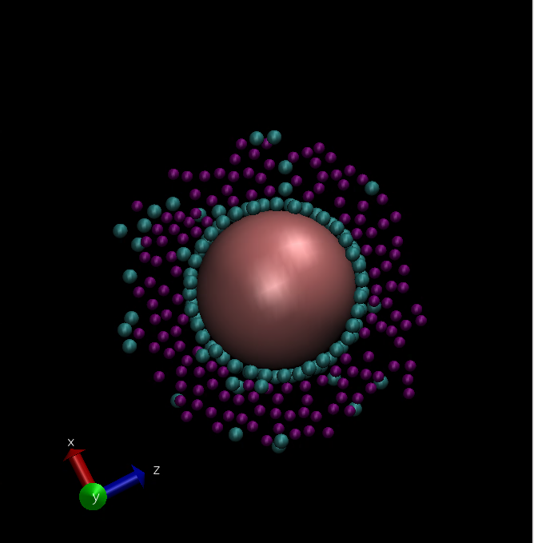
    - Snapshot with LIG_NUM = 1100
    - 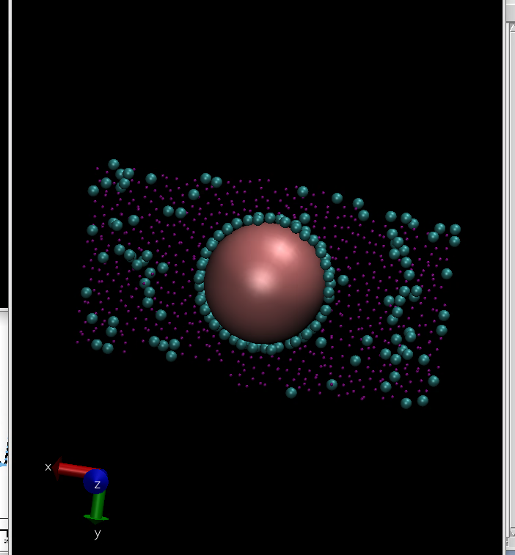
      * try weaker solvent, analogous to temperature
      * UNDERSTAND THIS, don’t get gaslit, be better
  + With higher ligand number (1100), a (**not spherically symmetric**) cylinder forms.
  + Attempting to determine the direction of the ligands in the second shell
    - Get an atom selection of the amines in the second shell
    - Get an atom selection of bonded carbons, which is just each index + 1
    - Determine which one is farther from the NP
    - Didn’t work because vmd language is hard, instead get indices of the second shell and manually do it
    - 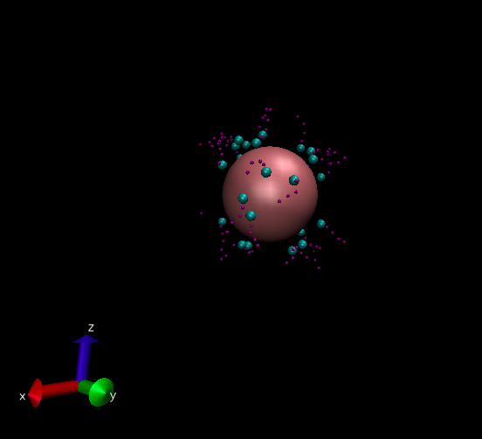
    - 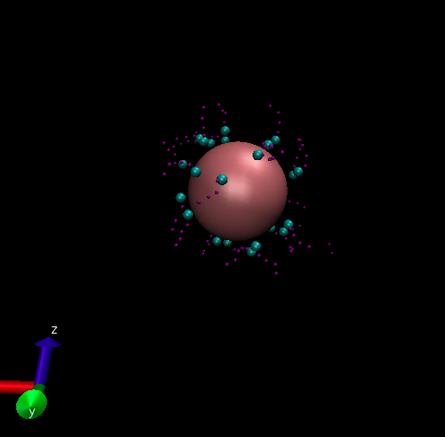
    - They point out
* Lit informed qual observations, into quant observations
* Quantitative observations
  + First analysis: basic coordination number analysis for inner shell. Finding eq, then determining average coordination number, giving the distribution, st dev, and time to equilibrium.
    - S= 0.1. first, 1 is kind of clean, 2/3 are mostly clean, possible but unlikely. Second, using the first min, it is unlikely there is a spoon pattern, **check that there is in fact no spoon pattern (later the PE dips to as low)**.
    - S=0.2. first, 1 is fine, 2 and 3 are both concerning, possible positive, check this. Second, taking the first min, again must confirm no spoon pattern. **Check there is no positive trend and no spoon pattern (PE dips back later)**.
    - S = 0.3. First, 1 is fine, but we see the same pattern as 2 on 2/3, assume fine. Take first min for same reason. **Check there is no positive trend and no spoon, assuming will decrease, and decrease down to min**.
    - S = 0.4. first, 1 is clean, 2 is mostly clean, possibly going up but unlikely, 3 is clean. Second, using the first min once again (see above).
    - S = 0.5. First, 1 is fine, 2 and 3 are concerning for a negative trend. First min is clear. **Check there is no negative trend**.
    - S = 0.6. First all 3 are fine, and there is a clear min. Could check there is no negative trend.
    - S = 0.7. Looks good.
    - S = 0.8. looks good. First min
    - S=0.9. Looks good. First min.
    - S=1.0. Looks good. First min.
    - Starting on ~0.7, we saw the clear jumps.
      * 0.5: maybe saw 2 levels
      * 0.6: barely see 3 levels, kind of see 2 levels
      * 0.7: 3 ish levels, close together
      * 0.8: 3 levels, slow
      * 1.0 and 0.9: 3 levels, quick
      * Generally at higher s things were less choppy which makes sense since the interactions are stronger (less ballistic?), not even between NP and amiines?
      * **Recheck these with this knowledge LIKE SOME IT WON’T MAKE SENSE**
  + Second analysis: second shell coordination number
    - Checking if same eq point is reasonable
    - Same thing
    - 0.2 and 0.1 shows a decreasing trend, the eq2 point may be a bit high.
  + Third analysis: timing of high vacuum PE drops

Break at 6:00pm: halfway for both. When get back do the qual obs for higher ligand number, and then finish out quant. Quant may be weird for the higher vacuum ones. Then need to do more quant, but prob before that do the lit review which so you first look at qual after the lit, and then quant after lit, yes qual, and make qual better as well. So qual quant lit after, then at some point general need to look at what I’m doing. Make everything better, esp qual and quant. Qual. GENERAL. ?

Second shell with bad solvent:

* For equilibrating second shell the fastest
  + Ebind up, gets the shells faster
  + Solvent up, stronger interactions
    - Solvent down makes it easier to break unfavorable interactions, but are there really those?
  + I want to saturate the second shell….
* Issue is with the s7 1100 that I have this stuff in equiliburm, and I’m not sure if it’s actually in equilibrium….
  + And the box being big, I’m not sure if that’s wrong –
* For now, messing around since can’t think super well

Key questions:

* Number of CPUs broke I think it was s7? (also had weird starting thing?)

Constant resolution:

* Data is collected every N timesteps. Either N stays constant or N scales so that total number of data points is constant.
* Seems I should definitely do it with constant N. So the time resolution stays constant, with statistics this may help? Only thing with scaling N is constant number of lines in the output file which just doesn’t seem to do much for the quantitative analysis. ? AGH?
* Don’t want crazy long movie? G(r)?
* Too long of N also takes too long for plots – not too long for calculations
  + Which we take for now… assuming things like time resolution will be good to stay the same,
  + Choose to give the most accurate numbers?
  + Moving on without thinking… ?
  + NEVERMIND – pressure just broken with the e-05

Assumptions

* Running these with same number of recorded timesteps to ease data analysis
* Maybe better to run with same timestep difference?
* NEVER CHECKED IF 29 IS GOOD FOR ALL?
  + Include this and other stuff in overleaf?

Restart notes:

* I want to design so I can do any number of restarts
* Probably easiest just to do folders
* Restart is basically done
* So next up just do the organize what you have done
* And then finish that tomorrow is plan
* And then wed can move to more analysis, including of second shell

Experiments:

* Higher s, higher ligand number (saturate it)
  + Try with lower s so don’t run into weird things
  + 0.9, 0.8
* One with s7 just longer

Second equilibrium criteria:

* General principles:
  + Run longer to be sure
  + You don’t want to repeat work, the idea is to organize work you’ve already done

Observations on blocks:

* If block width is too small, correlation gets messed since, well no duh it is too sensitive to the local fluctuations, increasing block width does help this. You also can’t sense general trends, in addition to it just spiking too much.
  + The question becomes, what am I trying to sense right?
  + 1 general trends – across the entire block (across the entire sim, or most of it), and this can be done with a full range correlation. For raw vs blocks, blocks should always show stronger correlation if there is a trend, it depends if there is no trend.
    - Really it just removes outliers. So you will see a stronger pattern if there is no pattern which could mean more correlation.
    - For general trend then blocks would probably make more sense
* So the idea is this: have we reached equilibrium?
  + If equilibrium has been reached, it will continue fluctuating like where it is now. If equilibrium has not been reached, this data is either too high or too low. This may happen anyways…? If you take the average for all time, it will be the same as this.
    - After this section, it will not increase or decrease without balance
  + Situations in which we have not reached equilibrium:
    - Case 1: continuous monotonic change. Likely, accounted for.
      * Beyond the time range, the PE continues a monotonic increase or decrease clear in the time range. PE average will be too high (decrease).
    - Case 2: continuous non-monotonic change. Possible, accounted for.
      * Beyond the time range, the PE changes in some way, which is a continuation of a non-monotonic trend in the time range. E.g., a LJ spoon. PE average will be too high or too low.
    - Case 3: discontinuous change. Unlikely, **not accounted for** (besides vmd).
      * In the time range, equilibrium has been established. Beyond the time range, the PE suddenly breaks from equilibrium and changes in some way. (or if there is some trend in the time range, and then this trend is suddenly broken)
  + Case 1 is straightforward and will be tested by finding the correlation coefficient r for a section of the time range (terminating on the right side of the time range) which appears to show a monotonic trend on either the raw PE graph or the block PE graph.
  + Case 2 is not straightforward. The (relative) size of fluctuations is irrelevant, and there will never be a straight line for blocked average.
    - Case 2A: if there is large fluctuations in both directions many times, it is unlikely to be Case 2.
    - Case 2B: if there is a possible pattern, extension needs to be done. Basically just spoon (up-down or down-up), but allow for others.
  + Both Case 1 and Case 2 can be tested by calculating correlation coefficient.
  + To sense Case 1 and Case 2:
    - Block graphs at 1/10 block width
    - If fluctuations are small and it is **not** clearly Case 1 or 2:
      * Generally, if it is oscillating more than 4 times you will count it as Class 2. Thus, do blocks of size ¼. Why you do not make it big is because you don’t want to miss smaller fluctuations – e.g. if you do the whole thing and it is a spoon you would get zero. Generally, the width needs to be small enough so that when it is centered on the max of one side, it is not affected too much by the opposite max. If it is one switch (a hump), the worst case is it is ¼ of the way, then you would have lots of zero correlation and some negative correlation. Think about this way – say there is 2 max and a min. If you have half the length, it will always have some of both, and that is bad. ¼ is more than enough if you have 4 min/max. So use 1/4.
  + Thus we have the test for equilibrium: if any (tripod) leg is broken, extension is needed
    - L1: Visual inspection
      * Visually inspect raw PE and 1/10 block PE for patterns.
    - L2: Case 1 brute force check
      * Calculate correlation coefficient for increasingly smaller blocks terminating on the right side. Once block is on the order of fluctuations, r will go crazy; ignore the end. If it is high near the beginning, you will take that seriously no matter what. If it gets high near the end, the closer to the end it is the more skeptical. It must deviate clearly from the general trend that as block approaches right side it gets crazier. Criteria for leg break:
        + A) r stays mostly positive OR negative
        + B) (assuming there is an initial drop) after the initial jump, r increases significantly
    - L3: Case 2 sensing
      * Blocks of ¼, correlation coefficient r. If it indicates a pattern. Magnitude is disregarded.
  + Next: calculate time to equilibrium
    - Priority 1: make sure nothing too high or too low is **included**. If something is clearly too high or low (it is not reached again), do not include it.
      * Exclusion matters less. This means go farther.
    - Priority 2: accuracy.
      * If the equilibriation appears to be monotonic: the first min within range of equilibrium. If you argue it is later, I could just as well argue that is equilibrium fluctuation.
      * If the equilibriation appears to not be monotonic: determine the slope of the final trend. If it is negative, find the first mind. If it is positive. Find the first max.
      * Min/max indicate the possible ending of equilibration. DON’T KNOW WHY – EASIEST POINT TO LOCATE.
* Confusing things
  + Increasing block width creates stronger patterns. Goes from fluctuations to clear patterns. Say you have a local fluctuation. With a smaller block width, this fluctuation will be picked up more strongly; with a larger block width, it may be diluted by the stuff around it. This reduces the number of local peaks and troughs and thus strengthens the larger trends. This makes sense generally.

Litearlly cannot think right nows

Lig 9?????

28 for lig?

Settings?

Too alte for smart running not on prepemt

Last day, really:

* I will stick with the equilibrim reasoning?
* It makes things a lot simpler…
* Did not lol agh
* Rounding is bad issue?

Honestly I am so confused

Base simulation and modification of binding energy:

* Making the simulation code good:
  + Different choices? ?
    - E.g. langevin, lj
    - Mostly not mine
    - Go over these, with respect to literature (after) (assume Gruenwald no mistakes ?)
  + Other modifications to basic code to make it better
    - Output more things?
    - Assuming basic, then yes just output
    - Read lit?
      * Nothing jumping out in quick search?
    - For now idk, lots of them are focused on lattices not this?
  + Things:
    - Big choice: output data on which timesteps?
    - Check to make sure 28 is a good number for all binding energies…
* After code, first question is how does binding energy change the coordination number
  + Find equilibrium point
  + How to find equilibrium?
  + Calculate average coordination number after

Binding energy:

* 10 requires longer for case 1

Below is bad plus last day notes (teal), above is the work and just above is the basic structure

Got there kinda quick, not too sure, but I think is okay

Blocks criteria:

* We are testing the claim that some section on the PE graph is at equilibrium.
* First, the PE graph must not show any patterns.
* Split the section into blocks, and find the average and correlation of each block.
* If the claim is true, these averages should stay about the same…
  + If block size is smaller, the averages may fluctuate more if there are large fluctuations at equilibrium
  + If block size is larger, it may be more difficult to see trends
* Second, if the claim is true, these averages should not show any trend, linear or otherwise visually clearly. Or that has the potential to change the equilibrium value. Thus test the correlation of:
  + The whole equilibrium (third)
  + Sections of the equilibrium which would show a linear relation if some trend does in fact exist (fourth)
  + Raw data vs. blocks: if there does exist a pattern, it will be more clear with blocks assuming the blocks are small enough.
* Fifth, if the claim is true, the correlation of each block should be near zero or equally likely to be positive or negative. There would be no clear trends in the correlations.
  + If block size is larger, these should be close to zero.
  + If block size is smaller, fluctuations at equilibrium would be larger than a block, so these may show radical values.
  + The idea is to detect any patterns that are hard to see because of graphs being imperfect (especially scale).
* Block size is determined empirically:
  + Large enough so that noise is reduced.
  + Large enough so that typical equilibrium fluctuations are reduced.
  + Small enough so that non-equilibrium fluctuations are visible. (these should be visible most of the time)
  + Have a large block size and a small block size.

Implement two block sizes and sections of eq testing, I think fine but reflect, then just go for it (anything else before go for it?) – like on whether this is? Agh

I’m lost, I give up. I literally do not know how to find a second equilibrium.

My brain is just fried. Don’t even get me started on everything else. Literally cannot do the first step.

Num cpus?

Last day:

* Must somehow relax
* Getting COVID here? Just try to leave early then?
* I guess, just work wherever?

New last day:

* Last day has lots of meaning. Must:
  + Finish what you can
  + Reflect, and decide what to do for ending this. For myself from what I’ve thought I know I want to end this today.
* Finish:
  + Basic first step: organize and finish basic qual/quant, ebind seemed to be a start, but doesn’t matter. Making sim good, okay and do some basic analysis so editing these variables and seeing effects, qual, and main thing is seeing effect on quant. But then the real stuff is after this so based on this and the literature what to do. For now just need to do this.
  + Got stuck on equilibrium
  + As much of second step as possible: more analysis, literature (confision over this, over everything there is the thing, you **must** stop)
* Reflect
  + You failed in your goal.
  + What do do?
    - Sending message
      * Last week has been so so bad
    - Saving stuff
    - For the future

Base simulation and modification of binding energy:

* Different choices? ?
  + E.g. langevin, lj
  + Mostly not mine
  + Go over these, with respect to literature (after) (assume Gruenwald no mistakes ?)
* Other modifications to basic code to make it better
  + Output more things?
  + Assuming basic, then yes just output
  + Read lit?
    - Nothing jumping out in quick search?
  + For now idk, lots of them are focused on lattices not this?
* Things:
  + Big choice: output data on which timesteps?
  + Check to make sure 28 is a good number for all binding energies…
* After code, first question is how does binding energy change the coordination number
  + Find equilibrium point
  + How to find equilibrium?
  + Calculate average coordination number after

PLANNING BELOW, WORK ABOVE

Plan on 6/19 for single NP finishing things:

* Organize what you have done
  + Simple modification of ebind: qual and quant
  + Simple modification of lig number and s: qual and quant
  + **Have all the data and scripts in one place, have a latex file summarizing quant and qual and data**.
  + Work required: establish criterion for equilibrium, learn restart
* Do more analysis using insight from the literature
  + Informed modification of ebind, lig, and s to see certain effects
    - Two shells effect for higher s values
    - Look at plots and decide what you want to look at
  + Read the literature to see other axes of analysis
  + Or yeah just more quant than the base right now which is coord number
    - So like both for each one, but overall analysis, and then also for each one diff? WHAT? What else?

For 6/20:

* Do the above 2 objectives, full stop. Need to actually reason.
  + For the first this makes sense, just need to do some dumb brute force work to get some product.
    - **Make sure this is what people would want**
  + For the second yes this is where if you were good things would happen. Try to do this. Should really be one **then** two.

Base simulation and modification of binding energy:

* Different choices? ?
  + E.g. langevin, lj
  + Mostly not mine
  + Go over these, with respect to literature (after) (assume Gruenwald no mistakes ?)
* Other modifications to basic code to make it better
  + Output more things?
  + Assuming basic, then yes just output
  + Read lit?
    - Nothing jumping out in quick search?
  + For now idk, lots of them are focused on lattices not this?
* Things:
  + Big choice: output data on which timesteps?
  + Check to make sure 28 is a good number for all binding energies…
* Assuming above is all good, so sims are good and produce good data, it is about analyzing that data which for now is yes editing binding energy how does this affect coordination number?
  + This is the base quant, but the point is more is needed, all second step technically, and yes just do this
  + BUT MORE
  + Right?
  + Yes, this is base quant, what you will work on here like for writing it down
  + But after do more, part of second step
  + Which wasn’t super clear but now it is
  + For now step 1 just so straightforward
  + Everything else at all more complex do in step 2
  + Step 1 is so straightforward, literally just this
  + Everything else in step 2, step 2 lots what?
* Fine here?
* CHECK IF FINE HERE, then move below. Then just finish this.
* Should be fine?
* After code, first question is how does binding energy change the coordination number
  + Find equilibrium point
  + How to find equilibrium?
  + Calculate average coordination number after

Criterion for equilibrium:

NEED THIS, THEN WORK, org?

Then after?

Looking at plots?

But then looking at just like WHAT? Lookinga t something else, missing something verybbad

Very very bad – basic, no but here was tinking, looking at some plots, seeing, but before, looking at some plots before that a new thing a new way for new analysis, BEFORE THAT

Brain fried fix, then work

Out of time, need to be better

It seems some of the key things for success are the eradication of the thing and the hoenst determination of what I need to do to succeed. Barring what was before, let’s look at this now.

* You have already failed in trying to get published like soon.
  + The most you can hope for is you provide good work, okay.
* Anything on the super lattice will likely be not quality, it is possible you can immediately get something because you have been studying things, but you cannot guarantee this or get close to a guarantee. Thus you simply cannot. The last thing you could do is bring it up in a meeting tomorrow or Friday, really tomorrow is last chance.
* If you simply cannot do this, the only thing you can do is have a very good single NP analysis, and I think the basics are here:
  + Step 1: organize the basic experiment which was varying of ebind, s, or lig and seeing coordination number, and qualitative.
  + Step 2: using literature and observations and reasoning to do further analysis
  + Message: didn’t get to work, here is what I have been doing and plan to do, meeting
    - Super lattice? – just don’t say no, just don’t say you are only going to work on this, what you are trying to allow is finish all this super well wow amazing and amazingly ready to do some quick? If not yes just really good ? Thursday would be good time since then can do it…time? Biggest thing is do good work right now. THINK ABOUT THIS ? GOOD WORK NOW
    - Update: sorry for the lack of updates. Unfortunately the past week has been rough productivity wise, I really wish I could have gotten work done but I did not. I am currently working on organizing the work I have done so far on the single NP and attempting to do some further analysis. Is there a good time to meet on Thursday or Friday?
    - Kind of got distracted but the message is now sent
    - So now it is time to get these two things here as good as possible

Constant resolution:

* Data is collected every N timesteps. Either N stays constant or N scales so that total number of data points is constant.
* Seems I should definitely do it with constant N. So the time resolution stays constant, with statistics this may help? Only thing with scaling N is constant number of lines in the output file which just doesn’t seem to do much for the quantitative analysis. ? AGH?
* Don’t want crazy long movie? G(r)?

Getting distracted once again. Time? Allow it for now. Keep track of time.

Assumptions

* Running these with same number of recorded timesteps to ease data analysis
* Maybe better to run with same timestep difference?

Restart notes:

* I want to design so I can do any number of restarts
* Probably easiest just to do folders
* Restart is basically done
* So next up just do the organize what you have done
* And then finish that tomorrow is plan
* And then wed can move to more analysis, including of second shell

Notes are below, very stressed:

Things to do:

* Second analysis
* Third analysis
* Throw what you have on plots
* vmd set up
* Lit review, see if consistent for quant and qual

How should we do this?

* The goal must be to complete the analysis, well yes to do this right you need to complete this.
* So what is left for AuNP-NH2R (study this, context is literature)
  + Establish a solid criterion for eq.
  + Complete the quant that you have right now
    - Learn slurm
  + Do literature informed qual
  + Do literature informed quant
    - Also for things like for the vacuum one how to get it?
  + Organize what you have done and save it, do more insightful things
* For AuNP superstructure –
  + Key is the study **with context**, so like I am actually studying something in a good way, like direction but also like insight into what is happening, INSIGHT I NEED INSIGHT so papers and literature and also experimental and also science and insight and more
* Insight
* SCIENCE – like e.g. the qual obs like solvent parameter s and different things and how that would affect and what to look at, SO MUCH BETTER, actually looking and thinking about my results, NEED TO MEET with prof TO UNDERSTAND MY RESULTS BECAUSE I CAN’T UNDERSTAND THEM AND THEN GET DIRECTION ON WHAT TO STUDY
* So actually thinking about my results – same way, and acting, langevin, liquid and then why solvent everything I showed today, the shell, the pattern of the ligands, and other things and more and ligands and wait he was talking about the saturation, , that type of thing so all of this
* **Bottom line is need to meet, but be better for science, science better**

From meeting today:

* If it becomes saturated earlier, it may be easier to see the second shell?
  + And it becomes saturated earlier if we use higher binding energy? Like ligand number right?
  + And then solvent as well for equilibrium
  + WHAT WAS THIS?
* Improving in this way, it will take a lot, after you learn slurm
* After you learn slurm, you do some solid organization work and then determine what to do, not just
  + Well like and what you had above
* Finish slurm
* FINISH
* Trying to finish, worried about being tilted right now but mostly worried about the above, so figuring out how I want to do this,

Okay this is bad:

The plan

* So you have the list of things to do, and it is just up to remembering things (like with solvent and everything, and like generally). And from this meeting doing these things and thinking through it.
* So then you have the list of things to do, do them.
* And then it is really about this last meeting realizing how bad I am for science.
* **Then it is figuring out how to meet**.
* Then for like working, figure out when to work/meet? Need to figure out timeline and what to do? AGH so bad. Tonight before you leave consider this. So bad.

Everything is so bad, how do you get back into the swing of things?

First things first: run sims to figure out this second shell situation

Don’t remember a bunch of things, including like what I am supposed to do, requires work and effort

First decision that is made:

* Focus only on single NP, give up on the super lattice
  + This defeats the whole purpose of the project which was to replicate the French collaborators
* ?

What you want to do, then:

* Decide what you want to do right now on the single NP stuff – make a list and finish it
* Then be ready to extend work on the single NP (like with reading), or maybe be able to do some quick work on the super lattice
* Holy shit you are still wasting time
* You have already failed, there’s not enough time

Simple:

* Assume you will just do single NP, and this is how it probably should be given your time frame and that they are at a conference, and the work you’ve done.
* Allow for the possibility of super lattice at the end of the week -- ?
* It really should just be NP
* But you want to do super lattice, and you can say I should not just delete it
* So figure out what you want to do for NP, and then do that
* Send updates on NP
  + Didn’t get to work
  + Here is what I have done, and plan to get done
  + If you have time, say I do have time if you want me to look at that, but like totally understand if not
  + It is under assumption that I could do something quickly since I already have all of this work done, so just say that
    - Could ask about it?
    - But you probably couldn’t, the work you’ve done has not been enough, if you want to bring it up on Thursday?
    - You can’t
    - You can’t
    - Bring it up on Wednesday
* **First message today:**
  + **Didn’t get to work**
  + **Here is what I have done, and plan to get done**
  + **Friday?**
* **Second message Tuesday**
  + **Establish last day, meeting**
* **Wednesday**
  + **If you are very sure and ready, look at superlattice (or Tuesday)**
    - **Can explain your case, or call**
    - **But it’s too late**
    - **But if it’s very easy and you know this you can bring it up**
    - **Develop tools, explain this**
    - **No matter what express regret**

Monday

* Work on NP
* Send message

For now: single NP***, do this***.

**Key questions**:

* Why don’t we use the Langevin model?
* I assume the friction terms added produce a different effect than solvent parameter – friction terms damp the simulation, i.e. the velocity is forgotten, while solvent parameter changes the forces between them.

Solvent vmd notes:

* 29 is the right number
* there are not noticeable second shells in the g(r) plot, they are pretty not noticeable
* eq reached in both 1 and 10
* 10 has a very noticeable trend – there is two equilibriums
* The second shell is very much noticeable

for now, 33 seems like a good number:

* so change to make 29 and 33…
* and then go and run

going to go with 35 since on the 1 that’s where it starts, although we do kind of cutoff randomly on the s10…,

ADD TO THIS