Fluids DLA
Timed Draining of a Bucket

Michael Ciriacy

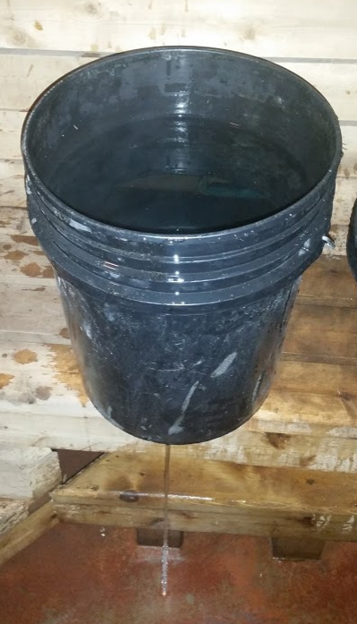

Abstract—In this paper it shows how the energy principle, continuity, and minor head loss can be used to estimate the time to drain a tank. To solve the equations that are used in this DLA were solved using excel. This used a method of entering a value for the head loss and letting excel solve the equations to find the correct value. This is much easier with excel so that it will solve the equations quiqly for every new value entered.

Introduction
Before the use of computers we had to do everything by hand. The use of computer simulations and programs like excel that can solve many equations very fast made solving problems like the one for this DLA take much less time. This also made it much easier to try multiple numbers for one variable in the equation until the final answer is correct. In this DLA this method is what will be used to find the value of K in the final equation.

  - Background
The principles used in this DLA have many applications in the real world. The energy principle is the main equation that was used in this DLA. This can be seen in any pumping system where the head of the pump needs to be calculated to see what pump would work.
The minor head loss can be used to find the amount of head loss from the change in diameter of a pipe. This can also be used like it was in this DLA to find the head loss in the output hole of a tank.

Principle Description
    - Continuity Principle
The continuity principle states that in a steady-state the volume of fluid that enters a pipe will be equal to the volume of fluid that is exiting the other end of the pipe if the density is constant. In a non-steady-state this adds that some of the volume can accumulate in the system in something like a tank. The equation for this is below [1].

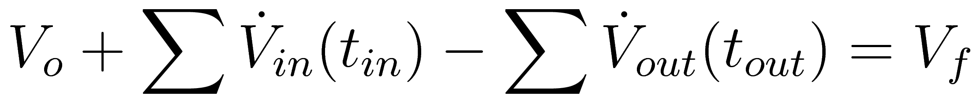

    - Energy Principle
The energy principle can be used to find the final velocity of a system if you have enough of the other variables in the equation. The equation for this principle can be seen below [2].

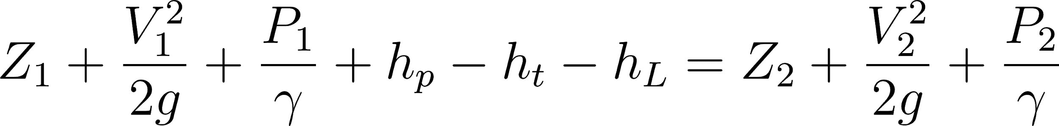

    - Minor Head Loss
The minor head loss can be used to find the head loss due to changes in the diameter of a pipe. This can also be used to find the head loss around corners and other fittings in the pipe [3].

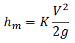

Overview
The goal of this DLA was to first drain some kind of container to find the amount of time that this took. After it had been timed then the value of K was found for the minor head loss of the fluid leaving the container.
With this value a new time to drain from a different initial height in the container was calculated using excel. Once the new time was calculated the container will be drained again to see how close to the calculated time the actual time for the new height is.

Method

Procedure
    - Since I started with a 5-gallon bucket that already had some holes in the bottom the first step was to tape all but one of them so that it would drain through one ¼ in hole, Figure 1.

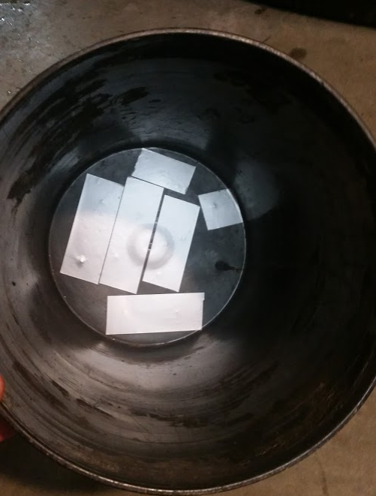
Figure 1 - Bucket with tape on all but one hole.

    - After this, the next step was to drain the bucket from the first height of 1 ft, Figure 2. This was done 5 times and timed for each one. Then the average was taken to get one value for the time to drain.

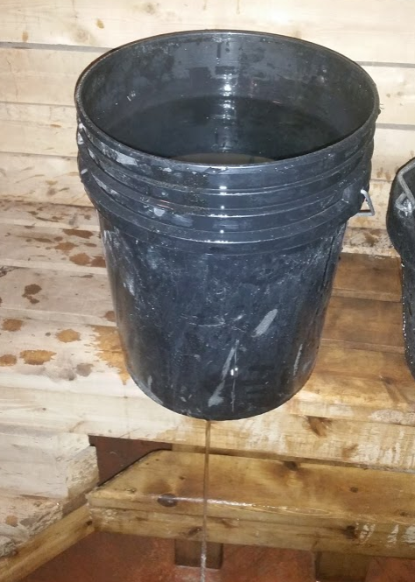
Figure 2 - Bucket draining with 1 ft of water.

    - The average time to drain for 1 ft was then used in the excel sheet to find the value of K to get the correct time that matched the actual time.

    - After the K value was found the time to drain from 0.5 ft was estimated with the Excel sheet.

    - The next step was to drain the bucket from 0.5 ft to see the actual time to drain and compare this to the estimated time from the excel sheet.

Important Equations
    - Velocity Leaving Tank Without K
This equation was used to estimate the time that it would take to drain the bucket without any head loss of the fluid flowing through the hole.
This equation was found by starting with the energy principle. The continuity principle was also used to substitute into the energy principle to get less variables so that the equation can be solved using the diameters of the bucket and outlet.

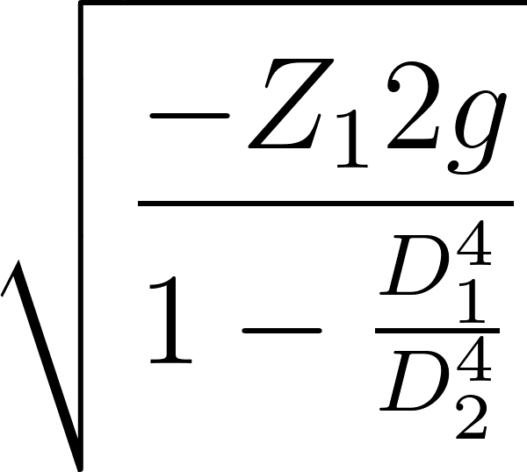

    - Velocity Leaving Tank With K
This equation was used to find the value of K for the minor head loss of the hole leaving the bucket. This was also used to find the estimate of teh time to drain with a changed height after the value of K was known.
This equation was also found by starting with the energy principle. The continuity principle was also used to substitute into the energy principle to get less variables so that the equation can be solved using the diameters of the bucket and outlet. For this equation the minor head loss was also used to find a more accurate time to drain the bucket.

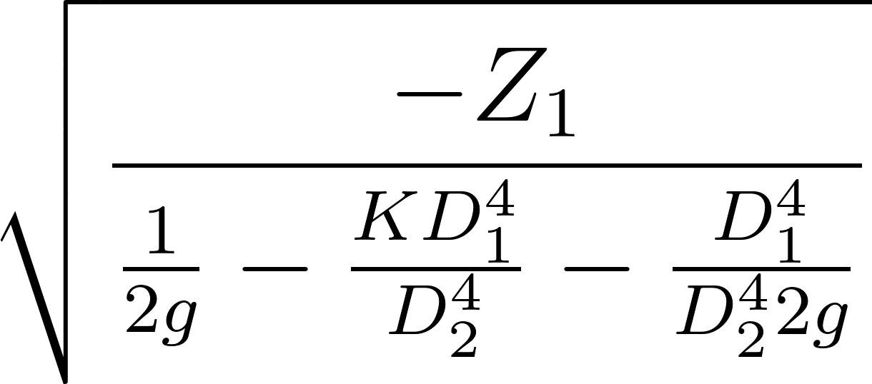

  - Blank Tables
    - Drain Times

      - 1 ft of Water
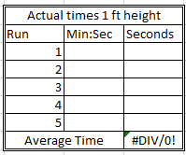
Figure 3 - Empty 1 ft height times to drain

      - 0.5 ft of Water
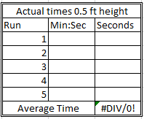
Figure 4 - Empty 0.5 ft height times to drain

    - Input and Output of Excel Sheet Equations
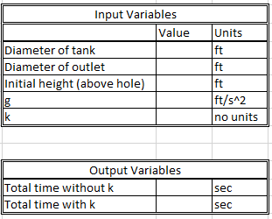
Figure 5 - Empty variables used in excel sheet

Results
  - Completed Tables
    - Actual Drain Times

      - 1 ft of Water
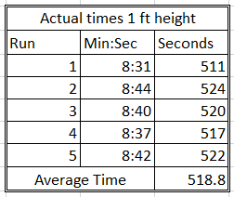
Figure 6 - 1 ft height times to drain

      - 0.5 ft of Water
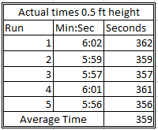
Figure 7 - 0.5 ft height times to drain

    - Input and Output of Excel Sheet Equations

      - 1 ft of Water
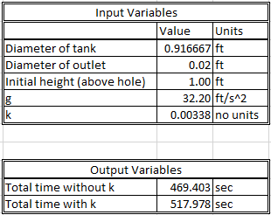
Figure 8 - Variables used in excel sheet 1 ft

      - 0.5 ft of Water
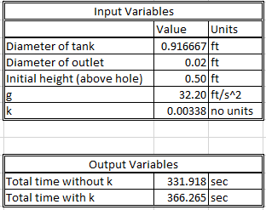
Figure 9 - Variables used in excel sheet 0.5 ft

  - Excel Calculations
The calculations for this DLA were all done in excel. The reason for this is that they need to find the velocity of the output and the time for many different heights during the draining.
The first step is to find the height at 100 evenly spaced intervals during the draining of the bucket. After that, the equations in excel find the velocity at every height and the time to drain between each interval.
After it has the velocity between each interval with and without K the times are totaled to see the amount of time to drain the bucket with the entered values of the diameters, height, and the value of K.

  - Graph of Velocity vs Height for 0.5 ft
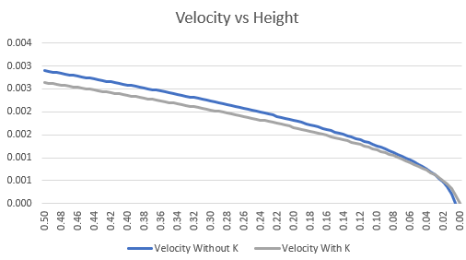
Figure 10 - Graph of output velocity when draining with K for 1 ft and 0.5 ft

Discussion

Analysis
The first part of this DLA was to estimate the time to drain the bucket without using any head loss in the equation. The estimated time without head loss can be seen in Figure 8. This value was 469.4 seconds. The actual time for 1 ft of water can be seen in Figure 6 and it was 518.8 seconds. There was a large difference in these two numbers so the next step was to add the head loss into the equation and find the value for K.
The value of K that worked to match the drain time for 1 ft can be seen in Figure 8. The value was 0.00338 and it was found with trial and error by entering a number until the estimated time matched the actual time to drain.
Once the value of K was known the next values to compare were the estimated value and the actual time for draining from 0.5 ft. The actual time can be seen in Figure 7. This value was 359 seconds. The value estimated with excel was 366.27 seconds, Figure 9. These values are not very far apart so the excel sheet was a close way to estimate the amount of time to drain once the minor head loss was added.
The graph shown in Figure 10 shows the velocity of the output draining with 0.5 ft of water in the bucket. This shows that without the head loss in the equation the velocity of the output will be larger. This is why the time is lower without the head loss.

Sources of Error
    - Timing Accuracy
One place where there could be some error in the results of this DLA is in the accuracy of starting and stopping the stopwatch to time the draining. This could change the times used and that is why the average was taken of five times draining the bucket to try to minimize this error.

    - Diameter Change in Bucket
Another thing that could cause errors in the times is that a 5 gallon bucket changes diameter from the top to the bottom. This did not cause much of a difference in the times for this DLA, but it could be part of the reason that the actual and estimated times for the second draining were a little different.

Improvements
    - More Tests
One way that I could improve this could be to run more tests at different heights. Running more tests and comparing the estimated time to the actual time for more different heights would show that this can be used for any heiget once you know the head loss of the fluid leaving the tank.

Reflection
Before this class, I had some experience with excel and making sheets in excel. I have even used visual basic code in a few excel sheets to do more complicated things. I think that this helped me understand what the excel sheet is doing and how the equations work.
One thing that this DLA showed me in the real world is how non linear the velocity of the water at the output of a draining bucket is. I knew that the bucket would not drain linearly before this but I did not expect it to be as slow as it was for the last few inches to drain. This showed me how much of an affect the fluid height has on the rate that a tank will drain.
During this DLA i also learned more about how excel can be used to solve difficult problems easily. Being able to enter the equations so that the variables can be changed and you will geet new answers instantly is very useful. This is much faster than solving the equations by hand and once you have the equations correct it could make less mistakes than solving them by hand if you are rushing.

References
- “Continuity Equation,” Princeton University. [Online]. Available: https://www.princeton.edu/~asmits/Bicycle_web/continuity.html. [Accessed: 07-May-2020].
- “Conservation of Energy in Fluid Mechanics - Bernoulli's Equation,” Nuclear Power. [Online]. Available: https://www.nuclear-power.net/laws-of-conservation/law-of-conservation-of-energy/conservation-of-energy-in-fluid-mechanics-bernoullis-principle/. [Accessed: 07-May-2020].
- Minor Loss Calculation for Liquid and Gas Flow. [Online]. Available: https://www.lmnoeng.com/minorloss.php. [Accessed: 07-May-2020].

