# Overview of the application

The application creates a GUI for the calculator from the assignment for week 1, using the **tkinter** framework.

It imports the **Calculator** (and the OPERATOR_xxx) from the Python engine.py.

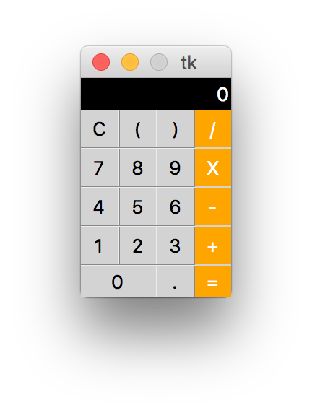

The *__init*__ builds the entire GUI, binds al keyboard keys and mouse left button click to *on_key* and *on_click* methods, respectively.

Both methods, delegate the event processing to the *_process* method.

When the ‘=’ symbol event is processed, it calls the *Calculator.calculate* method with the expression which is displayed on the display label.

Note that the expression is built with additional white space surrounding the operators and parenthesis in order to confirm to the expectation of the calculator.

The Calculator uses a state-machine for the purpose of manipulating the display:

any key but ‘C’

or ‘=‘

RESET

ENTRY

COMPUTED

ERROR

‘C’

‘C’

‘C’

any key but ‘C’ or ‘=‘

any key but ‘C’

or ‘=‘

‘=’ and success

‘=’ and

error

# Code Walk-thru

The GUI uses a grid layout manager with 7 columns (1, 3, and 5 are vertical separators) and 9 rows (2, 4, 6, and 8 are horizontal separators).

# Assignment

For this assignment, you need to add an additional row right below the display, with 4 buttons:

1. MC – memory clear
2. MS – memory store
3. MR – memory recall
4. sqrt – the square root operator added in the week 1 assignment

The meaning of the 3 memory buttons is the usual for a typical calculator, i.e. ”clear the memory”, “store number on the display in memory” and “recall the number from memory”, respectively.

The new GUI should look like this:

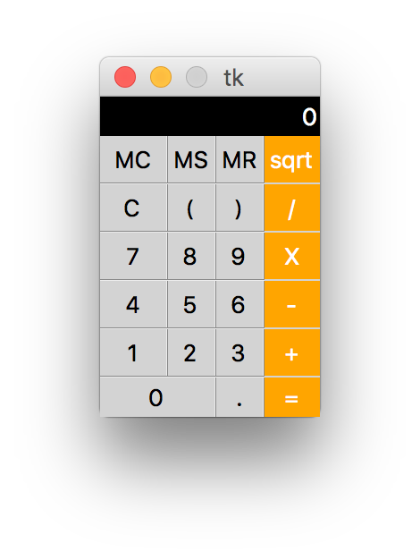

After completing the implementation, all the tests should pass.

Tests are t.b.d.

# Instructions for download

Download the homework_mod3.zip file and expand it in a directory. The directory structure should look like this:

Open the project in your preferred IDE or a text editor, and open the gui_calculator.py file; follow the TODO comments.

# What’s Next

The next assignment is t.b.d.