Openzeppelin Counters.sol is for keeping track of the voter’s vote

Event() is a very cheap way to store data in the blockchain

voterOrganizer is the message sender who deployed this smart contract.

Constant.js is used for connecting our smart contract with the front end.
Voter.js is used for write functionality of our smart contract and all the how data are shared through the entire application.

Web3modal

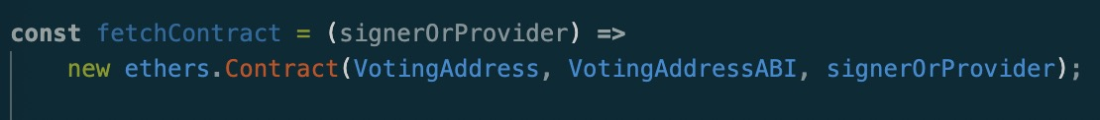
this function is used to communicate with the smart contract and the front end

react is used for sharing data

