BankApp Deployment Flow
How the deployed app will run in AWS.

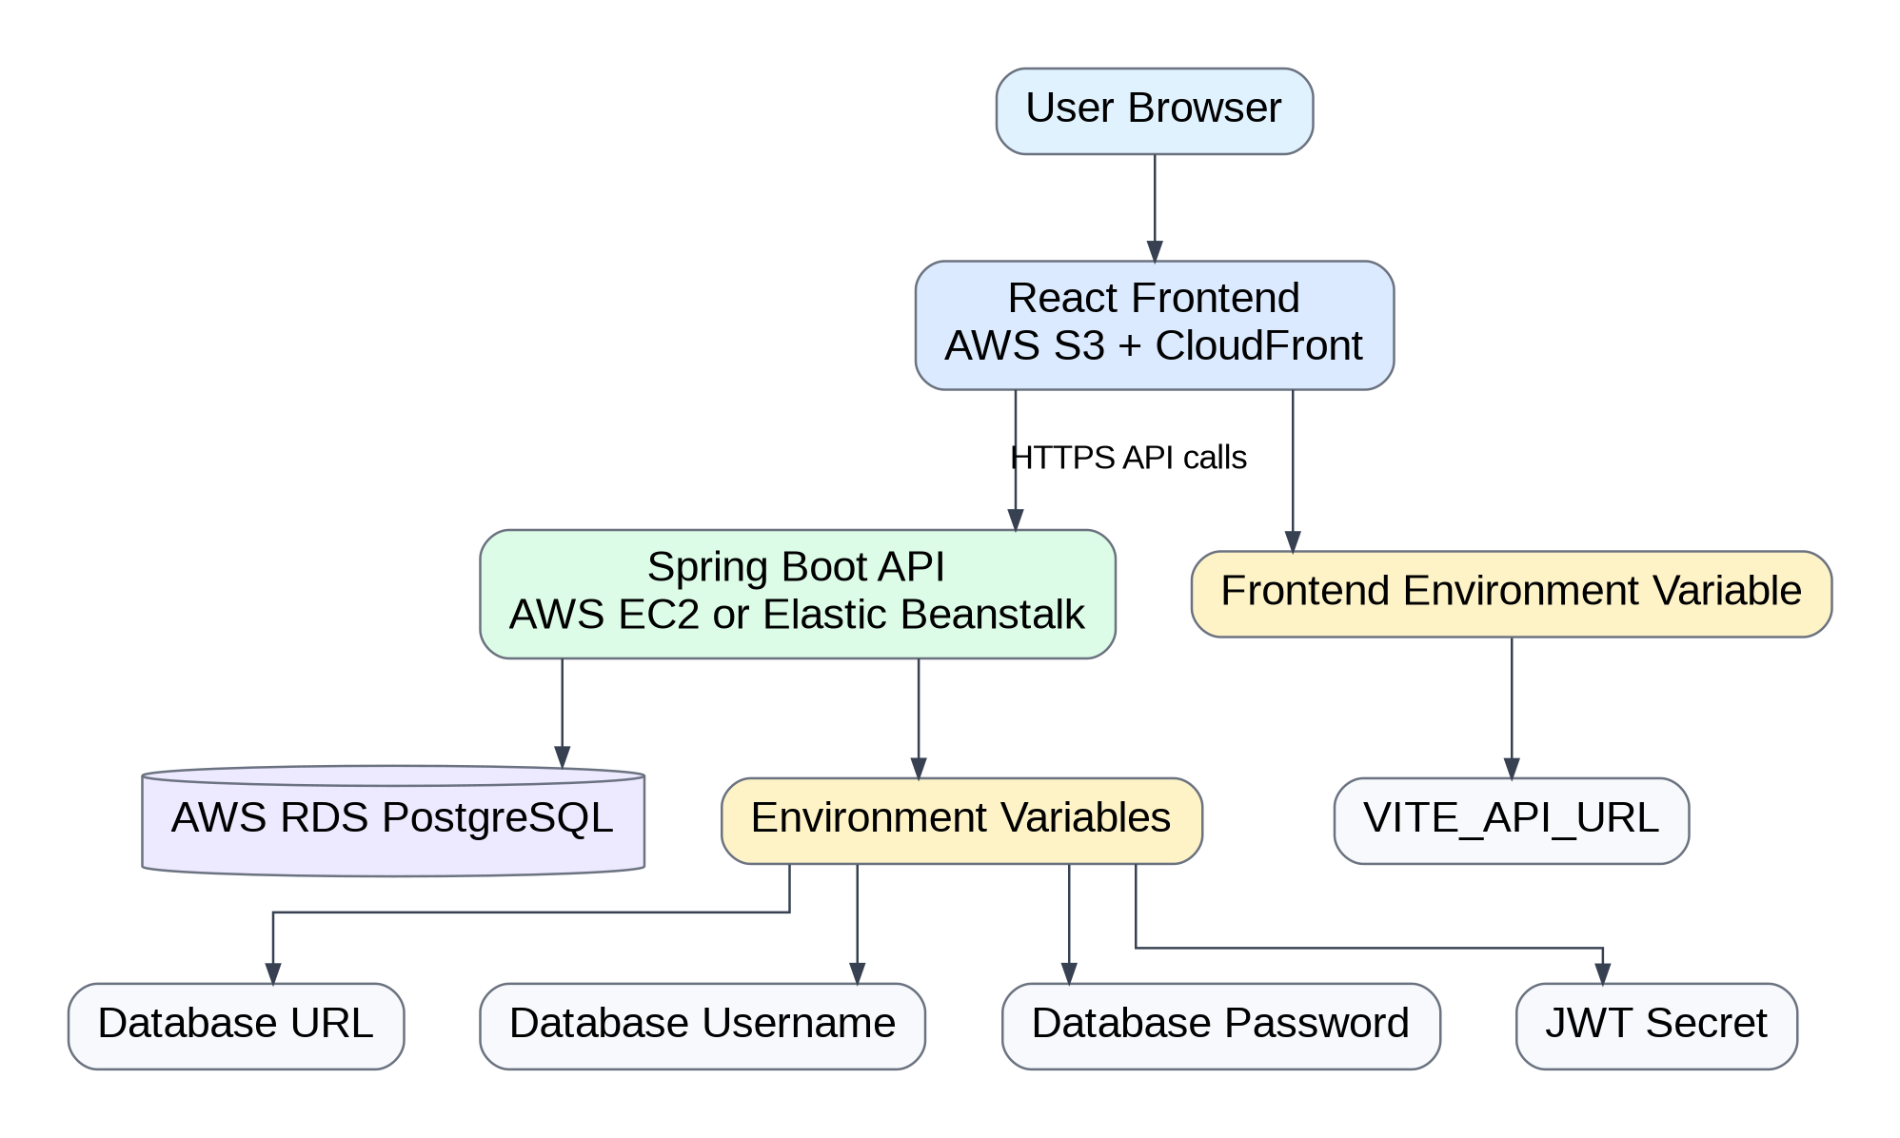

Use this document in your README, portfolio notes, or project documentation.

