BankApp User Flow
How a customer moves through the application.

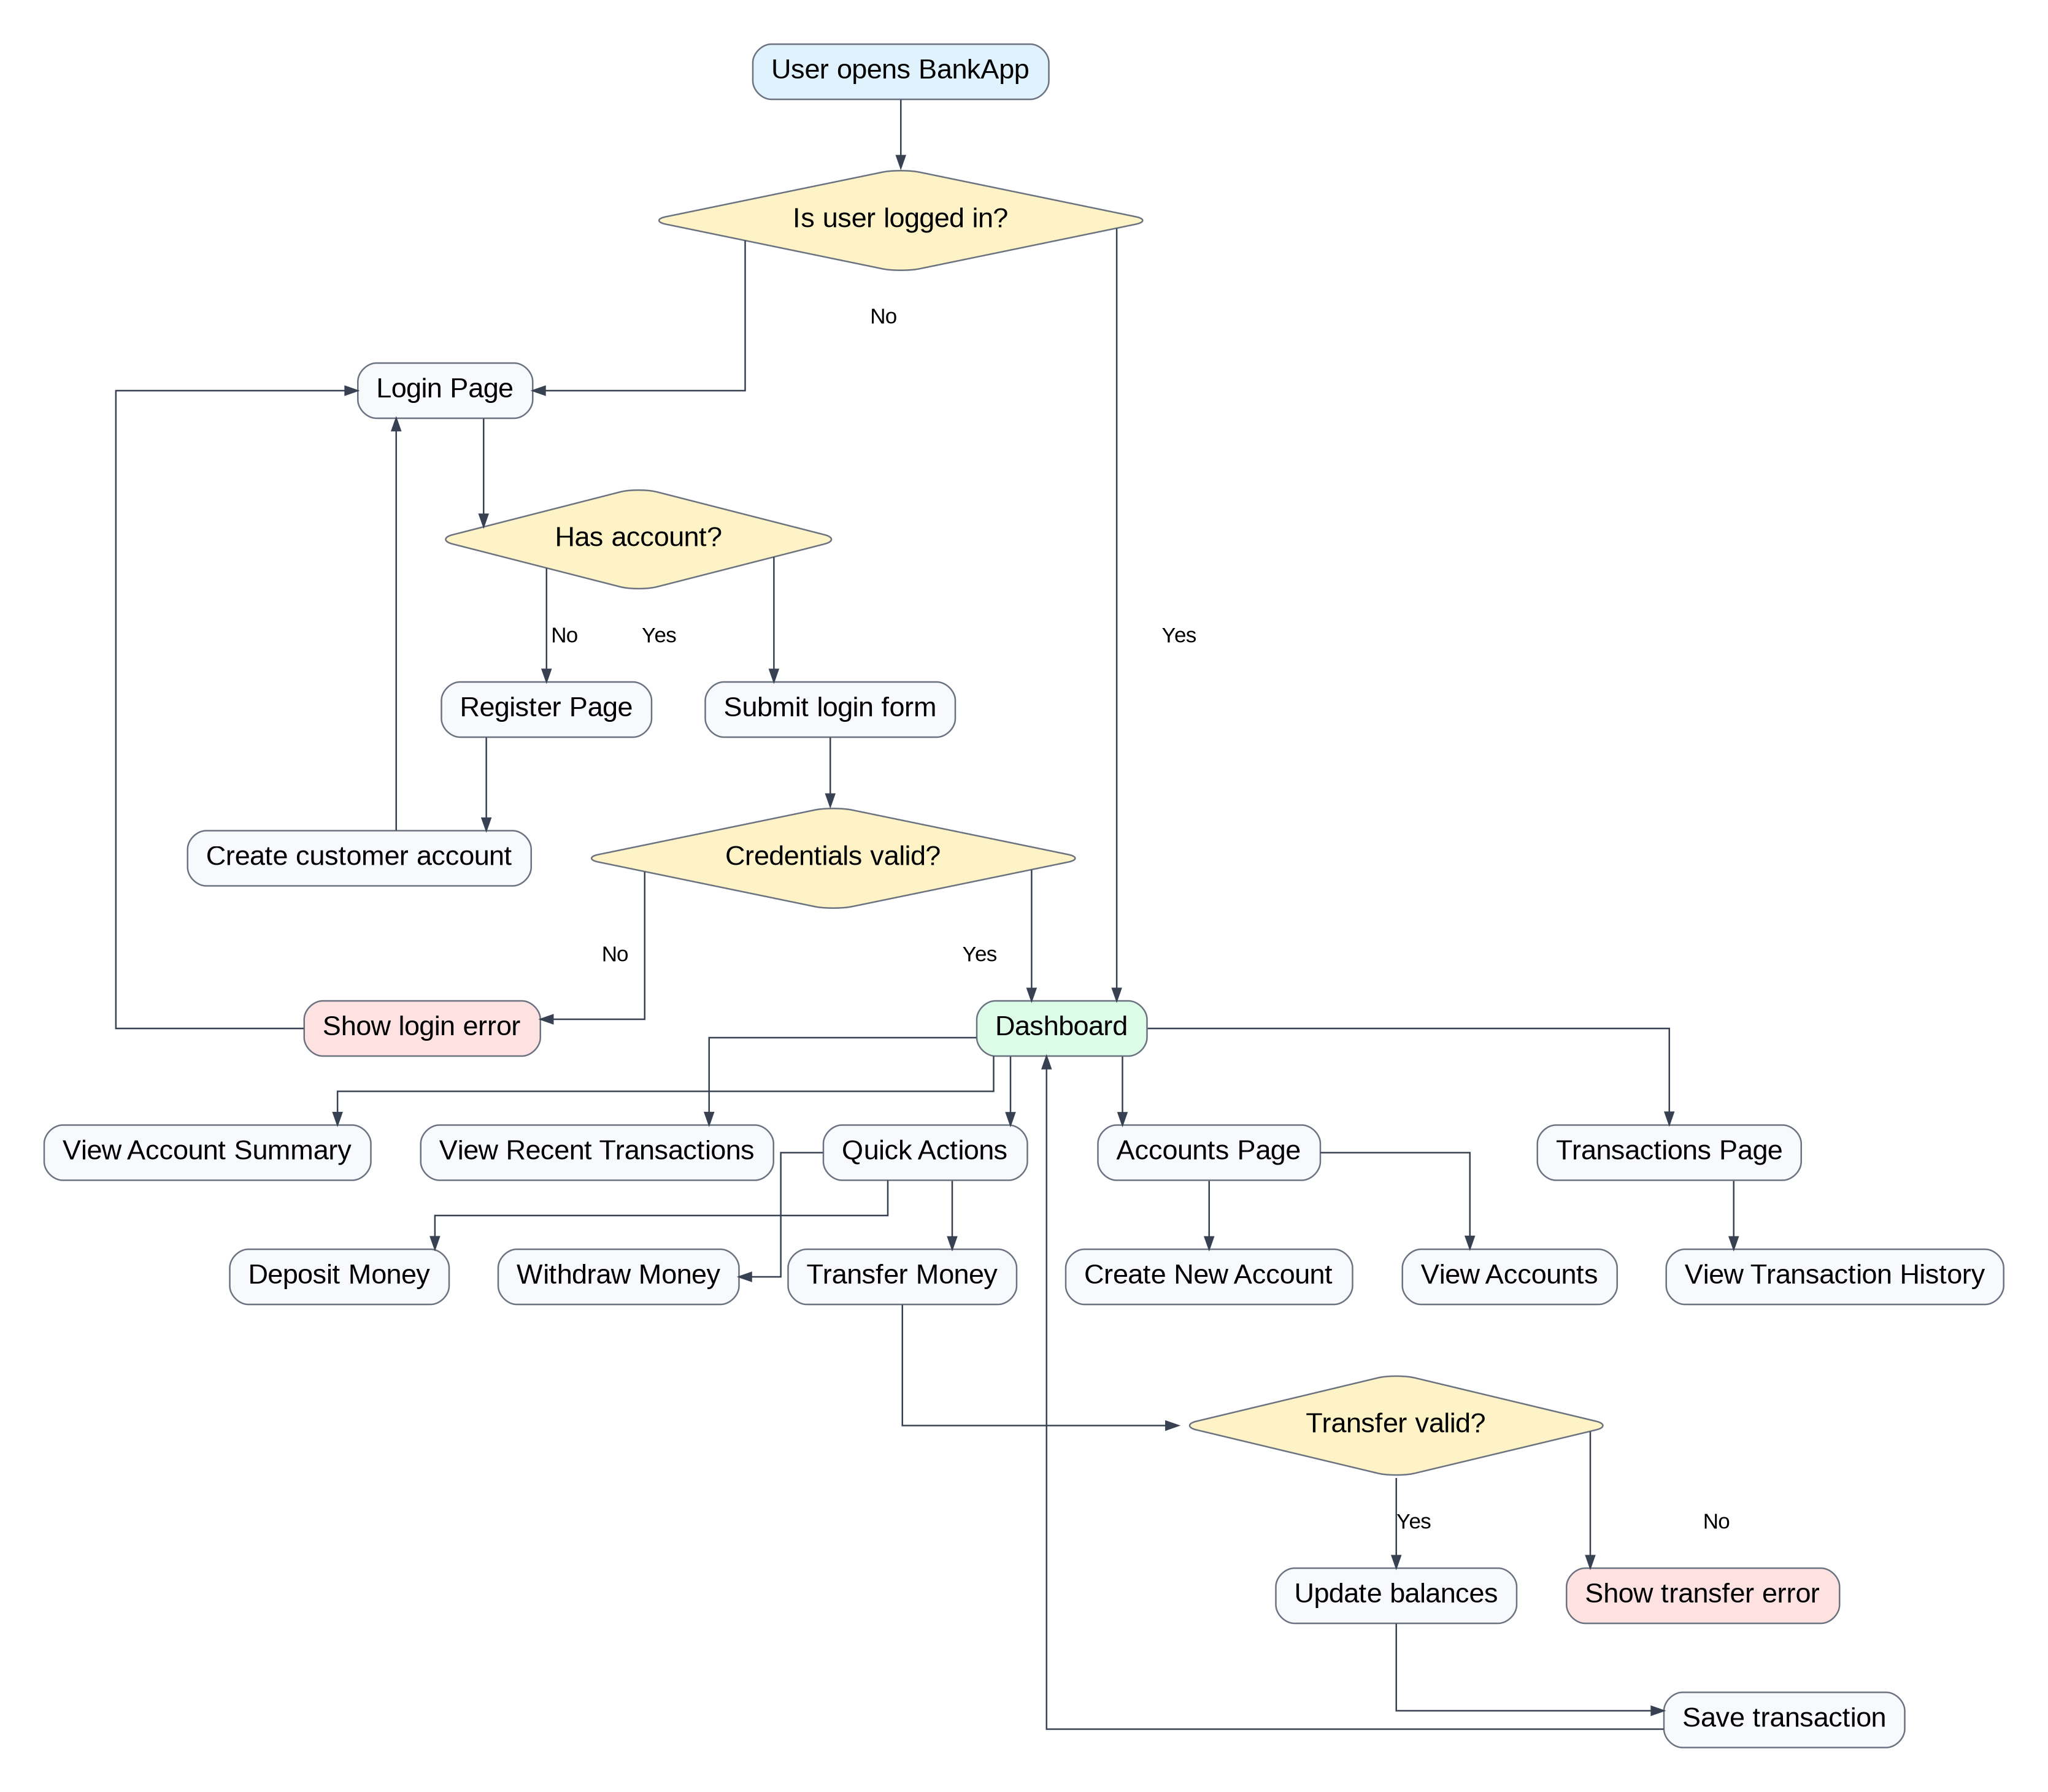

BankApp System Flow
How the frontend, backend, services, repositories, and database work together.

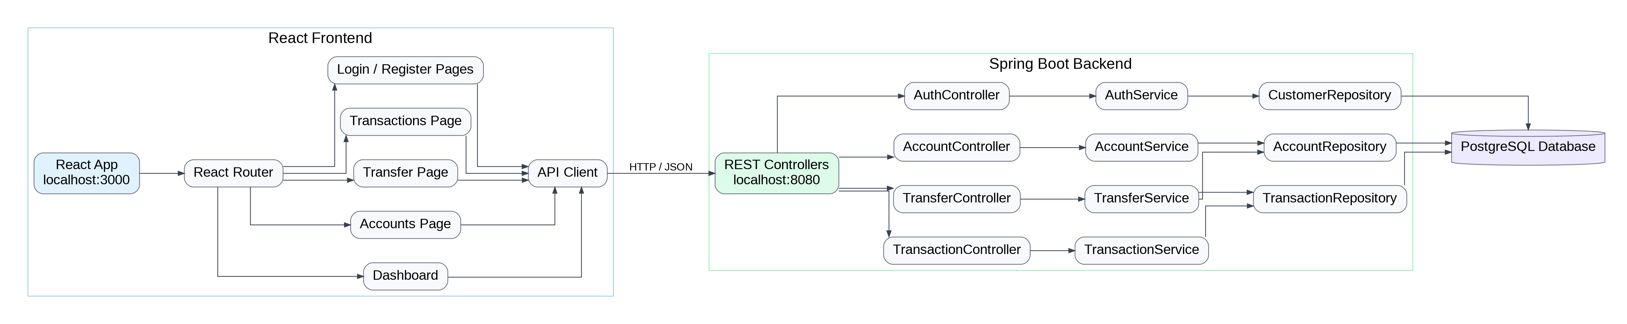

BankApp Deployment Flow
How the deployed app will run in AWS.

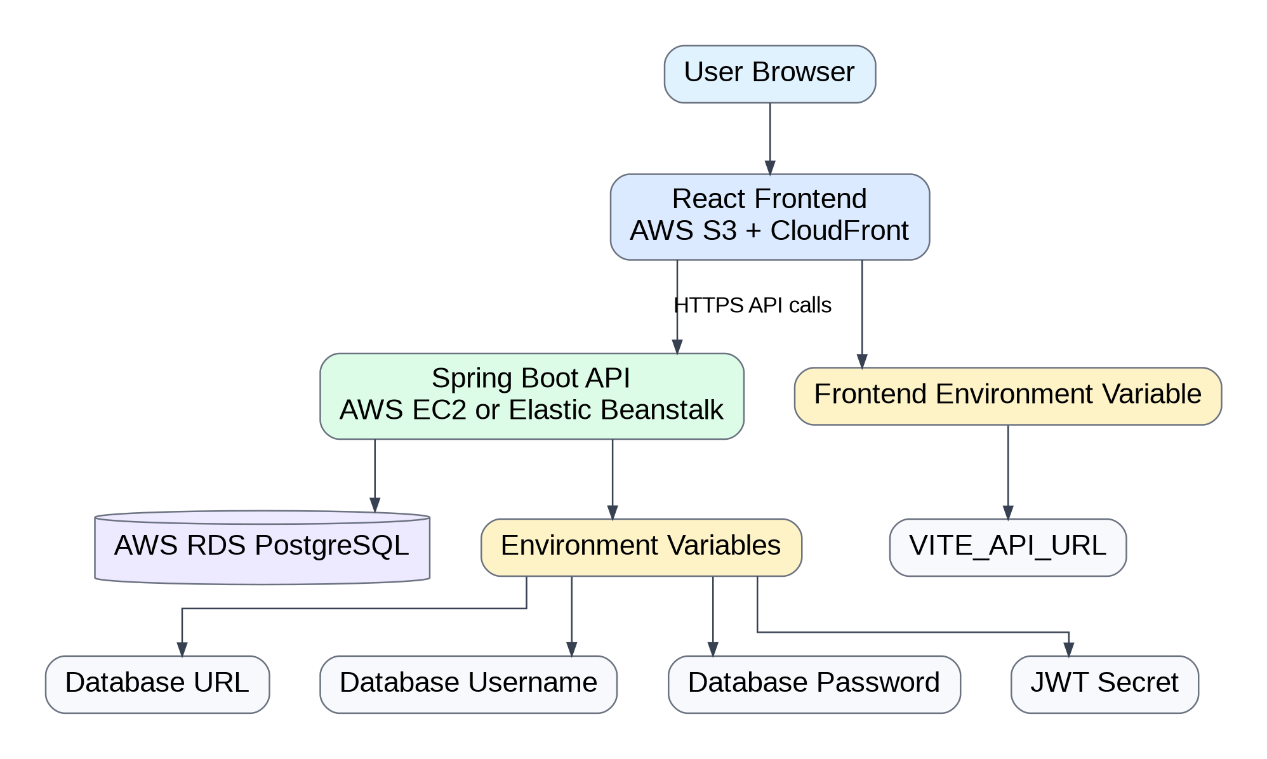

BankApp Core Feature Flow
The recommended build order for the project.

