BankApp System Flow
How the frontend, backend, services, repositories, and database work together.

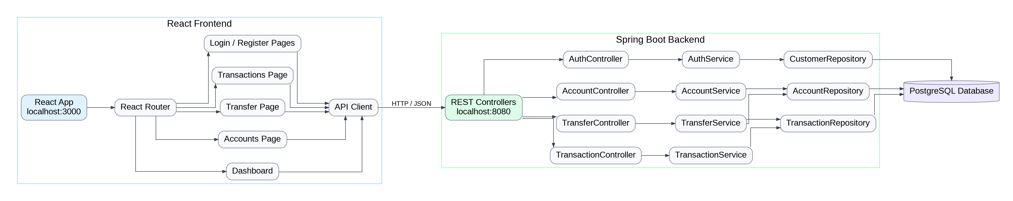

Use this document in your README, portfolio notes, or project documentation.

