BankApp User Flow
How a customer moves through the application.

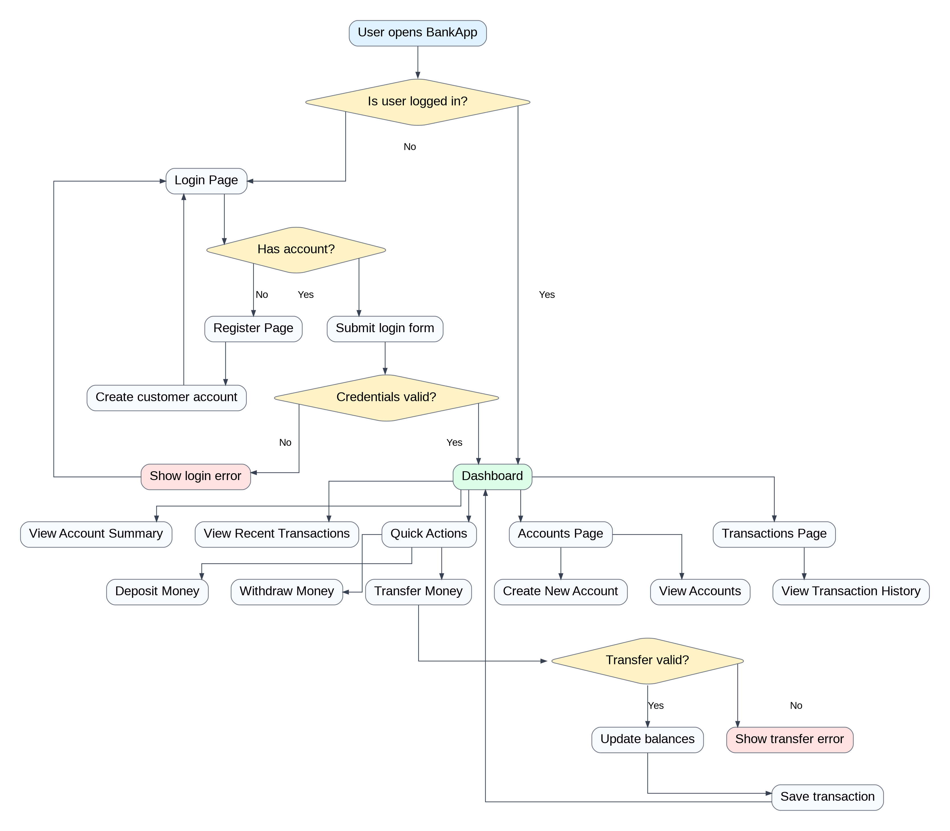

Use this document in your README, portfolio notes, or project documentation.

