Nigel Down
Data Privacy Professional
CIPP/E, CIPM and AIGP
m: 07795633377 email: nigel@nigeldown.com
I have more than 10 years of direct experience in data privacy and international data protection. I oversee and implement global privacy operations across the UK, EU, APAC and LATAM regions.
My work includes privacy assessments, data inventory, breach management, mapping data flows, and integrating privacy by design at every stage of the business processes. Additionally, I embed compliance and AI governance through conversations, training sessions, and privacy questionnaires while managing DPAs, PTAs, DPIAs, SCCs/IDTAs and vendor due diligence.
At MullenLowe Global (IPG), where I spent 8 years, I was the “go-to” data protection/compliance person, engaging with all data privacy challenges from audits, training, records of processing activities (RoPAs), to data subject access requests (DSARs), cookie management and divestments. I provided practical solutions and supported teams globally, while delivering detailed data privacy metrics that informed leadership decisions.
I thrive in fast-paced environments by simplifying complex privacy processes and enjoy combining my expertise in global privacy, project management, AI governance and data-driven personalization. A major achievement was leading the development and company-wide rollout of an AI/ML-powered dashboard that visualizes business activity and identifies privacy risks, regarded as the “heartbeat” of the organization and essential for proactive risk mitigation.
Experience and abilities:
- Excellent knowledge of Data Privacy compliance (GDPR (UK & EU), PECR, CCPA, POPIA)
- Data Privacy Engineer
- Confident working with clients and senior stakeholders globally to establish effective SLAs, DPAs, DPIAs and real-time reporting on initiatives.
- First class financial management at both project and department level.
- Excellent integrated project management skills.
- First class resource management and mentoring skills.
- BCP and digital accessibility champion.
- Good knowledge of AdTech, digital, data personalisation, video production and print.
- Broad experience working on global campaigns across personal care, food, home care, financial, automotive, retail, construction, Fashion, F&B, charity, and the leisure industries.
- Proficient at developing and installing company dashboard solutions, enhancing data privacy.
- Good understanding of OneTrust (Saas), Purview and Master Data Management
- Familiar with ISO27001 and ISO27701 and NIST Frameworks
- Self-starter, First Aider and Mental Health First Aider.
- Practitioner in Data Protection, CIPP/E, CIPM, AIGP and Fellow of Information Privacy (Application in progress)
Data Privacy & Operations Director - MullenLowe Global (IPG) | Jan 2018 - Jul 2026
- Responsible for delivering agency & campaign adherence to GDPR across UK & EU Agencies and Unilever Globally.
- Developed “Mantle” a bespoke digital dashboard to track data processing (RoPAs, PTAs, PIAs, DPIAs, TIAs, IDTAs/SCCs, LIAs, revenue review activity against forecasted capacity planning and initiatives across all work.
- Provided client, vendor and employee support for data privacy, data management, AI governance and digital accessibility globally.
- A core contributor to supporting M&A and divestitures (TSA’s) during a changing landscape.
- Developed and delivered role based, in language training material and inductions for all employees (Intro to Data Privacy, Data Management & Privacy by Design).
- Member of the core team to deliver All UK Government communications during Covid pandemic.
- Managed the vendor due diligence process ensuring that data privacy comms and DPAs were reviewed with all vendors annually or at a milestone reflecting process changes.
- Key member of the global business continuity team managing BCP across UK & EU during Covid
- Responsible for financial reporting of internal departments.
- Key member of the IPG/Omnicom project management team for the delelopment and implementation of Global Data Privacy Platform (One Trust)
- Initiated and delivered a quarterly data privacy competition video in multi-language for all employees globally.
- Developed the Privacy Audit Review to ensure the business can respond, at speed, to client and internal audits
- A key member of global data privacy steering committee and frequent contributor to data privacy forums.
Accounts: Unilever Globally (Home Care, Personal Care, Food and Ice Cream) UK Government, NHS, Western Union, Freemans and more…

Project Director - McCann Enterprise | Sept 2016 - Jan 2018
- Member of the McCann World Group task force for data privacy
- Key contributor to data privacy and agency process.
- Implemented data privacy training, documentation, compliance and internal audits
- Responsible for all key digital and integrated projects and pitches within the agency
- Guide and mentor a team of projects managers and producers across a variety of channels
- Forecast and manage resource levels to deliver the daily delivery of projects together with the reporting and monitoring of “burn rates” (£10m)
- Introduced daily “stand ups” across all clients working with agile and waterfall methodologies
- Introduced and manage weekly in-flight status to creative directors, account management and key client stakeholders used as a first alert for data compliance
- Managed all third-party relationships and the integration of McCann World Group agencies.
Accounts: Purina, Siemens, SKF.com, GCSP, LMG, Tata, Rockwool, Ideal Standard, F1, JLL and more…
Senior Project/Programme Manager / Director - Rapp (London) | Dec 2014 - Sept 2016
- Hybrid role encompassing data privacy and delivery of the “logic” a highly personalised, dynamically generated customer communications across the whole Virgin Media database (digital, print and mobile)
- Sole responsibility for the creative scoping, project management, production and cost management of the agency’s key client - Virgin Media (Customer and Acquisition projects across multiple channels).
- Forecasting the resource levels to deliver the daily delivery of projects together with the reporting and monitoring of “burn rates”.
- Member of the management team to convert both client and agency from a waterfall to a highly successful agile methodology.
Accounts: Virgin Media

FTC Project Director (Milan and London) - Leagas Delaney | Feb 2014 - Dec 2014
- Responsible for the delivery of all integrated campaigns for Telecom Italia. TVC’s, OOH, press, digital and social campaigns in a highly demanding sector.
- Implemented and audited data privacy compliance across the agency.
- Implementation of key status procedures including daily “stand ups” and weekly status meetings for the daily delivery of projects.
- Managed the digital delivery of data driven campaigns from the London office and project managed the delivery of new business pitches
Accounts: Telecom Italia, Glenfiddich, Patek Philippe, Lenz & Staehelin, MSC cruises, Penfolds
Head of Creative Services (FTC Paternity cover) - Pepper Corporation | Jan 2014 – Feb 2014
Programme Director / Head of Creative Services FTC - Proximity London | Jan 2012 - Jan 2014
- Successfully project-managed the Lloyds Rebrand in 2013, 6-month (£4m) project – expanding the delivery team from 8 to 27 whilst maintaining 90% utilisation.
- Project managed, resourced and delivered a highly challenging succession of pitches which resulted in an unprecedented 13 pitch wins, pitches included: Department of Health, John Lewis, Waitrose, Leaseplan, SSE, SNCF, Thomas Cook, MoneySupermarket.com, British Airways, Oxfam, RNLI, Camelot, Great Ormond Street Hospital, St Pancras International, Kenco / Mondelēz, Royal Mail, Post Office, Parcelforce.
- Responsible for the delivery of all projects, process and the project management within key accounts.
- Shared responsibility for conceptual teams, content copywriters, designers (digital and integrated), UX, QA, Developers (front end web mastering and back-end developers), print production and art buying.
- Financial responsibility for £2.5m expenditure on freelancers, reporting to CFO (AMVBBDO).
- Designed, developed and rolled out an all-agency online management tool for desktop, tablet and mobile. This encompasses: Resource management, Data Privacy, Project “health”, Agency status reports, archiving, client reporting (inflight and dashboard) and coordinates data feeds from existing software.
- Member of the ISO Forum/Internal Audit Team– maintaining agency process and data privacy in relation to ISO 9001 and 20074 across the whole agency.
- Winner of the Proximity I-Award for innovation in the workplace.
- Proximity London was described by industry commentators as “one of the best in town” and was runner up as Campaign’s annual agency of the year award 2013.
- Developed working practices across all areas of the demanding Lloyds Bank account. Working in collaboration with client and client services to develop working methodologies and dashboard reporting to provide weekly overview of work. Highlighted in the Lloyds ‘Client Satisfaction Survey’ as a key part of Proximity process.
Lloyds Bank, TVL, Oxfam, Great Ormond Street Hospital, Aviva, Cognisant, J&J,
RNLI, John Lewis, Royal Mail, Post Office, Parcelforce, SSE, Mondelēz, Proctor & Gamble and Camelot
Ad hoc short-term Freelance Projects | 2011 - 2012
Senior Group Project Director - HPS/BMW | 2007 - 2011
Data privacy, compliance and production responsibilities delivering highly reactive dynamically personalised communications at scale – BMW, Mini, Mazda and Rolls Royce.
Ad hoc short-term Freelance Projects | 2005 - 2007
Project Director – Dunnhumby (Tesco Clubcard) | 2002 - 2005
Data privacy / compliance lead working on Tesco Clubcard to help scale the delivery of highly personalised high volume customer communications.
Recent References available
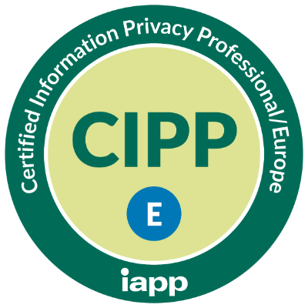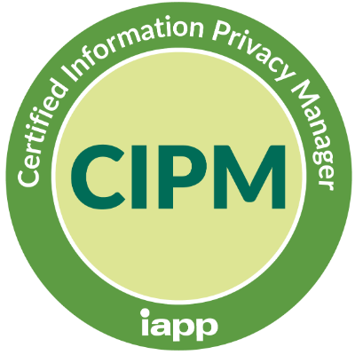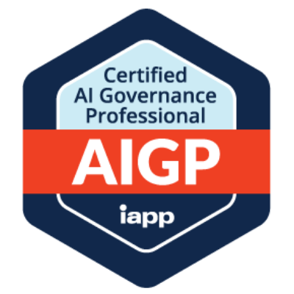
Currently studying for CIPT
Awaiting confirmation of acceptance of Fellow of Information Privacy
AI-assisted editing tools were used solely to improve spelling, grammar and readability;
all content, experience and achievements are my own.

