* + Write a summary of the two implementations, R and C++.
    - Did you get the same results?
    - How do the run times compare?
    - How did you measure execution time?
  + Include screen shots of the output of each program
  + Include screen shots of the run times of each program
  + Write out the algorithm you used for training the classifier
  + Cite all references used
  + No required format for the report

**Assignment 4 – Report**

CS 4375.501

Zain Husain & Mike D’Annunzio

**Logistic Regression compared:**

In R it was easy to reproduce the results that we get from the library function.

The results from hand-implementation in R directly match with the output from the glm() model.

Execution time was measured starting just before the gradient descent loop and stopping just after.

**R:**

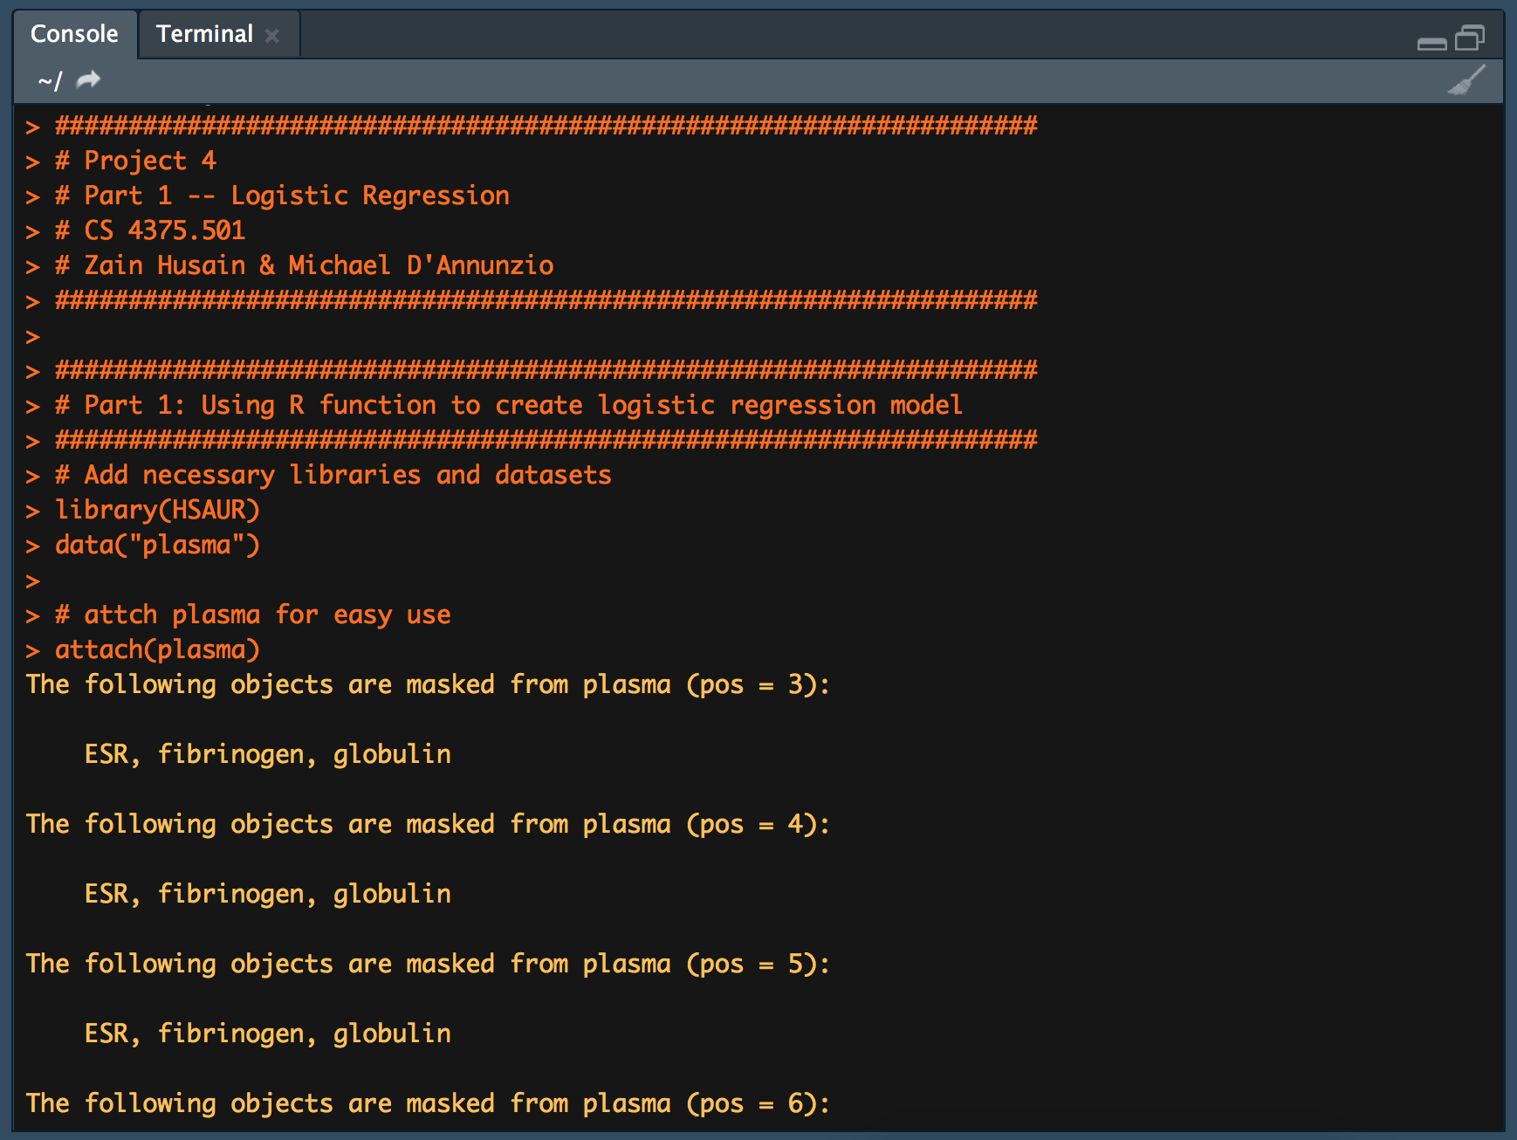

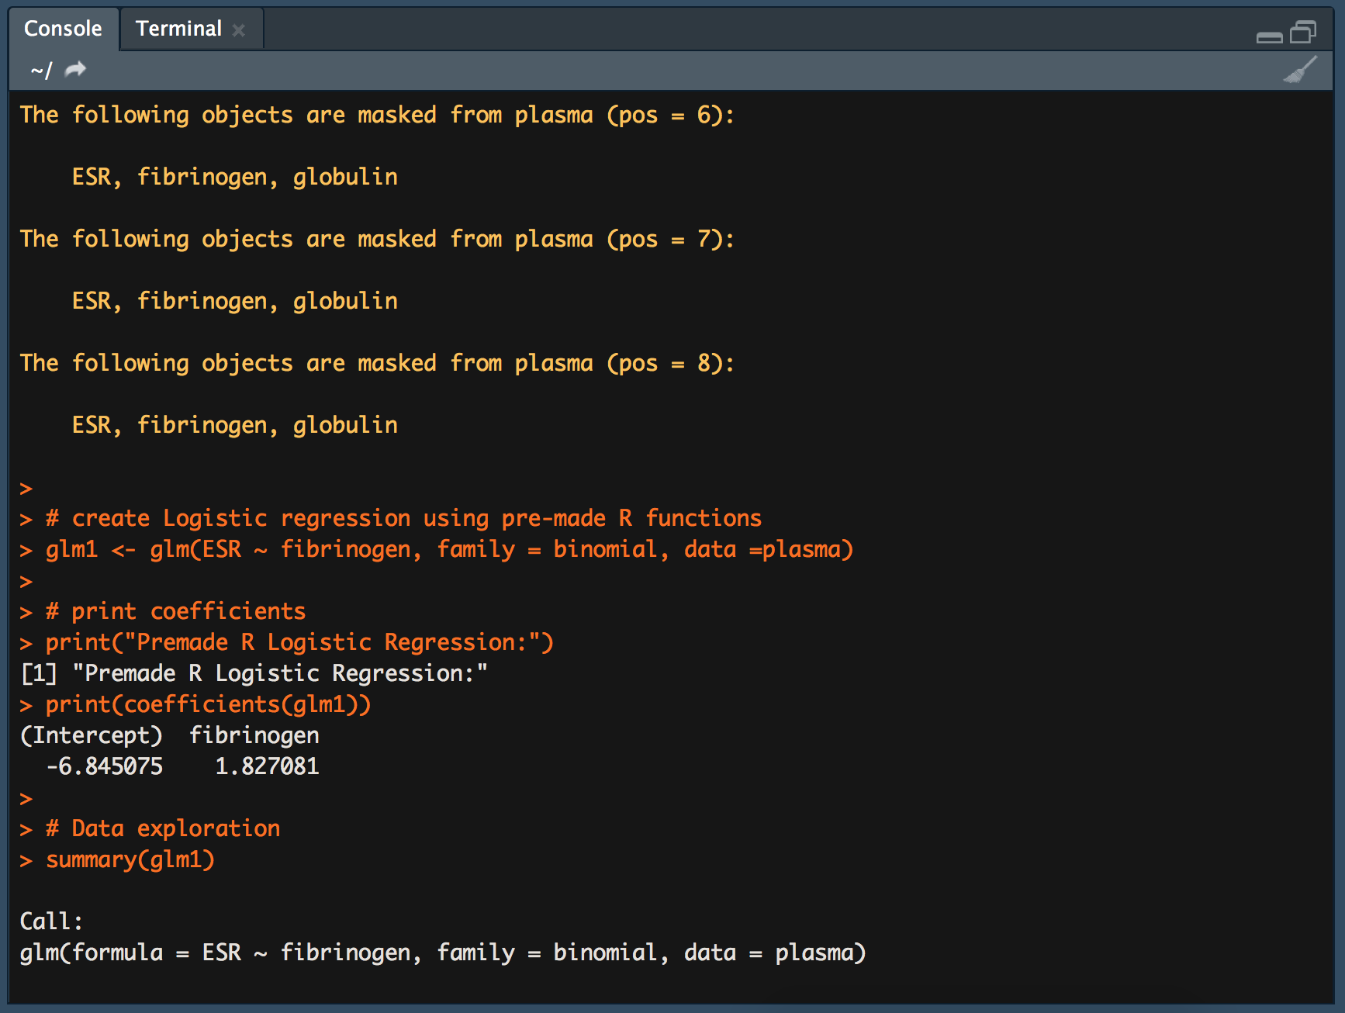

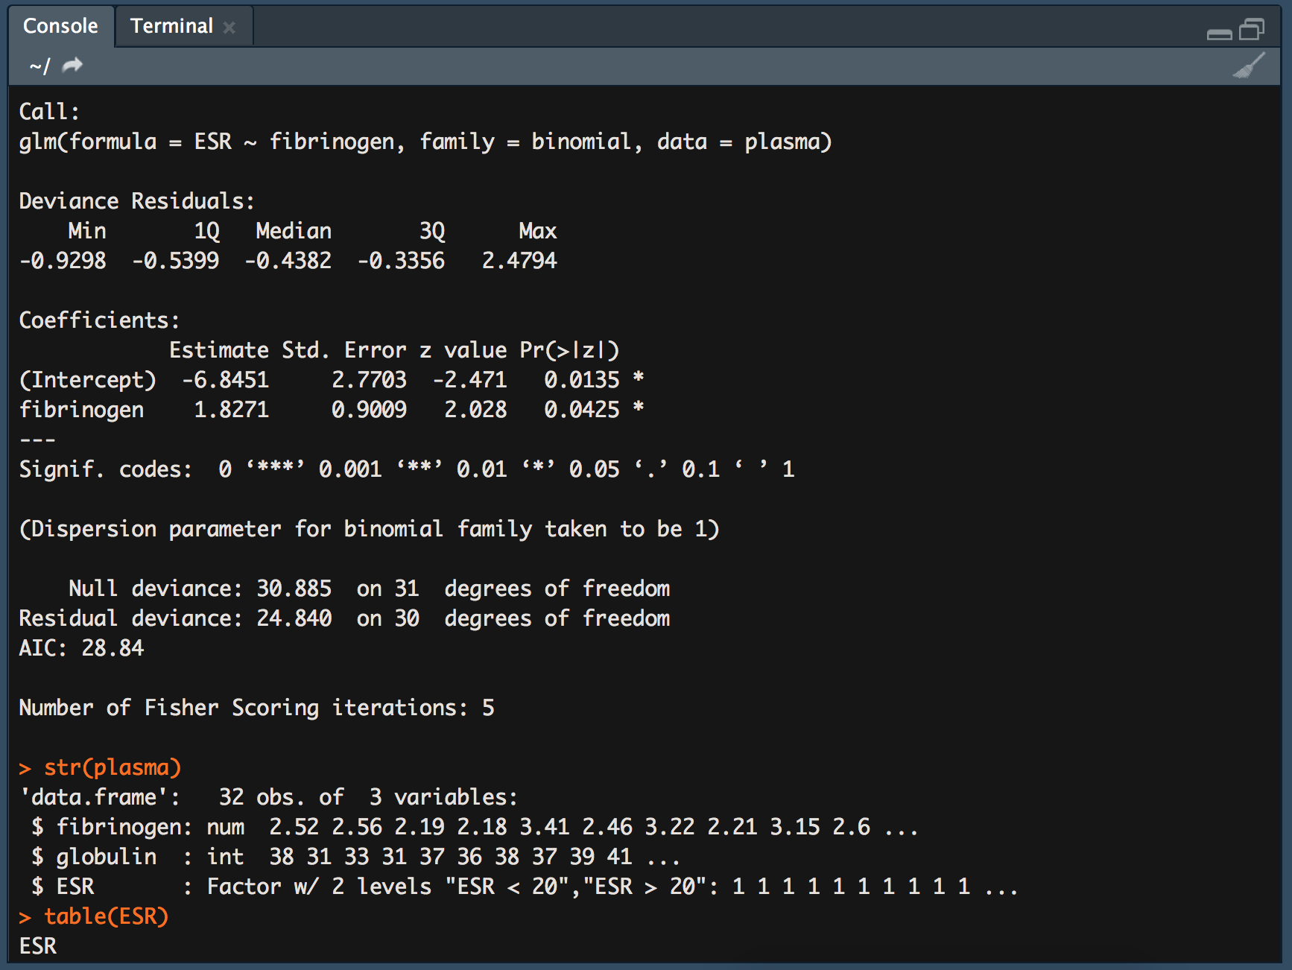

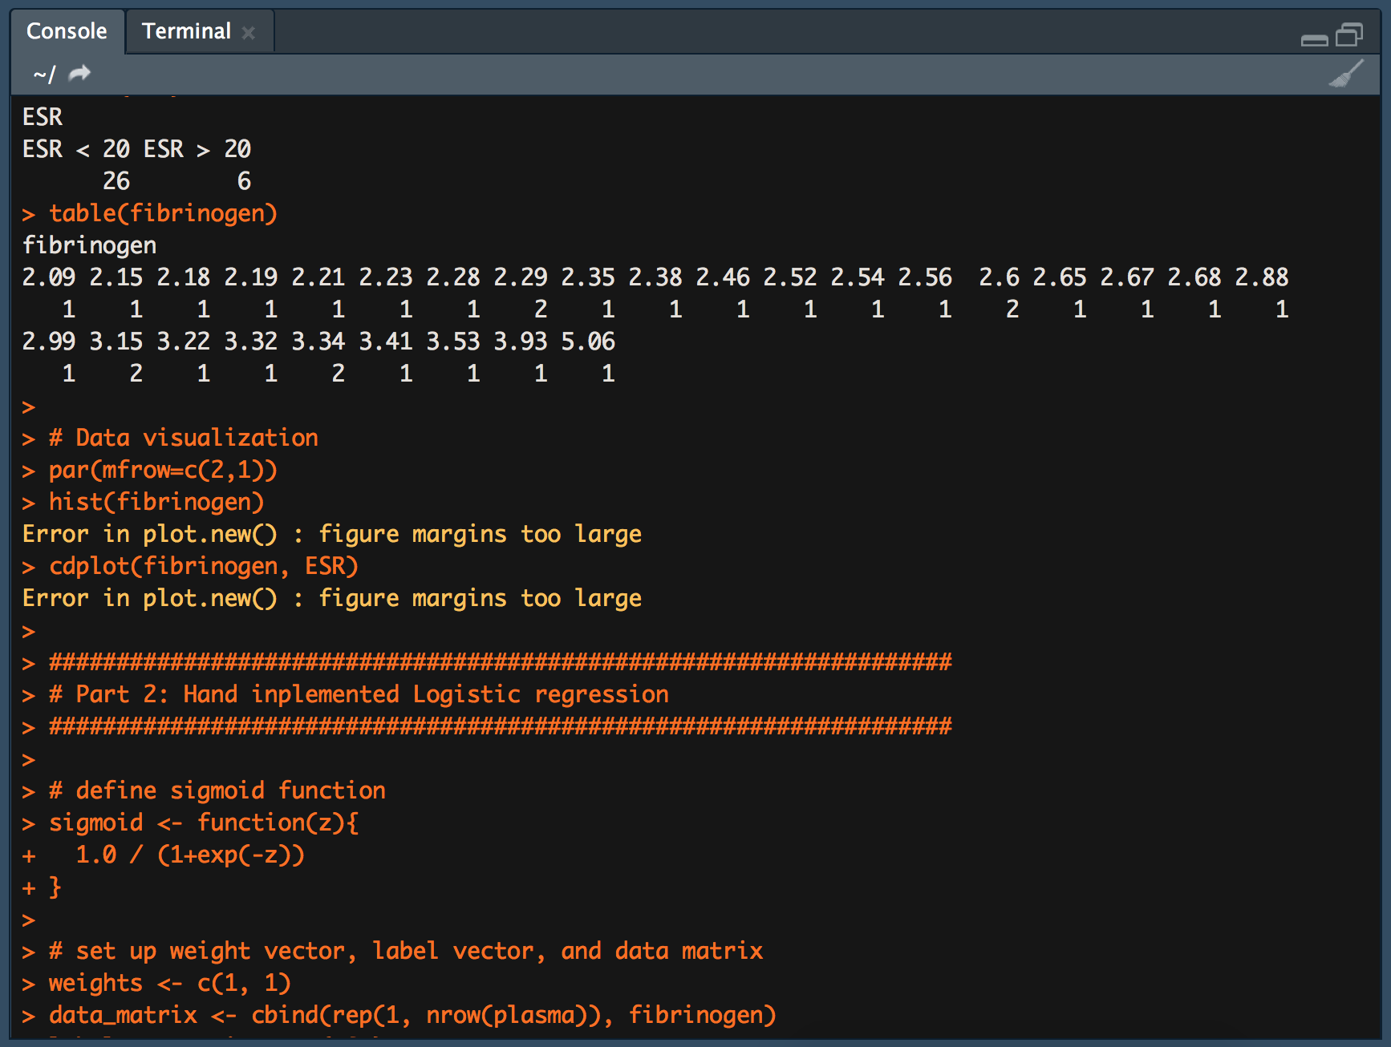

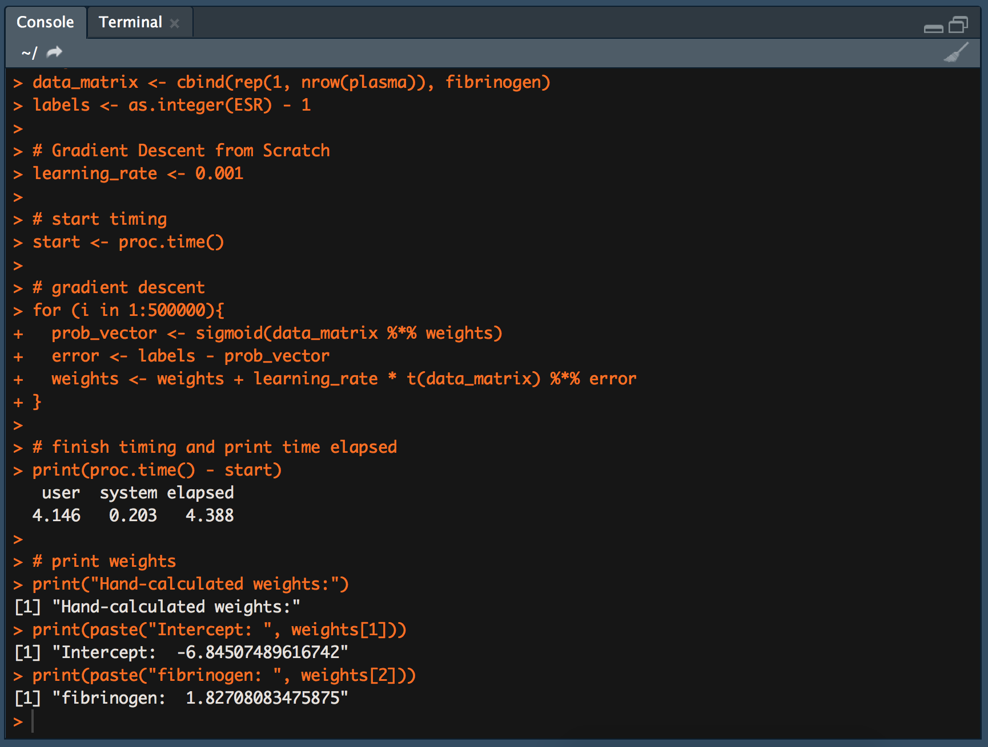

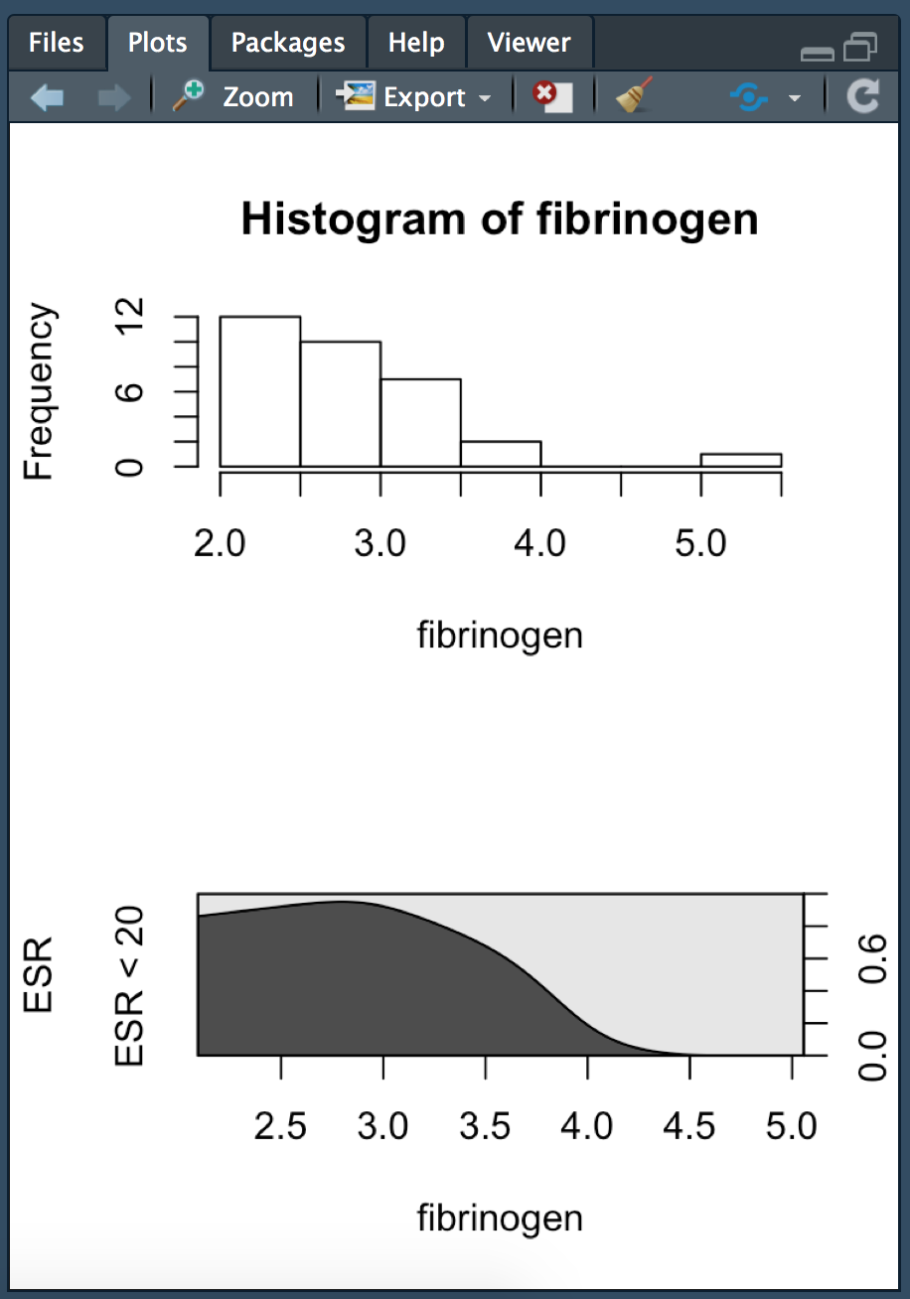

**C++:**

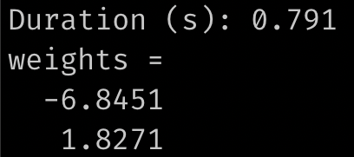

**Naïve Bayes compared:**

In R it was easy to reproduce the results that we get from the library functions.

The results from hand-implementation in R directly match with the output from the confusionMatrix() function.

Execution time was measured starting just before creating the Naïve Bayes model and stopping just after the computation of the metrics.

**R:**



