**Team ("Baratheon") Project #1 Proposal**

**Project Title**

* “Medicine Cabinet”

**Team Members**

* Katie Robertson
* Andraya Smith
* Mike Castillo
* Andrew Esquivel

**Project Description**

store user's current medications in "to-do" style list, check medications for contraindications, allow users to check symptoms

**Sketch of Final Product**

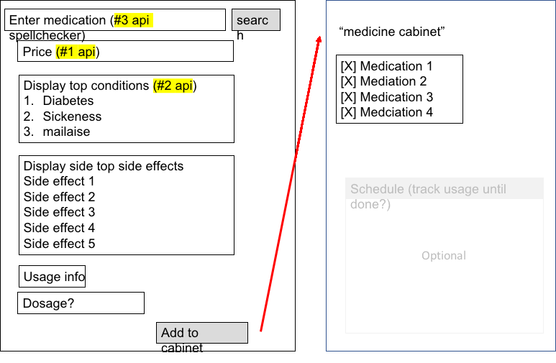

**APIs to be Used**

1. General medicine information
2. <https://www.goodrx.com/developer/documentation#drug-search>
3. Spellcheck

<https://www.programmableweb.com/api/national-library-medicine-chemspell>

1. Price information

<https://www.goodrx.com/developer/documentation#compare-price>

**Rough Breakdown of Tasks**

1. Create rough, shared HTML layout
2. Create generic event handler code for user inputs
3. Create generic data while working on separate API code samples
4. Code and test input validation using new framework/library
5. Integrate all pieces into single draft
6. Polish UI (use alternate CSS framework? Modal framework/library?)
7. Refactor as necessary, time permitting
8. Practice presentation